Team member :

-Monda Atef Ayad

-Mona Asim Mohamnad

-Fatma Abd elsamad

First come first served

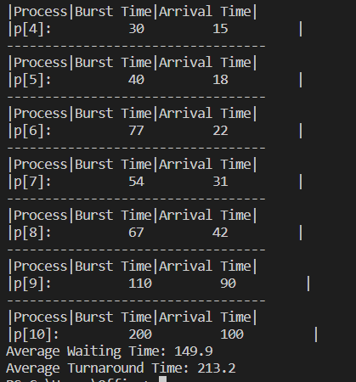

-In first come first served algorithm,the process enters the ready queue first is executed first. (the process that come first ,execute first) regardless of the type of tasks or requests it has to process

-It uses a very simple data structure queue for maintaining processes.

-The disadvantage of FCFS is poor in performance and Short processes have to wait for a long time until the bigger process which arrives before it. So the waiting time is usually high

-Resources utilization in parallel is not possible, which leads to Convoy Effect, and hence poor resource(CPU, I/O etc) utilization.

*Convoy Effect*:Convoy Effect is a situation where many processes, who need to use a resource for short time are blocked by one process holding that resource for a long time.

Shortest Job First(Non preemptive)

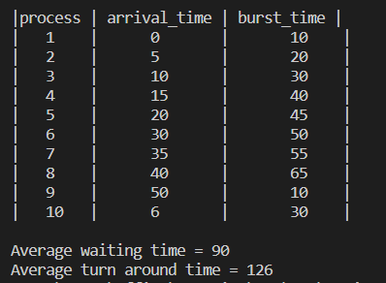

-In shortest job first It is associated with each job as a unit of time to complete.

-If two process or more entered the ready queue in the same time the process with the shorter burst time, execute first

-The SJF scheduling algorithm that holds the process till its reaches time. When the CPU cycle is allocated to a process, it holds that one till it finds out the reaching of a waiting state or a termination phase.

-This algorithm method is useful for batch-type processing, where waiting for jobs to complete is not critical.

SJF is an alternative to FCFS(First Come and First Serve) cause it reduces the average waiting time and is also good for Batch systems.

Shortest Job First preemptive

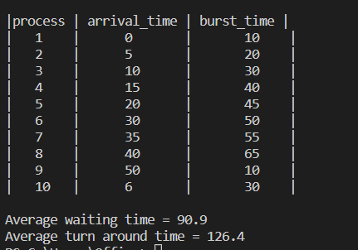

If a process with a much shorter burst time appears at first, the current process receives its removal or preemption from the execution phase. Also, the shorter job will take place in the CPU cycle.

-Reduces average waiting time.

-Optimal with regard to average turnaround time.

Difficult in implement this algorithm for CPU scheduling for the short term as we can’t predict the length of the upcoming CPU burst.

Round ronbin

-Round Robin CPU Algorithm generally focuses on Time Sharing technique

-It is preemptive as processes are assigned CPU only for a fixed slice of time at most.

-While performing a round-robin scheduling, a particular time quantum is allotted to different jobs.

Round-Robin with quantum equal to 0

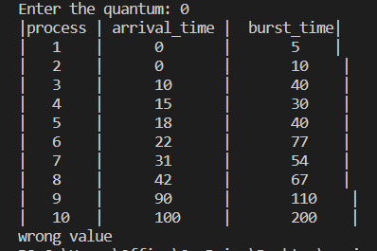

It returns “wrong value ”

Round-Robin with quantum equal to 10

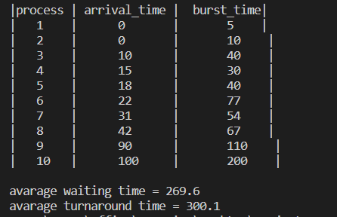

-the average turnaround time increases

- more context switches are required

-respond time decrease in that case

-Chances of starvation decrease .

Round-Robin with quantum equal to 100

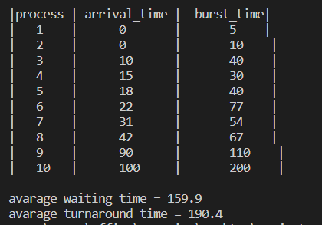

-the average turnaround time decreases

- less context switches are required

-Chances of starvation increases

-respond time increase because

-the response time for a process with a large burst time may be delayed.the process has to wait for its turn to be scheduled and execute for at least 100 units of time before being preempted

Round-Robin with quantum equal to 1000

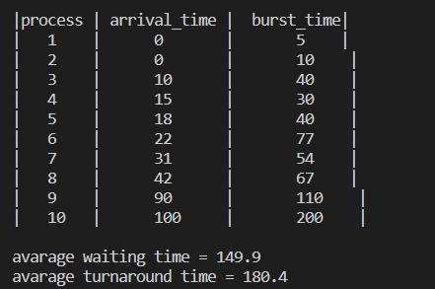

In this case when quantum too large ,the RR

scheduling provide longer execution times for individual processes, reduce context switching overhead, but it also increase waiting times

In this case the round-robin policy is the same as the FCFS policy.

* if the time quantum is extremely large, the RR policy is the same as the FCFS policy
* if the time quantum is extremely small , the RR approach can result in a large number of context switches-->slowing the execution of the process accordingly
* A rule of thumb is that 80 percent of the CPU bursts should be shorter than the time quantum

### Advantages of Round Robin Algorithm:

-Every job gets a fair allocation of CPU.

- time sharing: well-suited for time-sharing systems where multiple users or processes need to share the CPU. By allocating CPU time in small slices or time quantum to each process.

- Low starvation: it minimizes the occurrence of process starvation. Since each process has a guaranteed time quantum, even processes with lower priority or longer execution times are eventually given CPU time.

- Easy implementation: it is simple to implement compared to other scheduling algorithms. It involves maintaining a ready queue of processes and a timer to switch between processes at predefined intervals.

### Disadvantages of Round Robin Scheduling Algorithm:

-This algorithm spends more time on context switches.

-If time quantum is less for scheduling then its Gantt- hart seems to be too big.