**Software-Objects-Problem – Understand Concepts**

* Application Programming Interface.
* Object Oriented Programming Principles.
* Abstraction, Encapsulation, Polymorphism, Inheritance and more.
* Object Relationships.
* Functional Programming.
* Dynamic programming.
* Modelling and Models.
* Descriptive and Imperative programs.
* IPOS – Input process – output – storage.
* POJO Java concept.
* 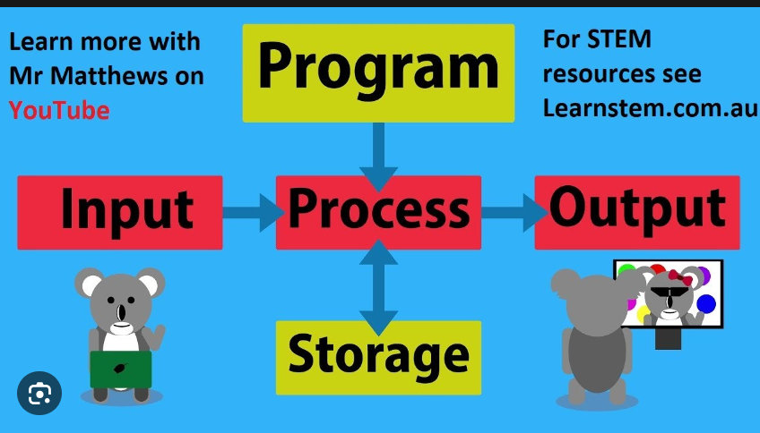

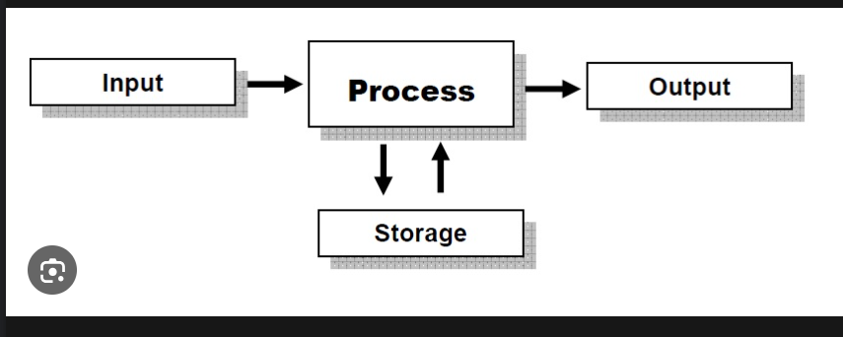

* The “Automation” anything that works without human or manual process.
* Serialization and Deserialization in all programming languages.
* Check parsing process in computer science.
* Testing pyramid
* Docker, Data Structure, and construction.
* **Test Automation Framework Building.**
* **Program input – process – output – storage.**
* **File System.**
* **Variable, parameter, key, column, attribute, field, property.**
* **Entity, element, Object, Program, resource, Functionality.**
* **A feature is a unit of functionality.**
* **https://playwright**
* 