**CONSUMER SPENDING ANALYSIS**  
  
 QUESTION 1: Which Category generates the most revenue?

SELECT

Category,

SUM(Total_Spent) as Total_Spending

FROM

Consumer_spending

GROUP BY

Category

ORDER BY

Total_Spending DESC;

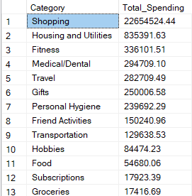

QUESTION 2: What payment methods do consumers prefer?

SELECT

COUNT(customer_id) as Transaction_Count,

Payment_Method

FROM

Consumer_spending

GROUP BY

Payment_Method

ORDER BY

Transaction_Count DESC;

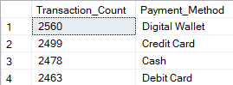

QUESTION 3: What are the most popular products/ services

SELECT

TOP 10

item,

SUM(Total_Spent) as Total_Spending,

COUNT(Customer_ID) as Purchase_Count

FROM

Consumer_spending

GROUP BY

Item

ORDER BY

Purchase_Count DESC;

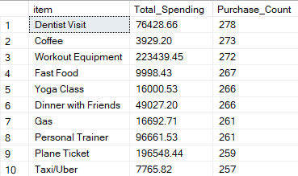

QUESTION 4: Where do people prefer to shop?

SELECT

location,

SUM(Total_Spent) as Total_Spending

FROM

Consumer_Spending

GROUP BY

Location

ORDER BY

Total_Spending DESC;

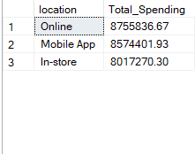

QUESTION 5: IDENTIFY HIGH-VALUE CUSTOMERS

SELECT

TOP 10

customer_id,

SUM(Total_Spent) AS total_spending,

COUNT(customer_id) AS purchase_count,

CAST(AVG(Total_Spent) AS DECIMAL (10,2)) AS avg_order_value

FROM

consumer_spending

GROUP BY

customer_id

ORDER BY

total_spending DESC;

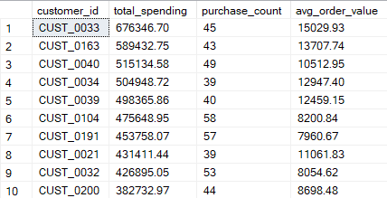

QUESTION 6: Analyze Purchase Frequency

WITH PurchaseIntervals AS (

SELECT

customer_id,

Transaction_Date,

LAG(Transaction_Date) OVER (PARTITION BY customer_id ORDER BY Transaction_Date) AS previous_purchase_date

FROM consumer_spending

)

SELECT

customer_id,

AVG(DATEDIFF(day, previous_purchase_date, Transaction_Date)) AS avg_days_between_purchases

FROM

PurchaseIntervals

GROUP BY

customer_id

ORDER BY

avg_days_between_purchases DESC;

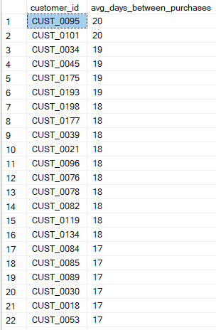

Question 7: Evaluate Weekday vs. Weekend Spending Behavior

SELECT

CASE

WHEN DATEPART(WEEKDAY, Transaction_Date) IN (1, 7) THEN 'Weekend'

ELSE 'Weekday'

END AS Day_Type,

SUM(Total_Spent) as Total_Spending,

COUNT(customer_ID) as Purchase_Count,

CAST(AVG(Total_Spent) AS DECIMAL (10,2)) as Avg_purchase_amount

FROM

Consumer_spending

GROUP BY

CASE

WHEN DATEPART(WEEKDAY, Transaction_Date) IN (1, 7) THEN 'Weekend'

ELSE 'Weekday'

END

ORDER BY

Total_Spending DESC;



Question 8: Analyze Monthly Sales Trends

SELECT

YEAR(Transaction_Date) AS Sales_Year,

MONTH(Transaction_Date) AS Sales_Month,

SUM(Total_Spent) AS total_sales,

COUNT(Customer_ID) AS transaction_count

FROM

consumer_spending

GROUP BY

YEAR(Transaction_Date),

MONTH(Transaction_Date)

ORDER BY

Sales_Year,

Sales_Month;

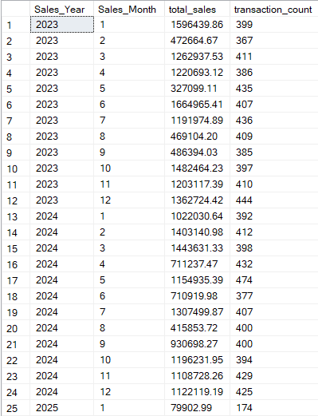

Question 9: Analyze Quarterly Sales Trends

SELECT

YEAR(Transaction_Date) AS Purchase_Year,

DATEPART(QUARTER, Transaction_Date) as Purchase_Quarter,

SUM(Total_Spent) as Total_Sales,

COUNT(Customer_ID) as Purchases

FROM

Consumer_spending

GROUP BY

YEAR(Transaction_Date),

DATEPART(QUARTER, Transaction_Date)

ORDER BY

Purchase_Year,

Purchase_Quarter;

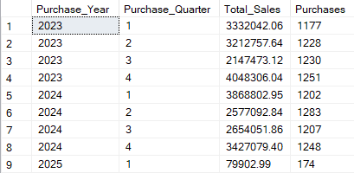

QUESTION 10: Segment customers into spending tiers based on their total purchases, and what portion of revenue does each contribute

WITH CustomerTotals AS (

SELECT

Customer_ID,

SUM(Total_Spent) AS Total_Spending

FROM

Consumer_spending

GROUP BY

Customer_ID

),

SpendingTiers AS (

SELECT

Customer_ID,

Total_Spending,

CASE

WHEN Total_Spending < 10000 THEN 'Low Tier'

WHEN Total_Spending BETWEEN 10000 AND 50000 THEN 'Mid Tier'

ELSE 'High Tier'

END AS Spending_Tier

FROM CustomerTotals

)

SELECT

Spending_Tier,

COUNT(Customer_ID) AS Num_Customers,

SUM(Total_Spending) AS Tier_Total_Spending,

CAST(AVG(Total_Spending) AS DECIMAL(10,2)) AS Avg_Tier_Spending

FROM

SpendingTiers

GROUP BY

Spending_Tier

ORDER BY

CASE WHEN Spending_Tier = 'high tier' THEN 1

WHEN Spending_Tier = 'mid tier' THEN 2

ELSE 3

END;

