Requirements:

Salesforce-native application called Logistica, a Logistics Management Centre designed to orchestrate global shipment operations. The system will receive shipment requests from external Salesforce orgs, validate and enrich them, and route them to regional agents for verification. Once verified, shipments are dispatched to external carrier systems hosted in a separate Salesforce org.

Setup Instructions

Org A – Logistica

Unmanaged package with all the components used, please install the same.

post-install instructions:
- Create Auth Provider
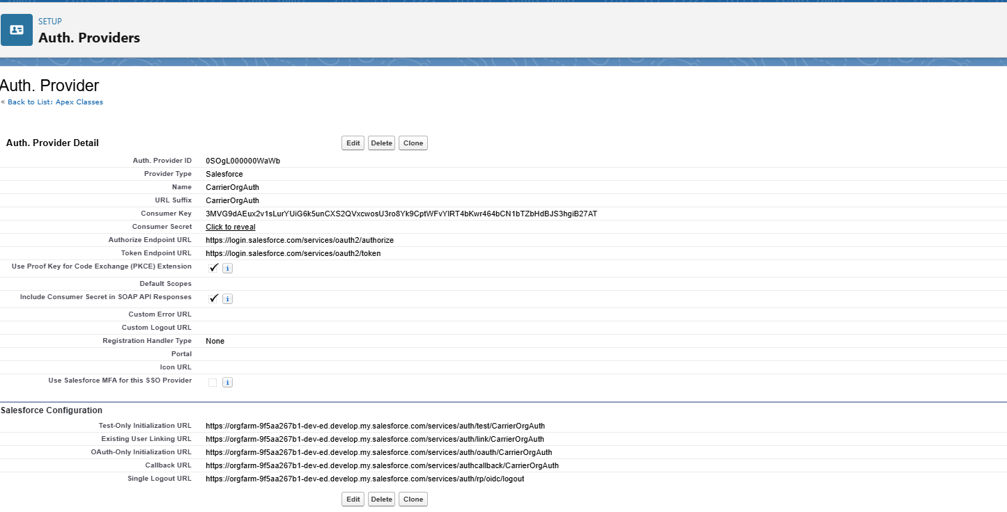
- Create Named Credential

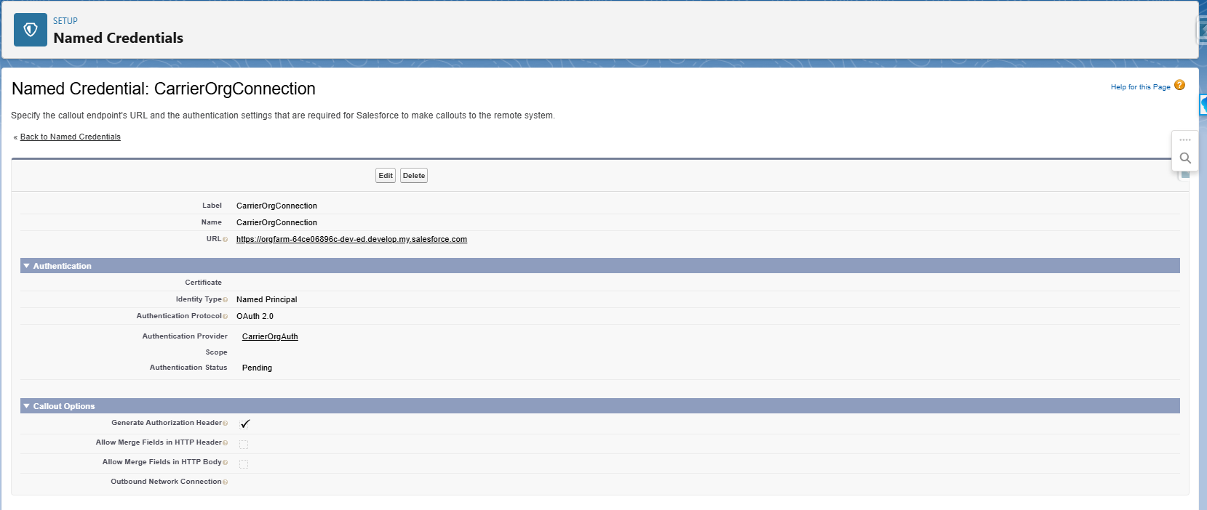
- Upload CMDT records (CSV or script)

- Add sharing rules
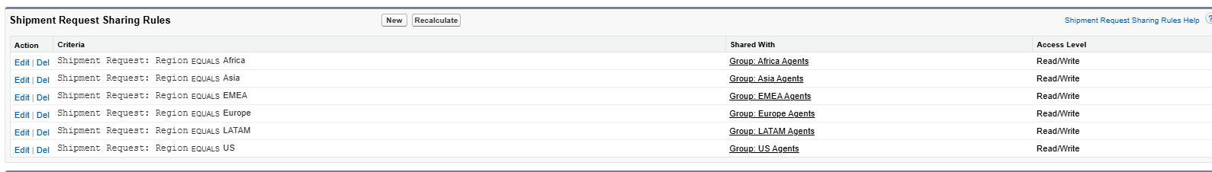

- Create Public Groups
Please refer to the above screenshot

ORG B

Unmanaged package with all the components used, please install the same.

End to End Journey
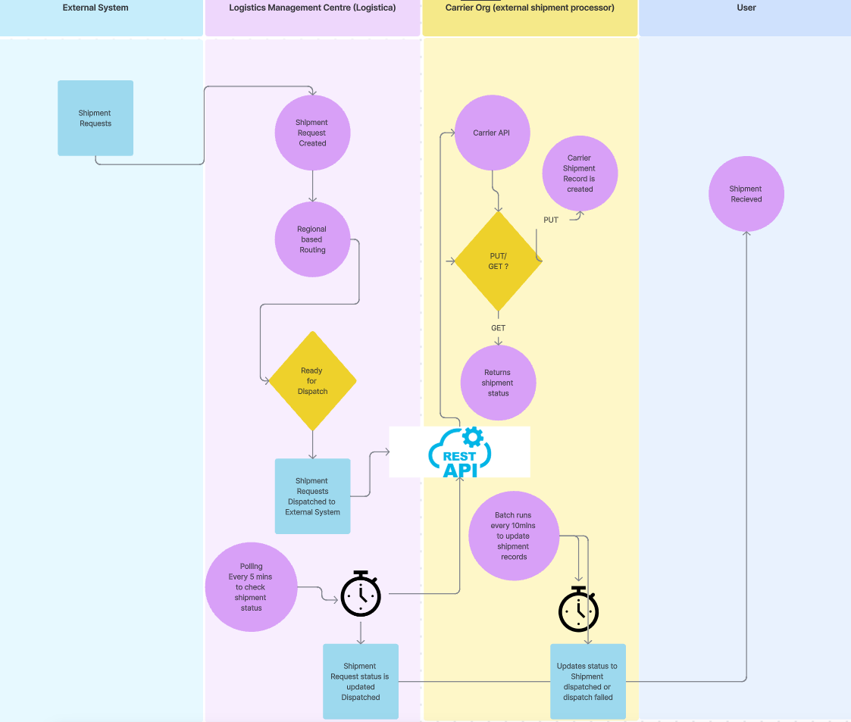
Shipment Request Status Orchestrations
Logistics Management Centre
Assigned to Agent
In Review

Carrier Org (external shipment processor)

Dispatching

Dispatched

Dispatch failed

Ready for Dispatch (Trigger to Carrier Org)
Dispatching

Dispatched
Dispatch Failed
Design Decisions:
Use case Description | Decision | Status
A polling REST API(another REST endpoint) in Org B allows Org A to check the status of dispatched shipments | This can be done using flow or batch class.  Pros with batch class :  - can handle multiple records at same  - reprocessing the failure records is easy  - Proper error handling  - Debugging is easy comparatively with flow
Once shipment request marked as Ready for Dispatch, the shipment is sent to the external Carrier API in Org B. | - This can be easily done with streaming API using platform events instead of Rest API.  - Can be done using trigger and flow.  - Limitations with trigger only 100 callouts per transaction.  For the demo purpose this has been done with Trigger.

Object & Custom Metadata Types Used:
Object Name | Object API Name | Description | Fields |  |  | Data Validations
Shipment Request | ShipmentRequest__c | This is for Shipment Requests | Carrier__c  Destination__c  Estimated_Delivery__c  Origin__c  Region__c  Retry_Count__c  Status__c  TrackingID__c |  |  | All the fields are mandatory
RegionCountryMapping | RegionCountryMapping__mdt | Region Country Mapping | Country__c  Region__c

Technical details like Components used / Created Org A
Component Name | Component Description
Logistica | App
ShipmentRequestTriggerHandlerTest | Test class
IntegrationHelperTest | Test class
IntegrationHelper | Helper class for API integrations
ShipmentRequestTriggerHandler | Helper class for trigger
ShipmentRequestTrigger | Shipment Request Trigger
shipmentRecordsDataTable | LWC Component
ShipmentController | Apex class to get shipment request records
BatchToCheckShipmentDispatchStatus | Polling Class
BatchToCheckShipmentDispatchStatusTest | Test class

Technical details like Components used / Created Org B
Component Name | Component Description
BatchToUpdateShipmentDispatch | This batch class is used to update shipment status
BatchToUpdateShipmentDispatchTest | Test class
ProcessShipmentDispatchRequests | API Class
ProcessShipmentDispatchRequestsTest | Test class

Salesforce Data Model

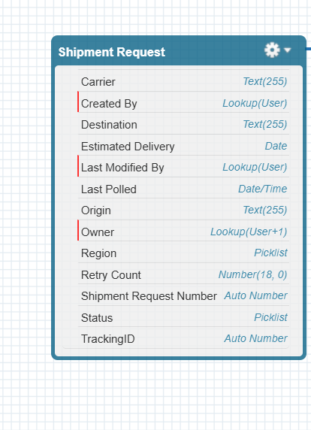

Testing :
Login to salesforce
go to Logistica App
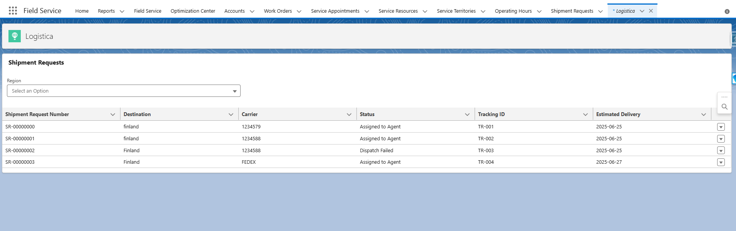

Filter the records based on the Region
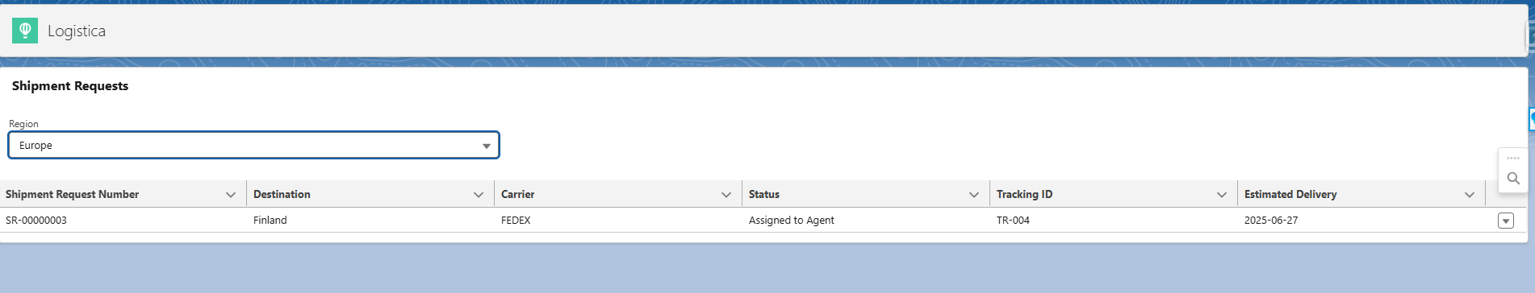

Update the shipment record the data table should be updated automatically

Create a new shipment record the data table should be updated automatically

Create a shipment record, Provide the values for destination country, Region will be automatically updated.

Verify the mandatory fields while creating or updating the record.

Update status to ready for dispatch and check if the request is created in Carrier Org, and status is updated after 10-20mins. Check if the same status is reflecting Org A.

