**SOURCE CODE MANAGEMENT:**

When developers are creating something like (an application)

They are making constant changes to the code and releasing new versions, up to & after the first official release.

Version control system keep these revisions.

* Straight
* Store modifications in the central repo(folder)

This allows DEVELOPERS to easily.

* Collaborate
* Download new versions.
* To know changes, make changes.
* Updates of new versions

Mainly every developer can see all these changes download and then contribute.

VERSION CONTROL TOOLS ARE LIKE

**Github**

**Versions is**

* **GitHub** is a hosting service platform.
* By using github we can

Store

Copy

Push

Pull

Commit files.

* We can store files in a created central repository (folder)
* Not only store we can also automatically get one URL to access.
* GitHub is used by not only one user also used by all users(multi-users)
* From github we can download files what ever we want
* Githud is developer’s community.

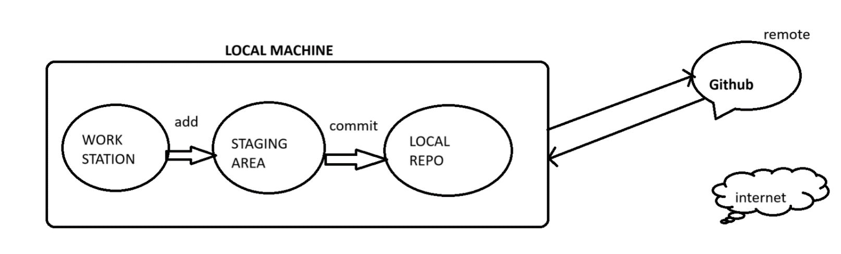**GITHUB Scenario:**

1. What is the difference between GIT & GITHUB?

Git- Open-source tool

Developers install locally to manage source code.

Github-It is a online service to which developers can connect & upload & download resources.

1. What is git repository?

It is directory with metadata to store our files. we have two types of repositories a) local repo.

b) remote repo

**3)** What is git config?

It is used to create or set up for a username.

**4)**What is git status?

i) current state of repo

ii) it gives difference between index directory & working directory

iii) it talks about where is your files exactly

**5)** What is git log?

i) It gives version history records about project commits

ii) whether your committed or not

**6)**  what does git revert?

Undo changes made commit & also do in multiple commits.

**7)** what is head in git?

Master is the head in git

**8)** what is git rm?

Removes or deletes a file from working directory.

**9)** what is git stash used for?

Useful to move to another task.

Git stash: put the working directory on stock & gives a clean working directory later get all edits back using git stash apply.

**10)** what is git master & branch?

Master: main copy of code

Branch:

* The current we are.
* Storing in a single file(copy)
* It is a copy-oriented file.
* Independent copy of code

To create branch

git branch <branch name>

to checkout branch -> to switch branch

git checkout <branch name>

to check branch

git branch

PULL REQUEST: getting one repo data to required repo data.

NOTE: In a company they want to create modify, testing, directly they can’t do

They copy main branch data to one branch is there any changes they send request to main branch.

**11)** Git merge

Put the branch code into master.

git branch –merged

lists any branches that are merged to the master

**12)** git merge and git rebase

Both commands can be used to commit but the difference is that rebase writes a linear commit history

**13)** git branch -d <branch name>

To delete branch

**14)**  git cherry pick

Commit from one branch to another branch in the repository.

**15)** what are hooks in git

These are scripts that are run after running the respective git commands.

**16)**  git pull

It will pull the changes directly into working directory of your git local repo

git pull=git fetch+merge

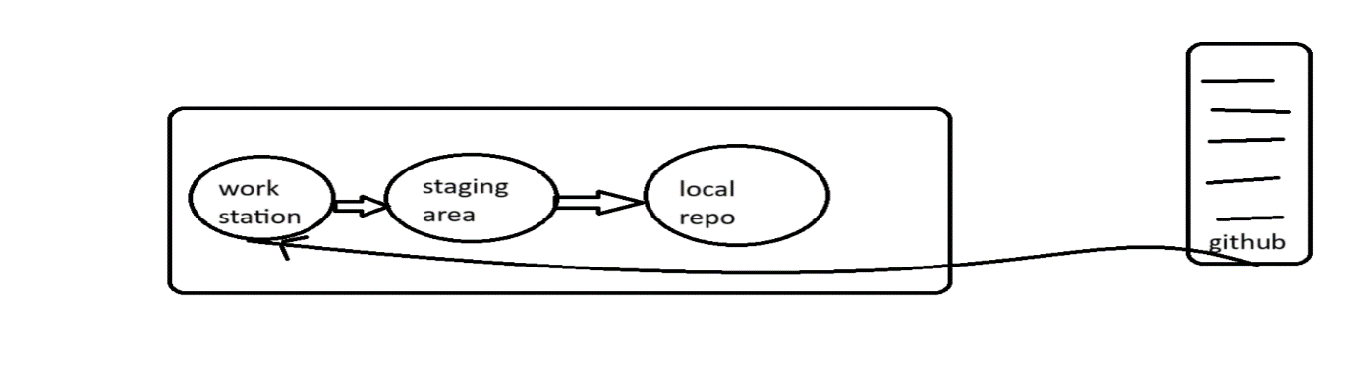

**17)** git fetch

It will fetch the changes into local repo, then you need to do it git merge to get changes into your working directory.

