2. Praktikum Grundgatter

Aufgabe 1



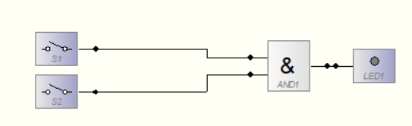

|  |  |  |
| --- | --- | --- |
| A | B | X |
| 0 | 0 | 0 |
| 0 | 1 | 0 |
| 1 | 0 | 0 |
| 1 | 1 | 1 |



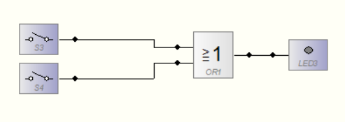

|  |  |  |
| --- | --- | --- |
| A | B | X |
| 0 | 0 | 0 |
| 0 | 1 | 1 |
| 1 | 0 | 1 |
| 1 | 1 | 0 |



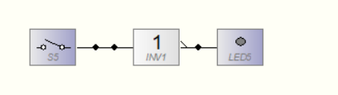

|  |  |
| --- | --- |
| A | X |
| 0 | 1 |
| 1 | 0 |



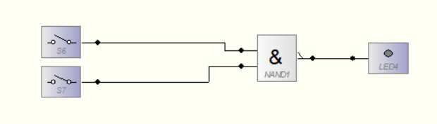

|  |  |  |
| --- | --- | --- |
| A | B | X |
| 0 | 0 | 1 |
| 0 | 1 | 1 |
| 1 | 0 | 1 |
| 1 | 1 | 0 |



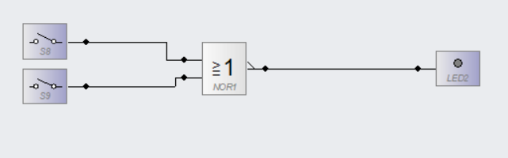

|  |  |  |
| --- | --- | --- |
| A | B | X |
| 0 | 0 | 1 |
| 0 | 1 | 0 |
| 1 | 0 | 0 |
| 1 | 1 | 1 |

Aufgabe 2

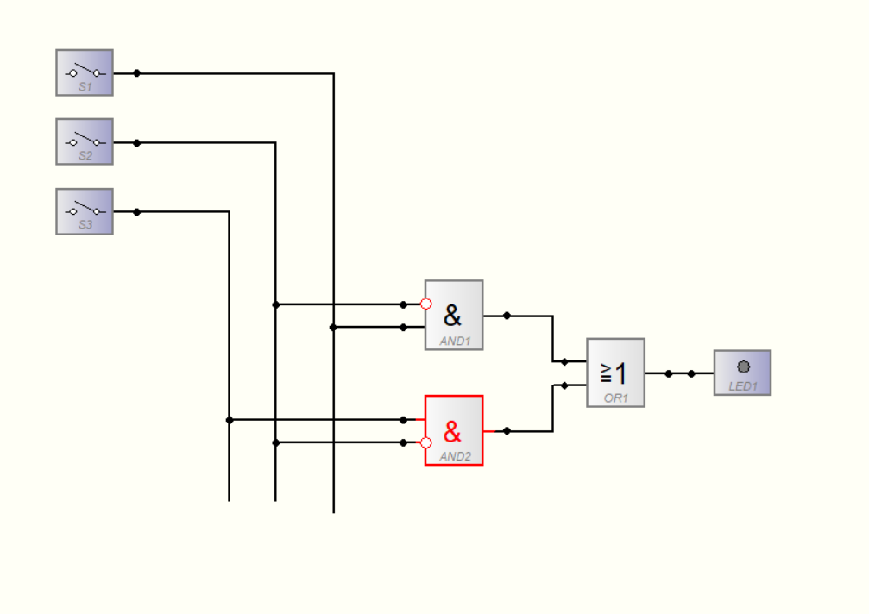

|  |  |  |  |
| --- | --- | --- | --- |
| A | B | C | X |
| 0 | 0 | 0 | 0 |
| 0 | 0 | 1 | 1 |
| 0 | 1 | 0 | 0 |
| 0 | 1 | 1 | 0 |
| 1 | 0 | 0 | 1 |
| 1 | 0 | 1 | 1 |
| 1 | 1 | 0 | 0 |
| 1 | 1 | 1 | 0 |

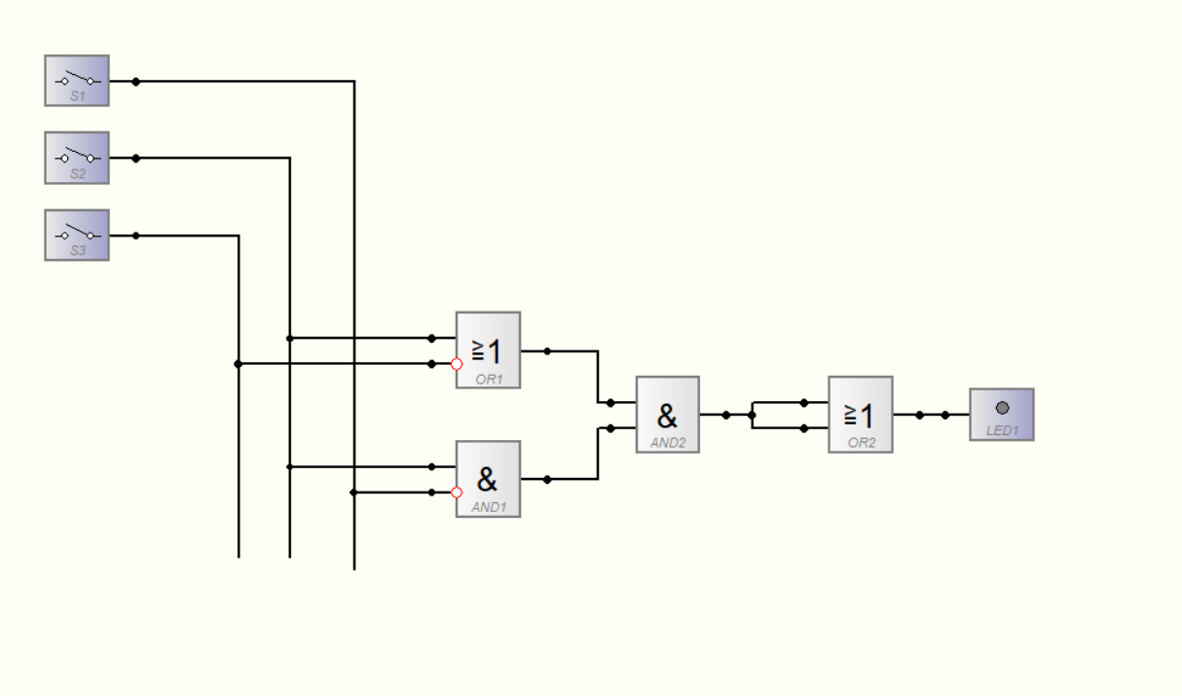

|  |  |  |  |
| --- | --- | --- | --- |
| A | B | C | X |
| 0 | 0 | 0 | 0 |
| 0 | 0 | 1 | 0 |
| 0 | 1 | 0 | 1 |
| 0 | 1 | 1 | 0 |
| 1 | 0 | 0 | 0 |
| 1 | 0 | 1 | 0 |
| 1 | 1 | 0 | 1 |
| 1 | 1 | 1 | 0 |