5. Übungen mit Gattern

Aufgabe 1:

Wahrheitstabelle:

|  |  |  |  |
| --- | --- | --- | --- |
| HL | V | S | MB |
| 0 | 0 | 0 | 0 |
| 0 | 0 | 1 | 1 |
| 0 | 1 | 0 | 0 |
| 0 | 1 | 1 | 0 |
| 1 | 0 | 0 | 0 |
| 1 | 0 | 1 | 0 |
| 1 | 1 | 0 | 0 |
| 1 | 1 | 1 | 0 |

Gleichung:



________________________________________________________



Schaltung:

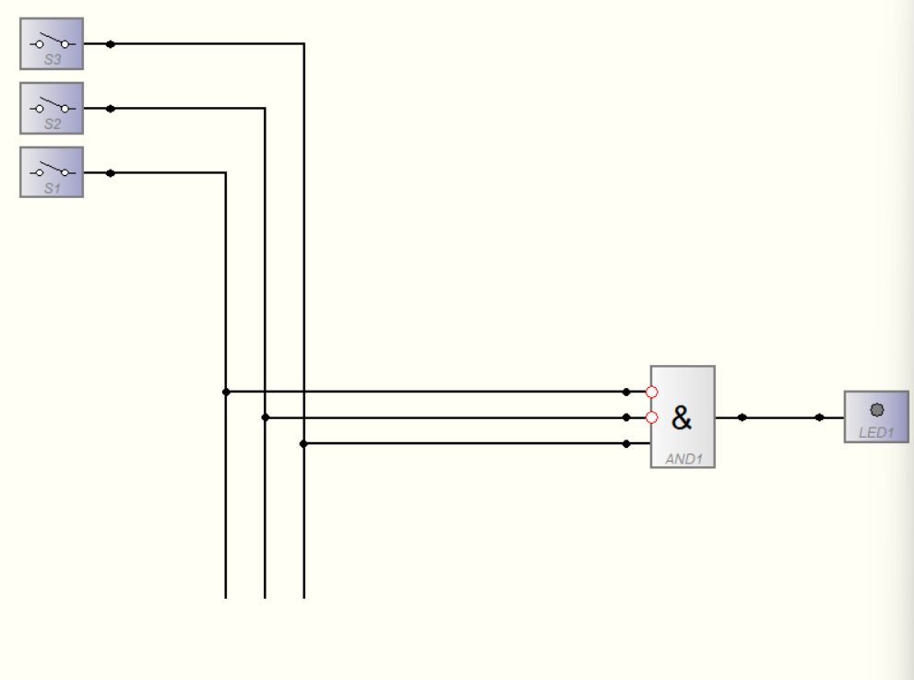

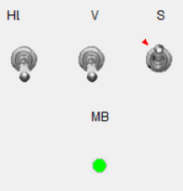

Aufgabe 2:

Wahrheitstabelle:

|  |  |  |  |
| --- | --- | --- | --- |
| A | B | C | X |
| 0 | 0 | 0 | 0 |
| 0 | 0 | 1 | 0 |
| 0 | 1 | 0 | 0 |
| 0 | 1 | 1 | 0 |
| 1 | 0 | 0 | 1 |
| 1 | 0 | 1 | 0 |
| 1 | 1 | 0 | 0 |
| 1 | 1 | 1 | 0 |

Gleichung:

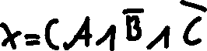

Schaltung:

