# Programming Assignment 2 Report

|  |  |
| --- | --- |
| Student(s): | Ilir Jusufi - [ilir.jusufi@lnu.se](mailto:ilir.jusufi@lnu.se)  Maria Ulan - [maria.ulan@lnu.se](mailto:maria.ulan@lnu.se) |

## Project Idea

For this assignment we have designed and implemented an order management system to store data about the daily sales of any shop, restaurant, supermarket etc. We have created the database on our own. Our tool enables admins to track different data about the orders on the daily basis and provide them a good visualization of the data.

## Schema Design

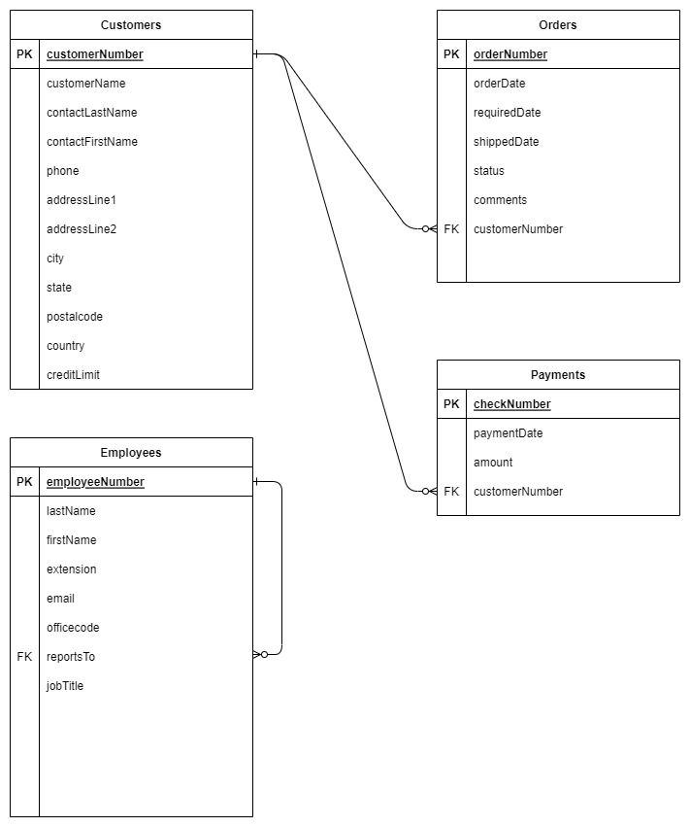

## SQL Queries

Q: **Get List of customers with their payments.**

SELECT c.customerName, SUM(p.amount) AS amount FROM payments p, customers c WHERE p.customerNumber = c.customerNumber GROUP BY p.customerNumber;

Q: **List customer with median payment.**

SET @rowindex := -1;

SELECT customerName, contactLastName, phone FROM customers WHERE customerNumber =

(SELECT customerNumber FROM payments WHERE amount =

(SELECT AVG(a.amount) as Median

FROM

(SELECT @rowindex:=@rowindex + 1 AS rowindex,

payments.amount AS amount

FROM payments

ORDER BY payments.amount) AS a

WHERE

a.rowindex IN (FLOOR(@rowindex / 2), CEIL(@rowindex / 2))));

Q: **List payments greater than average.**

SELECT * FROM payments WHERE amount > (SELECT AVG(amount) FROM payments);

Q: **List customers who cancelled order.**

SELECT * FROM customers WHERE customerNumber IN (SELECT DISTINCT customerNumber FROM orders WHERE status = "Cancelled");

Q: **List customers whom orders are on hold.**

SELECT * FROM customers WHERE customerNumber IN (SELECT customerNumber FROM orders WHERE status = "On Hold");

## Discussion and Resources

**Libraries used:**

* mysql.connector for database connection
* tkinter for graphical user interface
* pandas for using dataframes
* pandastable for using table objects