Internship Report

Node.js Development Internship

Week 3 - Blog Management API

1. Introduction

The Blog Management API is a RESTful web service built with Node.js and Express.js that provides complete backend functionality for managing blog posts. The API supports user authentication, blog CRUD operations, category management, text search, pagination and file uploads.

Project Objectives:

• Implement secure user registration and login with JWT authentication

• Provide full CRUD operations for blog posts and categories

• Enable text search across blog content, title, and tags

• Implement pagination and filtering for efficient data retrieval

• Support file/image uploads for blog cover images

• Ensure input validation and proper error handling

• Maintain clean, modular project architecture

2. Technology Stack
• Node.js – JavaScript runtime
• Express.js – Web framework
• MongoDB + Mongoose – Database & ODM
• JSON Web Tokens (JWT) – Token-based authentication
• bcryptjs – Password hashing (10 salt rounds)
• Multer – File upload handling
• express-validator – Request validation
• dotenv – Environment variable management
• CORS – Cross-Origin Resource Sharing

3. Project Structure
blog-api/
├── config/
│ └── db.js – MongoDB connection
├── controllers/
│ ├── authController.js – Auth logic
│ ├── blogController.js – Blog CRUD
│ └── categoryController.js – Category CRUD
├── middleware/
│ ├── auth.js – JWT verification
│ ├── errorHandler.js – Error handling
│ ├── upload.js – File upload config
│ └── validate.js – Request validation
├── models/
│ ├── User.js – User schema
│ ├── Blog.js – Blog schema
│ └── Category.js – Category schema
├── routes/
│ ├── authRoutes.js – Auth routes
│ ├── blogRoutes.js – Blog routes
│ └── categoryRoutes.js – Category routes
├── utils/
│ └── helpers.js – Utility functions
├── scripts/
│ ├── seed.js – Demo data seeder
│ └── export-db.js – DB export script
├── uploads/ – File storage directory
├── server.js – Entry point
├── .env – Environment variables
└── package.json – Dependencies

4. Implementation Steps

4.1 Auth Module

User schema with name, email, password, avatar, and role fields. Pre-save hook hashes password with bcrypt (10 rounds). comparePassword method for login. Controller handles register, login, getMe. JWT middleware verifies Bearer tokens and attaches user to req.

4.2 Blog Module

Blog schema with title, content, excerpt, author (ref User), category (ref Category), tags, coverImage, status (draft/published), publishedAt, and viewCount. Full CRUD controller with:

• createBlog – Validates and creates a new blog post with optional cover image upload.

• getBlogs – Supports pagination (page, limit), search (title, content, tags via regex), filtering (status, category, author, tag, date range), and sorting (any field, asc/desc). Returns count, total, page, totalPages.

• getBlog – Fetches a single blog by MongoDB ID. Increments viewCount on access.

• updateBlog (PUT) – Full or partial update. Only author or admin can update.

• deleteBlog – Removes blog by ID. Only author or admin can delete.

• getMyBlogs – Returns all blogs belonging to the authenticated user.

4.3 Category Module

Category schema with name, description, and auto-generated slug. CRUD controller with create, getAll, getById, update, delete. Only admin users can create, update, or delete categories. Protection against deleting categories that have associated blogs.

4.4 Server Setup

Express configured with CORS, JSON parser, URL-encoded parser. Static file serving for uploads directory. Auth routes mounted at /api/auth, blog routes at /api/blogs, category routes at /api/categories. 404 fallback for unknown routes. Centralized error handler for CastError (invalid ID), ValidationError, and duplicate key (11000) errors.

5. API Documentation

Base URL:

http://localhost:5000/api

Authentication:

Include JWT token in header – Authorization: Bearer <token>

5.1 Create User (POST)

Result:

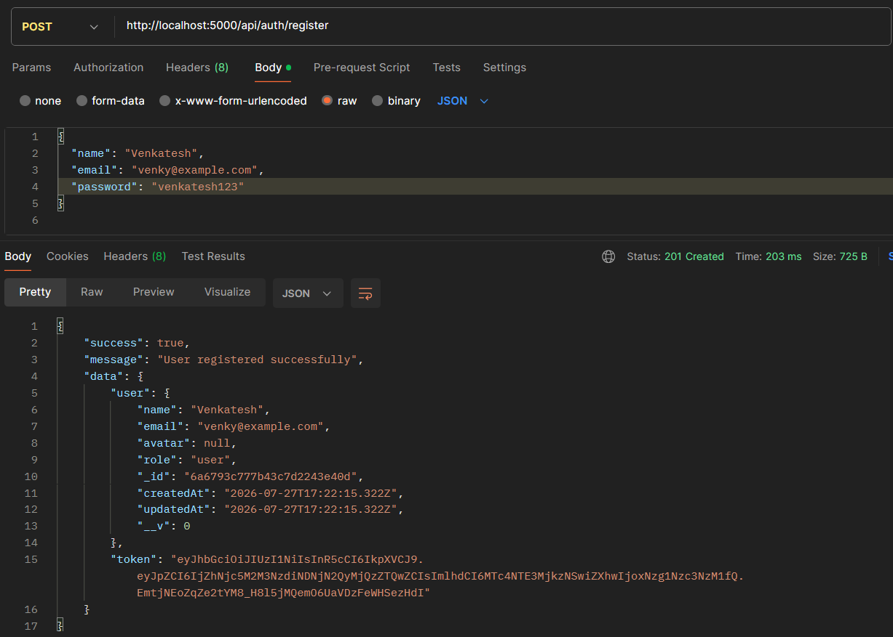

5.2 Get Users (GET)
• Status: 201 Created
• Response: Successfully created user record with all fields

Result

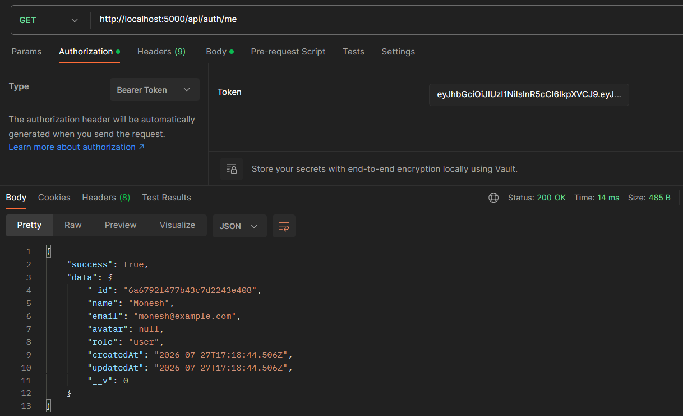

5.3 Upadate the Users (PUT)
Result:
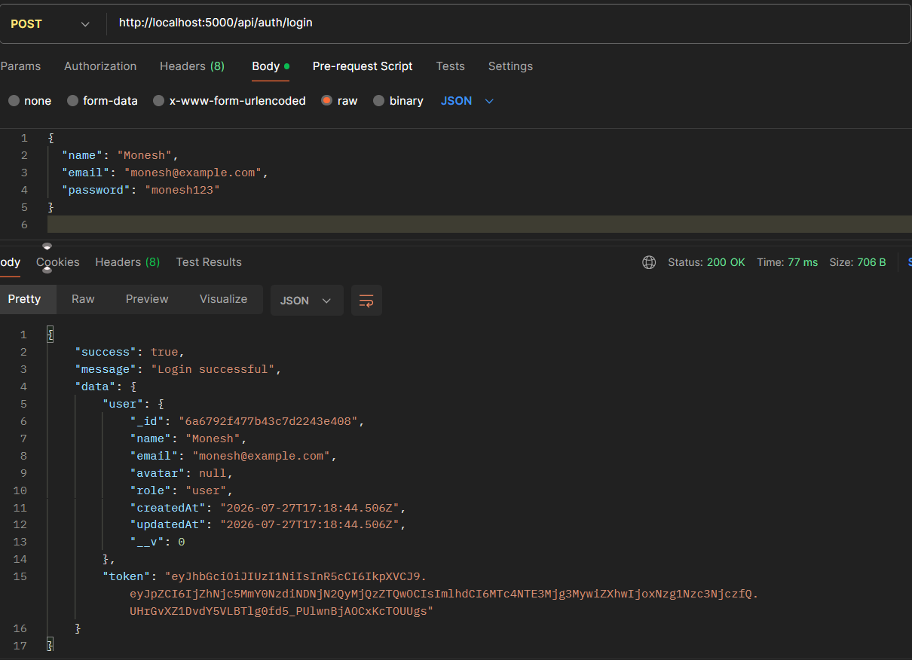

5.4 Delete the Users (DELETE)
Result:
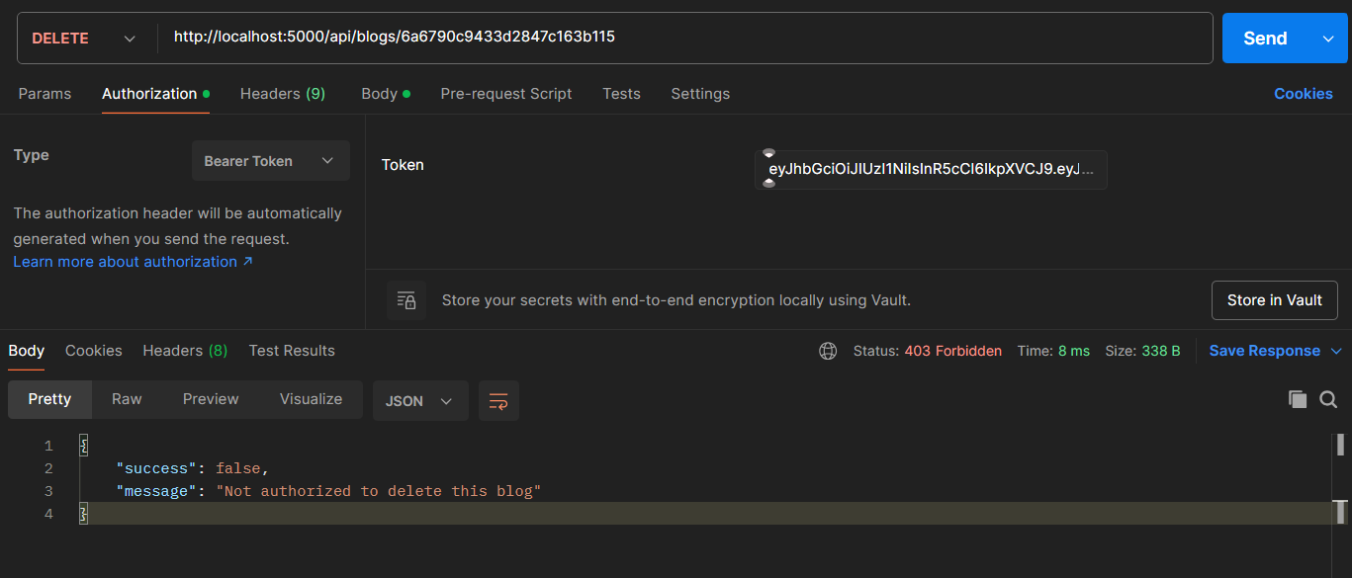

6. Security Measures

• Passwords hashed with bcrypt (10 salt rounds)

• JWT tokens with 7-day expiration

• Password field excluded from query results (select: false)

• Input validation on all model fields and request bodies

• Role-based access control (user vs admin)

• Environment variables for sensitive configuration

• Consistent error responses without leaking stack traces in production

• CORS enabled for controlled cross-origin requests

• File upload type and size validation (images only, max 5MB)

• Protected routes prevent unauthorized access to blog modification

8. Conclusion
The Blog Management API was successfully built with all required features: JWT authentication, password hashing, protected routes, full CRUD with pagination and filtering, category management, and file upload support. The project follows RESTful conventions, implements industry-standard security practices, and is modular and extensible.

