Internship Report

Node.js Development Internship

Week 4 - E-Commerce Backend API

1. Introduction

The E-Commerce Backend API is a complete RESTful web service built with Node.js and Express.js that provides comprehensive backend functionality for managing e-commerce operations. The API supports user authentication, product management, category management, shopping cart, order processing, and secure REST APIs.

Project Objectives:

Implement secure user registration and login with JWT authentication

Provide full CRUD operations for products and categories

Enable product search, filtering, and pagination

Implement shopping cart management with checkout functionality

Manage orders with status tracking and payment processing

Ensure input validation and proper error handling

Maintain clean, modular project architecture following best practices

Apply all concepts learned during the internship

2. Technology Stack
- Node.js - JavaScript runtime
- Express.js - Web framework
- MongoDB + Mongoose - Database & ODM
- JSON Web Tokens (JWT) - Token-based authentication
- bcryptjs - Password hashing (12 salt rounds)
- express-rate-limit - Rate limiting
- helmet - Security headers
- validator - Input validation
- dotenv - Environment variable management
- CORS - Cross-Origin Resource Sharing

3. Project Structure
├── config/
│ └── db.js # MongoDB connection
├── controllers/
│ ├── authController.js # Auth logic
│ ├── userController.js # User management
│ ├── productController.js# Product CRUD
│ ├── categoryController.js# Category CRUD
│ ├── cartController.js # Cart operations
│ └── orderController.js # Order management
├── middleware/
│ ├── auth.js # JWT verification and utilities
│ └── errorHandler.js # Error handling middleware
├── models/
│ ├── User.js # User schema
│ ├── Category.js # Category schema
│ ├── Product.js # Product schema
│ ├── Cart.js # Cart schema
│ └── Order.js # Order schema
├── routes/
│ └── api.js # API route definitions
├── server.js # Entry point
├── .env # Environment variables
├── package.json
├── README.md
└── .gitignore

4. Implementation Steps

4.1 Authentication Module

User Schema: Name, email, password, role, avatar, isActive, lastLogin

Password Security: bcrypt hashing with 12 salt rounds in pre-save hook

Authentication Methods:

register() - Create new user account

login() - Authenticate and generate JWT token

getMe() - Get current authenticated user details

JWT Middleware: Verify Bearer tokens and attach user to request object

Role-based Access Control: User vs Admin permissions

4.2 Product Management Module

Product Schema: Name, description, price, discountedPrice, category, stock, sku, images, tags, isFeatured, isActive, rating, numReviews

CRUD Controller: createProduct, getProducts, getProduct, updateProduct, deleteProduct

Advanced Features:

Pagination with page and limit parameters

Filtering by category, price range, featured status

Search functionality by name, description, tags

Text indexing for efficient search

Population of category details

Price sorting (ascending/descending)

4.3 Category Management Module

Category Schema: Name, description, slug (auto-generated), icon, isActive, displayOrder

CRUD Controller: createCategory, getCategories, getCategory, updateCategory, deleteCategory

Admin-only Operations: Only admin users can create, update, or delete categories

4.4 Shopping Cart Module

Cart Schema: User reference, items array, subtotal, tax, total, couponCode, discount, shippingAddress

Cart Operations:

Add items to cart with quantity management

Remove items from cart

Update item quantities

Calculate subtotal, tax (10%), and total

Clear entire cart

Apply coupon codes and discounts

4.5 Order Management Module

Order Schema: User reference, orderItems, shippingAddress, paymentMethod, paymentStatus, orderStatus, pricing details, timestamps

Order Operations:

Create new orders from cart contents

Track order status (pending, processing, shipped, delivered, cancelled)

Manage payment status (pending, completed, failed, refunded)

Admin-only order updates and deletion

User-specific order retrieval

4.6 Server Setup

Express Configuration: CORS, JSON parser, URL-encoded parser

Security Middleware: Rate limiting, helmet security headers

Database Connection: MongoDB with error handling

Static File Serving: Uploads directory for product images

Route Configuration: Auth, user, product, category, cart, order routes

Error Handling: Centralized error handler for common errors

5. API Documentation

Base URL:

http://localhost:5000/api

Authentication:

Include JWT token in header – Authorization: Bearer <token>

<token> is admin token

5.1 Create User (POST)

Result:

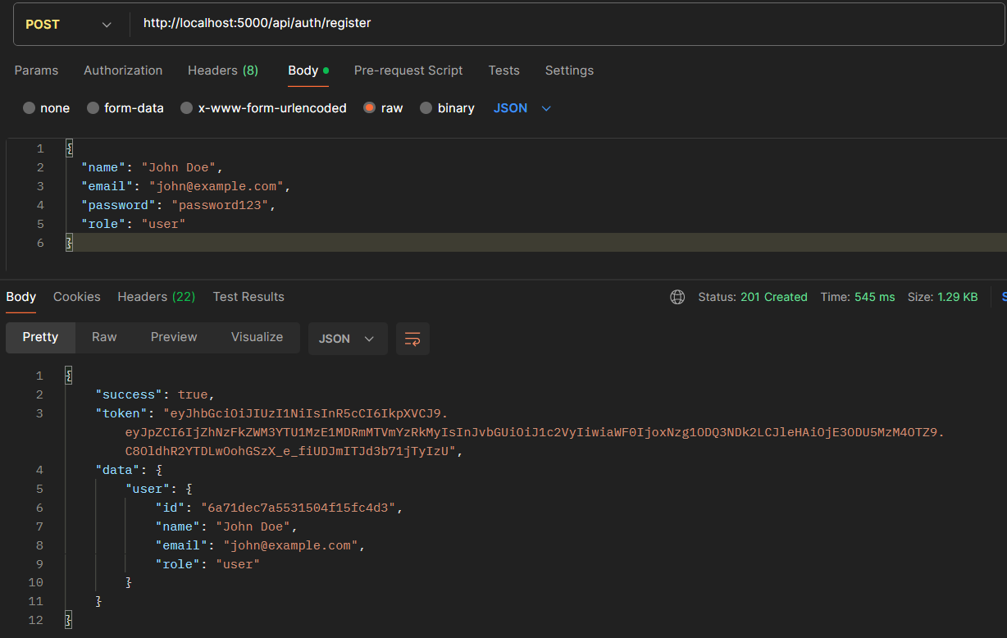

5.2 Get Users (GET)
• Status: 201 Created
• Response: Successfully created user record with all fields

Result

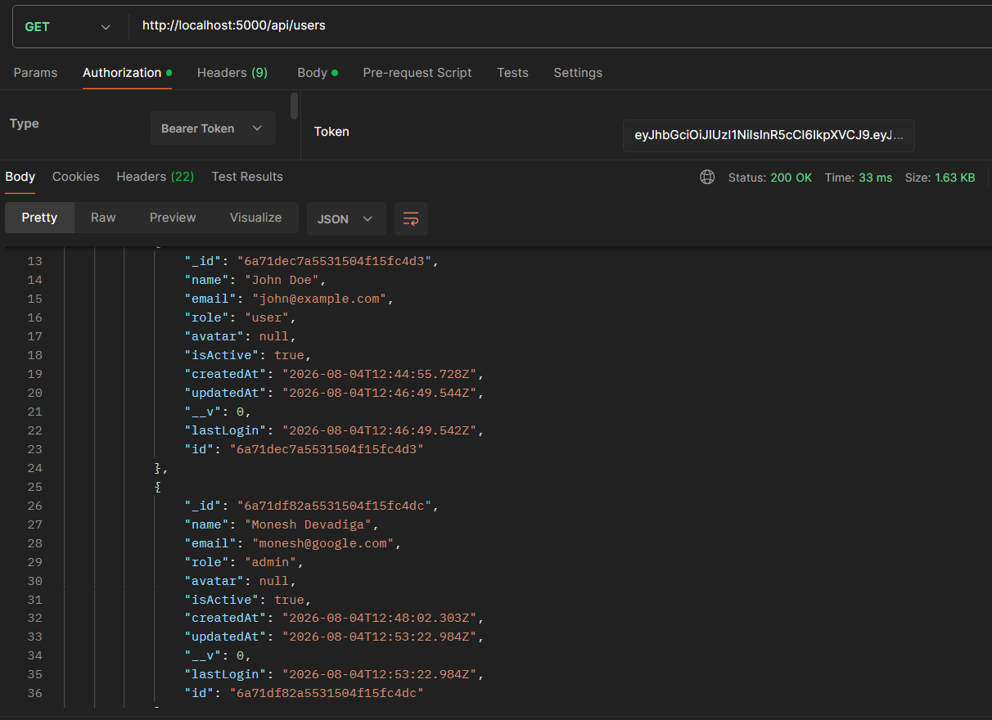

5.3 Get Users by id (GET)
Result:
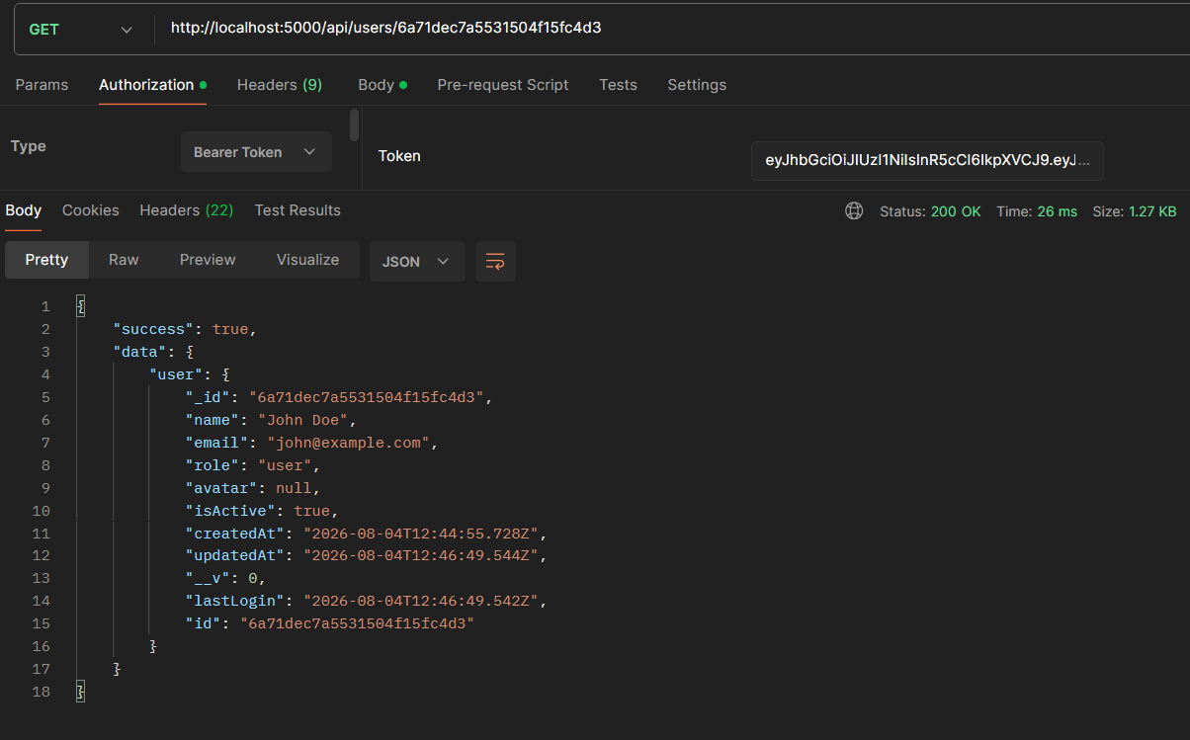
5.4 Upadate the Users (PUT)
Result:
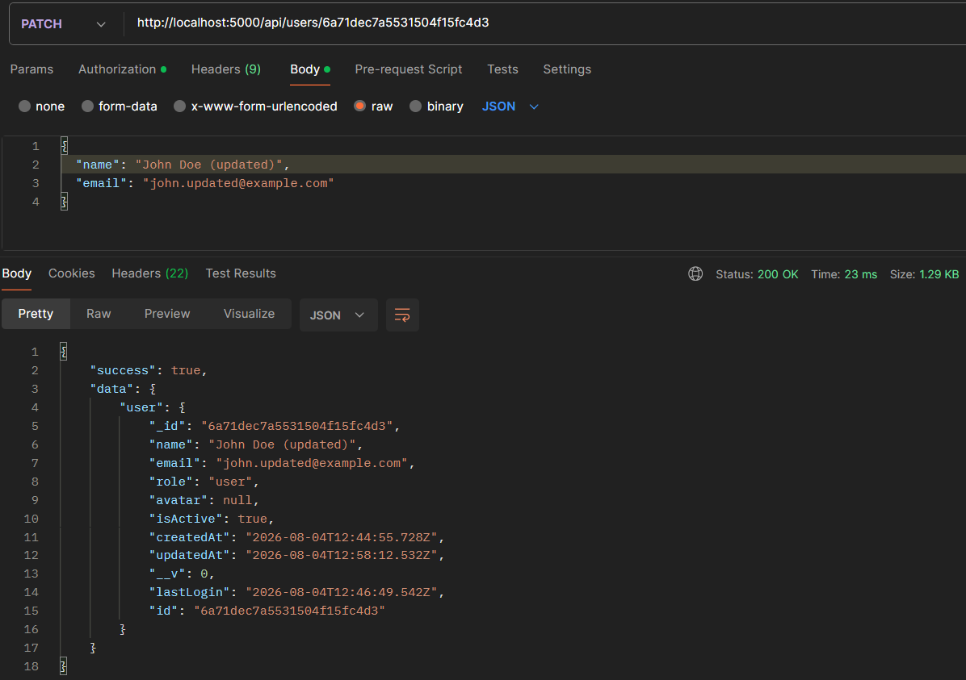

5.5 Delete the Users (DELETE)
Result:
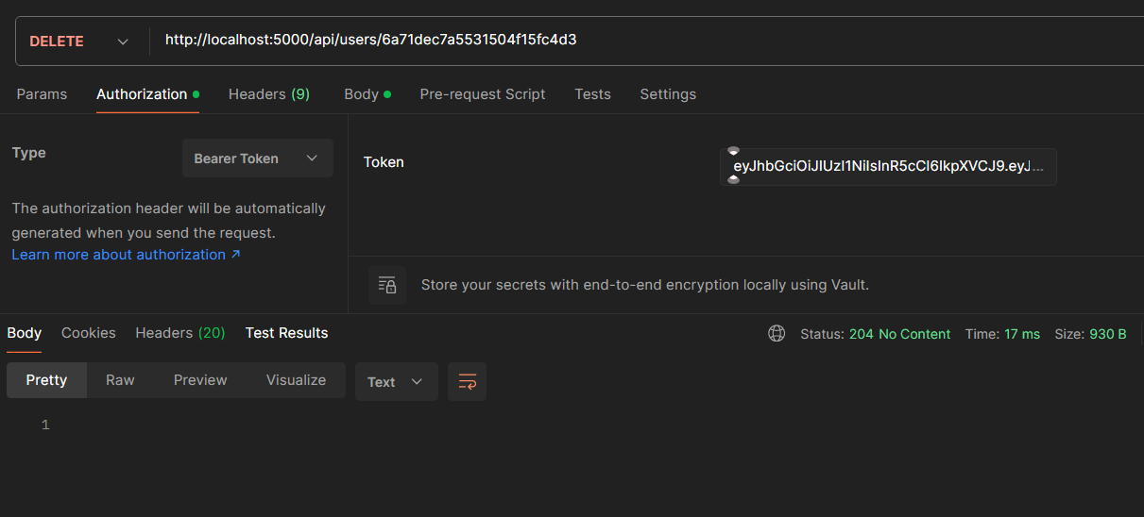

6. Security Measures

Password Security: bcrypt hashing with 12 salt rounds

JWT Authentication: Token-based with expiration time

Input Validation: Comprehensive validation on all model fields

Access Control: Role-based permissions (user vs admin)

Environment Security: Sensitive configuration via .env files

Error Handling: Consistent error responses without stack traces

CORS Configuration: Controlled cross-origin requests

Rate Limiting: Prevent abuse of API endpoints

Security Headers: Helmet middleware for enhanced security

Password Field Protection: Excluded from query results

8. Conclusion
The E-Commerce Backend API was successfully built with all required features:
- JWT authentication with password hashing
- Protected routes with role-based access control
- Complete CRUD operations for products, categories, users
- Advanced product search, filtering, and pagination
- Shopping cart management with checkout
- Order processing and status tracking
- Comprehensive error handling and validation
- Security best practices implementation
- Clean, modular project architecture
- All concepts from the internship applied successfully
The project provides a solid foundation for an e-commerce platform, following RESTful conventions and industry-standard security practices. The codebase is modular, maintainable and ready for further development and scaling.

