Internship Report

Node.js Development Internship

Week 1 - Student Management REST API

1. Introduction
This report presents the development and implementation of a Student Management REST API undertaken as the Week 1 task of the Node.js Development Internship at Chand Web Technology Private Limited.
The API facilitates comprehensive CRUD (Create, Read, Update, Delete) operations for managing student records, built using Node.js, Express.js and MongoDB. The project encompasses input validation, database integration, middleware implementation and thorough API testing to ensure robust and reliable performance.

2. Technology Stack
• Runtime: Node.js
• Framework: Express.js
• Database: MongoDB with Mongoose
• Input Validation: Joi
• Environment Management: dotenv (.env)

3. Implementation Steps

3.1 Project Setup
Initialized a Node.js project with npm.
Installed dependencies: express, mongoose, dotenv, joi, cors, and nodemon as a dev dependency.

3.2 Database Connection
Configured MongoDB connection using Mongoose.
Connection string is stored in the .env file for security and configurability.

3.3 Student Model
Created a Mongoose schema with fields:
Name
email (unique)
age
course
enrollmentDate
status (active/inactive/graduated)
Includes built-in validation and timestamps.

3.4 Validation Middleware
Implemented input validation using Joi to ensure all required fields are present and meet the defined constraints before processing requests.

3.5 CRUD Routes
Created RESTful endpoints:
POST (create)
GET (list with pagination/filtering)
GET/:id (single)
PUT/:id (full update)
PATCH/:id (partial update)
DELETE/:id (remove)

4. API Documentation

Base URL: http://localhost:5000/api/students

Method | Endpoint | Description
POST | /api/students | Create a new student
GET | /api/students | Get all students (paginated)
GET | /api/students/:id | Get student by ID
PUT | /api/students/:id | Full update student
PATCH | /api/students/:id | Partial update student
DELETE | /api/students/:id | Delete student
GET | /api/students?status=active | Filter by status

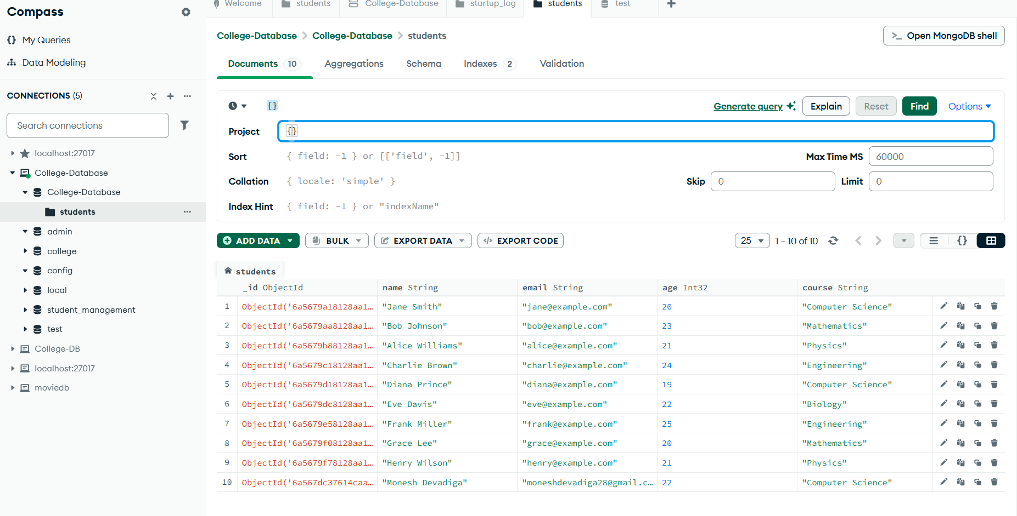
Student Database

5. Testing Results

5.1 Create Student (POST)
• Status: 201 Created
• Response: Successfully created student record with all fields

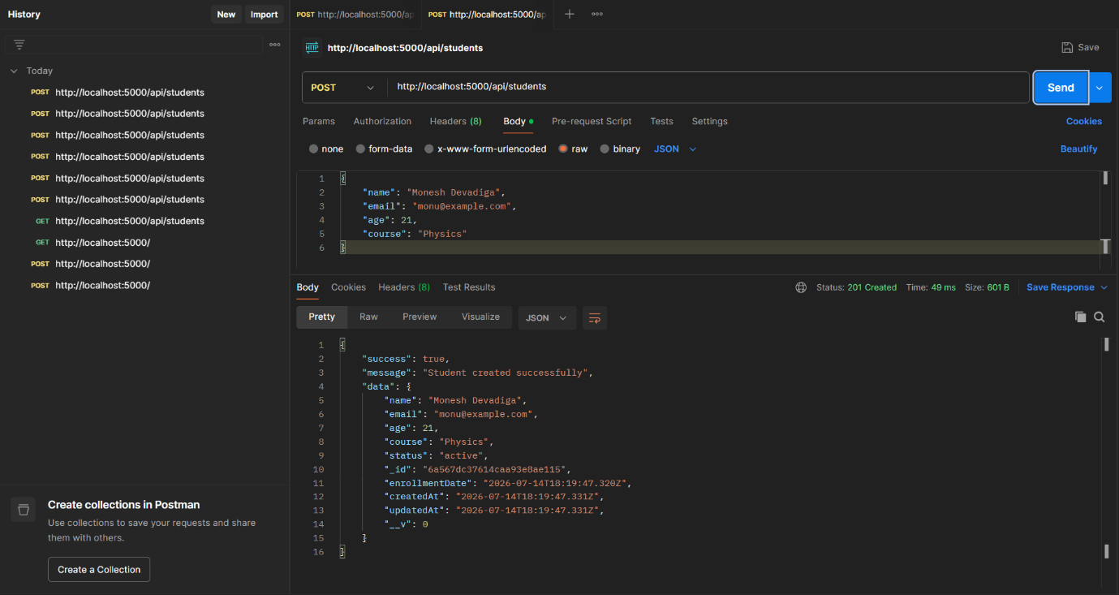
Result:

5.2 Get All Students (GET)
• Status: 200 OK
• Response: Returns paginated list with count and total pages

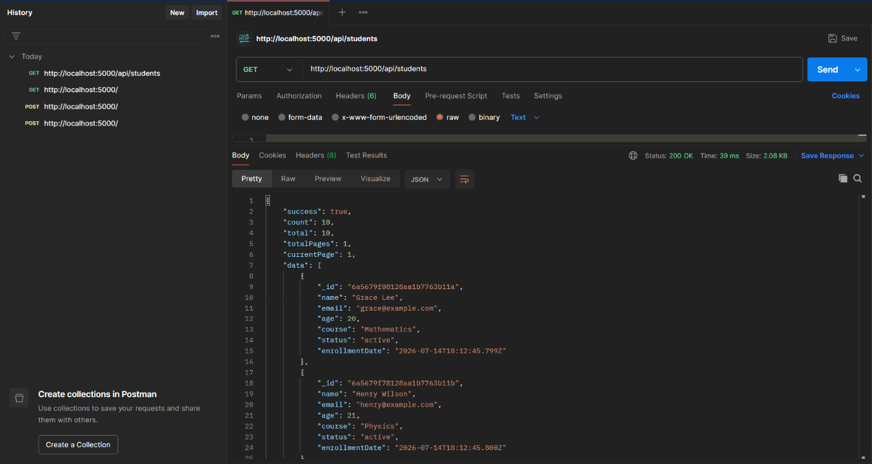
Result:

5.3 Update Student (PUT)
• Status: 200 OK

• Response: Fully replaces student data

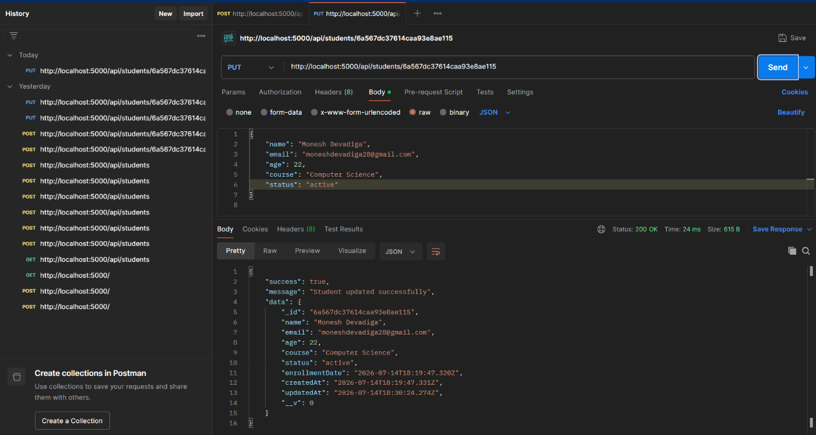
Result:

5.4 Delete Student (DELETE)
• Status: 200 OK
• Response: Removes student and returns success message

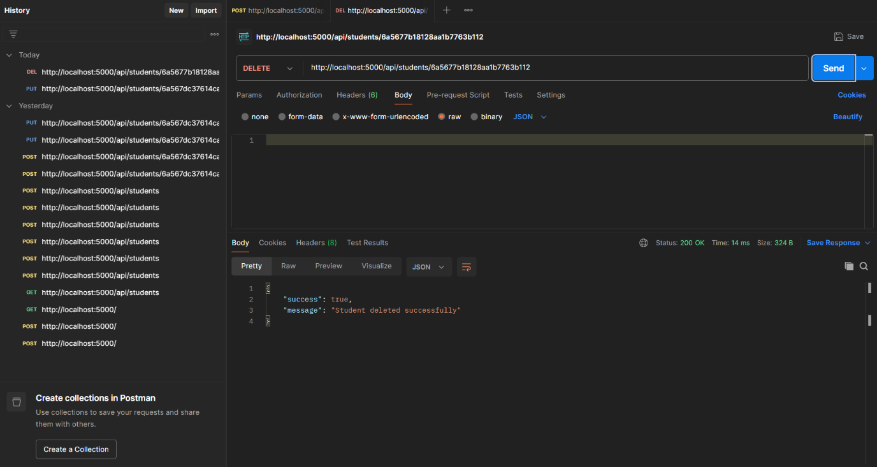
Result:

5.5 Input Validation
• Status: 400 Bad Request on invalid data
(Please provide a valid Email)
• Response: Returns array of detailed validation error messages

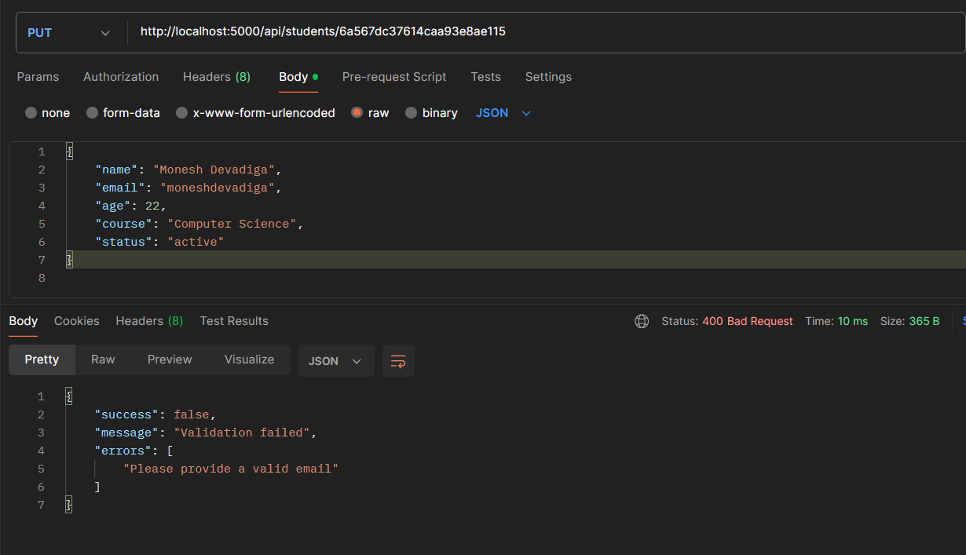
Result:

7. Conclusion

The Student Management REST API was successfully designed, developed and tested as part of the Week 1 internship task. All CRUD operations were implemented and verified using Postman, with input validation ensuring data integrity and reliability. The integration of MongoDB via Mongoose provides efficient data persistence, while Joi validation guarantees that only properly formatted data is accepted by the system.
Pagination and filtering features enhance data retrieval capabilities. The project demonstrates a solid understanding of Node.js, Express.js, RESTful API design principles, and database integration, meeting all the specified requirements for this task. The API is production-ready and can be further extended with authentication, logging and additional business logic as needed.

