

**Submitted By**

Ahla Mong Marma Student ID:1902038

Md. Mehedi Hasan Student ID:1902044

Md. Moshiur Rahman Student ID:1702060

Abubakar Saidu Student ID:1902077

B.Sc. (Engineering) in Computer Science & Engineering

Course Code: CSE 420

Course Title: System Analysis and Design Sessional

Level: 4, Semester: I

Department of Computer Science and Engineering (CSE)

**Faculty of Computer Science and Engineering**

**Hajee Mohammad Danesh Science and Technology University (HSTU)**

Name of the project

**Task Management System**

**Acknowledgement**

Presentation inspiration and motivation have always played a key role in the success of any venture. We are extremely grateful to our honorable Associate Professor **Hasi Saha** to encourage us to the highest peak and to provide us the opportunity to prepare the project. We are also thankful to her whose valuable guideline, invaluable suggestions and kind supervision in the completion of our project. Many thanks to go the team members and our classmates have made valuable comment suggestions on this proposal which gave us an inspiration to improve our project. We are also thankful all the people who helps us directly and indirectly.

With Regards

…………..

**Abstract**

This report presents a concise overview of the Task Management System (TMS), A digital solution aimed at enhancing task organization, tracking, and collaboration. The TMS offers user-friendly interfaces for creating and assigning tasks, while real-time progress tracking ensures effective time management. Through its collaborative feature, the system facilitates team communication and task delegation. The TMS also optimizes resource allocation by matching task with appropriate individuals, leading to increased efficiency. The report emphasizes the TMS’s contributions to improved task management, efficiency, collaboration, and resource Utilizations

For making this system some these platform of technology we need to use. These are Visual Studio IDE, HTML, CSS, JAVASCRIPT, PHP, XAMPP Control Panel v3.3.0 and MySQL Database.

**Table of Content**

CHAPTER 1: INTRODUCTION 1

Introduction 2

Objective 2

Key objectives 3

Contributions 3

Organization 3

Summary 4

CHAPTER 2: LITERATURE REVIEW 5

Introduction 6

Literature Review of TMS 6

CHAPTER 3: PROPOSED SYSTEM ANALYSIS AND DESIGN 7

Introduction 8

System Analysis 8

Analysis of existing system 8

Analysis of proposed system 8

Methods of Information Gathering 9

System Design 10

System Modeling 110

Functional requirement 11

Nonfunctional requirements 11

Database Specification: 12

Database Design 13

CHAPTER 4: USER MANUAL 14

Introduction 15

Homepage 15

Add Task List 16

Pending Task 16

Task List: 17

Completed Task List 17

CHAPTER 5: SYSTEM IMPLEMENTATION 18

Introduction 19

Development Tools 19

System Documentation 19

Hardware Requirement 19

Software Requirement 19

CHAPTER 6: CONCLUSION 20

Introduction 21

Recommendations 21

Limitations 21

Future Goals 21

**LIST OF FIGURES**

|  |  |  |
| --- | --- | --- |
| **FIGURE NO** | **TITLE** | **PAGE** |
| 01 | System Design | 8 |
| 02 | System Modeling | 9 |
| 03 | Home Page | 13 |
| 04 | Add Task | 14 |
| 05 | Pending Task | 15 |
| 06 | Task List | 16 |
| 07 | Completed Task | 17 |

# **CHAPTER 1: INTRODUCTION**

## **Introduction**

In an era characterized by constant demands and intricate responsibilities, efficient task management has emerged as a linchpin for personal and professional success. The Task Management System project embarks on the journey to meet this need by providing a cohesive digital platform. This system will empower users to methodically organize tasks, allocate resources, track progress, and foster collaboration.

The project's core objectives encompass creating an intuitive interface for task creation, assignment, and real-time monitoring. By enabling seamless communication and document sharing, the system aims to enhance team synergy. With the flexibility to adapt to individual preferences and the capacity to generate insightful reports, it strives to elevate task-oriented decision-making.

At its heart, the project prioritizes user experience, designing an accessible interface while ensuring scalability for diverse scales of operation. This report navigates through the system's design, development, and implementation phases, shedding light on pivotal choices and technical considerations. As a solution tailored to modern work paradigms, the Task Management System aspires to be an invaluable asset in driving efficiency and achieving objectives.

## **ObjectiveTop of Form**

1. Develop a user-friendly digital platform that facilitates task creation, assignment, and monitoring in real time.
2. Enhance collaboration and communication among team members through integrated messaging and file sharing functionalities.
3. Provide customizable task views and filters to cater to individual user preferences and workflows.
4. Enable data-driven decision-making by collecting and presenting task performance metrics and analytics.
5. Ensure a seamless and intuitive user experience, accommodating users with varying technical proficiency.

## **Key objectives**

The key objectives of a task management system are to enable efficient organization, tracking, and prioritization of tasks. This involves categorizing tasks, setting due dates, and assigning priorities. The system should facilitate collaboration by allowing task delegation and progress monitoring for teams. Notifications and reminders help users stay on top of their tasks and deadlines. Seamless integration with other tools like calendars and communication platforms enhances usability. Customizability, user-friendly interfaces, and cross-device accessibility ensure a tailored and convenient user experience. Data security and privacy are paramount, and performance metrics aid in evaluating productivity. Ultimately, the system aims to streamline workflow, increase productivity, and reduce the risk of tasks being overlooked or delayed.

## **Contributions**

A task management system contributes by enabling efficient task organization, ensuring timely completion, and boosting productivity. It aids in prioritizing tasks, reducing stress, and improving time management. Collaboration features foster teamwork, allowing task delegation and tracking. Reminders and notifications prevent missed deadlines and enhance accountability. Integration with other tools streamlines workflow, and customization options cater to individual preferences. User-friendly interfaces facilitate adoption, while data security safeguards sensitive information. Performance metrics offer insights for improvement, while cross-device access ensures flexibility. Overall, a task management system optimizes task handling, promotes organization, and enhances overall work effectiveness.

## **Organization**

Organizations benefit from task management systems by achieving better task coordination, increased efficiency, and improved productivity. These systems provide a centralized platform for task tracking, ensuring teams stay on schedule and meet deadlines. Collaboration features enable effective delegation and progress monitoring. Prioritization tools aid in resource allocation and focus on critical tasks. Integration with existing tools streamlines workflows, while data analytics offer insights for process improvement. Such systems enhance communication, reduce errors, and minimize duplication of efforts. By promoting organization and time management, they contribute to overall operational success and the achievement of strategic goals.

## **Summary**

A task management system streamlines tasks, deadlines, and priorities, fostering efficient organization and collaboration. It enables delegation, progress tracking, and timely reminders, enhancing productivity. Integration with other tools optimizes workflow, while customization caters to unique needs. User-friendly interfaces ensure easy adoption, and data security is upheld. Performance metrics offer insights into productivity trends. Overall, the system empowers individuals and teams to manage tasks effectively, minimize oversights, and accomplish goals with streamlined processes.

# **CHAPTER 2: LITERATURE REVIEW**

## **Introduction**

In the contemporary landscape of heightened productivity demands, task management systems have emerged as indispensable tools. These systems offer structured approaches to organizing and optimizing tasks, enabling individuals and groups to navigate their responsibilities efficiently. This literature review explores the evolution, functionalities, and effects of task management systems. By analyzing existing research, we aim to unveil the impact of these systems on personal productivity, collaborative endeavors, and project outcomes. Through a concise synthesis of insights, this review provides a succinct overview for both scholars and practitioners, underscoring the pivotal role of task management systems in modern work environments.

## **Literature Review of TMS**

In the realm of modern productivity, task management systems play a pivotal role. This review delves into their evolution, features, and effects. Analyzing existing literature, we explore how these systems enhance individual and collaborative task handling, from time management to goal achievement. Additionally, we assess their impact on project outcomes and team dynamics, considering both co-located and remote work scenarios. While highlighting their benefits, we also address concerns like information overload and dependency. By offering a concise overview, this review contributes to a deeper understanding of the value and implications of task management systems in today's fast-paced work environments.

# **CHAPTER 3: PROPOSED SYSTEM ANALYSIS AND DESIGN**

## **Introduction**

The proposed system analysis and design form the cornerstone of optimizing operational processes. This study aims to meticulously examine existing systems, identify inefficiencies, and devise innovative solutions. Through a comprehensive analysis, we seek to enhance system functionality, streamline workflows, and align technology with organizational objectives. This introduction outlines the intent and scope of our endeavor to create a robust and efficient system that addresses contemporary challenges and paves the way for enhanced performance.

## **System Analysis**

System analysis refers the study of interacting entities which includes computer system analysis. This field is also like as the requirement analysis. It is also an explicit formal inquiry. System analysis also works for collect facts about an existing system and find out more efficient system for replacing the system in a systematic approach.

## **Analysis of existing system**

**Overview**: The current task management system is integral to our daily operations, facilitating task tracking and collaboration.

**Functionality Assessment**: We evaluate the system's features, such as task creation, assignment, and status tracking, to gauge its effectiveness.

**User Experience**: By gathering user feedback, we identify usability issues, interface challenges, and user satisfaction levels.

**Workflow Evaluation**: We analyze the system's impact on workflows, considering bottlenecks, delays, and potential areas for optimization.

**Performance Metrics**: System logs provide insights into response times, uptime, and user activity, helping us measure its reliability and efficiency.

## **Analysis of proposed system**

**Conceptual Framework**: The proposed task management system envisions a dynamic platform for streamlined task organization and collaboration.

**Functional Components**: We examine key features like task creation, assignment, prioritization, and real-time tracking to ensure comprehensive functionality.

**Usability Considerations**: User-centric design is assessed through user testing and interface evaluations, aiming for an intuitive and efficient experience.

**Workflow Integration**: We analyze how the new system aligns with existing workflows, identifying potential integration challenges and opportunities.

**Performance Projection**: Anticipated system performance metrics, such as response times and scalability, provide insights into its expected reliability and efficiency.

## **Methods of Information Gathering**

**User Interviews**: Conducting one-on-one interviews with system users to gather insights into their experiences, needs, and pain points.

**Surveys and Questionnaires**: Distributing surveys to a larger user base to collect quantitative data on user preferences, satisfaction, and suggestions.

**Observation and Shadowing**: Observing users as they interact with the current system to identify usability challenges and areas for improvement.

**System Logs Analysis**: Examining system logs to understand usage patterns, common tasks, and potential bottlenecks.

**Focus Groups**: Organizing group discussions with users to facilitate open conversations, sharing their perspectives and generating collaborative insights.

## **System Design**

System design is define as the process of specified requirements through system modeling by defining the architecture, modules, and components for a system. The design of this system must be user friendly and it can be design in various ways.

Project Planning

Requirement Analysis & Specification

Project Interface Design and Development

Implementation & System Testing

Maintenance & Upgrading

Figure 01: System Design

The figure above is the system development life cycle that describes how the design of the project is divided into five different phases, which are Project Planning, Requirement Analysis and specification, Project Interface Design and Development, Implementation and System Testing, Maintenance and System Upgrading. The project Task Management System will start by determining the aim of the users and project objectives and after completing all the steps repeatedly it move to the final development phase

## 

## **System Modeling**

System modeling helps to show more details about the project in graphical representations that can be easily describe the system is too developed. Here also represent the set of components and the relationships between the components.

Figure 02: System Modeling

## **Functional requirement**

**User Account**s: Users can log in, and manage their profiles.

**Task Creation**: Users can create tasks with titles, descriptions, due dates.

**Tasks Assignment**: Tasks can be assigned to individuals or teams.

**Tasks Tracking**: Users can monitor task progress and mark tasks as complete.

## **Nonfunctional requirements**

**Performance**: The system should respond to user interactions within 1 second. It should support simultaneous access by at least 500 users without significant slowdown.

**Scalability:** The system architecture should allow easy scaling to accommodate growth in user base and tasks.

**Reliability**: The system should have an uptime of 99.9%.It should recover within 10 minutes from a system failure.

**Security**: User passwords should be stored using strong encryption. Data transfers should be secured using HTTPS. Regular security audits and penetration testing should be conducted.

**Usability**: The user interface should be intuitive for users with minimal training. User satisfaction surveys should achieve a score of at least 80%.

**Accessibility**: The system should adhere to Web Content Accessibility Guidelines (WCAG) to ensure accessibility for users with disabilities.

**Compatibility**: The system should work seamlessly on the latest versions of popular web browsers (Chrome, Firefox, Safari).

## 

## **Database Specification:**

A database is a single file which consists of structured data and records which are stored in minimum or no duplication of data. A good database must be common to all users and independent of the programs which use it to generate output.

**Pending Task**

Id

Task name

Priority

End date

Action

**Completed Task**

SL No

End date

Action

**Task Lists**

ID

Task Name

Priority

Start Date

End Date

Action

Figure 03: Schema Diagram of Database

**Database Design:**

**User Information Table**

|  |  |  |  |
| --- | --- | --- | --- |
| Field Name | Field Type | Field Length | Description |
| Id | integer | 20 | Primary Key |
| User Name | Varchar | 50 | Name of Admin |
| Password | integer | 20 | Security Password |

**Task Information Table**

|  |  |  |  |
| --- | --- | --- | --- |
| Field Name | Field Type | Field Length | Description |
| id | integer | 10 | Primary Key |
| t-name | Varchar | 20 | Name of Task |
| priority | Varchar | 20 | High/Low |
| s-date | date | 10 | Starting Date |
| e-date | date | 10 | End Date |
| status | integer | 1 | Completed/Pending |

# 

# **CHAPTER 4: USER MANUAL**

## 

## **Introduction**

Here we introduce the project overview. So that from here, you can know all about the project controlling, and the pages. Also we try to mention here the functionality of the pages. So user can easily understand the project and can know a basic controlling of the project.

## **Homepage**

This is the homepage appears when we open the system.

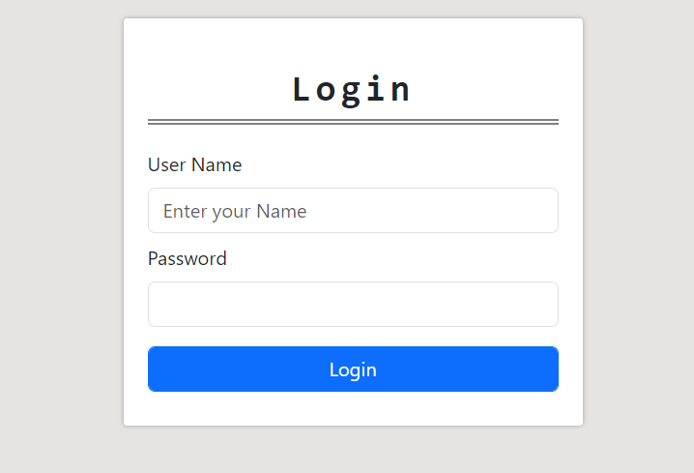

Figure 04: Homepage

## **Add Task List**

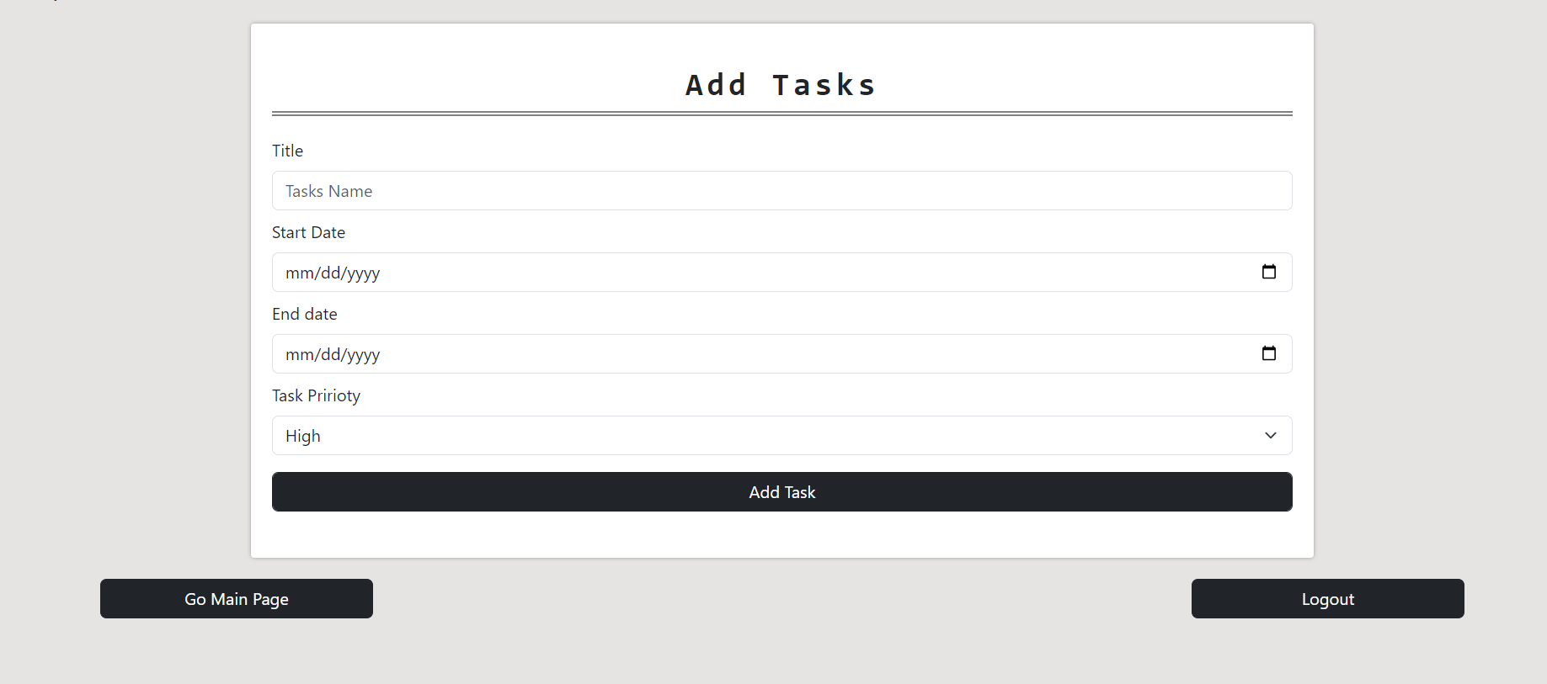

Figure 05: Add Task

## 

## **Pending Task**

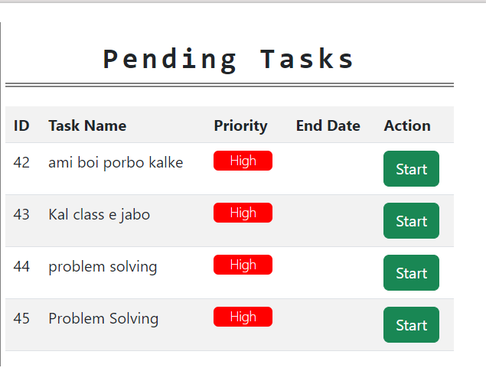

Figure 06: Pending Tasks

## 

## **Task List:**

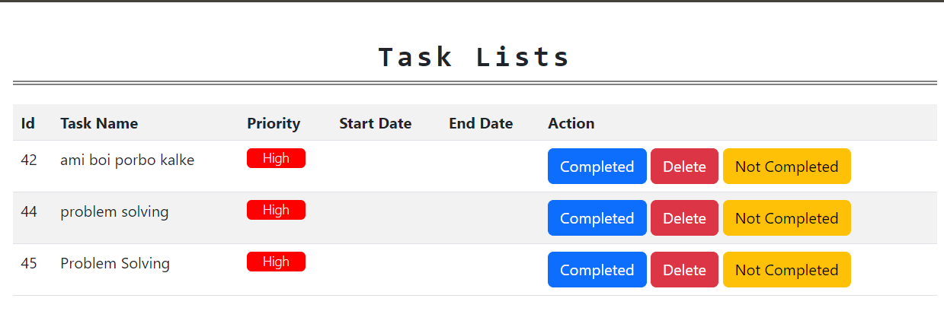

Figure 07: Task Lists

## 

## **Completed Task List**

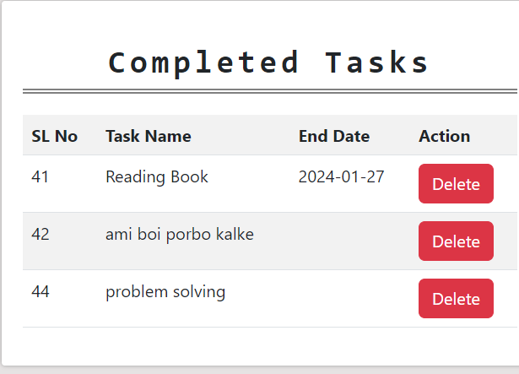

Figure 08: Completed Tasks

# 

# 

# **CHAPTER 5: SYSTEM IMPLEMENTATION**

## 

## **Introduction**

A very important part of making a successful software is implementing everything that has been planned and designed into a complete presentable software that can meet the user’s needs given proper requirements are made. It’s necessary to be able to have this new system operational and running efficiently.

## **Development Tools**

1. Visual Studio

2. MySql Database

## **System Documentation**

System documentation is the process of keeping record of the system’s journey to the end of it’s later stage of the production cycle. It helps others understand how the system was built and clears misconceptions or the lack of information. It’s a very important part of the documents as it is also useful in updating the system if needed by acquiring the information of the previous versions and analyzing it.

## **Hardware Requirement**

1. A laptop or desktop computer
2. A minimum hard disk space of 20 Giga Bytes (GB)
3. At least Pentium 4 dual processor CPU
4. Mouse
5. Keyboard
6. Monitor

## **Software Requirement**

At least Windows 7 of Windows Operating System

# **CHAPTER 6: CONCLUSION**

## 

## **Introduction**

A good feature of a software is it’s ability to update from it’s previous versions to a better one. Task Management System offers a comprehensive solution for individuals and teams to efficiently organize, prioritize, and track tasks. With its user-friendly interface, features like task categorization, prioritization, and reminders enhance productivity. The system's architecture, utilizing modern technologies such as Visual Studio and MySQL, ensures reliability and scalability. Both users and administrators benefit from its intuitive functionalities, with administrators having control over user management and system configuration. As a versatile tool for task organization, the Task Management System contributes to streamlined workflows and improved time management.

## **Recommendations**

Though the system can run in many different versions of operating systems and such, it is recommended to run the software on the given recommended versions of windows to be able to make use of it very efficiently.

## **Limitations**

Since the software is still in beta, there are still a few limitations and room for improvements.

1. The software is not platform independent; it can’t run on all devices.
2. Minor bugs exist.
3. Need to install in the computer before using
4. Features are still limited since it’s in it’s early stage

## **Future Goals**

We intend to update the software and add some new features in the future. One of them is barcode reader. We intend to fix the bugs in the upcoming updates. WE intend to add additional features according to the users’ feedback. Also, we intend to make the software cross-platform in the future updates.