

**Course: CSE 401**

**Group:** 1

**Group Member**: Israt Binte Rashid 17101102

Samina Yasmin 17101113

Nahian Ahmed 17101114

Tasnim Subah 17101115

**Project Name:** Online Examination Platform

**Project:** Online Examination Platform (OEM)

**Language:** Python, HTML, CSS, SQL, Bootstrap

**Framework:** Django version 2.0.1

**Goals:** Theprimary goal was to create an online Examination platform where students and teachers can take and give exams efficiently.

**Key Features:**

* Student & Teacher registration
* 1 Login page for all
* Separate Dashboard
* Create and assign quiz
* Course selection
* Auto result generation
* Display time and date of quiz

**Use Case Diagram:**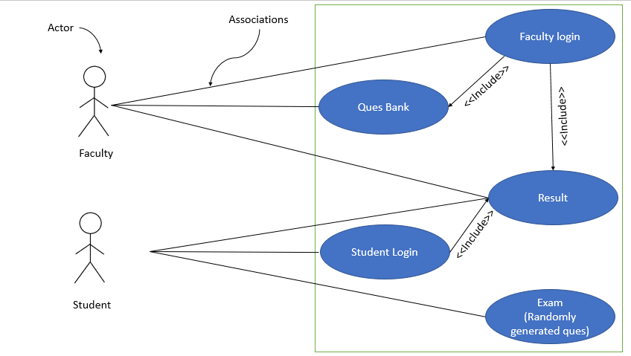

This the use case diagram of our project which was submitted on second week of the course time.

**Database:** For database we use MySqlClient. 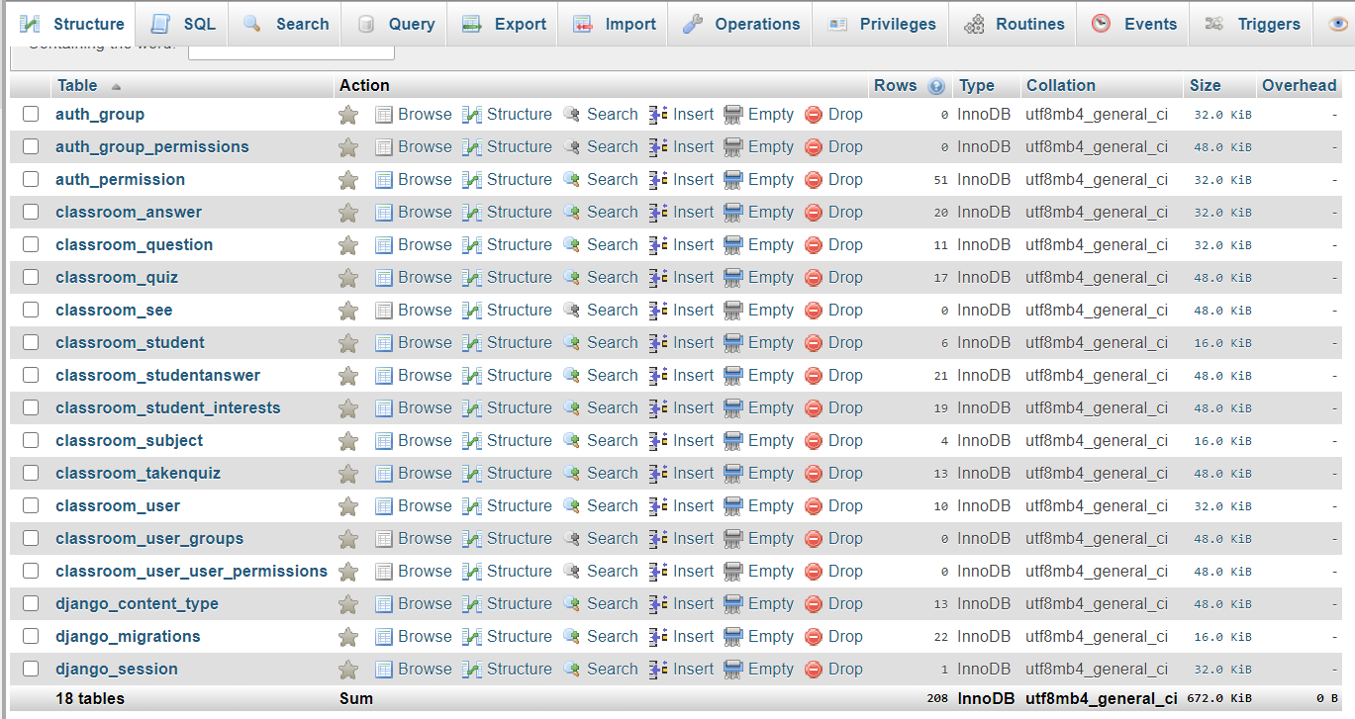

The given png file is our database of this project. We created our database using My SQL and for external observation of our database we use XAMPP.

**Home Page:**

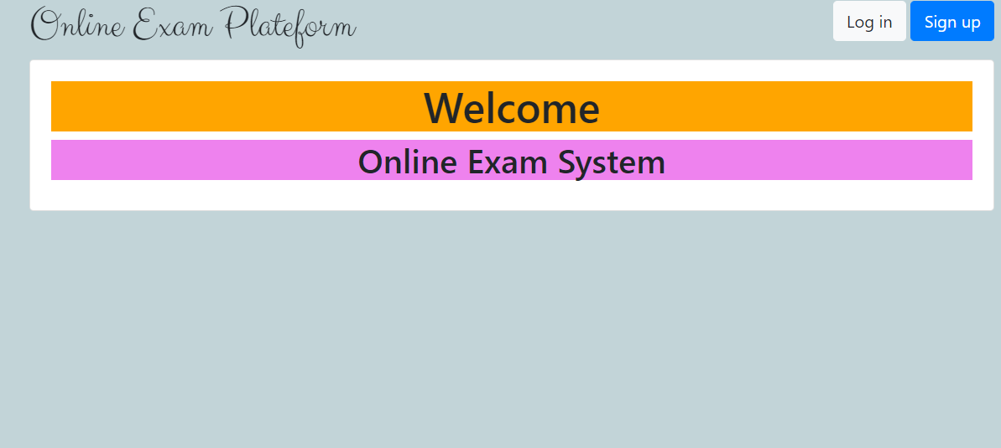

The home page is designed using bootstraps, CSS and other scripts. Keeping the homepage simple was something we were looking forward to. More updates are possible.

**Login page:** 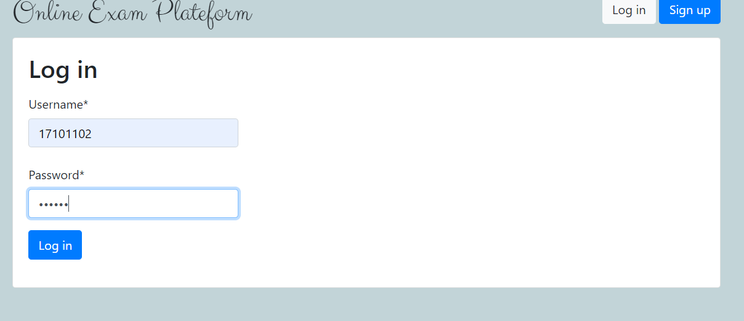

The logging page is a single logging page. That is both teacher and student will be logging using this page but they will be logged in according to their role to their respective dashboards. Here we use bootstrap for the Ui design.

**Teacher’s End:**

1. **Teacher’s Registration page:**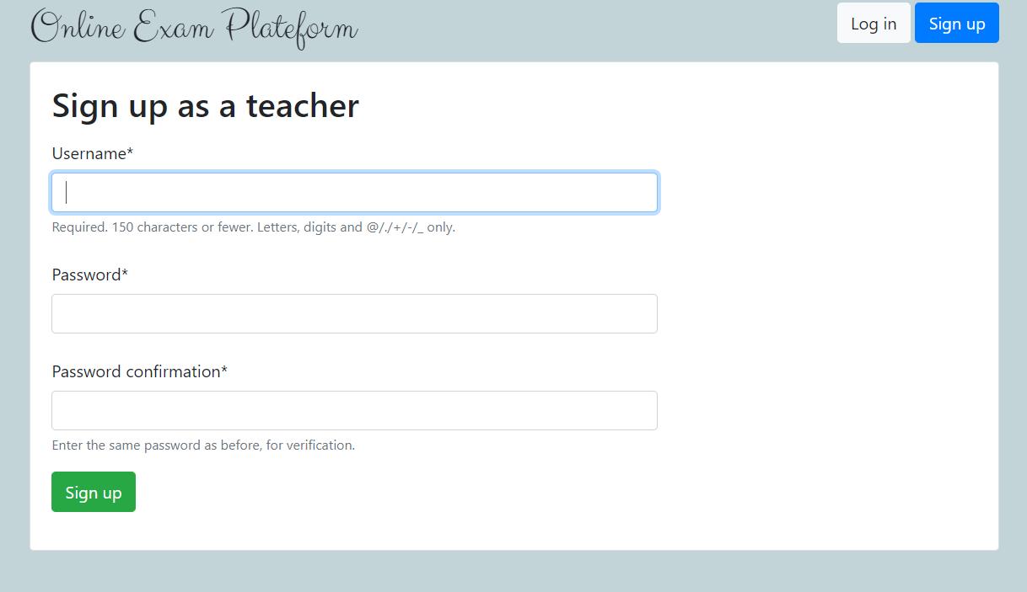
2. **Teacher’s dashboard:**

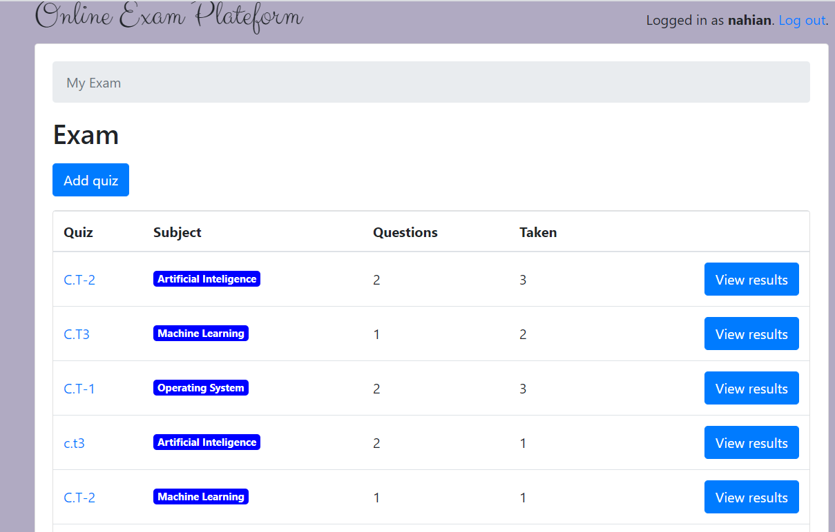

In this page Teacher can create quiz. Create or delete any quiz and also can see result.

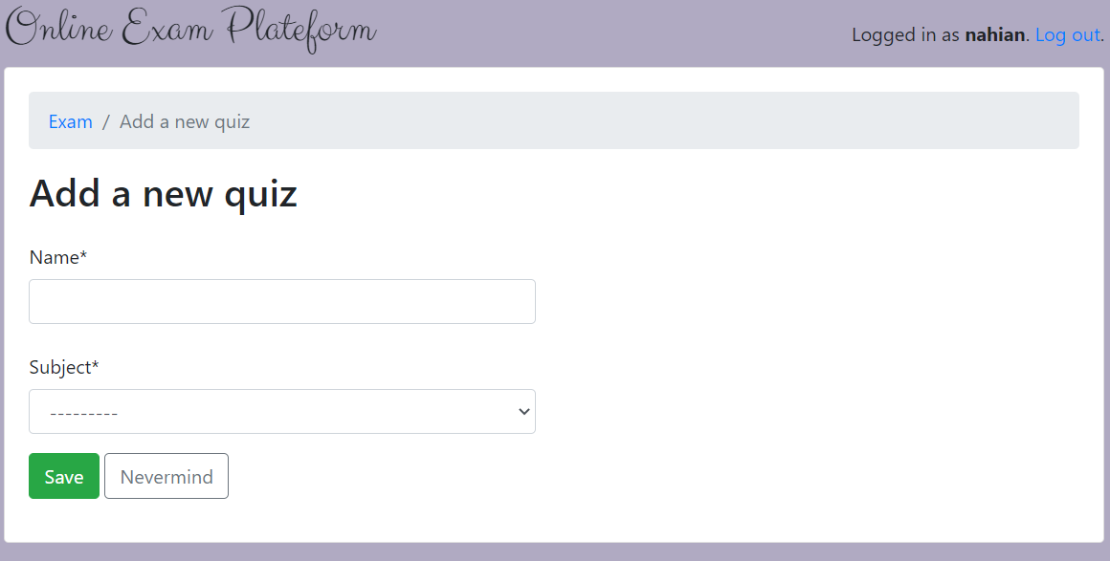

After adding a quiz, the next page will be this one.

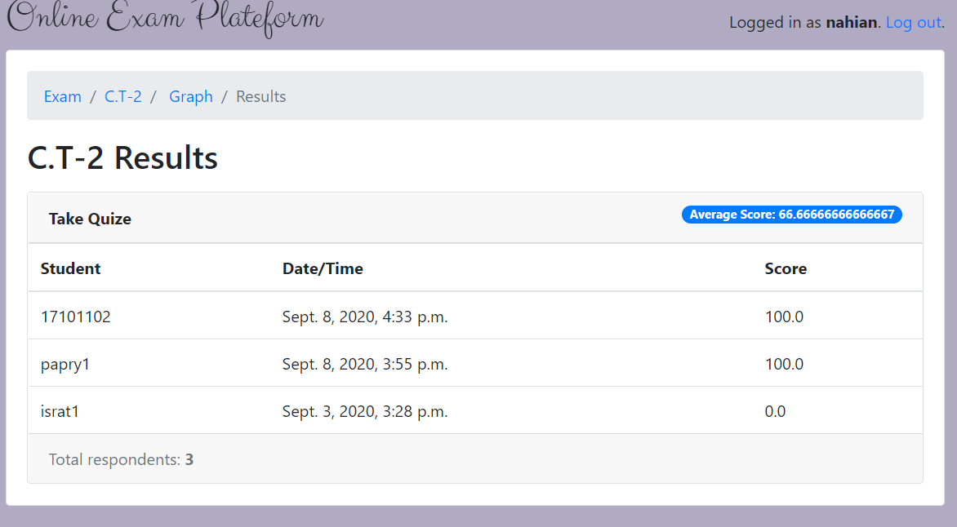

In this page the date and time of quiz and the result of all the students

who have taken quiz will be shown.

1. **Student’s end:**

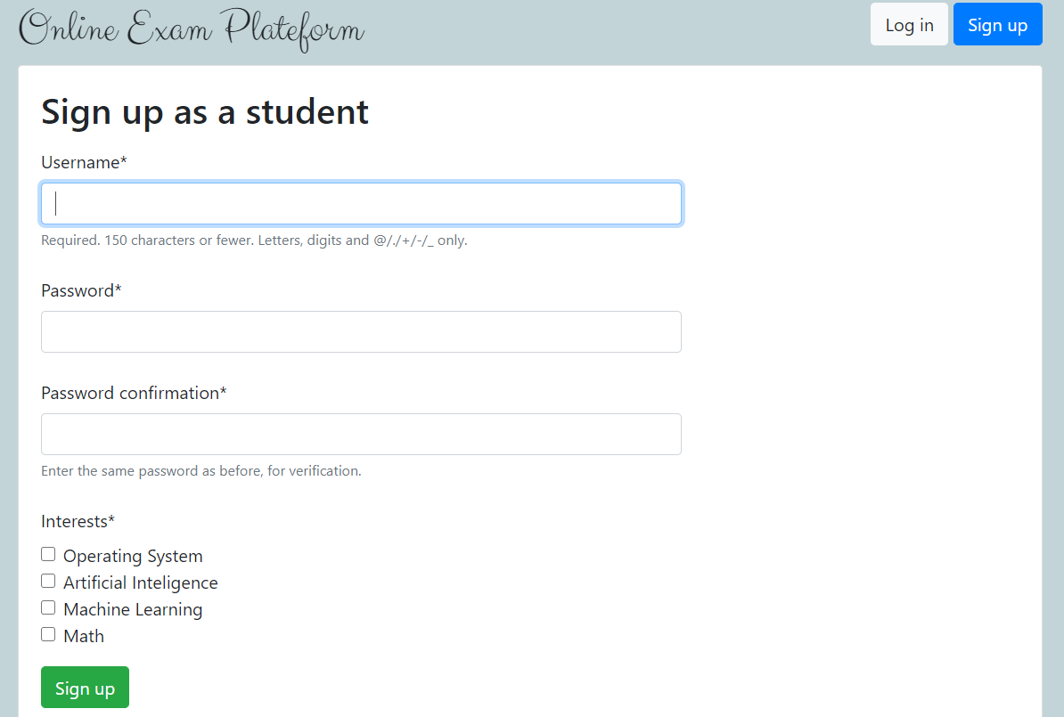

This is student sign up page. Here all the information of student are saved into student model in the database.

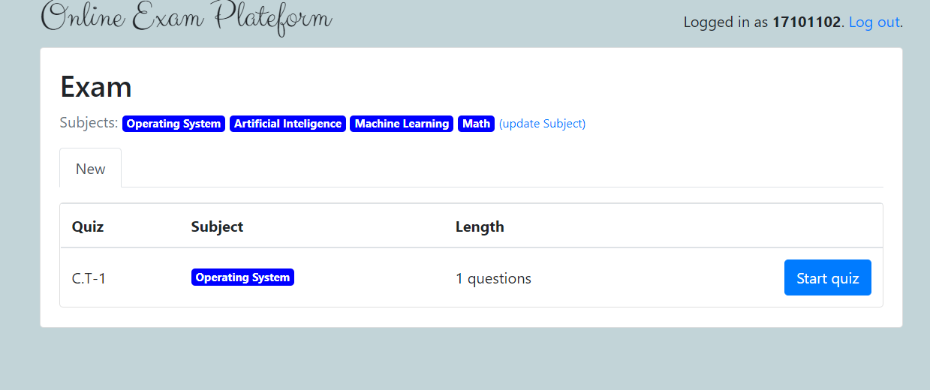

This the exam panel. It is only accessible to regestered students only.

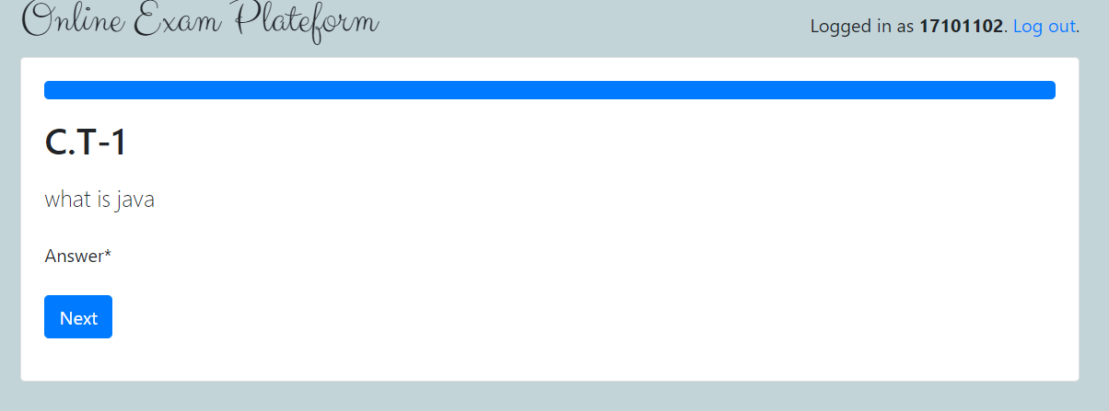

And here the student will answer their question for the exam.

**Version compatibility:** During the development process we face a problem regarding the version of python we were using. As a result, it took a great deal of time to solve these problems. The problem still exists, so we have to downgrade the python version from **3.8** to **3.6.1** to make it work. We are still working to solve the problem so that our project can run on any version of python.

There are other problems we face during development such as:

* Database connection & migration
* Django version
* Graph plotting
* Randomizations
* Package installation
* Pip upgrade

**GitHub Link:** https://github.com/Mongoose28/Online-Examination-Platform

**References & Resources:**

1. [www.djangoproject.org]
2. [www.github.com]
3. [www.w3schools.com]
4. [www.google.com]
5. [www.stackoverflow.com]
6. [www.fullstackpython.com]