P2
DeadlineBot
AI-Powered Deadline Reminder System
🔔 LIVE at deadlinebot.sbs
Text + Voice Input • Telegram Reminders • N8N Automation

📅 Day 2 Project | 🤖 GPT-4o-mini + N8N | 🗓️ June 2, 2026

1. Project Overview
DeadlineBot is an AI-powered deadline reminder system that helps users track important deadlines and receive automated Telegram notifications. Users can add deadlines via natural language text or voice input, and the system automatically schedules reminders at 7 days, 3 days, and 1 day before each deadline.

Project Name | P2 — DeadlineBot
Live URL | https://deadlinebot.sbs
API URL | https://api.deadlinebot.sbs
Build Day | Day 2 of 5-Project Sprint
Status | ✅ LIVE — Fully Deployed
Payment Model | Assignment Only — No Payment Integration
AI Runtime | GPT-4o-mini (OpenAI)
Automation | N8N Workflow — Telegram Reminders
Database | Supabase (deadlinebot project)

2. Problem & Solution

The Problem
Migrants and busy professionals in Germany frequently miss critical deadlines for Behörden appointments, visa renewals, tax submissions, and insurance renewals. Existing calendar apps require manual setup and don't understand natural language.

The Solution
DeadlineBot accepts natural language input like "Submit Steuererklärung by June 30th" and automatically:
- Extracts the deadline date using GPT-4o-mini
- Saves it to Supabase with user's Telegram Chat ID
- Schedules 3 automated reminders via N8N (7d, 3d, 1d before)
- Sends formatted Telegram messages with urgency indicators
- Displays all deadlines with color-coded urgency on the web dashboard

3. Technical Architecture
Component | Technology | Purpose
Frontend | Next.js 14 | Dashboard, text input, voice recorder, deadline cards with urgency colors
Backend API | FastAPI (Python) | POST /deadlines (text), POST /voice (Whisper), GET /deadlines, DELETE
AI Engine | GPT-4o-mini | Natural language date extraction from text and voice
Voice Input | OpenAI Whisper | Speech-to-text transcription for voice deadlines
Telegram Bot | python-telegram-bot | /start registers user + shows Chat ID, /deadlines lists upcoming
Automation | N8N Workflow | Webhook → calculates 3 wait times → sends formatted Telegram reminders
Database | Supabase (PostgreSQL) | users + deadlines tables with RLS policies
Infrastructure | Docker + Traefik | Container orchestration, SSL, domain routing
VPS | Hostinger (Ubuntu 24) | 72.61.178.139 — shared with all 5 projects

4. N8N Automation Workflow
The reminder system is powered by an N8N workflow that handles all scheduling logic without writing cron jobs or complex backend code.

Workflow Flow
- Webhook receives POST from backend when deadline is created
- Code node calculates 3 trigger timestamps (7d, 3d, 1d before deadline)
- Wait node pauses execution until exact trigger time (survives restarts)
- Format node builds urgency-colored message (🟢 🟡 🔴)
- Telegram node sends message to user's Chat ID

Webhook URL
Production: https://n8n.srv1645088.hstgr.cloud/webhook/deadlinebot-schedule
Internal: http://n8n-n8n-1:5678/webhook/deadlinebot-schedule

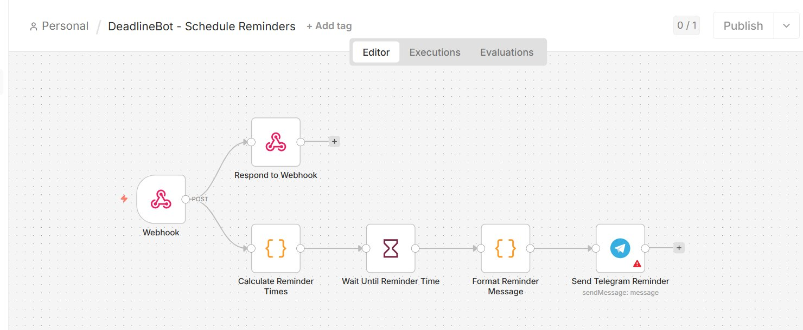
N8N Workflow — 5-node automation pipeline imported and activated

Reminder Message Format
⏰ Deadline Reminder — 🔴 TOMORROW
📌 Submit Steuererklärung
📅 Due: 2026-06-10
Don't forget to prepare! 💪

5. Supabase Database Setup

Project Details
Project Name | deadlinebot
Project URL | https://cerlhhtgqlplljaxuixb.supabase.co
Shared With | P3 ResearchAgent, P4 ContentFactory, P5 NebenkostenCheck
RLS | Enabled — Service role full access policy

Database Schema
-- Users table
create table users (
id uuid primary key default uuid_generate_v4(),
telegram_id bigint unique,
chat_id bigint,
created_at timestamptz default now()
);

-- Deadlines table
create table deadlines (
id uuid primary key default uuid_generate_v4(),
user_id uuid references users(id) on delete cascade,
title text not null,
deadline_date date not null,
is_active boolean default true,
created_at timestamptz default now()
);

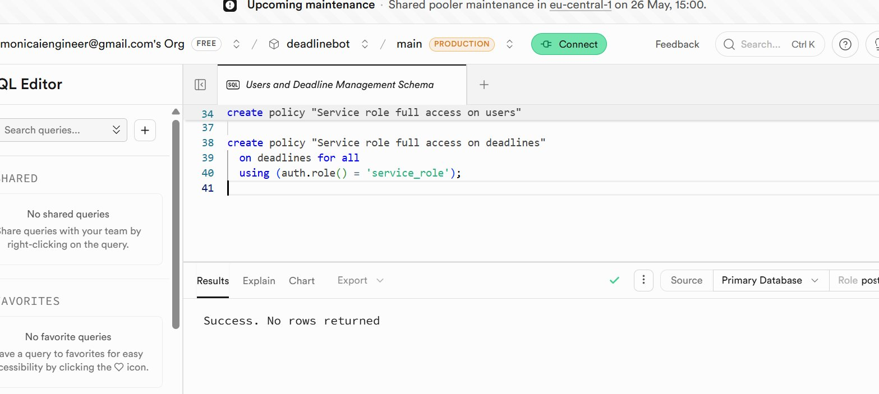
Supabase SQL Editor — Migration ran successfully

6. Live Application Screenshots

6.1 — DeadlineBot Dashboard (Live)
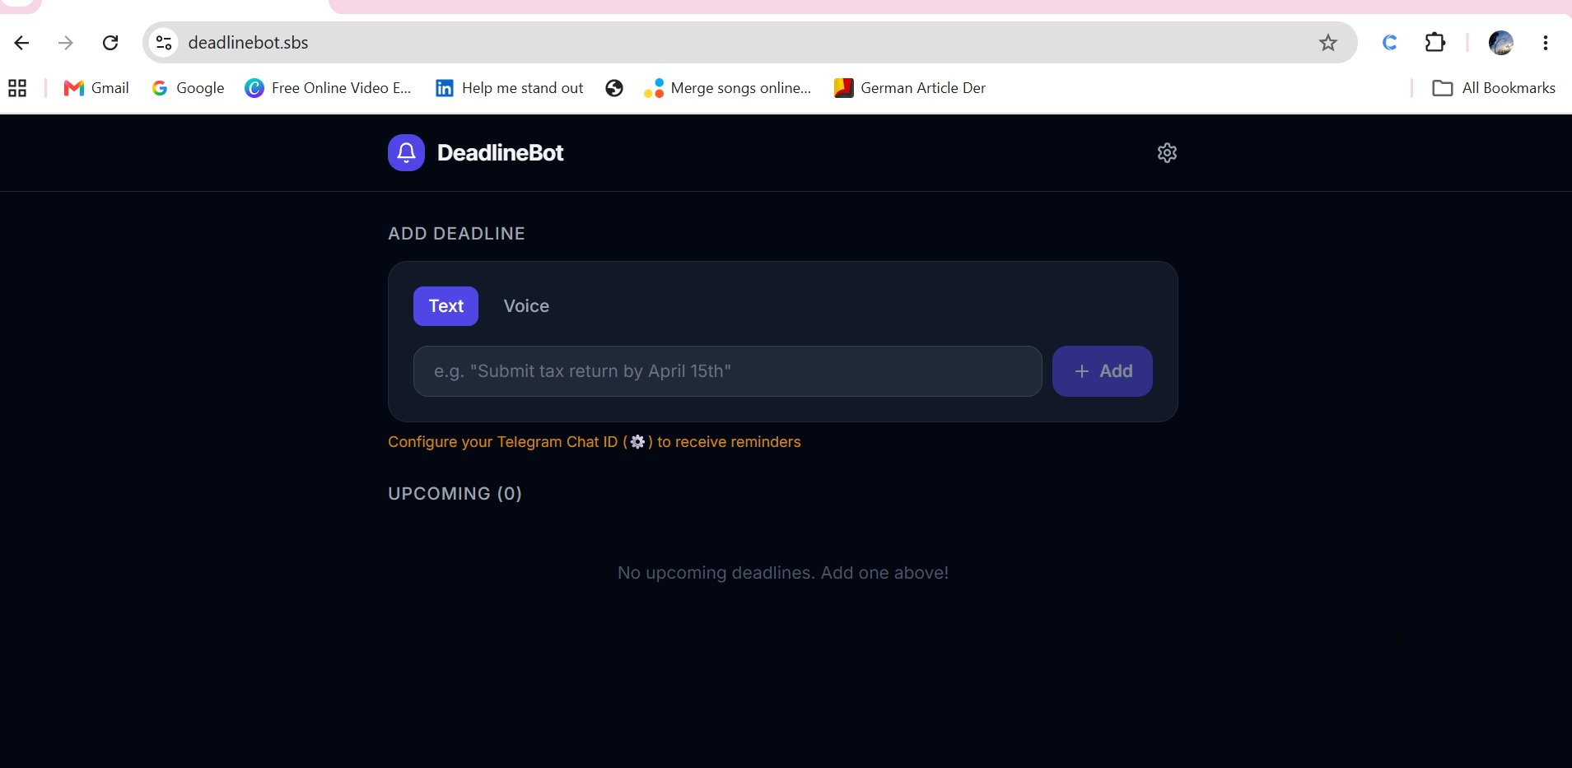
deadlinebot.sbs — Live dashboard with Voice input active

6.2 — Deadline Cards with Urgency Colors
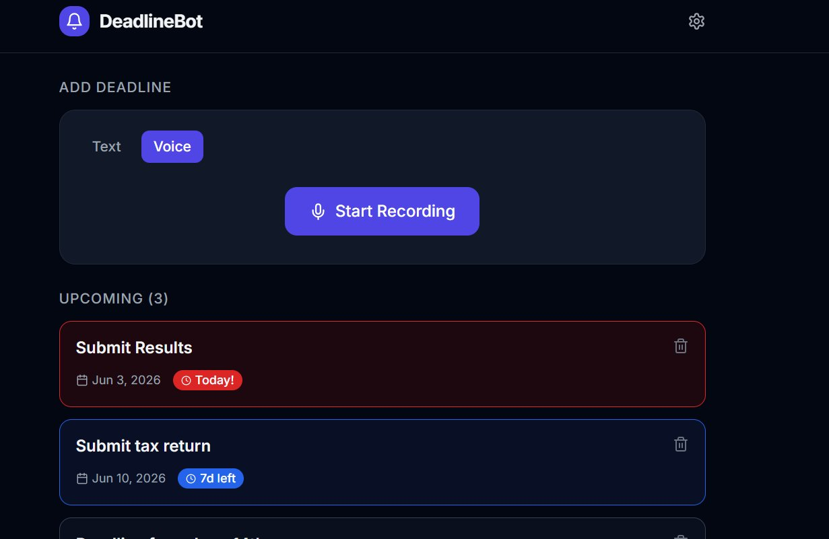
Urgency system: 🔴 Today/Overdue, 🟡 1-3 days, 🔵 4-7 days, ⚪ 8+ days

6.3 — Date Calculation Fixed
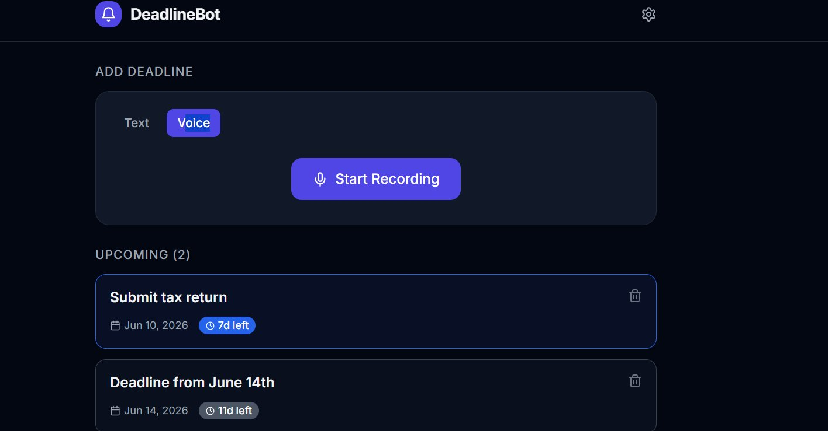
Fixed date calculation: Jun 3 = 1d left, Jun 10 = 8d left, Jun 14 = 12d left

6.4 — Telegram Bot Working
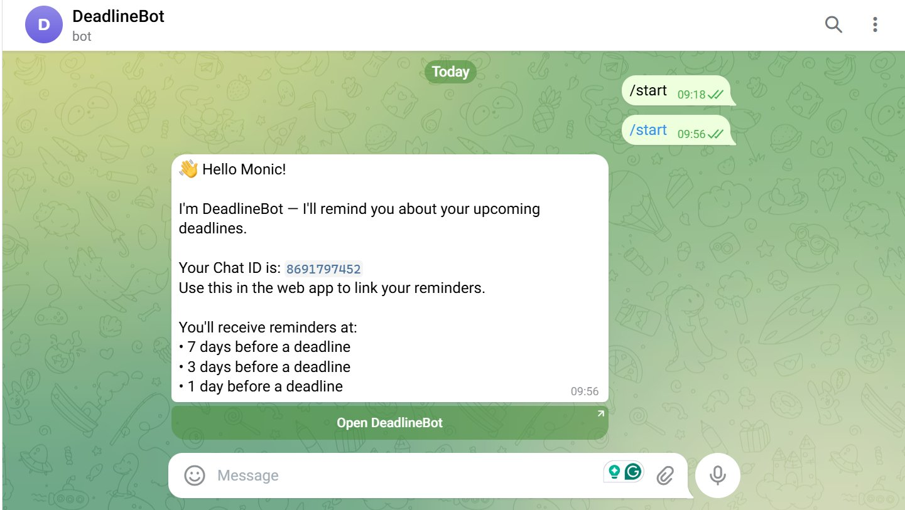
Telegram bot responds to /start with Chat ID and reminder schedule

7. Telegram Bot

Bot Details
Bot Name | DeadlineBot
Bot Token | 8975065955:AAFYH3y... (stored in .env)
Commands | /start — Register + show Chat ID
Commands | /deadlines — List upcoming deadlines
Reminder Times | 7 days, 3 days, 1 day before deadline

How to Link Telegram
- Open Telegram → search DeadlineBot
- Send /start → bot replies with your Chat ID
- Go to deadlinebot.sbs → click ⚙️ settings
- Enter your Chat ID → Save
- All future deadlines will send reminders to your Telegram

8. Deployment Details

Docker Services
Container | Status | Details
deadlinebot-frontend-1 | ✅ Running | Next.js 14 — port 3000 → deadlinebot.sbs
deadlinebot-backend-1 | ✅ Running | FastAPI — port 8000 → api.deadlinebot.sbs
deadlinebot-telegram-bot-1 | ✅ Running | python-telegram-bot — polling mode

Key Deployment Commands
cd /opt/deadlinebot
docker compose up --build -d
docker compose logs -f

Key Files
/opt/deadlinebot/.env — Environment variables
/opt/deadlinebot/docker-compose.yml — Service definitions
/opt/deadlinebot/backend/main.py — FastAPI backend
/opt/deadlinebot/telegram-bot/bot.py — Telegram bot
/opt/deadlinebot/n8n/deadline_reminders_workflow.json — N8N workflow

9. Issues Resolved During Deployment

Issue 1 — Supabase URL Mismatch
Problem: The .env had SUPABASE_URL pointing to a different project ref than the API keys. Backend returned 'Invalid API key'.
Fix: Updated SUPABASE_URL to match the key's project ref (cerlhhtgqlplljaxuixb).

Issue 2 — Wrong Supabase Variable Name
Problem: Backend code used SUPABASE_SERVICE_KEY but .env had SUPABASE_SERVICE_ROLE_KEY.
Fix: Renamed variable in .env to match what the code expected.

Issue 3 — SSL Certificate (TLS-ALPN-01)
Problem: Traefik was using tls-alpn-01 challenge but Cloudflare blocked port 443 ALPN negotiation.
Fix: Switched to httpChallenge (HTTP-01) in Traefik config. Certificates issued successfully.

Issue 4 — Date Calculation Off By 1
Problem: frontend showed 'Today!' for tomorrow's date. differenceInDays(parseISO(date), new Date()) was mixing UTC and local time.
Fix: Changed to differenceInDays(parseISO(date), startOfDay(new Date())) for accurate day counting.

Issue 5 — N8N Workflow JSON Corruption
Problem: Copying workflow JSON via PuTTY terminal caused line breaks and corruption.
Fix: Generated clean JSON file via Claude and downloaded directly.

10. LinkedIn Carousel Content

Slide 1 — Hook
🔔 I built DeadlineBot in 1 day — an AI that reminds you about deadlines via Telegram
Voice input. Natural language. Zero setup.

Slide 2 — The Problem
Migrants in Germany miss critical deadlines every year:
- Visa renewal → deportation risk
- Tax submission → €150+ fine
- Anmeldung → blocks bank accounts
- KFZ insurance → €10,000+ liability

Slide 3 — How It Works
Just type or say: 'Submit Steuererklärung by June 30th'
- GPT-4o-mini extracts the date
- Saves to Supabase
- N8N schedules 3 Telegram reminders
- You get notified 7d, 3d, 1d before

Slide 4 — Tech Stack
- Frontend: Next.js 14 + dark UI
- Backend: FastAPI + OpenAI Whisper
- Automation: N8N workflow
- Database: Supabase PostgreSQL
- Bot: python-telegram-bot
- Infra: Docker + Traefik + VPS

Slide 5 — CTA
Try it free at deadlinebot.sbs
Built in 1 day as part of my 5 AI Projects in 5 Days sprint.
Follow for P3 tomorrow — ResearchAgent with Apify!

