Result Report
1. Preparation
- I don’t use c++ in the daily work. So I run the whole project and get a brief result.
- Download and install Wireshark to have a view of the data in input.pcap
- Some modification is needed to run the project on my computer
2. Finding the gap between output. Csv and ground truth.csv
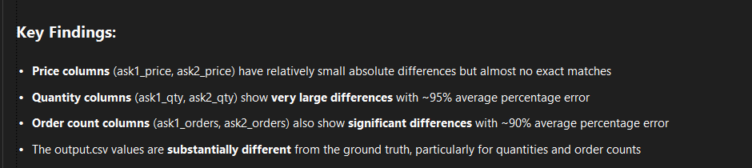
Value them by MAP,R^2 and Corrrelation. Ask1_price,ask2_price behave well, ask1_qty, ask2_qty, ask1_orders, ask2_orders need to improve.
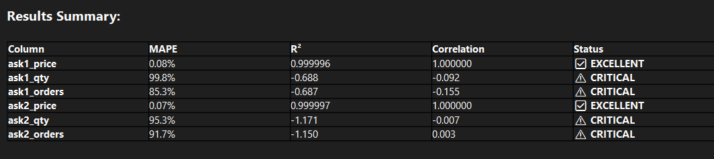

3. Optimization
Problems with Original Code:
1. Only Updated One Side: The original code looked for either the ask OR the bid order, but not both. It would find one and only update that one order.
2. Wrong Trade Quantity: It calculated `trade_qty = min(message.quantity, it->second.qty)` but this doesn't make sense because:
- A trade message represents a completed trade with a specific quantity
- The trade quantity should be exactly `message.quantity`, not some minimum
- Both the bid AND ask side should be reduced by the trade quantity
3. Incorrect Order Book Updates: Since it only found one order, it would only reduce quantity on one side of the trade, leaving the other side incorrect.
I optimize the function and we can see improvements on ask1_qty, ask2_qty, ask1_orders, ask2_orders for MAP,R^2 and Corrrelation.

