**RAJALAKSHMI ENGINEERING COLLEGE**

**RAJALAKSHMI NAGAR,**

**THANDALAM – 602 105**



CS23332

DATABASE MANAGEMENT SYSTEM

LAB MANUAL

**Laboratory Record Notebook**



# CS23332 DATABASE MANAGEMENT SYSTEMS

|  |  |
| --- | --- |
| NAME | MONIC AUDITYA.A |
| ROLL NO. | 230701194 |
| DEPT | CSE |
| SEC | C |

|  |  |  |
| --- | --- | --- |
| **Ex.No.: 1** | | **CREATION OF BASE TABLE AND**  **DML OPERATIONS** |
| **Date:** | 31/7/24 |

1. Create MY_EMPLOYEE table with the following structure

|  |  |  |
| --- | --- | --- |
| NAME | NULL? | TYPE |
| ID | Not null | Number(4) |
| Last_name |  | Varchar(25) |
| First_name |  | Varchar(25) |
| Userid |  | Varchar(25) |
| Salary |  | Number(9,2) |

CREATE TABLE MY_EMPLOYEE (ID NUMBER(4) NOT NULL, Last_name VARCHAR2(25), First_name VARCHAR2(25), Userid VARCHAR2(25),Salary NUMBER(9, 2));

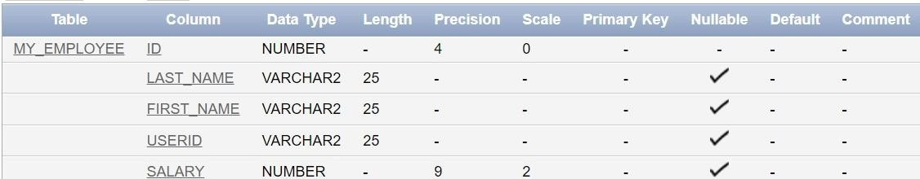

1. Add the first and second rows data to MY_EMPLOYEE table from the following sample data.

|  |  |  |  |  |
| --- | --- | --- | --- | --- |
| **ID** | **Last_name** | **First_name** | **Userid** | **salary** |
| 1 | Patel | Ralph | rpatel | 895 |
| 2 | Dancs | Betty | bdancs | 860 |
| 3 | Biri | Ben | bbiri | 1100 |
| 4 | Newman | Chad | Cnewman | 750 |
| 5 | Ropebur | Audrey | aropebur | 1550 |

Begin

INSERT INTO MY_EMPLOYEE VALUES (1, 'Patel', 'Ralph', 'rpatel', 895); INSERT INTO MY_EMPLOYEE VALUES (2, 'Dancs', 'Betty', 'bdancs', 860);

End;

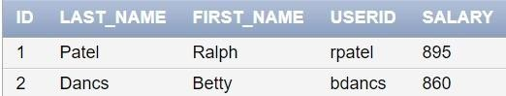

1. Display the table with values.

Select * from My_Employee;



1. Populate the next two rows of data from the sample data. Concatenate the first letter of the first_name with the first seven characters of the last_name to produce Userid.

Begin

INSERT INTO MY_EMPLOYEE (ID, Last_name, First_name, Userid, Salary) VALUES (3, 'Biri', 'Ben', SUBSTR('Biri', 1, 1) || SUBSTR('Biri', 1, 7), 1100);

INSERT INTO MY_EMPLOYEE (ID, Last_name, First_name, Userid, Salary)

VALUES (4, 'Newman', 'Chad', SUBSTR('Newman', 1, 1) || SUBSTR('Newman', 1, 7), 750);

End;

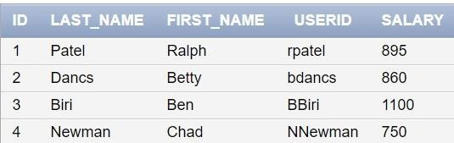

1. Delete Betty dancs from MY _EMPLOYEE table.

DELETE FROM MY_EMPLOYEE WHERE Last_name = 'Dancs';

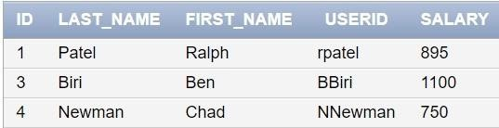

1. Empty the fourth row of the emp table.

DELETE FROM MY_EMPLOYEE WHERE ID = 4;

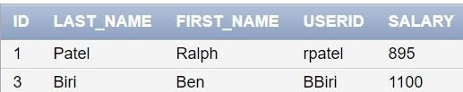

1. Make the data additions permanent.

COMMIT;

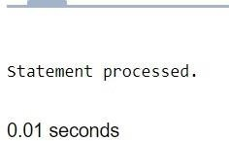

1. Change the last name of employee 3 to Drexler.

UPDATE MY_EMPLOYEE SET Last_name = 'Drexler' WHERE ID = 3;

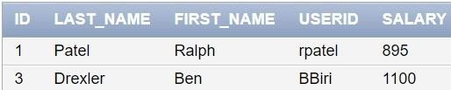

1. Change the salary to 1000 for all the employees with a salary less than 900.

UPDATE MY_EMPLOYEE SET Salary = 1000 WHERE Salary < 900;

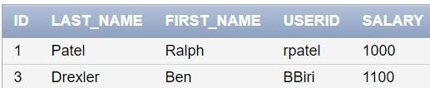

|  |  |  |
| --- | --- | --- |
| **Ex.No.: 2** | | **DATA MANIPULATIONS** |
| **Date:** | 5/8/24 |

### Create the following tables with the given structure. EMPLOYEES TABLE

|  |  |  |
| --- | --- | --- |
| **NAME** | **NULL?** | **TYPE** |
| Employee_id | Not null | Number(6) |
| First_Name |  | Varchar(20) |
| Last_Name | Not null | Varchar(25) |
| Email | Not null | Varchar(25) |
| Phone_Number |  | Varchar(20) |
| Hire_date | Not null | Date |
| Job_id | Not null | Varchar(10) |
| Salary |  | Number(8,2) |
| Commission_pct |  | Number(2,2) |
| Manager_id |  | Number(6) |
| Department_id |  | Number(4) |

1. Find out the employee id, names, salaries of all the employees

SELECT Employee_id, First_name, Last_name, Salary FROM EMPLOYEES;

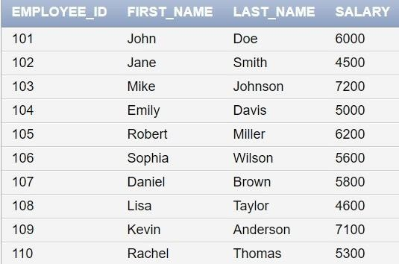

1. List out the employees who works under manager 100

SELECT Employee_id, First_name, Last_name FROM EMPLOYEES WHERE Manager_id = 100;

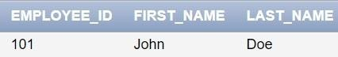

1. 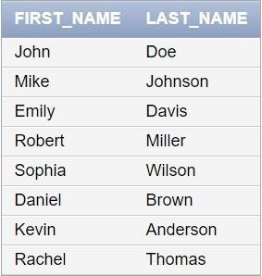Find the names of the employees who have a salary greater than or equal to 4800 SELECT First_name, Last_name FROM EMPLOYEES WHERE Salary >= 4800;
2. List out the employees whose last name is ‗AUSTIN‘

SELECT Employee_id, First_name, Last_name FROM EMPLOYEES WHERE Last_name = 'AUSTIN';

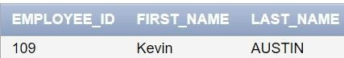

1. Find the names of the employees who works in departments 60,70 and 80

SELECT First_name, Last_name FROM EMPLOYEES WHERE Department_id IN (60, 70, 80);

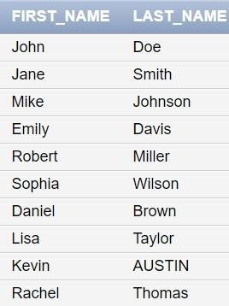

1. Display the unique Manager_Id.

SELECT DISTINCT Manager_id FROM EMPLOYEES;

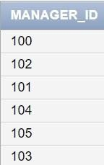

Create an Emp table with the following fields: (EmpNo, EmpName, Job,Basic, DA, HRA,PF, GrossPay, NetPay) (Calculate DA as 30% of Basic and HRA as 40% of Basic)

1. Insert Five Records and calculate GrossPay and NetPay.

INSERT INTO EMP (EmpNo, EmpName, Job, Basic, DA, HRA, PF, GrossPay, NetPay) VALUES (1, 'John Doe', 'Manager', 50000, 0.30 * 50000, -- DA as 30% of Basic

0.40 * 50000, -- HRA as 40% of Basic,0.12 * 50000, -- PF as 12% of Basic

50000 + (0.30 * 50000) + (0.40 * 50000), -- GrossPay (50000 + (0.30 * 50000) + (0.40 *

50000)) - (0.12 * 50000) -- NetPay

);

INSERT INTO EMP (EmpNo, EmpName, Job, Basic, DA, HRA, PF, GrossPay, NetPay) VALUES (2, 'Jane Smith', 'Clerk', 30000, 0.30 * 30000, 0.40 * 30000,

0.12 * 30000,

30000 + (0.30 * 30000) + (0.40 * 30000),

(30000 + (0.30 * 30000) + (0.40 * 30000)) - (0.12 * 30000)

);

INSERT INTO EMP (EmpNo, EmpName, Job, Basic, DA, HRA, PF, GrossPay, NetPay) VALUES (3, 'Mike Johnson', 'Salesman', 40000,

0.30 * 40000,

0.40 * 40000,

0.12 * 40000,

40000 + (0.30 * 40000) + (0.40 * 40000),

(40000 + (0.30 * 40000) + (0.40 * 40000)) - (0.12 * 40000)

);

INSERT INTO EMP (EmpNo, EmpName, Job, Basic, DA, HRA, PF, GrossPay, NetPay) VALUES (4, 'Emily Davis', 'Accountant', 35000,

0.30 * 35000,

0.40 * 35000,

0.12 * 35000,

35000 + (0.30 * 35000) + (0.40 * 35000),

(35000 + (0.30 * 35000) + (0.40 * 35000)) - (0.12 * 35000)

);

INSERT INTO EMP (EmpNo, EmpName, Job, Basic, DA, HRA, PF, GrossPay, NetPay) VALUES (5, 'Robert Miller', 'Clerk', 25000,

0.30 * 25000,

0.40 * 25000,

0.12 * 25000,

25000 + (0.30 * 25000) + (0.40 * 25000),

(25000 + (0.30 * 25000) + (0.40 * 25000)) - (0.12 * 25000)

);

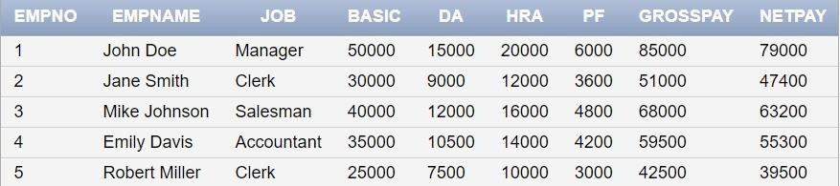

1. Display the employees whose Basic is lowest in each department.

SELECT EmpNo, EmpName, Job, Basic FROM EMP E1 WHERE Basic = ( SELECT MIN(Basic) FROM EMP E2 WHERE E2.Job = E1.Job);

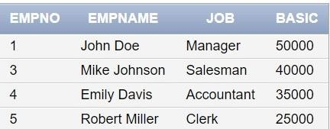

1. 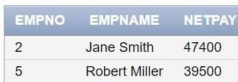If Net Pay is less than 50000, display employee number,name and net pay SELECT EmpNo, EmpName, NetPay FROM EMP WHERE NetPay < 50000;

### DEPARTMENT TABLE

|  |  |  |
| --- | --- | --- |
| **NAME** | **NULL?** | **TYPE** |
| Dept_id | Not null | Number(6) |
| Dept_name | Not null | Varchar(20) |
| Manager_id |  | Number(6) |
| Location_id |  | Number(4) |

**JOB_GRADE TABLE**

|  |  |  |
| --- | --- | --- |
| **NAME** | **NULL?** | **TYPE** |
| Grade_level |  | Varchar(2) |
| Lowest_sal |  | Number |
| Highest_sal |  | Number |

### LOCATION TABLE

|  |  |  |
| --- | --- | --- |
| **NAME** | **NULL?** | **TYPE** |
| Location_id | Not null | Number(4) |
| St_addr |  | Varchar(40) |
| Postal_code |  | Varchar(12) |
| City | Not null | Varchar(30) |
| State_province |  | Varchar(25) |
| Country_id |  | Char(2) |

* 1. Create the DEPT table based on the DEPARTMENT following the table instance chart below. Confirm that the table is created.

|  |  |  |
| --- | --- | --- |
| **Column name** | ID | NAME |
| **Key Type** |  |  |
| **Nulls/Unique** |  |  |
| **FK table** |  |  |
| **FK column** |  |  |
| **Data Type** | Number | Varchar2 |
| **Length** | 7 | 25 |

CREATE TABLE DEPT (Dept_id NUMBER(6) NOT NULL, Dept_name VARCHAR2(20)

NOT NULL,Manager_id NUMBER(6), Location_id NUMBER(4), CONSTRAINT my_dept_id_pk PRIMARY KEY (Dept_id));

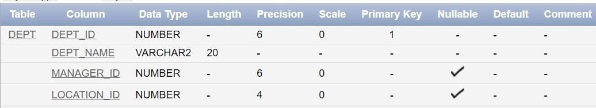

* 1. Create the EMP table based on the following instance chart. Confirm that the table is created.

|  |  |  |  |  |
| --- | --- | --- | --- | --- |
| **Column name** | ID | LAST_NAME | FIRST_NAME | DEPT_ID |
| **Key Type** |  |  |  |  |
| **Nulls/Unique** |  |  |  |  |
| **FK table** |  |  |  |  |
| **FK column** |  |  |  |  |
| **Data Type** | Number | Varchar2 | Varchar2 | Number |
| **Length** | 7 | 25 | 25 | 7 |

CREATE TABLE EMP (EmpNo NUMBER(7) PRIMARY KEY,Last_name VARCHAR2(25)

NOT NULL,First_name VARCHAR2(25),Dept_id NUMBER(7), CONSTRAINT my_emp_dept_id_fk FOREIGN KEY (Dept_id) REFERENCES DEPT(Dept_id));

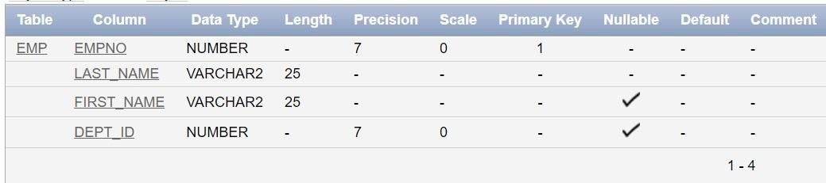

* 1. Modify the EMP table to allow for longer employee last names. Confirm the modification.(Hint: Increase the size to 50)

ALTER TABLE EMP MODIFY (Last_name VARCHAR2(50));

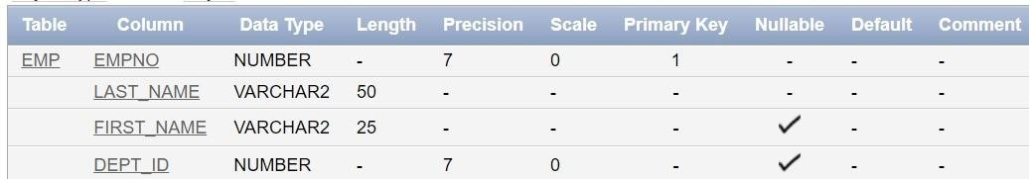

* 1. Create the EMPLOYEES2 table based on the structure of EMPLOYEES table. Include Only the Employee_id, First_name, Last_name, Salary and Dept_id coloumns. Name the columns Id, First_name, Last_name, salary and Dept_id respectively.

CREATE TABLE EMPLOYEES2 (Id NUMBER(6) PRIMARY

KEY,First_name VARCHAR2(20),Last_name VARCHAR2(25), Salary NUMBER(8,2),Dept_id NUMBER(4));

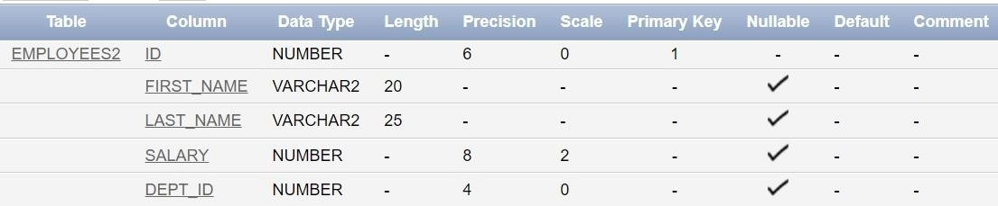

* 1. Drop the EMP Table DROP TABLE EMP;



* 1. Rename the EMPLOYEES2 table as EMP.

ALTER TABLE EMPLOYEES2 RENAME TO EMP;



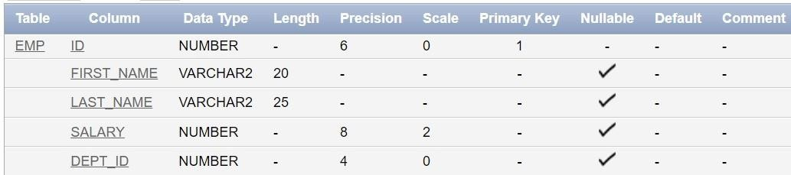

* 1. Add a comment on DEPT and EMP tables. Confirm the modification by describing the table.

COMMENT ON TABLE DEPT IS 'This table contains department information.'; COMMENT ON TABLE EMP IS 'This table contains employee information.';

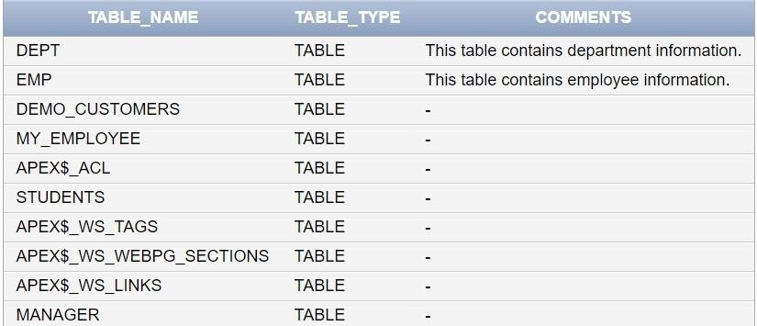

* 1. Drop the First_name column from the EMP table and confirm it.

ALTER TABLE EMP DROP COLUMN First_name;

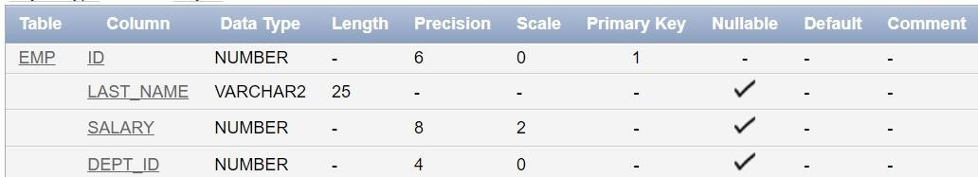

|  |  |  |
| --- | --- | --- |
| **Ex.No.: 3** | | **WRITING BASIC SQL SELECT STATEMENTS** |
| **Date:** | 6/8/24 |

**Find the Solution for the following:**

**True OR False**

1. The following statement executes successfully.

### Identify the Errors

SELECT employee_id, last_name sal*12 ANNUAL SALARY

FROM employees;

False ->Corrected Query and Output

Select employee_id,last_name,salary*12 AS "Annual Salary" from Employees;

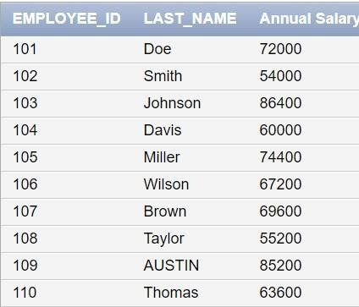

1. Show the structure of departments the table. Select all the data from it.

DESC department;

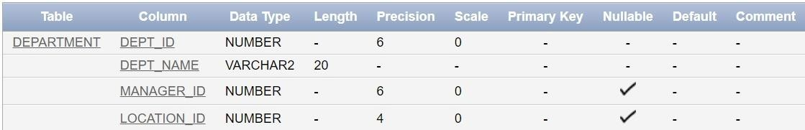

Select * from Department;

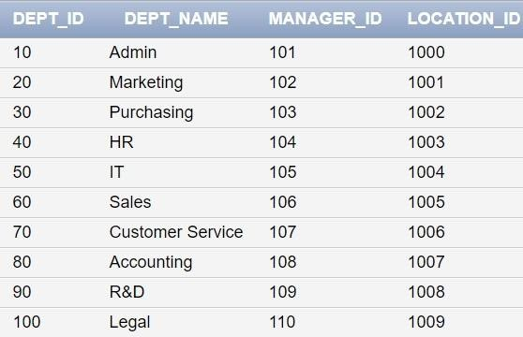

1. Create a query to display the last name, job code, hire date, and employee number for each employee, with employee number appearing first.

SELECT employee_id, last_name, job_id, hire_date FROM employees;

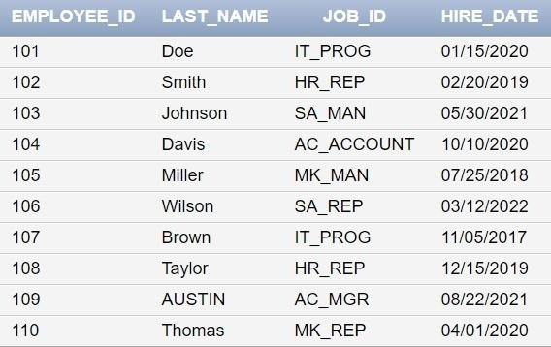

1. Provide an alias STARTDATE for the hire date.

SELECT employee_id, last_name, job_id, hire_date AS STARTDATE FROM employees;

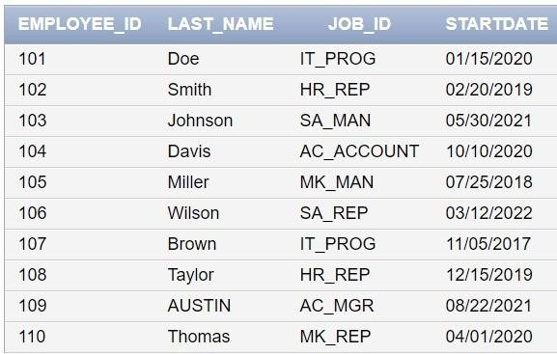

1. Create a query to display unique job codes from the employee table.

SELECT DISTINCT job_id FROM employees;

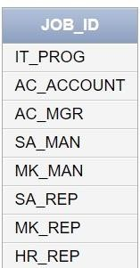

1. Display the last name concatenated with the job ID , separated by a comma and space, and name the column EMPLOYEE and TITLE.

SELECT last_name || ', ' || job_id AS "EMPLOYEE and TITLE" FROM employees;

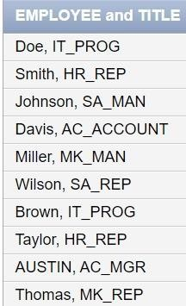

1. Create a query to display all the data from the employees table. Separate each column by a comma. Name the column THE_OUTPUT.

SELECT employee_id || ', ' || last_name || ', ' || job_id || ', ' || hire_date AS THE_OUTPUT FROM employees;

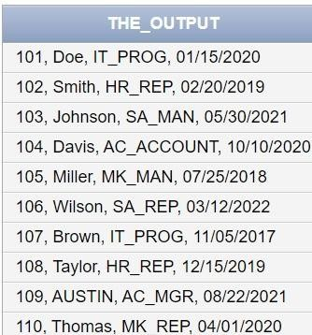

|  |  |  |
| --- | --- | --- |
| **Ex.No.: 5** | | **CREATING VIEWS** |
| **Date:** | 14/8/24 |

1. Create a view called EMPLOYEE_VU based on the employee numbers, employee names and department numbers from the EMPLOYEES table. Change the heading for the employee name to EMPLOYEE.

CREATE VIEW EMPLOYEE_VU AS SELECT employee_id, last_name AS EMPLOYEE, department_id FROM EMPLOYEES;

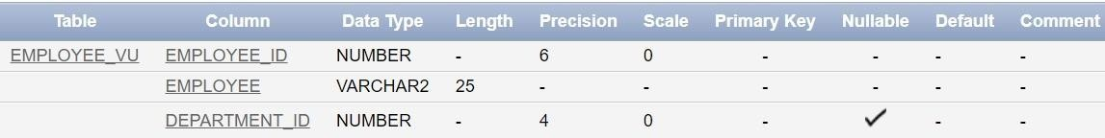

1. Display the contents of the EMPLOYEES_VU view.

SELECT * FROM EMPLOYEE_VU;

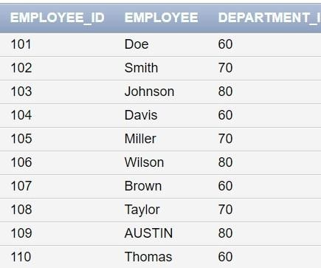

1. Select the view name and text from the USER_VIEWS data dictionary views.

SELECT view_name, text FROM USER_VIEWS WHERE view_name = 'EMPLOYEE_VU';



1. Using your EMPLOYEES_VU view, enter a query to display all employees names and department.

SELECT EMPLOYEE, department_id FROM EMPLOYEE_VU;

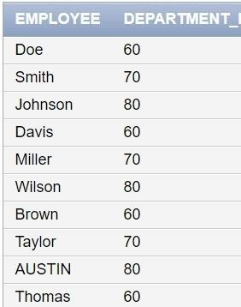

1. Create a view named DEPT50 that contains the employee number, employee last names and department numbers for all employees in department 50.Label the view columns EMPNO, EMPLOYEE and DEPTNO. Do not allow an employee to be reassigned to another department through the view.

CREATE OR REPLACE VIEW DEPT50 (EMPNO, EMPLOYEE, DEPTNO) AS

SELECT employee_id, last_name, department_id FROM EMPLOYEES

WHERE department_id = 50 WITH CHECK OPTION;

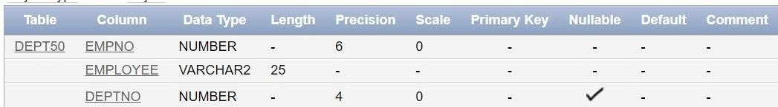

1. Display the structure and contents of the DEPT50 view.

SELECT * FROM DEPT50;

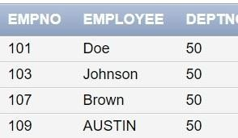

1. Attempt to reassign Matos to department 80.

UPDATE DEPT50 SET DEPTNO = 80 WHERE EMPLOYEE = 'Matos';



1. Create a view called SALARY_VU based on the employee last names, department names, salaries, and salary grades for all employees. Use the Employees, DEPARTMENTS and JOB_GRADE tables. Label the column Employee,Department, salary, and Grade respectively.

CREATE VIEW SALARY_VU AS

SELECT e.last_name AS Employee, d.department_name AS Department, e.salary AS Salary,

j.grade_level AS Grade FROM EMPLOYEES e

JOIN DEPARTMENTS d ON e.department_id = d.department_id

JOIN JOB_GRADE j ON e.salary BETWEEN j.lowest_sal AND j.highest_sal;

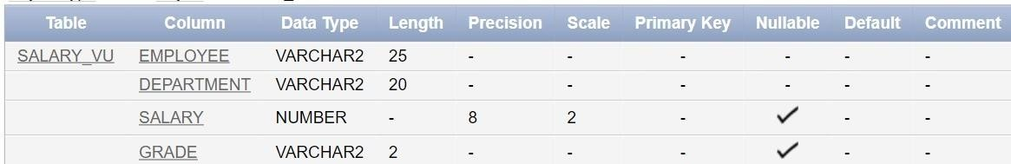

|  |  |  |
| --- | --- | --- |
| **Ex.No.: 6** | | **RESTRICTING AND SORTING DATA** |
| **Date:** | 14/8/24 |

1. Create a query to display the last name and salary of employees earning more than 12000.

SELECT last_name, salary FROM employees WHERE salary > 12000;

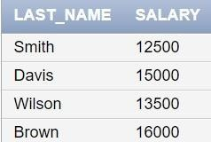

1. Create a query to display the employee last name and department number for employee number 176.

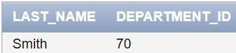SELECT last_name, department_id FROM employees WHERE employee_id = 176;

1. Create a query to display the last name and salary of employees whose salary is not in the range of 5000 and 12000. (hints: not between ).

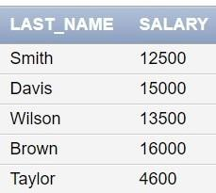SELECT last_name, salary FROM employees WHERE salary NOT BETWEEN 5000 AND 12000;

1. Display the employee last name, job ID, and start date of employees hired between February 20,1998 and May 1,1998.order the query in ascending order by start date.(hints: between)

SELECT last_name, job_id, hire_date FROM employees WHERE hire_date BETWEEN '02-20-1998' AND '05-01-1998' ORDER BY hire_date ASC;

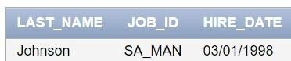

1. Display the last name and department number of all employees in departments 20 and 50 in alphabetical order by name.(hints: in, orderby)

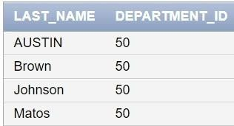SELECT last_name, department_id FROM employees WHERE department_id IN (20, 50) ORDER BY last_name ASC;

1. Display the last name and salary of all employees who earn between 5000 and 12000 and are in departments 20 and 50 in alphabetical order by name. Label the columns EMPLOYEE, MONTHLY SALARY respectively.(hints: between, in)

SELECT last_name AS "EMPLOYEE", salary AS "MONTHLY SALARY" FROM

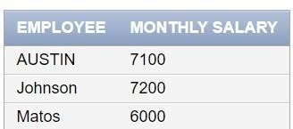employees WHERE salary BETWEEN 5000 AND 12000 AND department_id IN (20, 50) ORDER BY last_name ASC;

1. Display the last name and hire date of every employee who was hired in 1994.(hints: like) SELECT last_name, hire_date FROM employees WHERE hire_date LIKE '%1994%';

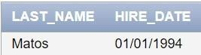

1. Display the last name and job title of all employees who do not have a manager.(hints: is null)

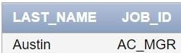SELECT last_name, job_id FROM employees WHERE manager_id IS NULL;

1. Display the last name, salary, and commission for all employees who earn commissions. Sort data in descending order of salary and commissions.(hints: is not nul,orderby)

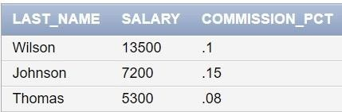SELECT last_name, salary, commission_pct FROM employees WHERE commission_pct IS NOT NULL ORDER BY salary DESC, commission_pct DESC;

1. Display the last name of all employees where the third letter of the name is ***a***.(hints:like) SELECT last_name FROM employees WHERE last_name LIKE ' _a%';

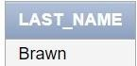

1. Display the last name of all employees who have an a and an ***e*** in their last name.(hints:

like)

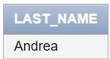SELECT last_name FROM employees WHERE last_name LIKE '%a%' AND last_name LIKE '%e%';

1. Display the last name and job and salary for all employees whose job is sales representative or stock clerk and whose salary is not equal to 2500 ,3500 or 7000.(hints:in,not in)

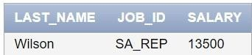SELECT last_name, job_id, salary FROM employees WHERE job_id IN ('SA_REP', 'ST_CLERK') AND salary NOT IN (2500, 3500, 7000);



|  |  |  |
| --- | --- | --- |
| **Ex.No.: 7** | | **USING SET OPERATORS** |
| **Date:** | 28/8/24 |

1. The HR department needs a list of department IDs for departments that do not contain the job ID ST_CLERK. Use set operators to create this report.

SELECT department_id FROM departments MINUS SELECT department_id FROM employees WHERE job_id = 'ST_CLERK';

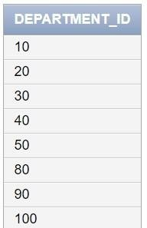

1. The HR department needs a list of countries that have no departments located in them. Display the country ID and the name of the countries. Use set operators to create this report.

SELECT country_id, country_name FROM countries MINUS SELECT country_id, country_name FROM departments;

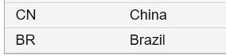

1. Produce a list of jobs for departments 10, 50, and 20, in that order. Display job ID and department ID using set operators.

SELECT job_id, department_id FROM employees WHERE department_id = 10 UNION

SELECT job_id, department_id FROM employees WHERE department_id = 50 UNION

SELECT job_id, department_id FROM employees WHERE department_id = 20;

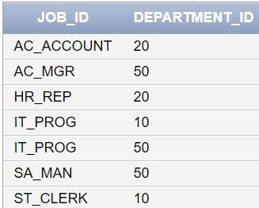

1. Create a report that lists the employee IDs and job IDs of those employees who currently have a job title that is the same as their job title when they were initially hired by the company (that is, they changed jobs but have now gone back to doing their original job).

SELECT employee_id, job_id FROM employees INTERSECT

SELECT employee_id, job_id FROM job_history;

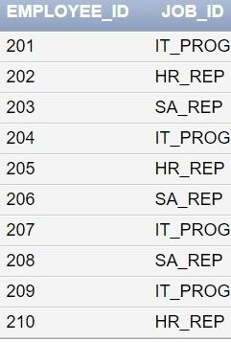

1. The HR department needs a report with the following specifications:

* Last name and department ID of all the employees from the EMPLOYEES table, regardless of whether or not they belong to a department.
* Department ID and department name of all the departments from the DEPARTMENTS table, regardless of whether or not they have employees working in them Write a compound query to accomplish this.

SELECT last_name, department_id FROM employees UNION

SELECT department_name, department_id FROM departments;

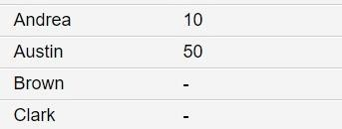



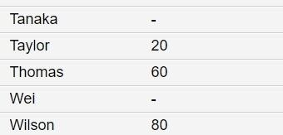

|  |  |  |  |  |  |
| --- | --- | --- | --- | --- | --- |
| **Ex.No.: 8** | | | **WORKINGWITHMULTIPLETABLES** | |  |
|  | **Date:** | 10/9/24 | |  | |

1. Write a query to display the last name, department number, and department name for all employees.

SELECT e.last_name, e.department_id, d.department_name FROM employees e JOIN departments d ON e.department_id = d.department_id;

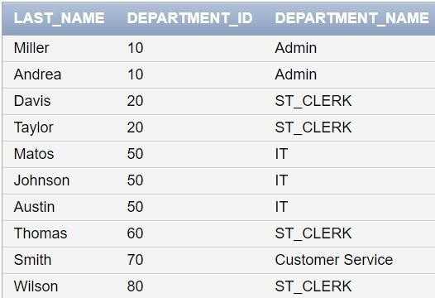

1. Create a unique listing of all jobs that are in department 80. Include the location of the department in the output.

SELECT DISTINCT e.job_id, d.location_id FROM employees e JOIN departments d ON e.department_id = d.department_id WHERE e.department_id = 80;

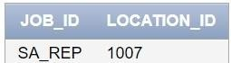

1. Write a query to display the employee last name, department name, location ID, and city of all employees who earn a commission

SELECT e.last_name, d.department_name, d.location_id, l.city FROM employees e JOIN departments d ON e.department_id = d.department_id JOIN locations l ON d.location_id = l.location_id WHERE e.commission_pct IS NOT NULL;

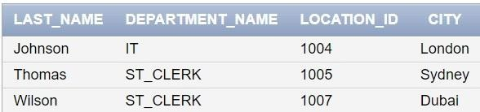

1. Display the employee last name and department name for all employees who have an a(lowercase) in their last names. P

SELECT e.last_name, d.department_name FROM employees e JOIN departments d ON e.department_id = d.department_id WHERE e.last_name LIKE '%a%';

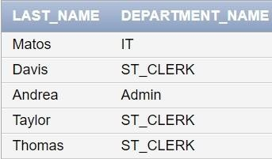

1. Write a query to display the last name, job, department number, and department name for all employees who work in Toronto.

SELECT e.last_name, e.job_id, e.department_id, d.department_name FROM employees e JOIN departments d ON e.department_id = d.department_id JOIN locations l ON d.location_id = l.location_id WHERE l.city = 'Toronto';

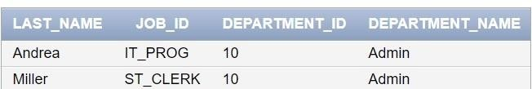

1. Display the employee last name and employee number along with their manager‘s last name and manager number. Label the columns Employee, Emp#, Manager, and Mgr#, Respectively

SELECT e.last_name AS Employee, e.employee_id AS Emp#, m.last_name AS Manager, m.employee_id AS Mgr# FROM employees e LEFT JOIN employees m ON e.manager_id = m.employee_id;

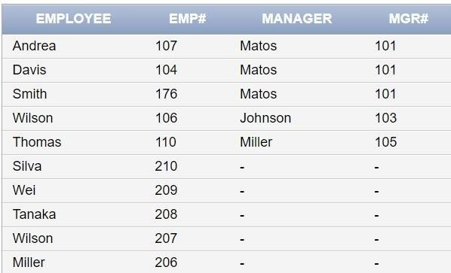

1. Modify lab4_6.sql to display all employees including King, who has no manager. Order the results by the employee number.

SELECT e.last_name, e.employee_id, m.last_name AS Manager FROM employees e LEFT JOIN employees m ON e.manager_id = m.employee_id ORDER BY e.employee_id;

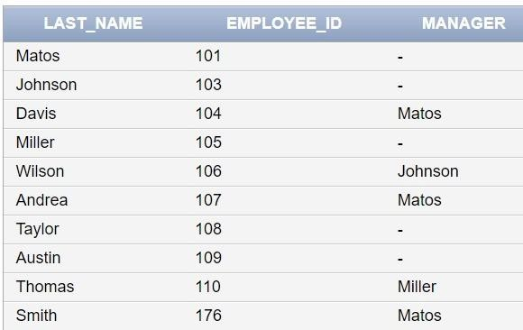

1. Create a query that displays employee last names, department numbers, and all the employees who work in the same department as a given employee. Give each column an appropriate label

SELECT e1.last_name AS Employee, e2.last_name AS Colleague FROM employees e1 JOIN employees e2 ON e1.department_id = e2.department_id WHERE e1.employee_id =

:employee_id;

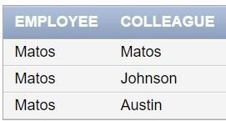

1. Show the structure of the JOB_GRADES table. Create a query that displays the name, job, department name, salary, and grade for all employees

DESC job_grades;

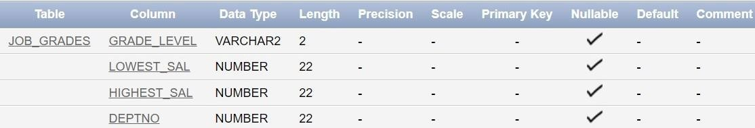

SELECT e.last_name, e.job_id, d.department_name, e.salary, j.grade_level FROM employees e JOIN departments d ON e.department_id = d.department_id JOIN job_grades j ON e.salary BETWEEN j.lowest_sal AND j.highest_sal;

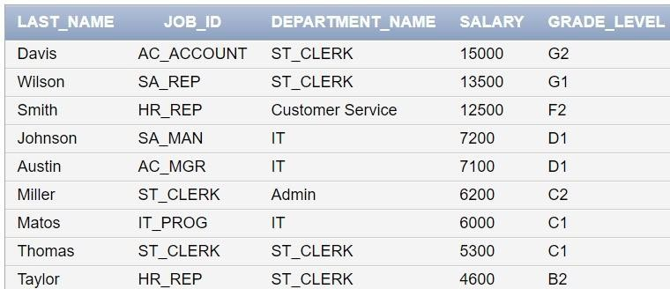

1. Create a query to display the name and hire date of any employee hired after employee Davies.

SELECT last_name, hire_date FROM employees WHERE hire_date > (SELECT hire_date FROM employees WHERE last_name = 'Davies');

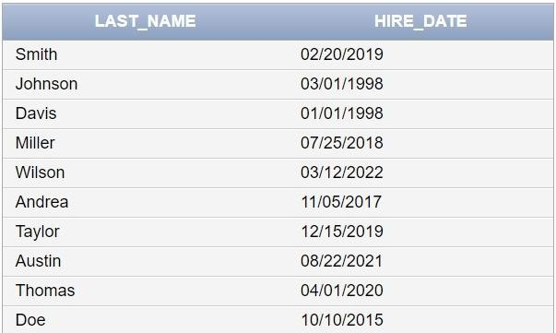

1. Display the names and hire dates for all employees who were hired before their managers, along with their manager‘s names and hire dates. Label the columns Employee, Emp Hired, Manager, and Mgr Hired, respectively.

SELECT e.last_name AS Employee, e.hire_date AS Emp_Hired, m.last_name AS Manager, m.hire_date AS Mgr_Hired FROM employees e JOIN employees m ON e.manager_id = m.employee_id WHERE e.hire_date < m.hire_date;

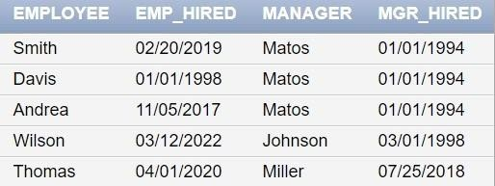

|  |  |  |  |  |  |
| --- | --- | --- | --- | --- | --- |
| **Ex.No.: 9** | | | **SUB QUERIES** | |  |
|  | **Date:** | 10/9/24 | |  | |

1. The HR department needs a query that prompts the user for an employee last name. The query then displays the last name and hire date of any employee in the same department as the employee whose name they supply (excluding that employee). For example, if the user enters Zlotkey, find all employees who work with Zlotkey (excluding Zlotkey).

SELECT e.last_name, e.hire_date FROM employees e JOIN employees e2 ON e.department_id = e2.department_id WHERE e2.last_name = :emp_name AND e.employee_id != e2.employee_id;

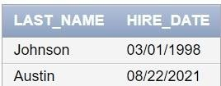

1. Create a report that displays the employee number, last name, and salary of all employees who earn more than the average salary. Sort the results in order of ascending salary.

SELECT employee_id, last_name, salary FROM employees WHERE salary > (SELECT AVG(salary) FROM employees) ORDER BY salary ASC;

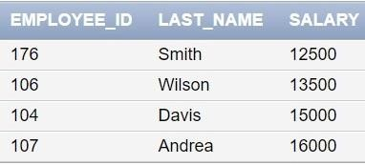

1. Write a query that displays the employee number and last name of all employees who work in a department with any employee whose last name contains a *u*.

SELECT DISTINCT e1.employee_id, e1.last_name FROM employees e1 JOIN employees e2 ON e1.department_id = e2.department_id WHERE e2.last_name LIKE '%u%';

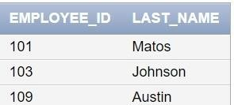

1. The HR department needs a report that displays the last name, department number, and job ID of all employees whose department location ID is 1700.

SELECT e.last_name, e.department_id, e.job_id FROM employees e

JOIN departments d ON e.department_id = d.department_id WHERE d.location_id = 1700;

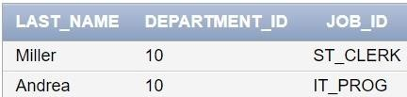

1. Create a report for HR that displays the last name and salary of every employee who reports to King.

SELECT e.last_name, e.salary FROM employees e JOIN employees m ON e.manager_id = m.employee_id WHERE m.last_name = 'King';

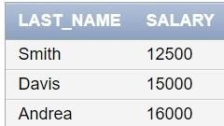

1. Create a report for HR that displays the department number, last name, and job ID for every employee in the Executive department.

SELECT e.department_id, e.last_name, e.job_id FROM employees e JOIN departments d ON e.department_id = d.department_id WHERE d.department_name = 'Executive';

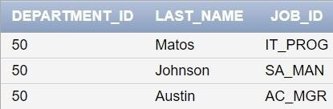

1. Modify the query 3 to display the employee number, last name, and salary of all employees who earn more than the average salary and who work in a department with any employee whose last name contains a *u*.

SELECT e1.employee_id, e1.last_name, e1.salary FROM employees e1

JOIN employees e2 ON e1.department_id = e2.department_id WHERE e2.last_name LIKE '%u%' AND e1.salary > (SELECT AVG(salary) FROM employees);

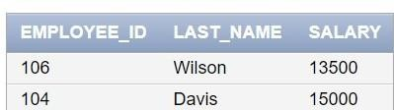

|  |  |  |
| --- | --- | --- |
| **Ex.No.: 10** | | **AGGREGATING DATA USING GROUP FUNCTIONS** |
| **Date:** | 11/9/24 |

Determine the validity of the following three statements. Circle either True or False.

1. Group functions work across many rows to produce one result per group. True/False

TRUE

1. Group functions include nulls in calculations. True/False

FALSE

1. The WHERE clause restricts rows prior to inclusion in a group calculation. True/False

TRUE

### The HR department needs the following reports:

1. Find the highest, lowest, sum, and average salary of all employees. Label the columns Maximum, Minimum, Sum, and Average, respectively. Round your results to the nearest whole number

SELECT ROUND(MAX(salary)) AS "Maximum",ROUND(MIN(salary)) AS "Minimum", ROUND(SUM(salary)) AS "Sum", ROUND(AVG(salary)) AS "Average"FROM employees;

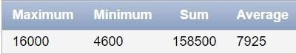

1. Modify the above query to display the minimum, maximum, sum, and average salary for each job type.

SELECT job_id, ROUND(MAX(salary)) AS "Maximum", ROUND(MIN(salary)) AS "Minimum", ROUND(SUM(salary)) AS "Sum", ROUND(AVG(salary)) AS "Average" FROM employees GROUP BY job_id;

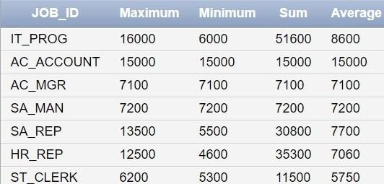

1. Write a query to display the number of people with the same job. Generalize the query so that the user in the HR department is prompted for a job title.

SELECT COUNT(*) AS "Number of People" FROM employees WHERE job_id = '&job_title';

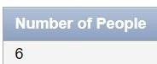

1. Determine the number of managers without listing them. Label the column Number of Managers. *Hint: Use the MANAGER_ID column to determine the number of managers.*

SELECT COUNT(DISTINCT manager_id) AS "Number of Managers"FROM employees WHERE manager_id IS NOT NULL;

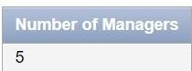

1. Find the difference between the highest and lowest salaries. Label the column DIFFERENCE.

SELECT (MAX(salary) - MIN(salary)) AS "DIFFERENCE" FROM employees;

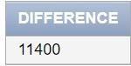

1. Create a report to display the manager number and the salary of the lowest-paid employee for that manager. Exclude anyone whose manager is not known. Exclude any groups where the minimum salary is $6,000 or less. Sort the output in descending order of salary.

SELECT manager_id, MIN(salary) AS "Lowest Salary" FROM employees

WHERE manager_id IS NOT NULL GROUP BY manager_id HAVING MIN(salary) > 6000 ORDER BY MIN(salary) DESC;

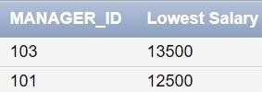

1. Create a query to display the total number of employees and, of that total, the number of employees hired in 1995, 1996, 1997, and 1998. Create appropriate column headings.

SELECT

COUNT(*) AS "Total Employees",

SUM(CASE WHEN TO_CHAR(hire_date, 'YYYY') = '1995' THEN 1 ELSE 0 END) AS

"Hired in 1995",

SUM(CASE WHEN TO_CHAR(hire_date, 'YYYY') = '1996' THEN 1 ELSE 0 END) AS

"Hired in 1996",

SUM(CASE WHEN TO_CHAR(hire_date, 'YYYY') = '1997' THEN 1 ELSE 0 END) AS

"Hired in 1997",

SUM(CASE WHEN TO_CHAR(hire_date, 'YYYY') = '1998' THEN 1 ELSE 0 END) AS

"Hired in 1998" FROM employees;

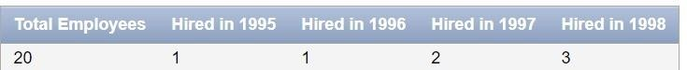

1. Create a matrix query to display the job, the salary for that job based on department number, and the total salary for that job, for departments 20, 50, 80, and 90, giving each column an appropriate heading.

SELECT job_id,

SUM(CASE WHEN department_id = 20 THEN salary ELSE 0 END) AS "Dept 20", SUM(CASE WHEN department_id = 50 THEN salary ELSE 0 END) AS "Dept 50", SUM(CASE WHEN department_id = 80 THEN salary ELSE 0 END) AS "Dept 80", SUM(CASE WHEN department_id = 90 THEN salary ELSE 0 END) AS "Dept 90", SUM(salary) AS "Total Salary"

FROM employees WHERE department_id IN (20, 50, 80, 90) GROUP BY job_id;

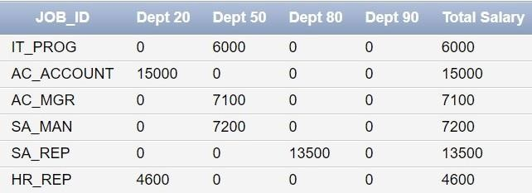

1. Write a query to display each department‘s name, location, number of employees, and the average salary for all the employees in that department. Label the column

name-Location, Number of people, and salary respectively. Round the average salary to two decimal places.

SELECT d.department_name AS "Department Name", l.city AS "Location", COUNT(e.employee_id) AS "Number of People", ROUND(AVG(e.salary), 2) AS "Average Salary" FROM employees e JOIN departments d ON e.department_id = d.department_id JOIN locations l ON d.location_id = l.location_id GROUP BY d.department_name, l.city;

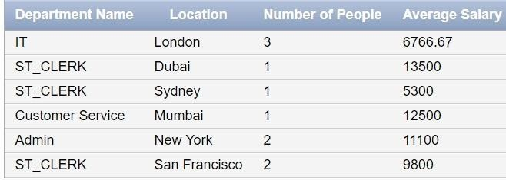

|  |  |  |
| --- | --- | --- |
| **Ex.No.: 12** | | **WORKING WITH CURSOR, PROCEDURES AND**  **FUNCTIONS** |
| **Date:** | **23.10.2024** |

Program 1

FACTORIAL OF A NUMBER USING FUNCTION

create or replace function fact (a number) return number is fact number:=1;

b number; begin b:=a; while b>0 loop

fact:=fact*b; b:=b-1;

end loop; return(fact); end;

/

declare

a number(2); f number(10); begin

a := :n ;

f:=fact(a);

dbms_output.put_line('The factorial is '||f); end;

/

Input : 5

Program 2

Write a PL/SQL program using Procedures IN,INOUT,OUT parameters to retrieve the corresponding book information in library

--PROCEDURE FOR IN PARAMETER

create procedure proc(a in number) is bprice number; begin

select price into bprice from library where book_id=a; dbms_output.put_line('The price of the book is '||bprice); end;

declare

a number(2); begin

a := :n;

proc(a); end;

Input: 5

--PROCEDURE FOR OUT PARAMETER

create or replace procedure proc(a in number,n out number) is begin

select publication_year into n from library where book_id=a; end;

declare

a number(2); n number(4); begin

a := :b;

proc(a,n);

dbms_output.put_line('The year of publication of the book is '||n); end;

Input 7



--PROCEDURE FOR INOUT PARAMETER

create or replace procedure proc(a in out number) is begin

a:=a+10;

end;

declare

a number(2); id number(2); begin

id := :b;

select price into a from library where book_id=id; proc(a);

dbms_output.put_line('The updated price of the book is '||a); end;

Input 3



|  |  |  |
| --- | --- | --- |
| **Ex.No.: 11** | | **PL SQL PROGRAMS** |
| **Date:** | 11/9/24 |

PROGRAM 1

Write a PL/SQL block to calculate the incentive of an employee whose ID is 110.

declare

a employees.employee_id%type; b employees.salary%type;

begin

Select salary into a from employees where employee_id = 110; b:=0.05*a;

dbms_output.put_line('Salary after incentive : '||(a+b)); end;

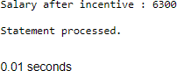

PROGRAM 2

Write a PL/SQL block to show an invalid case-insensitive reference to a quoted and without quoted user-defined identifier.

declare

non_quoted_variable varchar2(10) := 'Hi'; "quoted_variable" varchar2(10) := 'Hello'; begin

dbms_output.put_line(NON_QUOTED_VARIABLE); dbms_output.put_line("quoted_variable"); dbms_output.put_line("QUOTED_VARIABLE"); end;

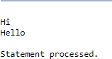

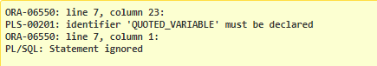

PROGRAM 3

Write a PL/SQL block to adjust the salary of the employee whose ID

122. Sample table: employees

declare

old_salary employees.salary%type; new_salary employees.salary%type; begin

new_salary:= :sal;

Select salary into old_salary from employees where employee_id = 122; dbms_output.put_line('Before updation: '||old_salary);

Update employees set salary = salary + new_salary where employee_id = 122; Select salary into new_salary from employees where employee_id = 122; dbms_output.put_line('After updation: '||new_salary);

end;

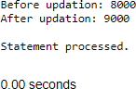

PROGRAM 4

Write a PL/SQL block to create a procedure using the "IS [NOT] NULL Operator" and show AND operator returns TRUE if and only if both operands are TRUE.

Create or replace procedure proc1( a boolean, b boolean) IS BEGIN

if(a is not null) and (b is not null) then if(a = TRUE and b = TRUE) then dbms_output.put_line('TRUE');

else dbms_output.put_line('FALSE'); end if;

else

dbms_output.put_line('NULL VALUES in arguments'); end if;

end proc1;

BEGIN proc1(TRUE,TRUE); proc1(TRUE,FALSE); proc1(NULL,NULL);

end;

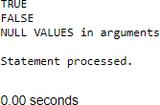

PROGRAM 5

Write a PL/SQL block to describe the usage of LIKE operator including wildcard characters and escape character.

Declare

name varchar2(20); num number(3);

Begin num := :n;

Select first_name into name from employees where employee_id=num; if name like 'D%' then

dbms_output.put_line('Name starts with "D"'); end if;

if name like 'Dan_el%' then

dbms_output.put_line('Name contains "Dan" followed by one character'); end if;

name := 'Daniel_Andrea';

if name like 'Daniel\_Andrea' escape '\' then dbms_output.put_line('Name contains "Daniel_Andrea"'); end if;

end;

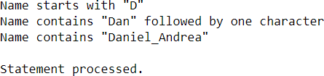

PROGRAM 6

Write a PL/SQL program to arrange the number of two variable in such a way that the small number will store in num_small variable and large number will store in num_large variable.

declare

a number(2); b number(2);

num_small number(2); num_large number(2); begin

a := :s;

b := :l;

dbms_output.put_line('Value in a : '||a); dbms_output.put_line('Value in b : '||b); if a>b then

num_small := b; num_large := a; else

num_small :=a; num_large :=b; end if;

dbms_output.put_line('Smaller number is '||num_small); dbms_output.put_line('Larger number is '||num_large); end;

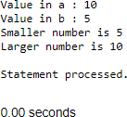

PROGRAM 7

Write a PL/SQL procedure to calculate the incentive on a target achieved and display the message either the record updated or not.

Create or replace procedure calc_incen(emp_id number,achievement number,target number) AS

incentive number; rowcount number;

Begin

if achievement > target then incentive:= achievement*0.2; else

incentive:=0; end if;

Update employees set salary = salary + incentive where employee_id = emp_id; rowcount:= SQL%ROWCOUNT;

if rowcount>0 then dbms_output.put_line('Record(s) updated'); else

dbms_output.put_line('No Record(s) updated'); end if;

end;

Declare

id number; achievement number; target number;

Begin

id := :emp_id; achievement := :achieve; target := :target_;

calc_incen(id,achievement,target); end;



PROGRAM 8

Write a PL/SQL procedure to calculate incentive achieved according to the specific sale limit.

Create or replace procedure calc_incen(emp_id number,sales number) AS incentive number;

rowcount number;

Begin

if sales < 1000 then incentive:= 0;

elsif sales > 1000 and sales < 2000 then incentive := sales * 0.2;

else

incentive := sales * 0.5; end if;

Update employees set salary = salary + incentive where employee_id = emp_id; rowcount:= SQL%ROWCOUNT;

if rowcount>0 then dbms_output.put_line('Record(s) updated'); else

dbms_output.put_line('No Record(s) updated'); end if;

end;

Declare

id number; sales number; sal number;

Begin

id := :emp_id; sales := :sale;

select salary into sal from employees where employee_id = id; dbms_output.put_line('Before incentive calculation: '||sal); calc_incen(id,sales);

select salary into sal from employees where employee_id = id; dbms_output.put_line('After incentive calculation: '||sal);

end;

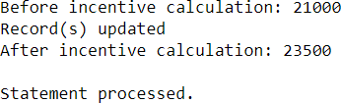

PROGRAM 9

Write a PL/SQL program to count number of employees in department 50 and check whether this department have any vacancies or not. There are 45 vacancies in this department.

declare

emp_count number; vacancy number := 20; begin

Select count(*) into emp_count from employees where department_id = 10; dbms_output.put_line('Total seats : '||vacancy);

dbms_output.put_line('Number of employees in Department 50 : '||emp_count); if emp_count>vacancy then

dbms_output.put_line('No vacancies available'); else

dbms_output.put_line('Available vacancies : '||(vacancy-emp_count)); end if;

end;

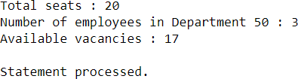

PROGRAM 10

Write a PL/SQL program to count number of employees in a specific department and check whether this department have any vacancies or not. If any vacancies, how many vacancies are in that department.

declare

dept_id number; emp_count number; vacancy number := 10; begin

dept_id := :id;

Select count(*) into emp_count from employees where department_id = dept_id; dbms_output.put_line('Total seats : '||vacancy);

dbms_output.put_line('Number of employees in Department : '||emp_count); if emp_count>vacancy then

dbms_output.put_line('No vacancies available'); else

dbms_output.put_line('Available vacancies : '||(vacancy-emp_count)); end if;

end;

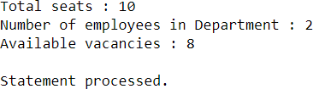

PROGRAM 11

Write a PL/SQL program to display the employee IDs, names, job titles, hire dates, and salaries of all employees.

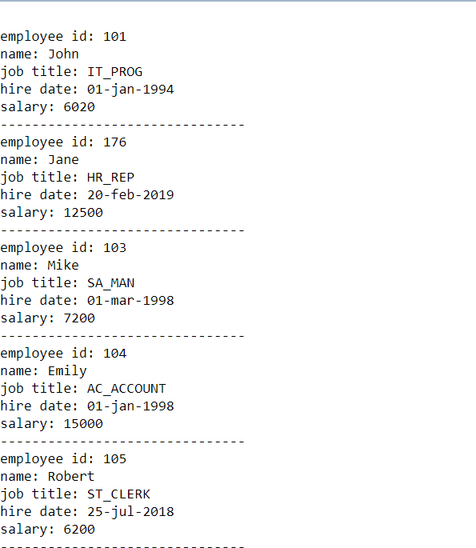

begin

for i in (select employee_id, first_name, job_id, hire_date, salary from employees) loop

dbms_output.put_line('employee id: ' || i.employee_id); dbms_output.put_line('name: ' || i.first_name); dbms_output.put_line('job title: ' || i.job_id);

dbms_output.put_line('hire date: ' || to_char(i.hire_date, 'dd-mon-yyyy')); dbms_output.put_line('salary: ' || i.salary);

dbms_output.put_line(' ');

end loop; end;

PROGRAM 12

Write a PL/SQL program to display the employee IDs, names, and department names of all employees.

begin

for i in (select e.employee_id, e.first_name, e.job_id from employees e) loop

dbms_output.put_line('employee id: ' || i.employee_id); dbms_output.put_line('name: ' || i.first_name); dbms_output.put_line('department name: ' || i.job_id); dbms_output.put_line(' ');

end loop; end;

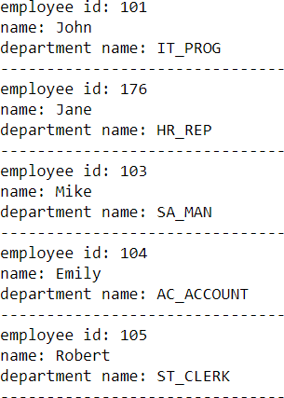

PROGRAM 13

Write a PL/SQL program to display the job IDs, titles, and minimum salaries of all jobs.

Begin

for i in (select job_id,job_title,min_salary from jobs) loop

dbms_output.put_line('job id: ' || i.job_id); dbms_output.put_line('job title: ' || i.job_title); dbms_output.put_line('minimum salary: ' || i.min_salary); dbms_output.put_line(' ');

end loop; end;

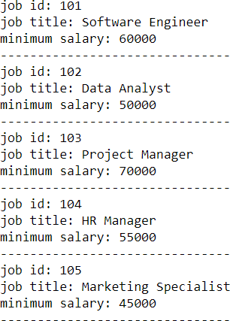

PROGRAM 14

Write a PL/SQL program to display the employee IDs, names, and job history start dates of all employees.

Begin

for i in (select employee_id,employee_name,start_date from job_history) loop

dbms_output.put_line('employee id: ' || i.employee_id); dbms_output.put_line('name: ' || i.employee_name); dbms_output.put_line('start date: ' ||to_char(i.start_date, 'dd-mon-yyyy')); dbms_output.put_line(' ');

end loop; end;

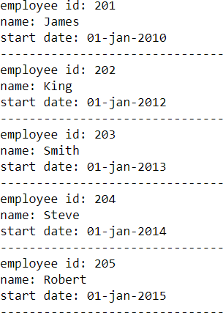

PROGRAM 15

Write a PL/SQL program to display the employee IDs, names, and job history end dates of all employees.

Begin

for i in (select employee_id,employee_name,end_date from job_history) loop

dbms_output.put_line('employee id: ' || i.employee_id); dbms_output.put_line('name: ' || i.employee_name); dbms_output.put_line('end date: ' ||to_char(i.end_date, 'dd-mon-yyyy')); dbms_output.put_line(' ');

end loop; end;

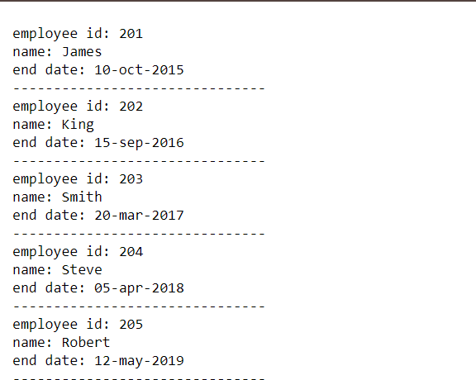

|  |  |  |
| --- | --- | --- |
| **Ex.No.: 13** | | **WORKING WITH TRIGGER TRIGGER** |
| **Date:** | **29.10.2024** |

Program 1

Write a code in PL/SQL to develop a trigger that enforces referential integrity by preventing the deletion of a parent record if child records exist.



CREATE OR REPLACE TRIGGER prevent_parent_deletion BEFORE DELETE ON parent_table

FOR EACH ROW DECLARE

child_count NUMBER; BEGIN

SELECT COUNT(*) INTO child_count FROM child_table

WHERE parent_id = :OLD.parent_id;

IF child_count > 0 THEN

RAISE_APPLICATION_ERROR(-20001, 'Cannot delete parent record as child records exist.');

END IF;

END;

Testing of Trigger

DELETE FROM parent_table WHERE parent_id = 1;

Program 2

Write a code in PL/SQL to create a trigger that checks for duplicate values in a specific column and raises an exception if found.

CREATE OR REPLACE TRIGGER check_duplicate_value BEFORE INSERT OR UPDATE ON table_name

FOR EACH ROW DECLARE

v_count NUMBER; BEGIN

-- Check if the new value already exists in the table SELECT COUNT(*) INTO v_count

FROM table_name

WHERE specific_column = :NEW.specific_column;

-- If a duplicate is found, raise an error IF v_count > 0 THEN

RAISE_APPLICATION_ERROR(-20002, 'Duplicate value detected in specific column.'); END IF;

END;

/

**Output:**

ORA-20002: Duplicate value detected in specific column.

Program 3

Write a code in PL/SQL to create a trigger that restricts the insertion of new rows if the total of a column's values exceeds a certain threshold.

CREATE OR REPLACE TRIGGER restrict_insertion BEFORE INSERT ON table_name

FOR EACH ROW DECLARE

v_total NUMBER;

v_threshold CONSTANT NUMBER := 10000; -- Set your threshold here BEGIN

-- Calculate the total sum of the column values

SELECT SUM(column_name) INTO v_total FROM table_name;

-- Prevent insertion if the threshold is exceeded

IF v_total + :NEW.column_name > v_threshold THEN RAISE_APPLICATION_ERROR(-20003, 'Cannot insert, total column value

exceeds threshold.');

END IF;

END;

/

## Output:

ORA-20003: Cannot insert, total column value exceeds threshold.

Program 4

Write a code in PL/SQL to design a trigger that captures changes made to specific columns and logs them in an audit table.

CREATE OR REPLACE TRIGGER log_column_changes AFTER UPDATE ON table_name

FOR EACH ROW BEGIN

-- Check if specific columns have been modified

IF :OLD.column_name1 != :NEW.column_name1 OR :OLD.column_name2 !=

:NEW.column_name2 THEN

-- Insert the old and new values into the audit table

INSERT INTO audit_table (user_id, change_time, old_value, new_value) VALUES (USER, SYSDATE, :OLD.column_name1 || ', ' || :OLD.column_name2,

:NEW.column_name1 || ', ' || :NEW.column_name2); END IF;

END;

/

Output:

### User_ID Change_Time Old_Value New_Value

SYSTEM 2024-09-19

10:05:00

OldValue1, OldValue2

NewValue, AnotherNewValue

Program 5

Write a code in PL/SQL to implement a trigger that records user activity (inserts, updates, deletes) in an audit log for a given set of tables.

CREATE OR REPLACE TRIGGER audit_user_activity AFTER INSERT OR UPDATE OR DELETE ON table_name FOR EACH ROW

BEGIN

IF INSERTING THEN

INSERT INTO audit_log (user_id, operation, record_id, change_time) VALUES (USER, 'INSERT', :NEW.id_column, SYSDATE);

ELSIF UPDATING THEN

INSERT INTO audit_log (user_id, operation, record_id, change_time) VALUES (USER, 'UPDATE', :NEW.id_column, SYSDATE);

ELSIF DELETING THEN

INSERT INTO audit_log (user_id, operation, record_id, change_time) VALUES (USER, 'DELETE', :OLD.id_column, SYSDATE);

END IF;

END;

/

|  |  |  |  |
| --- | --- | --- | --- |
| Output:  **User_ID** | **Operation** | **Record_ID** | **Change_Time** |
| SYSTEM | INSERT | 1 | 2024-09-19  10:10:00 |
| SYSTEM | UPDATE | 1 | 2024-09-19  10:15:00 |
| SYSTEM | DELETE | 1 | 2024-09-19  10:20:00 |

Program 6

Write a code in PL/SQL to implement a trigger that automatically calculates and updates a running total column for a table whenever new rows are inserted.

CREATE OR REPLACE TRIGGER update_running_total AFTER INSERT ON table_name

FOR EACH ROW BEGIN

-- Update the running total column in the total_table UPDATE total_table

SET running_total = running_total + :NEW.value_column WHERE total_id = :NEW.total_id;

END;

/

Output:

### Total_ID Running_Total

1 1500

Program 7

Write a code in PL/SQL to create a trigger that validates the availability of items before allowing an order to be placed, considering stock levels and pending orders.

CREATE OR REPLACE TRIGGER validate_item_availability BEFORE INSERT ON orders

FOR EACH ROW DECLARE

v_stock_level NUMBER; v_pending_orders NUMBER; BEGIN

SELECT stock INTO v_stock_level FROM inventory WHERE item_id = :NEW.item_id;

-- Check pending orders

SELECT SUM(quantity) INTO v_pending_orders FROM orders

WHERE item_id = :NEW.item_id AND status = 'Pending';

-- Ensure stock is available for the order

IF v_stock_level - v_pending_orders < :NEW.order_quantity THEN RAISE_APPLICATION_ERROR(-20004, 'Insufficient stock available for this

order.'); END IF; END;

/

### Output:

ORA-20004: Insufficient stock available for this order.

|  |  |  |
| --- | --- | --- |
| **Ex.No.: 14** | | **MongoDB** |
| **Date:** | 30/10/24 |

**Restaurant Collection**

1. **Write a MongoDB query to find the restaurant Id, name, borough and cuisine for those restaurants which prepared dishes except 'American' and 'Chinese' or restaurant's name begins with letter 'Wil'.**

db.restaurants.find(

{

$or: [

{

'Chinese'

},

{

cuisine: { $nin: ['American', 'Chinese'] } // Cuisines other than 'American' and

name: { $regex: '^Wil', $options: 'i' } // Restaurant names that begin with 'Wil'

(case-insensitive)

}

]

},

{

_id: 1, // Retrieve the restaurant ID name: 1, // Retrieve the restaurant name borough: 1, // Retrieve the borough cuisine: 1 // Retrieve the cuisine

}

)

1. **Write a mongoDB query to find the restaurant Id, name, and grades for those restaurants which achieved a grade of "A" and scored 11 on an ISODate "2014-08-11 T00:00:00Z" among many of survey dates.**

db.restaurants.find(

{

"grades": {

$elemMatch: {

"grade": "A", // Grade must be "A"

"score": 11, // Score must be 11

"date": ISODate("2014-08-11T00:00:00Z") // Date must match the specified

ISODate

}

}

},

{

_id: 1, // Retrieve the restaurant ID name: 1, // Retrieve the restaurant name grades: 1 // Retrieve the grades

}

)

1. **Write a MongoDB query to find the restaurant Id, name and grades for those restaurants where the 2nd element of grades array contains a grade of "A" and score 9 on an ISODate "2014-08-11T00:00:00Z".**

db.restaurants.find(

{

"grades.1": { // Accessing the 2nd element (index 1) of the grades array "grade": "A", // Grade must be "A"

"score": 9, // Score must be 9

"date": ISODate("2014-08-11T00:00:00Z") // Date must match the specified ISODate

}

},

{

_id: 1, // Retrieve the restaurant ID name: 1, // Retrieve the restaurant name grades: 1 // Retrieve the grades

}

)

1. **Write a MongoDB query to find the restaurant Id, name, address and geographical location for those restaurants where 2nd element of the coord array contains a value which is more than 42 and up to 52.**

db.restaurants.find(

{

"coord.1": { $gt: 42, $lte: 52 } // Accessing the 2nd element (index 1) of the coord array

},

{

_id: 1, // Retrieve the restaurant ID name: 1, // Retrieve the restaurant name address: 1, // Retrieve the address

coord: 1 // Retrieve the geographical location (coord)

}

)

1. **Write a MongoDB query to arrange the name of the restaurants in ascending order along with all the columns.**

db.restaurants.find().sort({ name: 1 })

1. **Write a mongoDB query to arrange the name of the restaurants in descending order along with all the columns.**

db.restaurants.find().sort({ name: -1 })

1. **Write a MongoDB query to arrange the name of the cuisine in ascending order and for that same cuisine borough should be in descending order.**

db.restaurants.find().sort({ cuisine: 1, borough: -1 })

1. **Write a MongoDB query to know whether all the addresses contains the street or not.**

db.restaurants.find({ "address.street": { $exists: false } })

1. **Write a MongoDB query which will select all documents in the restaurants collection where the coord field value is Double.**

db.restaurants.find({

"coord": { $type: "double" } // or you can use $type: 1

})

1. **Write a mongoDB query which will select the restaurant Id, name and grades for those restaurants which return 0 as a remainder after dividing the score by 7.**

db.restaurants.find(

{

"grades": {

$elemMatch: {

$expr: {

$eq: [{ $mod: ["$score", 7] }, 0] // Check if score % 7 == 0

}

}

}

},

{

_id: 1, // Retrieve the restaurant ID name: 1, // Retrieve the restaurant name grades: 1 // Retrieve the grades

}

)

1. **Write a mongodb query to find the restaurant name, borough, longitude and attitude and cuisine for those restaurants which contains 'mon' as three letters somewhere in its name.**

db.restaurants.find(

{

name: { $regex: /mon/i } // Regex to find 'mon' anywhere in the name (case-insensitive)

},

{

name: 1, // Retrieve the restaurant name borough: 1, // Retrieve the borough

"coord.0": 1, // Retrieve longitude (assuming longitude is the first element in the coord array)

"coord.1": 1, // Retrieve latitude (assuming latitude is the second element in the coord array)

cuisine: 1, // Retrieve the cuisine

_id: 0 // Exclude the restaurant ID from the results

}

)

1. **Write a mongodb query to find the restaurant name, borough, longitude and attitude and cuisine for those restaurants which contains 'Mad' as first three letters in its name.**

db.restaurants.find(

{

name: { $regex: /^Mad/i } // Regex to find names starting with 'Mad' (case-insensitive)

},

{

name: 1, // Retrieve the restaurant name borough: 1, // Retrieve the borough

"coord.0": 1, // Retrieve longitude (assuming longitude is the first element in the coord array)

"coord.1": 1, // Retrieve latitude (assuming latitude is the second element in the coord array)

cuisine: 1, // Retrieve the cuisine

_id: 0 // Exclude the restaurant ID from the results

}

)

1. **Write a mongoDB query to find the restaurants that have at least one grade with a score of less than 5.**

db.restaurants.find(

{

"grades": {

$elemMatch: {

score: { $lt: 5 } // Score must be less than 5

}

}

}

)

1. **Write a mongoDB query to find the restaurants that have at least one grade with a score of less than 5 and that are located in the borough of Manhattan.**

db.restaurants.find(

{

borough: "Manhattan", // Condition to filter by borough "grades": {

$elemMatch: {

score: { $lt: 5 } // Condition to filter grades with score less than 5

}

}

}

)

1. **Write a mongoDB query to find the restaurants that have at least one grade with a score of less than 5 and that are located in the borough of Manhattan or Brooklyn.**

db.restaurants.find(

{

$or: [

{ borough: "Manhattan" }, // Condition to filter by borough Manhattan

{ borough: "Brooklyn" } // Condition to filter by borough Brooklyn

],

"grades": {

$elemMatch: {

score: { $lt: 5 } // Condition to filter grades with score less than 5

}

}

}

)

}

)

# Movies Collection

1. **Find all movies with full information from the 'movies' collection that released in the year 1893.**

db.movies.find(

{

releaseYear: 1893 // Assuming the field for the release year is named 'releaseYear'

}

)

1. **Find all movies with full information from the 'movies' collection that have a runtime greater than 120 minutes.**

db.movies.find(

{

runtime: { $gt: 120 } // Assuming the field for runtime is named 'runtime'

}

)

1. **Find all movies with full information from the 'movies' collection that have "Short" genre.**

db.movies.find(

{

genres: "Short" // Assuming the field for genres is an array named 'genres'

}

)

1. **Retrieve all movies from the 'movies' collection that were directed by "William K.**

**L. Dickson" and include complete information for each movie.**

db.movies.find(

{

director: "William K. L. Dickson" // Assuming the field for the director is named 'director'

}

)

1. **Retrieve all movies from the 'movies' collection that were released in the USA and include complete information for each movie.**

db.movies.find(

{

country: "USA" // Assuming the field for the release country is named 'country'

}

)

1. **Retrieve all movies from the 'movies' collection that have complete information and are rated as "UNRATED".**

db.movies.find(

{

rating: "UNRATED" // Assuming the field for the rating is named 'rating'

}

)

1. **Retrieve all movies from the 'movies' collection that have complete information and have received more than 1000 votes on IMDb.**

db.movies.find(

{

votes: { $gt: 1000 } // Assuming the field for votes is named 'votes'

}

)

1. **Retrieve all movies from the 'movies' collection that have complete information and have an IMDb rating higher than 7.**

db.movies.find(

{

imdbRating: { $gt: 7 } // Assuming the field for IMDb rating is named 'imdbRating'

}

)

1. **Retrieve all movies from the 'movies' collection that have complete information and have a viewer rating higher than 4 on tomatoes.**

db.movies.find(

{

tomatoes: { viewer: { $gt: 4 } } // Assuming the viewer rating is nested within a 'tomatoes' object

}

)

|  |  |  |
| --- | --- | --- |
| **Ex.No.: 15** | | **OTHER DATABASE OBJECTS** |
| **Date:** | **04.11.2024** |

1. Create a sequence to be used with the primary key column of the DEPT table. The sequence should start at 200 and have a maximum value of 1000. Have your sequence increment by ten numbers. Name the sequence DEPT_ID_SEQ.

Create Sequence dept_id_sequence start with 200 increment by 10 maxvalue 1000;

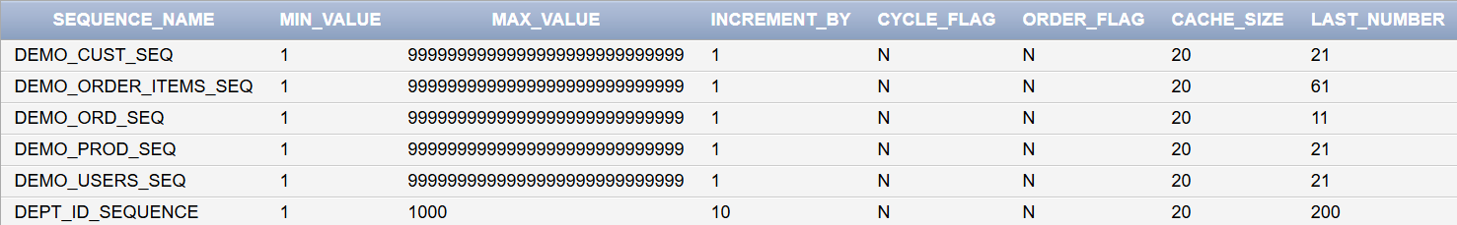

1. Write a query in a script to display the following information about your sequences: sequence name, maximum value, increment size, and last number

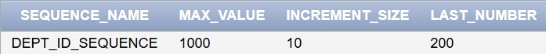SELECT sequence_name, max_value,increment_by AS increment_size,last_number FROM user_sequences WHERE sequence_name = 'DEPT_ID_SEQUENCE';

1. Write a script to insert two rows into the DEPT table. Name your script lab12_3.sql. Be sure to use the sequence that you created for the ID column. Add two departments named Education and Administration. Confirm your additions. Run the commands in your script.

Insert into departments values(dept_id_sequence.nextval,'HR',111,1010,'US','United States'); Insert into departments values(dept_id_seq.nextval,'Admin',112,1011,'IN','India');



1. Create a nonunique index on the foreign key column (DEPT_ID) in the EMP table.

Create index emp_dept_index on Employees(department_id);



1. Display the indexes and uniqueness that exist in the data dictionary for the EMP table.

SELECT index_name, uniqueness FROM user_indexes WHERE table_name = 'Employees'; Output :

Index_name : EMPLOYEE_INDEX Uniqueness : NONUNIQUE

|  |  |  |
| --- | --- | --- |
| **Ex.No.: 16** | | **CONTROLLING USER ACCESS** |
| **Date:** | **06.11.2024** |

1. What privilege should a user be given to log on to the Oracle Server? Is this a system or an object privilege?

**~** The privilege is CREATE SESSION. This privilege allows a user to log on to the Oracle Server. It is a system privilege, not an object privilege.

1. What privilege should a user be given to create tables?

**~** The privilege is CREATE TABLE . This is a system privilege that allows a user to create tables in their own schema.

1. If you create a table, who can pass along privileges to other users on your table?

**~** The owner of the table (the user who created it) can pass along privileges to other users. This is done using the GRANT command.

For example:

GRANT SELECT ON my_table TO other_user;

1. You are the DBA. You are creating many users who require the same system privileges. What should you use to make your job easier?

**~** Use a role to bundle common system privileges.

Assign this role to users instead of granting privileges individually.

1. What command do you use to change your password?

**~** ALTER USER username IDENTIFIED BY new_password;

1. Grant another user access to your DEPARTMENTS table. Have the user grant you query Access to his or her DEPARTMENTS table.

**~** GRANT SELECT ON DEPARTMENTS TO other_user;

**~** GRANT SELECT ON DEPARTMENTS TO your_username;

1. Query all the rows in your DEPARTMENTS table.

**~** SELECT * FROM DEPARTMENTS;

1. Add a new row to your DEPARTMENTS table. Team 1 should add Education as department number 500. Team 2 should add Human Resources department number 510. Query the other team‘s table.

**~** Team 1 should execute:

INSERT INTO DEPARTMENTS (DEPARTMENT_ID, DEPARTMENT_NAME) VALUES

(500, 'Education'); COMMIT;

**~** Team 2 should execute:

INSERT INTO DEPARTMENTS (DEPARTMENT_ID, DEPARTMENT_NAME) VALUES

(510, 'Human Resources');

COMMIT;

**~** To query the other team’s table:

SELECT * FROM other_user.DEPARTMENTS;

1. Query the USER_TABLES data dictionary to see information about the tables that you own.

**~** SELECT * FROM USER_TABLES;

1. Revoke the SELECT privilege on your table from the other team.

**~** To revoke the SELECT privilege on your table from the other team: REVOKE SELECT ON DEPARTMENTS FROM other_user;

1. Remove the row you inserted into the DEPARTMENTS table in step 8 and save the changes.

**~** To remove the row you inserted into the DEPARTMENTS table and save the changes: For Team 1 (removing the Education department with ID 500):

DELETE FROM DEPARTMENTS WHERE DEPARTMENT_ID = 500; COMMIT;

For Team 2 (removing the Human Resources department with ID 510): DELETE FROM DEPARTMENTS WHERE DEPARTMENT_ID = 510; COMMIT;