|  |
| --- |
| 下载地址：https://addon.dismall.com/?@xigua_hb.plugin.75088 |

[**3.jpg**](https://www.wxigua.com/forum.php?mod=attachment&aid=MzE1N3wxMWVhZTEzZHwxNTgyMjA1Njk1fDk2MzV8MTQyNA%3D%3D&nothumb=yes) (29.54 KB, 下载次数: 4)

[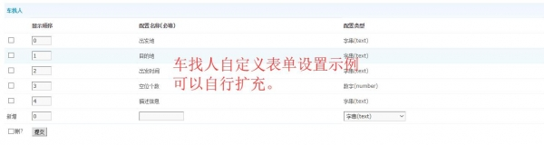](javascript:;)

[**QQ图片20180406183321.png**](https://www.wxigua.com/forum.php?mod=attachment&aid=MzE1OHw1MmRlODVjNXwxNTgyMjA1Njk1fDk2MzV8MTQyNA%3D%3D&nothumb=yes) (25.98 KB, 下载次数: 6)

[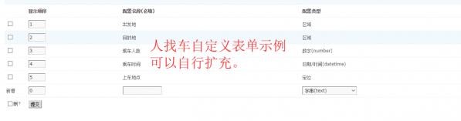](javascript:;)