**修改宽度样式说明（以宽度1200px为例）：**  
.grid_c2a{width:1200px;}  
.mainbar,#goodsfind,.mod_auction_goods{width:955px;}  
.game_act_filter,#slides-thumbnail{width:950px}  
#slides-thumbnail .slidesjs-slide img{width:948px;height:350px;}  
.jp_lite .des{width:472px;}.xq_proinfo{width:480px;}  
.xq_mod_box_inner ul li{width:460px}  
.xq_jjck{width:460px;}  
#userpricelist,#userdeallist{width:449px;}  
#userpricelist li,#userdeallist li{width:442px;}  
.auctionmenu,.auctioncon{width:950px}  
.auctioncon .dealul li.info{width:830px}  
  
**再修改插件设置首页轮播图片的宽高，设置修改宽度修改，如图：**  
**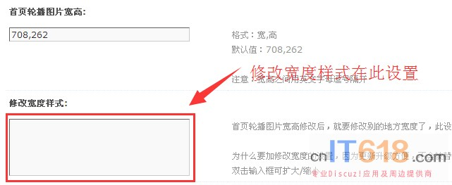  
宽度为1200px时，推荐轮播图片的宽高：948,350，注意：修改轮播图片的宽高时，以上样式红色部分也要修改**  
  
