Justification

Our interest in conducting this investigation of COVID-19 data in Mexico and the creation of dashboards due to the declaration of a worldwide health emergency after the origin of the SARS-COV2 coronavirus that appeared in China in December 2019 and that causes a disease called COVID-19, which has spread enormously and was declared a global pandemic by the World Health Organization.

<https://coronavirus.gob.mx/>





|  |  |
| --- | --- |
| CONFIRMED **9,501** | NEGATIVE **33,871** |
| SUSPICIOUS **8,262** | DEATHS **857** |
| WOMEN 42% | MEN 57% |
| HOSPITALIZED **37.24 %** | AMBULATORY **62.76 %** |

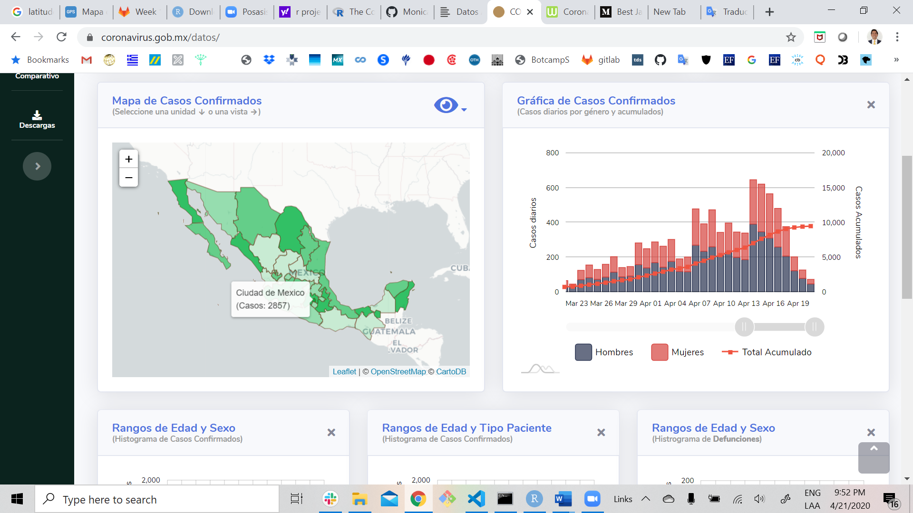

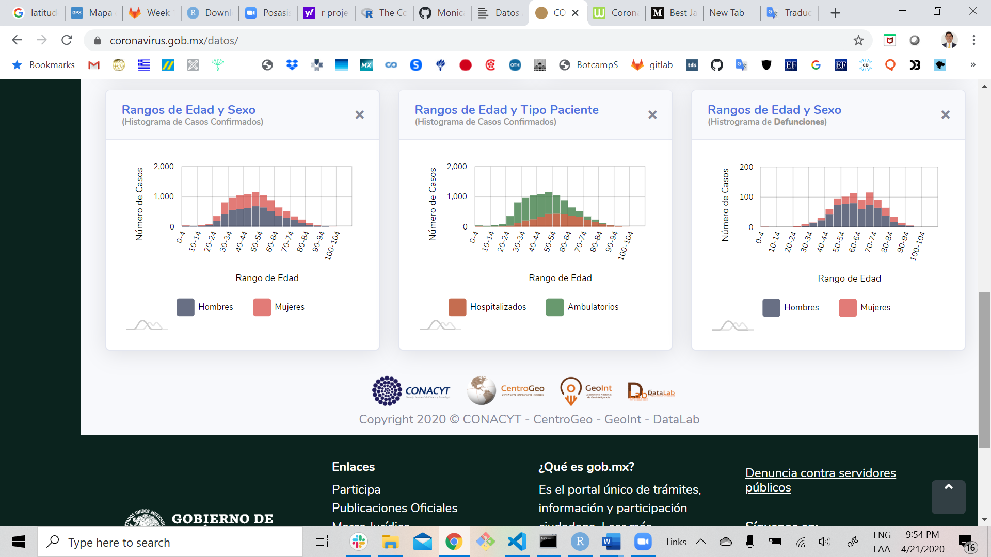

<https://www.worldometers.info/coronavirus/#countries>

