# 保序加密

保研https://zhuanlan.zhihu.com/p/416678489

保序加密<https://blog.alienx.cn/2019/11/07/E11071745/>

开源库<https://github.com/tonyo/pyope>

论文解读<https://blog.csdn.net/qq_37150711/article/details/111348696>

源码来源 https://blog.csdn.net/qq_38234785/article/details/106428908

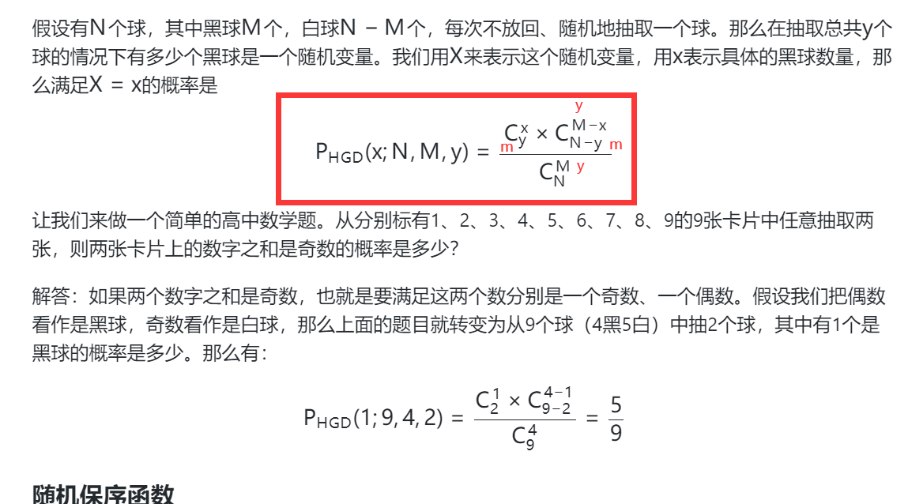

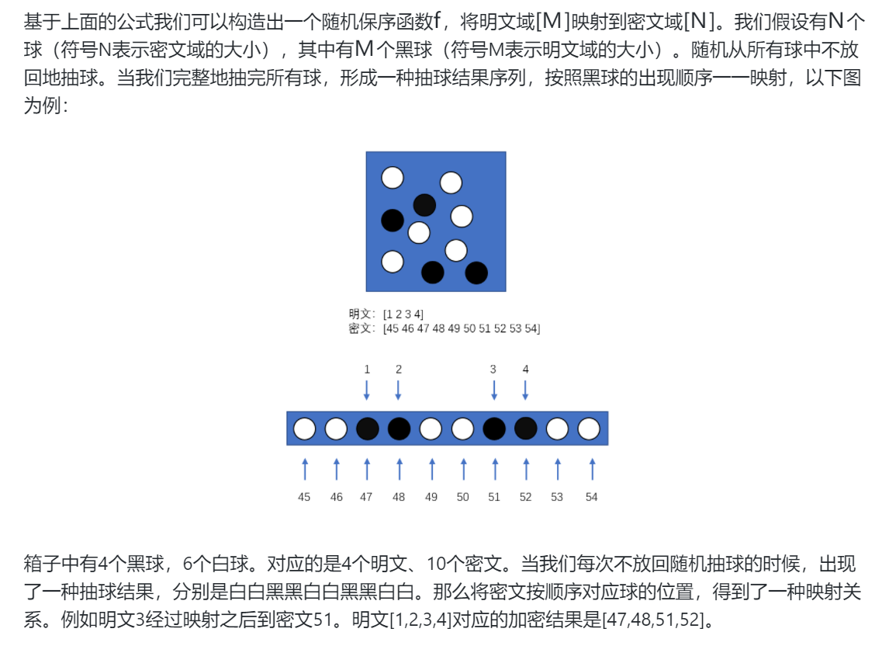

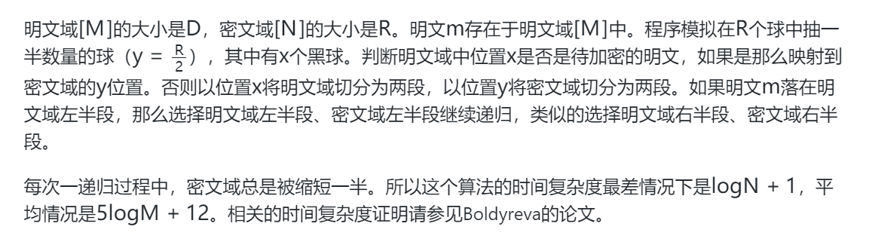

# KD树索引

KD树搜索二维点云的邻近点

[(14条消息) kd-tree搜索近邻点_MagiChos的博客-CSDN博客](https://blog.csdn.net/hanshuobest/article/details/50852663)

<https://download.csdn.net/download/wq198909/12668930>

<https://blog.csdn.net/qq_14922445/article/details/84312840>

<https://blog.csdn.net/ggdhs/article/details/93738324>

<https://blog.csdn.net/weixin_41529093/article/details/109908397>

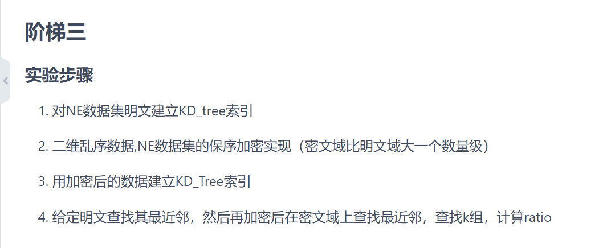

<https://blog.csdn.net/pipisorry/article/details/52186307> k近邻