Create a 2 Linux instances and enable password less authentication between them and user name should be eranki and make sure that user is forced to change his initial login password.

I have created to linux instances named linux1 (i.e.server 1)and linux 2(server 2) .

In server 2 create a user :

sudo useradd Eranki

passwd eanki -setting password

cat /etc/passwd – to check users

su eranki – to switch to particular user

In server 1 generate the key :

ssh-keygen

cd .ssh/

ls – to list the key created

ssh-copy-id (server2 ip address)

ssh server 2_user_ip(to login to server 2)

The following are console outputs :

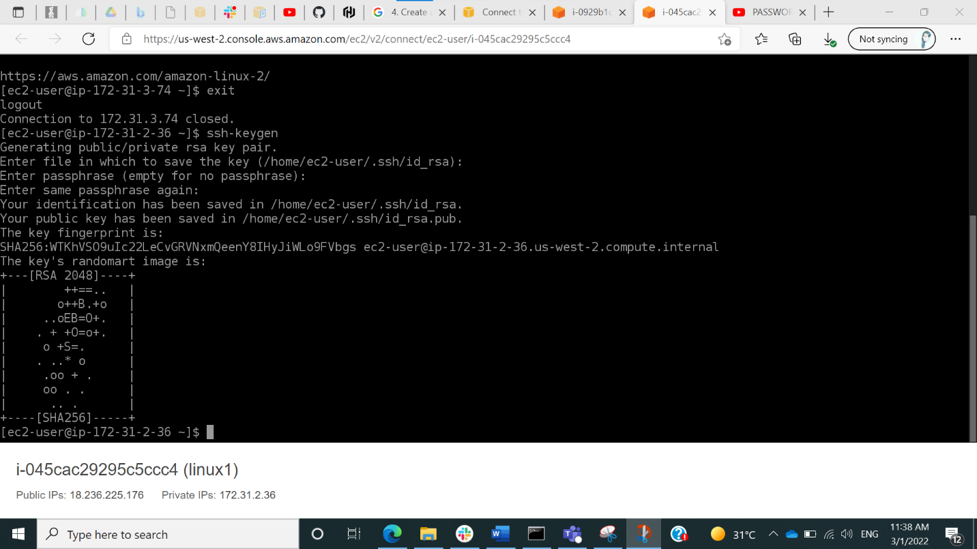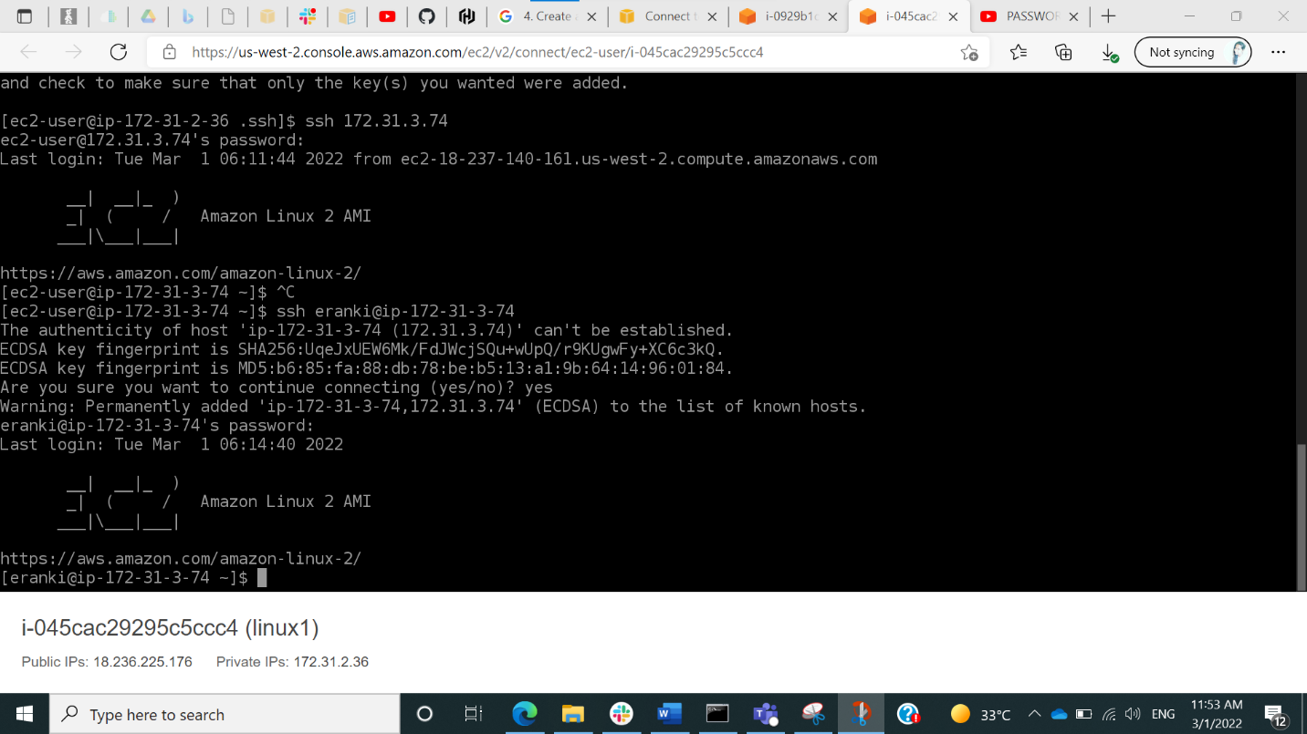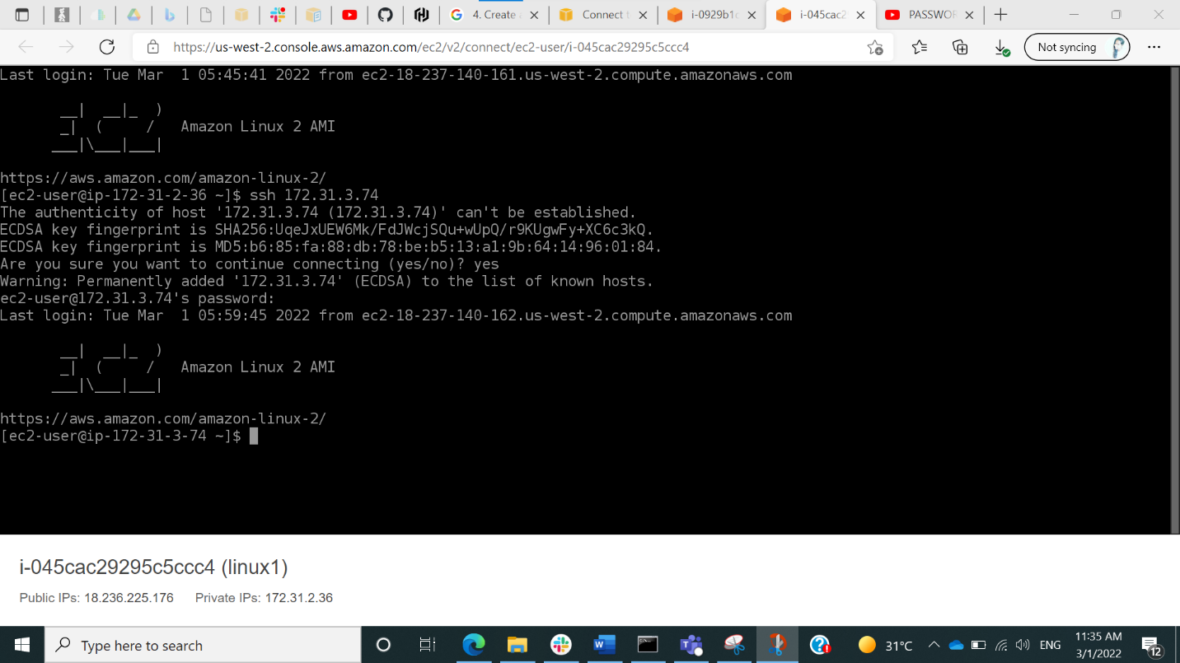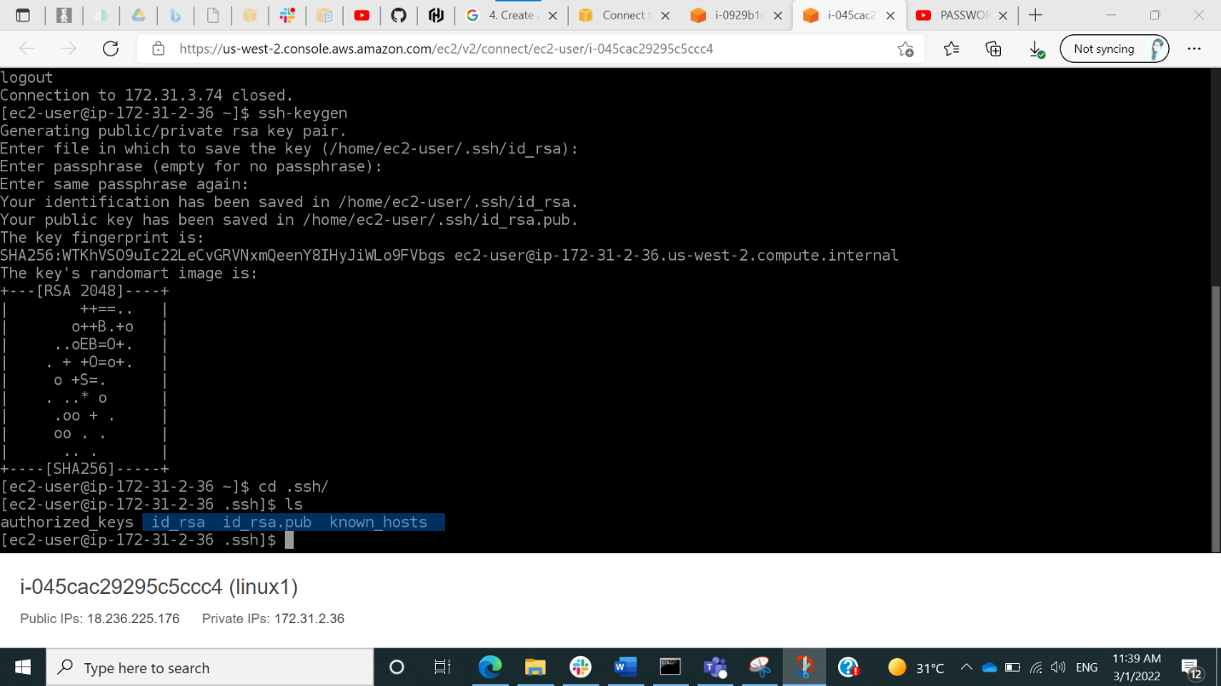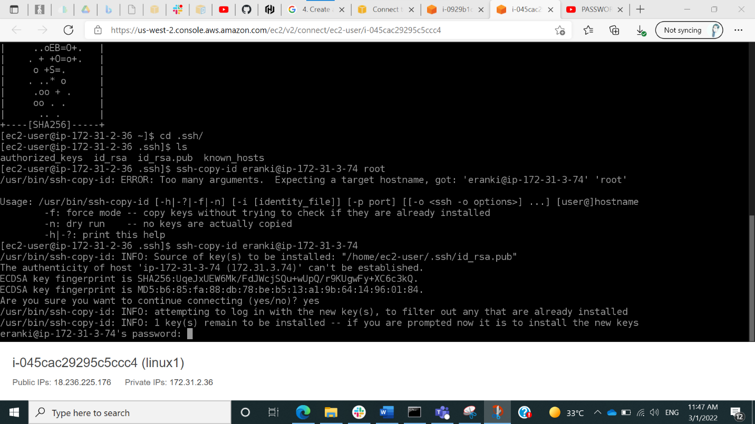

After the final step while logging in for first time password will be asked but from the next time it wont be asked .

Ref: [PASSWORD LESS login between two EC2 instances || using SSH-KEYGEN || 2020 - YouTube](https://www.youtube.com/watch?v=LlH0MVsv1-A)