Create a Bucket policy to auto archive the objects which are older than 5-days using AWS console.

Step 1: I have chosen an existing bucket named newaccountbucket2 .

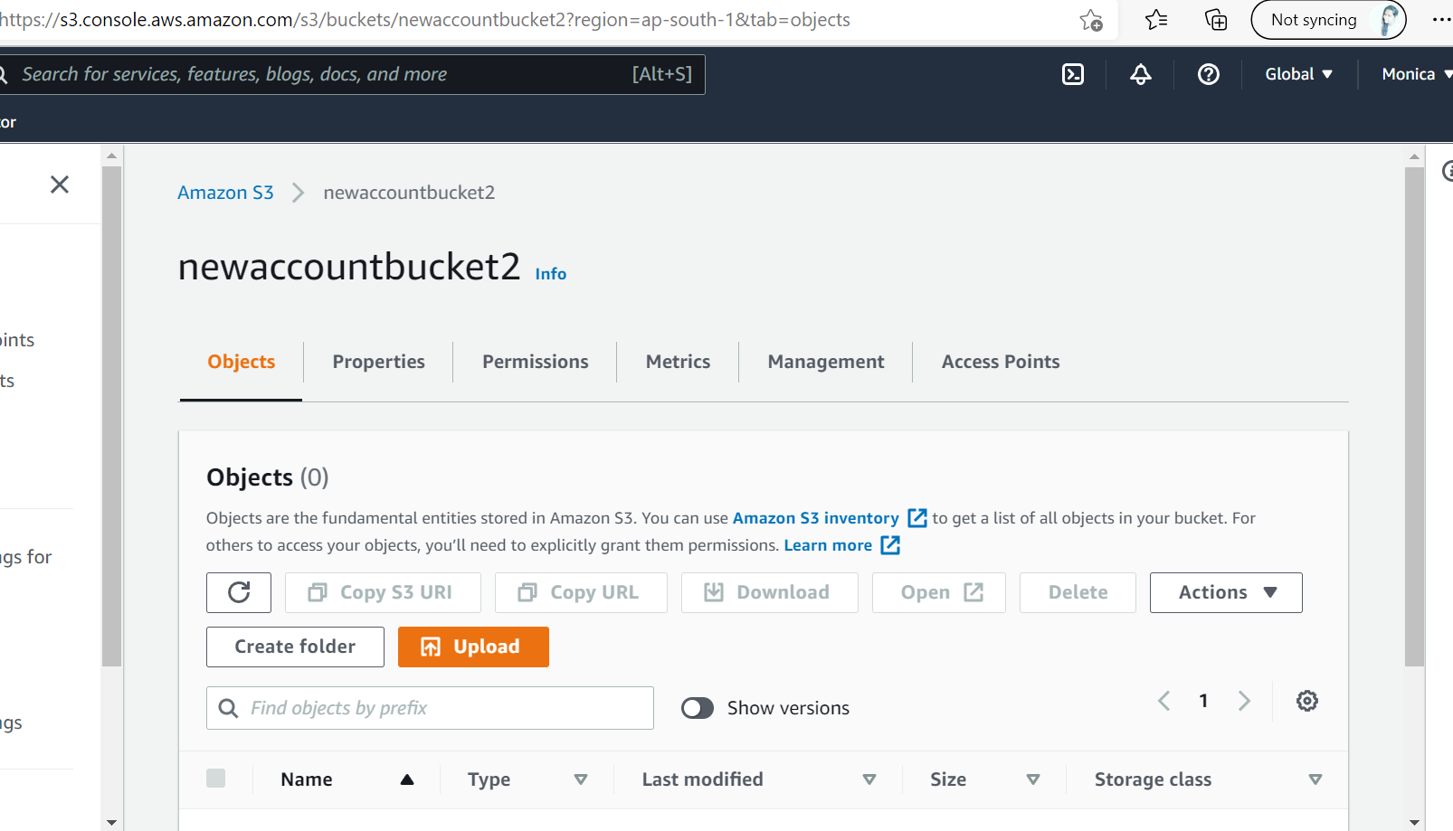

Step 2: Now I uploaded some objects into the bucket .

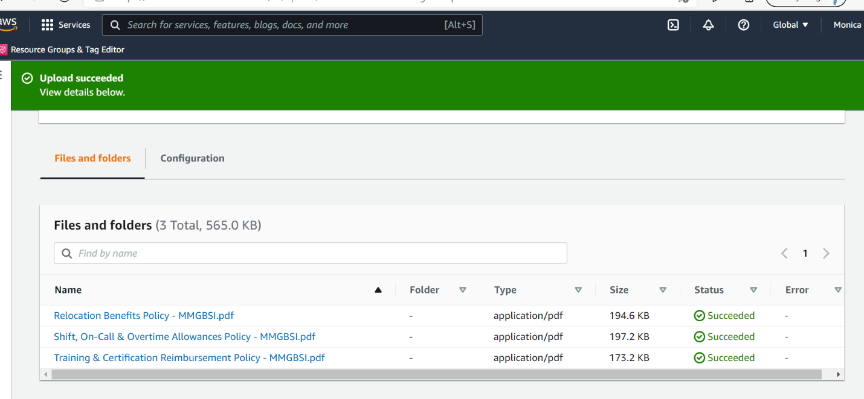

Step 3: Navigate to Management tab and you can see there is no lifecycle rule added .

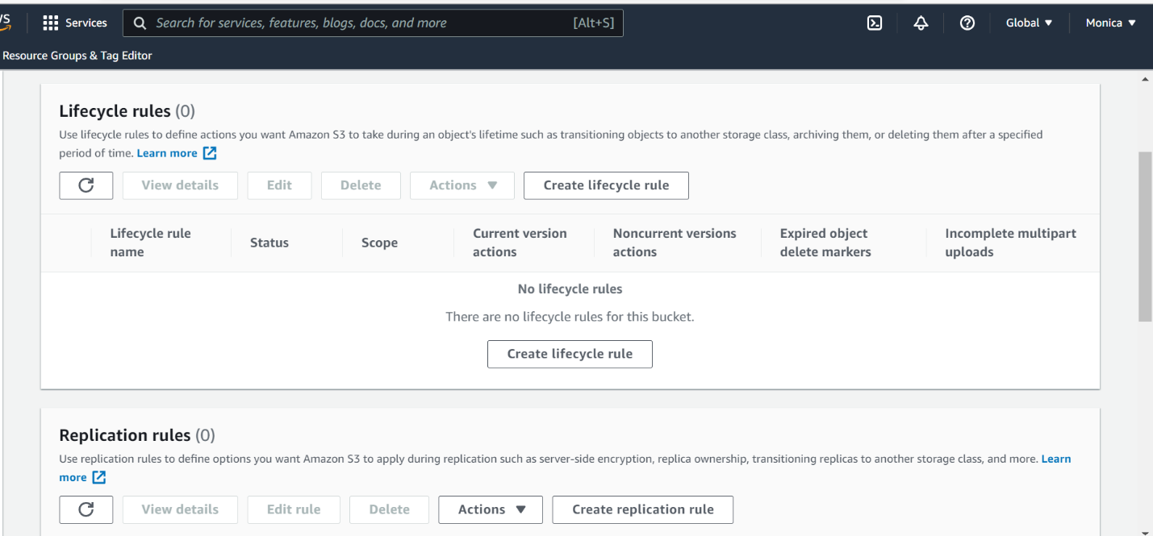

Step 4: Create a lifecycle rule . I have named the rule as AutoArchive.

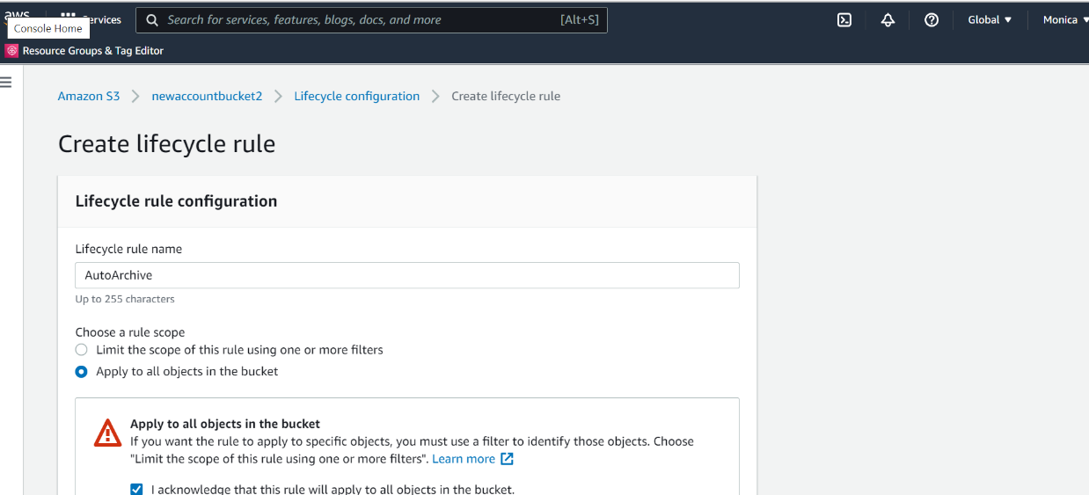

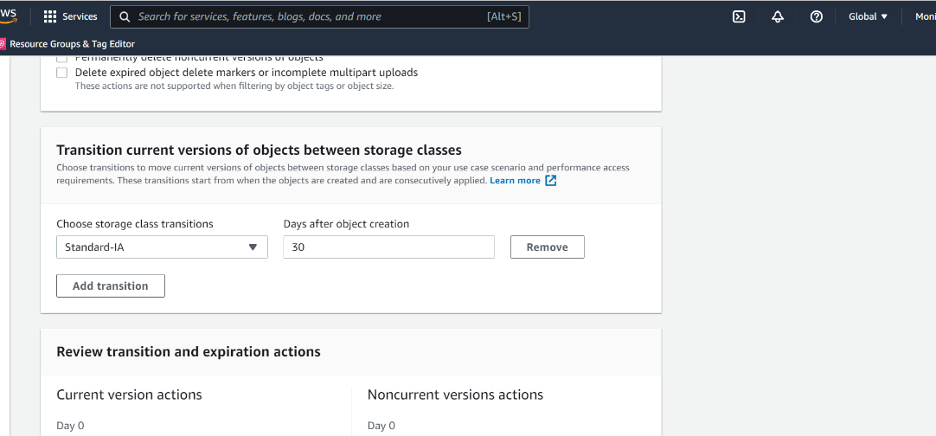

Step 5: I have chosen Standard IA which archives objects if they are not used for a minimum of 30 days .

