For above Linux instance create a new user call Arun and he should be part of DBA group and secondary group should be eranki  and make sure that group has a group ID of 1001

In the linux 2 instance already there is an existing user named eranki so Arun user should be added .

To add user : $ sudo useradd Arun

Now create two groups named DBA group and second-grp :

$sudo groupadd DBA

$sudo groupadd second-grp

To add user to the above created group :

$sudo usermod -a -G DBA

$sudo usermod -a -G second-grp

To change group id :

$sudo groupmod -g 1008 second-grp . (I have chosen 1008 instead of 1001 because its is already taken ).

The following are the console outputs :

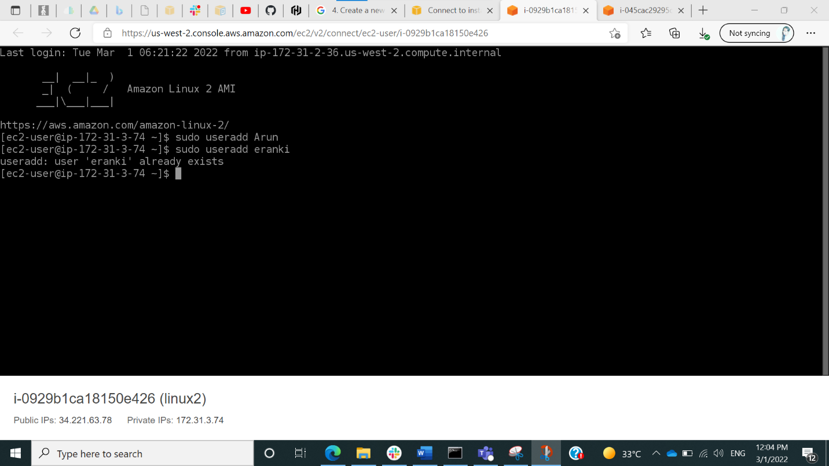

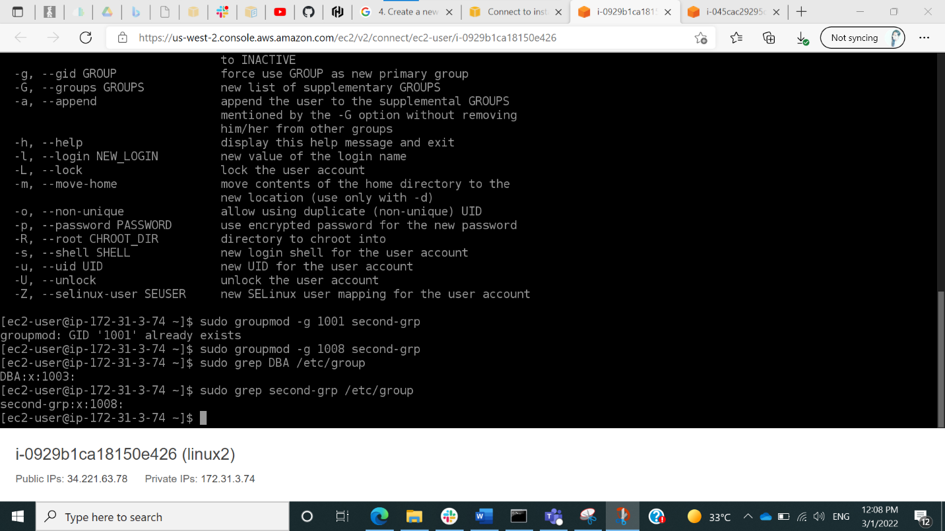

The following are the commands used :

