Create a new file share of 500GB between above 2 Linux instances and mount it on both the servers.

First I created and EFS system of 500GB:

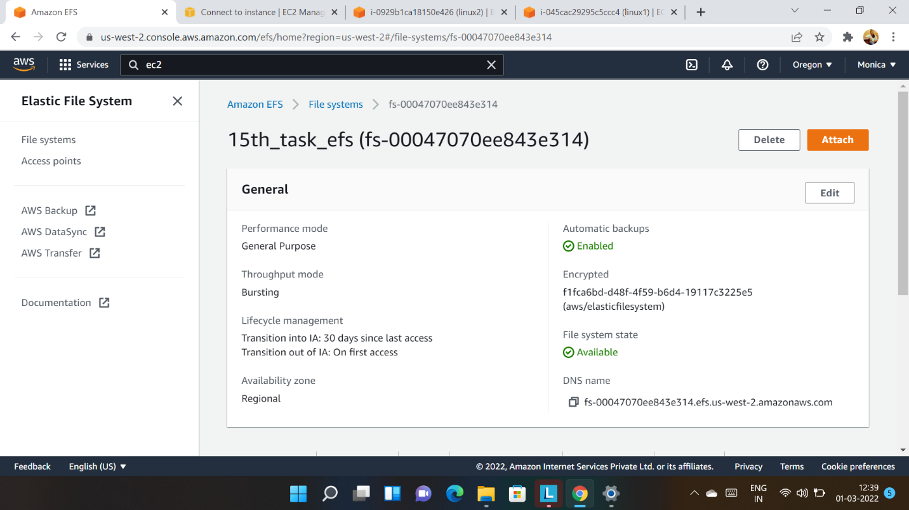

Then in Linux instances 1 and 2 instal file sharing systems and mount on the instances by running commands :

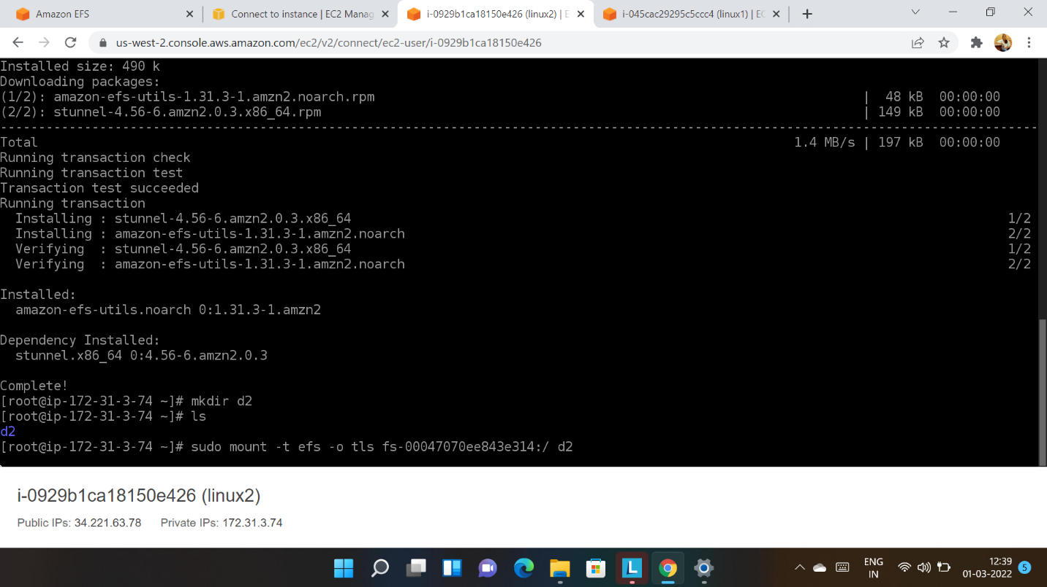

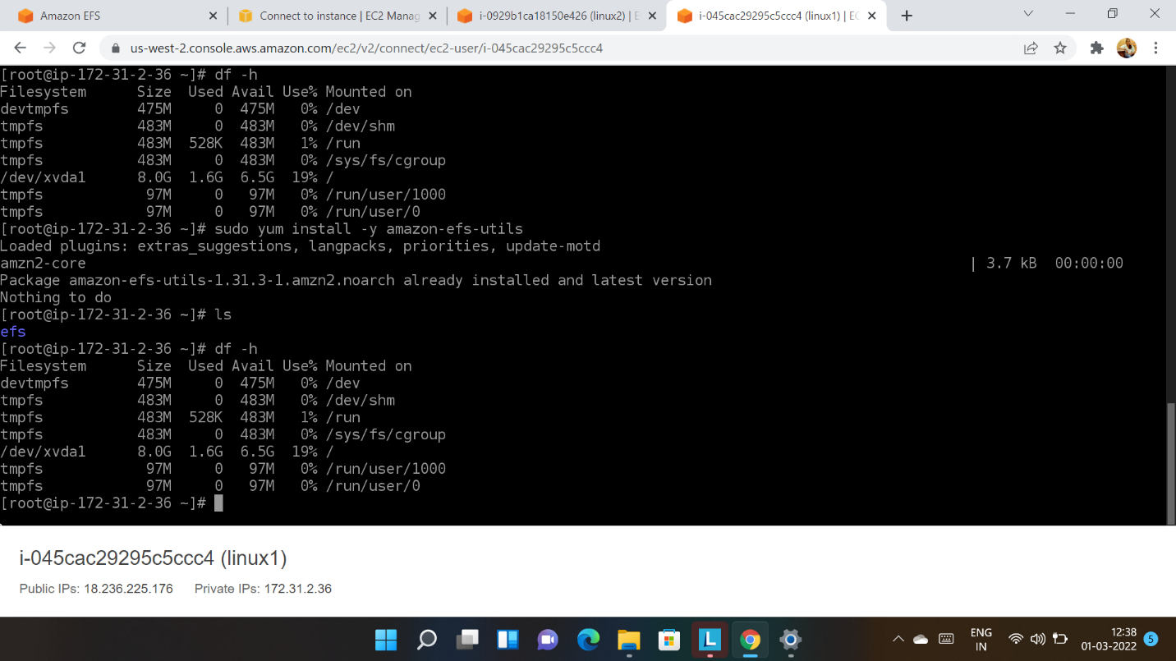

The following are the commands used :

sudo yum -y install amazon-efs-utils

sudo mount -t efs (file system id ) :/ efs-mount-point