ATTACHING AND MOUNTING EBS TO WINDOWS INSTANCE : USING DISK MANAGEMENT TOOL

Steps 1 and 2 remain same , except the AMI has to be chosen for windows type .

STEP 3:Connect to your Windows instance using RDP

STEP 4: Right click on the windows logo on the taskbar 🡪Choose Disk Management and open

STEP 5: Bring the volume online. In the lower pane, open the context (right-click) menu for the left panel for the disk for the EBS volume. Choose **Online**.


            Bring the volume online.
          

STEP 6: (Conditional) You must initialize the disk before you can use it. If the disk is not initialized, initialize it as follows. Open the context (right-click) menu for the left panel for the disk and choose **Initialize Disk**. In the **Initialize Disk** dialog box, select a partition style and choose **OK**.


            Initialize the volume.
          

STEP 7: Open the context (right-click) menu for the right panel for the disk and choose **New Simple Volume**. Complete the wizard.


            Mount a simple volume.
          

ATTACHING AND MOUNTING EBS TO WINDOWS INSTANCE:USING DISKPART COMMAND LINE TOOL

[Make an Amazon EBS volume available for use on Windows - Amazon Elastic Compute Cloud](https://docs.aws.amazon.com/AWSEC2/latest/WindowsGuide/ebs-using-volumes.html)

CONSOLE PRACTICAL OUTPUTS

1. Created Windows Instance

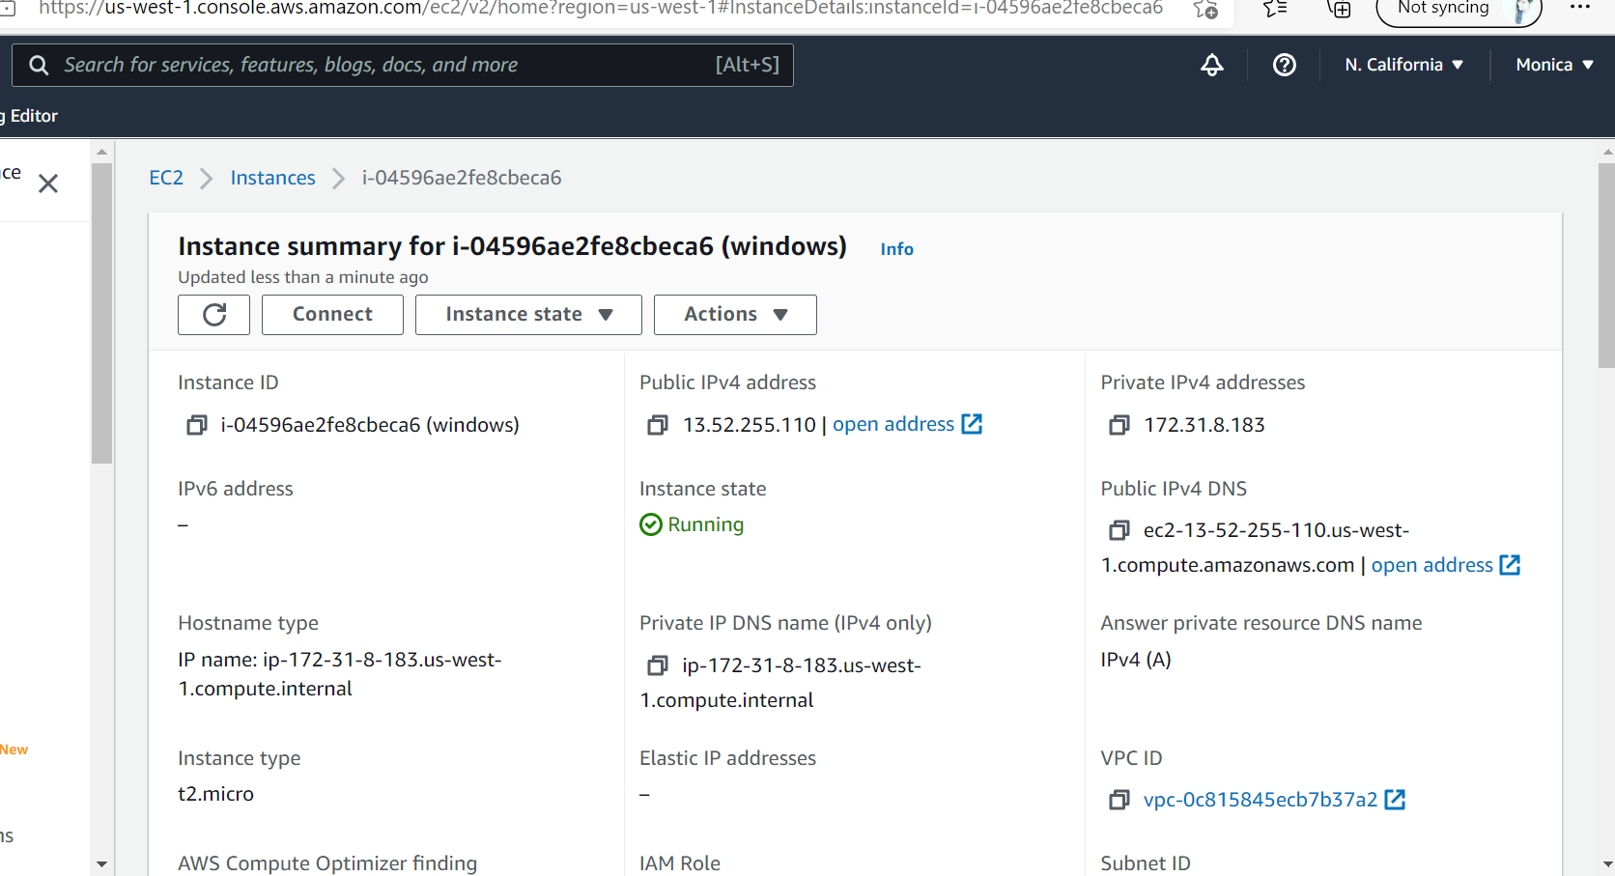

2.Create volumes and attach

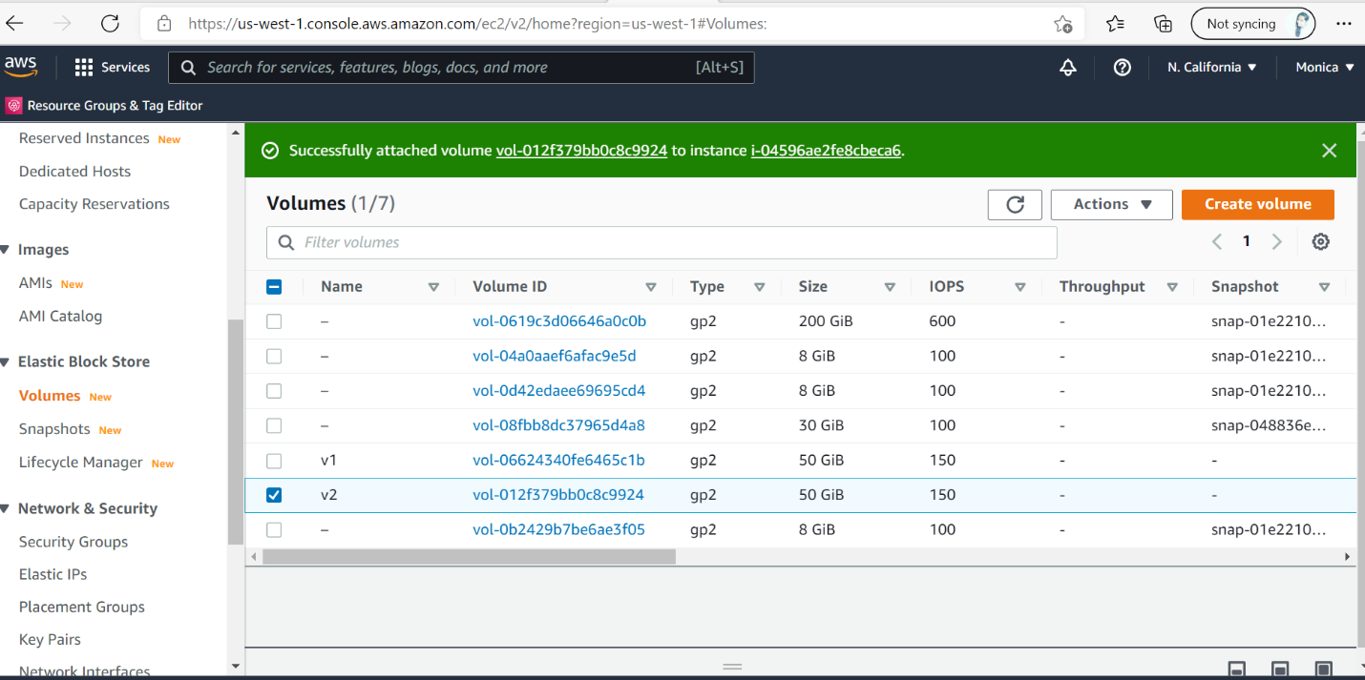

3.Connect to the instance with RDP and perform disk partitioning .

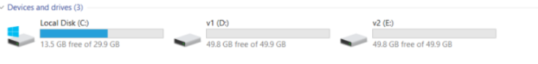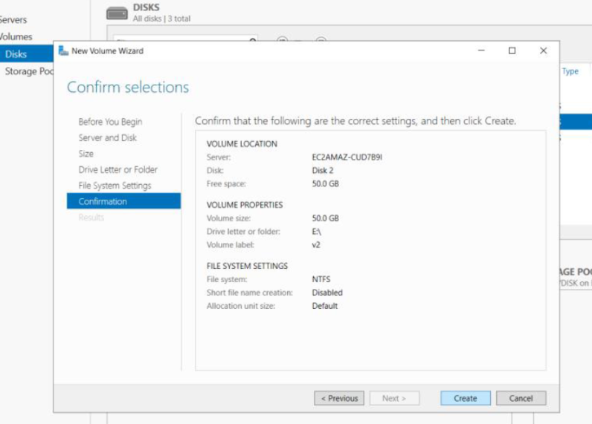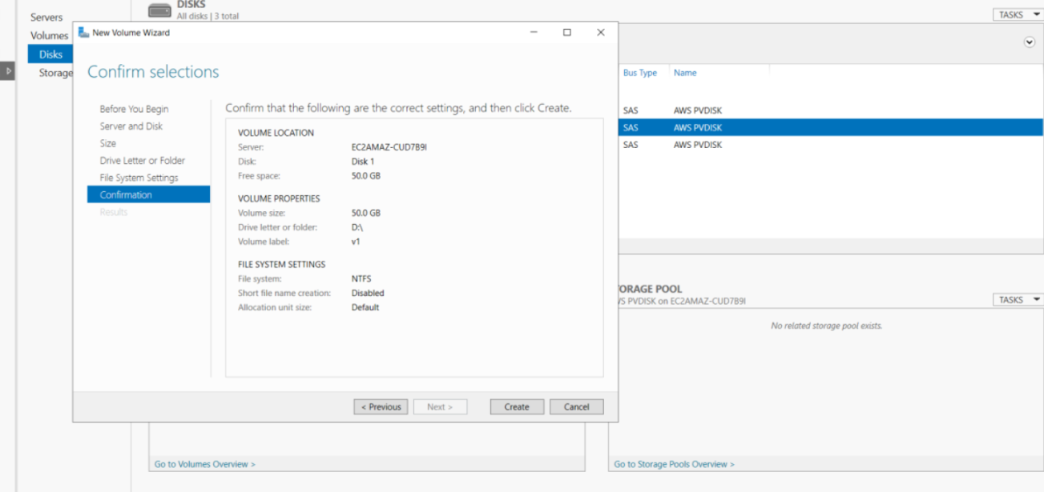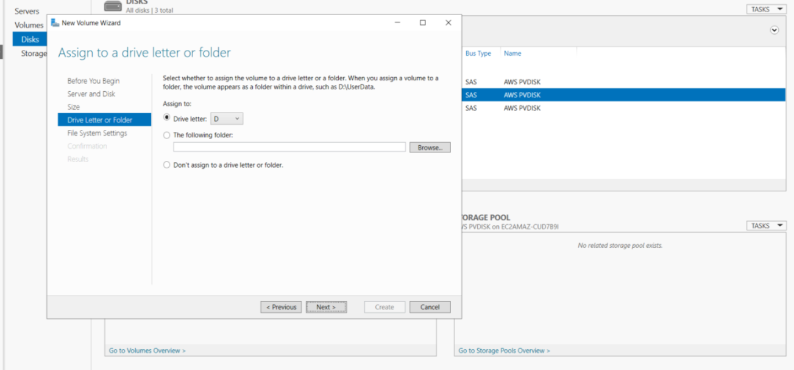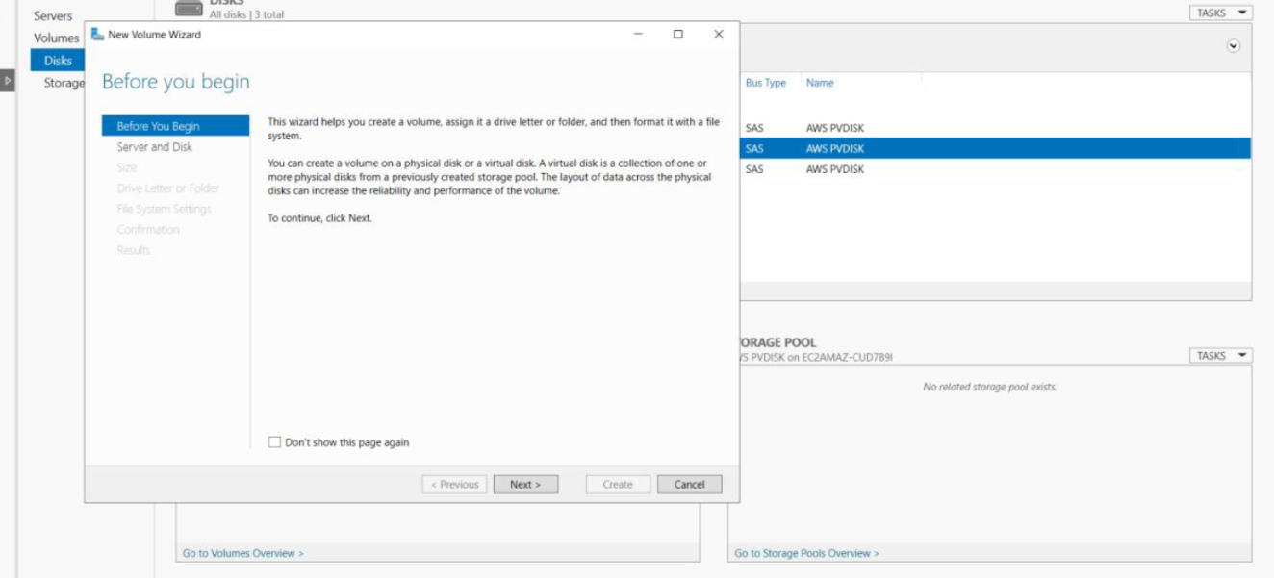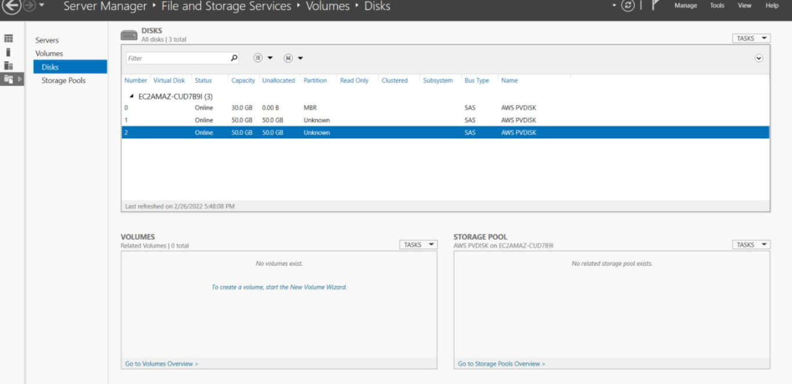

TERRAFORM OUTPUTS :

