**How can I provide cross-account access to objects that are in Amazon S3 buckets? Using AWS Console.**

**I have considered two AWS accounts Monica and Shivani .**

**Monica🡪Prod Account**

**Shivani 🡪Test Account**

Step 1: In AWS account of Monica (Prod Account ) I have already created an S3 bucket named newaccountbucket1 which doesn’t have any objects in it . I will be uploading objects from Shivani’s Account ( Test Account ) .

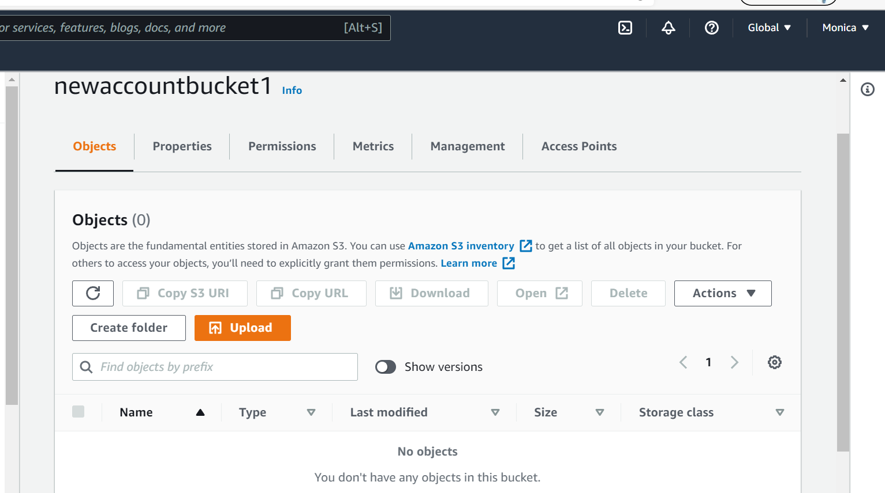

Step 2: Create user in Shivani’s account named crossaccountuser_for_monica.

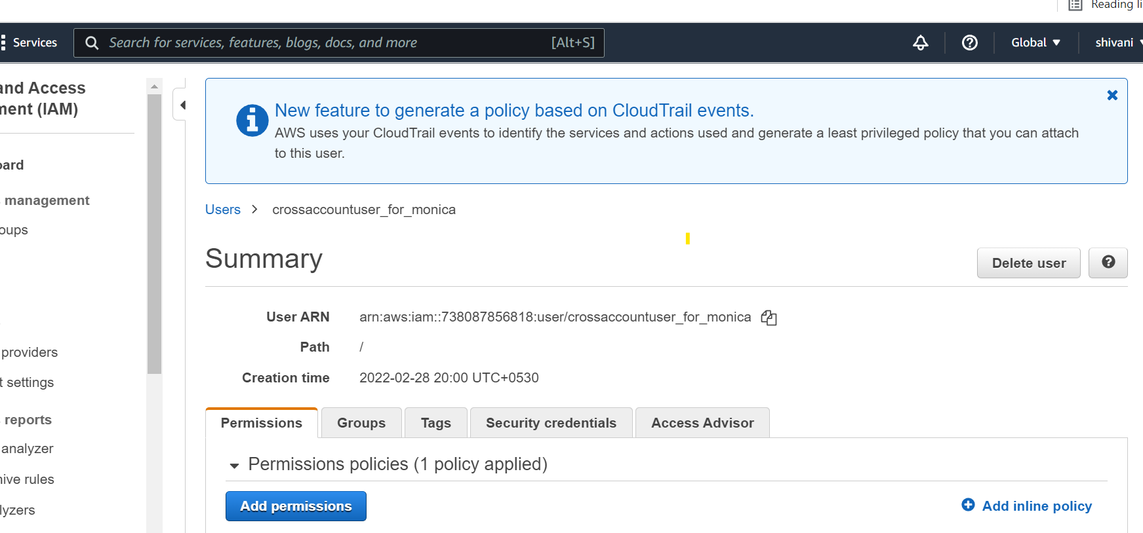

Step 3: Create role in Monica’s account named crossaccountrole_for_monica

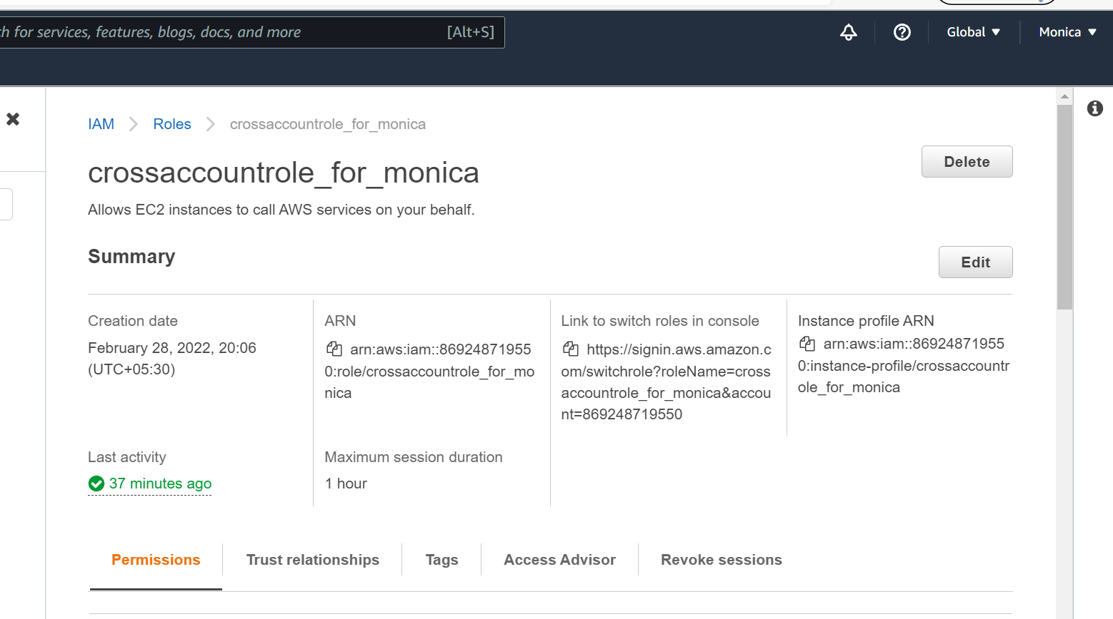

Now we create a policy and attach it to the role . The policy defines certain S3 actions where the user can access all buckets but only upload objects of any name to newaccountbucket1 only.

The following is the JSON code of the policy :

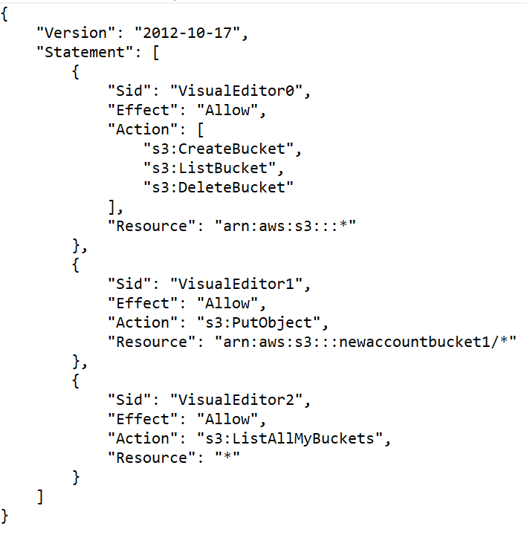

Step 4: After the role is created and policy is attached now we navigate to Shivani’s account and define and attach a policy to the user previously created . The policy is to assume role for that user .

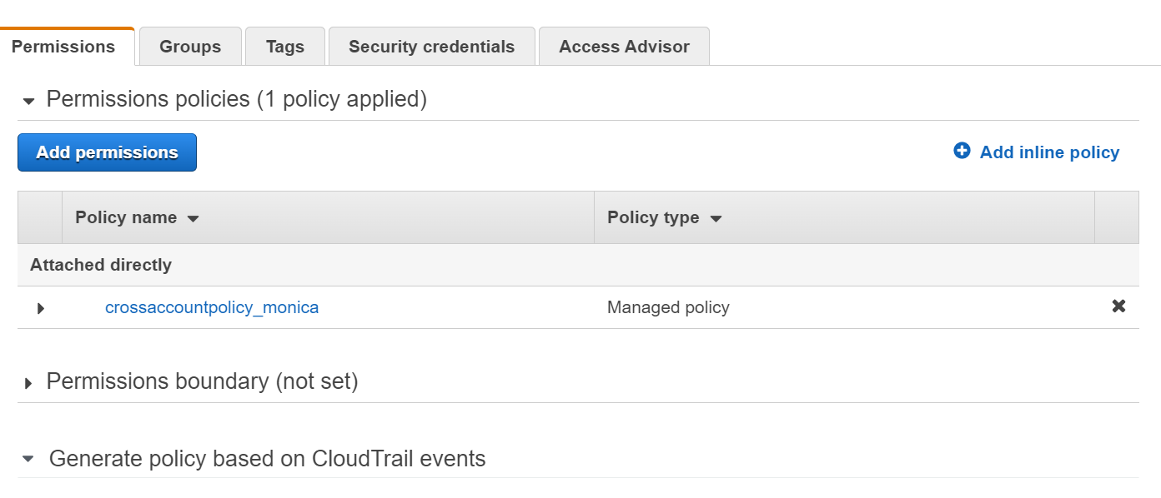

The JSON code of the policy attached is given below :

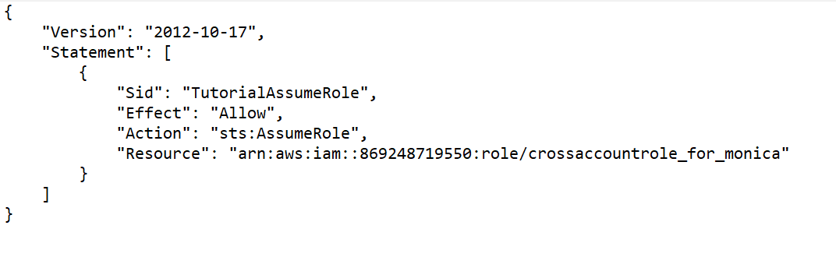

Step 5: Now the final step is to add this user of Shivani’s account to the trusted entities of the role in Monica’s account .

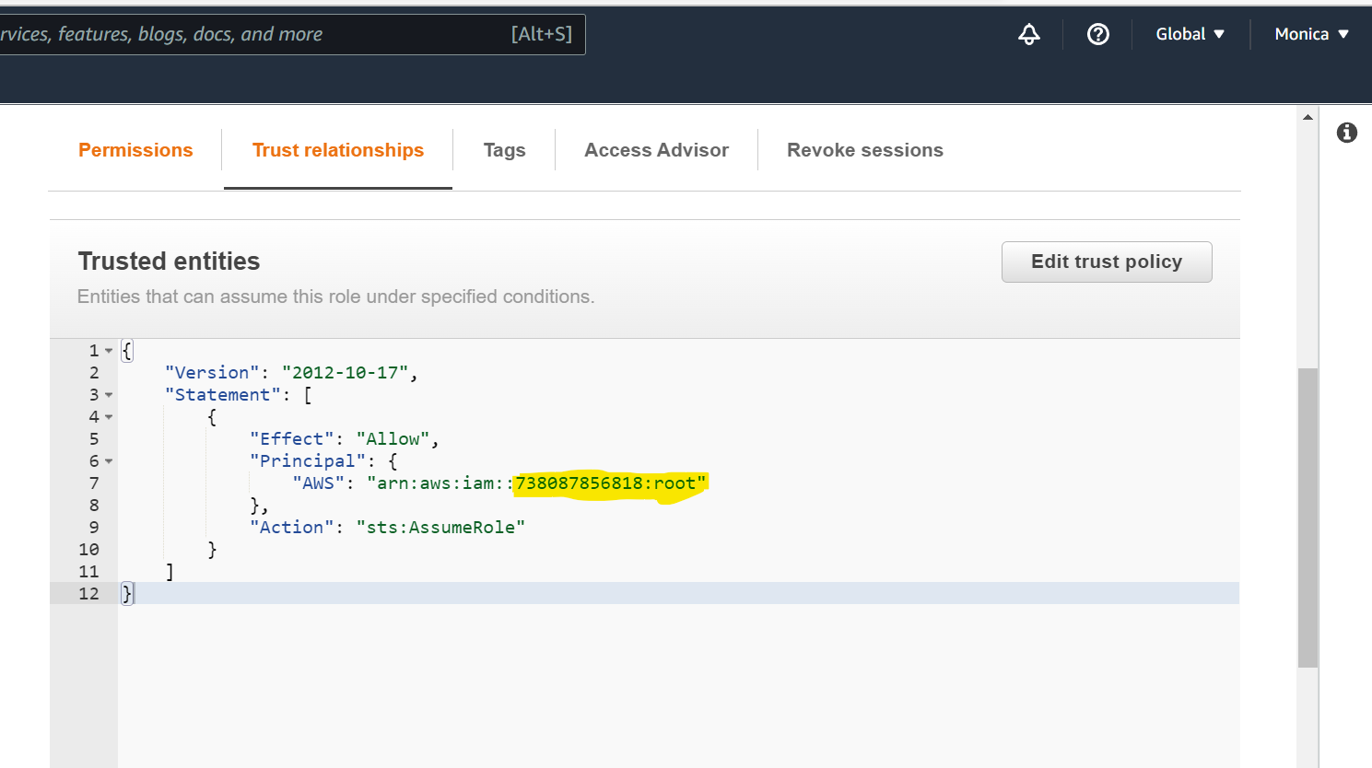

The highlighted part is the account number of Shivani’s account and the permissions are being given to the entire root account not only to a specific user or group.

Step 6: Now copy the created user arn of Shivani’s account and log out from the console . Now login as IAM user with the credentials .

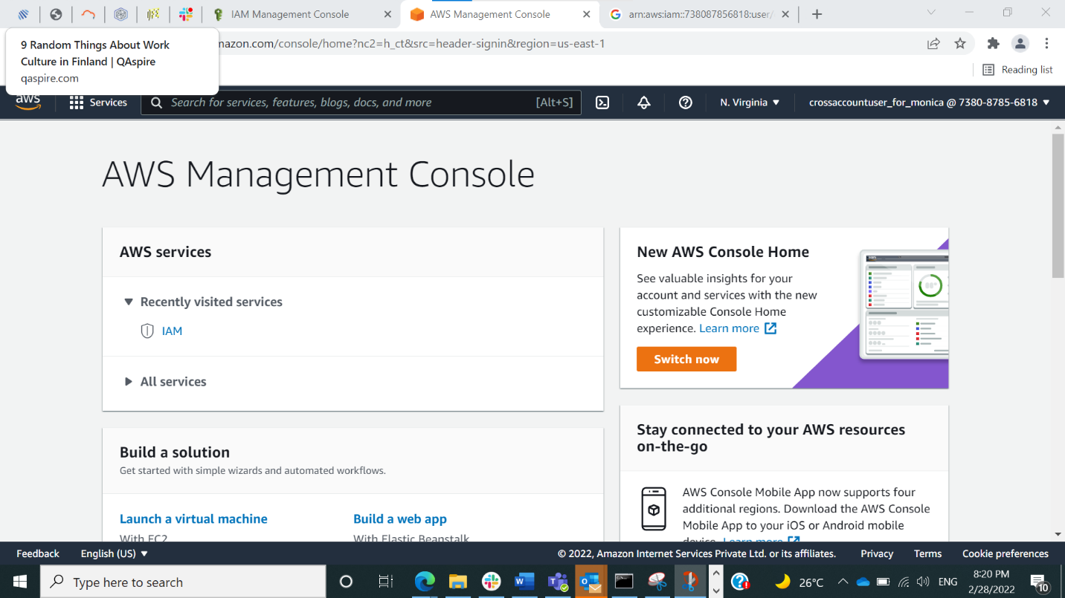

Now choose switch role : Enter Monica’s account number and role name .

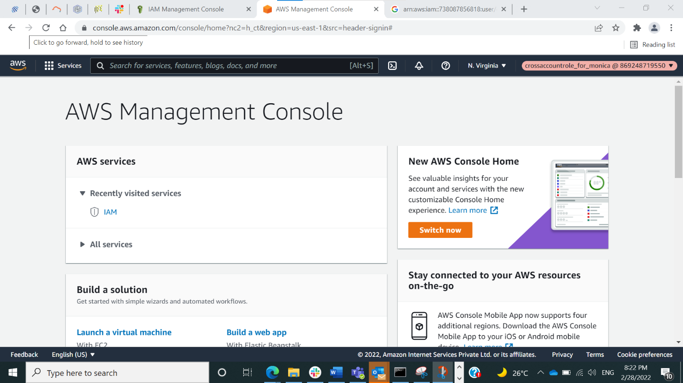

Step 7: Navigate to S3 in this crossaccountfor_monica_role console and try adding objects to S3 bucket , the objects will be uploaded .

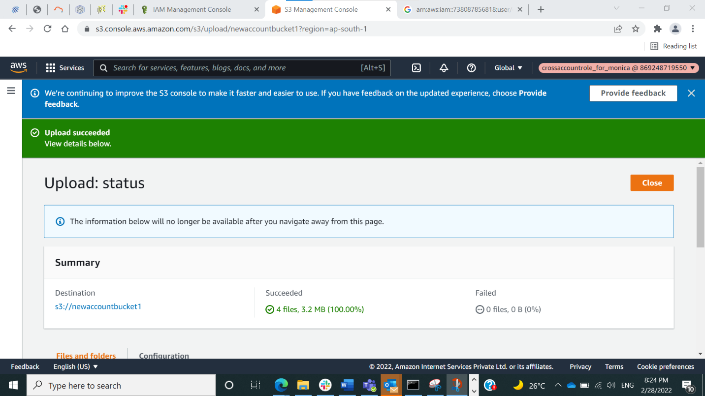

We cannot add objects to other buckets due to permission restrictions set previously .