**Bucket owner granting cross-account bucket permissions using AWS console**

Considering the same scenario of task 6 where Monica is the bucket owner and cross account permission is granted to Shivani .

Step 1: Create role is Monica’s account and attach the policy which defines bucket permissions.

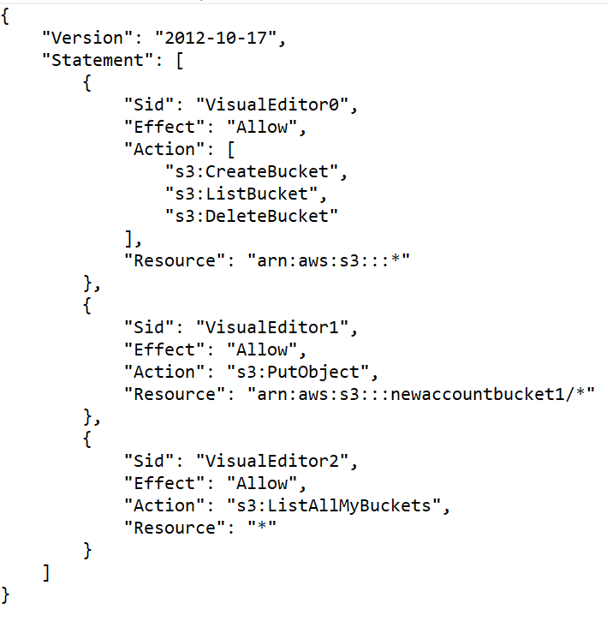This is the policy in JSON format .

Step 2 : Create user in Shivani’s account and attach a policy that assumes a role for that user .

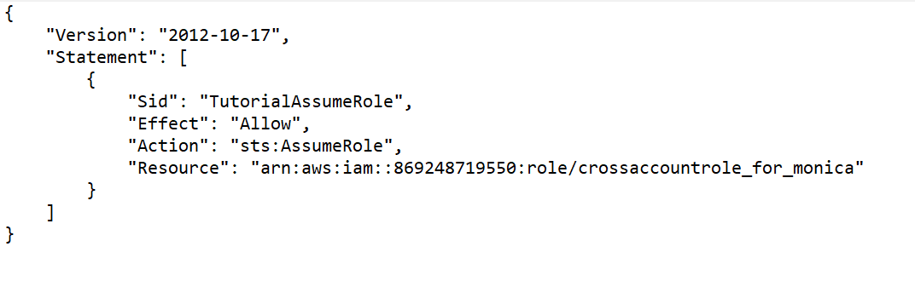

This is the policy attached to the user **.**

Step 3: Now in Trusted entities of the role in Monica’s account add user of Shivani’s account **.**

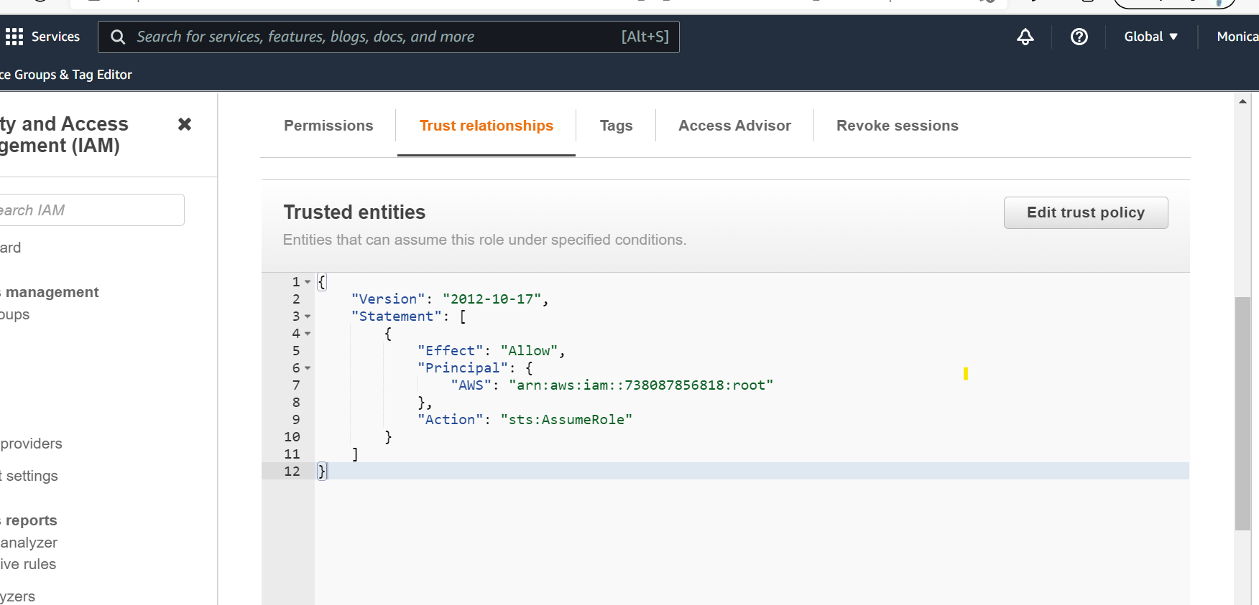

Cross account has been granted.