

“STUDENT PORTAL ”

Project Report submitted in partial fulfillment of the requirements for the award of the degree of

Bachelor’s of Computer Applications (BCA)


Submitted By

Name : Monica G

RollNo:25BCAC41

Under the guidance of

V S Prakash

SCHOOL OF COMPUTATIONAL AND PHYSICAL SCIENCES
DEPARTMENT OF COMPUTER SCIENCE
BCA/B.Sc PROGRAMME

KRISTU JAYANTI [Deemed to be University]
K. Narayanapura, Kothanur P.O., Bangalore – 560077



DEPARTMENT OF COMPUTER SCIENCE

CERTIFICATE OF COMPLETION

This is to certify that the project entitled “Student Portal” has been satisfactorily completed by 25BCAC41, Monica G in partial fulfillment of the award of the Bachelor of Computer Applications degree requirements prescribed by Kristu Jayanti [Deemed to be University] Bengaluru during the academic year 2025 -26.

Internal Guide Head of the Department



DECLARATION

I, 25BCAC41, Monica G hereby declare that the project work entitled ‘Student Portal’ is an original project work carried out by me, under the guidance of V S Prakash

Signature

Bengaluru Date:
25-03-2026

TABLE OF CONTENTS

Sl. No | Topics | Pages
1 | Introduction | 5
2 | Tools and Technologies used | 5
3 | Modern Web Development Workflow | 6
4 | Screenshots | 7
5 | Conclusion | 10
6 | References | 10

- INTRODUCTION

The Student Portal is a web-based application developed to facilitate student engagement with their academic information. It provides a centralized dashboard where students can log in, view their enrolled courses, track their academic progress, and manage their profile information.
This project was developed as part of the BCA curriculum to demonstrate practical application of modern web development technologies. The portal addresses the need for students to have easy access to their course-related data in a clean and responsive interface.
The system supports features such as user registration, authentication, a personalized dashboard displaying course progress, semester information, and a profile management section. The application is hosted on a cloud platform, making it accessible from any device with an internet connection.
The goal of this project is to provide a simple yet functional portal that improves the student experience by consolidating academic information in one place. The portal currently serves students of Kristu Jayanti College and is accessible at: https://student-portal-lc0k.onrender.com

- TOOLS AND TECHNOLOGIES USED

The following tools and technologies were used in the development of the Student Portal:

Frontend:

• HTML5 – Used for structuring the web pages including login, registration, dashboard, and profile pages.

• CSS3 – Used for styling the application. Custom CSS was used to design a dark-themed, modern interface.

• JavaScript (JS) – Used for client-side interactivity, form validation, and dynamic rendering of user data on the dashboard.

Backend:

• Node.js – Server-side JavaScript runtime used to handle API requests.

• Express.js – Web application framework for Node.js used to build RESTful routes for login, registration, and profile management.

Database:

• MongoDB – NoSQL database used to store user credentials, course information, and progress data.

Deployment:

• Render – Cloud platform used to host and deploy the application. The live URL is: https://student-portal-lc0k.onrender.com

Development Tools:

• Visual Studio Code – Source code editor used for writing and managing the project files.

• Git & GitHub – Version control system used for code management and collaboration.

• Postman – Used to test API endpoints during development.

- MODERN WEB DEVELOPMENT WORKFLOW

The development of the Student Portal followed a structured modern web development workflow to ensure code quality, maintainability, and efficient deployment.

- Planning and Requirement Analysis:

The project began with identifying the requirements of a student portal. Key features such as login/registration, dashboard display, course tracking, and profile management were planned before development began.

- Frontend Development:

The frontend was designed using HTML, CSS, and JavaScript. A dark-themed UI was created to provide a modern user experience. Each page (login, register, dashboard, profile) was developed as a separate HTML file with linked CSS and JS for modularity.

- Backend Development:

The backend was built using Node.js and Express.js. RESTful API endpoints were created to handle user authentication (login/register), data retrieval for the dashboard, and profile updates. Passwords were stored securely using hashing techniques.

- Database Integration:

MongoDB was used to store and retrieve data. Collections were created for users and courses. The backend communicated with the database using Mongoose, an Object Data Modeling (ODM) library for MongoDB.

- Testing:

API endpoints were tested using Postman. The frontend was tested across different browsers and screen sizes to ensure responsiveness. Bugs and errors were identified and resolved during this phase.

- Deployment:

The completed application was deployed on the Render cloud platform. The application is publicly accessible and runs continuously on the server, allowing students to access the portal from anywhere.

- SCREENSHOTS

The following screenshots illustrate the key pages and features of the Student Portal application:

Figure 1: Login Page

The login page allows registered students to sign in using their email and password. It includes a link to the registration page for new users.

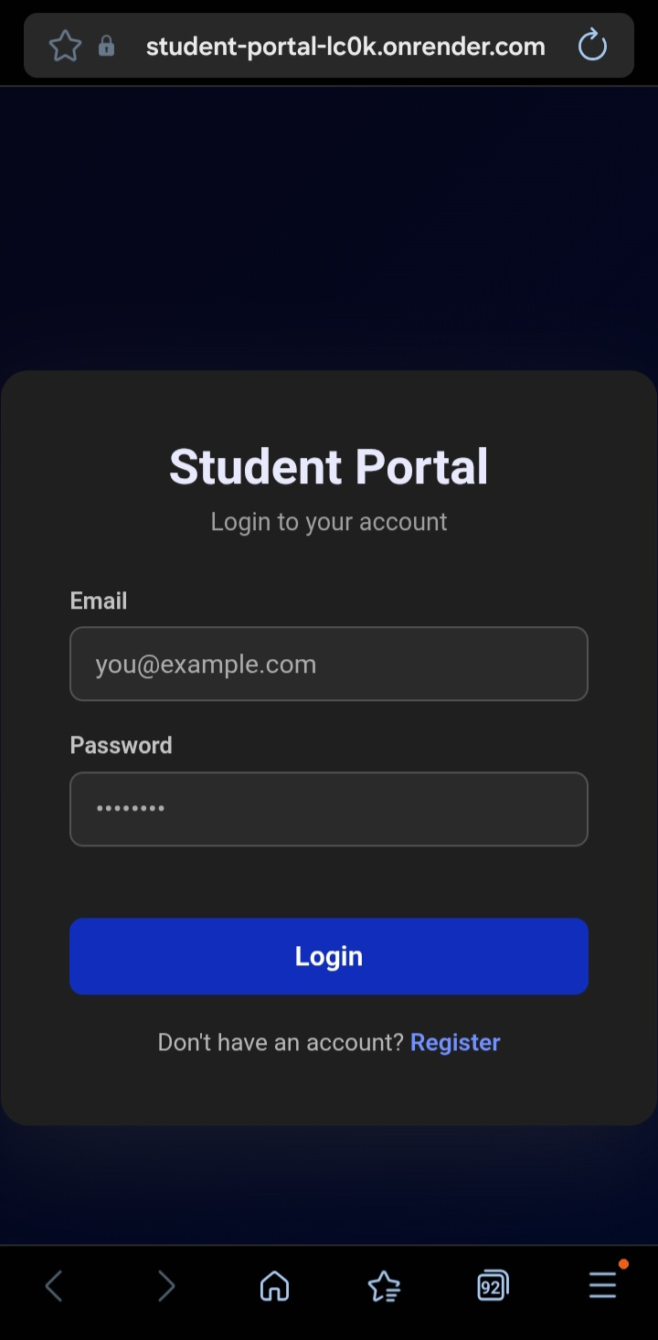

Figure 2: Registration Page

The registration page allows new students to create an account by providing their full name, email, password, and confirming the password.

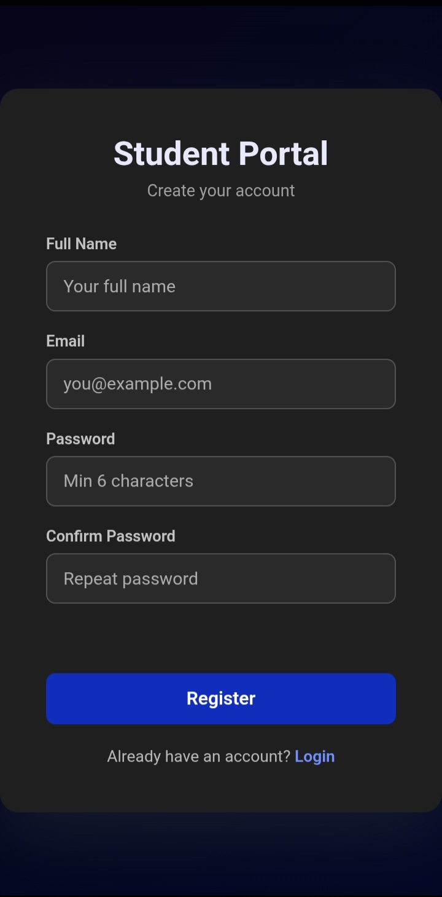

Figure 3: Dashboard

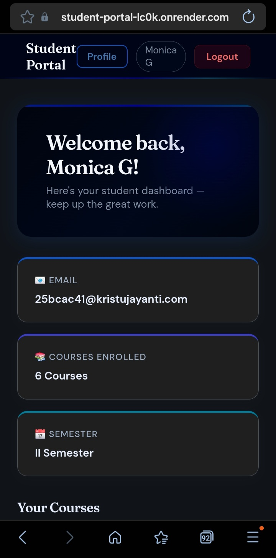
The dashboard displays a personalized welcome message for Monica G, along with email, total courses enrolled (6 Courses), and current semester (II Semester).

- CONCLUSION

The Student Portal project successfully demonstrates the development of a full-stack web application using modern technologies including HTML, CSS, JavaScript, Node.js, Express.js, and MongoDB. The application provides a functional and user-friendly interface for students to manage and track their academic information.

The project achieved its primary objectives: enabling secure user authentication, displaying personalized dashboards with course progress, and allowing profile management. The deployment on Render ensures the portal is accessible online, simulating a real-world application environment.

Through this project, practical knowledge of the complete web development lifecycle was gained — from planning and design to coding, testing, and deployment. The experience reinforced the importance of following a structured development workflow and using appropriate tools at each stage.

Future enhancements could include adding an admin panel for faculty to update course details, integrating notifications for assignment deadlines, implementing a grade tracking system, and adding mobile application support for better accessibility.

Overall, the Student Portal project serves as a solid foundation for understanding real-world web application development and provides valuable hands-on experience in full-stack development.

- References

- Mozilla Developer Network (MDN) – HTML, CSS, and JavaScript Documentation. Available at: https://developer.mozilla.org

- Node.js Official Documentation. Available at: https://nodejs.org/en/docs

- Express.js Official Documentation. Available at: https://expressjs.com

- Render Cloud Platform. Available at: https://render.com

- W3Schools – Web Development Tutorials. Available at: https://www.w3schools.com

- Git Documentation. Available at: https://git-scm.com/doc

- Visual Studio Code Documentation. Available at: https://code.visualstudio.com/docs

- Kristu Jayanti College – BCA Programme Guidelines. Kristu Jayanti [Deemed to be University], Bangalore.

