*MYSQL PROJECT*

* *Introduction*
* JDBC (Java Database Connectivity) is the Java API that manages connecting to a database, issuing queries and commands, and handling result sets obtained from the database.
* It was released as part of JDK 1.1 in 1997, JDBC was one of the first components developed for the Java persistence layer.
* JDBC is a Technology, which can be used to communicate with Database from Java Application.
* JDBC is the Part of Java Standard Edition (J2SE|JSE)
* JDBC is a Specification  defined by Java Vendor (Sun Micro Systems) and implemented by Database Vendors.
* Database Vendor provided Implementation is called "Driver Software".

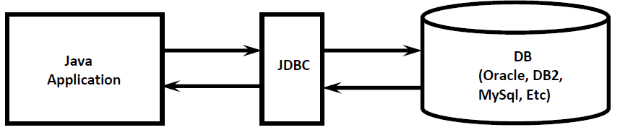

*-Design and Features*   
  
🡪JDBC API is Standard API. We can communicate with any Database without rewriting our Application i.e. it is Database Independent API.

🡪JDBC Drivers are developed in Java and hence JDBC Concept is applicable for any Platform. i.e. JDBC Is Platform Independent Technology.

🡪By using JDBC API, we can perform basic CRUD Operations very easily.  
C ➔ Create (Insert)  
R ➔ Retrieve (Select)  
U ➔ Update (Update)  
D ➔ Delete (Delete)

🡪 We can also perform Complex Operations (like Inner Joins, Outer Joins, calling Stored Procedures etc) very easily by using JDBC API.

🡪 JDBC API supported by Large Number of Vendors and they developed multiple Products based on JDBC API

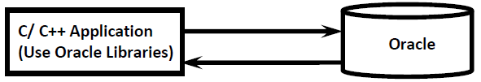

*-JDBC Versions*

* JDBC 3.0 is Part J2SE 1.4
* No Update in Java SE 5.0
* JDBC 4.0 is Part Java SE 6.0
* JDBC 4.1 is Part Java SE 7.0
* JDBC 4.2 is Part Java SE 8.0

*-Codes*

package databaseproject;

import static com.sun.xml.internal.fastinfoset.alphabet.BuiltInRestrictedAlphabets.table;

import java.awt.HeadlessException;

import java.sql.Connection;

import java.sql.DriverManager;

import java.sql.PreparedStatement;

import java.sql.ResultSet;

import java.sql.SQLException;

import java.sql.Statement;

import java.util.logging.Level;

import java.util.logging.Logger;

import javax.swing.JOptionPane;

import javax.swing.table.DefaultTableModel;

import static jdk.nashorn.tools.ShellFunctions.input;

public class DB2 extends javax.swing.JFrame {

Connection con;

public DB2() {

initComponents();

createConnection();

}

void createConnection() {

try{

Class.forName("com.mysql.jdbc.Driver");

con = DriverManager.getConnection("jdbc:mysql://localhost:3306/mydb","root","2845@MONICA");

}catch (ClassNotFoundException ex){

Logger.getLogger(Databaseproject.class.getName()).log(Level.SEVERE, null, ex);

} catch (SQLException ex) {

Logger.getLogger(Databaseproject.class.getName()).log(Level.SEVERE, null, ex);

}

}

@SuppressWarnings("unchecked")

// <editor-fold defaultstate="collapsed" desc="Generated Code">

private void initComponents() {

jTextField2 = new javax.swing.JTextField();

jScrollPane1 = new javax.swing.JScrollPane();

jTable1 = new javax.swing.JTable();

jTextField3 = new javax.swing.JTextField();

jColorChooser1 = new javax.swing.JColorChooser();

Rollno = new javax.swing.JTextField();

ROLLNO = new javax.swing.JLabel();

NAME = new javax.swing.JLabel();

jButton2 = new javax.swing.JButton();

jButton3 = new javax.swing.JButton();

jButton4 = new javax.swing.JButton();

Name = new javax.swing.JTextField();

jLabel1 = new javax.swing.JLabel();

jLabel2 = new javax.swing.JLabel();

jTextField2.setText("jTextField2");

jTable1.setModel(new javax.swing.table.DefaultTableModel(

new Object [][] {

{null, null, null, null},

{null, null, null, null},

{null, null, null, null},

{null, null, null, null}

},

new String [] {

"Title 1", "Title 2", "Title 3", "Title 4"

}

));

jScrollPane1.setViewportView(jTable1);

jTextField3.setText("jTextField3");

setDefaultCloseOperation(javax.swing.WindowConstants.EXIT\_ON\_CLOSE);

ROLLNO.setFont(new java.awt.Font("Tahoma", 0, 14)); // NOI18N

ROLLNO.setText("ROLLNO");

NAME.setFont(new java.awt.Font("Tahoma", 0, 14)); // NOI18N

NAME.setText("NAME");

jButton2.setFont(new java.awt.Font("Trebuchet MS", 1, 14)); // NOI18N

jButton2.setText("INSERT");

jButton2.addActionListener(new java.awt.event.ActionListener() {

public void actionPerformed(java.awt.event.ActionEvent evt) {

jButton2ActionPerformed(evt);

}

});

jButton3.setFont(new java.awt.Font("Trebuchet MS", 1, 14)); // NOI18N

jButton3.setText("UPDATE");

jButton3.addActionListener(new java.awt.event.ActionListener() {

public void actionPerformed(java.awt.event.ActionEvent evt) {

jButton3ActionPerformed(evt);

}

});

jButton4.setFont(new java.awt.Font("Trebuchet MS", 1, 14)); // NOI18N

jButton4.setText("DELETE");

jButton4.addActionListener(new java.awt.event.ActionListener() {

public void actionPerformed(java.awt.event.ActionEvent evt) {

jButton4ActionPerformed(evt);

}

});

jLabel1.setFont(new java.awt.Font("Times New Roman", 0, 48)); // NOI18N

jLabel1.setText("STUDENT DATA");

jLabel2.setIcon(new javax.swing.ImageIcon("C:\\Users\\mraj9\\OneDrive\\Desktop\\logo.jpg.png")); // NOI18N

javax.swing.GroupLayout layout = new javax.swing.GroupLayout(getContentPane());

getContentPane().setLayout(layout);

layout.setHorizontalGroup(

layout.createParallelGroup(javax.swing.GroupLayout.Alignment.LEADING)

.addGroup(layout.createSequentialGroup()

.addGroup(layout.createParallelGroup(javax.swing.GroupLayout.Alignment.LEADING)

.addGroup(layout.createSequentialGroup()

.addGap(153, 153, 153)

.addGroup(layout.createParallelGroup(javax.swing.GroupLayout.Alignment.LEADING)

.addComponent(jLabel1, javax.swing.GroupLayout.PREFERRED\_SIZE, 414, javax.swing.GroupLayout.PREFERRED\_SIZE)

.addGroup(layout.createSequentialGroup()

.addGroup(layout.createParallelGroup(javax.swing.GroupLayout.Alignment.LEADING)

.addComponent(ROLLNO, javax.swing.GroupLayout.Alignment.TRAILING)

.addComponent(NAME, javax.swing.GroupLayout.Alignment.TRAILING, javax.swing.GroupLayout.PREFERRED\_SIZE, 46, javax.swing.GroupLayout.PREFERRED\_SIZE))

.addGap(57, 57, 57)

.addGroup(layout.createParallelGroup(javax.swing.GroupLayout.Alignment.LEADING)

.addComponent(Name, javax.swing.GroupLayout.PREFERRED\_SIZE, 315, javax.swing.GroupLayout.PREFERRED\_SIZE)

.addComponent(Rollno, javax.swing.GroupLayout.PREFERRED\_SIZE, 152, javax.swing.GroupLayout.PREFERRED\_SIZE)))))

.addGroup(layout.createSequentialGroup()

.addGap(130, 130, 130)

.addComponent(jButton2, javax.swing.GroupLayout.PREFERRED\_SIZE, 98, javax.swing.GroupLayout.PREFERRED\_SIZE)

.addGap(65, 65, 65)

.addComponent(jButton3, javax.swing.GroupLayout.PREFERRED\_SIZE, 98, javax.swing.GroupLayout.PREFERRED\_SIZE)

.addGap(50, 50, 50)

.addComponent(jButton4, javax.swing.GroupLayout.PREFERRED\_SIZE, 97, javax.swing.GroupLayout.PREFERRED\_SIZE))

.addGroup(layout.createSequentialGroup()

.addGap(98, 98, 98)

.addComponent(jLabel2, javax.swing.GroupLayout.PREFERRED\_SIZE, 545, javax.swing.GroupLayout.PREFERRED\_SIZE)))

.addContainerGap(115, Short.MAX\_VALUE))

);

layout.setVerticalGroup(

layout.createParallelGroup(javax.swing.GroupLayout.Alignment.LEADING)

.addGroup(layout.createSequentialGroup()

.addContainerGap(javax.swing.GroupLayout.DEFAULT\_SIZE, Short.MAX\_VALUE)

.addComponent(jLabel1, javax.swing.GroupLayout.PREFERRED\_SIZE, 90, javax.swing.GroupLayout.PREFERRED\_SIZE)

.addPreferredGap(javax.swing.LayoutStyle.ComponentPlacement.UNRELATED)

.addGroup(layout.createParallelGroup(javax.swing.GroupLayout.Alignment.BASELINE)

.addComponent(Rollno, javax.swing.GroupLayout.PREFERRED\_SIZE, javax.swing.GroupLayout.DEFAULT\_SIZE, javax.swing.GroupLayout.PREFERRED\_SIZE)

.addComponent(ROLLNO, javax.swing.GroupLayout.PREFERRED\_SIZE, 37, javax.swing.GroupLayout.PREFERRED\_SIZE))

.addGap(18, 18, 18)

.addGroup(layout.createParallelGroup(javax.swing.GroupLayout.Alignment.BASELINE)

.addComponent(NAME, javax.swing.GroupLayout.PREFERRED\_SIZE, 35, javax.swing.GroupLayout.PREFERRED\_SIZE)

.addComponent(Name, javax.swing.GroupLayout.PREFERRED\_SIZE, javax.swing.GroupLayout.DEFAULT\_SIZE, javax.swing.GroupLayout.PREFERRED\_SIZE))

.addGap(57, 57, 57)

.addGroup(layout.createParallelGroup(javax.swing.GroupLayout.Alignment.BASELINE, false)

.addComponent(jButton3, javax.swing.GroupLayout.DEFAULT\_SIZE, javax.swing.GroupLayout.DEFAULT\_SIZE, Short.MAX\_VALUE)

.addComponent(jButton4, javax.swing.GroupLayout.DEFAULT\_SIZE, javax.swing.GroupLayout.DEFAULT\_SIZE, Short.MAX\_VALUE)

.addComponent(jButton2, javax.swing.GroupLayout.DEFAULT\_SIZE, javax.swing.GroupLayout.DEFAULT\_SIZE, Short.MAX\_VALUE))

.addGap(80, 80, 80)

.addComponent(jLabel2, javax.swing.GroupLayout.PREFERRED\_SIZE, 312, javax.swing.GroupLayout.PREFERRED\_SIZE)

.addGap(90, 90, 90))

);

pack();

}// </editor-fold>

private void jButton2ActionPerformed(java.awt.event.ActionEvent evt) {

// TODO add your handling code here:

try{ Connection con = null;

Class.forName("com.mysql.jdbc.Driver");

con = DriverManager.getConnection("jdbc:mysql://localhost:3306/mydb","root","2845@MONICA");

//int rollno=Integer.parseInt(ROLLNO.getText());

//String name=NAME.getText();

try(PreparedStatement st= con.prepareStatement("insert into java (ROLLNO,NAME) values(?,?)")){

//st.setInt(1,Integer.parseInt(Rollno.getText()));

st.setString(1,Rollno.getText());

st.setString(2,Name.getText());

st.execute();

st.close();

ROLLNO.setText("");

NAME.setText("");}

}

catch(SQLException e){

System.out.println("check entries");

} catch (ClassNotFoundException ex) {

Logger.getLogger(DB2.class.getName()).log(Level.SEVERE, null, ex);

}

}

private void jButton3ActionPerformed(java.awt.event.ActionEvent evt) {

try {

Connection conn =null;

Class.forName("com.mysql.jdbc.Driver");

conn = DriverManager.getConnection("jdbc:mysql://localhost:3306/mydb","root","2845@MONICA");

String query = "Update java set ROLLNO =? , NAME = ? where ROLLNO = ?";

try (PreparedStatement ps= conn.prepareStatement(query)) {

ps.setInt(1, Integer.parseInt(Rollno.getText()));

ps.setString(2,Name.getText());

ps.setString(3,Rollno.getText());

ps.execute();

}

Display();

}

catch (ClassNotFoundException | SQLException | NumberFormatException | HeadlessException e) {

JOptionPane.showMessageDialog(null,e);

}

}

private void jButton4ActionPerformed(java.awt.event.ActionEvent evt) {

// TODO add your handling code here:

try {

Connection con =null;

Class.forName("com.mysql.jdbc.Driver");

con = DriverManager.getConnection("jdbc:mysql://localhost:3306/mydb","root","2845@MONICA");

String query = "Delete from java where ROLLNO = ? ";

try (PreparedStatement ps = con.prepareStatement(query)) {

ps.setInt(1, Integer.parseInt(Rollno.getText()));

ps.execute();

}

Display();

}

catch (ClassNotFoundException | SQLException | NumberFormatException | HeadlessException e) {

JOptionPane.showMessageDialog(null,e);

}

}

/\*\*

\* @param args the command line arguments

\*/

public static void main(String args[]) {

/\* Set the Nimbus look and feel \*/

//<editor-fold defaultstate="collapsed" desc=" Look and feel setting code (optional) ">

/\* If Nimbus (introduced in Java SE 6) is not available, stay with the default look and feel.

\* For details see http://download.oracle.com/javase/tutorial/uiswing/lookandfeel/plaf.html

\*/

try {

for (javax.swing.UIManager.LookAndFeelInfo info : javax.swing.UIManager.getInstalledLookAndFeels()) {

if ("Nimbus".equals(info.getName())) {

javax.swing.UIManager.setLookAndFeel(info.getClassName());

break;

}

}

} catch (ClassNotFoundException ex) {

java.util.logging.Logger.getLogger(DB2.class.getName()).log(java.util.logging.Level.SEVERE, null, ex);

} catch (InstantiationException ex) {

java.util.logging.Logger.getLogger(DB2.class.getName()).log(java.util.logging.Level.SEVERE, null, ex);

} catch (IllegalAccessException ex) {

java.util.logging.Logger.getLogger(DB2.class.getName()).log(java.util.logging.Level.SEVERE, null, ex);

} catch (javax.swing.UnsupportedLookAndFeelException ex) {

java.util.logging.Logger.getLogger(DB2.class.getName()).log(java.util.logging.Level.SEVERE, null, ex);

}

//</editor-fold>

/\* Create and display the form \*/

java.awt.EventQueue.invokeLater(new Runnable() {

public void run() {

new DB2().setVisible(true);

}

});

}

// Variables declaration - do not modify

private javax.swing.JLabel NAME;

private javax.swing.JTextField Name;

private javax.swing.JLabel ROLLNO;

private javax.swing.JTextField Rollno;

private javax.swing.JButton jButton2;

private javax.swing.JButton jButton3;

private javax.swing.JButton jButton4;

private javax.swing.JColorChooser jColorChooser1;

private javax.swing.JLabel jLabel1;

private javax.swing.JLabel jLabel2;

private javax.swing.JScrollPane jScrollPane1;

private javax.swing.JTable jTable1;

private javax.swing.JTextField jTextField2;

private javax.swing.JTextField jTextField3;

// End of variables declaration

private void Display() {

throw new UnsupportedOperationException("Not supported yet."); //To change body of generated methods, choose Tools | Templates.

}

}

*-Outputs*

DATA ENTRY FORM

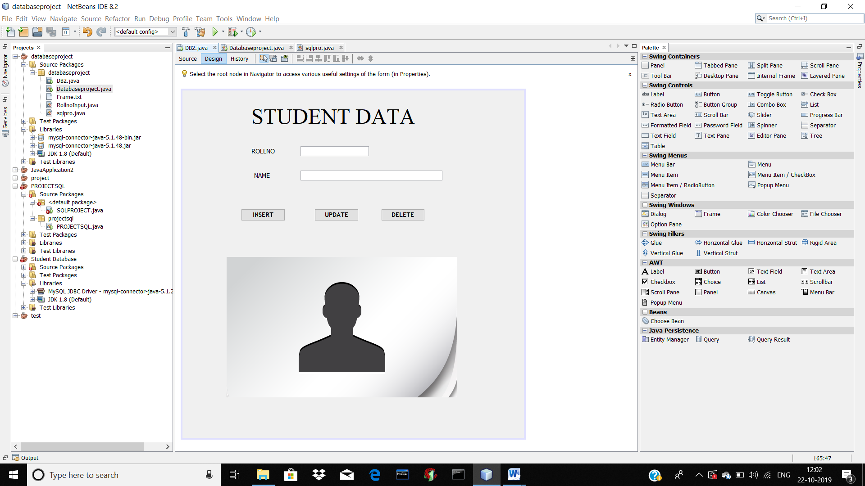

INSERT DATA

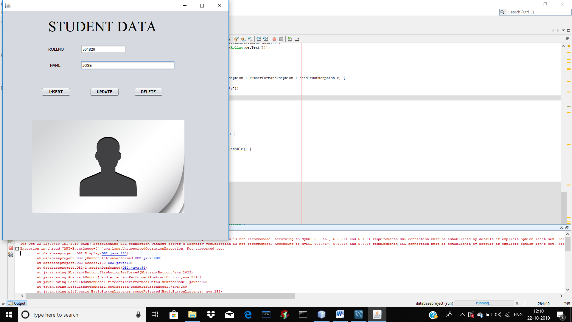

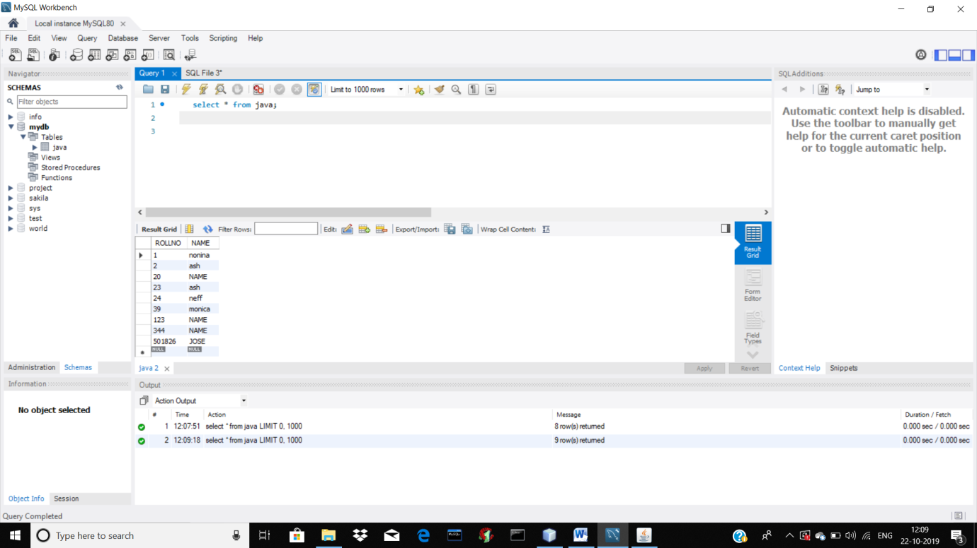

UPDATE DATA

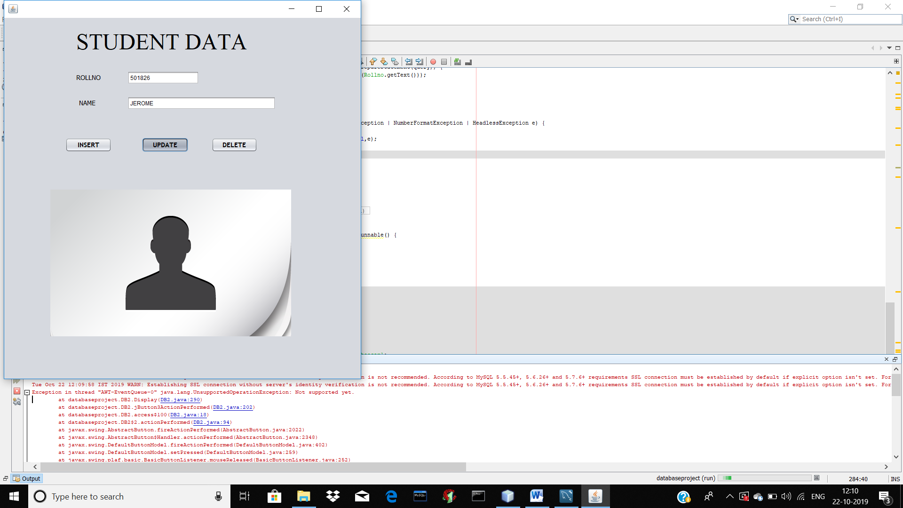

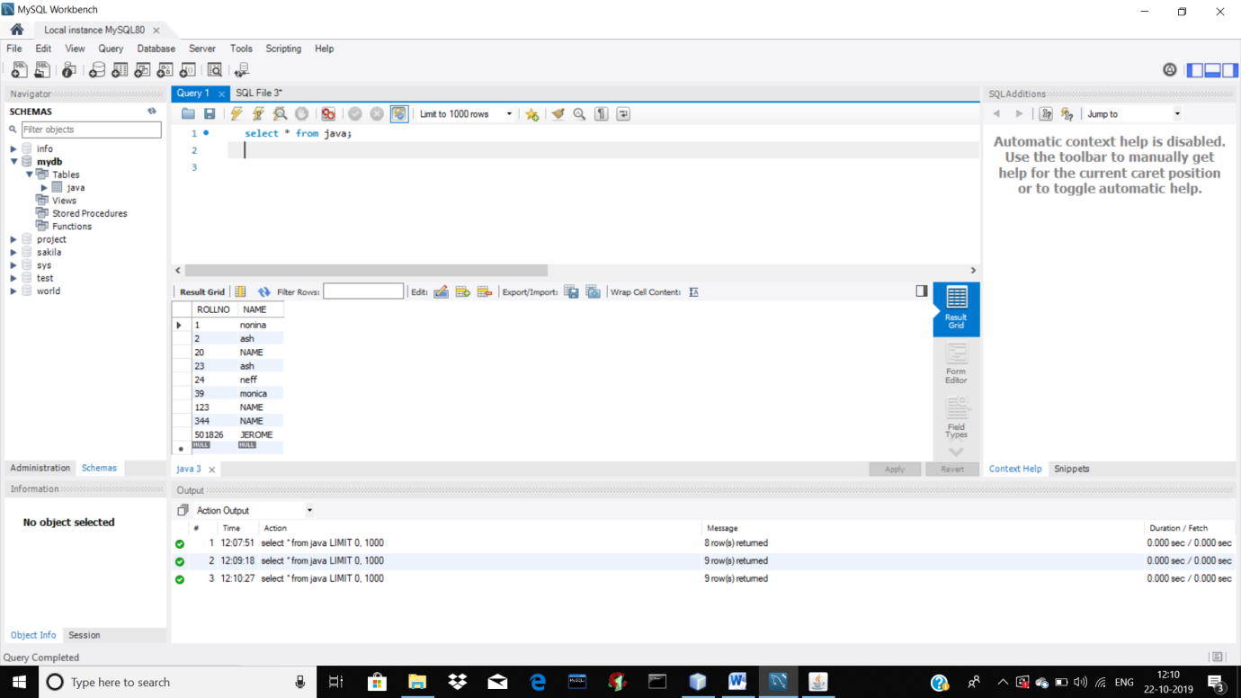

DELETE DATA

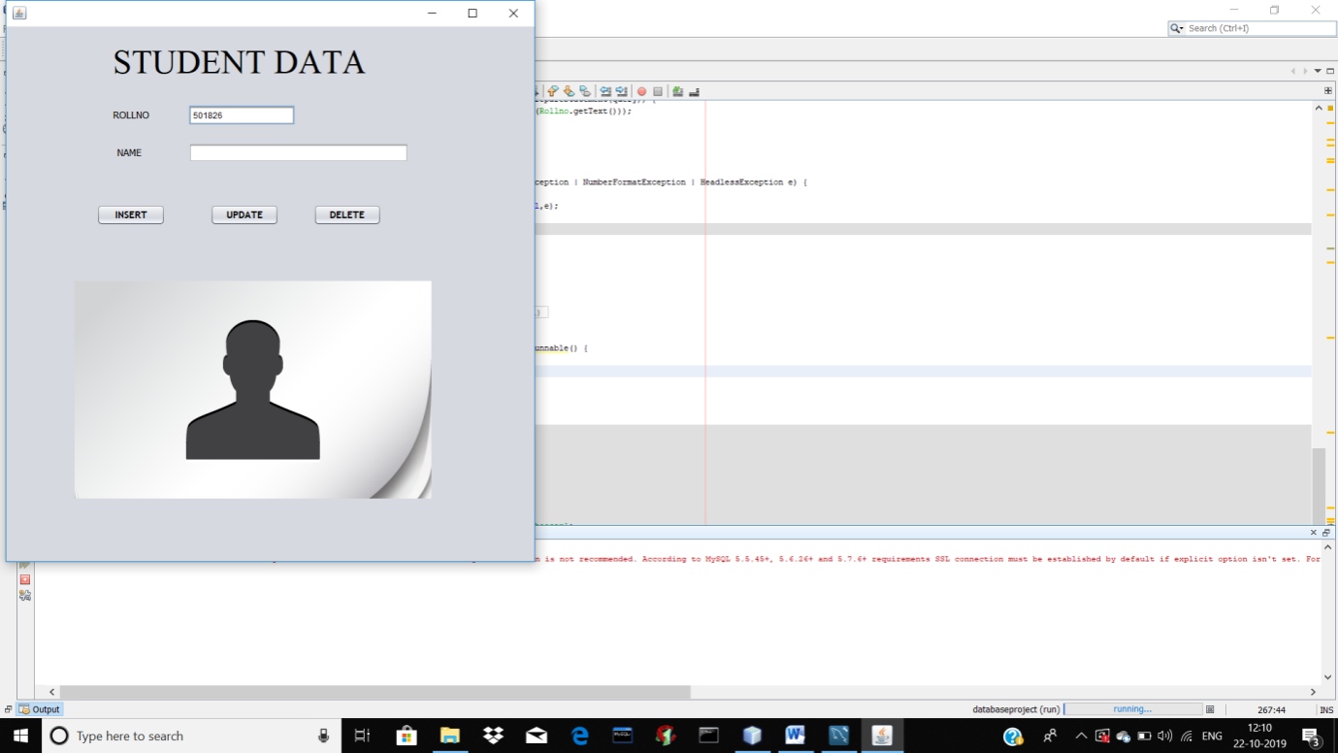

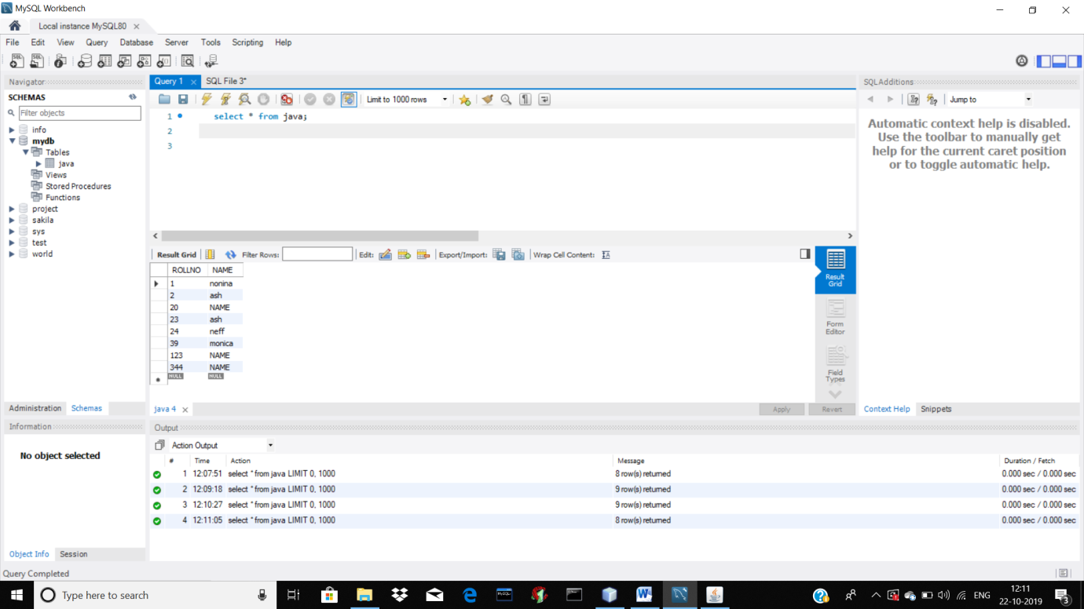

REFERENCE-

[https://www.waytoeasylearn.com/2018/11/about-jdbc.html?m=1](https://www.waytoeasylearn.com/2018/11/about-jdbc.html?m=1" \t "_blank)

[http://cs-fundamentals.com/java-programming/java-jdbc-connection-tutorial.php#jdbc-connection-create-database](http://cs-fundamentals.com/java-programming/java-jdbc-connection-tutorial.php" \l "jdbc-connection-create-database" \t "_blank)

|  |  |
| --- | --- |
|  |  |

BY- 501826

501839

501846