Monica Cornejo

May 18, 2021

Foundations of Databases & SQL Programming

Assignment06

Module 6: Questions

# Introduction

In this document, I will answer the questions from Assignment06 regarding SQL Views and the differences and similarities between Views, Functions, and Stored Procedures.

# Content

## Explain when you would use a SQL View

You can use a view for the following cases:

1. To store complex Select queries without having to retype them. The code in a view function is stored within the Database, under the Views folder.

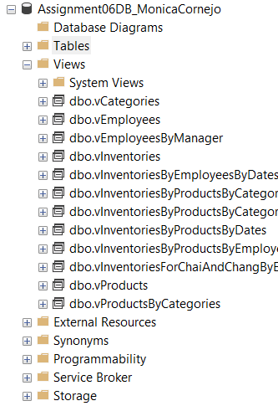

Figure 1 Views stored in the “Assignment06DB_MonicaCornejo” database.

1. To restrict access to specific columns from a table, using the Deny or Grant statements, to protect the private data with permissions.
2. To protect a table from being dropped, using the Schema Binding statement.
3. To keep changes to your database structure (original table) from breaking applications that depend on your tables.

## Explain are the differences and similarities between a View, Function, and Stored Procedure

## View

A view is considered a *virtual table* because it can perform the same operations as a table would, but it is created only when you use the view; then, it is deleted. This helps to maintain information in the views updated each time it is used.

## Function

A function is a set of SQL statements that perform a specific task. (<https://www.sqlshack.com/use-sql-server-built-functions-create-user-defined-scalar-functions/#:~:text=A%20function%20is%20a%20set,that%20perform%20a%20specific%20task.&text=Next%20time%20instead%20of%20rewriting,perform%20a%20variety%20of%20tasks>, 2021) External Link.

There are built-in functions and User Defined Functions (UDF), and they can return either a table of values or a single value.

### Functions with Parameters

Parameters change the results of the query as it is executed.

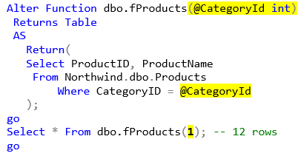

Figure Function With Parameters expressed between Parenthesis.

### Scalar Functions

These type of functions returns a single value instead of a table.

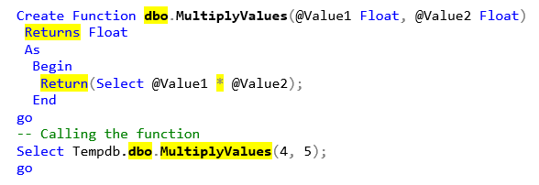

Figure Scalar Function representing a multiplication between two variables

## Stored Procedure

Stored Procedures are a named set of statements that can also be saved within the Database, such as Views and Functions, and can be called as part of a query to add an abstraction layer and simplify the code.

# Summary

In this Module, I answered all the questions related to the three abstraction layers and explained the differences between them: Views, Functions, and Stored Procedures. I gave code examples for the Scalar Functions and Functions with Parameters.