Veha Technologies – Internship
Day 2 Task

Title: Linux Basics – File Permissions and Editors.
Date: 16/09/2025
Intern Name: Monica

Objective

Understand how Linux uses a permissions system to determine who can read, write, and execute files and directories. Learning and practicing the nano and vi editors for creating, editing, and managing text files directly from the command line.

Linux File Permissions and Editors
Linux protects files and directories by assigning access rights to three types of users: the owner, the group, and others. These rights come in three basic types:
- Read (r): View file content or list directory contents.
- Write (w): Modify a file or add/delete files in a directory.
- Execute (x): Run an executable file or enter a directory.
To see the permissions of files and directories, use the ls -l command. The output will show a 10-character string at the beginning of each line.
Example output: drwxr-xr-x 2 user1 group1 4096 Sep 6 10:00 my_directory
Here is a breakdown of the permission string:
- 1st character: Indicates the file type (- for a regular file, d for a directory).
- Characters 2-4: Permissions for the owner (rwx in this example).
- Characters 5-7: Permissions for the group (r-x). A dash (-) indicates no permission.
- Characters 8-10: Permissions for others (r-x).
chmod (Change permissions):
Purpose: The chmod (change mode) command lets you modify permissions for a file or directory. You can use symbolic mode (using characters like u, g, o, +, -) or numeric mode (using a three-digit octal value).
Commands:
- chmod u+x my_notes.txt Adds execute permission for the owner.
- chmod go-w my_notes.txt Removes write permission for the group and others.
- Chmod a=rwx my_directory Sets all permissions for all user types.
Outputs:
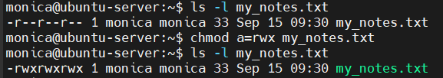
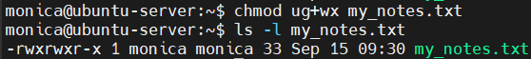
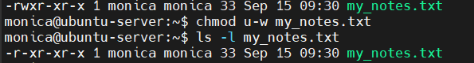
Numeric mode:
Numeric mode uses a three-digit number to define permissions for the owner, group, and others. The values are:
- 4: read (r)
- 2: write (w)
- 1: execute (x)
- 0: no permissions (-)
To find the correct digit, sum the values for the desired permissions. For example, read (4) + write (2) = 6 (read/write). Read (4) + execute (1) = 5 (read/execute).
Command:
- chmod 755 my_notes.txt
- Gives read, write, and execute to the owner (4+2+1=7), and read and execute to the group and others (4+1=5).
Output:
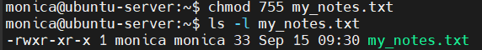
Chown (change ownership);
Purpose: Changes the user owner of a file or directory. Requires superuser privileges (sudo).
Command:
- sudo chown newuser file.txt changes the owner to newuser.
Output:
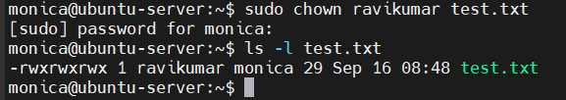
Chgrp (change group):
Purpose: Changes only the group ownership of a file or directory.
Command:
- sudo chgrp newgroup file.txt Changes the group to newgroup.
- sudo chown -R newuser:newgroup my_notes.txt Recursively changes the group for a directory.
Output:
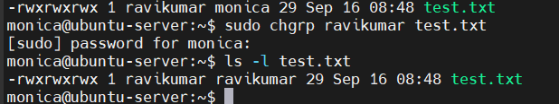
Change both owner and group:
Command:
- sudo chown newuser:newgroup file.txt Changes both the owner and group.
- sudo chown -R newuser:newgroup my_project/ Recursively changes the owner and group for a directory.
Output:

Nano Editor:
The nano editor is a simple, beginner-friendly editor.
Purpose: To create or open a file. We can begin typing and editing immediately after opening file.
Commands:
- nano filename.txt to create or open/edit the existing file.
- Ctrl + O Save the file (O for Output).
- Ctrl + X Exit nano.
- Ctrl + W Search for test (W for Where Is).
Outputs:
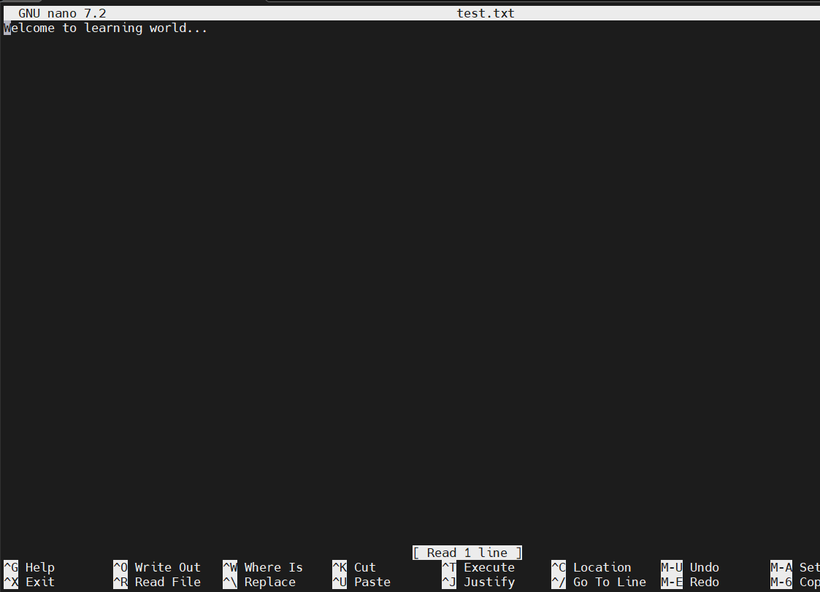
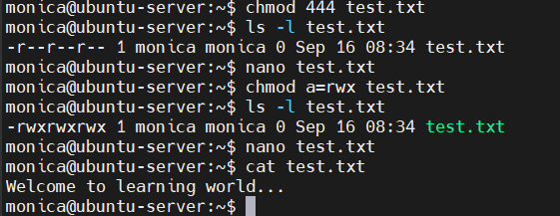

Vi Editor:
vi and its more feature-rich counterpart vim are more powerful but have a steeper learning curve because they operate in different "modes".
Purpose: To create or open a file. We can begin typing and editing immediately after opening file.
Navigation modes:
- Command Mode: This is the default mode when you open a file in vi. In this mode, you can move the cursor and run commands, but you cannot type text directly.
- Insert Mode: To begin typing, press the i key to enter Insert Mode. The word -- INSERT -- will appear at the bottom of your screen to confirm.
- Switch back to Command Mode: To stop inserting text and re-enter Command Mode, press the Esc key.
To save and exit:
- From Command mode, type :wq and press Enter to write (save) and quit.
- To quit without saving, type :q! and press Enter. The exclamation mark forces the command.
Commands:
- vi file3.txt open the file.
- i insert content.
- :wq to save and quit.
- :ql to quit without saving.

Outputs:
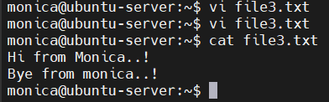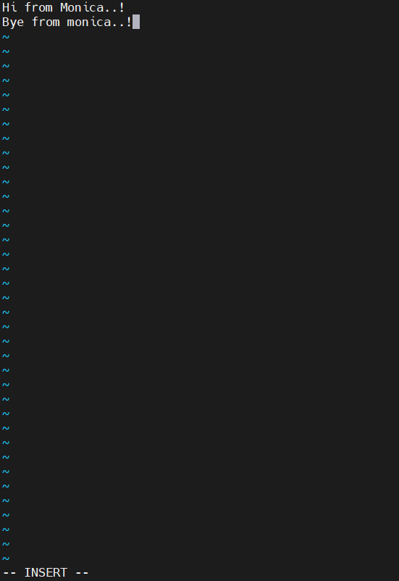
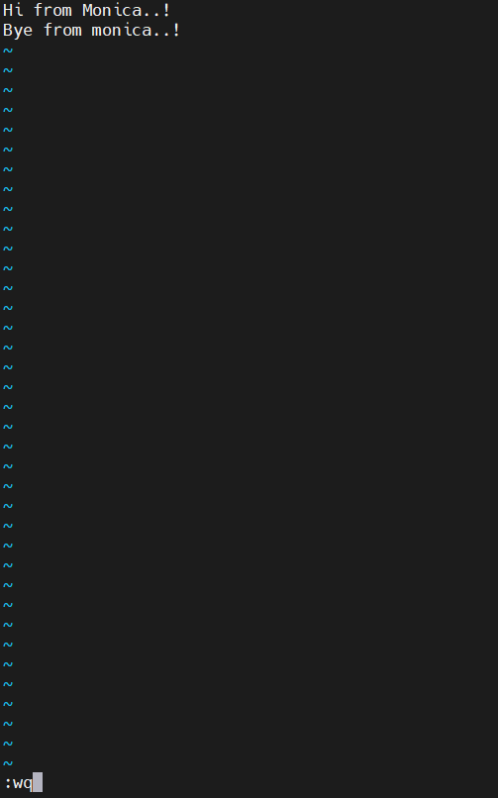

Challenges / Issues
While working with the vi editor, I found it challenging to practice and remember the various commands.

Learning / Observations
I have learned that Linux file permissions are essential for controlling who can read, write, or execute files and directories. Learned how to grant and restrict the permissions for the all users to access the files and directories. I also practiced editing files with the nano editor, which offers a simple and beginner-friendly interface. Additionally, I learned to use the vi editor, which, though more complex, provides powerful editing features through its different modes.

Screenshot / Code Snippets



