DATASTRUCTURE & ALGORITHMS

**TOPICS TO BE COVERED**

***DATASTRUCTURES:***

1. Linked Lists
2. Doubly Linked Lists
3. Stacks & Queues
4. Binary Search Trees
5. Hash Tables
6. Graphs

***ALGORITHMS:***

1. Bubble Sort
2. Selection Sort
3. Insertion Sort
4. Merge Sort
5. Quick Sort
6. Tree Traversal

* Breadth First Search
* Depth First Search - Pre Order
* Depth First Search - Post Order
* Depth First Search - In Order

***COURSE TAKEN FROM UDEMY:***

[Java Data Structures & Algorithms + LEETCODE Exercises (udemy.com)](https://dxc.udemy.com/course/data-structures-and-algorithms-java/learn/lecture/27815396#overview)

**BIG O NOTATION**

* Time Complexity – Calculated Based on how long (time) it takes to execute the code
* Space Complexity – Calculated Based on how much space is consumed when code is executed

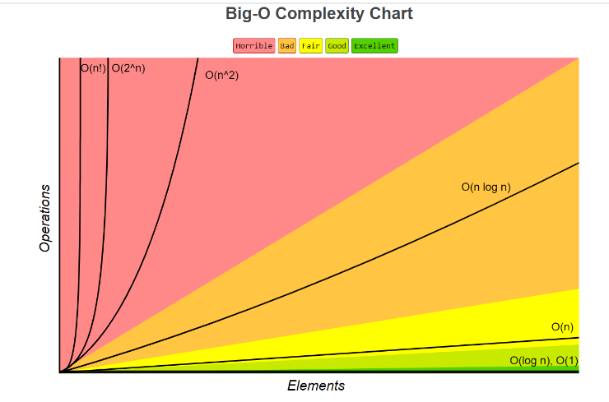***CATERGORIES OF BIG – O:***

* *LINEAR TIME – O(n)*
* *LINEAR TIME- DROP CONSTANTS.*
* *QUADRATIC TIME – O(n^2)*
* *DROP NON-DOMINANTS*
* *CONSTANT TIME - O (1)*
* *LOGARITHMIC TIME -O (log n)*
* *QUASILINEAR TIME – O (n log n)*
* *DIFFERENT TERM OF INPUTS*

*For O(n) & O(n^2)*

***LINEAR TIME – O(n)***

*Examples:*

* *Looping through an element in an array*
* *Searching through a Linked List*

package com.big.o;  
  
public class LinearTime {  
//O(n) - LinearTime Example  
 public static void printItems(int n){  
 for(int i =0; i< n ;i++){  
 System.*out*.println(i);  
 }  
 }  
 public static void main(String[] args){  
 *printItems*(10);  
 }  
}

***LINEAR TIME- DROP CONSTANTS***

*O(Xn), where X may be 1,2,3…etc.*

*n + n = 2n , where we drop constants, and it becomes O(n)*

package com.big.o;  
  
public class LinearTime_dropConstants {  
//O(2n) or O(3n)... O(Xn) = Drop Constants and its O(n) - Linear Time Example  
 public static void printItems(int n){  
 for(int i =0; i< n ;i++){  
 System.*out*.println(i);  
 }  
 for(int j =0; j< n ;j++){  
 System.*out*.println(j);  
 }  
 }  
 public static void main(String[] args){  
  
 *printItems*(10);  
 }  
}

***QUADRATIC TIME – O(n^2)***

***n * n = n2 🡺 O(n2)***

*EXAMPLES :*

* *Insertion Sort*
* *Selection Sort*
* *Bubble Sort*
* package com.big.o;  
    
  public class QuadraticTime {  
    
   //O(n Exponent of 2) - n * n = n exponent 2  
    
   public static void printItems(int n){  
   for(int i =0; i< n ;i++){  
   for(int j =0; j< n ;j++){  
   System.*out*.println(i + " " +j);  
   }  
   }  
    
   }  
   public static void main(String[] args){  
    
   *printItems*(10);  
   }  
  }

***DROP NON-DOMINANTS***

***O(n2+ n) = O(n2) ,where + n is dropped***

*If n =100, (n2) = 1000 and n = 100*

*Here* ***(n2) is Dominant*** *and* ***n is Non – Dominant***

package com.big.o;  
  
public class QuadraticTime_NonDominant_Drop {  
 /*O(n2+ n ) = O(n2) ,where + n is dropped  
 If n =100, (n2) = 1000 and n = 100  
 Here (n2) is Dominant and n is Non – Dominant*/  
 public static void printItems(int n){  
 for(int i =0; i< n ;i++){  
 for(int j =0; j< n ;j++){  
 System.*out*.println(i + " " +j);  
 }  
 }  
 for( int k = 0; k < n ; k++){  
 System.*out*.println(k);  
 }  
 }  
 public static void main(String[] args){  
 *printItems*(10);  
 }  
}

***CONSTANT TIME – O(1)***

*n + n 🡺 No of Operations is only one, so O(1)*

*As n grows, No of Operations always stays constant*

*Examples:*

* *Random Access of an element in an array*
* *Insertion at the beginning of the LinkedList*
* package com.big.o;  
    
  public class ConstantTime {  
   /*  
   n + n ⎝ No of Operations is only one, so O(1)  
   As n grows, No of Operations always stays constant*/  
    
    
   public static void printItems(int n){  
   System.*out*.println(n+n);  
   }  
   public static void main(String[] args){  
    
   *printItems*(10);  
   }  
  }

***LOGARITHMIC TIME – O(log n)***

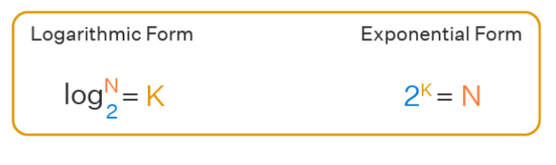

*If N = 8,*

*Log2N = K 🡺 Log28 = 3, i.e. 23=8*

*EXAMPLES:*

* *Binary Search*

*Here I want to find number 1 from an array.*

8

7

6

5

1

2

4

3

**OMIT IF TARGET NOT FOUND**

Split the Array into Two Halves equally

**Step = 1**

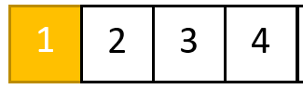 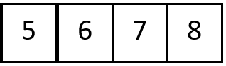

**OMIT IF TARGET NOT FOUND**

**Step = 2**

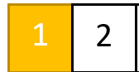 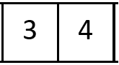

**Step = 3**

**OMIT IF TARGET NOT FOUND**

 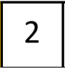

***QUASILINEAR TIME – O(n log n)***

*EXAMPLES*

* *Quick Sort*
* *Merge Sort*
* *Heap Sort*

***DIFFERENT TERM OF INPUTS***

* *Linear Time – O(n)*
* *Quadratic Time - O(n^2)*

*Linear Time – O(n) 🡺 if Two Inputs a, b then O (a +b)*

package com.big.o;  
  
public class DiffTermInputs1 {  
 public static void printItems(int a, int b){  
 for(int i =0; i< a ;i++){  
 System.*out*.println(i);  
 }  
 for(int j =0; j< b ;j++){  
 System.*out*.println(j);  
 }  
 }  
 public static void main(String[] args){  
  
 *printItems*(5,4);  
 }  
}

*Quadratic Time - O(n^2)🡺 if Two Inputs a, b then O (a * b)*

package com.big.o;  
  
public class DiffTermInputs2 {  
 public static void printItems(int a, int b){  
 for(int i =0; i< a ;i++){  
 for(int j =0; j< b ;j++){  
 System.*out*.println(i + " " +j);  
 }  
 }  
 }  
 public static void main(String[] args){  
  
 *printItems*(5,4);  
 }  
}

***BIG O ARRAYLIST***

* *If Adding or Removing an Element at Last Index of An array, then Time Complexity is O(1)*
* *If Adding or Removing an Element at First or Middle Index of an array, then Time Complexity is O(n)*
* *If fetching the value from an array using that specific value, then Time Complexity is O(n)*
* *If fetching the value from an array using that specific index, then Time Complexity is O(1)*

package com.big.o;  
  
import java.util.ArrayList;  
import java.util.Arrays;  
import java.util.List;  
  
public class BigOarrayList {  
 public static void main(String[] args){  
 List<Integer> myList = new ArrayList<Integer>(Arrays.*asList*(3,5,7,9,11));  
 myList.add(13);  
 System.*out*.println("Element Added " +myList);  
 myList.remove(5);  
 System.*out*.println("Element Removed " +myList);  
 myList.add(1,0);  
 System.*out*.println("Element Removed " +myList);  
 myList.remove(1);  
 System.*out*.println("Element Removed " +myList);  
 }  
}

***BIG O CHEAT SHEET***

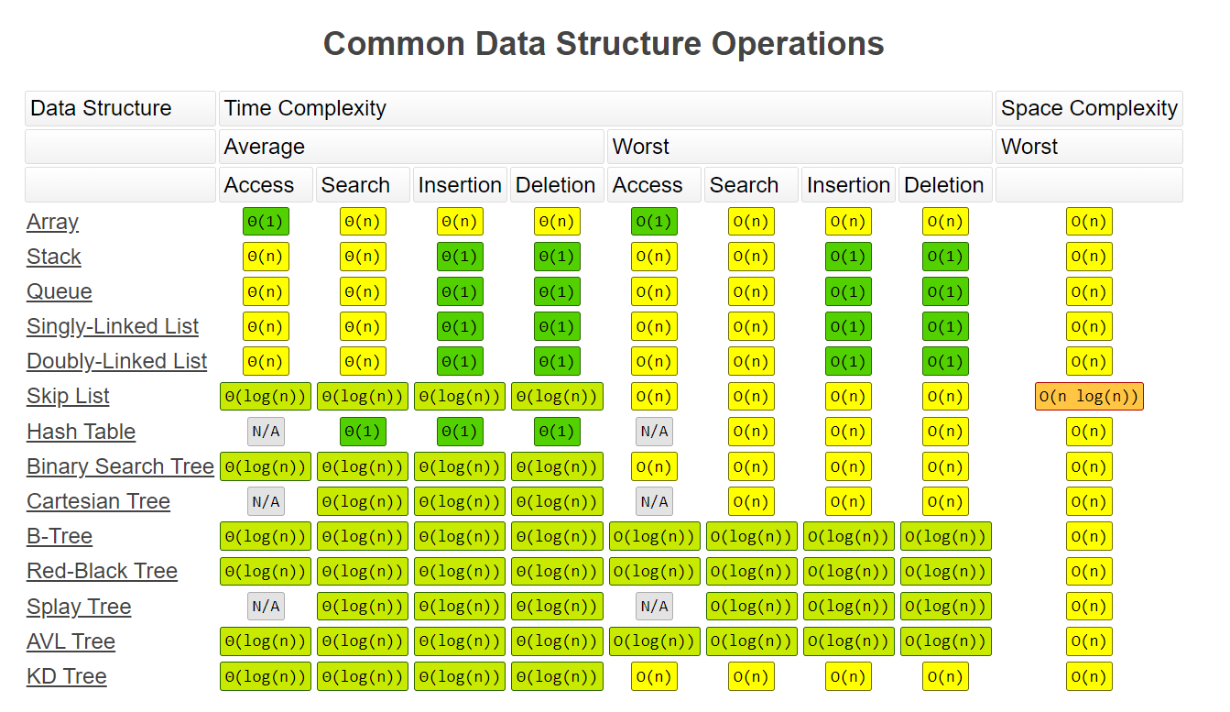

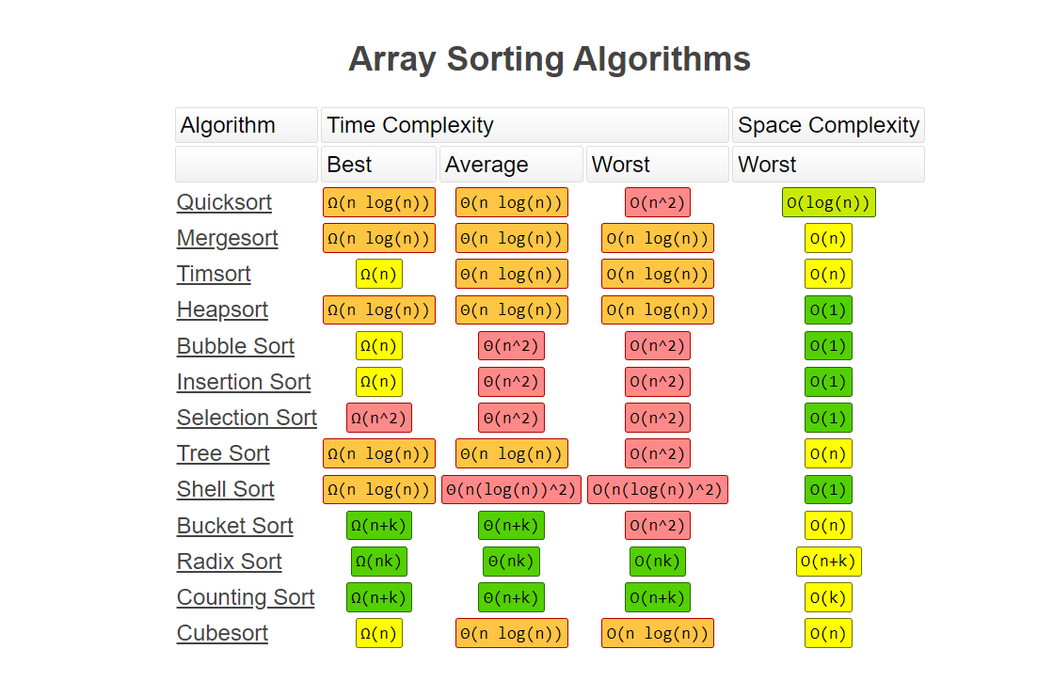

***CLASSES :***

package com.classes;  
  
public class Cookie {  
 private String color;  
  
 public Cookie(String color) {  
 this.color = color;  
 }  
 public String getColor() {  
 return color;  
 }  
 public void setColor(String color) {  
 this.color = color;  
 }  
  
}

package com.classes;  
  
// Press Shift twice to open the Search Everywhere dialog and type `show whitespaces`,  
// then press Enter. You can now see whitespace characters in your code.  
public class Main {  
 public static void main(String[] args) {  
  
 Cookie cookieOne = new Cookie("Yellow");  
 Cookie cookieTwo = new Cookie("Red");  
 cookieOne.setColor("Pink");  
 System.*out*.println(cookieOne.getColor());  
 System.*out*.println(cookieTwo.getColor());  
 }  
}

***POINTERS:***

*Without Pointers Example:*

package com.pointers;  
import java.sql.SQLOutput;  
public class WithoutPointers {  
 public static void main(String[] args){  
 int num1 = 11;  
 int num2 = num1;  
 num1 = 22;  
 System.*out*.println(num1);  
 System.*out*.println(num2);  
 }  
}

*With Pointers Example:*

package com.pointers;  
import java.util.HashMap;  
public class WithPointers {  
 public static void main(String[] args){  
 HashMap<String,Integer> map1 = new HashMap<>();  
 HashMap<String,Integer> map2 = new HashMap<>();  
 map1.put("value",11);  
 map2 = map1;  
 map1.put("value",22);  
 System.*out*.println(map1);  
 System.*out*.println(map2);  
 }  
}

***DIFFERENEC BETWEEN ARRAYLIST AND LINKEDLIST***

|  |  |  |  |
| --- | --- | --- | --- |
|  | **ArrayList** | **LinkedList** | |
| Internal Implementation | Uses an array to store elements | Uses a doubly linked list to store elements |
| Access time | O(1) for random access, O(n) for insertion and deletion | O(n) for random access, O(1) for insertion and deletion |
| Memory usage | More memory is used for maintaining the size of the array | Less memory is used since only the elements and pointers are stored |
| Iteration performance | Fast, since elements are stored in contiguous memory locations | Slower, since elements are not stored in contiguous memory locations |
| Adding elements | Can be slow if the size of the array needs to be increased to accommodate new elements | Fast, since only pointers need to be updated |
| Removing elements | Can be slow if elements need to be shifted to fill the gap left by the removed element | Fast, since only pointers need to be updated |
| Thread safety | Not inherently thread-safe, but can be made thread-safe using synchronization. | Not inherently thread-safe, but can be made thread-safe using synchronization. |
| Use cases | Best suited for scenarios where random access is required and the list will not be modified frequently | Best suited for scenarios where insertion and deletion are frequent, and random access is not required. |

***BIG O -LINKEDLIST vs ARRAYLIST***

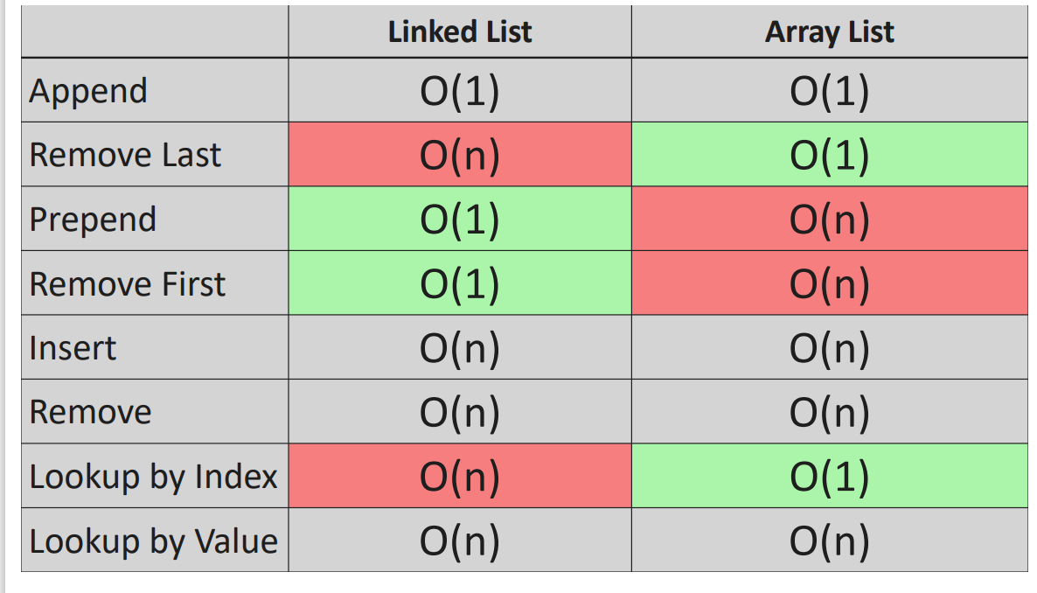

*LINKED LIST*

***LINKEDLIST –***

1. *Singly Linked List*
2. *Doubly Linked List*

***ADVANTAGES –***

1. *Dynamic Data Structures (Allocates needed memory while running)*
2. *Insertion and deletion of node is easy .O(1)*
3. *No/Low memory waste*

***DISADVANTAGE-***

1. *Greater Memory Usage (Additional Pointer)*
2. *No Random Access of Elements (no index[i])*
3. *Accessing/searching elements is more time consuming. O(n)*

***USES –***

1. *Implements stack/Queue*
2. *GPS Navigation*
3. *Music Playlist*
4. public class Test {  
    /LinkedList as STACK  
    LinkedList<String> stackList = new LinkedList<String>();  
    stackList.push("D");  
    stackList.push("W");  
    stackList.push("R");  
    stackList.push("A");  
    System.out.println(stackList);  
    System.out.println(stackList.pop());  
    // LinkedList as QUEUE  
    LinkedList<String> queueList = new LinkedList<String>();  
    queueList.offer("D");  
    queueList.offer("W");  
    queueList.offer("R");  
    queueList.offer("A");  
    System.out.println(queueList);  
    System.out.println(queueList.poll());  
   }

***CODING EXERCISE FOR LINKED LIST***

**EXERCISE 1 🡺LL: Constructor**

Write a Java class called **LinkedList** that represents a singly linked list.  
The class should have the following properties and methods:

1. A private **Node** object called **head** that points to the first node in the linked list.
2. A private **Node** object called **tail** that points to the last node in the linked list.
3. A private integer attribute called **length** that represents the number of nodes in the linked list.
4. A nested **Node** class with the following attributes:
   * An integer attribute called **value** that stores the value of the node.
   * A **Node** object called **next** that points to the next node in the linked list.
   * A constructor that accepts an integer **value** as an argument and initializes the **value** attribute.
5. A constructor for the **LinkedList** class that accepts an integer **value** as an argument and performs the following tasks:
   * Create a new **Node** object called **newNode** with the given **value**.
   * Set both the **head** and **tail** pointers of the list to the **newNode**.
   * Set the **length** attribute of the list to 1.

*  *

**EXERCISE 2 🡺LL: Append**

Implement the **append** method that appends a new node to the end of the linked list.  
Return type: **void**

The method should perform the following tasks:

1. Accept an integer **value** as an argument, which will be the value of the new node.
2. Create a new **Node** object called **newNode** with the given **value**.
3. If the length of the linked list is 0, set both the **head** and **tail** pointers of the list to the **newNode**.
4. If the length of the linked list is greater than 0, perform the following tasks:
   * Set the **next** attribute of the current **tail** node to the **newNode**.
   * Update the **tail** pointer of the list to point to the **newNode**.
5. Increment the **length** attribute of the list by 1.

* *

**EXERCISE 3 🡺LL: Remove Last**

Implement a method called **removeLast** that removes the last node from the linked list.  
Return type: **Node** (we are returning the Node that is being removed)

The method should perform the following tasks:

1. If the length of the linked list is 0, return null.
2. Create two variables that can point to a **Node** , **temp** and **pre**, both initially pointing to the head of the linked list.
3. Traverse the linked list until **temp.next** is null, performing the following tasks during traversal:
   * Update **pre** to point to the current **temp** node.
   * Update **temp** to point to the next node in the linked list.
4. After traversal, set the **tail** pointer to **pre**.
5. Set the **next** attribute of the **tail** node to null.
6. Decrement the **length** attribute of the list by 1.
7. If the length of the linked list becomes 0 after removing the last node, set both the **head** and **tail** pointers to null.
8. Return the removed node (pointed to by **temp**).

* *

**EXERCISE 4 🡺LL: Prepend**

Implement a method called **prepend** that adds a new node at the beginning of the linked list.  
Return type: **void**

The method should perform the following tasks:

1. Accept an integer value as an argument, which will be the value of the new node.
2. Create a new Node object called **newNode** with the given value.
3. If the length of the linked list is 0, set both the head and tail pointers of the list to the **newNode**.
4. If the length of the linked list is greater than 0, perform the following tasks:
   * Set the **next** attribute of **newNode** to the current head node.
   * Update the head pointer of the list to point to the **newNode**.
5. Increment the length attribute of the list by 1.

* *

**EXERCISE 5 🡺LL: Remove First**

Implement a method called **removeFirst** that removes the first node from the linked list and returns it.  
Return type: **Node** (the node that is removed)

The method should perform the following tasks:

1. If the length of the linked list is 0, return null.
2. Create a temporary Node object called **temp** and set it to the current head node.
3. Update the head pointer of the list to point to the next node in the list.
4. Set the **next** attribute of **temp** to null.
5. Decrement the length attribute of the list by 1.
6. If the length of the list becomes 0 after removing the first node, set the tail pointer to null.
7. Return the removed **temp** node.

* *

**EXERCISE 6 🡺LL: Get**

Implement a method called **get** that retrieves a node from the linked list by its index.  
Return type: **Node**

The method should perform the following tasks:

1. Accept an integer **index** as an argument, which will be the index of the node to be retrieved.
2. If the index is less than 0 or greater than or equal to the length of the linked list, return null.
3. Create a temporary Node object called **temp** and set it to the current head node.
4. Iterate through the linked list by updating **temp** to its next node until the desired index is reached.
5. Return the node located at the specified index.

 

**EXERCISE 7 🡺LL: Set**

Implement a method called **set** that updates the value of a node in the linked list by its index.  
Return type: **Boolean**

The method should perform the following tasks:

Accept an integer **index** as an argument, representing the index of the node to be updated.

1. Accept an integer **value** as an argument, representing the new value to set for the node at the specified index.
2. Call the **get** method with the provided index to obtain a pointer to the node at the specified index.
3. If the node exists (i.e., the **get** method returns a non-null value), update the node's value with the provided value and return true.
4. If the node does not exist (i.e., the **get** method returns null), return false.

* *

**EXERCISE 8 🡺LL: Insert**

Implement a method called **insert** that inserts a new node at a specified index in the linked list.  
Return type: **Boolean**

The method should perform the following tasks:

Accept an integer **index** as an argument, representing the index at which the new node should be inserted.

1. Accept an integer **value** as an argument, representing the value of the new node.
2. If the index is less than 0 or greater than the length of the list, return false.
3. If the index is 0, call the **prepend** method with the provided value and return true.
4. If the index is equal to the length of the list, call the **append** method with the provided value and return true.
5. Create a new Node object called **newNode** with the provided value.
6. Call the **get** method with the index minus 1 to obtain the node before the specified index.
7. Update the **next** attribute of the **newNode** to point to the **next** attribute of the node before the specified index.
8. Update the **next** attribute of the node before the specified index to point to the **newNode**.
9. Increment the length attribute of the list by 1.

 

**EXERCISE 9 🡺LL: Remove**

Implement a method called **remove** that removes a node at a specified index in the linked list.  
Return type: **Node** (the node that has been removed)

The method should perform the following tasks:

1. Accept an integer **index** as an argument, representing the index of the node to be removed.
2. If the index is less than 0 or greater than or equal to the length of the list, return null.
3. If the index is 0, call the **removeFirst** method and return its result.
4. If the index is equal to the length of the list minus 1, call the **removeLast** method and return its result.
5. Call the **get** method with the index minus 1 to obtain the node before the specified index.
6. Create a temporary Node object called **temp** and set it to the **next** attribute of the node before the specified index.
7. Update the **next** attribute of the node before the specified index to point to the **next** attribute of the temporary Node object.
8. Set the **next** attribute of the temporary Node object to null.
9. Decrement the length attribute of the list by 1.

* *

**EXERCISE 10 🡺LL: Reverse**

Implement a method called **reverse** that reverses the order of the nodes in the linked list.  
When solving the **reverse()** method, students are not allowed to create a new list or use any additional data structures besides the linked list itself.  
They must reverse the nodes in the existing linked list by manipulating the pointers between them.  
Return type: **void**

The method should perform the following tasks:

1. Create a temporary Node object called **temp** and set it to the **head** attribute of the list.
2. Set the **head** attribute of the list to the current **tail** attribute.
3. Set the **tail** attribute of the list to the temporary Node object.
4. Create a Node object called **after** and set it to the **next** attribute of the temporary Node object.
5. Create a Node object called **before** and initialize it to null.
6. Loop through the linked list using a for loop with a counter variable **i**, starting from 0 and ending at the **length** attribute of the list. a. Set the **after** attribute to the **next** attribute of the temporary Node object. b. Set the **next** attribute of the temporary Node object to the **before** attribute. c. Set the **before** attribute to the temporary Node object. d. Set the temporary Node object to the **after** attribute.
7. The method has no return value.

 