**Workshop 1 – Inlämning**

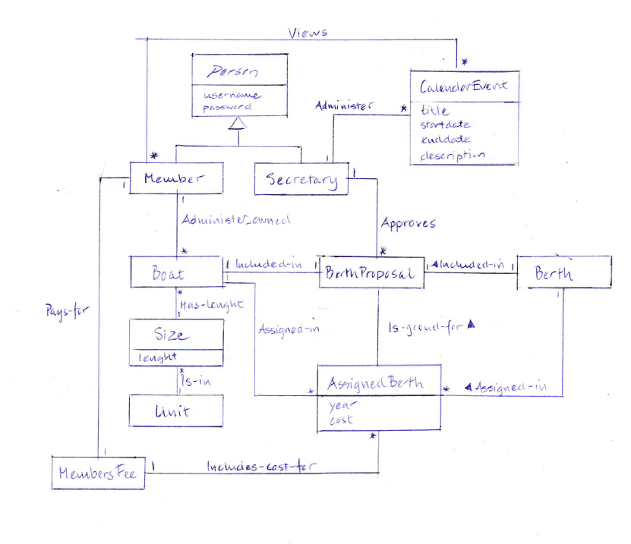

I assumed that a person needs to be authenticated to be using the system so I made Person an abstract conceptual superclass. I included the subclasses Member and Secretary as they are of interest in this iteration. Treasurer and Cashier are excluded as they don’t add anything extra to the domain model in this iteration. I added the attributes username and password for person as they are needed in the authentication use-case.

A member administers his/hers own boats and can register, alter or delete information. A member also pays a members fee which includes cost for assigned berths.

For the Boat I added Size and Unit at separate conceptual classes as I assumed size of a boat can be given in different units.

A member can also view CalendarEvents. I added the association view zero or many to cover the use-cases where the member views either a list of CalendarEvents or a specific event.

For the class BoatType I didn’t add the different types (sailboat etc) as I didn’t think they added anything more of value in this iteration and as they don’t have any associations or attributes that vary at this stage.

BerthProposal shows the proposed boat-berth assignments for current year. AssignedBerth shows the assignments for previous years and are also the ground for the BerthProposal.

The Secretary approves the BerthProposal and administers CalendarEvents.

I excluded different types of CalendarEvents (such as meeting and competition) as I didn’t think they would add anything more to the model at this stage.