HOMEWORK I (Part I) Report

Xx1011074 杜雪吟

Summary what has been done:

[universal counter]

* RTL level design - 16 bit counter (Fig.1)
* Pre-synthesis simulation (Fig.2 ~ Fig.9)
* Synthesis
* Post-synthesis simulation with Error (Fig.10)
* nLint analysis (Fig.11)
* README file for ucounter

[universal counter]

* Pre-synthesis simulation (Fig.12)
* Synthesis
* Post-synthesis simulation (Success!)
* nLint analysis (Fig.13)
* README file for alu

Required tools:

* Lab: NC-Verilog, Debussy (nTrace & nWave), Design Compiler(dv)
* Ubuntu: Icarus Verilog (iverilog), gtkwave, Dia

Learned lessons:

* Stuck:
  + Unfamiliar with Verilog language.
  + Design 16 bit counter with 8 bit counter modules.
  + Draw block diagram.

16 bit counter design:

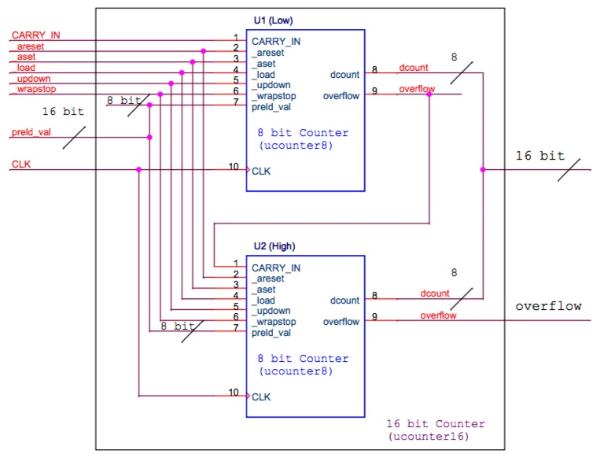

Fig 1: RTL level design - 16 bit counter

Pre-simulated waveforms:

* _areset

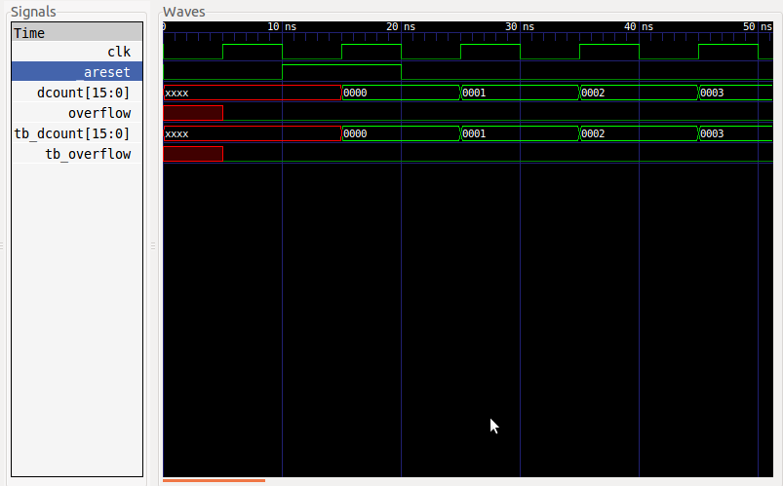

Fig 2: Pre-simulated waveforms for _areset

* _aset

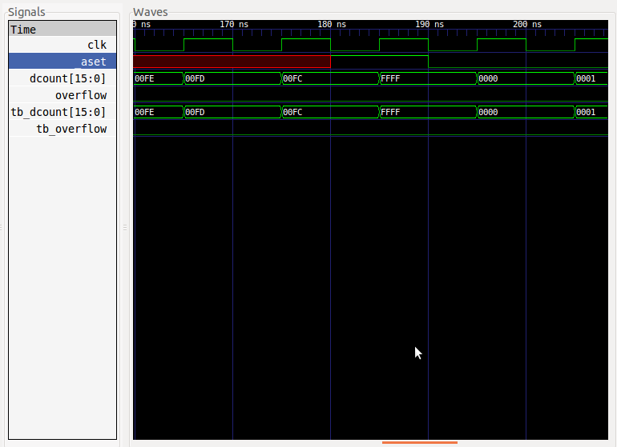

Fig 3: Pre-simulated waveforms for _aset

* _load and preld_val

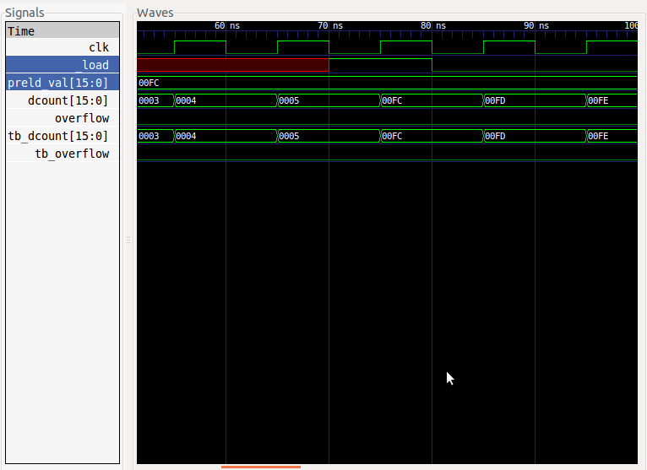

Fig 4: Pre-simulated waveforms for _load and preld_val

* _updown (up)

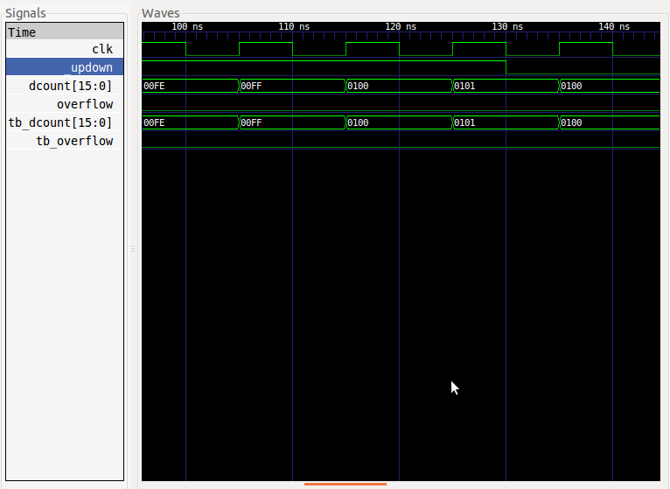

Fig 5: Pre-simulated waveforms for _updown (up)

* _updown (down)

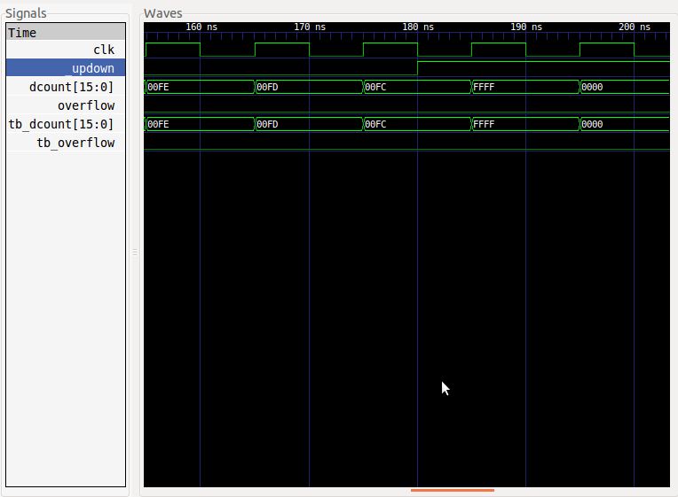

Fig 6: Pre-simulated waveforms for _updown (down)

* _wrapstop (cycle)

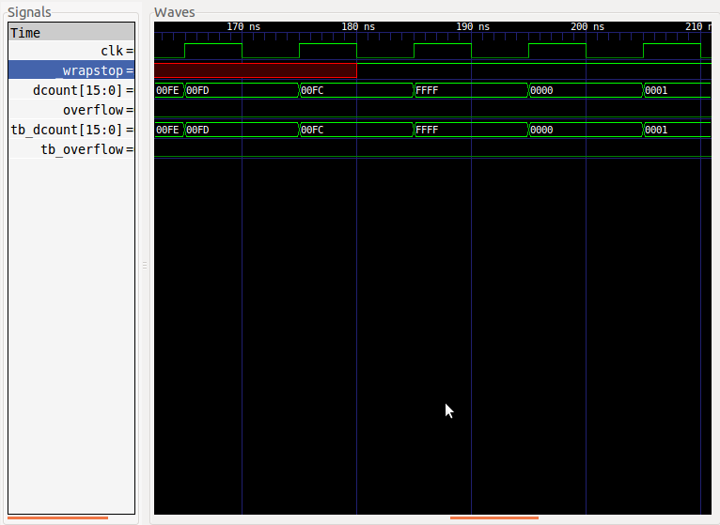

Fig 7: Pre-simulated waveforms for _wrapstop (cycle)

* _wrapstop (stop) and overflow

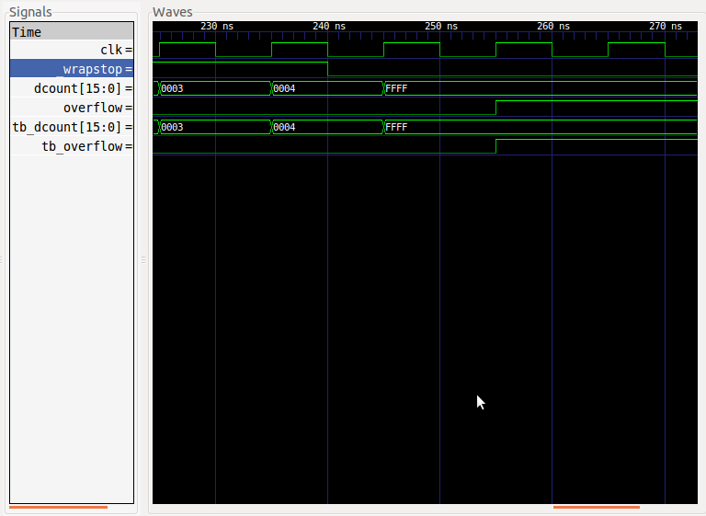

Fig 8: Pre-simulated waveforms for _wrapstop (stop) and overflow

* Know issue:

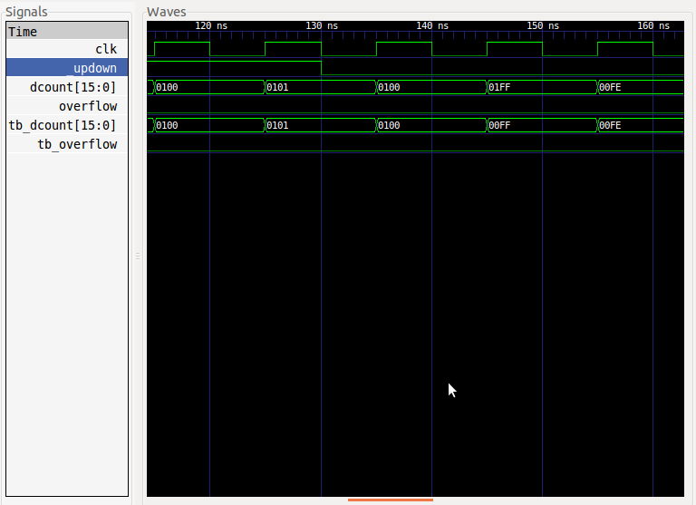

Fig 9: Result error.

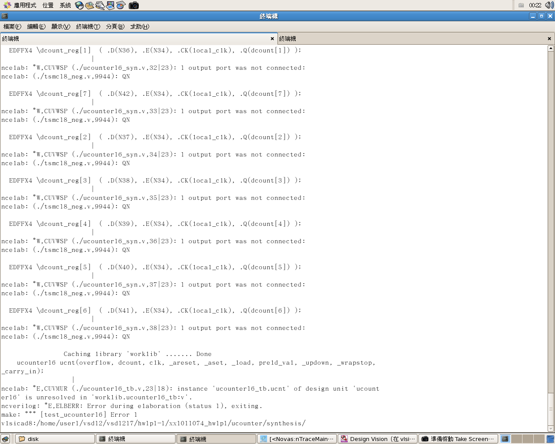

Fig 10: dv errors

EDFFX4 \dcount_reg[0] ( .D(N35), .E(N34), .CK(local_clk), .Q(dcount[0]) );

|

ncelab: *W,CUVWSP (./ucounter16_syn.v,31|23): 1 output port was not connected:

ncelab: (./tsmc18_neg.v,9944): QN

EDFFX4 \dcount_reg[1] ( .D(N36), .E(N34), .CK(local_clk), .Q(dcount[1]) );

|

ncelab: *W,CUVWSP (./ucounter16_syn.v,32|23): 1 output port was not connected:

ncelab: (./tsmc18_neg.v,9944): QN

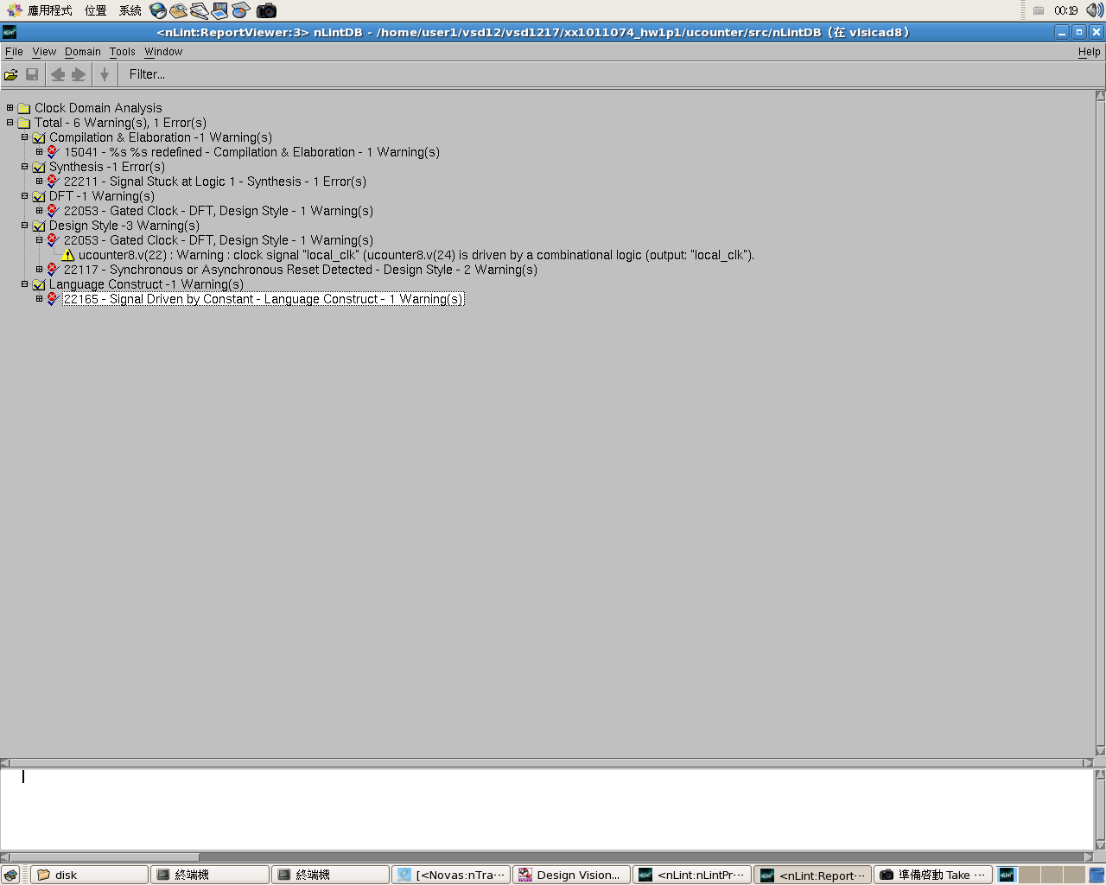

Fig 11: nLint errors (ucounter8.v & ucounter16.v)

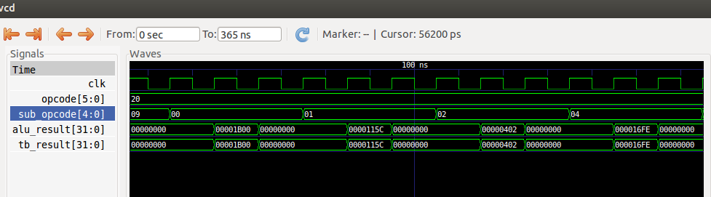

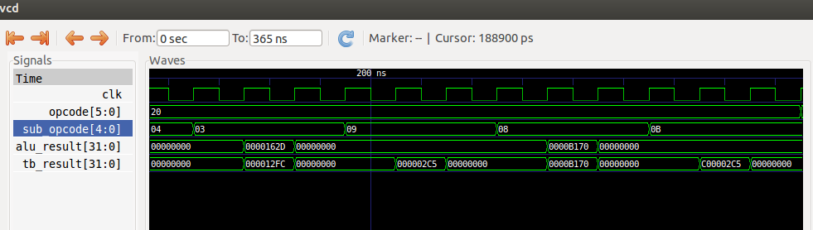

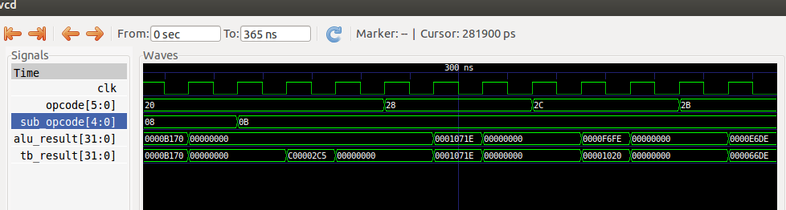

Fig 12: Waveform for ALU

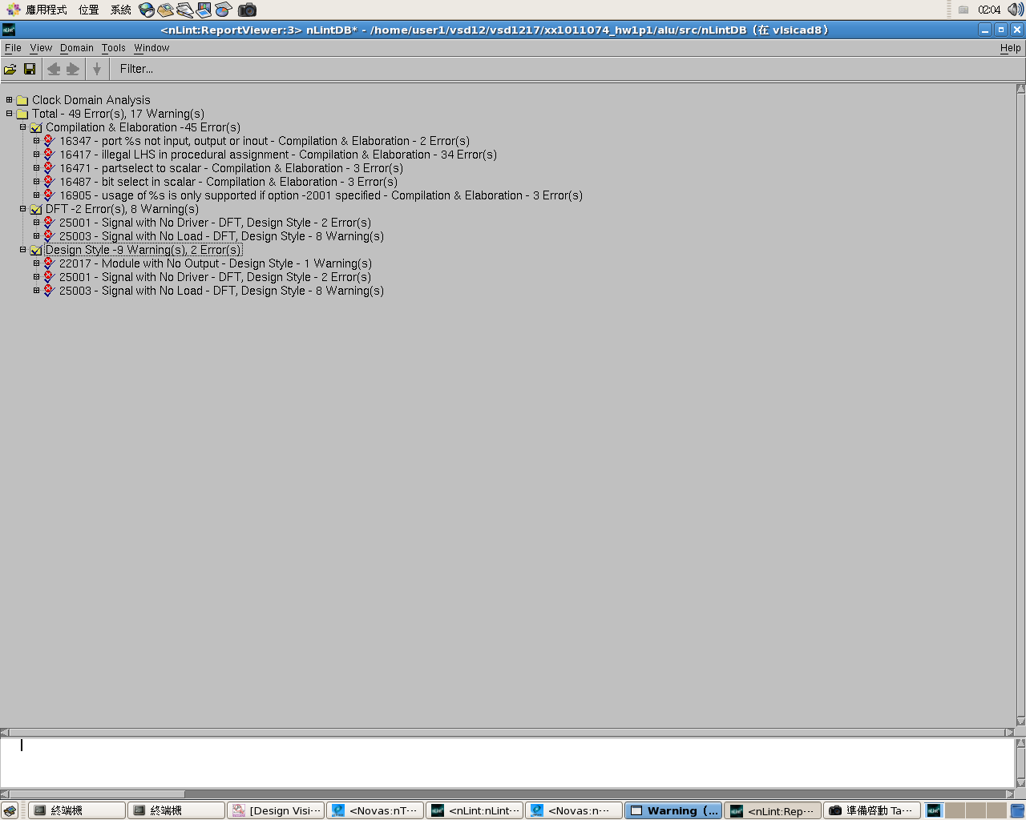

Fig 13: nLint errors (alu32.v)

ucounter

---------------------------------------------------------------------------------------------------

Usage:

$ cd ucounter

$ make test_ucounter16

Description:

RTL/ucounter16.v - Top module for 16 bit counter.

RTL/ucounter16_tb.v - Testbench for 16 bit counter.

RTL/ucounter8.v - Module for 8 bit counter.

RTL/ucounter8_tb.v - Testbench for 8 bit counter.

RTL/nLintErros - Screenshot of nLint errors.

pre-syn/ucounter16_tb.vcd - Dumped file.

pre-syn/ucounter16_tb.fsdb - Dumped file.

post-syn/ucounter16_syn.v - Timing report.

post-syn /ucounter16_syn.sdf - Timing information.

post-syn /ucounter16_tb.v - Modified file for gate level simulation.

post-syn /dv_erros - Error message at gate level simulation.

post-syn /dv_erros.png - Screenshot of dv errors.

alu

---------------------------------------------------------------------------------------------------

Usage:

$ cd alu

$ make test_alu32

Description:

RTL/alu32.v - Top module for 32 bit ALU.

RTL/alu32_tb.v - Testbench for 32 bit ALU.

RTL/nLintErros - Screenshot of nLint errors.

pre-syn/alu32_tb.vcd - Pre-synthesis dumped .vcd file.

pre-syn/ alu32_tb.fsdb - Pre-synthesis dumped .fsdb file.

post-syn/ alu32_syn.v - Timing report.

post-syn / alu32_syn.sdf - Timing information.

post-syn / alu32_tb.v - Modified file for gate level simulation.

pre-syn/alu32_tb.vcd - Post-synthesis dumped .vcd file

pre-syn/ alu32_tb.fsdb - Post-synthesis dumped .fsdb file