HOMEWORK I (Part 3/4/5) Report

Summary what has been done:

* RTL level design (16 bit counter)
* Pre-synthesis simulation
* Synthesis
* Post-synthesis simulation

Required tools:

* Lab: NC-Verilog, Debussy (nTrace & nWave), Design Compiler(dv)
* Ubuntu: Icarus Verilog (iverilog), gtkwave, Dia

Learned lessons:

* Stuck:
  + Unfamiliar with Verilog language.
  + Design 16 bit counter with 8 bit counter modules.
  + Draw block diagram.
* Find:
* Exciting things:

16 bit counter Design:

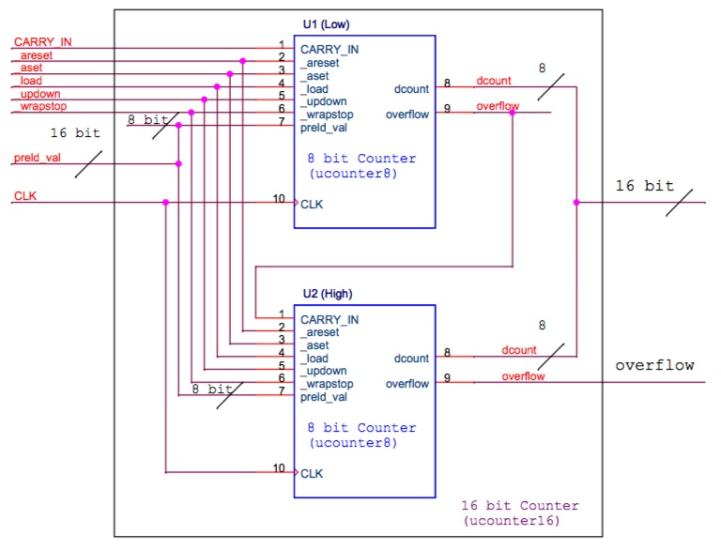

Part 3 pre-simulated waveforms:

* Test1. NOP

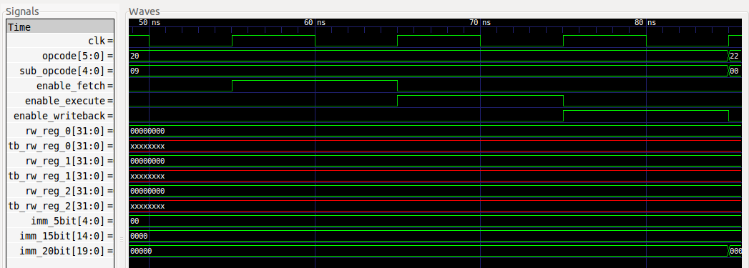

* Test 2. MOVI(rw_reg[0] = ‘h00C8)

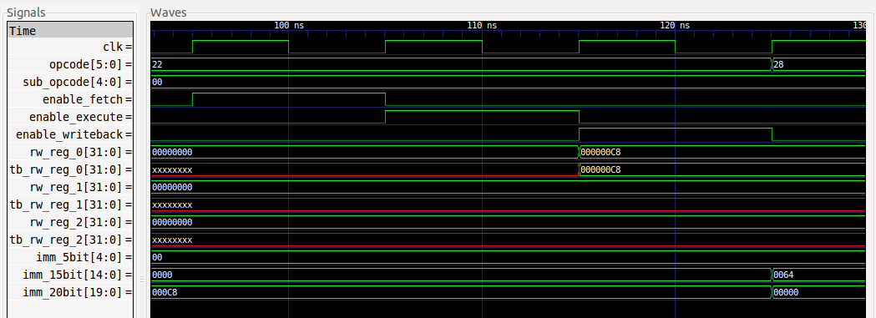

* Test 3. ADDI(rw_reg[1]=rw_reg[0]+’h0064)

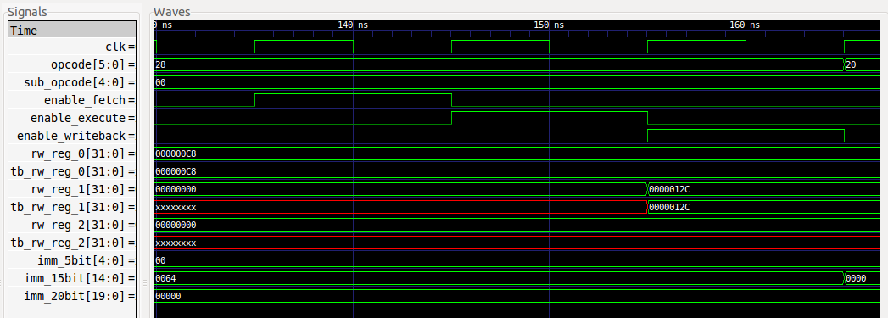

* Test 4. ADD(rw_reg[2]= rw_reg[0]+ rw_reg[1])

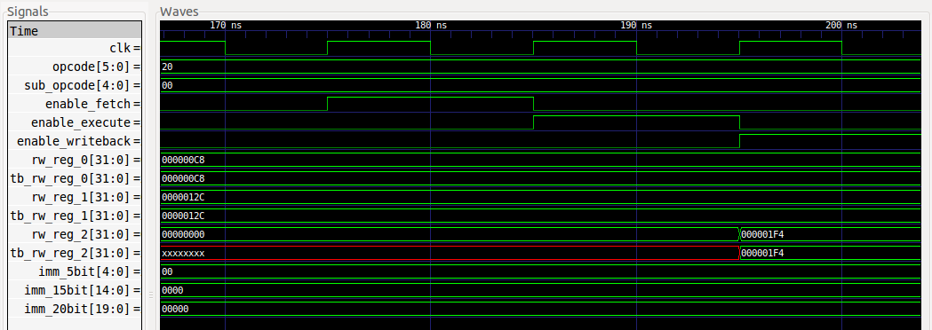

* Test 5. SUB(rw_reg[2]= rw_reg[1]- rw_reg[0])

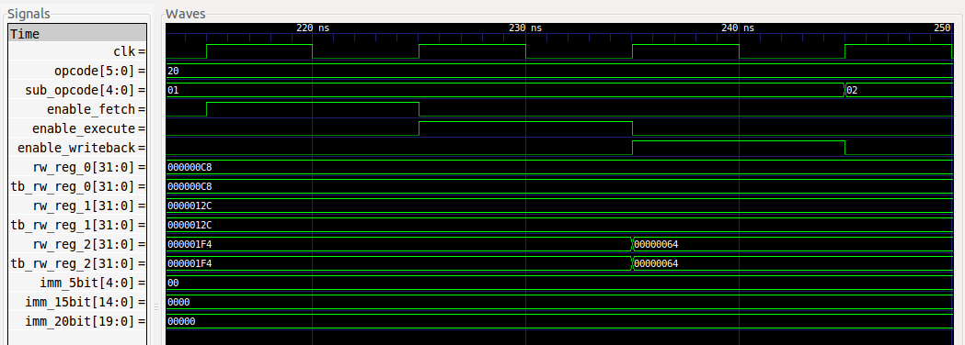

* Test 6. AND(rw_reg[2]= rw_reg[0]& rw_reg[1])

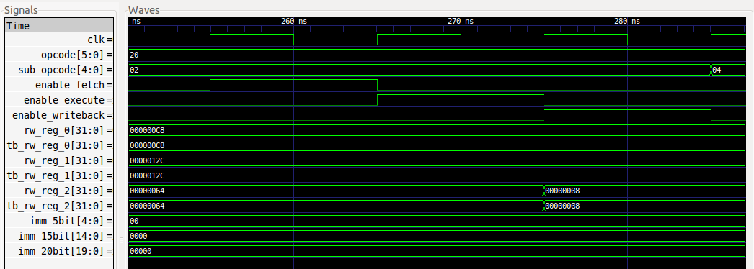

* Test 7. OR(rw_reg[2]= rw_reg[0]| rw_reg[1])

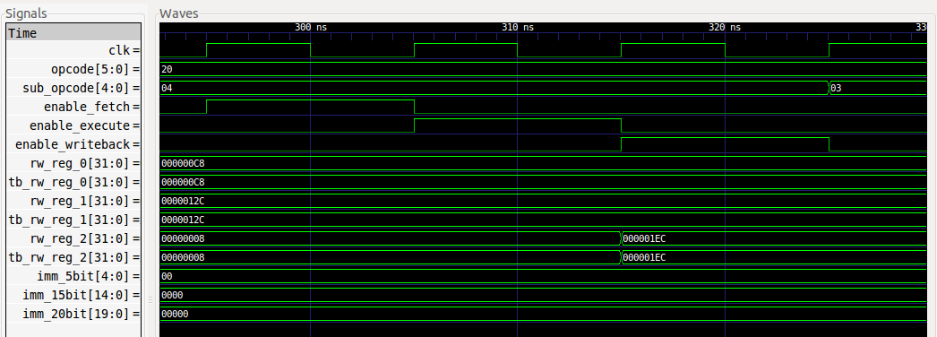

* Test 8. XOR(rw_reg[2]= rw_reg[0]^ rw_reg[1])

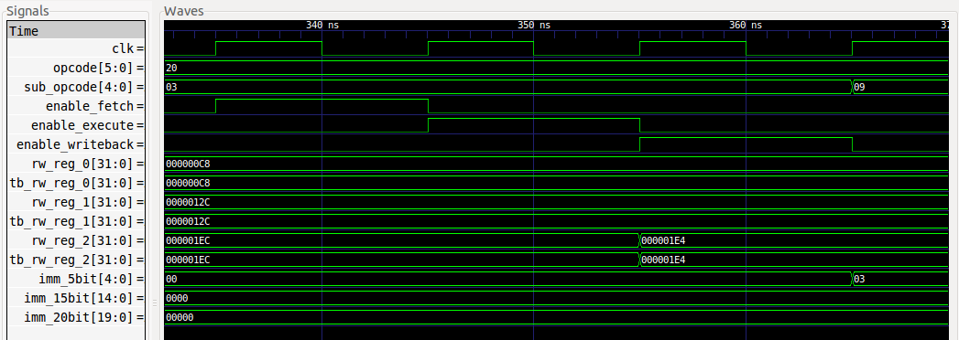

* Test 9. SRLI(rw_reg[2]= rw_reg[0]>>’h0003)

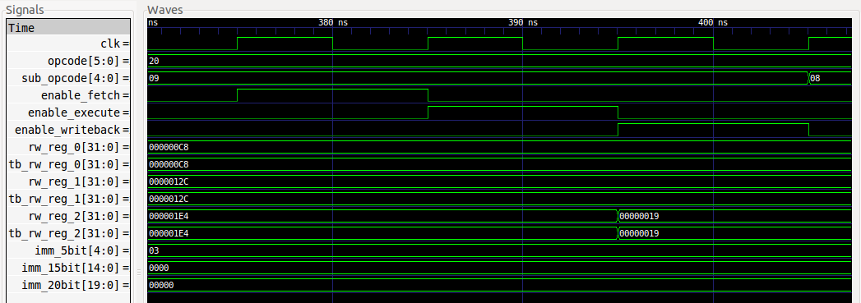

* Test 10. SLLI(rw_reg[2]= rw_reg[0] <<’h0003)

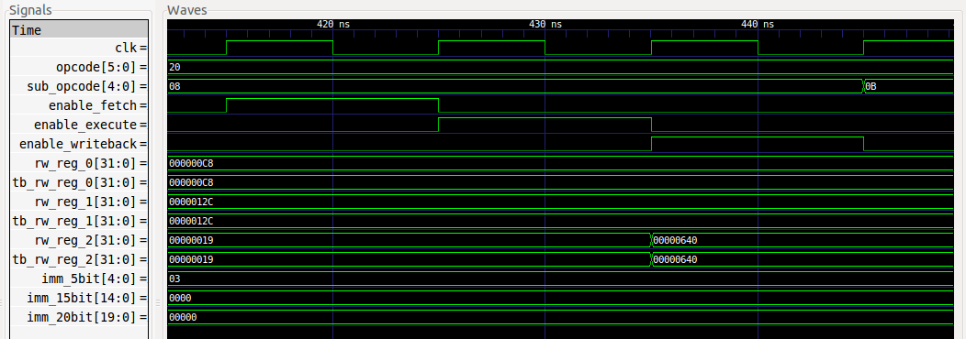

* Test 11. ROTRI(rw_reg[2]= rw_reg[0] >>’h0003)

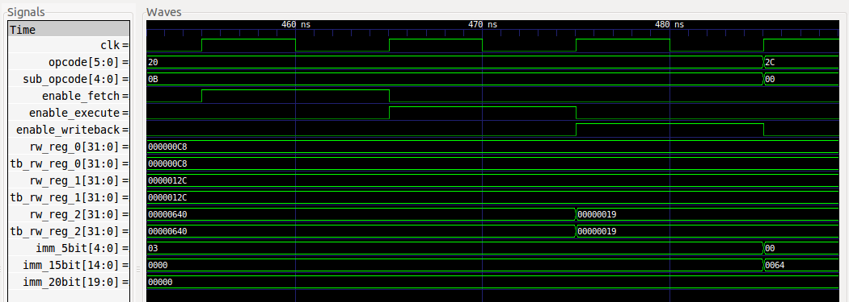

* Test 12. ORI(rw_reg[2]= rw_reg[0] |’h0064)

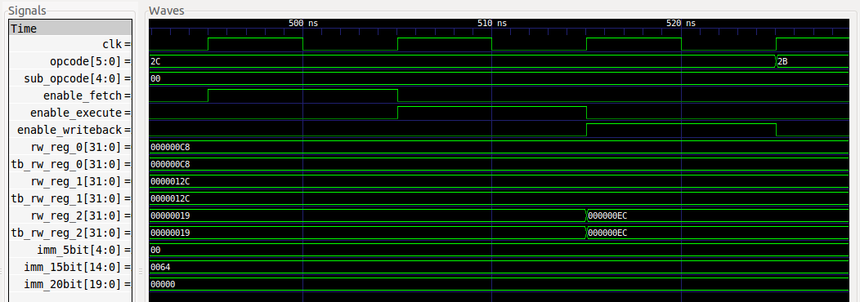

* Test 13. XORI(rw_reg[2]= rw_reg[0] ^’h0064)

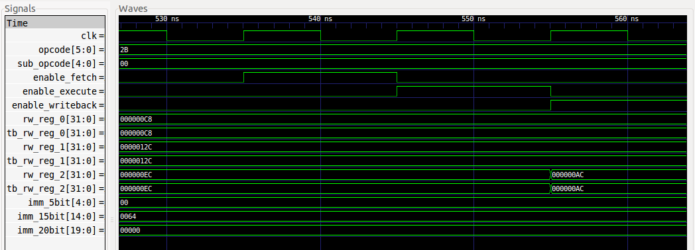

Part 4-1 pre-simulated waveforms:

* Test 1. ADDI (R0=R0+5’b01101)

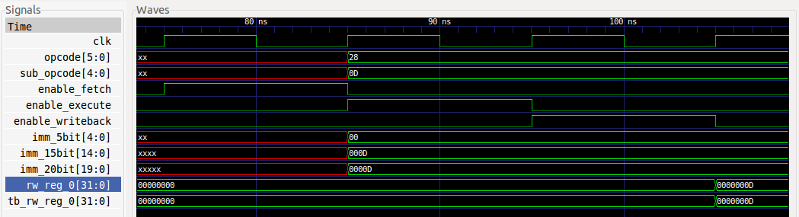

* Test 2. ADDI (R1=R1+5’b01100)

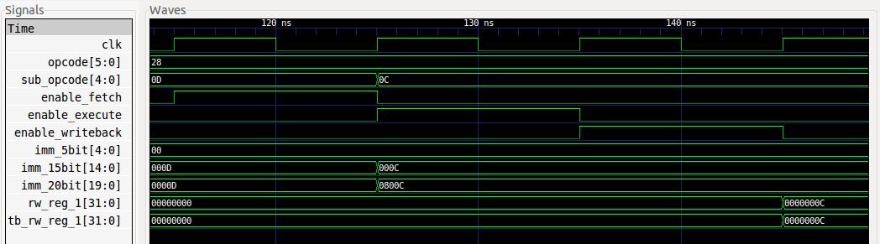

* Test 3. MOVI (R2= 5’b01000)

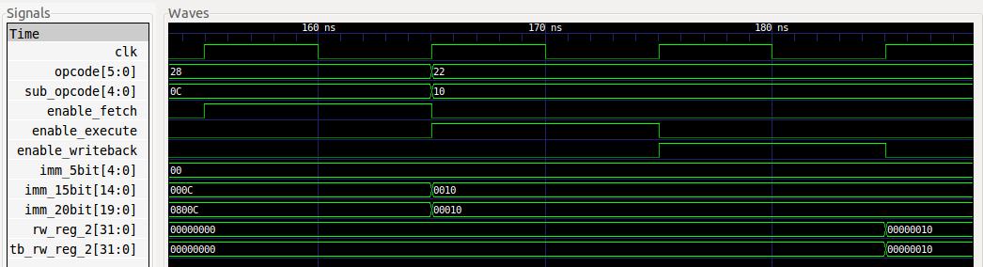

* Test 4. ADD (R3=R0+R1)

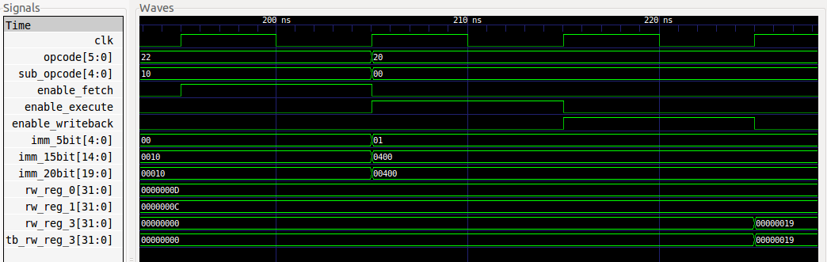

* Test 5. SUB (R4=R0-R1)

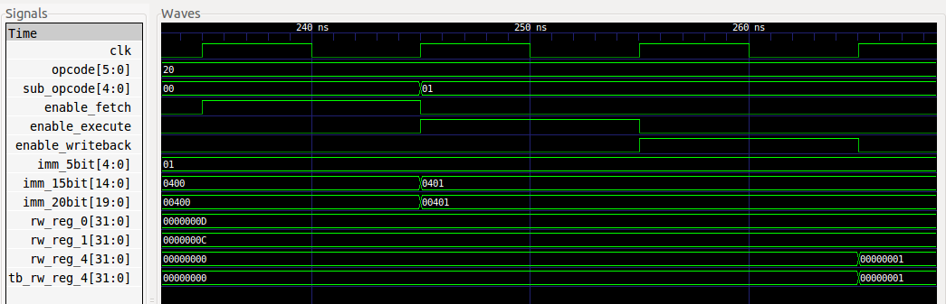

* Test 6. AND (R5=R3&R4)

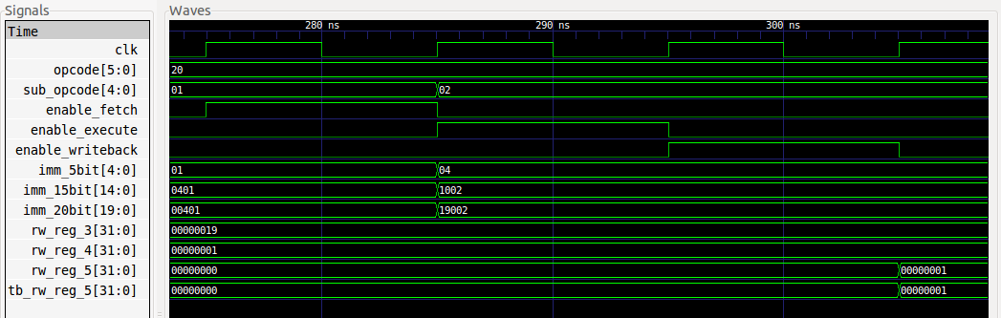

* Test 7. OR (R6=R3|R4)

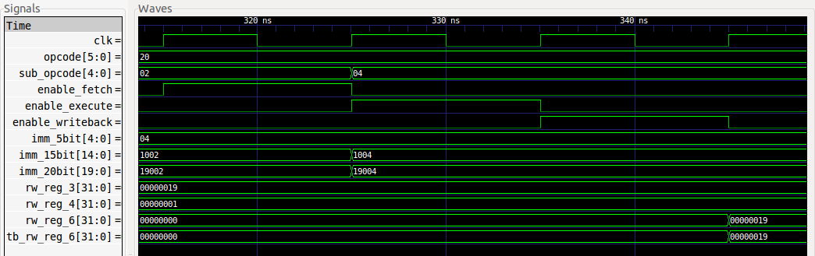

* Test 8. XOR(R7= R3^R4)

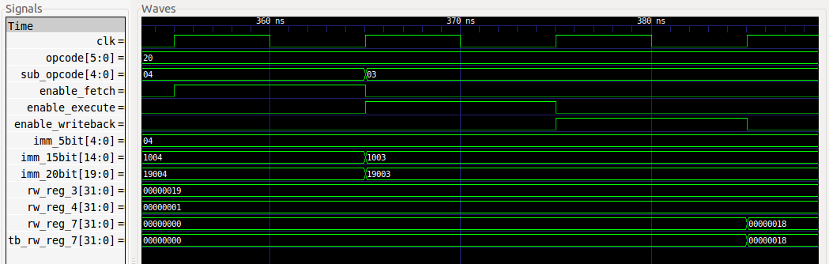

* Test 9. SLLI (R8=R0<<5’b00100)

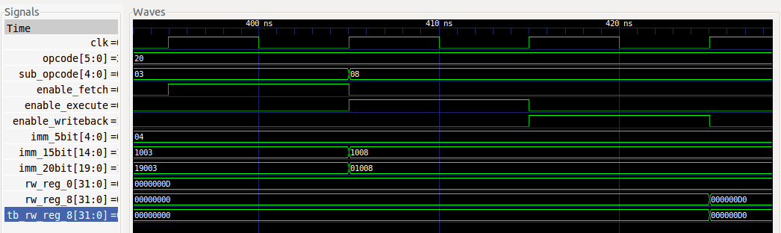

* Test 10. ROTRI (R9=R1>>5’b01000)

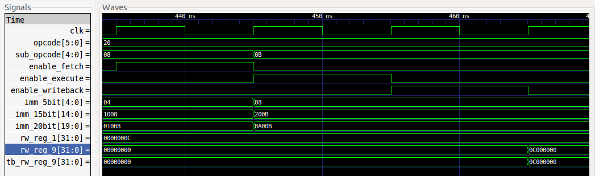

* Test 11. ORI (R0=R0|5’b11111)

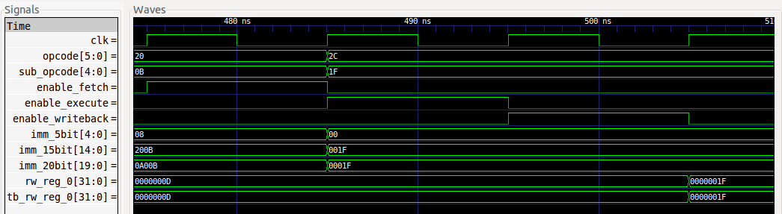

* Test 12. XORI (R1=R1+5’b10101)

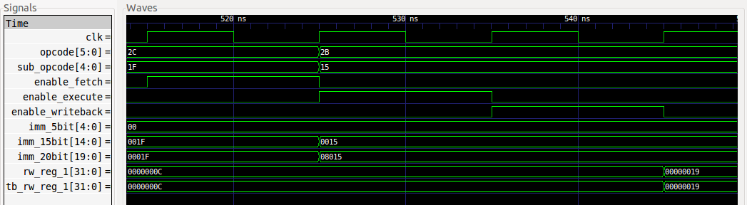

Part 4-2 pre-simulated waveforms:

* Test1. NOP

*instruction = 32'b0_100000_00000_00000_00000_00000_01001;*

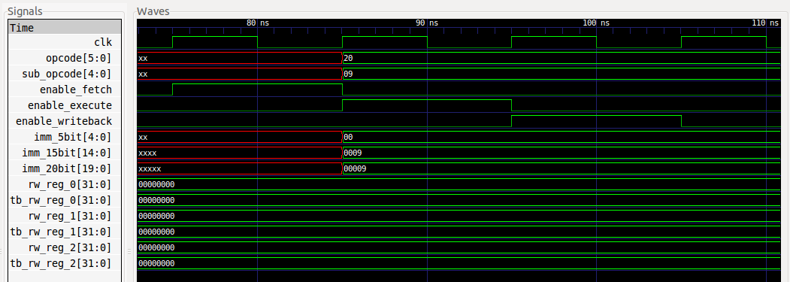

* Test 2. MOVI(rw_reg[0] = ‘h00C8)

*instruction = 32'b0_100010_00000_0000_0000_0000_1100_1000;*

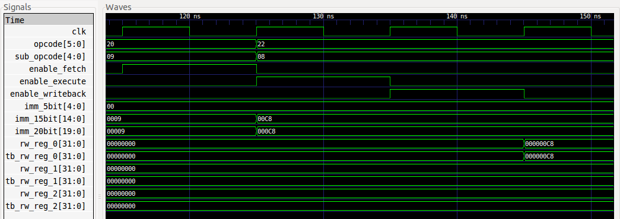

* Test 3. ADDI(rw_reg[1]=rw_reg[0]+’h0064)

*instruction = 32'b0_101000_00001_00000_0000_0000_1100_100;*

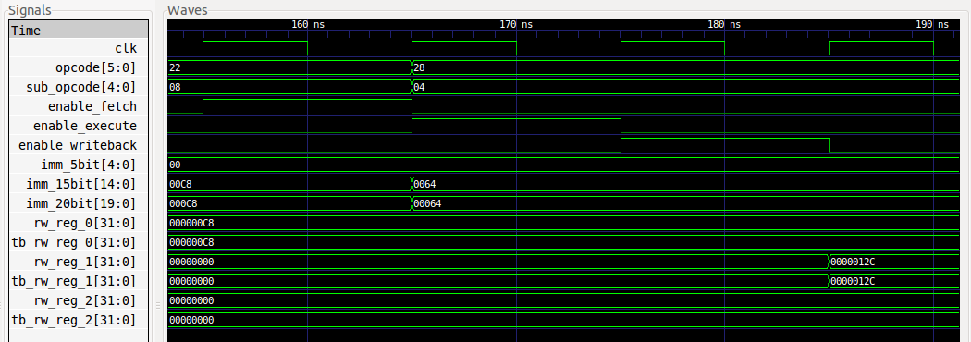

* Test 4. ADD(rw_reg[2]= rw_reg[0]+ rw_reg[1])

*instruction = 32'b0_100000_00010_00000_00001_00000_00000;*

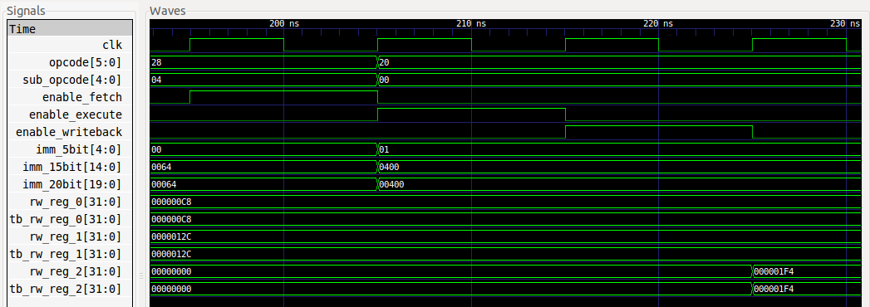

* Test 5. SUB(rw_reg[2]= rw_reg[1]- rw_reg[0])

*instruction = 32'b0_100000_00010_00001_00000_00000_00001;*

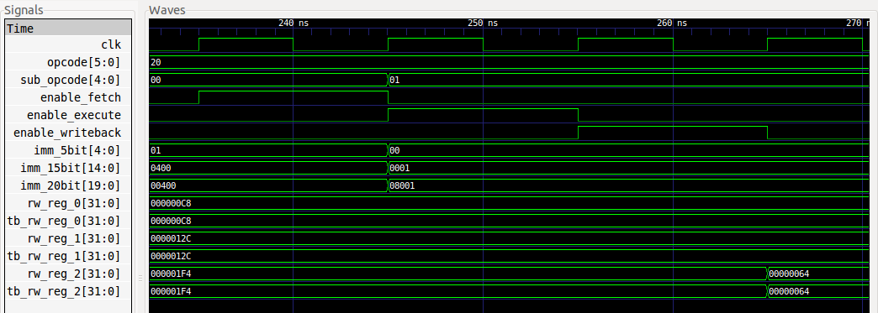

* Test 6. AND(rw_reg[2]= rw_reg[0]& rw_reg[1])

*instruction = 32'b0_100000_00010_00000_00001_00000_00010;*

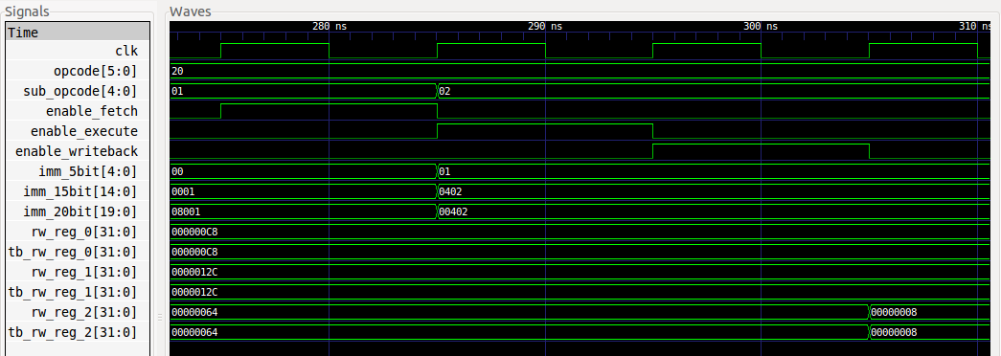

* Test 7. OR(rw_reg[2]= rw_reg[0]| rw_reg[1])

*instruction = 32'b0_100000_00010_00000_00001_00000_00100;*

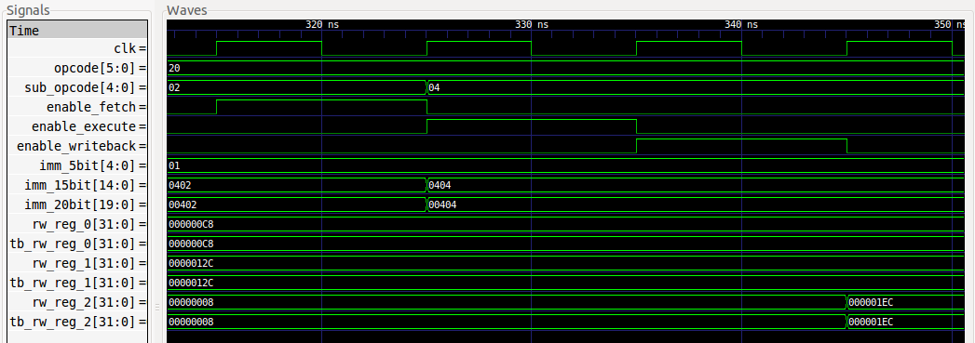

* Test 8. XOR(rw_reg[2]= rw_reg[0]^ rw_reg[1])

*instruction = 32'b0_100000_00010_00000_00001_00000_00011;*

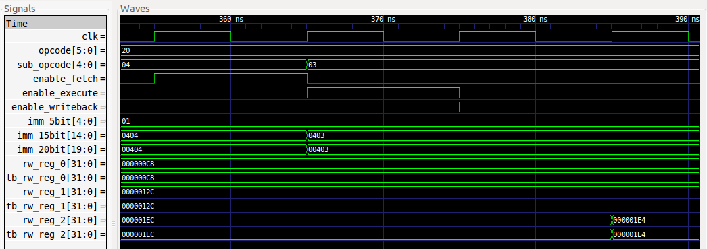

* Test 9. SRLI(rw_reg[2]= rw_reg[0]>>’h0003)

*instruction = 32'b0_100000_00010_00000_00011_00000_01001;*

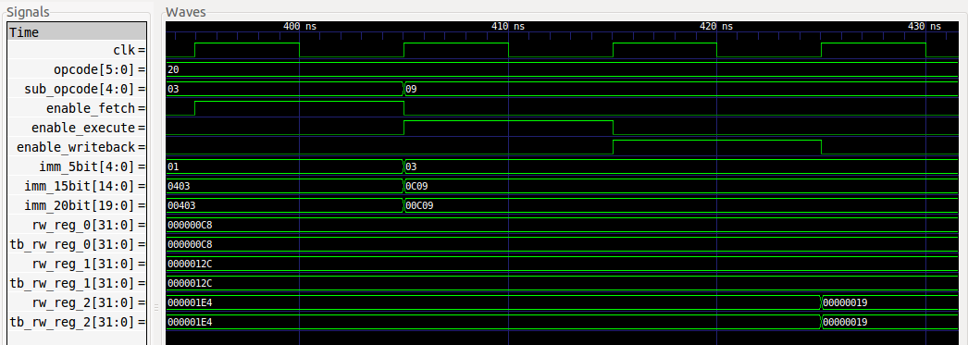

* Test 10. SLLI(rw_reg[2]= rw_reg[0] <<’h0003)

*instruction = 32'b0_100000_00010_00000_00011_00000_01000;*

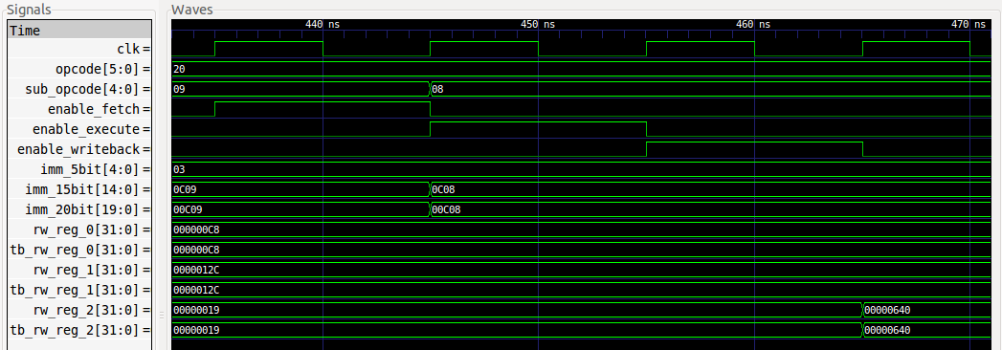

* Test 11. ROTRI(rw_reg[2]= rw_reg[0] >>’h0003)

*instruction = 32'b0_100000_00010_00000_00011_00000_01011;*

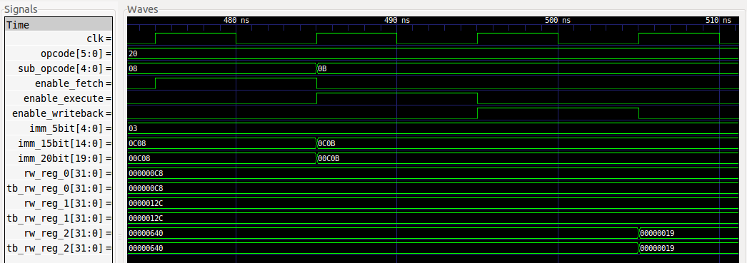

* Test 12. ORI(rw_reg[2]= rw_reg[0] |’h0064)

*instruction = 32'b0_101100_00010_00000_0000_0000_1100_100;*



* Test 13. XORI(rw_reg[2]= rw_reg[0] ^’h0064)

*instruction = 32'b0_101011_00010_00000_0000_0000_1100_100;*

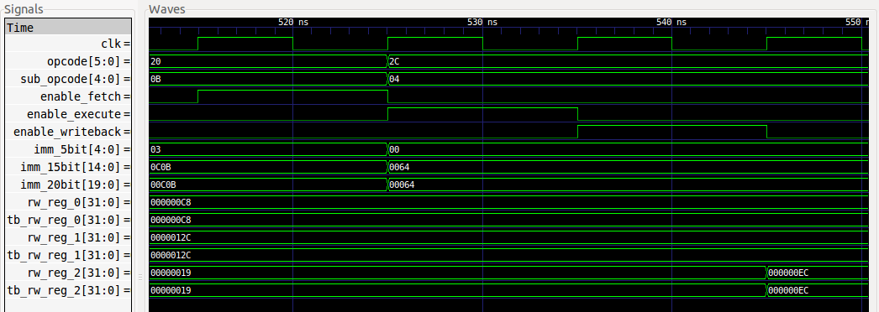

Post-simulated waveforms:

* Test 2. _aset

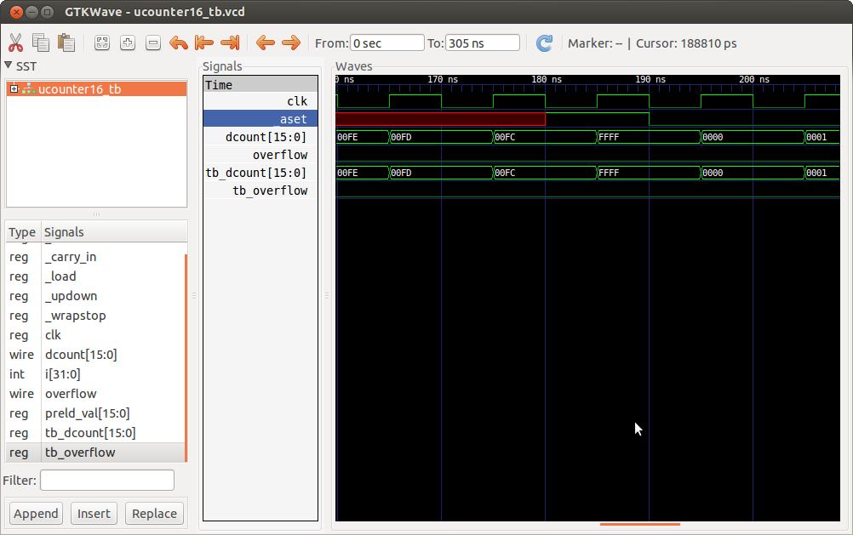

* Test 3. _load and preld_val

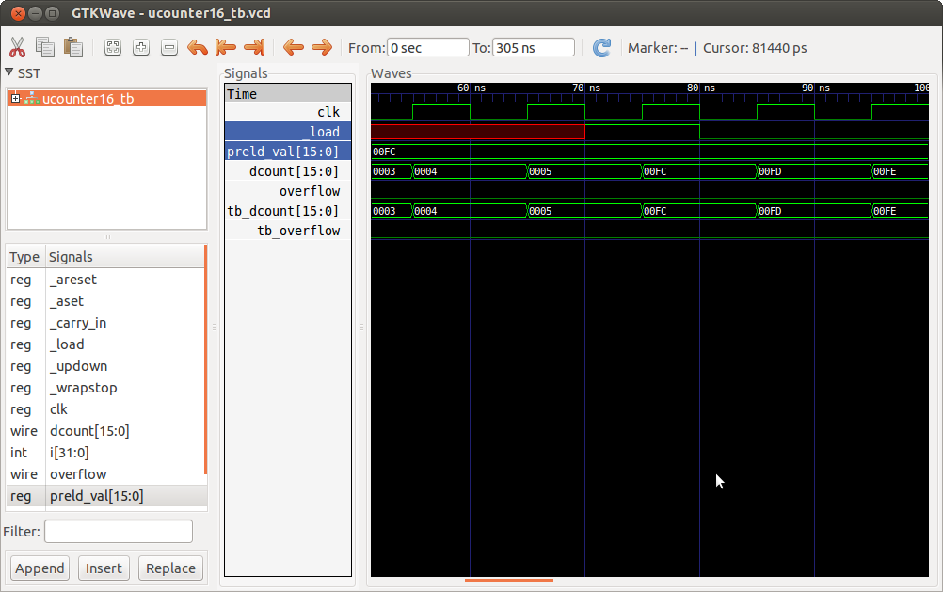

* Test 4. _updown (up)

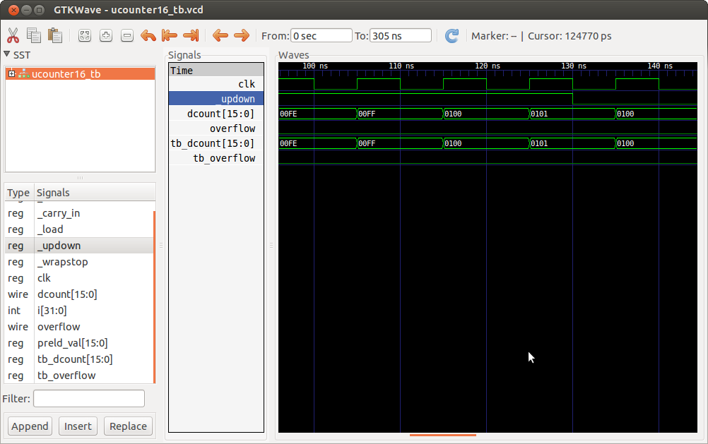

* Test 5. _updown (down)

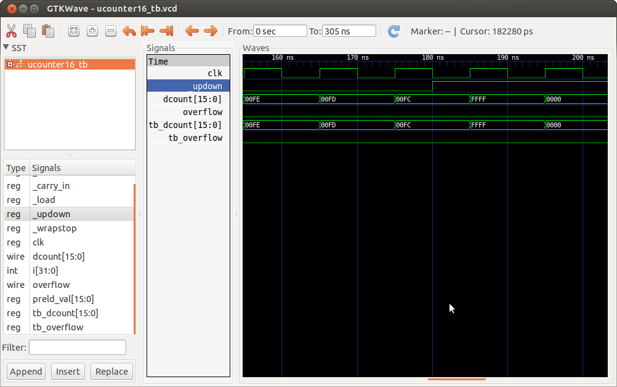

* Test 6. _wrapstop (cycle)

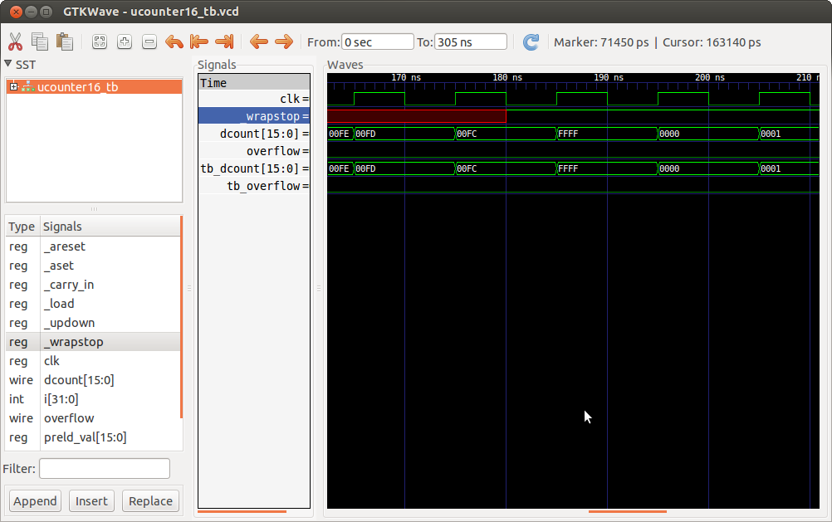

* Test 7. _wrapstop (stop) and overflow

