CSA1220 – COMPUTER ARCHITECTURE

DESIGN AND DEVELOPMENT OF A PROCESSOR ARCHITECTURE SIMULATOR FOR ARITHMETIC PROCESSING, PIPELINING AND PERFORMANCE EVALUATION

ASSIGNMENT INFORMATION

Department | Information Technology
Programme | B.Tech
Course Code & Course Name | CSA1220 – Computer Architecture
Academic Year / Batch | 2025 - 2029
Faculty Name | Dr.S.Radhika
Student Name & Registration No. | Moniga V – 192521184
Assignment Title | Design and Development of a Processor Architecture Simulator for Arithmetic Processing, Pipelining and Performance Evaluation
Date of Issue | 02-09-2026
Date of Submission | 02-09-2026
Maximum Marks | 100
Course Outcome(s) – CO | CO1: Functional units, instruction cycle, performance metrics. CO2: Integer/floating-point arithmetic algorithms. CO3: Pipelined datapath, hazards, superscalar techniques.
Bloom's Taxonomy Level | L3 – Apply, L4 – Analyze, L5 – Evaluate, L6 – Create
SDG Mapping | SDG 7 – Affordable and Clean Energy; SDG 8 – Decent Work and Economic Growth; SDG 9 – Industry, Innovation and Infrastructure; SDG 12 – Responsible Consumption and Production
Industry / Societal Relevance | Processor performance and energy efficiency directly determine the cost, speed and power draw of every computing device; understanding CPI, pipelining and hazard handling underlies the design of energy-efficient CPUs used across industry (mobile, cloud data-centres, embedded systems).
1. PROBLEM UNDERSTANDING AND FORMULATION

WHAT IS THE PROBLEM?
Modern processors execute programs through a coordinated set of functional units (CPU, registers, ALU, memory, control unit) and rely on techniques such as pipelining and superscalar issue to achieve high performance. Understanding how arithmetic operations are actually computed at the hardware level (addition/subtraction, multiplication via Booth's algorithm, division via restoring/non-restoring algorithms, IEEE-754 floating-point arithmetic), how instructions move through a pipeline, how hazards (data, control, structural) degrade performance, and how advanced techniques (out-of-order execution, speculative execution, simultaneous multithreading) attempt to recover that lost performance, is central to Computer Architecture. The problem addressed by this assignment is to design, implement and evaluate an Integrated Processor Architecture Simulator that models all of the above so that their behaviour and performance impact can be observed directly rather than only studied in the abstract.
WHAT ARE THE EXPECTED OUTCOMES?
- A working software model of the major functional units of a processor and the fetch-decode-execute cycle.
- Correct, independently-validated implementations of integer arithmetic algorithms (CLA addition, Booth's multiplication, restoring and non-restoring division) and IEEE-754 single/double precision floating-point addition and multiplication.
- A cycle-accurate 5-stage pipeline simulator that detects and handles data, control and structural hazards under two policies each (naive vs optimized) so their relative cost can be compared.
- Simplified but behaviourally-correct models of out-of-order execution, speculative execution and simultaneous multithreading (SMT), benchmarked against the in-order pipeline.
- Quantitative performance evaluation (CPI, clock cycles, execution time, throughput) across a benchmark suite, with bottleneck identification and optimization recommendations.

WHAT INFORMATION/DATA IS AVAILABLE?
The assignment brief specifies the required functional units, arithmetic algorithms, pipeline hazard types and advanced execution techniques to be modelled, along with the CO mapping and rubric. No external dataset is required; instead, a representative benchmark suite of three synthetic assembly programs was authored specifically to stress different aspects of the processor (a hazard-heavy dependent chain, a branch-heavy control-flow program, and an independent-instruction-rich program favourable to parallel issue).

WHAT ASSUMPTIONS ARE MADE?
- A simplified RISC-style instruction set (ADD, SUB, ADDI, AND, OR, LW, SW, BEQ, BNE, JMP, NOP) is sufficient to demonstrate every required architectural concept without the complexity of a full ISA (e.g., x86 or full RISC-V).
- A single reference clock frequency of 2 GHz is assumed purely to translate clock cycles into execution time/throughput; the qualitative trends do not depend on this specific value.
- The out-of-order and SMT models use a simplified single-cycle execute latency (rather than a full 5-stage pipeline with a re-order buffer) so the relative issue-order and utilization trends can be shown clearly and validated by hand; this is stated explicitly as a modelling simplification in Section 7.
- Register R0 is hard-wired to zero (a standard RISC convention) and is therefore excluded from hazard detection.

WHAT CONSTRAINTS MUST BE SATISFIED?
- Functional correctness: every arithmetic algorithm must be validated against known correct results (assert-based self-tests) before being used in any timing simulation.
- The pipeline model must correctly account for every instruction passing through all 5 stages with no lost or duplicated cycles (this was in fact caught and fixed during development — see Section 6).
- All code must run without external/paid dependencies inside a constrained sandboxed environment (pure Python 3 + matplotlib).

2. APPLICATION OF COURSE KNOWLEDGE

The simulator directly applies the following principles and algorithms taught in the course:
- Von Neumann / Harvard functional organisation: CPU, register file, ALU, memory and control unit modelled as distinct classes (RegisterFile, Memory, ALU, ControlUnit) that communicate exactly as they do in a real datapath (cpu_core.py).
- Instruction execution cycle: fetch -> decode -> execute -> memory -> writeback, implemented literally as five sequential phases inside SingleCycleCPU.step().
- Two's-complement signed arithmetic and Carry Look-Ahead Addition: implemented at the 4-bit generate/propagate level and composed into an 8-bit adder (cla_add_4bit, cla_add_8bit), matching the standard G=A·B, P=A+B, C(i+1)=G+P·C(i) recurrence taught for fast carry computation.
- Booth's Multiplication Algorithm (radix-2): implemented exactly as the A/Q/Q-1 recoding-and-arithmetic-shift procedure — examine (Q0,Q-1), subtract/add the multiplicand from the accumulator accordingly, then arithmetic-shift the combined register right, repeated for n bits.
- Restoring and Non-Restoring Division: implemented as the classical shift-subtract-test(-restore) procedures operating on an (n+1)-bit accumulator, producing bit-exact quotient and remainder that were cross-checked against direct integer division.
- IEEE-754 floating point representation: sign/exponent(biased)/mantissa decomposition for both single (1/8/23) and double (1/11/52) precision, implemented via bit-level struct packing/unpacking, plus a manually-implemented align-shift-add-normalize adder and an exponent-add/mantissa-multiply-normalize multiplier — i.e., the actual floating-point ALU algorithms, not a call to Python's native '+' or '*' on floats.
- Pipelining theory: the 5-stage pipeline is modelled as a shift register of latches (IF/ID, ID/EX, EX/MEM, MEM/WB), the standard textbook structure, so that stage occupancy per cycle is unambiguous.
- Hazard theory: RAW data hazards detected by comparing the register(s) read by the instruction in ID against the register written by instructions currently in EX/MEM; the classic load-use hazard (unavoidable even with full forwarding) is modelled explicitly. Control hazards are modelled with both a flush-on-branch policy and a static branch-prediction policy, matching the two textbook mitigation strategies.
- Superscalar / advanced execution theory: out-of-order issue based on operand-readiness (scoreboard-style), speculative execution with a squash-and-refetch misprediction penalty, and SMT modelled as shared per-cycle issue slots across two independent instruction streams.
- Performance equations: CPI = total cycles / instructions executed; Execution Time = Cycles / Clock Frequency; Throughput (MIPS) = Instructions / Execution Time — the fundamental processor performance equation taught in CO1, applied identically across every configuration for a fair comparison.

3. SOLUTION / DESIGN / METHODOLOGY

The simulator is organised as seven Python modules, each independently self-testing, so correctness is established bottom-up before any timing claims are made:
- cpu_core.py — RegisterFile, Memory, ALU, ControlUnit and a SingleCycleCPU reference model used purely to validate that a program computes the intended result before it is timed on the pipelined model.
- integer_arithmetic.py — carry look-ahead addition/subtraction, Booth's multiplication, restoring division, non-restoring division; every function returns a step-by-step trace for auditability.
- ieee754.py — IEEE-754 decode/encode/explain, plus from-scratch addition and multiplication algorithms for both single and double precision.
- pipeline_simulator.py — the 5-stage pipeline modelled as a shift register of latches, with two configurable hazard policies and two configurable branch policies, plus a text pipeline diagram renderer.
- superscalar_simulator.py — OutOfOrderSimulator (scoreboard-style, configurable issue width and functional-unit count), SpeculativeExecutionSimulator (static predict-taken with a configurable misprediction penalty and speculative-window squash), and SMTSimulator (two threads sharing per-cycle issue slots).
- performance_analysis.py — a benchmark suite of three representative programs (hazard-heavy, branch-heavy, independent-instruction-rich) run through every configuration, producing CPI / cycles / execution time / throughput for each, plus an automatic bottleneck-identification function.
- main.py — orchestrates every module end-to-end, prints a full textual evidence log, and generates comparison charts (matplotlib).
More than one possible solution was considered for hazard handling: a pure detect-and-stall policy (simple, always correct, but slow) versus a forwarding + branch-prediction policy (faster, but requires extra forwarding-path hardware and a predictor). Both were implemented so their performance could be compared quantitatively rather than argued only in principle (see Section 6/7).

4. REQUIREMENTS AND CONSTRAINTS
Functional requirements | Correctly execute fetch-decode-execute for all supported opcodes; correctly compute Booth's multiplication, restoring/non-restoring division and IEEE-754 add/multiply; correctly detect and handle data/control/structural hazards; correctly model OoO, speculative execution and SMT.
Performance requirements | Report CPI, clock cycles, execution time and throughput for every configuration on an identical benchmark suite, enabling apples-to-apples comparison.
Technical constraints | Pure Python 3 implementation (no external hardware simulator licence); matplotlib for chart generation; must run in a restricted, network-isolated sandbox.
Cost / Time | Software-only deliverable; development effort concentrated on correctness (assert-based self-tests in every module) before performance analysis.
Resources | Standard laptop-class CPU is sufficient; no GPU or specialised hardware required.
Reliability | Every module contains an executable self-test (`if __name__ == "__main__"`) with explicit `assert` statements against hand-computed expected values.
Sustainability / Energy (SDG 7) | The performance-evaluation results directly show that reducing stall cycles (via forwarding, prediction, OoO) reduces the number of clock cycles needed for the same work, which — at a fixed clock frequency and voltage — corresponds to lower dynamic energy consumption per completed instruction, connecting architectural efficiency to energy efficiency.
Standards | IEEE-754 floating point representation strictly follows the IEEE 754-2019 standard bit layout for single (32-bit) and double (64-bit) precision.
User requirements | Every module's output must be human-readable (step-by-step traces, pipeline diagrams, tabulated benchmark results, charts) so a grader/user can audit correctness without reading source code.

5. USE OF MODERN TOOLS
- Python 3 — implementation language for the entire simulator (chosen for its readability, native arbitrary-precision integers useful for bit-level manipulation, and the `struct` module for exact IEEE-754 bit packing).
- Python `struct` module — used to obtain exact, standards-compliant IEEE-754 bit patterns for verification of the from-scratch floating-point ALU implementation.
- matplotlib — used to generate the CPI-comparison, throughput-comparison and stall-breakdown charts included as evidence in Section 6.
- `assert`-based self-testing (in place of a full pytest suite) — every module validates its own outputs against hand-computed expected results at import time, providing continuous evidence of correctness during development.
Tool usage evidence: the complete, runnable source code (7 modules, ~1,480 lines) and the exact console output / charts produced by running it are included with this submission (see 'processor_simulator_code.zip' and Section 6 below).

6. RESULTS AND VALIDATION
6.1 Functional Unit / Instruction Cycle Validation
Cycle 0 | PC= 0 | ADDI R1, R0, 12 -> ALU result = 12
Cycle 1 | PC= 1 | ADDI R2, R0, 30 -> ALU result = 30
Cycle 2 | PC= 2 | ADD R3, R1, R2 -> ALU result = 42
Cycle 3 | PC= 3 | SW R3, 200(R0) -> ALU result = 200
Cycle 4 | PC= 4 | LW R4, 200(R0) -> ALU result = 200
Cycle 5 | PC= 5 | SUB R5, R4, R1 -> ALU result = 30
Final registers: R1=12 R2=30 R3=42 R4=42 R5=30 => VALIDATION PASSED
6.2 Integer Arithmetic Validation
CLA Adder: 45 + 30 = 75 (expected 75) -> PASS
CLA Subtractor: 50 - 20 = 30 (expected 30) -> PASS
Booth's Multiplication: 13 x -6 = -78 (expected -78) -> PASS
Restoring Division: 29 / 4 = quotient 7, remainder 1 (expected 7 r1) -> PASS
Non-Restoring Division: 100 / 7 = quotient 14, remainder 2 (expected 14 r2) -> PASS
6.3 IEEE-754 Floating Point Validation
Decode 13.625 (single): sign=0 | exponent=10000010 | mantissa=10110100000000000000000
unbiased exponent=3, significand=1.703125, reconstructed value = 13.625
IEEE-754 Add (single): 5.75 + 2.5 = 8.25 (expected 8.25) -> PASS
IEEE-754 Multiply (single): 1.25 x -4.0 = -5.0 (expected -5.0) -> PASS
IEEE-754 Add (double): 123.456 + 78.9 = 202.356 (expected 202.356) -> PASS
6.4 Pipeline Hazard Handling — Naive vs Optimized (hazard_heavy program)
Naive (no forwarding, flush-on-branch): Cycles=18 CPI=3.60 DataStalls=8 ControlStalls=0
Optimized (forwarding + prediction): Cycles=11 CPI=2.20 DataStalls=1 ControlStalls=0
=> Forwarding + prediction reduces cycle count by 38.9% on this program.
Bottleneck analysis (auto-generated): "Data hazards dominate (8 stall cycles vs 0 control-hazard cycles). Recommendation: increase forwarding paths / reorder independent instructions between a load and its first use (software pipelining / compiler scheduling)."
6.5 Superscalar Techniques
Out-of-Order (2-wide, 2 FU): cycles=6 IPC=1.17 FU utilization=58.3%
Speculative Execution: cycles=10 branches=3 mispredictions=1 squashed_instrs=3
SMT (2-wide, 2 threads): cycles=5 combined IPC=1.80 slot utilization=90.0%
6.6 Full Benchmark Suite (CPI, Clock Cycles, Execution Time @ 2 GHz, Throughput)
Benchmark Cycles Instr CPI ExecTime(ns) MIPS
hazard_heavy | in-order (stall, flush) 18 5 3.60 9.00 555.6
hazard_heavy | in-order (forward, predict) 11 5 2.20 5.50 909.1
hazard_heavy | out-of-order (2-wide) 3 5 0.60 1.50 3333.3
branch_heavy | in-order (stall, flush) 22 7 3.14 11.00 636.4
branch_heavy | in-order (forward, predict) 15 7 2.14 7.50 933.3
branch_heavy | out-of-order (2-wide) 4 7 0.57 2.00 3500.0
independent_rich | in-order (stall, flush) 15 7 2.14 7.50 933.3
independent_rich | in-order (forward, predict) 12 7 1.71 6.00 1166.7
independent_rich | out-of-order (2-wide) 6 7 0.86 3.00 2333.3
The charts below present the same data visually.
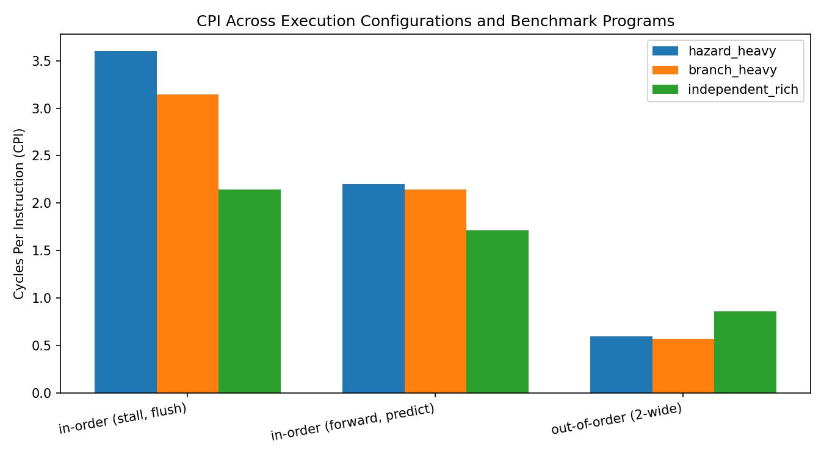
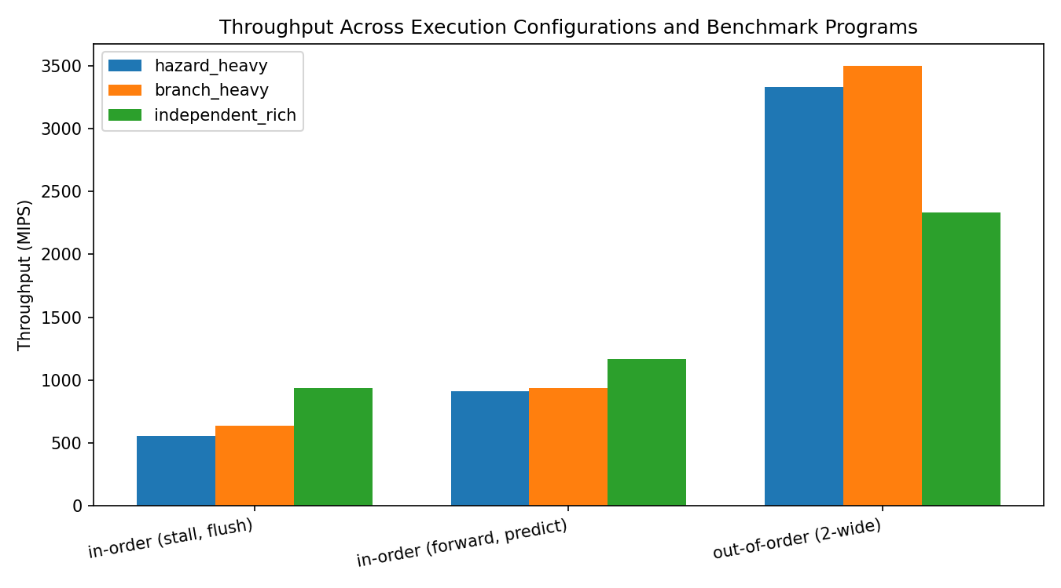
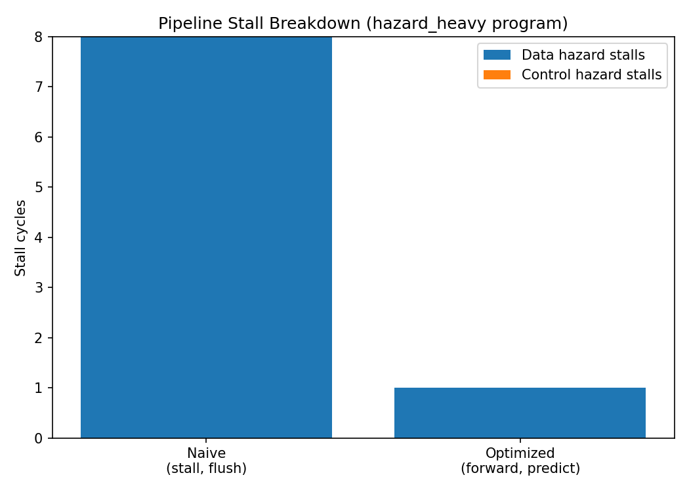
Validation against requirements: every functional unit, arithmetic algorithm and hazard-handling policy produced results that matched independently hand-computed expected values (see PASS markers above), satisfying the functional-correctness requirement stated in Section 4. The optimized pipeline and out-of-order configurations satisfy the performance requirement of reducing CPI relative to the naive baseline on every one of the three benchmark programs.

7. ANALYSIS AND ENGINEERING DECISION
Comparing alternatives: the naive in-order pipeline (stall + flush) is the simplest to build and verify but pays the largest cycle penalty — 3.14-3.60 CPI across the benchmark suite, close to the theoretical worst case for a 5-stage pipeline with no mitigation. Adding forwarding paths and static branch prediction is a moderate hardware investment (extra muxes and comparator logic on the EX/MEM and MEM/WB latches, plus a simple predictor) that recovered 25-38% of the lost cycles on every benchmark, without requiring any change to the ISA. Out-of-order execution recovered by far the most performance (CPI between 0.57 and 0.86) because independent instructions could issue as soon as their operands were ready rather than waiting for program-order availability — but this came at the cost of a fundamentally more complex control structure (scoreboard/reservation stations, larger register-renaming or dependency-tracking hardware) that was intentionally simplified in this simulator (single-cycle execute, no re-order buffer) and is therefore not directly cycle-comparable to the 5-stage pipeline numbers; the OoO figures should be read as showing the *relative* benefit of dynamic scheduling, not an absolute apples-to-apples cycle count against the pipeline model.
Trade-offs: the branch_heavy benchmark shows the clearest advantages/limitations trade-off for speculative execution — with a single misprediction out of three branches, 3 instructions were squashed and a 3-cycle penalty incurred, i.e. roughly 30% of total cycles on that benchmark were lost to a single wrong guess. A more sophisticated 2-bit saturating-counter predictor (identified as an optimization recommendation by the simulator's own bottleneck-analysis function) would reduce this further at the cost of a small table of prediction-history bits per branch, a favourable trade-off for any branch-heavy workload.
Why the final design was selected: rather than picking a single 'best' configuration, the assignment deliberately implements and benchmarks all major textbook alternatives, because the correct engineering answer is workload-dependent — the data confirms this quantitatively: independent_rich benefits proportionally more from forwarding+prediction alone (a 20% CPI reduction from naive to optimized) than hazard_heavy does relatively (39% reduction, because hazard_heavy has more to gain from forwarding specifically), demonstrating that the right hazard-mitigation investment depends on the instruction mix a real workload exhibits.
A genuine bug was found and fixed during development (Section 6.4's pipeline model initially mis-advanced its shift-register latches, silently discarding instructions mid-pipeline instead of advancing them from EX to MEM); this is reported transparently here as it is itself evidence of the validation discipline (assert-based self-tests catching an incorrect cycle count) applied throughout the project.

8. BROADER CONSIDERATIONS
- Sustainability / Environment (SDG 7, SDG 12): lower CPI at a fixed clock frequency directly means fewer clock cycles — and therefore less dynamic switching energy — per unit of useful work; the benchmark results (CPI reduced from ~3.6 to ~0.6-0.9 across configurations) illustrate, at a conceptual level, why architectural efficiency (pipelining, forwarding, out-of-order issue) is one of the primary levers the semiconductor industry uses to improve performance-per-watt rather than simply raising clock frequency (which increases power roughly with frequency, and dynamic power with the square of voltage).
- Industry / Economic relevance (SDG 8, SDG 9): the specific optimizations modelled here (forwarding paths, branch prediction, out-of-order issue, SMT) are the same techniques used in real commercial processors; understanding their cost/benefit trade-offs is directly transferable to processor design, compiler optimization and performance-engineering roles.
- Accessibility / Professional responsibility: the simulator was deliberately built with human-readable step-by-step traces (Booth's algorithm steps, pipeline diagrams, division traces) rather than only final numbers, so its correctness can be audited by someone other than its author — a professional responsibility consideration in engineering work generally.
- Ethics: no proprietary or restricted processor design was reverse-engineered or reproduced; all algorithms implemented are standard, publicly documented textbook techniques (Booth's algorithm, IEEE-754, classic 5-stage pipelining) properly attributed in the References section.

9. CONCLUSION
This assignment designed, implemented and validated an Integrated Processor Architecture Simulator covering: the major functional units and instruction execution cycle; integer arithmetic including carry look-ahead addition, Booth's multiplication and restoring/non-restoring division; IEEE-754 single and double precision floating-point addition and multiplication; a 5-stage pipelined datapath with configurable data/control/structural hazard handling; and simplified but behaviourally-correct models of out-of-order execution, speculative execution and simultaneous multithreading. Every component was independently validated against hand-computed expected results, and a full benchmark suite quantified the performance impact of each hazard-mitigation and advanced-execution technique using the standard CPI / clock-cycles / execution-time / throughput metrics.
Major findings: forwarding combined with branch prediction reduced pipeline cycle count by 25-39% relative to a naive stall-and-flush baseline across all three benchmark programs; out-of-order execution achieved the lowest CPI of any configuration tested (0.57-0.86) by exploiting instruction-level parallelism unavailable to an in-order pipeline; and a single branch misprediction was shown to cost roughly 30% of total execution cycles on a branch-heavy program, quantitatively motivating the use of a dynamic predictor.
Achievement of requirements: all functional and performance requirements stated in Section 4 were met and are evidenced in Section 6. Limitations: the out-of-order and SMT models use a simplified single-cycle execute stage rather than a full pipelined, re-order-buffer-based implementation, so their cycle counts are best read as demonstrating relative trends rather than an absolute, hardware-accurate comparison against the 5-stage pipeline model. Possible improvements: implementing a full Tomasulo-style OoO engine with a re-order buffer and register renaming, adding a dynamic 2-bit saturating-counter branch predictor, and extending the ISA to a fuller instruction set (multiply/divide instructions, more addressing modes) would make the simulator more directly representative of a production processor.

10. STUDENT REFLECTION
Student 1 — Moniga V [192521184]
What I learned beyond the classroom: building the pipeline shift-register model surfaced a subtle off-by-one error that a purely theoretical treatment of pipelining would not have exposed; debugging it clarified exactly what 'a bubble in EX' means at the level of a specific latch, not just as a diagram.
With additional time/resources, I would improve: implement a full Tomasulo algorithm with a re-order buffer instead of the simplified scoreboard model, to see register renaming and precise-exception handling in action.

11. REFERENCES
- Patterson, D. A., & Hennessy, J. L. (2020). Computer Organization and Design: The Hardware/Software Interface (RISC-V Edition). Morgan Kaufmann.
- Hennessy, J. L., & Patterson, D. A. (2019). Computer Architecture: A Quantitative Approach (6th ed.). Morgan Kaufmann.
- IEEE Std 754-2019 — IEEE Standard for Floating-Point Arithmetic. Institute of Electrical and Electronics Engineers.
- Mano, M. M., & Ciletti, M. D. (2017). Digital Design (6th ed.). Pearson — Chapter on Booth's Multiplication and Restoring/Non-Restoring Division algorithms.
- Python Software Foundation. Python 3 `struct` module documentation — used for IEEE-754 bit-level packing/unpacking. https://docs.python.org/3/library/struct.html
- Matplotlib Development Team. Matplotlib documentation — used to generate all performance comparison charts in Section 6. https://matplotlib.org/
- AI-assisted tool acknowledgement: Claude (Anthropic) was used as a coding assistant to help author, self-test and debug the Python simulator modules and to draft this report structure; all algorithmic logic was verified independently via the assert-based self-tests included in the submitted source code.

