Automating Data Import and Relationship Mapping Using Import Sets & Dot Walking
Team Leader: MONIGA.R
Team Members: MATHIVADHANI.R, NARMADA.G, PREETHI.S
Course: B.SC(COMPUTER SCIENCE) Final Year Project
Date: 2026

Abstract:
This project focuses on automating the process of importing employee data into ServiceNow and mapping relationships between employees, departments, and managers using Import Sets, Transform Maps, and Dot Walking. The system imports employee records from external CSV files and automatically maps relationships so that related information is displayed when incidents are assigned to users.

Introduction:
Organizations often receive employee data from external systems. Manually entering employee records into ServiceNow is time-consuming and error-prone. This project automates the data import process using ServiceNow Import Sets and Transform Maps. Additionally, Dot Walking is used to retrieve related data such as department and manager details directly in the incident form.

Problem Statement:
Organizations want to regularly import a list of new employees with details such as name, email, department, manager, and phone number from an external system. When an incident is assigned to an employee, the incident form should automatically display the department and manager details.

Objectives:
- Import employee records from external CSV files.
- Automatically map employee data to ServiceNow tables.
- Establish relationships between employees, departments, and managers.
- Display department and manager information automatically in incident forms.

System Implementation:
The implementation involves creating an employee dataset, importing it into ServiceNow using Import Sets, mapping fields using Transform Maps, and using Dot Walking to retrieve related information.

Implementation Screenshot 1:
Screenshot from ServiceNow implementation showing the process step.
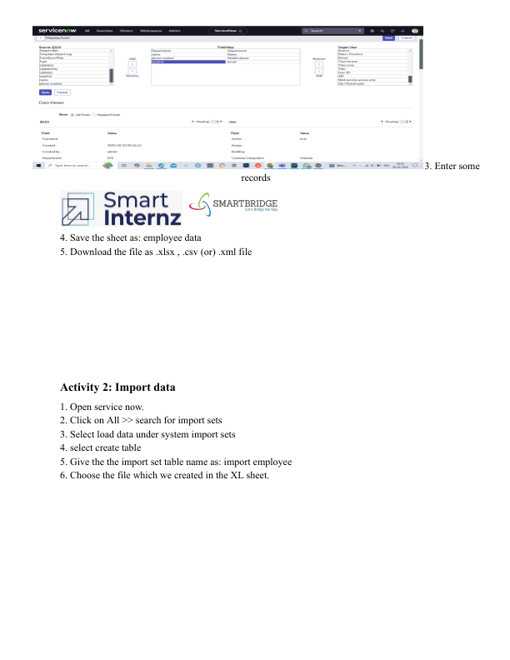

Implementation Screenshot 2:
Screenshot from ServiceNow implementation showing the process step.
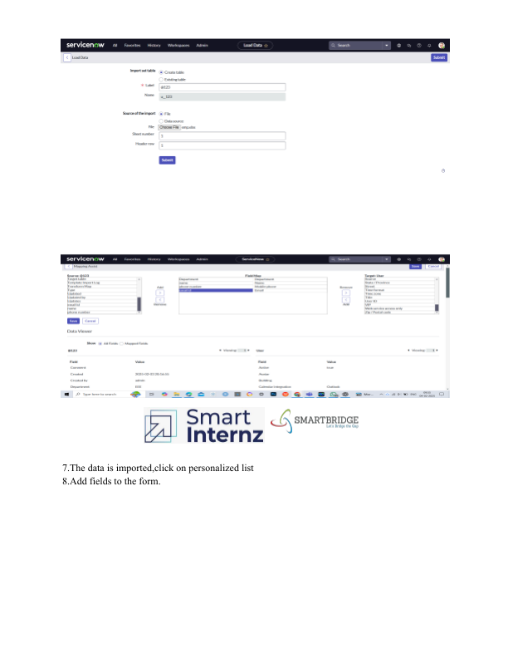

Implementation Screenshot 3:
Screenshot from ServiceNow implementation showing the process step.
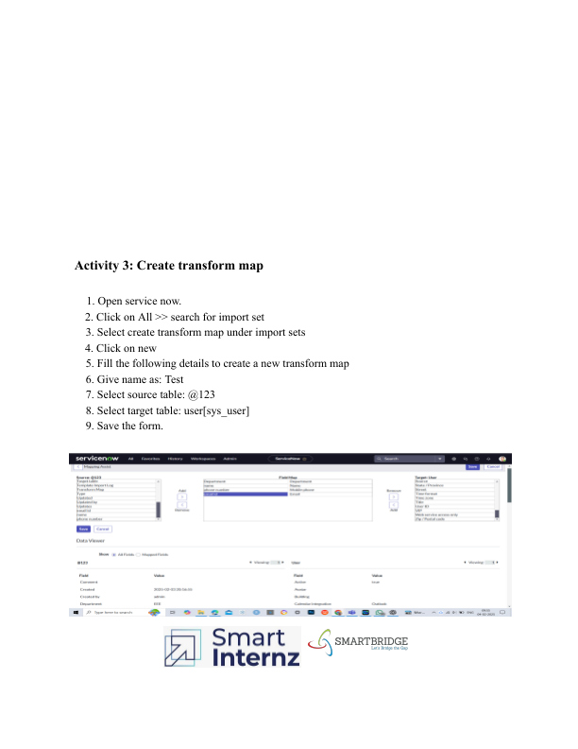

Implementation Screenshot 4:
Screenshot from ServiceNow implementation showing the process step.
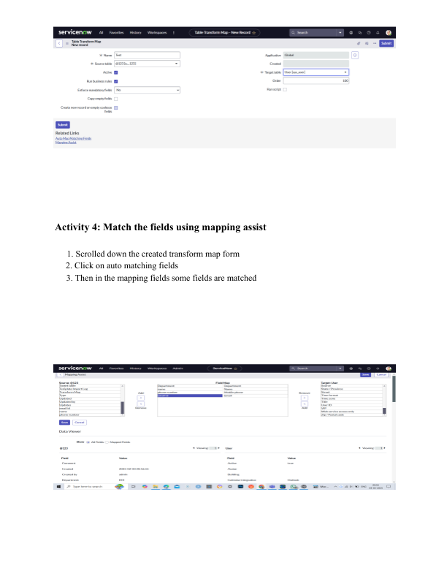

Implementation Screenshot 5:
Screenshot from ServiceNow implementation showing the process step.
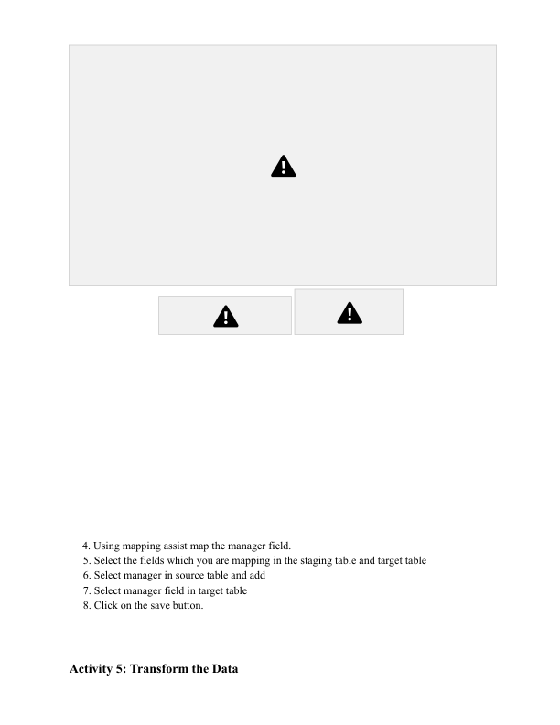

Testing:
The system was tested using multiple employee datasets. Test cases ensured that employee records were correctly imported, mapped to the appropriate fields, and displayed correctly when incidents were assigned.
Test Case | Input | Expected Result | Status
Import CSV | Employee data file | Records loaded into import set | Pass
Transform Map | Imported records | Mapped to user table | Pass
Incident Assignment | Assign user | Department auto display | Pass
Dot Walking | Assign employee | Manager email auto display | Pass

Conclusion:
The project successfully demonstrates how ServiceNow Import Sets, Transform Maps, and Dot Walking can automate data import and relationship mapping. This approach reduces manual work, improves accuracy, and enhances incident management processes.

