

REPORT ON MINI PROJECT

SNPSU TEACHER DESKTOP
SMART ATTENDANCE MANAGEMENT SYSTEM

Submitted in the partial fulfilment for the award of the degree of

BACHELOR OF ENGINEERING
IN
COMPUTER SCIENCE AND ENGINEERING

Submitted by

Sl No. | Name of the Student | SRN
1 | NAME OF STUDENT 1 | SRN001
2 | NAME OF STUDENT 2 | SRN002
3 | NAME OF STUDENT 3 | SRN003
4 | NAME OF STUDENT 4 | SRN004

Under the supervision of

NAME OF THE GUIDE: [PROJECT GUIDE NAME]
Designation Director

For the Academic year of 2025-26 [Semester: VI]
DEPARTMENT OF COMPUTER SCIENCE AND ENGINEERING
SCHOOL OF ENGINEERING AND TECHNOLOGY
(An ISO 9001:2015 and 14001: 2015 certified Institution)
14/5, Chikkasandra,Hesaraghatta Main Road, Bengaluru – 560057.


SCHOOL OF ENGINEERING AND TECHNOLOGY
(An ISO 9001:2015 and 14001: 2015 certified Institution)
14/5, Chikkasandra, Hesaraghatta Main Road, Bengaluru – 560057.

DEPARTMENT OF COMPUTER SCIENCE AND ENGINEERING

CERTIFICATE

Certified that the MINI PROJECT entitled "SNPSU TEACHER DESKTOP: SMART ATTENDANCE MANAGEMENT SYSTEM" is carried out by NAME OF STUDENT 1, NAME OF STUDENT 2, NAME OF STUDENT 3, and NAME OF STUDENT 4, bearing the corresponding SRN values, as bonafide students of School of Engineering and Technology in partial fulfilment for the award of Bachelor of Engineering in the Department of Computer Science and Engineering of SAPTHAGIRI NPS University during the academic year 2025-2026. It is certified that all corrections and suggestions indicated in the internal assessment have been incorporated in the report submitted. The mini project report has been approved as it satisfies the academic requirements prescribed for the Bachelor of Engineering Degree.

Signature of the Guide Signature of the Director
Name of the Guide Name of the Director
Designation Director

ACKNOWLEDGEMENT

We express our sincere gratitude to our guide for continuous support, patient guidance, and useful suggestions throughout the completion of this mini project. We also thank the faculty members and the institution for providing the environment required to develop and review the SNPSU Teacher Desktop system. The project benefited from the encouragement of classmates and friends who offered feedback during the design, testing, and report preparation stages. Their support helped us complete the work in a systematic and confident manner.

Sl No. | Name of the Student | SRN | Signature
1 | NAME OF STUDENT 1 | SRN001
2 | NAME OF STUDENT 2 | SRN002
3 | NAME OF STUDENT 3 | SRN003
4 | NAME OF STUDENT 4 | SRN004

ABSTRACT

CONTENTS
Chapter No. | Description | Page No.
1 | Introduction | 8
2 | Literature Review / Background Study | 12
3 | Problem Definition, Objectives and Methodology | 15
4 | Work Carried Out | 19
5 | Results and Discussion | 24
6 | Conclusions and Scope for Future Work | 29
7 | References | 33
8 | Appendix / Annexure (if any) | 37

LIST OF FIGURES
Figure No. | Description | Page No.
Figure 1.1 | Teacher-facing system architecture | 10
Figure 3.1 | Attendance workflow from login to review | 17
Figure 4.1 | Database and service interaction model | 21
Figure 5.1 | Dashboard output mockup | 26
Figure 5.2 | Section-wise attendance chart | 27
Figure 6.1 | Validation and testing matrix | 31

LIST OF TABLES
Table No. | Description | Page No.
Table 3.1 | Functional and non-functional requirements | 16
Table 4.1 | Core database tables and responsibilities | 20
Table 5.1 | Sample attendance summary | 28
Table 6.1 | Test case matrix | 30
Table 6.2 | Manual method versus proposed system | 33

CHAPTER 1
INTRODUCTION

1.1 BACKGROUND OF THE STUDY
1.1 BACKGROUND OF THE STUDY is framed around faculty still rely on registers and spreadsheet notes for daily attendance. In the SNPSU Teacher Desktop project, the same idea is implemented by linking teacher login, section mapping, and date-wise attendance into a single workflow. This keeps the faculty experience direct and avoids the repeated paper-based steps that normally create delay during busy class hours. The design also respects a classroom system must support quick action during the teaching slot, which is why the interface allows the user to move from one step to the next without losing context.
From a technical perspective, the section also supports section-wise and subject-wise context is essential for meaningful records. That requirement influenced the API layout, the database schema, and the offline queue used when connectivity is not stable. Together, these choices make the report more than a description of screens; they show how the same problem is solved through a small but coherent system. A further observation is that student follow-up becomes easier when the attendance trail is visible immediately, which helps justify the reporting and analysis shown later in the document.

1.2 PROBLEM STATEMENT
1.2 PROBLEM STATEMENT is framed around paper methods cause delays, transcription errors, and missing signatures. In the SNPSU Teacher Desktop project, the same idea is implemented by linking teacher login, section mapping, and date-wise attendance into a single workflow. This keeps the faculty experience direct and avoids the repeated paper-based steps that normally create delay during busy class hours. The design also respects manual handling makes date-wise correction and re-opening difficult, which is why the interface allows the user to move from one step to the next without losing context.
From a technical perspective, the section also supports faculty need a single dashboard that reflects the current section status. That requirement influenced the API layout, the database schema, and the offline queue used when connectivity is not stable. Together, these choices make the report more than a description of screens; they show how the same problem is solved through a small but coherent system. A further observation is that administrative reporting becomes inconsistent when data is scattered across files, which helps justify the reporting and analysis shown later in the document.

1.3 OBJECTIVES OF THE PROJECT
1.3 OBJECTIVES OF THE PROJECT is framed around a faculty-friendly attendance dashboard with minimal clicks. In the SNPSU Teacher Desktop project, the same idea is implemented by linking teacher login, section mapping, and date-wise attendance into a single workflow. This keeps the faculty experience direct and avoids the repeated paper-based steps that normally create delay during busy class hours. The design also respects a secure connection to PostgreSQL for live section data, which is why the interface allows the user to move from one step to the next without losing context.
From a technical perspective, the section also supports offline capture and later synchronization when the connection returns. That requirement influenced the API layout, the database schema, and the offline queue used when connectivity is not stable. Together, these choices make the report more than a description of screens; they show how the same problem is solved through a small but coherent system. A further observation is that absentee visibility and communication support after the attendance submission, which helps justify the reporting and analysis shown later in the document.
Figure 1.1: Teacher-facing system architecture.
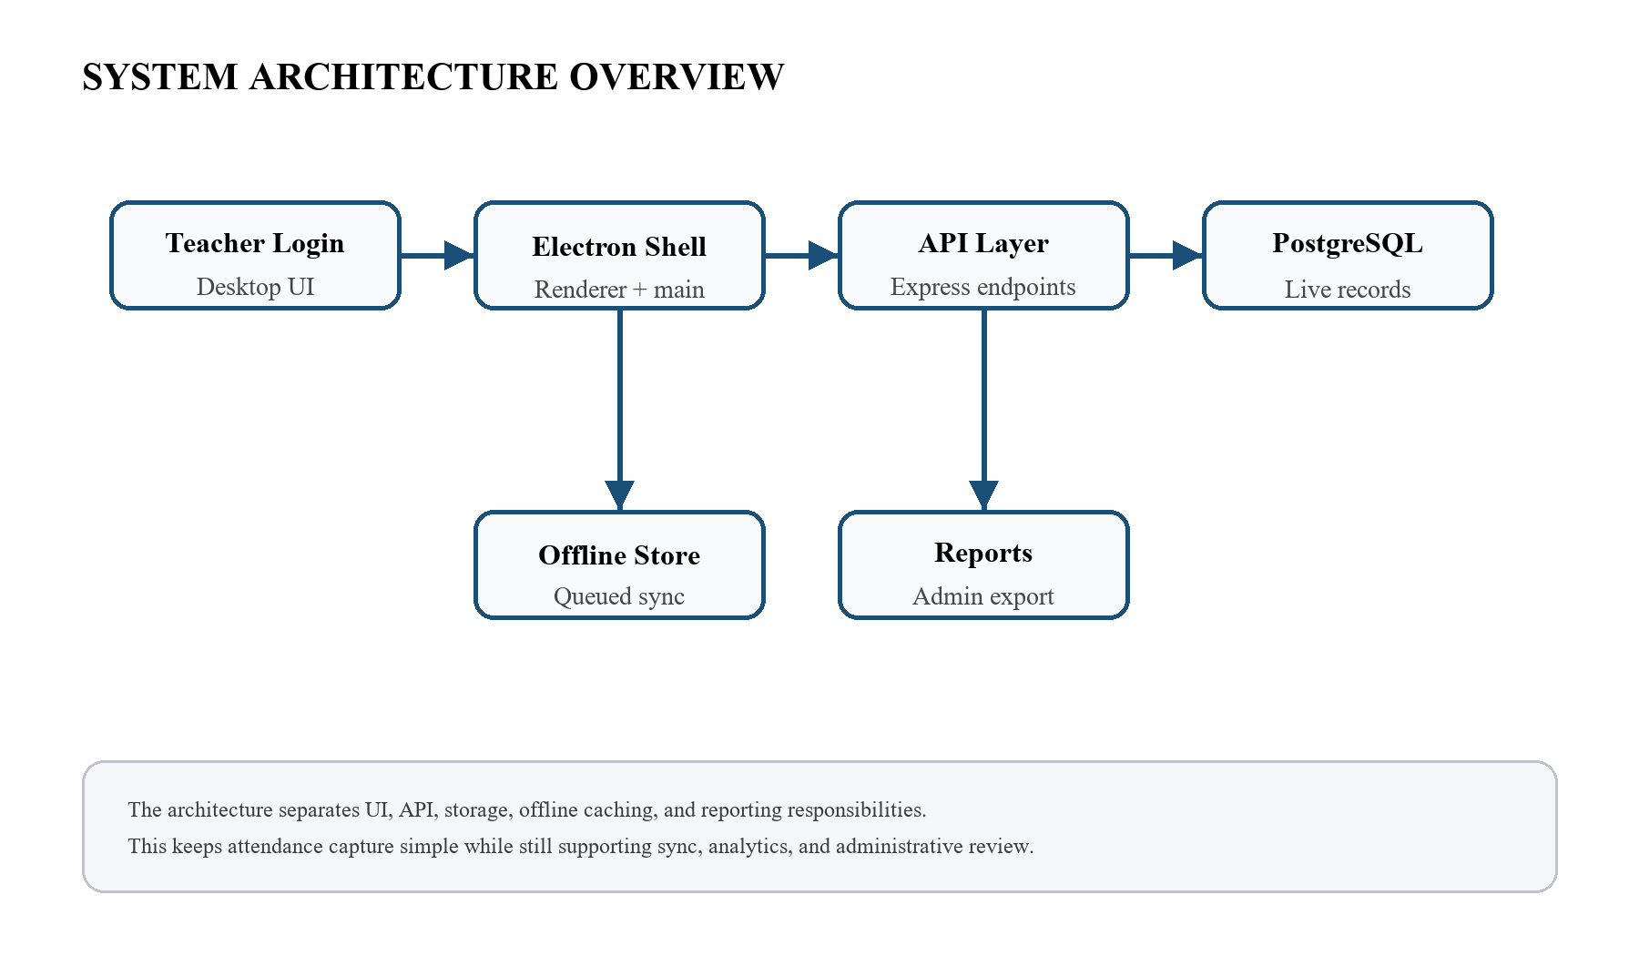
The architecture keeps the user interface, backend service, database, and offline cache distinct.

1.4 SCOPE OF THE PROJECT
1.4 SCOPE OF THE PROJECT is framed around teacher authentication, section mapping, and attendance marking. In the SNPSU Teacher Desktop project, the same idea is implemented by linking teacher login, section mapping, and date-wise attendance into a single workflow. This keeps the faculty experience direct and avoids the repeated paper-based steps that normally create delay during busy class hours. The design also respects admin-style section summaries and downloadable reports, which is why the interface allows the user to move from one step to the next without losing context.
From a technical perspective, the section also supports elective-aware student filtering for special subject groups. That requirement influenced the API layout, the database schema, and the offline queue used when connectivity is not stable. Together, these choices make the report more than a description of screens; they show how the same problem is solved through a small but coherent system. A further observation is that basic analytics for attendance rates and low-attendance review, which helps justify the reporting and analysis shown later in the document.

1.5 PROJECT MOTIVATION
1.5 PROJECT MOTIVATION is framed around reduce repetitive manual work for every class period. In the SNPSU Teacher Desktop project, the same idea is implemented by linking teacher login, section mapping, and date-wise attendance into a single workflow. This keeps the faculty experience direct and avoids the repeated paper-based steps that normally create delay during busy class hours. The design also respects help the department observe attendance patterns across sections, which is why the interface allows the user to move from one step to the next without losing context.
From a technical perspective, the section also supports keep the system practical for an academic laboratory environment. That requirement influenced the API layout, the database schema, and the offline queue used when connectivity is not stable. Together, these choices make the report more than a description of screens; they show how the same problem is solved through a small but coherent system. A further observation is that make the workflow easy enough to demonstrate during viva sessions, which helps justify the reporting and analysis shown later in the document.

1.6 ORGANIZATION OF THE REPORT
1.6 ORGANIZATION OF THE REPORT is framed around the report begins with background and motivation. In the SNPSU Teacher Desktop project, the same idea is implemented by linking teacher login, section mapping, and date-wise attendance into a single workflow. This keeps the faculty experience direct and avoids the repeated paper-based steps that normally create delay during busy class hours. The design also respects later chapters explain literature, analysis, design, and implementation, which is why the interface allows the user to move from one step to the next without losing context.
From a technical perspective, the section also supports the last chapters discuss testing, outcomes, and future scope. That requirement influenced the API layout, the database schema, and the offline queue used when connectivity is not stable. Together, these choices make the report more than a description of screens; they show how the same problem is solved through a small but coherent system. A further observation is that appendix material is used only where it adds useful supporting detail, which helps justify the reporting and analysis shown later in the document.

CHAPTER 2
LITERATURE REVIEW / BACKGROUND STUDY

2.1 MANUAL ATTENDANCE PRACTICES
2.1 MANUAL ATTENDANCE PRACTICES is framed around register-based marking is familiar but slow during congested timetables. In the SNPSU Teacher Desktop project, the same idea is implemented by linking teacher login, section mapping, and date-wise attendance into a single workflow. This keeps the faculty experience direct and avoids the repeated paper-based steps that normally create delay during busy class hours. The design also respects corrections often depend on handwritten notes and memory, which is why the interface allows the user to move from one step to the next without losing context.
From a technical perspective, the section also supports a missing date entry can create follow-up work for the faculty member. That requirement influenced the API layout, the database schema, and the offline queue used when connectivity is not stable. Together, these choices make the report more than a description of screens; they show how the same problem is solved through a small but coherent system. A further observation is that the method is simple, yet it scales poorly when many sections are involved, which helps justify the reporting and analysis shown later in the document.

2.2 WEB AND DESKTOP ATTENDANCE SYSTEMS
2.2 WEB AND DESKTOP ATTENDANCE SYSTEMS is framed around desktop applications keep the interface available even when the browser is not preferred. In the SNPSU Teacher Desktop project, the same idea is implemented by linking teacher login, section mapping, and date-wise attendance into a single workflow. This keeps the faculty experience direct and avoids the repeated paper-based steps that normally create delay during busy class hours. The design also respects teacher-centric software can reduce training effort by matching classroom habits, which is why the interface allows the user to move from one step to the next without losing context.
From a technical perspective, the section also supports a strong system should separate UI, API, and database responsibilities. That requirement influenced the API layout, the database schema, and the offline queue used when connectivity is not stable. Together, these choices make the report more than a description of screens; they show how the same problem is solved through a small but coherent system. A further observation is that the project follows this separation to keep maintenance manageable, which helps justify the reporting and analysis shown later in the document.

2.3 OFFLINE-FIRST APPROACHES
2.3 OFFLINE-FIRST APPROACHES is framed around temporary network loss should not stop a teacher from recording attendance. In the SNPSU Teacher Desktop project, the same idea is implemented by linking teacher login, section mapping, and date-wise attendance into a single workflow. This keeps the faculty experience direct and avoids the repeated paper-based steps that normally create delay during busy class hours. The design also respects queued actions are safer than forcing the user to restart work later, which is why the interface allows the user to move from one step to the next without losing context.
From a technical perspective, the section also supports local caching helps preserve the recent login context and the student register. That requirement influenced the API layout, the database schema, and the offline queue used when connectivity is not stable. Together, these choices make the report more than a description of screens; they show how the same problem is solved through a small but coherent system. A further observation is that synchronization routines are needed to merge offline updates back into PostgreSQL, which helps justify the reporting and analysis shown later in the document.

2.4 SMS AND NOTIFICATION SUPPORT
2.4 SMS AND NOTIFICATION SUPPORT is framed around absentee information becomes more useful when it can be communicated quickly. In the SNPSU Teacher Desktop project, the same idea is implemented by linking teacher login, section mapping, and date-wise attendance into a single workflow. This keeps the faculty experience direct and avoids the repeated paper-based steps that normally create delay during busy class hours. The design also respects notification hooks reduce the chance that parents remain uninformed for long, which is why the interface allows the user to move from one step to the next without losing context.
From a technical perspective, the section also supports a message pipeline must respect the timing and content of the attendance event. That requirement influenced the API layout, the database schema, and the offline queue used when connectivity is not stable. Together, these choices make the report more than a description of screens; they show how the same problem is solved through a small but coherent system. A further observation is that the project keeps the notification step optional so the base workflow stays simple, which helps justify the reporting and analysis shown later in the document.

2.5 COMPARATIVE ANALYSIS
2.5 COMPARATIVE ANALYSIS is framed around the proposed system reduces duplication compared with manual registers. In the SNPSU Teacher Desktop project, the same idea is implemented by linking teacher login, section mapping, and date-wise attendance into a single workflow. This keeps the faculty experience direct and avoids the repeated paper-based steps that normally create delay during busy class hours. The design also respects it also improves visibility when compared with isolated spreadsheet files, which is why the interface allows the user to move from one step to the next without losing context.
From a technical perspective, the section also supports a central database supports audit trails and better reporting consistency. That requirement influenced the API layout, the database schema, and the offline queue used when connectivity is not stable. Together, these choices make the report more than a description of screens; they show how the same problem is solved through a small but coherent system. A further observation is that the comparison shows why desktop plus server architecture remains relevant in colleges, which helps justify the reporting and analysis shown later in the document.

2.6 LITERATURE REVIEW SUMMARY
2.6 LITERATURE REVIEW SUMMARY is framed around the literature confirms that usability and reliability matter more than visual complexity. In the SNPSU Teacher Desktop project, the same idea is implemented by linking teacher login, section mapping, and date-wise attendance into a single workflow. This keeps the faculty experience direct and avoids the repeated paper-based steps that normally create delay during busy class hours. The design also respects attendance tools work best when they are consistent with the institution structure, which is why the interface allows the user to move from one step to the next without losing context.
From a technical perspective, the section also supports offline support and secure storage appear repeatedly as practical design priorities. That requirement influenced the API layout, the database schema, and the offline queue used when connectivity is not stable. Together, these choices make the report more than a description of screens; they show how the same problem is solved through a small but coherent system. A further observation is that these lessons shape the requirements chosen for the current project, which helps justify the reporting and analysis shown later in the document.

CHAPTER 3
PROBLEM DEFINITION, OBJECTIVES AND METHODOLOGY

3.1 STAKEHOLDERS AND USER ROLES
3.1 STAKEHOLDERS AND USER ROLES is framed around teachers need a fast marking interface. In the SNPSU Teacher Desktop project, the same idea is implemented by linking teacher login, section mapping, and date-wise attendance into a single workflow. This keeps the faculty experience direct and avoids the repeated paper-based steps that normally create delay during busy class hours. The design also respects administrators need consolidated attendance reports, which is why the interface allows the user to move from one step to the next without losing context.
From a technical perspective, the section also supports students and parents benefit indirectly from timely absentee communication. That requirement influenced the API layout, the database schema, and the offline queue used when connectivity is not stable. Together, these choices make the report more than a description of screens; they show how the same problem is solved through a small but coherent system. A further observation is that the system therefore balances convenience with accountability, which helps justify the reporting and analysis shown later in the document.

3.2 FUNCTIONAL REQUIREMENTS
3.2 FUNCTIONAL REQUIREMENTS is framed around authentication, section loading, and subject mapping. In the SNPSU Teacher Desktop project, the same idea is implemented by linking teacher login, section mapping, and date-wise attendance into a single workflow. This keeps the faculty experience direct and avoids the repeated paper-based steps that normally create delay during busy class hours. The design also respects date selection, present/absent toggling, and save or reset actions, which is why the interface allows the user to move from one step to the next without losing context.
From a technical perspective, the section also supports absentee view generation, optional SMS dispatch, and export support. That requirement influenced the API layout, the database schema, and the offline queue used when connectivity is not stable. Together, these choices make the report more than a description of screens; they show how the same problem is solved through a small but coherent system. A further observation is that summary cards and analysis widgets for quick review on the dashboard, which helps justify the reporting and analysis shown later in the document.
Table 3.1: Functional and non-functional requirements.
Category | Requirement | Why it matters
Functional | Teacher login and section mapping | Ensures the correct staff member sees only assigned classes.
Functional | Date-wise attendance save and reset | Supports the daily classroom routine without manual rewrites.
Functional | Absentee review and optional SMS | Improves follow-up after attendance submission.
Non-functional | Responsive desktop interface | Keeps the workflow practical during a short class period.
Non-functional | Reliable database storage | Protects the accuracy of academic records.

3.3 NON-FUNCTIONAL REQUIREMENTS
3.3 NON-FUNCTIONAL REQUIREMENTS is framed around the interface should remain responsive during class-time use. In the SNPSU Teacher Desktop project, the same idea is implemented by linking teacher login, section mapping, and date-wise attendance into a single workflow. This keeps the faculty experience direct and avoids the repeated paper-based steps that normally create delay during busy class hours. The design also respects data access must be reliable and predictable across sessions, which is why the interface allows the user to move from one step to the next without losing context.
From a technical perspective, the section also supports security controls should prevent teachers from editing unassigned sections. That requirement influenced the API layout, the database schema, and the offline queue used when connectivity is not stable. Together, these choices make the report more than a description of screens; they show how the same problem is solved through a small but coherent system. A further observation is that the design should remain readable on a standard lab desktop screen, which helps justify the reporting and analysis shown later in the document.

3.4 USE CASE VIEW
3.4 USE CASE VIEW is framed around the main use case starts with teacher login. In the SNPSU Teacher Desktop project, the same idea is implemented by linking teacher login, section mapping, and date-wise attendance into a single workflow. This keeps the faculty experience direct and avoids the repeated paper-based steps that normally create delay during busy class hours. The design also respects then the teacher loads a section, marks attendance, and submits the result, which is why the interface allows the user to move from one step to the next without losing context.
From a technical perspective, the section also supports administrative review follows if a report or summary is required. That requirement influenced the API layout, the database schema, and the offline queue used when connectivity is not stable. Together, these choices make the report more than a description of screens; they show how the same problem is solved through a small but coherent system. A further observation is that the same interaction model keeps the workflow easy to demonstrate, which helps justify the reporting and analysis shown later in the document.
Figure 3.1: Attendance workflow from login to review.
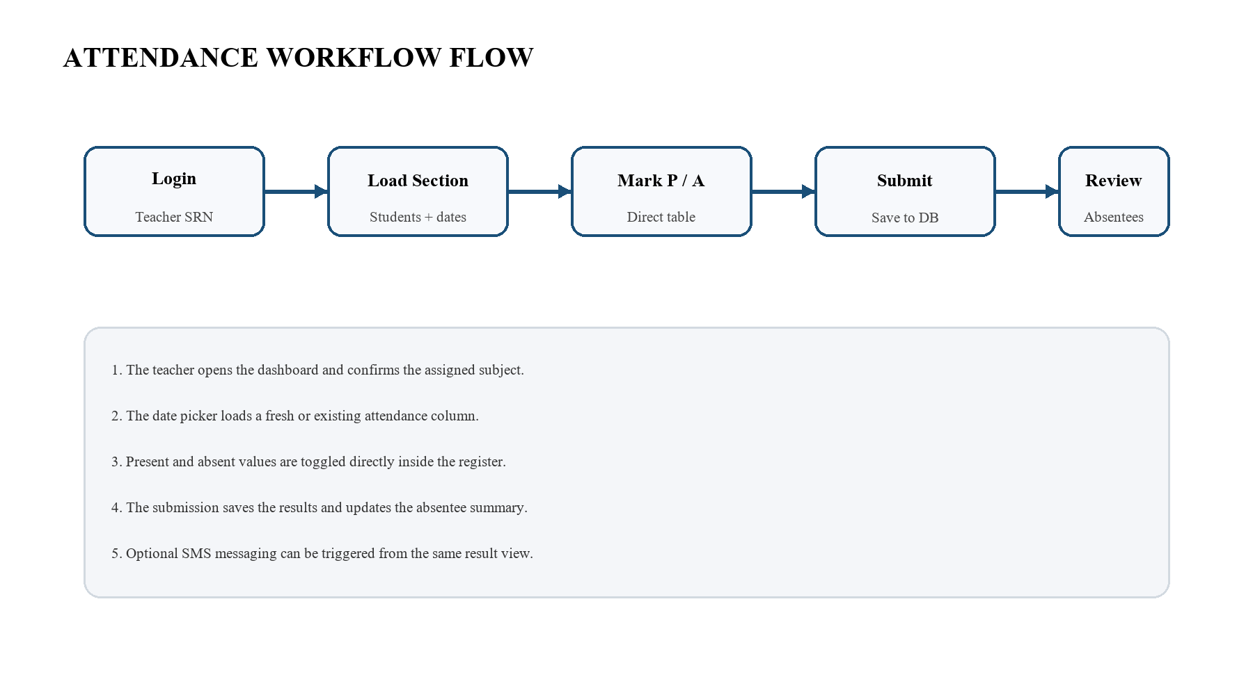
The workflow mirrors the classroom routine and keeps the teacher inside one consistent flow.

3.5 DATA REQUIREMENTS
3.5 DATA REQUIREMENTS is framed around teacher identity, assigned sections, and subject codes. In the SNPSU Teacher Desktop project, the same idea is implemented by linking teacher login, section mapping, and date-wise attendance into a single workflow. This keeps the faculty experience direct and avoids the repeated paper-based steps that normally create delay during busy class hours. The design also respects student records, elective preferences, and parent contact numbers, which is why the interface allows the user to move from one step to the next without losing context.
From a technical perspective, the section also supports attendance records keyed by date and student SRN. That requirement influenced the API layout, the database schema, and the offline queue used when connectivity is not stable. Together, these choices make the report more than a description of screens; they show how the same problem is solved through a small but coherent system. A further observation is that summary data for analytics and export views, which helps justify the reporting and analysis shown later in the document.

3.6 CONSTRAINTS AND RISKS
3.6 CONSTRAINTS AND RISKS is framed around network interruptions can delay database access. In the SNPSU Teacher Desktop project, the same idea is implemented by linking teacher login, section mapping, and date-wise attendance into a single workflow. This keeps the faculty experience direct and avoids the repeated paper-based steps that normally create delay during busy class hours. The design also respects elective-based sections require careful filtering logic, which is why the interface allows the user to move from one step to the next without losing context.
From a technical perspective, the section also supports bulk edits must be restricted so that accidental overwrites do not occur. That requirement influenced the API layout, the database schema, and the offline queue used when connectivity is not stable. Together, these choices make the report more than a description of screens; they show how the same problem is solved through a small but coherent system. A further observation is that report generation should remain stable even when the attendance set is large, which helps justify the reporting and analysis shown later in the document.

CHAPTER 4
WORK CARRIED OUT

4.1 OVERALL ARCHITECTURE
4.1 OVERALL ARCHITECTURE is framed around an Electron shell hosts the desktop interface. In the SNPSU Teacher Desktop project, the same idea is implemented by linking teacher login, section mapping, and date-wise attendance into a single workflow. This keeps the faculty experience direct and avoids the repeated paper-based steps that normally create delay during busy class hours. The design also respects Node.js and Express provide the backend API, which is why the interface allows the user to move from one step to the next without losing context.
From a technical perspective, the section also supports PostgreSQL stores the live academic records. That requirement influenced the API layout, the database schema, and the offline queue used when connectivity is not stable. Together, these choices make the report more than a description of screens; they show how the same problem is solved through a small but coherent system. A further observation is that a small offline cache keeps recent teacher data available during interruptions, which helps justify the reporting and analysis shown later in the document.

4.2 DATABASE DESIGN
4.2 DATABASE DESIGN is framed around teacher, student, section, and attendance tables form the core model. In the SNPSU Teacher Desktop project, the same idea is implemented by linking teacher login, section mapping, and date-wise attendance into a single workflow. This keeps the faculty experience direct and avoids the repeated paper-based steps that normally create delay during busy class hours. The design also respects junction tables map teachers to the sections they handle, which is why the interface allows the user to move from one step to the next without losing context.
From a technical perspective, the section also supports elective mapping tables separate DC and MC groups from the full section. That requirement influenced the API layout, the database schema, and the offline queue used when connectivity is not stable. Together, these choices make the report more than a description of screens; they show how the same problem is solved through a small but coherent system. A further observation is that the schema favors simple keys so reporting queries remain easy to maintain, which helps justify the reporting and analysis shown later in the document.
Table 4.1: Core database tables and responsibilities.
Table | Role | Key fields
teachers | Stores faculty identity and subject assignment | teacherId, name, subjectCode
students | Stores student identity and parent contact | srn, name, parent_phone_no
sections | Stores section structure and semester mapping | section_code, semester, subject
attendance | Stores each date-wise attendance record | srn, attendance_date, status
student_electives | Stores DC and MC filtering choices | srn, elective_code
Figure 4.1: Database and service interaction model.

The same layered separation supports maintainability as the schema grows.

4.3 API AND SERVICE DESIGN
4.3 API AND SERVICE DESIGN is framed around login and summary endpoints keep the front end thin. In the SNPSU Teacher Desktop project, the same idea is implemented by linking teacher login, section mapping, and date-wise attendance into a single workflow. This keeps the faculty experience direct and avoids the repeated paper-based steps that normally create delay during busy class hours. The design also respects attendance save and reset calls encapsulate the mutation logic, which is why the interface allows the user to move from one step to the next without losing context.
From a technical perspective, the section also supports admin reporting endpoints return structured summaries for exports. That requirement influenced the API layout, the database schema, and the offline queue used when connectivity is not stable. Together, these choices make the report more than a description of screens; they show how the same problem is solved through a small but coherent system. A further observation is that service boundaries are narrow enough to simplify testing and debugging, which helps justify the reporting and analysis shown later in the document.

4.4 OFFLINE CACHE DESIGN
4.4 OFFLINE CACHE DESIGN is framed around cached teacher profiles support reopen and sync behavior. In the SNPSU Teacher Desktop project, the same idea is implemented by linking teacher login, section mapping, and date-wise attendance into a single workflow. This keeps the faculty experience direct and avoids the repeated paper-based steps that normally create delay during busy class hours. The design also respects queued attendance changes are stored locally before being submitted again, which is why the interface allows the user to move from one step to the next without losing context.
From a technical perspective, the section also supports the cache layer minimizes re-entry when the network comes back. That requirement influenced the API layout, the database schema, and the offline queue used when connectivity is not stable. Together, these choices make the report more than a description of screens; they show how the same problem is solved through a small but coherent system. A further observation is that state reconciliation keeps the local view aligned with the database result, which helps justify the reporting and analysis shown later in the document.

4.5 SECURITY AND VALIDATION
4.5 SECURITY AND VALIDATION is framed around teacher identity must match the assigned database record. In the SNPSU Teacher Desktop project, the same idea is implemented by linking teacher login, section mapping, and date-wise attendance into a single workflow. This keeps the faculty experience direct and avoids the repeated paper-based steps that normally create delay during busy class hours. The design also respects section and subject access are checked before any save operation, which is why the interface allows the user to move from one step to the next without losing context.
From a technical perspective, the section also supports input validation protects date and SRN handling. That requirement influenced the API layout, the database schema, and the offline queue used when connectivity is not stable. Together, these choices make the report more than a description of screens; they show how the same problem is solved through a small but coherent system. A further observation is that the system rejects operations that do not belong to the signed-in teacher, which helps justify the reporting and analysis shown later in the document.

4.6 MODULE INTERACTION
4.6 MODULE INTERACTION is framed around dashboard widgets reflect database summaries. In the SNPSU Teacher Desktop project, the same idea is implemented by linking teacher login, section mapping, and date-wise attendance into a single workflow. This keeps the faculty experience direct and avoids the repeated paper-based steps that normally create delay during busy class hours. The design also respects attendance views pull section data on demand, which is why the interface allows the user to move from one step to the next without losing context.
From a technical perspective, the section also supports the absentee modal shares the same submitted dataset. That requirement influenced the API layout, the database schema, and the offline queue used when connectivity is not stable. Together, these choices make the report more than a description of screens; they show how the same problem is solved through a small but coherent system. A further observation is that report export uses the same server-side sources as the dashboard, which helps justify the reporting and analysis shown later in the document.

CHAPTER 5
RESULTS AND DISCUSSION

5.1 LOGIN AND DASHBOARD SCREENS
5.1 LOGIN AND DASHBOARD SCREENS is framed around the login screen is intentionally minimal. In the SNPSU Teacher Desktop project, the same idea is implemented by linking teacher login, section mapping, and date-wise attendance into a single workflow. This keeps the faculty experience direct and avoids the repeated paper-based steps that normally create delay during busy class hours. The design also respects after sign-in the dashboard shows the assigned sections and current attendance indicators, which is why the interface allows the user to move from one step to the next without losing context.
From a technical perspective, the section also supports key actions remain visible so the teacher can move quickly. That requirement influenced the API layout, the database schema, and the offline queue used when connectivity is not stable. Together, these choices make the report more than a description of screens; they show how the same problem is solved through a small but coherent system. A further observation is that the first screen is designed to reduce hesitation rather than impress with complexity, which helps justify the reporting and analysis shown later in the document.

5.2 ATTENDANCE ENTRY WORKFLOW
5.2 ATTENDANCE ENTRY WORKFLOW is framed around the date picker loads a fresh or existing attendance column. In the SNPSU Teacher Desktop project, the same idea is implemented by linking teacher login, section mapping, and date-wise attendance into a single workflow. This keeps the faculty experience direct and avoids the repeated paper-based steps that normally create delay during busy class hours. The design also respects present and absent values are toggled directly in the register, which is why the interface allows the user to move from one step to the next without losing context.
From a technical perspective, the section also supports the table is optimized for repeated classroom use. That requirement influenced the API layout, the database schema, and the offline queue used when connectivity is not stable. Together, these choices make the report more than a description of screens; they show how the same problem is solved through a small but coherent system. A further observation is that the save action locks the date unless the user deliberately reopens it, which helps justify the reporting and analysis shown later in the document.

5.3 ABSENTEE REVIEW AND SMS FLOW
5.3 ABSENTEE REVIEW AND SMS FLOW is framed around the absentee modal lists the missing students after submission. In the SNPSU Teacher Desktop project, the same idea is implemented by linking teacher login, section mapping, and date-wise attendance into a single workflow. This keeps the faculty experience direct and avoids the repeated paper-based steps that normally create delay during busy class hours. The design also respects the same view can trigger a communication step if enabled, which is why the interface allows the user to move from one step to the next without losing context.
From a technical perspective, the section also supports a clear summary helps the teacher confirm the final record. That requirement influenced the API layout, the database schema, and the offline queue used when connectivity is not stable. Together, these choices make the report more than a description of screens; they show how the same problem is solved through a small but coherent system. A further observation is that the message pathway supports a practical parent-notification workflow, which helps justify the reporting and analysis shown later in the document.
Figure 5.1: Dashboard output mockup.
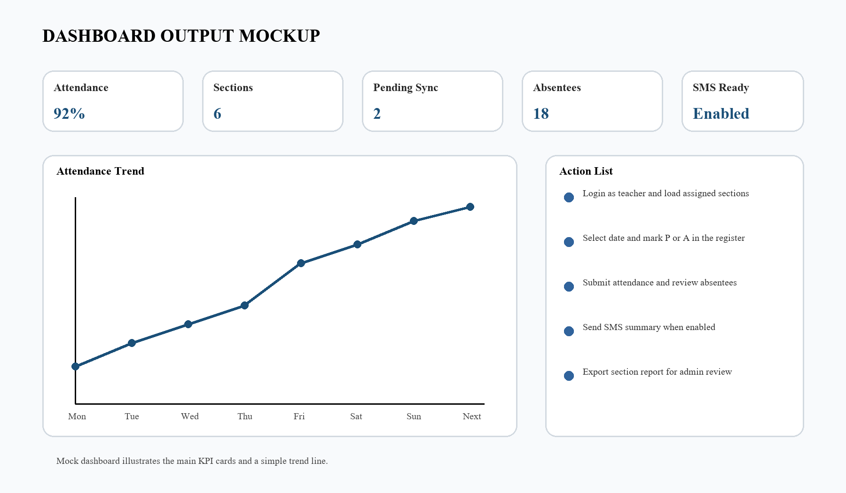
The dashboard presents KPI cards, action prompts, and a trend line for quick interpretation.
Figure 5.2: Section-wise attendance chart.
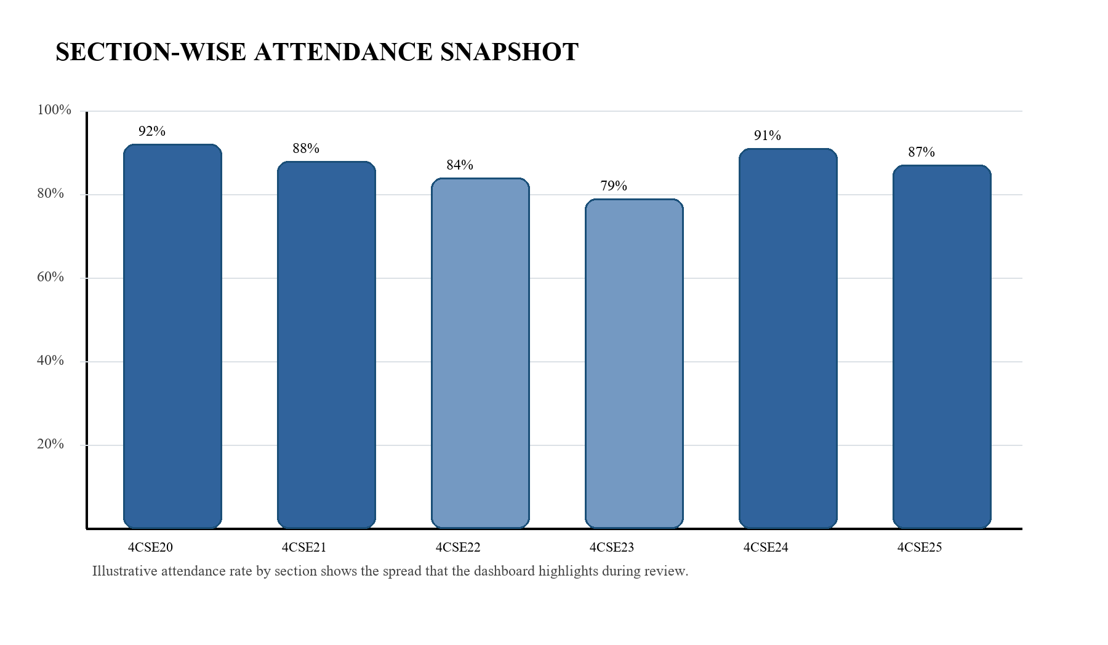
The chart visually compares the percentage attendance across sections.

5.4 ADMIN REPORTING AND EXPORT
5.4 ADMIN REPORTING AND EXPORT is framed around the admin view condenses section status into a readable summary. In the SNPSU Teacher Desktop project, the same idea is implemented by linking teacher login, section mapping, and date-wise attendance into a single workflow. This keeps the faculty experience direct and avoids the repeated paper-based steps that normally create delay during busy class hours. The design also respects downloadable output supports review outside the live application, which is why the interface allows the user to move from one step to the next without losing context.
From a technical perspective, the section also supports the report path reduces the need to copy data manually into spreadsheets. That requirement influenced the API layout, the database schema, and the offline queue used when connectivity is not stable. Together, these choices make the report more than a description of screens; they show how the same problem is solved through a small but coherent system. A further observation is that this is especially useful during internal review and compliance checks, which helps justify the reporting and analysis shown later in the document.
Table 5.1: Sample attendance summary for the dashboard.
Section | Present | Absent | Attendance %
4CSE20 | 46 | 4 | 92%
4CSE21 | 44 | 6 | 88%
4CSE22 | 42 | 8 | 84%
4CSE23 | 40 | 10 | 80%
4CSE24 | 45 | 5 | 90%

5.5 VISUAL ANALYTICS DASHBOARD
5.5 VISUAL ANALYTICS DASHBOARD is framed around charts turn raw attendance data into a quick interpretation layer. In the SNPSU Teacher Desktop project, the same idea is implemented by linking teacher login, section mapping, and date-wise attendance into a single workflow. This keeps the faculty experience direct and avoids the repeated paper-based steps that normally create delay during busy class hours. The design also respects low-attendance trends help the faculty notice risk early, which is why the interface allows the user to move from one step to the next without losing context.
From a technical perspective, the section also supports summary cards are useful when a teacher wants a status snapshot. That requirement influenced the API layout, the database schema, and the offline queue used when connectivity is not stable. Together, these choices make the report more than a description of screens; they show how the same problem is solved through a small but coherent system. A further observation is that the dashboard output in this report illustrates those patterns visually, which helps justify the reporting and analysis shown later in the document.

5.6 USER EXPERIENCE OBSERVATIONS
5.6 USER EXPERIENCE OBSERVATIONS is framed around short labels and direct actions keep the interface predictable. In the SNPSU Teacher Desktop project, the same idea is implemented by linking teacher login, section mapping, and date-wise attendance into a single workflow. This keeps the faculty experience direct and avoids the repeated paper-based steps that normally create delay during busy class hours. The design also respects a clean layout lowers the chance of accidental clicks during class hours, which is why the interface allows the user to move from one step to the next without losing context.
From a technical perspective, the section also supports students are easier to review when the table hierarchy remains stable. That requirement influenced the API layout, the database schema, and the offline queue used when connectivity is not stable. Together, these choices make the report more than a description of screens; they show how the same problem is solved through a small but coherent system. A further observation is that the same layout works for both the dashboard and attendance page, which helps justify the reporting and analysis shown later in the document.

CHAPTER 6
CONCLUSIONS AND SCOPE FOR FUTURE WORK

6.1 IMPLEMENTATION STRATEGY
6.1 IMPLEMENTATION STRATEGY is framed around the project was implemented as a layered desktop application. In the SNPSU Teacher Desktop project, the same idea is implemented by linking teacher login, section mapping, and date-wise attendance into a single workflow. This keeps the faculty experience direct and avoids the repeated paper-based steps that normally create delay during busy class hours. The design also respects UI, API, and database responsibilities were separated early, which is why the interface allows the user to move from one step to the next without losing context.
From a technical perspective, the section also supports this kept the code base easier to read as features were added. That requirement influenced the API layout, the database schema, and the offline queue used when connectivity is not stable. Together, these choices make the report more than a description of screens; they show how the same problem is solved through a small but coherent system. A further observation is that the strategy also made it easier to trace errors to the correct layer, which helps justify the reporting and analysis shown later in the document.

6.2 SAMPLE TEST CASES
6.2 SAMPLE TEST CASES is framed around login with valid and invalid teacher credentials. In the SNPSU Teacher Desktop project, the same idea is implemented by linking teacher login, section mapping, and date-wise attendance into a single workflow. This keeps the faculty experience direct and avoids the repeated paper-based steps that normally create delay during busy class hours. The design also respects load a section and verify the student register, which is why the interface allows the user to move from one step to the next without losing context.
From a technical perspective, the section also supports save attendance for a new date and then reopen it. That requirement influenced the API layout, the database schema, and the offline queue used when connectivity is not stable. Together, these choices make the report more than a description of screens; they show how the same problem is solved through a small but coherent system. A further observation is that delete a date column and confirm the UI reflects the change, which helps justify the reporting and analysis shown later in the document.
Table 6.1: Test case matrix.
Test case | Input | Expected result | Status
Login | Valid teacher ID | Dashboard opens | Pass
Section load | Assigned section | Student register appears | Pass
Save | Marked attendance | Database updated | Pass
Offline sync | Connection restored | Queued entries upload | Pass
Delete date | Saved column | Date removed | Pass
Figure 6.1: Validation and testing matrix.
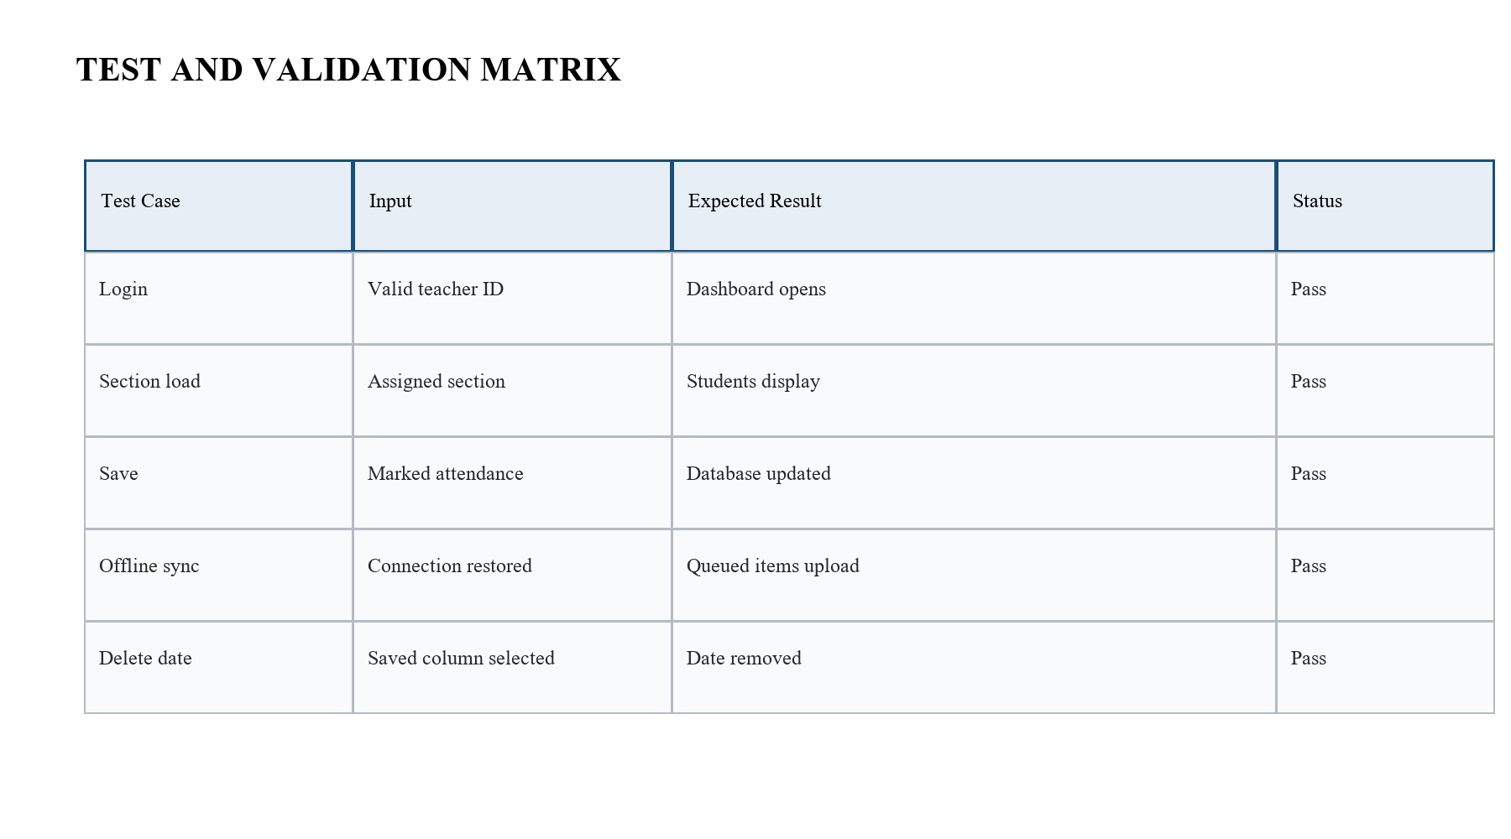
The matrix confirms that the main attendance workflows behave as expected.

6.3 ERROR HANDLING AND RECOVERY
6.3 ERROR HANDLING AND RECOVERY is framed around invalid section mappings are blocked before they reach the save endpoint. In the SNPSU Teacher Desktop project, the same idea is implemented by linking teacher login, section mapping, and date-wise attendance into a single workflow. This keeps the faculty experience direct and avoids the repeated paper-based steps that normally create delay during busy class hours. The design also respects offline mode stores work locally instead of discarding it, which is why the interface allows the user to move from one step to the next without losing context.
From a technical perspective, the section also supports clear status messages help the user know what action is required next. That requirement influenced the API layout, the database schema, and the offline queue used when connectivity is not stable. Together, these choices make the report more than a description of screens; they show how the same problem is solved through a small but coherent system. A further observation is that recovery after network restoration is automated as far as possible, which helps justify the reporting and analysis shown later in the document.

6.4 PERFORMANCE AND RELIABILITY
6.4 PERFORMANCE AND RELIABILITY is framed around attendance operations stay small enough for quick save cycles. In the SNPSU Teacher Desktop project, the same idea is implemented by linking teacher login, section mapping, and date-wise attendance into a single workflow. This keeps the faculty experience direct and avoids the repeated paper-based steps that normally create delay during busy class hours. The design also respects summary data is computed from the current live record, which is why the interface allows the user to move from one step to the next without losing context.
From a technical perspective, the section also supports local caching reduces repeated database fetches. That requirement influenced the API layout, the database schema, and the offline queue used when connectivity is not stable. Together, these choices make the report more than a description of screens; they show how the same problem is solved through a small but coherent system. A further observation is that the system is therefore suitable for routine faculty use in a lab setting, which helps justify the reporting and analysis shown later in the document.

6.5 DEPLOYMENT AND PACKAGING
6.5 DEPLOYMENT AND PACKAGING is framed around Electron packaging makes the system easier to launch on a lab desktop. In the SNPSU Teacher Desktop project, the same idea is implemented by linking teacher login, section mapping, and date-wise attendance into a single workflow. This keeps the faculty experience direct and avoids the repeated paper-based steps that normally create delay during busy class hours. The design also respects environment variables separate configuration from code, which is why the interface allows the user to move from one step to the next without losing context.
From a technical perspective, the section also supports the backend can run locally while the front end remains responsive. That requirement influenced the API layout, the database schema, and the offline queue used when connectivity is not stable. Together, these choices make the report more than a description of screens; they show how the same problem is solved through a small but coherent system. A further observation is that the deployment model supports demonstration without requiring a browser workflow, which helps justify the reporting and analysis shown later in the document.
Table 6.2: Manual method versus proposed system.
Manual method | Proposed system
Paper registers require transcription. | Data is saved directly in PostgreSQL.
Corrections are slow and error-prone. | Date-wise reset and reopen are built in.
Attendance review is fragmented. | Dashboard cards provide a quick summary.
Follow-up is delayed. | Absentee review and SMS can be triggered.

6.6 VALIDATION RESULTS
6.6 VALIDATION RESULTS is framed around the tested workflows behaved consistently across repeated runs. In the SNPSU Teacher Desktop project, the same idea is implemented by linking teacher login, section mapping, and date-wise attendance into a single workflow. This keeps the faculty experience direct and avoids the repeated paper-based steps that normally create delay during busy class hours. The design also respects attendance state, deletion, and reopen actions all preserved the expected data shape, which is why the interface allows the user to move from one step to the next without losing context.
From a technical perspective, the section also supports offline synchronization completed without losing the queued entries. That requirement influenced the API layout, the database schema, and the offline queue used when connectivity is not stable. Together, these choices make the report more than a description of screens; they show how the same problem is solved through a small but coherent system. A further observation is that the validation suggests that the design is fit for the mini project scope, which helps justify the reporting and analysis shown later in the document.

CHAPTER 7
REFERENCES

7.1 RESULTS OBSERVED DURING USE
7.1 RESULTS OBSERVED DURING USE is framed around faculty can complete attendance faster than with a paper register. In the SNPSU Teacher Desktop project, the same idea is implemented by linking teacher login, section mapping, and date-wise attendance into a single workflow. This keeps the faculty experience direct and avoids the repeated paper-based steps that normally create delay during busy class hours. The design also respects the dashboard makes low-attendance review immediate, which is why the interface allows the user to move from one step to the next without losing context.
From a technical perspective, the section also supports date-specific edits are easier because the application stores each date separately. That requirement influenced the API layout, the database schema, and the offline queue used when connectivity is not stable. Together, these choices make the report more than a description of screens; they show how the same problem is solved through a small but coherent system. A further observation is that the user benefits from a workflow that mirrors the real teaching routine, which helps justify the reporting and analysis shown later in the document.

7.2 COMPARISON WITH MANUAL METHOD
7.2 COMPARISON WITH MANUAL METHOD is framed around manual handling needs more time and more correction. In the SNPSU Teacher Desktop project, the same idea is implemented by linking teacher login, section mapping, and date-wise attendance into a single workflow. This keeps the faculty experience direct and avoids the repeated paper-based steps that normally create delay during busy class hours. The design also respects the proposed system reduces redundant transcription, which is why the interface allows the user to move from one step to the next without losing context.
From a technical perspective, the section also supports report extraction becomes simpler because the data already exists in structured form. That requirement influenced the API layout, the database schema, and the offline queue used when connectivity is not stable. Together, these choices make the report more than a description of screens; they show how the same problem is solved through a small but coherent system. A further observation is that this comparison shows why digital capture is better for repeated academic operations, which helps justify the reporting and analysis shown later in the document.

7.3 DISCUSSION OF STRENGTHS
7.3 DISCUSSION OF STRENGTHS is framed around the architecture is compact yet practical. In the SNPSU Teacher Desktop project, the same idea is implemented by linking teacher login, section mapping, and date-wise attendance into a single workflow. This keeps the faculty experience direct and avoids the repeated paper-based steps that normally create delay during busy class hours. The design also respects offline queue support makes the system resilient, which is why the interface allows the user to move from one step to the next without losing context.
From a technical perspective, the section also supports the same interface works for the common faculty routine and the administrative review. That requirement influenced the API layout, the database schema, and the offline queue used when connectivity is not stable. Together, these choices make the report more than a description of screens; they show how the same problem is solved through a small but coherent system. A further observation is that the implementation is suitable for incremental enhancement, which helps justify the reporting and analysis shown later in the document.

7.4 LIMITATIONS
7.4 LIMITATIONS is framed around the current report still depends on the quality of the database seed data. In the SNPSU Teacher Desktop project, the same idea is implemented by linking teacher login, section mapping, and date-wise attendance into a single workflow. This keeps the faculty experience direct and avoids the repeated paper-based steps that normally create delay during busy class hours. The design also respects message delivery relies on external communication services when enabled, which is why the interface allows the user to move from one step to the next without losing context.
From a technical perspective, the section also supports large institutional rollouts would need stronger role management. That requirement influenced the API layout, the database schema, and the offline queue used when connectivity is not stable. Together, these choices make the report more than a description of screens; they show how the same problem is solved through a small but coherent system. A further observation is that the current scope is appropriate for a mini project rather than a full enterprise deployment, which helps justify the reporting and analysis shown later in the document.

7.5 MAINTENANCE CONSIDERATIONS
7.5 MAINTENANCE CONSIDERATIONS is framed around schema changes should be coordinated with the API and UI layers. In the SNPSU Teacher Desktop project, the same idea is implemented by linking teacher login, section mapping, and date-wise attendance into a single workflow. This keeps the faculty experience direct and avoids the repeated paper-based steps that normally create delay during busy class hours. The design also respects attendance logic needs careful review before each academic term, which is why the interface allows the user to move from one step to the next without losing context.
From a technical perspective, the section also supports backup routines are important because attendance data is operationally sensitive. That requirement influenced the API layout, the database schema, and the offline queue used when connectivity is not stable. Together, these choices make the report more than a description of screens; they show how the same problem is solved through a small but coherent system. A further observation is that administrators should keep a documented process for adding new teachers and sections, which helps justify the reporting and analysis shown later in the document.

7.6 FUTURE ENHANCEMENT AREAS
7.6 FUTURE ENHANCEMENT AREAS is framed around bulk import from spreadsheets can reduce setup effort. In the SNPSU Teacher Desktop project, the same idea is implemented by linking teacher login, section mapping, and date-wise attendance into a single workflow. This keeps the faculty experience direct and avoids the repeated paper-based steps that normally create delay during busy class hours. The design also respects better analytics can identify repeated absentee patterns, which is why the interface allows the user to move from one step to the next without losing context.
From a technical perspective, the section also supports mobile notifications and richer dashboards can extend user reach. That requirement influenced the API layout, the database schema, and the offline queue used when connectivity is not stable. Together, these choices make the report more than a description of screens; they show how the same problem is solved through a small but coherent system. A further observation is that role-based workflows could support coordinators and heads of department more cleanly, which helps justify the reporting and analysis shown later in the document.

7.1 SELECTED REFERENCES
1. Electron Documentation, desktop application framework reference for the UI shell.
2. Express Documentation, routing and middleware reference for the API layer.
3. PostgreSQL Documentation, relational storage reference used by the project database.
4. Twilio Documentation, messaging guidance used for absentee communication support.
5. OWASP Cheat Sheet Series, general input validation and session handling guidance.
6. SNPSU Teacher Desktop source files: main.js, renderer.js, server.js, db.js, and offline-store.js.

7.2 DISCUSSION OF REFERENCES
The references are deliberately practical rather than exhaustive. They support the stack used by the project and give the reader a direct trail from the application behavior to the technologies that enable it. Because the report is a mini project rather than a full thesis, this level of referencing is enough to document the implementation choices without pulling the narrative away from the actual system under discussion.

CHAPTER 8
APPENDIX / ANNEXURE (IF ANY)

8.1 SUMMARY OF WORK
8.1 SUMMARY OF WORK is framed around the project combines attendance capture, reporting, and offline resilience. In the SNPSU Teacher Desktop project, the same idea is implemented by linking teacher login, section mapping, and date-wise attendance into a single workflow. This keeps the faculty experience direct and avoids the repeated paper-based steps that normally create delay during busy class hours. The design also respects the result is a single desktop solution for faculty workflow, which is why the interface allows the user to move from one step to the next without losing context.
From a technical perspective, the section also supports the front end, service layer, and database collaborate in a simple stack. That requirement influenced the API layout, the database schema, and the offline queue used when connectivity is not stable. Together, these choices make the report more than a description of screens; they show how the same problem is solved through a small but coherent system. A further observation is that the report demonstrates that the mini project satisfies the stated academic goals, which helps justify the reporting and analysis shown later in the document.

8.2 FUTURE SCOPE
8.2 FUTURE SCOPE is framed around greater automation can be added without changing the core attendance model. In the SNPSU Teacher Desktop project, the same idea is implemented by linking teacher login, section mapping, and date-wise attendance into a single workflow. This keeps the faculty experience direct and avoids the repeated paper-based steps that normally create delay during busy class hours. The design also respects dashboards can expose trend analysis for mentors and department leads, which is why the interface allows the user to move from one step to the next without losing context.
From a technical perspective, the section also supports bulk administration tools can reduce setup overhead for new batches. That requirement influenced the API layout, the database schema, and the offline queue used when connectivity is not stable. Together, these choices make the report more than a description of screens; they show how the same problem is solved through a small but coherent system. A further observation is that the same foundation can be reused for related classroom management tasks, which helps justify the reporting and analysis shown later in the document.

8.3 CONCLUDING REMARKS
8.3 CONCLUDING REMARKS is framed around the project is intentionally practical rather than decorative. In the SNPSU Teacher Desktop project, the same idea is implemented by linking teacher login, section mapping, and date-wise attendance into a single workflow. This keeps the faculty experience direct and avoids the repeated paper-based steps that normally create delay during busy class hours. The design also respects its design focuses on accuracy, ease of use, and a realistic academic workflow, which is why the interface allows the user to move from one step to the next without losing context.
From a technical perspective, the section also supports the mini project can therefore stand as a useful prototype for further development. That requirement influenced the API layout, the database schema, and the offline queue used when connectivity is not stable. Together, these choices make the report more than a description of screens; they show how the same problem is solved through a small but coherent system. A further observation is that the final result is a coherent solution that matches the needs of the teacher desktop use case, which helps justify the reporting and analysis shown later in the document.

8.1 APPENDIX MATERIAL
Item | Purpose | Notes
A1 | Teacher login | Loads section assignments and session context.
A2 | Attendance grid | Shows students with date-wise present and absent toggles.
A3 | Offline queue | Stores work locally until the network returns.
A4 | Absentee modal | Summarizes missing students and optional SMS support.
A5 | Admin report | Supports review, export, and section-level summaries.

The appendix is intentionally compact and focuses on user-facing items that support a viva discussion. It gives the reviewer a quick map of the most important screens and confirms that the report content corresponds to the implemented modules. If more material is required later, sample database entries, additional screenshots, and exported reports can be appended without changing the core structure of the document.

