Day 26 - 20th Aug 2026

Understanding Legacy and Monolithic Applications
Task 1:
Why are legacy systems often resistant to change, and what risks do they pose to modernization efforts?
Legacy systems resist change for a mix of technical and human reasons:
Why they're so resistant
- Tangled dependencies – Over years, other systems, reports, and workflows quietly wire themselves into the legacy system. Nobody has a full map of what depends on what, so touching one thing risks breaking five others.
- Lost knowledge – The people who built it are often gone. The documentation is thin or outdated. What's left is code that works, but nobody fully understands why it works that way.
- "If it ain't broke" thinking – It's running the business right now. Leadership is naturally wary of risking a working (if ugly) system for the promise of something better.
- Sunk cost – Millions may have already gone into building and maintaining it. Replacing it can feel like admitting that investment was wasted.
- Compliance and stability requirements – In banking, healthcare, government, etc., the system has been validated and trusted for years. Change reopens a whole can of regulatory and risk worms.
Risks this poses to modernization
- Hidden breakage – Because nobody fully understands the system, changes can trigger failures in places no one expected.
- Data loss or corruption during migration, especially with messy, undocumented data structures.
- Downtime – Critical operations can grind to a halt if the cutover goes wrong.
- Cost and timeline overruns – What looks like a 6-month project often turns into 2+ years once hidden complexity surfaces.
- Skill gaps – Few engineers want to learn old, dying tech stacks, making both maintenance and migration harder to staff.
- Resistance from people, not just tech — employees comfortable with the old system may slow-walk or subvert the change.

Task 2:
What are common challenges when integrating legacy applications with modern platforms?
Common challenges when integrating legacy applications with modern platforms:
- Incompatible architectures – Legacy systems are often monolithic and tightly coupled, while modern platforms are built around microservices, APIs, and cloud-native design. Bridging the two isn't a natural fit.
- Lack of APIs – Older systems were built before API-first thinking was standard. Integration often means bolting on custom connectors or middleware just to let systems "talk."
- Data format mismatches – Legacy data may live in outdated formats, flat files, or proprietary databases that don't map cleanly to modern JSON/REST-based structures, requiring heavy transformation work.
- Poor or missing documentation – Understanding what the legacy system actually does under the hood — its business logic, edge cases, quirks — is often guesswork, making safe integration harder.
- Performance mismatches – Modern platforms expect real-time or near-real-time responses; legacy systems built for batch processing can become bottlenecks.
- Security gaps – Older systems may lack modern authentication standards (OAuth, SSO, encryption protocols), creating vulnerabilities when exposed to newer, more connected environments.
- Scalability limits – Legacy infrastructure often wasn't designed to handle the load or elasticity that cloud-based modern platforms assume.
- Testing complexity – With unclear dependencies, it's hard to know what "safe" integration testing even covers, raising the risk of unnoticed side effects.

Task 3:
How does technical debt accumulate in monolithic systems?
Technical debt builds up in monolithic systems through a mix of shortcuts, growth, and neglect:
- Quick fixes over proper solutions – Under deadline pressure, teams patch bugs or add features the fastest way possible instead of the cleanest way, planning to "fix it later." Later rarely comes.
- Tight coupling – In a monolith, everything shares the same codebase and often the same database. Over time, components get so interlinked that even small changes require touching unrelated parts, making every future change riskier and slower.
- Lack of modularity – Without clear boundaries between components, code gets duplicated, business logic gets scattered, and it becomes hard to isolate or refactor any single piece without affecting the whole.
- Outdated dependencies – Libraries, frameworks, and languages age. Upgrading them in a monolith is a massive, all-or-nothing risk, so teams often delay updates, letting the gap between "current" and "supported" grow wider.
- Knowledge loss – As original developers leave, the reasoning behind design decisions disappears. New developers add code without fully understanding existing logic, compounding complexity and inconsistency.
Task 4:

// Legacy monolithic example
class OrderService {
void processOrder(Order order) {
// validation, discount, inventory, email all here
}
}

// Q: Refactor this into a microservice-style design.
// Identify which responsibilities should be separated.

Responsibilities to separate
Responsibility | Why it should be separate
Validation | Business rule changes shouldn't require touching order processing logic
Discount/Pricing | Pricing rules evolve independently (promotions, loyalty programs)
Inventory | Often owned by a different team/system; needs its own scaling and consistency
Payment | Implicit but critical — should never be bundled with order logic (security/compliance)
Notification (Email) | Should be async and decoupled — a failed email shouldn't fail an order
Orchestration | Coordinates the above without owning any of their logic itself

Task 5:
What is the difference between a bug and a code smell?
A bug is something that's actually broken — the code produces wrong output or crashes. It's a functional problem.
A code smell is code that works fine but is written in a way that hints at deeper design problems — things like duplicated logic, long methods, or classes doing too much. It won't crash your app today, but it makes future changes harder and riskier.
A bug breaks behavior, a smell threatens maintainability.

Task 6:
Why is duplicated code considered harmful in long-term projects?
- Bugs multiply – if the same logic exists in five places and one has a bug, you have to remember to fix it in all five (and you usually won't).
- Inconsistent updates – business rules change, but developers often update only the copy they're looking at, leaving the others outdated and buggy.
- Bloated codebase – more code to read, test, and maintain, which slows down every future change.
- Harder onboarding – new developers can't tell which copy is the "real" one, or if they're all supposed to be identical.

Task 7:
What is Feature Envy, and how does it indicate poor object-oriented design?
Feature Envy happens when a method in one class is more interested in the data and methods of another class than its own — constantly reaching into another object to pull data and do work that arguably belongs there.
It signals poor OOP design because it breaks encapsulation: behavior and the data it needs should live together. When a method envies another class's data, it usually means responsibilities are misplaced, and that logic should probably be moved into the class it keeps "borrowing" from.

Task 8:
How do Shotgun Surgery and Divergent Change differ in their impact on maintainability?
Both are signs of poor separation of concerns, but they hit maintainability from opposite directions:
- Shotgun Surgery – one change requires you to make small edits across many different classes. It's risky because it's easy to forget one, and it makes the system fragile — a single business rule change touches everything.
- Divergent Change – one class has to change for many different, unrelated reasons. It's a sign the class is doing too much (violating single responsibility) — every unrelated feature request forces you back into the same bloated class.

Task 09:
// ❌ Code Smell: Duplicated Logic
if(user.getAge() > 18) { System.out.println("Adult"); }
if(customer.getAge() > 18) { System.out.println("Adult"); }

// Q: Refactor this duplication. What technique would you apply?
For this to work cleanly, user and customer should share a common type — like both being a Person, or implementing a shared interface. That way the same method can be reused for both instead of needing separate copies.
// ❌ Code Smell: Long Parameter List
public void createUser(String fn, String ln, String addr, String city, String state, String zip, String phone) {}

// Q: Suggest a refactoring technique to improve readability.
Technique: Introduce Parameter Object
Group the related parameters into a single object instead of passing them individually.
java
class Address {
String street;
String city;
String state;
String zip;
}

class UserDetails {
String firstName;
String lastName;
Address address;
String phone;
}

public void createUser(UserDetails userDetails) {
// clean and readable
}
Why it improves readability:
- The method signature becomes short and clear instead of a long, confusing list of same-typed strings.
- Related fields (like address details) are grouped logically, so they read as one meaningful unit.
- Adding a new field later (like email) just extends the object — no need to touch the method signature everywhere it's called.
- It also prevents a common bug: accidentally passing arguments in the wrong order (like swapping city and state), which the compiler won't catch with plain strings but is far less likely with a structured object.

Task 10:
How does the Extract Method technique improve readability?
Extract Method improves readability by breaking a large, complex method into smaller, well-named pieces — each doing one clear thing.
- Self-documenting code – Instead of reading through a block of logic to figure out what it does, you read a method name like validateOrder() or calculateDiscount() and immediately know its purpose. The code explains itself without needing comments.
- Reduces cognitive load – A long method forces you to hold the entire flow in your head at once. Smaller methods let you understand one piece at a time, then trust it and move on.
- Easier to scan – A method that's just a sequence of well-named calls reads almost like a summary or table of contents for what the code does, instead of a wall of implementation details.
- Simplifies debugging – When something breaks, it's much faster to isolate the problem to a small, focused method than to trace through a giant block of mixed logic.
- Encourages reuse – Once logic is extracted into its own method, it can be reused elsewhere instead of being copy-pasted
- Makes testing easier – Smaller methods can be unit tested individually, rather than needing to test one giant method that does everything.

Task 11:
// ❌ Code Smell: God Class
class BankSystem {
void createAccount() {}
void calculateInterest() {}
void generateReport() {}
void sendEmail() {}
}

// Q: Apply SRP. How would you split this class into smaller services?

Applying SRP to the God Class
The BankSystem class is a God Class because it is responsible for many unrelated tasks. This violates the Single Responsibility Principle (SRP), which states that a class should have only one main responsibility.
To apply SRP, the responsibilities can be divided into separate services:
- AccountService – Responsible for creating and managing bank accounts.
- InterestService – Responsible for calculating interest.
- ReportService – Responsible for generating bank reports.
- EmailService – Responsible for sending emails and notifications.

// ❌ Code Smell: Magic Number
double area = radius * radius * 3.14159;

// Q: Refactor using Replace Magic Number with Constant.

Working Effectively with Legacy Code (Seams, Test Harnesses)

Task 12:
What is a "seam" in legacy code?
A seam is a place in the code where you can change behavior without editing the code itself — usually by injecting a different dependency, mock, or subclass at that exact point.
Think of it like a seam in fabric: a spot where you can pull things apart and insert something new, without ripping the whole thing.
Why it matters for testing:
- Legacy code is often tightly coupled with no interfaces, making it impossible to isolate a class for testing — everything drags in real databases, real network calls, real dependencies.
- A seam gives you a place to substitute a test double (a mock or stub) instead of the real dependency, so you can test logic in isolation.
- Without seams, you're forced to test the entire system end-to-end just to check one small piece of logic — slow, fragile, and hard to debug when it fails.

Task 13:
How do test harnesses help in safely modifying legacy systems?
A test harness is the surrounding scaffolding — test cases, mocks, fixtures, runners — that lets you exercise code and check its behavior automatically.
Here's why it's critical for legacy systems specifically:
- Creates a safety net – Before touching risky legacy code, you can write tests that capture its current behavior. If a refactor breaks something, the tests catch it immediately instead of it surfacing in production.
- Enables "characterization testing" – Even if you don't fully understand why the legacy code works the way it does, you can write tests that document what it currently does — giving you a baseline to refactor against safely.
- Reduces fear of change – One of the biggest blockers to legacy modernization is fear of breaking something nobody understands. A solid harness turns "I hope this doesn't break anything" into "I'll know immediately if it does."
- Enables incremental refactoring – With tests in place, you can make small, controlled changes (like introducing seams) step by step, instead of a risky big-bang rewrite.
- Speeds up feedback loops – Instead of manually testing the whole system after every change, automated harnesses give fast, repeatable feedback.
Task 14:
// Legacy code without tests
public double calculateDiscount(Customer c) {
if(c.isPremium()) return 0.2;
else return 0.1;
}

// Q: Write a characterization test for this method.
// How would you introduce a seam if the logic was buried deep in a large class?

A characterization test is used in legacy code to capture the method's current behavior before making changes. It helps ensure that refactoring does not accidentally change existing behavior.
For the given method:
public double calculateDiscount(Customer c) {
if(c.isPremium()) return 0.2;
else return 0.1;
}
How to Introduce a Seam in a Large Class
- Identify the tightly coupled logic that is difficult to test directly.
- Find a natural separation point where the logic can be isolated.
- Extract the logic into a separate method, class, or component.
- Introduce an interface or dependency so the extracted part can be replaced during testing.
- Inject the dependency into the large class instead of creating it directly inside the class.
- Write tests for the isolated component to verify its current behavior.
- Gradually refactor the large class while running the tests to ensure existing behavior is preserved.
- Use the seam to control or replace dependencies during testing without changing the rest of the application.
Task 15:
// Legacy dependency
class ReportGenerator {
void generate() {
Database db = new Database(); // tightly coupled
db.query("SELECT * FROM orders");
}
}

// Q: Refactor to allow dependency injection.
// How does this create a seam for testing?

Refactoring to Allow Dependency Injection
The main problem with the legacy code is that ReportGenerator directly creates the Database object using new Database(). This makes the class tightly coupled to the database and difficult to test.
To refactor it:
- Identify the dependency – Here, Database is the dependency of ReportGenerator.
- Move dependency creation outside the class – Instead of creating Database inside generate(), provide it from outside.
- Use constructor injection – Pass the Database object to ReportGenerator through its constructor.
- Use the injected dependency – The generate() method uses the database object provided to the class.
- Create a test double when testing – A mock or fake database can be provided instead of the real database.
How does this create a seam for testing?
Dependency injection creates a seam because it gives us a point where the real Database can be replaced with a mock or fake database during testing.
This means the test does not need to connect to an actual database. We can control the database behaviour and verify whether Report Generator works correctly.

Task 16:
Domain-Driven Design (DDD)
1. Why is DDD considered a strategic design approach rather than just a technical one?
DDD is strategic because it focuses on understanding the business domain and its goals before designing the software. It helps developers and business experts use a common language and divide the system into meaningful business areas.
2. How does DDD help align software models with business goals?
DDD aligns software with business goals by modelling real-world business concepts, rules, and processes directly in the code. This makes the system easier to understand, maintain, and change when business requirements change.
Coding
- Implement a simple Customer entity in Java with an id and name. Show how identity is preserved even if attributes change.

class Customer {
private final int id;
private String name;
Customer(int id, String name) {
this.id = id;
this.name = name;
}
public int getId() {
return id;
}
public void setName(String name) {
this.name = name;
}
}

- Write a Money value object class in Java that ensures immutability and equality based on value, not identity
import java.util.Objects;
final class Money {
private final double amount;
private final String currency;
Money(double amount, String currency) {
this.amount = amount;
this.currency = currency;
}
public double getAmount() {
return amount;
}
public String getCurrency() {
return currency;
}
@Override
public boolean equals(Object obj) {
if (this == obj) return true;
if (!(obj instanceof Money)) return false;
Money other = (Money) obj;
return Double.compare(amount, other.amount) == 0
&& currency.equals(other.currency);
}
@Override
public int hashCode() {
return Objects.hash(amount, currency);
}
}

Task 17:
Ubiquitous Language and Bounded Contexts

Coding
- Create two bounded contexts (Sales and Support) with separate Customer classes. Show how their attributes differ.
- Demonstrate how to use Java packages or modules to enforce separation between bounded contexts.
public class Customer {
private int id;
private String name;
private String email;
private double totalPurchase;
public Customer(int id, String name, String email, double totalPurchase) {
this.id = id;
this.name = name;
this.email = email;
this.totalPurchase = totalPurchase;
}
public void display() {
System.out.println("Sales Customer");
System.out.println("ID: " + id);
System.out.println("Name: " + name);
System.out.println("Email: " + email);
System.out.println("Total Purchase: " + totalPurchase);
}
}

package support;
public class Customer {
private int id;
private String name;
private String issue;
private String supportStatus;
public Customer(int id, String name, String issue, String supportStatus) {
this.id = id;
this.name = name;
this.issue = issue;
this.supportStatus = supportStatus;
}
public void display() {
System.out.println("Support Customer");
System.out.println("ID: " + id);
System.out.println("Name: " + name);
System.out.println("Issue: " + issue);
System.out.println("Status: " + supportStatus);
}
}

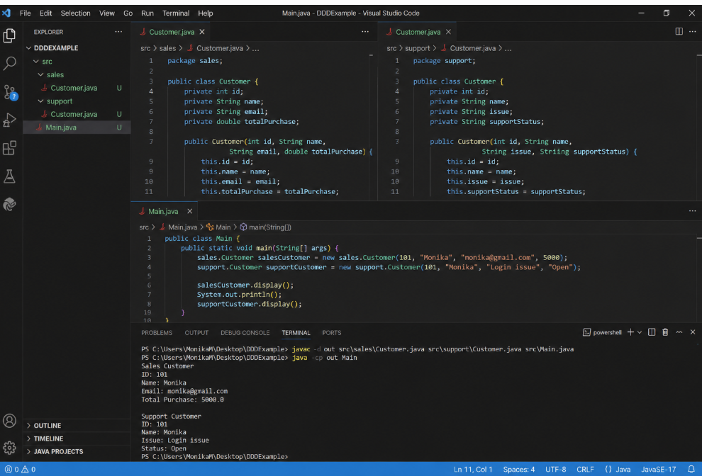
Task 18:
Aggregates, Entities, and Value Objects
1. Why must aggregates enforce invariants across their entities and value objects?
Aggregates enforce business rules and consistency within a group of related objects. The aggregate root ensures that invalid data or invalid operations cannot occur.
Example: An Order aggregate can ensure that the order total is never negative and that an order cannot be shipped before payment.
2. Difference between Entity and Value Object
Entity | Value Object
Has a unique identity (ID). | Has no unique identity.
Identity remains the same even when attributes change. | Defined by its values.
Has a longer and independent lifecycle. | Usually has a short lifecycle and can be replaced.
Example: Customer, Order | Example: Money, Address

Coding
- Implement an Order aggregate root with OrderLine entities and a Money value object. Ensure totals are recalculated when lines are added.
- Write a test case to verify that two Money objects with the same amount and currency are equal, even if created separately.
import java.util.*;
final class Money {
private final double amount;
private final String currency;
public Money(double amount, String currency) {
this.amount = amount;
this.currency = currency;
}
public double getAmount() {
return amount;
}
public String getCurrency() {
return currency;
}
public Money add(Money other) {
return new Money(amount + other.amount, currency);
}
@Override
public boolean equals(Object obj) {
if (this == obj) return true;
if (!(obj instanceof Money)) return false;
Money other = (Money) obj;
return amount == other.amount &&
currency.equals(other.currency);
}
@Override
public int hashCode() {
return Objects.hash(amount, currency);
}
}
class OrderLine {
private final String product;
private final Money price;
private final int quantity;
public OrderLine(String product, Money price, int quantity) {
this.product = product;
this.price = price;
this.quantity = quantity;
}
public Money getTotal() {
return new Money(
price.getAmount() * quantity,
price.getCurrency()
);
}
}
class Order {
private final int id;
private final List<OrderLine> lines = new ArrayList<>();
private Money total = new Money(0, "INR");
public Order(int id) {
this.id = id;
}
public void addLine(OrderLine line) {
lines.add(line);
recalculateTotal();
}
private void recalculateTotal() {
double amount = 0;
for (OrderLine line : lines) {
amount += line.getTotal().getAmount();
}
total = new Money(amount, "INR");
}
public Money getTotal() {
return total;
}
}

Task 19:
Context Mapping
Conceptual
1.What is the purpose of context mapping in DDD, and how does it help in system integration?
Context Mapping in Domain-Driven Design (DDD) is used to show how different Bounded Contexts in a system are connected and interact with each other.
It helps in:
- Understanding the relationship and dependencies between different systems.
- Defining clear boundaries between contexts.
- Managing how data and information are exchanged.
- Making system integration easier and reducing misunderstandings between teams.
Example: In an e-commerce system, the Order, Payment, and Shipping contexts may communicate with each other. A context map shows these connections clearly.

2.Explain the difference between a Partnership and a Customer-Supplier relationship in context maps.
Partnership:
Both teams or contexts work together as equals. They communicate and coordinate their changes because both depend on each other.
Example: Order and Shipping teams working together to maintain their integration.
Customer-Supplier:
One context acts as the customer and depends on another context, the supplier, for a service or data.
Example: The Order context requests payment processing from the Payment context.
In short:
- Partnership → Both sides cooperate equally.
- Customer-Supplier → One side provides, the other depends on it.

Coding
- Model two bounded contexts (Billing and Shipping) in Java, and create interfaces to simulate their integration points.
- // Billing Context
interface BillingService {
boolean processPayment(double amount);
}
class Billing implements BillingService {
public boolean processPayment(double amount) {
System.out.println("Payment processed: ₹" + amount);
return true;
}
}
// Shipping Context
interface ShippingService {
void shipOrder(String orderId);
}
class Shipping implements ShippingService {
public void shipOrder(String orderId) {
System.out.println("Order shipped: " + orderId);
}
}
// Integration
public class Main {
public static void main(String[] args) {
BillingService billing = new Billing();
ShippingService shipping = new Shipping();
if (billing.processPayment(1500)) {
shipping.shipOrder("ORD101");
}
}
}

- Write code to demonstrate an Anti-Corruption Layer (ACL) between a legacy system and a modern bounded context.
// Legacy System
class LegacyBilling {
public String makePayment(String amount) {
return "SUCCESS";
}
}
// Modern Bounded Context
class ModernBilling {
public void processPayment(double amount) {
System.out.println("Modern payment processed: ₹" + amount);
}
}
// Anti-Corruption Layer
class BillingAdapter {
private LegacyBilling legacy = new LegacyBilling();
private ModernBilling modern = new ModernBilling();
public void process(double amount) {
String result = legacy.makePayment(String.valueOf(amount));
if (result.equals("SUCCESS")) {
modern.processPayment(amount);
}
}
}
// Main
public class Main {
public static void main(String[] args) {
BillingAdapter adapter = new BillingAdapter();
adapter.process(2000);
}
}

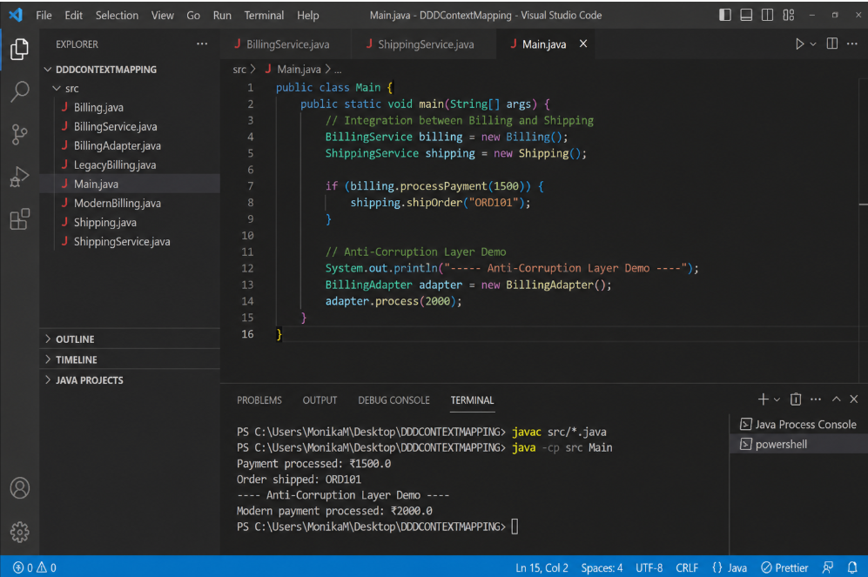

Task 20:
Decomposing a Monolith into Microservices
1. What challenges arise when decomposing a monolith into microservices without proper domain analysis?
Without proper domain analysis, it becomes difficult to decide what should become a separate service. This can lead to:
- Poorly defined service boundaries and tightly coupled services.
- Duplicate business logic and data across services.
- Frequent communication between services, increasing complexity.
- Difficult maintenance, testing, and deployment.
- Performance and consistency issues.
In short: Decomposing without understanding the business domain can turn one large monolith into many small but tightly connected services.

2. How does DDD guide the identification of microservice boundaries?
Domain-Driven Design (DDD) helps identify microservice boundaries by focusing on the business domain and its responsibilities. It uses concepts such as Bounded Contexts to group related business logic and data together.
For example, in an e-commerce system, Order, Payment, and Shipping can be separate bounded contexts and therefore potential microservices.
DDD ensures that each microservice has a clear business responsibility and remains as independent as possible.

Coding
- Refactor a monolithic BankingApplication class into separate microservices (AccountService, TransactionService, NotificationService).

@Service
public class AccountService {
public String getAccountDetails() {
return "Account details retrieved";
}
}

@Service
public class TransactionService {
public String processTransaction() {
return "Transaction processed successfully";
}
}

@Service
public class NotificationService {
public String sendNotification() {
return "Notification sent successfully";
}
}

- Write a Spring Boot configuration to register these microservices with Eureka for service discovery.
@SpringBootApplication
@EnableEurekaServer
public class EurekaServerApplication {
public static void main(String[] args) {
SpringApplication.run(EurekaServerApplication.class, args);
}
}

Task 21:
1. Strangler Fig Pattern in Practice
Conceptual Question:
How does the Strangler Fig Pattern reduce risk compared to a “big bang” rewrite of a monolithic system?
The Strangler Fig Pattern replaces the monolith gradually, one part at a time. The existing system continues to work while new features are moved to microservices.
In short: It reduces risk because problems are limited to small migrated parts, and rollback is easier.
Coding Question:
Implement an API Gateway route that directs /orders/** requests to a new microservice while keeping /inventory/** requests in the legacy monolith.
spring:
cloud:
gateway:
routes:
- id: order-service
uri: http://localhost:8081
predicates:
- Path=/orders/**

- id: legacy-inventory
uri: http://localhost:8080
predicates:
- Path=/inventory/**
Result:
- /orders/** → New Order Microservice
- /inventory/** → Legacy Monolith

2. Anti-Corruption Layer Implementation
Conceptual Question:
Why is an Anti-Corruption Layer critical when integrating a modern microservice with a legacy system?
An Anti-Corruption Layer (ACL) protects the modern service from the old system's outdated data models and formats. It translates legacy data into a format the new service understands.
In short: It keeps legacy complexity isolated from the modern system.
Coding Question:
Write a service adapter in Java that translates legacy XML responses into modern JSON DTOs for a new microservice.
public class CustomerDTO {
private String id;
private String name;

public CustomerDTO(String id, String name) {
this.id = id;
this.name = name;
}
}
@Service
public class LegacyCustomerAdapter {

public CustomerDTO convert(String xml) {
String id = xml.replaceAll(".*<id>(.*?)</id>.*", "$1");
String name = xml.replaceAll(".*<name>(.*?)</name>.*", "$1");

return new CustomerDTO(id, name);
}
}
Flow:
Legacy XML → Adapter → CustomerDTO → Modern JSON

3. Branch by Abstraction
Conceptual Question:
What advantages does Branch by Abstraction provide over traditional branching strategies during refactoring?
Branch by Abstraction allows the old and new implementations to exist together behind a common interface. This makes it possible to switch gradually without maintaining a long-lived code branch.
In short: It makes refactoring safer, easier to test, and easier to roll back.
Coding Question:
Create an abstraction interface for a payment processor and implement both the legacy and new versions, allowing runtime switching.
public interface PaymentProcessor {
void processPayment(double amount);
}
Legacy implementation:
@Service("legacyPayment")
public class LegacyPaymentProcessor implements PaymentProcessor {

public void processPayment(double amount) {
System.out.println("Legacy payment: " + amount);
}
}
New implementation:
@Service("newPayment")
public class NewPaymentProcessor implements PaymentProcessor {

public void processPayment(double amount) {
System.out.println("New payment: " + amount);
}
}
Runtime switching:
@Value("${payment.new:false}")
private boolean useNew;

public void pay(double amount) {
if (useNew)
newPayment.processPayment(amount);
else
legacyPayment.processPayment(amount);
}

4. Database Decomposition and Shared-Data Challenges
Conceptual Question:
What are the risks of shared databases across multiple microservices, and how can decomposition mitigate them?
A shared database creates tight coupling between services. A change made for one service can affect other services.
Database decomposition gives each service ownership of its data, making services more independent and easier to maintain.
Coding Question:
Write SQL scripts to split a monolithic users table into separate accounts and profiles tables, ensuring foreign key integrity.
CREATE TABLE accounts (
account_id INT PRIMARY KEY,
email VARCHAR(100) UNIQUE NOT NULL,
password VARCHAR(255) NOT NULL
);

CREATE TABLE profiles (
profile_id INT PRIMARY KEY,
account_id INT NOT NULL,
name VARCHAR(100),
phone VARCHAR(20),

FOREIGN KEY (account_id)
REFERENCES accounts(account_id)
);
Relationship:
Accounts
|
| account_id
↓
Profiles

5. Incremental Migration Strategies
Conceptual Question:
How does incremental migration help balance delivery speed and system stability during modernization?
Incremental migration moves the system in small batches instead of changing everything at once. Teams can deliver improvements while continuously testing and fixing issues.
In short: Smaller changes mean lower risk and easier recovery.
Coding Question:
Demonstrate a migration script that moves customer records from a legacy database to a new microservice database in batches of 1000.
INSERT INTO new_customers (id, name, email)
SELECT id, name, email
FROM legacy_customers
WHERE id > :last_id
ORDER BY id
LIMIT 1000;
The migration processes 1000 customers at a time and then continues with the next batch.

6. Feature Toggles for Safe Rollout
Conceptual Question:
How do feature toggles enable controlled experimentation and rollback in production environments?
Feature toggles allow developers to turn a feature ON or OFF without redeploying the application. A new feature can be tested gradually and disabled immediately if problems occur.
Coding Question:
Implement a Spring Boot configuration that enables or disables a new checkout flow based on a feature flag.
application.properties
checkout.new-flow=true
Spring Boot Configuration:
@Configuration
public class CheckoutConfig {

@Value("${checkout.new-flow:false}")
private boolean newFlow;

@Bean
public CheckoutService checkoutService() {

if (newFlow)
return new NewCheckoutService();

return new LegacyCheckoutService();
}
}
Result:
true → New Checkout Flow
false → Legacy Checkout Flow

7. Avoiding the Distributed Monolith
Conceptual Question:
What architectural mistakes lead to a distributed monolith, and how can teams avoid them?
A distributed monolith occurs when microservices are separated technically but remain highly dependent on each other.
Common causes include:
- Too many synchronous REST calls.
- Shared databases.
- Strong dependencies between services.
- Services that must always be deployed together.
Teams should use loose coupling, asynchronous communication, independent databases, and clear service boundaries.
Coding Question:
Refactor a service call chain so that Service A communicates asynchronously with Service B via Kafka, instead of synchronous REST calls.
Service A – Producer
@Service
public class OrderService {

private final KafkaTemplate<String, String> kafka;

public OrderService(KafkaTemplate<String, String> kafka) {
this.kafka = kafka;
}

public void createOrder(String orderId) {
kafka.send("order-created", orderId);
System.out.println("Order event sent");
}
}
Service B – Consumer
@Service
public class InventoryService {

@KafkaListener(topics = "order-created")
public void handleOrder(String orderId) {
System.out.println(
"Inventory updated for: " + orderId
);
}
}
Flow:
Service A
↓
Kafka
↓
Service B
This removes the direct REST dependency and makes communication asynchronous and loosely coupled.

