DAY 19
HOME TASK [Day 18]
Can you create a java code for earch of the below sort and search …
The snippet for your ref is given below
3. Insertion Sort
- Concept: Builds the sorted array one element at a time.
- Complexity: O(n2)
- Best for: Nearly sorted data.
java
for (int i = 1; i < n; i++) {
int key = arr[i];
int j = i - 1;
while (j >= 0 && arr[j] > key)
arr[j+1] = arr[j--];
arr[j+1] = key;
}

public class InesertionSort {
public static void main(String[] args) {
int[] arr = {5, 3, 8, 4, 2};
for (int i = 1; i < arr.length; i++) {
int key = arr[i];
int j = i - 1;
while (j >= 0 && arr[j] > key) {
arr[j + 1] = arr[j];
j--;
}
arr[j + 1] = key;
}
System.out.println("Sorted Array:");
for (int num : arr) {
System.out.print(num + " ");
}
}
}

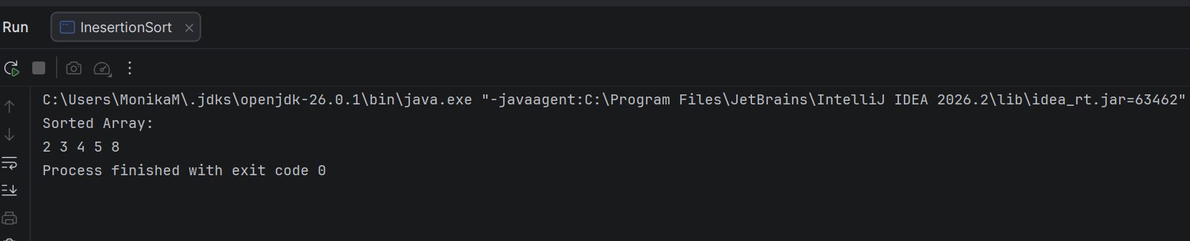
4. Merge Sort
- Concept: Divide and conquer — splits array, sorts halves, merges results.
- Complexity: O(nlog⁡n)
- Best for: Large datasets.
java
void mergeSort(int[] arr, int l, int r) {
if (l < r) {
int m = (l + r) / 2;
mergeSort(arr, l, m);
mergeSort(arr, m+1, r);
merge(arr, l, m, r);
}
}

public class MergeSort {
static void merge(int[] arr, int left, int mid, int right) {
int n1 = mid - left + 1;
int n2 = right - mid;
int[] L = new int[n1];
int[] R = new int[n2];
for (int i = 0; i < n1; i++)
L[i] = arr[left + i];
for (int j = 0; j < n2; j++)
R[j] = arr[mid + 1 + j];
int i = 0, j = 0, k = left;
while (i < n1 && j < n2) {
if (L[i] <= R[j])
arr[k++] = L[i++];
else
arr[k++] = R[j++];
}
while (i < n1)
arr[k++] = L[i++];
while (j < n2)
arr[k++] = R[j++];
}
static void mergeSort(int[] arr, int left, int right) {
if (left < right) {
int mid = (left + right) / 2;
mergeSort(arr, left, mid);
mergeSort(arr, mid + 1, right);
merge(arr, left, mid, right);
}
}
public static void main(String[] args) {
int[] arr = {5, 3, 8, 4, 2};
mergeSort(arr, 0, arr.length - 1);
System.out.println("Sorted Array:");
for (int num : arr) {
System.out.print(num + " ");
}
}
}

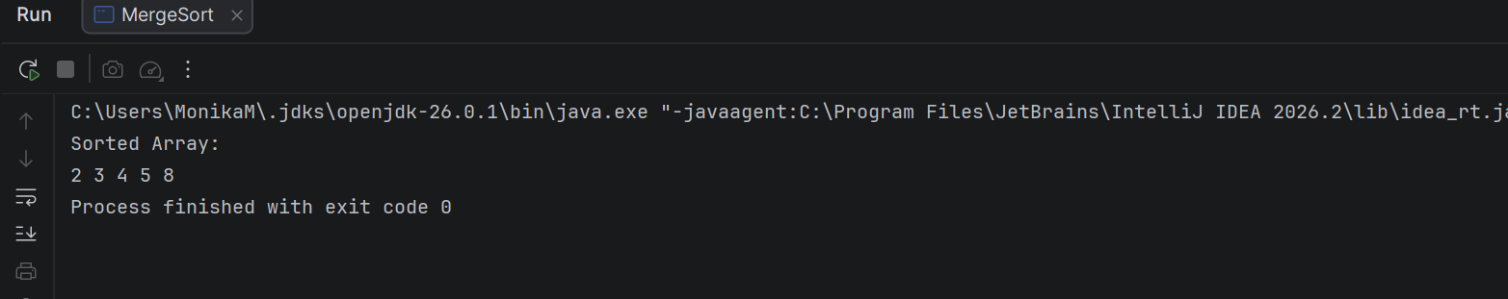

5. Quick Sort
- Concept: Selects a pivot, partitions array around it.
- Complexity: Average O(nlog⁡n), Worst O(n2)
- Best for: Fast in practice, widely used.
java
int partition(int[] arr, int low, int high) {
int pivot = arr[high];
int i = low - 1;
for (int j = low; j < high; j++)
if (arr[j] < pivot) swap(arr[++i], arr[j]);
swap(arr[i+1], arr[high]);
return i+1;
}

public class QuickSort {
static void quickSort(int[] arr, int low, int high) {
if (low < high) {
int pivot = partition(arr, low, high);
quickSort(arr, low, pivot - 1);
quickSort(arr, pivot + 1, high);
}
}
static int partition(int[] arr, int low, int high) {
int pivot = arr[high];
int i = low - 1;
for (int j = low; j < high; j++) {
if (arr[j] < pivot) {
i++;
int temp = arr[i];
arr[i] = arr[j];
arr[j] = temp;
}
}
int temp = arr[i + 1];
arr[i + 1] = arr[high];
arr[high] = temp;
return i + 1;
}
public static void main(String[] args) {
int[] arr = {5, 3, 8, 4, 2};
quickSort(arr, 0, arr.length - 1);
System.out.println("Sorted Array:");
for (int num : arr) {
System.out.print(num + " ");
}
}
}

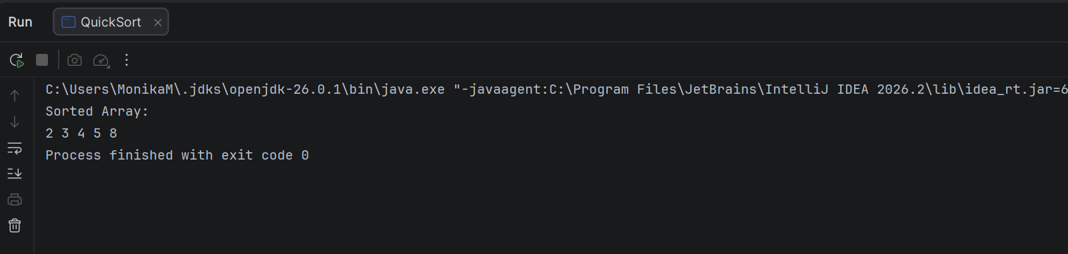
Binary Search
- Concept: Repeatedly divides sorted array in half.
- Complexity: O(log⁡n)
- Best for: Sorted data.
java
int binarySearch(int[] arr, int key) {
int low = 0, high = arr.length - 1;
while (low <= high) {
int mid = (low + high) / 2;
if (arr[mid] == key) return mid;
if (arr[mid] < key) low = mid + 1;
else high = mid - 1;
}
return -1;
}

Algorithm | Type | Time Complexity | Space Complexity | Stability
Bubble Sort | Sorting | O(n2) | O(1) | ✅
Selection Sort | Sorting | O(n2) | O(1) | ❌
Insertion Sort | Sorting | O(n2) | O(1) | ✅
Merge Sort | Sorting | O(nlog⁡n) | O(n) | ✅
Quick Sort | Sorting | O(nlog⁡n) | O(log⁡n) | ❌
public class BinarySearch {
static int binarySearch(int[] arr, int key) {
int low = 0;
int high = arr.length - 1;
while (low <= high) {
int mid = (low + high) / 2;
if (arr[mid] == key)
return mid;
if (arr[mid] < key)
low = mid + 1;
else
high = mid - 1;
}
return -1;
}
public static void main(String[] args) {
int[] arr = {2, 3, 4, 5, 8};
int key = 5;
int result = binarySearch(arr, key);
if (result != -1)
System.out.println(key + " found at index " + result);
else
System.out.println(key + " not found");
}
}

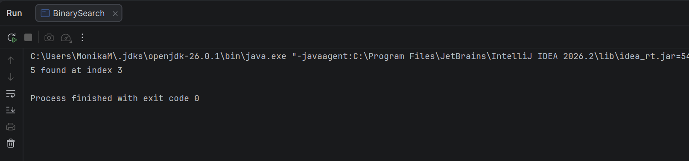

Day 19 - 11th Aug 2026
Task 1:
What are wrapper class?
- Wrapper classes are predefined classes in Java that are used to convert primitive data types into objects.
- Each primitive data type has a corresponding wrapper class in the java.lang package. For example, the wrapper class for int is Integer, for char is Character, and for boolean is Boolean.

Task 2:
What do you understand by auto boxing and unboxing?
Autoboxing
- Autoboxing is the automatic conversion of a primitive data type into its corresponding wrapper class object by the Java compiler.
- For example, an int value is automatically converted into an Integer object, and a double value is converted into a Double object.

Unboxing
- Unboxing is the automatic conversion of a wrapper class object into its corresponding primitive data type.

Task 3:
Can you create a program to show the use of wrapper classes
Eg:
// Autoboxing: primitive to wrapper
int primitiveInt = 10;
Integer wrappedInt = primitiveInt; // compiler converts automatically

Integer objInt = new Integer(25); // explicit wrapper object
int unboxedInt = objInt; // compiler converts automatically

public class WrapperClassDemo {
public static void main(String[] args) {
// Autoboxing: primitive to wrapper
int primitiveInt = 10;
Integer wrappedInt = primitiveInt; // compiler converts automatically
System.out.println("Primitive int value: " + primitiveInt);
System.out.println("Wrapped Integer object: " + wrappedInt);
// Explicit creation of wrapper object
Integer objInt = Integer.valueOf(25);
// Unboxing: wrapper to primitive
int unboxedInt = objInt; // compiler converts automatically
System.out.println("Wrapper Integer object: " + objInt);
System.out.println("Unboxed int value: " + unboxedInt);
}
}

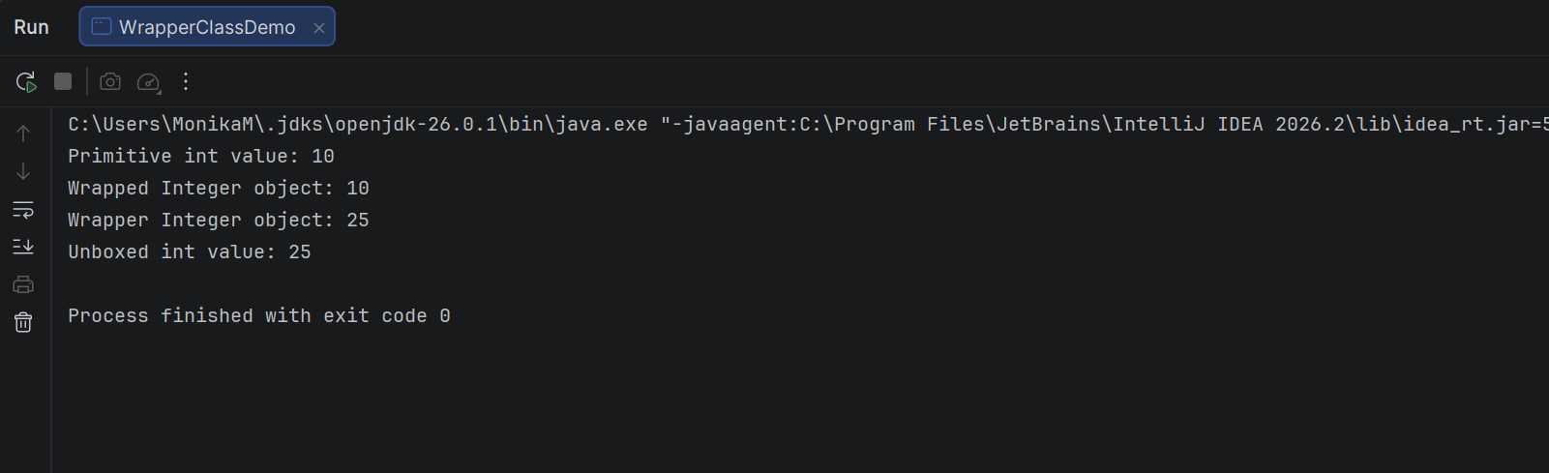

TASK 4:

Where do we use wrapper classes?

Wrapper classes are used to convert Java primitive data types into objects. They are mainly used when an object is required instead of a primitive value.
Common uses of Wrapper Classes:
- Collections
  - Java collections such as ArrayList, HashSet, and HashMap store objects, not primitive data types.
  - Therefore, wrapper classes are used instead of primitives.
  - Example: ArrayList<Integer> instead of ArrayList<int>.
- Generics
  - Generics work only with objects, so primitive types cannot be directly used.
  - Wrapper classes allow primitives to be used with generics.
- Converting Strings to Primitive Values
  - Wrapper classes provide methods to convert strings into primitive values.
  - For example, converting "100" into an int.
- Converting Primitive Values to Strings
  - Wrapper classes provide methods for converting numeric values into their string representations.
- Object-Based Operations
  - Sometimes a value needs to behave like an object, such as when passing it to methods that accept Object.
  - Wrapper classes provide an object representation of primitive values.
- Null Values
  - Primitive types cannot store null, whereas wrapper objects can.
  - This is useful when a value may be absent or unknown.
- Utility Methods and Constants
  - Wrapper classes provide useful methods and constants related to their corresponding primitive types, such as minimum/maximum values and parsing methods.

Task 5:

Can you create a program to show the difference between abstraction and encapsulation
- Encapsulation: Hiding data using private variables and providing access through getters/setters.
- Abstraction: Hiding implementation details and exposing only essential functionality using an abstract class.

// Abstraction
abstract class Event {
private String eventName; // Encapsulation
public Event(String eventName) {
this.eventName = eventName;
}
// Getter (Encapsulation)
public String getEventName() {
return eventName;
}
// Setter (Encapsulation)
public void setEventName(String eventName) {
this.eventName = eventName;
}
// Abstract method (Abstraction)
abstract void conductEvent();
}
// Concrete Class
class Conference extends Event {
public Conference(String eventName) {
super(eventName);
}
@Override
void conductEvent() {
System.out.println(getEventName() + " is being conducted.");
}
}
public class AbstrationEncapculationDemo {
public static void main(String[] args) {
// Abstraction: Reference of abstract class
Event event = new Conference("Java Summit 2026");
// Encapsulation: Accessing private data through getter
System.out.println("Event Name: " + event.getEventName());
// Calling abstract method implementation
event.conductEvent();
// Encapsulation: Updating data through setter
event.setEventName("Spring Boot Conference");
System.out.println("\nUpdated Event Name: "
+ event.getEventName());
event.conductEvent();
}
}

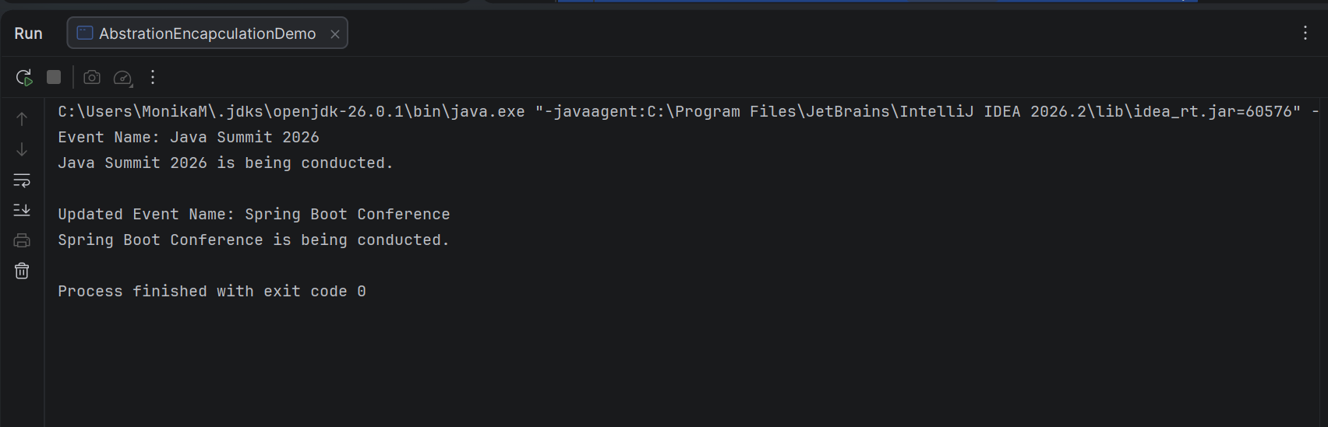

TASK 06:

What is executor framework in Java 5?why do we use? Where do we use?
- The Executor Framework was introduced in Java 5 under the package java.util.concurrent.
- It simplifies multithreaded programming by separating task submission from task execution.
Main reasons:
1. Thread management
It manages threads for us, so we don't have to manually create, start, and stop every thread.
2. Thread Pooling
It can maintain a pool of reusable threads.
3. Better performance
Creating a new thread repeatedly has overhead. Thread pools reduce unnecessary thread creation.
4. Handles multiple tasks
Many tasks can be submitted and executed concurrently.
5. Makes concurrent programming easier
We can focus on the task rather than complicated thread-management logic.

- It is commonly used when an application has multiple independent tasks that need to be executed concurrently.
Background tasks
For example:
- Sending emails
- Processing files
- Generating reports
- Logging
- Data processing

Task 07:

Can you explain.. Executor, executor service and executors?
1. Executor

- Executor is an interface that provides a simple mechanism for executing tasks.Its main purpose is to decouple task submission from the details of how the task is executed.
- It provides the execute() method, which accepts a Runnable task.

2. ExecutorService

- ExecutorService is an interface that extends the Executor interface. It provides additional features for managing the execution and lifecycle of tasks and threads.
- It allows applications to:
- Submit tasks for execution.
- Execute multiple tasks concurrently.
- Receive results from tasks using Future.
- Manage the lifecycle of the executor.
- Shut down the executor when it is no longer required.

3. Executors

- Executors is a utility class provided by the java.util.concurrent package. It contains factory methods used to create different types of ExecutorService implementations and thread pools.

Task 8:
When do we use callable interface with future?
- The Callable interface is used with Future when we need to execute a task in another thread and get a result back after the task is completed.
- We use the Callable interface with Future when a task needs to return a result after being executed asynchronously.
- Callable performs the task and returns a value, while Future is used to retrieve that result later.
Task 9:
How do we create ExecutorService, Submit Tasks, Manage Results and Shutdown Executor.
Can you explain the flow

Flow of ExecutorService
1. Create ExecutorService → Create a thread pool using Executors.
2. Submit Tasks → Submit Runnable or Callable tasks using execute() or submit().
3. Manage Results → For Callable, submit() returns a Future, which is used to retrieve the result using get().
4. Shutdown Executor → After all tasks are completed/submitted, call shutdown() to stop accepting new tasks.

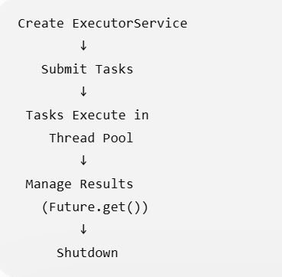

Task 10:

Can you create programs which uses the concepts of character input output in file handling and buffer input output in file handling?

import java.io.FileReader;
import java.io.FileWriter;
import java.io.IOException;
public class CharacterIOExample {
public static void main(String[] args) throws IOException {
FileWriter writer = new FileWriter("data.txt");
writer.write("Hello, Java!");
writer.write("\nCharacter Input and Output");
writer.close();
FileReader reader = new FileReader("data.txt");
int ch;
while ((ch = reader.read()) != -1) {
System.out.print((char) ch);
}
reader.close();
}
}
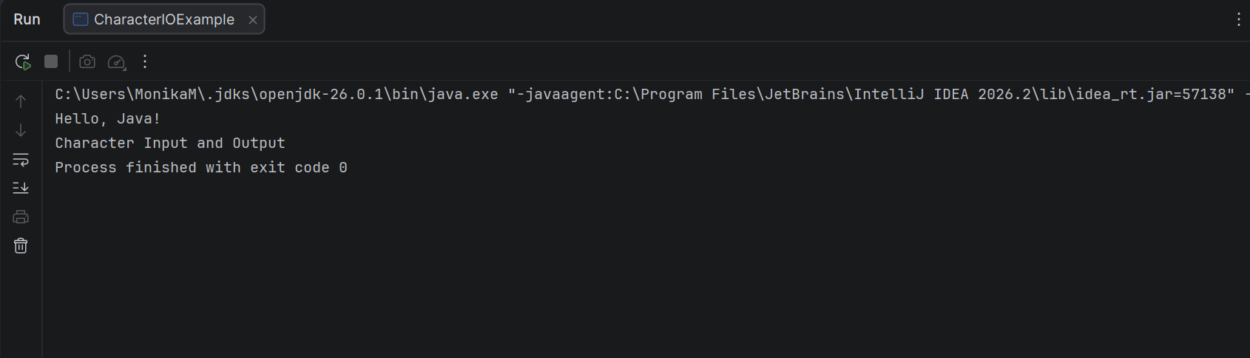

Task 11:
What is an Object class?
Why do we use them?
Can you show me the diagramatic representation of object with other classes.

Object is the root class of the Java class hierarchy. Every class in Java directly or indirectly inherits from Object, so its methods are available to all Java objects.
It belongs to the java.lang package and is automatically available without importing it.

The Object class provides common methods that every Java object can use, such as:
- toString() – returns a string representation of an object.
- equals() – compares objects for equality.
- hashCode() – returns a hash code for an object.
- getClass() – returns the runtime class of the object.
- clone() – creates a copy of an object under supported conditions.
- wait(), notify(), notifyAll() – used for thread coordination.

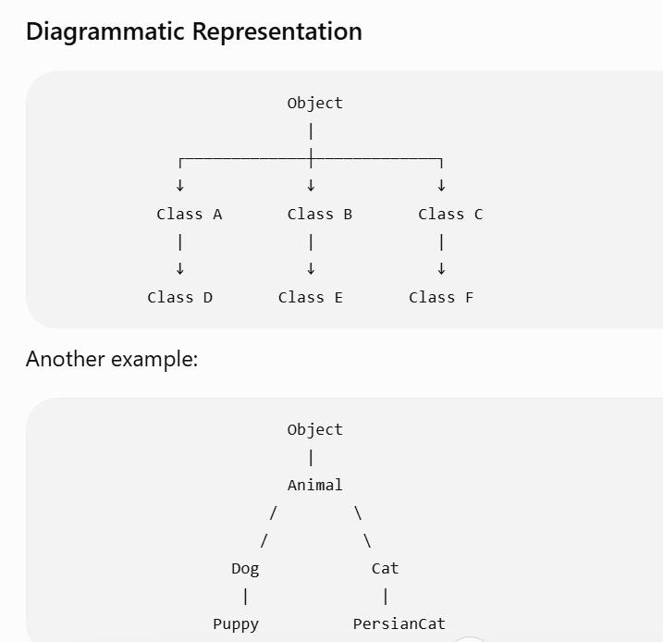

Task 12:
Can you display the methods in Object class

The java.lang.Object class provides the following important methods:
Method | Purpose
toString() | Returns a string representation of the object
equals(Object obj) | Compares two objects for equality
hashCode() | Returns the hash code of the object
getClass() | Returns the runtime class of the object
clone() | Creates and returns a copy of the object
finalize() | Was used before garbage collection, but is deprecated
wait() | Makes the current thread wait
wait(long timeout) | Waits for a specified time
wait(long timeout, int nanos) | Waits for a specified time including nanoseconds
notify() | Wakes up one waiting thread
notifyAll() | Wakes up all waiting threads

Task 13:

What are generics ? benefits of generics .. can you explain wit a code .

Generics in Java
Generics allow us to specify the type of data that a class, interface, or method can work with. They provide type safety and allow code to be reused with different data types.
Generics are commonly used with Collections, such as ArrayList, HashMap, Set, etc.

Benefits of Generics
1. Type Safety

Generics ensure that only the specified type is stored.
ArrayList<Integer> numbers = new ArrayList<>();

numbers.add(10);
numbers.add(20);
// numbers.add("Java"); // Error

2. Compile-Time Error Detection
Incorrect types are detected during compilation instead of causing problems at runtime.

3. No Explicit Type Casting
ArrayList<String> names = new ArrayList<>();

names.add("Monika");

String name = names.get(0);
No casting is required.

4. Code Reusability
The same generic class or method can work with different data types.
class Box<T> {
T value;

void set(T value) {
this.value = value;
}

T get() {
return value;
}
}
It can be used with different types:
Box<String> b1 = new Box<>();
b1.set("Java");

Box<Integer> b2 = new Box<>();
b2.set(100);
Here, T is a type parameter that can represent different data types.

Java 8 features 👍

Task 14:
1. Explain why lambda expressions were introduced in Java 8.
- Lambda expressions were introduced in Java 8 to provide a concise way of representing functional behavior and reduce the amount of boilerplate code required for implementing functional interfaces.
- They are mainly used with functional interfaces, collections, and streams to support functional-style programming.

2. What is a functional interface? Give two examples from the Java API.

- A functional interface is an interface that contains exactly one abstract method. It can be implemented using lambda expressions and method references.
- Examples from the Java API are Runnable and Predicate<T>.

3. Differentiate between Streams and Collections.

- A Collection is used to store and manage data, whereas a Stream is used to process data from a source such as a collection.
- Collections store elements, while streams perform operations such as filtering, mapping, sorting, and collecting without directly modifying the original collection.

4. What problem does the Optional class solve?

- The Optional class helps handle the possibility of a missing or null value without directly using null.
- It reduces the risk of NullPointerException and provides methods such as isPresent(), orElse(), and ifPresent() to safely work with optional values.

5. Why were default methods added to interfaces in Java 8?

- Default methods were introduced to allow new methods to be added to existing interfaces without breaking the classes that already implement them.
- They provide a method implementation directly inside the interface using the default keyword.

6. What are method references and how do they improve readability?

- Method references provide a shorter way to refer to an existing method using the :: operator instead of writing a lambda expression. They make code more concise and readable when the lambda only calls an existing method.
Example:
logs.forEach(System.out::println);
Instead of:
logs.forEach(log -> System.out.println(log));

7. Describe the improvements in the Date-Time API compared to java.util.Date.

- Java 8 introduced the modern Date-Time API in the java.time package. It provides immutable and thread-safe classes such as LocalDate, LocalTime, LocalDateTime, and ZonedDateTime, making date and time operations easier, clearer, and less error-prone than the older java.util.Date and Calendar APIs.

8. How does the Base64 API simplify encoding/decoding tasks?

- Java 8 introduced the Base64 API in the java.util package to provide built-in methods for encoding and decoding Base64 data. It eliminates the need for external libraries and supports basic, URL-safe, and MIME Base64 encoding and decoding.
9. Give a real-world example where static methods in interfaces are useful.

Static methods in interfaces are useful when we want to provide utility or helper methods that are directly related to the interface without requiring an object of the implementing class.
For example, an interface Payment can have a static method to validate a payment amount:
interface Payment {

static boolean isValidAmount(double amount) {
return amount > 0;
}
}
It can be called directly using the interface name:
boolean valid = Payment.isValidAmount(500);

Task 15:
Whats going on in this code snippet? Can you check .. can you imagine a traditional code for performing the same.

public record Customer(String name, int age) {}

public class RecordDemo {
public static void main(String[] args) {
Customer c = new Customer("Prasunamba", 30);
System.out.println(c.name()); // Prasunamba
System.out.println(c); // Customer[name=Prasunamba, age=30]
}
}

- A record is a special type of Java class designed primarily to hold immutable data.
- Records were introduced as a preview feature in Java 14 and became a standard feature in Java 16.
- Records provide a concise way to create immutable data-carrying classes. They automatically provide constructors, accessors, equals(), hashCode(), and toString(), reducing boilerplate code.

Task 16:
Can you extend this code for creating a fd child class.. Will it work? If not whats stopping to extend fd from Transaction..
java
public sealed class Transaction permits Credit, Debit {}
final class Credit extends Transaction {}
final class Debit extends Transaction {}

- A sealed class restricts which classes are allowed to extend it.

public class SealedClass{
public static void main(String[] args) {
Transaction t1 = new Credit();
Transaction t2 = new Debit();
System.out.println(t1);
System.out.println(t2);
}
}
sealed class Transaction permits Credit, Debit {
}
final class Credit extends Transaction {
@Override
public String toString() {
return "Credit Transaction";
}
}
final class Debit extends Transaction {
@Override
public String toString() {
return "Debit Transaction";
}
}
final class FD extends Transaction {
}

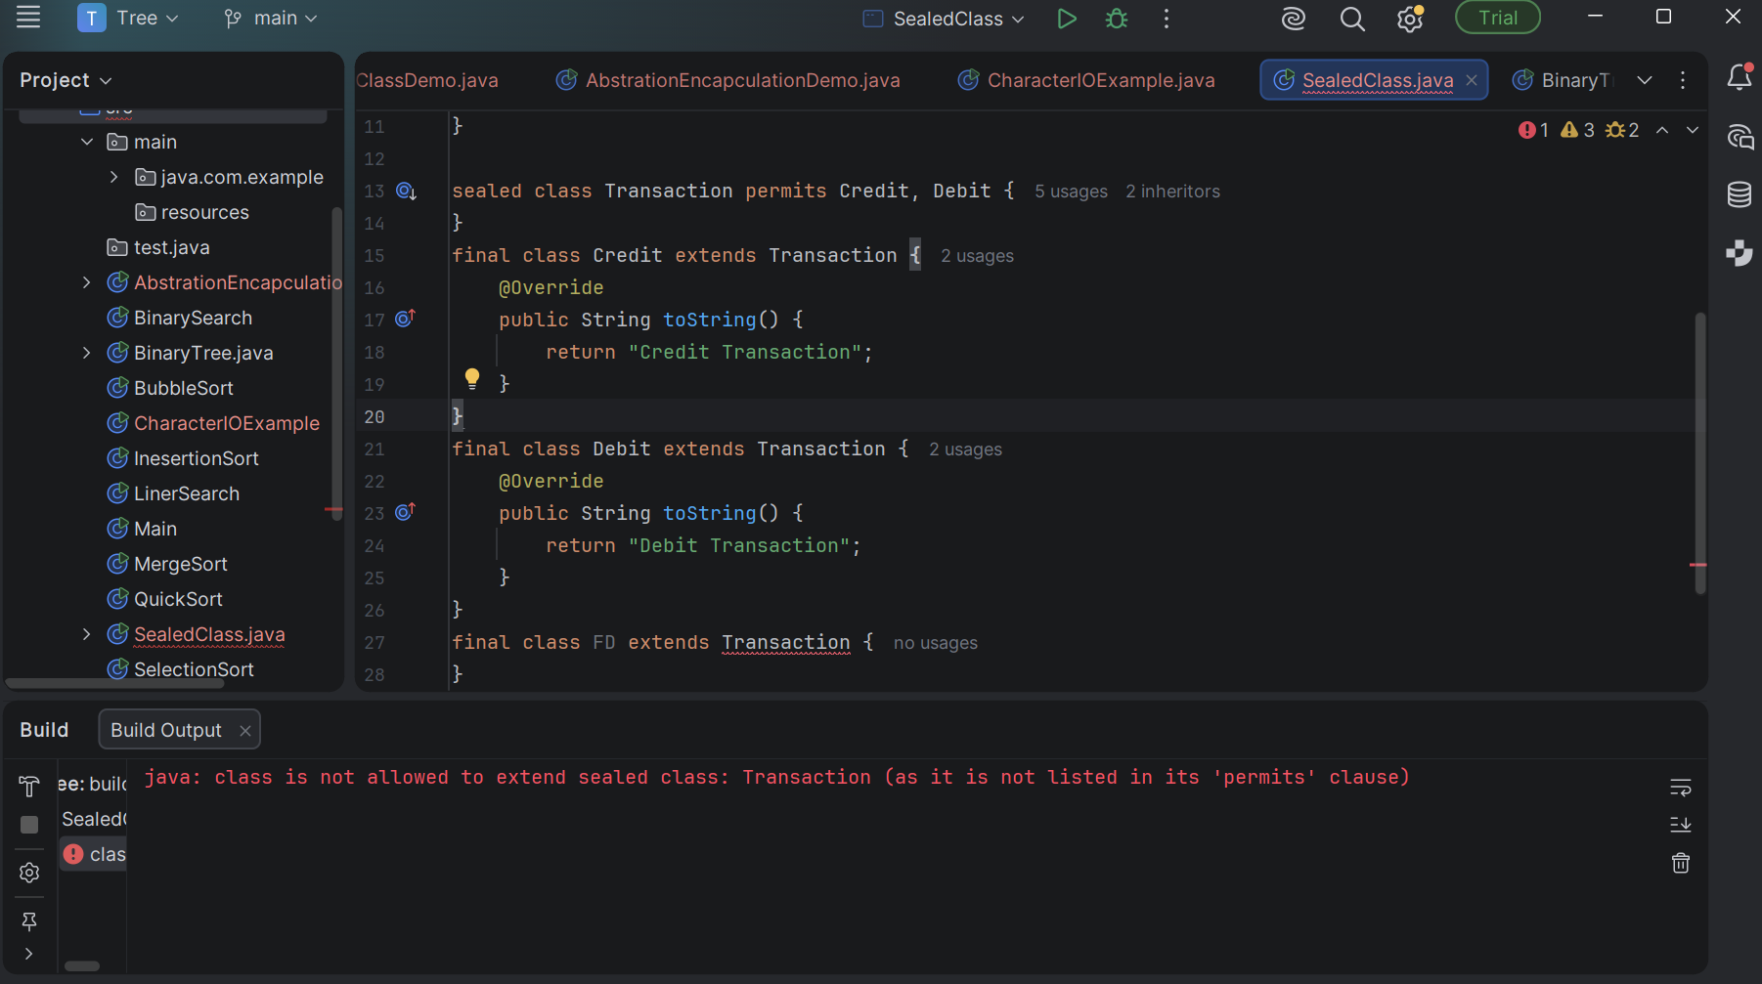
- Here when I tried extend Transaction its throwing a error.

Task 17:
Can I write a switch case.. Like this also?... my traditional switch case is now parsing heterogeneous data??????????????????????????????? How ???

static void process(Object obj) {
switch (obj) {
case String s -> System.out.println("String: " + s.toUpperCase());
case Integer i -> System.out.println("Integer x10: " + i * 10);
default -> System.out.println("Unknown type");
}
}

- Modern Java allows switch to perform pattern matching, where the type of an object can be checked directly inside the case.
- public class PatternSwitchDemo {
static void process(Object obj) {
switch (obj) {
case String s ->
System.out.println("String: " + s.toUpperCase());
case Integer i ->
System.out.println("Integer x10: " + i * 10);
default ->
System.out.println("Unknown type");
}
}
public static void main(String[] args) {
process("hello");
process(10);
process(10.5);
process(true);
}
}

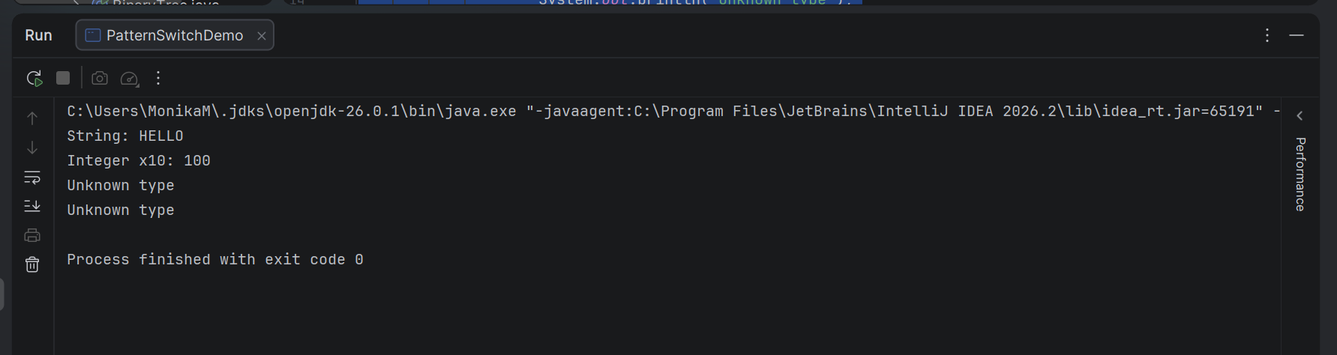

Task 18:
We dont know what threads do internally… \
And now these imaginary threads????????????????

Whats nonsense ? in this code..

import java.util.concurrent.Executors;

public class VirtualThreadDemo {
public static void main(String[] args) {
try (var executor = Executors.newVirtualThreadPerTaskExecutor()) {
executor.submit(() -> System.out.println("Running on virtual thread"));
}
}
}

- A virtual thread is a lightweight thread managed by the Java Virtual Machine (JVM) rather than being directly tied to one operating-system thread for its entire lifetime.
- Virtual threads were introduced as a preview feature in Java 19 and became a standard feature in Java 21.

Task 19:
- What is a code smell and how does it differ from a bug or error?

- A code smell is a sign in the source code that something may be wrong with the design or structure of the code. It does not necessarily mean that the program has an immediate error. Instead, it indicates that the code may have a deeper problem that could cause difficulties in the future.

Bug
A bug is a defect that causes the software to behave incorrectly.
Example:
int total = price - quantity;
If the intended operation was multiplication:
int total = price * quantity;
then the first code produces an incorrect result. This is a bug.

Error
An error generally refers to a mistake or condition that prevents the program from working as expected. For example:
int number = 10 / 0;
This causes an ArithmeticException

- Why are code smells considered indicators of deeper design problems?

- Code smells usually don't appear randomly. They are often symptoms of problems in the design, structure, or organization of the software.

As applications grow, developers often add features quickly. Instead of redesigning existing code, they may keep adding more conditions, methods, and responsibilities to existing classes.
Over time, this can result in:
- Large classes
- Long methods
- Duplicate code
- Too many dependencies
- Complex conditional statements
- Tightly coupled components
These are all common code smells.

- How do code smells affect maintainability, scalability, and readability of software?
- Impact on Maintainability

Maintainability means how easily developers can understand, modify, fix, and improve the software.

This increases the chance of introducing bugs.

Code smells such as:
- Duplicate code
- Long methods
- Large classes
- Complex conditions
- Excessive dependencies

make maintenance harder.

Real-world situation

Imagine joining a project where one class contains 5,000 lines of code.

Even if the application works correctly, it may take a long time to understand where a particular piece of functionality is implemented.

That's a maintainability problem.

B. Impact on Scalability

Scalability refers to the ability of software to grow and handle additional features, users, or workloads without becoming unmanageable.

Poorly designed code can make adding new functionality increasingly difficult.

C. Impact on Readability

Readability means how easily another developer can understand the code.

Readable code makes it easier for developers to:
- Understand existing functionality
- Find problems
- Make changes
- Review code
- Work as a team
- Can you explain the difference between Long Method and Large Class smells?
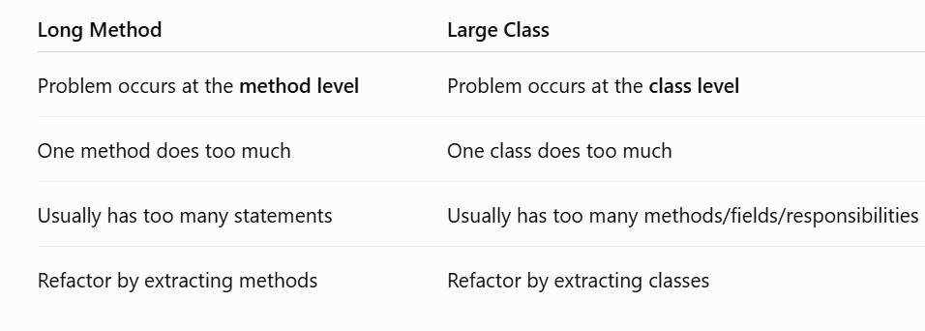

- How does Duplicated Code impact future development and bug fixing?

Duplicated Code means the same or very similar logic appears in multiple places in the application.
For example:
class OrderService {

void calculateTax() {
// tax calculation logic
}
}
And somewhere else:
class InvoiceService {

void calculateTax() {
// same tax calculation logic
}
}
Initially, this may not seem like a problem. But it becomes problematic when the logic needs to change.

Impact on Future Development
Duplicated code makes new development slower because developers have to:
- Find every copy of the logic
- Understand each copy
- Update multiple places
- Test multiple implementations
- Make sure the copies remain consistent
As the application grows, the maintenance cost grows too.

HOME TASK[DAY 19]

Create a Mini Banking App project using Java 8 features.

Project structure can be like this .. juz for ref only.. You can create in your own style..

Code
BankingDemo/
├── src/
│ └── com/bank/demo/
│ ├── Customer.java
│ ├── Transaction.java
│ ├── Payment.java
│ ├── CreditCardPayment.java
│ └── BankingApp.java
└── README.md

- Created a project Called MiniBankingApplication

BankingApp.java
package com.example;
import java.time.LocalDate;
import java.util.Arrays;
import java.util.List;
import java.util.stream.Collectors;
public class BankingApp {
public static void main(String[] args) {
System.out.println("===== MINI BANKING APPLICATION =====");
// ---------------------------------------
// 1. Transactions using Lambda + Streams
// ---------------------------------------
List<Transaction> transactions = Arrays.asList(
new Transaction(500, LocalDate.now()),
new Transaction(2500, LocalDate.now()),
new Transaction(1200, LocalDate.now()),
new Transaction(800, LocalDate.now()),
new Transaction(5000, LocalDate.now())
);
System.out.println("\nAll Transactions:");
transactions.forEach(
transaction -> System.out.println(
"Amount: Rs." + transaction.getAmount()
+ " | Date: " + transaction.getDate()
)
);
// Find transactions greater than Rs.1000
List<Transaction> highValueTransactions =
transactions.stream()
.filter(transaction -> transaction.getAmount() > 1000)
.collect(Collectors.toList());
System.out.println("\nHigh Value Transactions:");
highValueTransactions.forEach(
transaction -> System.out.println(
"Amount: Rs." + transaction.getAmount()
)
);
// ---------------------------------------
// 2. Optional for Customer PAN
// ---------------------------------------
Customer customer = new Customer("Ravi", null);
System.out.println("\nCustomer Name: " + customer.getName());
String pan = customer.getPanCard()
.orElse("PAN not available");
System.out.println("PAN: " + pan);
// ---------------------------------------
// 3. Java 8 Date-Time API
// ---------------------------------------
LocalDate today = LocalDate.now();
LocalDate nextEmi = today.plusMonths(1);
System.out.println("\nToday: " + today);
System.out.println("Next EMI Due Date: " + nextEmi);
// ---------------------------------------
// 4. Default Method in Interface
// ---------------------------------------
Payment payment = new CreditCardPayment();
System.out.println("\nPayment Processing:");
payment.validate();
// ---------------------------------------
// 5. Static Method in Interface
// ---------------------------------------
Payment.log("Credit card payment processed successfully.");
// ---------------------------------------
// 6. Method Reference
// ---------------------------------------
List<String> logs = Arrays.asList(
"Debit",
"Credit",
"Transfer"
);
System.out.println("\nTransaction Types:");
logs.forEach(System.out::println);
// ---------------------------------------
// 7. Calculate Total Transaction Amount
// ---------------------------------------
int totalAmount = transactions.stream()
.mapToInt(Transaction::getAmount)
.sum();
System.out.println("\nTotal Transaction Amount: Rs."
+ totalAmount);
// ---------------------------------------
// 8. Find Maximum Transaction
// ---------------------------------------
transactions.stream()
.map(Transaction::getAmount)
.max(Integer::compareTo)
.ifPresent(max ->
System.out.println(
"Highest Transaction: Rs." + max
)
);
System.out.println("\n===== BANKING APPLICATION COMPLETED =====");
}
}

Customer.java
package com.example;
import java.util.Optional;
public class Customer {
private String name;
private Optional<String> panCard;
public Customer(String name, String panCard) {
this.name = name;
this.panCard = Optional.ofNullable(panCard);
}
public String getName() {
return name;
}
public Optional<String> getPanCard() {
return panCard;
}
}

Payment.java

package com.example;
public interface Payment {
// Java 8 default method
default void validate() {
System.out.println("Basic payment validation completed.");
}
// Java 8 static method
static void log(String message) {
System.out.println("LOG: " + message);
}
}

Transation.java

package com.example;
import java.time.LocalDate;
public class Transaction {
private int amount;
private LocalDate date;
public Transaction(int amount, LocalDate date) {
this.amount = amount;
this.date = date;
}
public int getAmount() {
return amount;
}
public LocalDate getDate() {
return date;
}
@Override
public String toString() {
return "Transaction{" +
"amount=" + amount +
", date=" + date +
'}';
}
}

OUTPUT

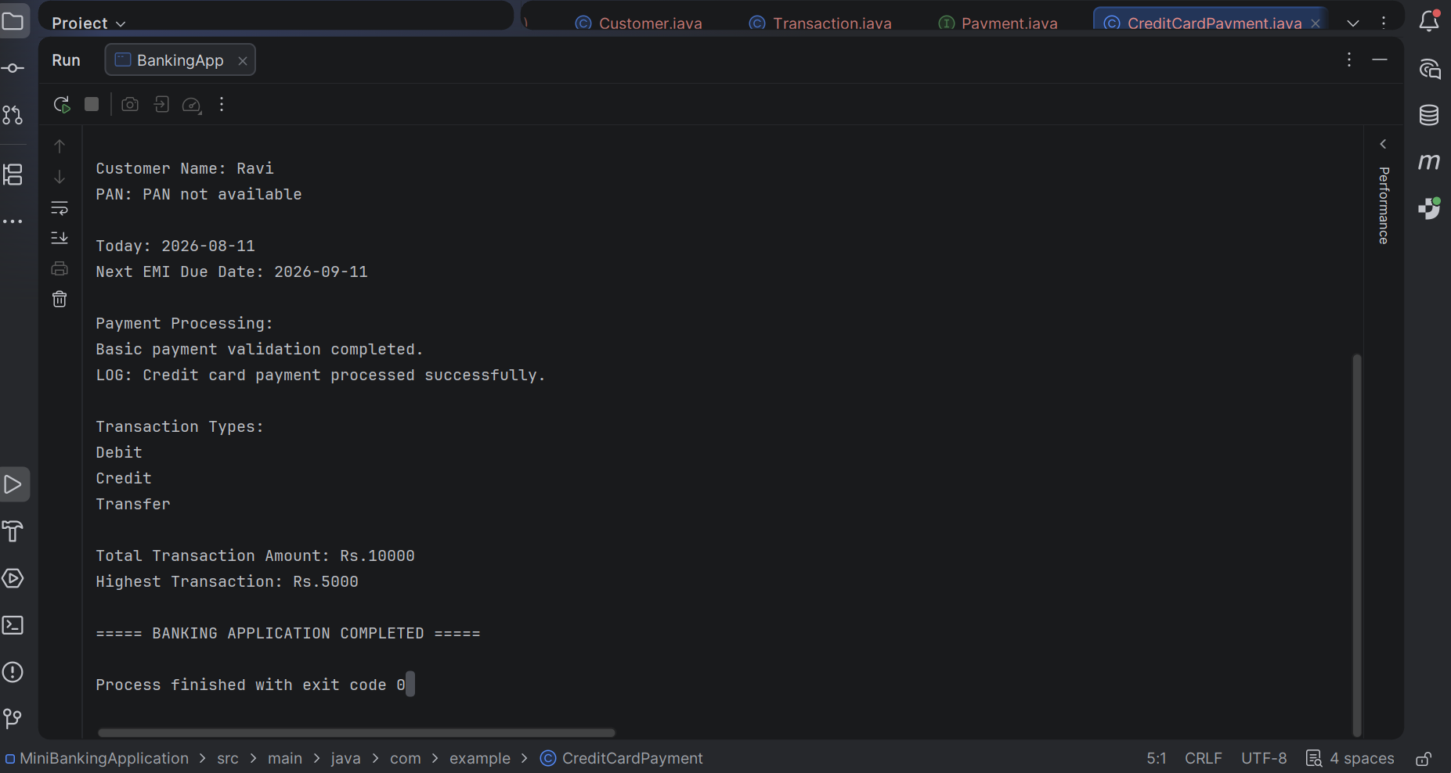

Task 2

Create a Mini Banking App project using Java 17 n 21 features.

ode
banking-app/
├── src/
│ ├── main/
│ │ ├── java/
│ │ │ └── com/bank/
│ │ │ ├── model/
│ │ │ │ ├── Customer.java
│ │ │ │ ├── Transaction.java
│ │ │ │ ├── Credit.java
│ │ │ │ ├── Debit.java
│ │ │ │ └── Transfer.java
│ │ │ ├── service/
│ │ │ │ └── BankService.java
│ │ │ ├── processor/
│ │ │ │ └── TransactionProcessor.java
│ │ │ └── App.java
└── pom.xml (if using Maven)

Project name MiniBankingApp

App.java
package com.example;
public class App {
public static void main(String[] args) {
System.out.println("""
==============================
MINI BANKING APP
==============================
""");
BankService bankService = new BankService();
// Create customers
var customer1 = new Customer(
1,
"Monika",
"ACC1001",
10000
);
var customer2 = new Customer(
2,
"Rahul",
"ACC1002",
5000
);
// Add customers
bankService.addCustomer(customer1);
bankService.addCustomer(customer2);
System.out.println("Initial Accounts:");
bankService.displayAccount("ACC1001");
bankService.displayAccount("ACC1002");
// Create transaction processor
TransactionProcessor processor =
new TransactionProcessor(bankService);
// Credit
System.out.println("\n--- Credit Transaction ---");
processor.process(
"ACC1001",
new Credit(2000, "Salary Credit")
);
bankService.displayAccount("ACC1001");
// Debit
System.out.println("\n--- Debit Transaction ---");
processor.process(
"ACC1001",
new Debit(1500, "Shopping")
);
bankService.displayAccount("ACC1001");
// Transfer
System.out.println("\n--- Transfer Transaction ---");
processor.process(
"ACC1001",
new Transfer(3000, "Money Transfer", "ACC1001", "ACC1002")
);
// Final balances
System.out.println("\n--- Final Account Details ---");
bankService.displayAccount("ACC1001");
bankService.displayAccount("ACC1002");
System.out.println("""
==============================
TRANSACTIONS COMPLETED
==============================
""");
}
}

Credit.java
package com.example;
public record Credit(
double amount,
String description
) implements Transaction {
public Credit {
if (amount <= 0) {
throw new IllegalArgumentException(
"Credit amount must be greater than zero"
);
}
}
}

Debit.java

package com.example;
public record Debit(
double amount,
String description
) implements Transaction{
public Debit {
if (amount <= 0) {
throw new IllegalArgumentException(
"Debit amount must be greater than zero"
);
}
}
}

Transfer.java

package com.example;
public record Transfer(
double amount,
String description,
String fromAccount,
String toAccount
) implements Transaction {
public Transfer {
if (amount <= 0) {
throw new IllegalArgumentException(
"Transfer amount must be greater than zero"
);
}
}
}

TransactionProcess.java

package com.example;
public class TransactionProcessor {
private final BankService bankService;
public TransactionProcessor(BankService bankService) {
this.bankService = bankService;
}
public void process(String accountNumber, Transaction transaction) {
switch (transaction) {
case Credit credit -> {
bankService.deposit(
accountNumber,
credit.amount()
);
System.out.println(
"Credit successful: ₹" + credit.amount()
);
}
case Debit debit -> {
bankService.withdraw(
accountNumber,
debit.amount()
);
System.out.println(
"Debit successful: ₹" + debit.amount()
);
}
case Transfer transfer -> {
bankService.transfer(
transfer.fromAccount(),
transfer.toAccount(),
transfer.amount()
);
System.out.println(
"Transfer successful: ₹"
+ transfer.amount()
);
}
}
}
}

OUTPUT

