Day 23 - 17th Aug 2026
Brownfield vs. Greenfield
1. What distinguishes a Brownfield application from a Greenfield one in terms of constraints and opportunities?
A Brownfield application is an existing system that already has users, data, integrations, and business rules. It comes with constraints such as legacy code, technical debt, and dependencies, but modernization can build on what already works. A Greenfield application is built from scratch, giving the team more freedom to choose modern technologies, architecture, and design without legacy limitations.
2. Why might modernization of a Brownfield system be more complex than building a Greenfield solution?
Modernizing a Brownfield system requires understanding and preserving existing functionality, data, integrations, and business rules. Changing one component can affect other dependent systems. In contrast, a Greenfield project starts with a clean design and has fewer compatibility and dependency concerns.

Business Drivers
3. How do business drivers such as cost reduction, agility, and compliance influence migration decisions?
Business drivers help determine why and when migration should happen. Cost reduction may encourage moving away from expensive infrastructure, while agility may require faster deployment and scaling. Compliance requirements can also push organizations toward platforms with better security, monitoring, and regulatory support.
4. Can modernization be justified purely on technical grounds without business drivers? Why or why not?
Technical improvements alone are usually not enough to justify a major modernization investment. The project should demonstrate business value such as reduced costs, improved customer experience, faster delivery, or reduced risk. Business drivers help justify the investment and measure its success.
Application Portfolio Assessment
5. What is the purpose of conducting an application portfolio assessment before migration?
An application portfolio assessment helps understand the current state of applications, including their business value, technology, dependencies, costs, and risks. It helps decide which applications should be migrated, modernized, replaced, retained, or retired.
6. How does inventorying applications and dependencies reduce risk during modernization?
Creating an inventory provides a clear picture of what applications exist and how they interact. It helps identify critical dependencies before migration, reducing the chances of unexpected failures or service disruptions.

Discovery & Mapping
7. Why is mapping integration points critical when planning migration?
Integration points show how an application communicates with databases, APIs, external services, and other applications. Mapping them helps ensure that these connections continue to work correctly after migration.
8. How can overlooked dependencies derail a migration project?
An overlooked dependency may cause an application to stop working after migration. For example, an old application may depend on a database, API, or service that was not identified during planning. This can lead to outages, delays, and additional costs.

Technical Debt & Stack Evaluation
9. How does technical debt impact modernization strategy selection?
High technical debt can make an application difficult and expensive to maintain or modify. Depending on its condition, the organization may choose to refactor, replatform, replace, or retire the application instead of simply moving it as-is.
10. What role does evaluating runtime dependencies play in migration planning?
Runtime dependency analysis identifies the operating systems, libraries, frameworks, databases, middleware, and services required by an application. This helps determine whether the application can run in the target environment and what changes may be required.

Database & Infrastructure
11. What are the main risks in database migration, and how can they be mitigated?
Common risks include data loss, corruption, downtime, compatibility issues, and performance problems. These can be reduced through backups, data validation, compatibility testing, migration rehearsals, monitoring, and rollback plans.
12. How does hosting infrastructure assessment influence cloud-readiness decisions?
Assessing the existing infrastructure helps determine whether an application can move directly to the cloud or needs changes first. Factors such as hardware requirements, operating systems, networking, storage, scalability, and security influence the cloud migration approach.

Security & Compliance
13. Why must security and compliance be reassessed during migration, even if the application was previously compliant?
Migration can change the application's infrastructure, network boundaries, access controls, data storage, and security configurations. Therefore, previous compliance does not automatically guarantee compliance in the new environment.
14. How does modernization affect risk posture?
Modernization can reduce risks by removing outdated technologies, improving security controls, and enabling better monitoring. However, it can also introduce new risks during migration, such as configuration errors, data exposure, or new cloud dependencies. Proper assessment and testing help manage these risks.
Migration Strategies – 6 R's
15. How do the 6 R's of migration provide a framework for decision-making?
The 6 R's provide different options for handling an application:
- Rehost – Move the application with minimal changes.
- Replatform – Make limited changes to use the target platform better.
- Refactor – Redesign or modify the application significantly.
- Repurchase – Replace it with a commercial or SaaS solution.
- Retire – Remove applications that are no longer needed.
- Retain – Keep the application in its current environment.
This framework helps organizations select the most suitable approach for each application.
16. In what scenario would refactoring be preferable to rehosting?
Refactoring is preferable when an application needs significant improvement in scalability, performance, maintainability, or cloud-native capabilities. Rehosting may be faster, but it simply moves many existing limitations to the new environment.

Cost & Effort Analysis
17. How does TCO (Total Cost of Ownership) differ from upfront migration cost?
Upfront migration cost covers the initial expenses of moving or modernizing an application. TCO considers the overall cost of owning and operating the solution over time, including infrastructure, licensing, maintenance, support, security, and operational costs.
18. Why is effort, complexity, and risk scoring essential for prioritization?
Scoring helps compare applications objectively. An application with high business value but extremely high complexity may require more preparation, while a low-risk application can be migrated earlier. This helps create realistic migration waves and reduces project risk.

Prioritization & Planning
19. What factors determine wave planning for application migration?
Wave planning considers factors such as business criticality, dependencies, technical complexity, migration effort, risk, compliance requirements, and resource availability. Applications with similar characteristics or dependencies can often be grouped into the same migration wave.
20. How does prioritization balance business urgency with technical feasibility?
Business urgency identifies what needs to be migrated quickly, while technical feasibility determines what can realistically be migrated safely. A good plan balances both factors instead of focusing only on business priority or technical simplicity.

Target-State Architecture & Patterns
21. How does defining a target-state architecture guide modernization choices?
The target-state architecture describes what the application environment should look like after modernization. It helps teams choose appropriate technologies, cloud services, integration methods, security controls, and deployment models while avoiding short-term decisions that conflict with long-term goals.
22. Compare the Strangler Fig pattern with the Anti-Corruption Layer in terms of risk mitigation.
The Strangler Fig pattern reduces migration risk by gradually replacing parts of a legacy application with new components instead of replacing everything at once.
An Anti-Corruption Layer (ACL) protects the new system from legacy design and data models by acting as a translation layer between the old and new systems.
In simple terms, Strangler Fig manages gradual replacement, while ACL protects the new system from legacy dependencies.

Containerization & Cloud-Readiness
23. What are the key indicators that an application is cloud-ready?
A cloud-ready application generally has:
- Minimal dependency on specific hardware
- Configurable environments
- Automated deployment capabilities
- Scalable architecture
- Externalized configuration
- Good monitoring and logging
- Secure network and access controls
- Compatibility with cloud services
24. How does containerization support modernization goals?
Containers package an application with its required dependencies, making it easier to run consistently across environments. They support portability, scalability, automated deployment, and efficient use of infrastructure, making them useful for cloud modernization.

Success Metrics & Roadmap
25. Why are KPIs critical in measuring migration success?
Key Performance Indicators (KPIs) provide measurable evidence of whether migration achieved its goals. Examples include reduced infrastructure cost, improved application performance, reduced downtime, faster deployments, and improved availability.
26. How does a migration roadmap align technical execution with business case justification?
A migration roadmap connects migration activities with business objectives, timelines, costs, and expected benefits. It helps stakeholders understand what will be migrated, when it will happen, how much it will cost, and what business value it will provide.

Tools & Documentation
27. What role do assessment tools play in reducing subjectivity during migration planning?
Assessment tools collect and analyse application data such as dependencies, technology versions, performance, and infrastructure usage. This provides evidence-based information, making migration decisions more consistent and less dependent on assumptions.
28. Why is documenting findings essential for stakeholder buy-in?
Documentation provides a clear record of the application's current state, identified risks, recommended strategy, costs, and expected benefits. It helps stakeholders understand the reasoning behind migration decisions and builds confidence in the modernization plan.
Task 1:
What is Redis used for? Why?
Redis (Remote Dictionary Server) is an open-source, in-memory data store used for caching, session management, real-time analytics, messaging, and rate limiting.
Why Redis?
- Stores data in memory, making it extremely fast.
- Reduces load on primary databases.
- Improves application performance and response time.
- Supports real-time data processing.
Common Use Cases
- Caching – Store frequently accessed data.
- Session Management – Store user sessions and login information.
- Real-Time Applications – Chat systems, notifications, gaming.
- Message Queues – Communication between services.
- Rate Limiting – Control API request frequency.

Task 2:
Can you explain the architecture of Redis with a diagram?
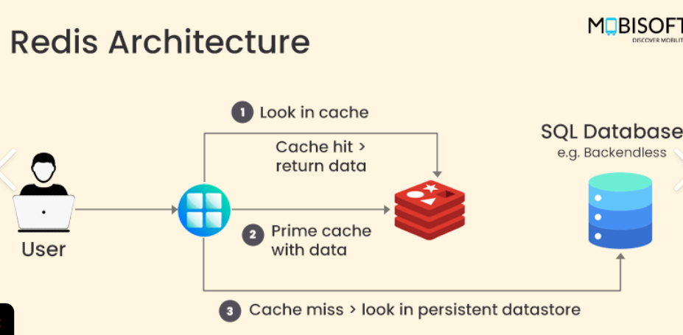
Main Components:
- Client: Sends commands to Redis.
- Redis Server: Processes commands and manages data.
- In-Memory Store: Stores data in RAM for high-speed access.
- Persistence: RDB and AOF can save data to disk for recovery.
Working:
- Look in Cache:
The user sends a request. The application first checks Redis for the required data.
- Cache Hit:
If the data is available in Redis, it is returned directly to the user. This makes the response very fast.
- Cache Miss:
If the data is not available in Redis, the application gets it from the SQL database, stores it in Redis (prime cache), and then returns it to the user.

TASK 3:
What are the advantages of redis and also disadvantages?
Advantages:
- Very Fast: Stores data in memory, providing low-latency access.
- Simple to Use: Supports easy key-value operations.
- Multiple Data Types: Supports Strings, Lists, Sets, Hashes, and more.
- Scalable: Supports replication and clustering.
- Useful for Caching: Reduces database load and improves application performance.
Disadvantages:
- Memory Cost: Primarily uses RAM, which is more expensive than disk storage.
- Limited by RAM: Large datasets may require significant memory.
- Persistence Overhead: Disk persistence can add some performance overhead.
- Not Ideal for Complex Queries: Less suitable for complex relational queries and joins.

Task 4:
Install docker in your system
Steps
- Download from https://www.docker.com/products/docker-desktop
- Run installer
- Enable hyper-v
- Restart the system
- Check docker version in cmd
  - docker –version
- Done installed docker ..

Task 5:
Open docker from the start menu
Now check
Docker version
It should show
Client and server version information like the below ss
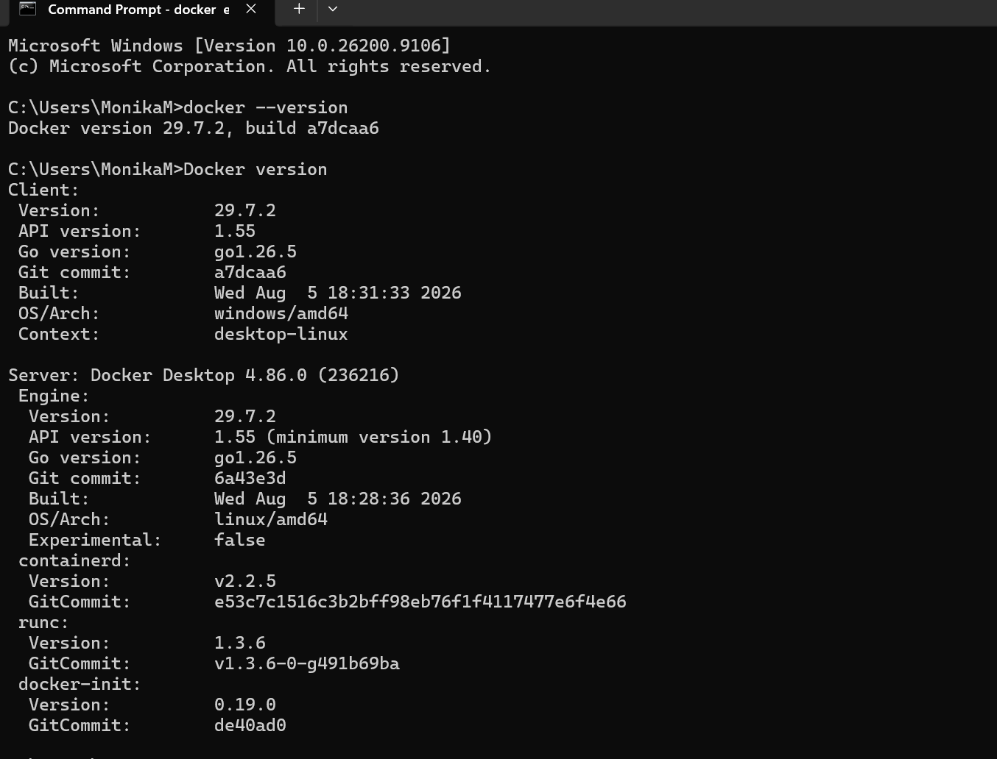
docker pull redis
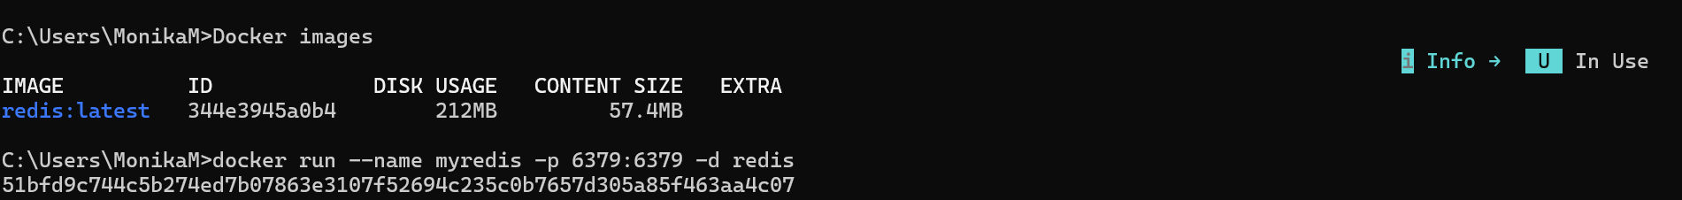
Task 6:
Now run redis container
docker run --name myredis -p 6379:6379 -d redis
Myredis is the name of the container i m creating you can give ur own
-p 6379:6379 this will map the port no to th local host.
-d redis means we RE RUNNING IN detached mode..

Task 7:
Now will test the connection
docker exec -it myredis redis-cli
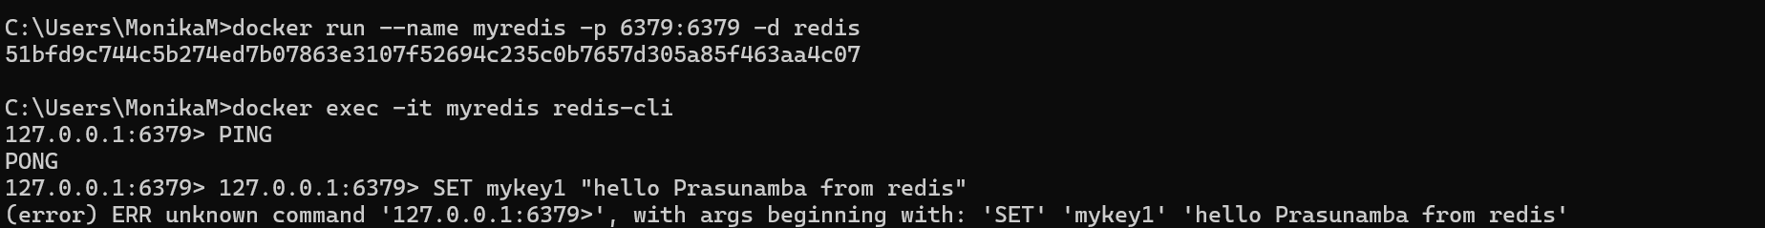

Task 8:
Type Ping
The output should be pong
Pong
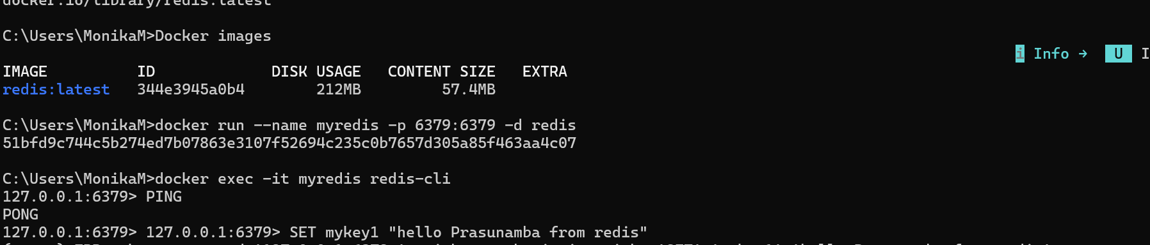

Task 9:
127.0.0.1:6379> set mykey1 "hello Prasunamba from redis"
OK
127.0.0.1:6379> get mykey1
"hello Prasunamba from redis"
127.0.0.1:6379>
Task 10:
127.0.0.1:6379> incr counter
(integer) 1
127.0.0.1:6379> get counter
"1"
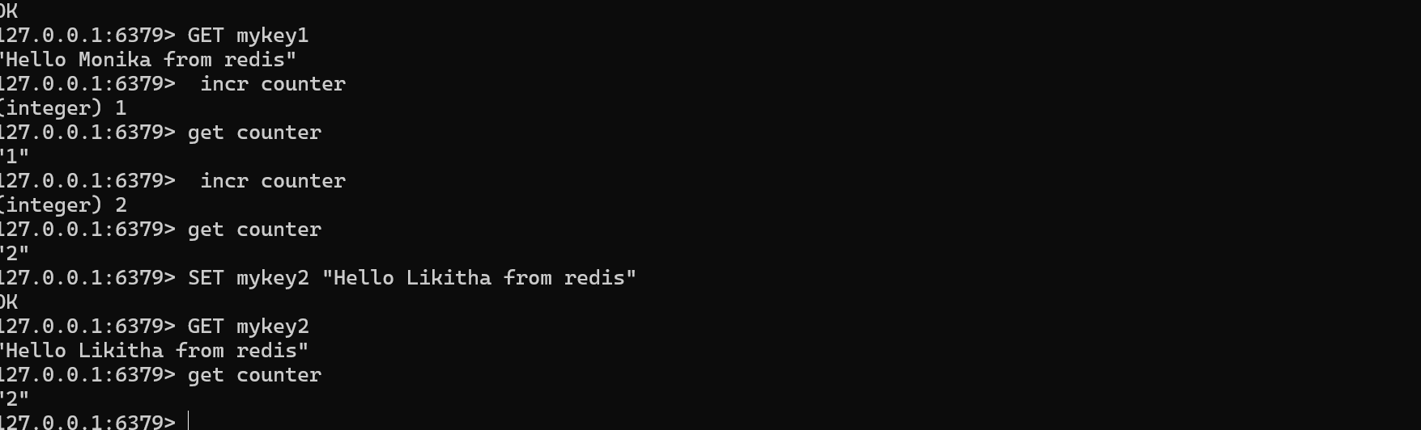
Task 11:
To run hashset you need to open redis - cli
How to do that
- Use command you will see redis if its working or else it will show exit status
  - docker ps -a
Now open another command promt
And use
HSET user:101 name "Prasunamba" email "Prasunamba.mk@gmail.com"

And get using
hgetall user:101
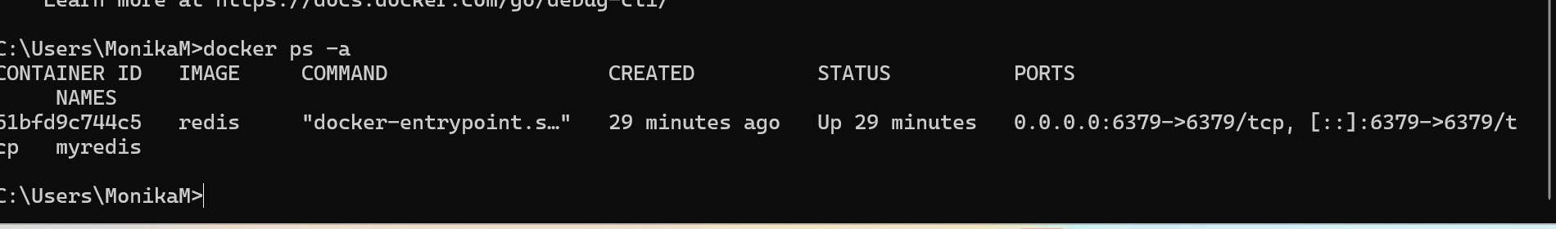
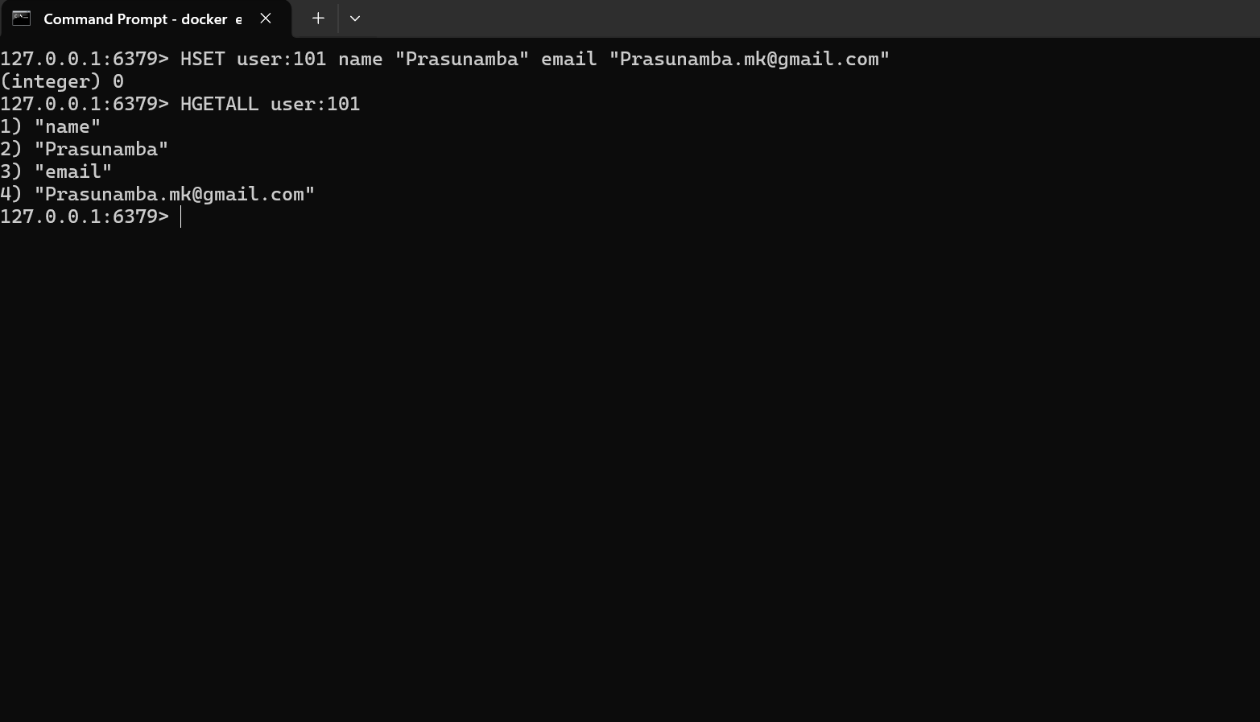
Task 12:
List of ordered collections
LPUSH tasks "Task1"
LPUSH tasks "Task2"
LRANGE tasks 0 -1
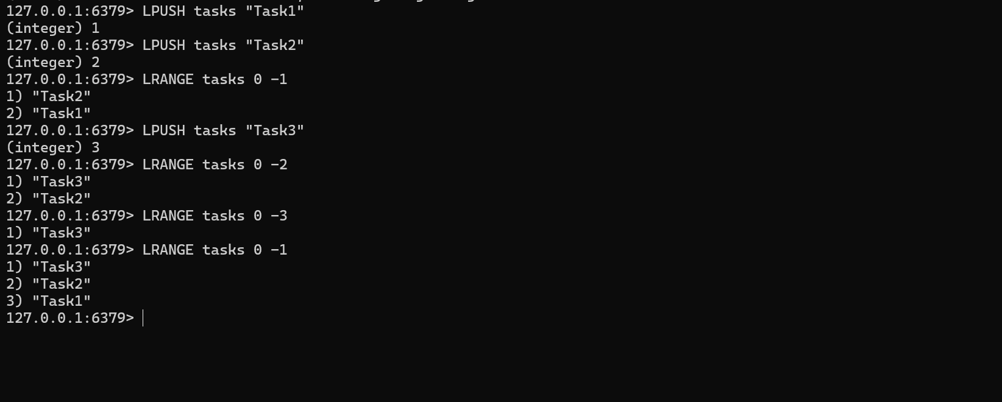

Task 13:
Sets (unique value)
SADD customrs1 "Prasunamba" "Meher" "K"
SMEMBERS customrs1
SISMEMBER customrs1 "K" (sismember is checking if the value exists or not.
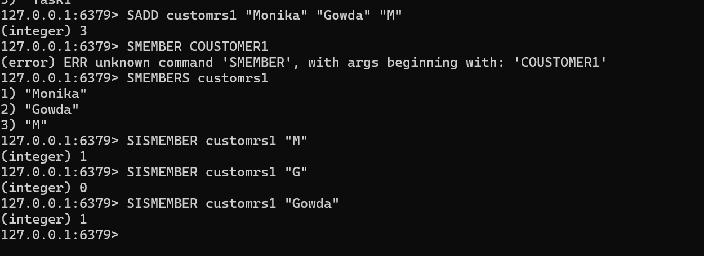

Task 14:
In the same way can you check sorted set … zsets .. what are they ?why they are used ? how to use ? cn you try ?
Like zadd leaderboard 100 “Prasunamba”
A Sorted Set (ZSET) is a Redis data type that stores unique values with a score. Redis automatically keeps the members ordered according to their scores.
Why are ZSETs used?
ZSETs are useful when we need to rank or sort data based on scores, such as:
- Leaderboards
- Student rankings
- Player scores
- Priority-based data
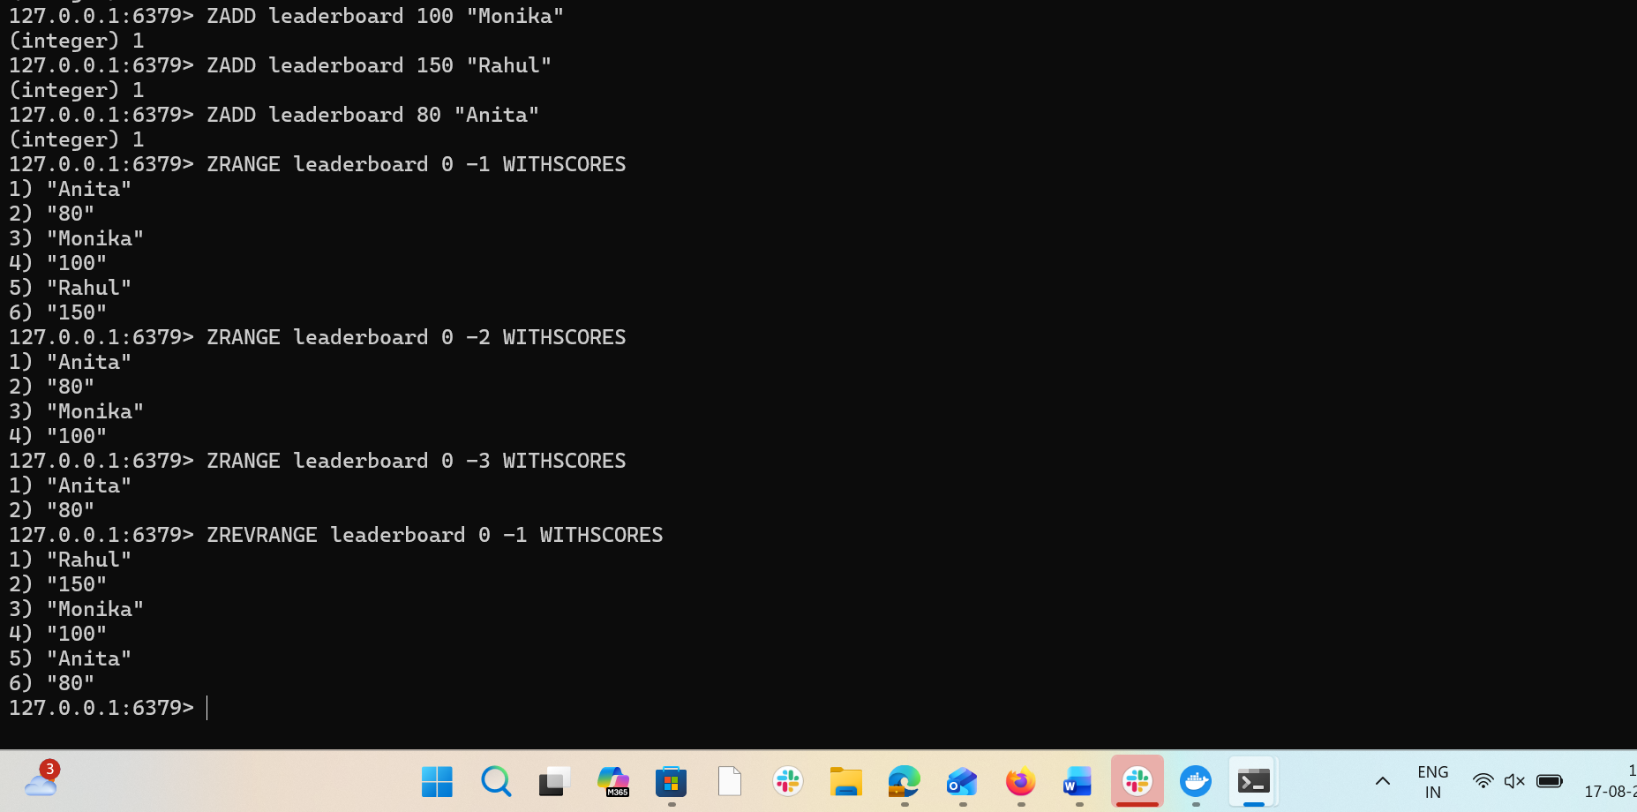
Task 15:
127.0.0.1:6379> set user:1 "Prasunamba"
OK
127.0.0.1:6379> exists user:1
(integer) 1
127.0.0.1:6379> del user:1
(integer) 1
127.0.0.1:6379> keys *
1) "user:101"
2) "customrs"
3) "user"
4) "tasks"
5) "customrs1"
127.0.0.1:6379> rename user:1 user:100
(error) ERR no such key
127.0.0.1:6379> rename user:2 user:100
(error) ERR no such key
127.0.0.1:6379> set user:1 "Prasunamba"
OK
127.0.0.1:6379> rename user:1 user:100
OK
127.0.0.1:6379> keys *
1) "user:100"
2) "user:101"
3) "customrs"
4) "user"
5) "tasks"
6) "customrs1"
127.0.0.1:6379> expire session:123 10
(integer) 0
127.0.0.1:6379> expire session:123 10 ttl session:123
(error) ERR Unsupported option ttl
127.0.0.1:6379> SET session:123 "active"
OK
127.0.0.1:6379> expire session:123 10
(integer) 1
127.0.0.1:6379> ttl session:123
(integer) -2
127.0.0.1:6379> expire session:123 1000
(integer) 0
127.0.0.1:6379> ttl session:123
(integer) -2
127.0.0.1:6379> expire session:123 1000000
(integer) 0
127.0.0.1:6379> ttl session:123
(integer) -2
127.0.0.1:6379> get session:123
(nil)
127.0.0.1:6379>
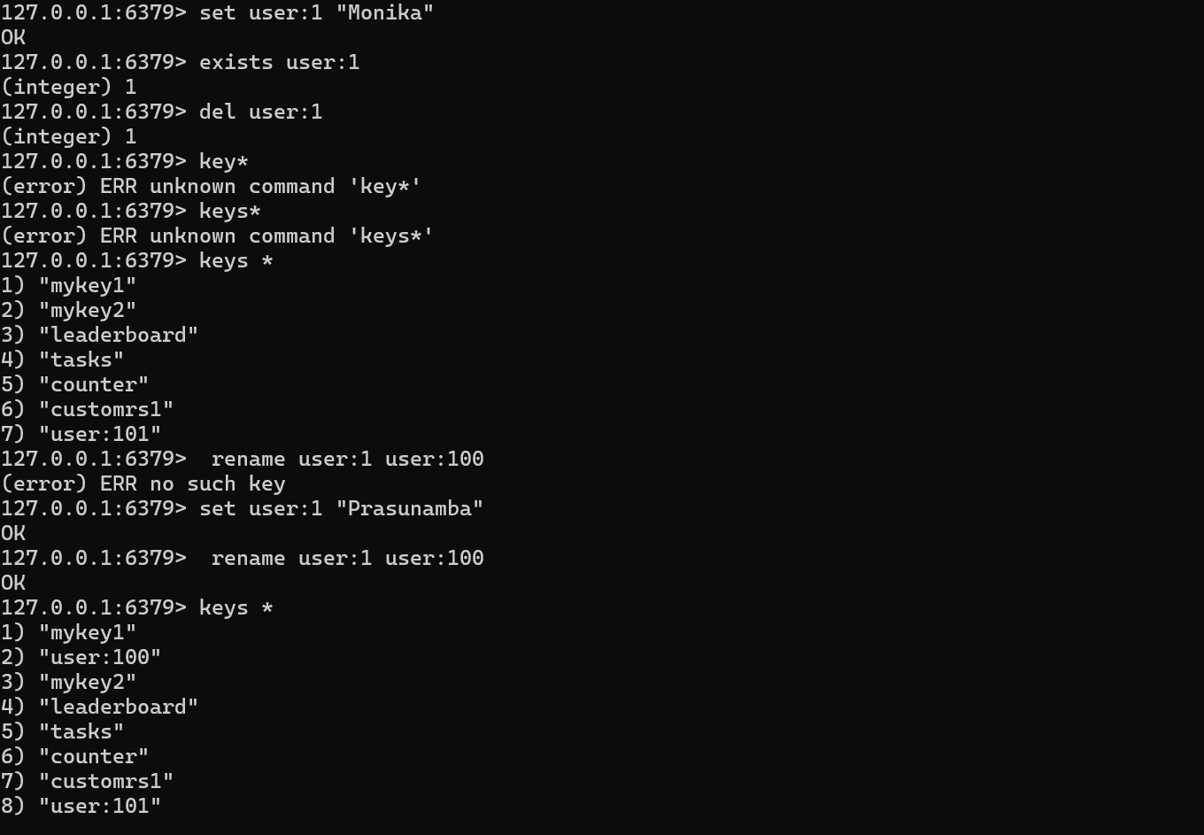

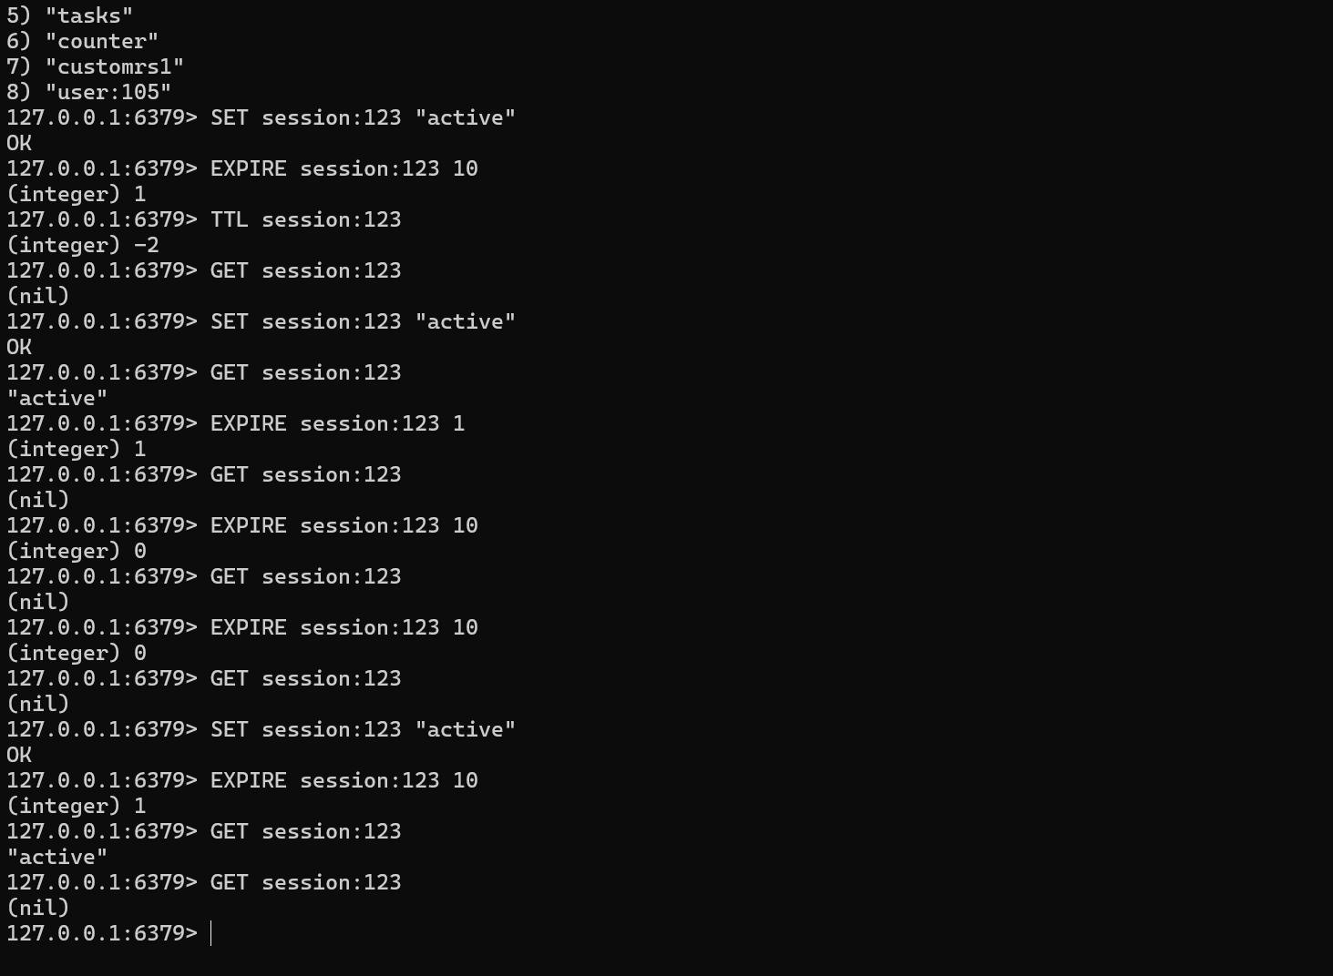
Task 16:
expire session:123 10000 // setting expiry to 10000
(integer) 1
127.0.0.1:6379> ttl session:123
(integer) 9993 // plz observe every time you check ttl it will decrease.
127.0.0.1:6379> ttl session:123
(integer) 9989 // still time to live is 9989 sec
127.0.0.1:6379> ttl session:123
(integer) 9987
127.0.0.1:6379> ttl session:123
(integer) 9985
127.0.0.1:6379> ttl session:123
(integer) 9984
127.0.0.1:6379> ttl session:123
(integer) 9983
127.0.0.1:6379> ttl session:123
(integer) 9977
127.0.0.1:6379> PERSIST session:123 // checking if still persists or not 1 says yes 0 says expired.
(integer) 1

PERSIST is used to remove the expiration time from a key, making the key permanent until it is manually deleted.
Conclusion
- EXPIRE → Sets an expiration time.
- TTL → Checks the remaining time.
- PERSIST → Removes the expiration and makes the key permanent.
- PERSIST returns 1 → Expiration removed successfully.
- PERSIST returns 0 → Key does not exist or has no expiration.
- TTL -1 → Key exists but has no expiration
- TTL -2 → Key does not exist / has expired
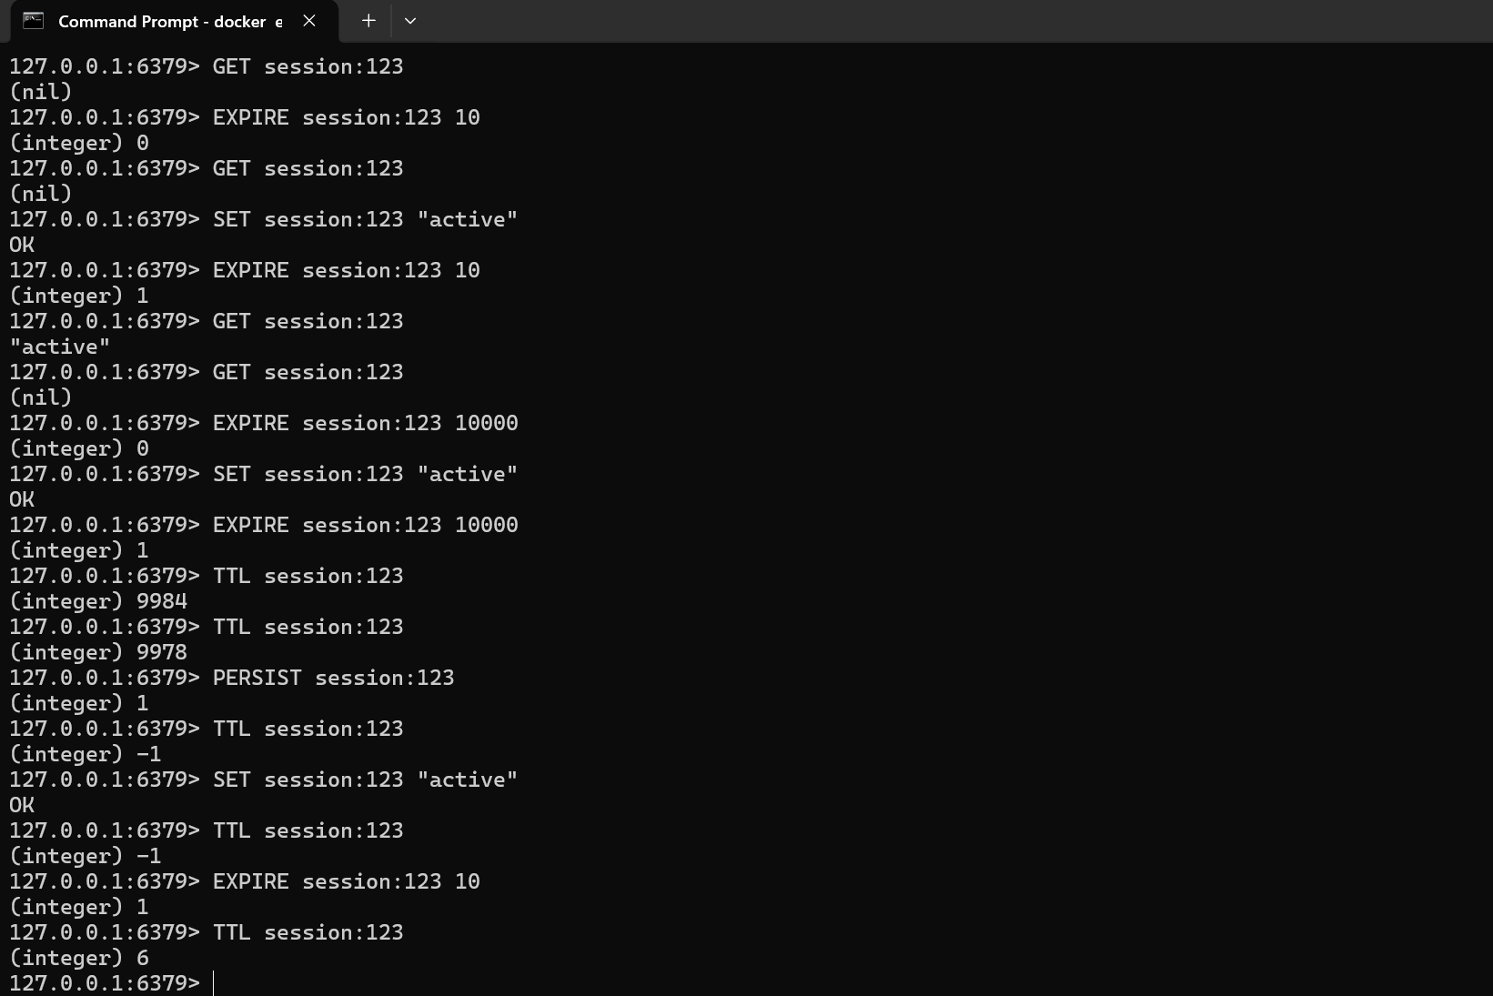
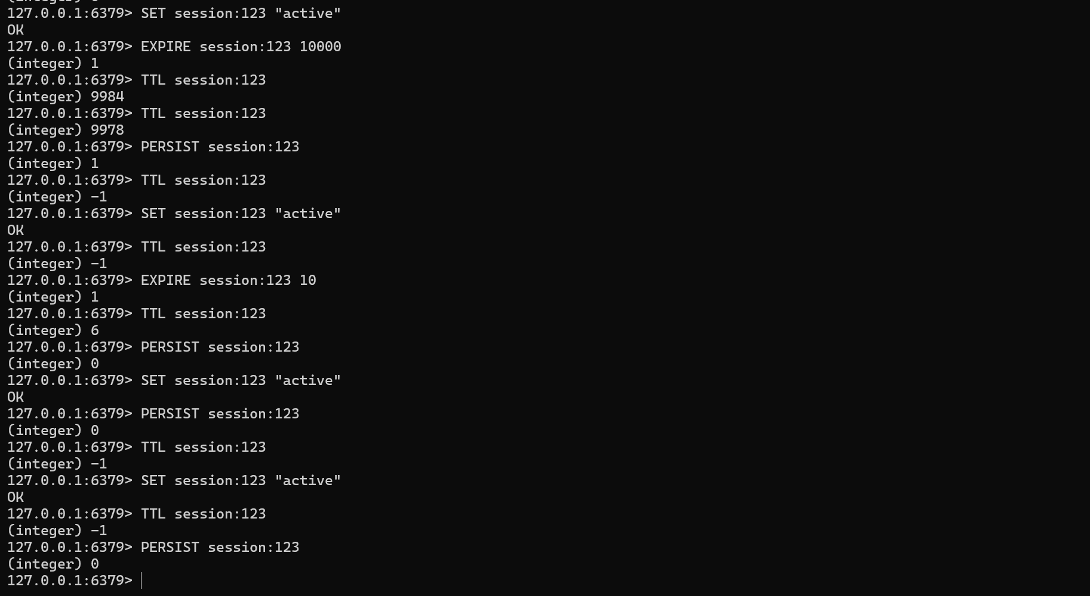
Task 17:
How does Cache-Aside balance freshness and performance, and what risks arise if the database is updated frequently?
Cache-Aside improves performance by reading frequently used data from the cache while fetching missing data from the database.
Balance: Provides fast access while keeping data reasonably fresh.
Risk: If the database is updated frequently, the cache may contain stale data until it is updated or invalidated.

Task 18:
In what type of workload would Write-Behind caching introduce consistency challenges compared to Write-Through?
Write-Behind can cause consistency issues in workloads with frequent updates and strong consistency requirements, such as banking or financial transactions.
- Write-Behind: Updates cache first and database later → faster but may temporarily have inconsistent data.
- Write-Through: Updates cache and database together → better consistency but slightly slower.

Task 19:
Why might LFU eviction be more suitable than LRU eviction in recommendation systems?
LFU (Least Frequently Used) can be more suitable because recommendation systems often access certain popular items repeatedly.
- LFU: Keeps frequently accessed items in cache.
- LRU: Removes items that have not been accessed recently.
Therefore, LFU helps retain popular recommendations even when other less-important items are accessed more recently.

Task 20:
What are the trade-offs between time-based invalidation and event-based invalidation?
- Time-Based: Cache expires after a fixed time. It is simple to implement but may serve stale data.
- Event-Based: Cache is invalidated whenever the underlying data changes. It provides fresher data but is more complex to implement.
Trade-off: Time-based is simple but less fresh, while event-based is more accurate but more complex.

Task 21:
How would you design cache invalidation for a real-time stock trading system?
Use event-based invalidation because stock prices change frequently and must remain up to date.
- Update the database when stock data changes.
- Publish an invalidation event.
- Remove or update the corresponding Redis cache entry immediately.
- Use a short TTL as a backup for stale data.
Goal: Ensure fresh stock prices, low latency, and minimal stale data.

HOME TASK
Task 22:
How does sharding in Redis clusters improve scalability, and what complexity does it add to key management?
Sharding divides data across multiple Redis nodes based on keys.
Advantages:
- Distributes data and workload across multiple servers.
- Increases storage capacity and performance.
- Allows the cluster to scale horizontally.
Complexity:
- Keys must be distributed correctly across nodes.
- Moving or reorganizing data can be complex.
- Related keys may need hash tags to ensure they are stored on the same node.
In short: Sharding provides better scalability and performance, but makes key management and data distribution more complex.

