Day 18 - 10th Aug 2026

Redirecting Output (> and >>)
ls > files.txt
cat files.txt
Redirecting Output (> and >>)
ls > files.txt
cat files.txt
Append instead of overwrite
echo "New entry" >> files.txt
Redirecting Input (<)
echo -e "banana\napple\ncherry" > fruits.txt
Redirecting Errors (2>)
ls /not_a_real_folder 2> errors.txt
Pipes (|) ls | wc -l
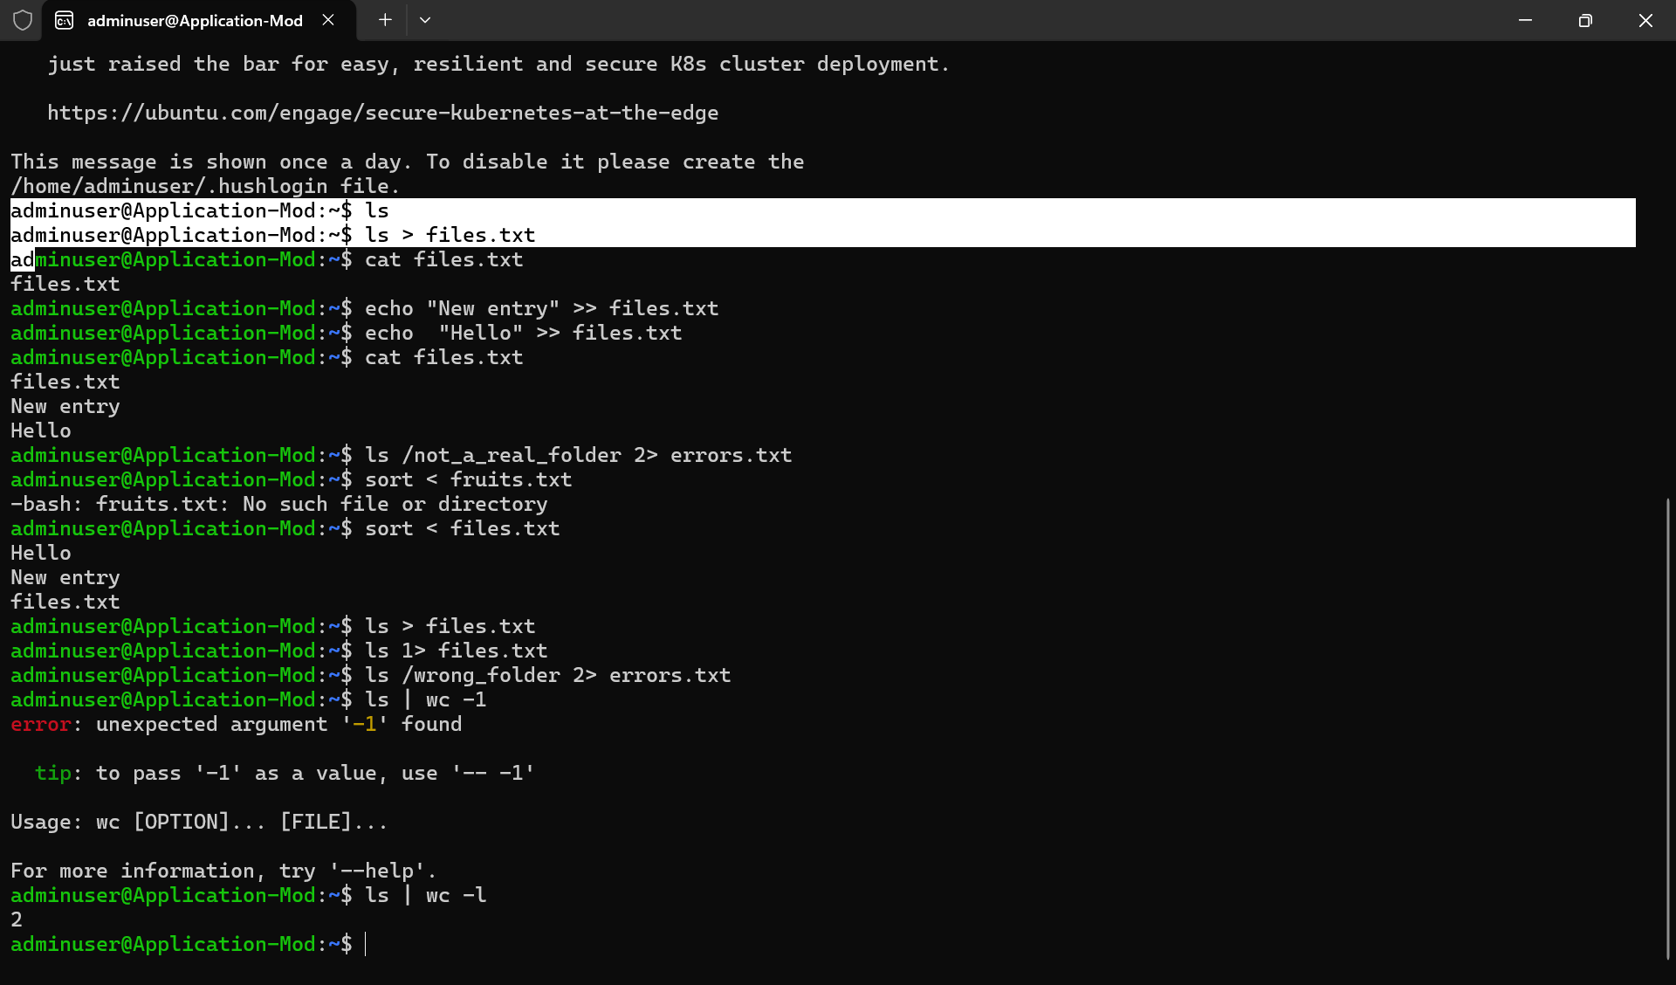

Filter processes
ps aux | grep bash
Check with
Ps a
- a → show processes on terminals, not just your own.
Ps au
- a → processes associated with terminals, including other users
- u → user-oriented format
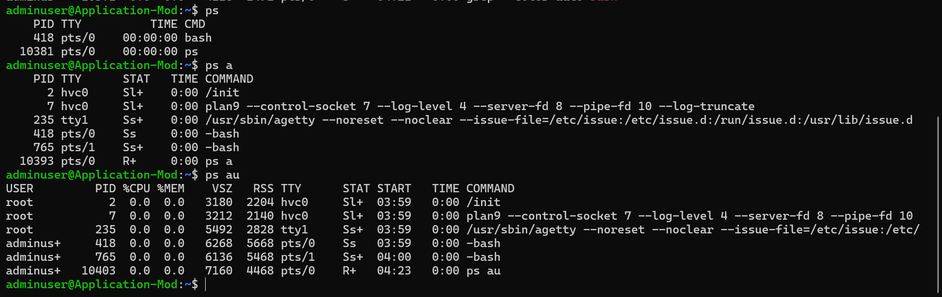
Ps aux
- a → processes associated with terminals
- u → user-oriented format
- x → include processes without a controlling terminal
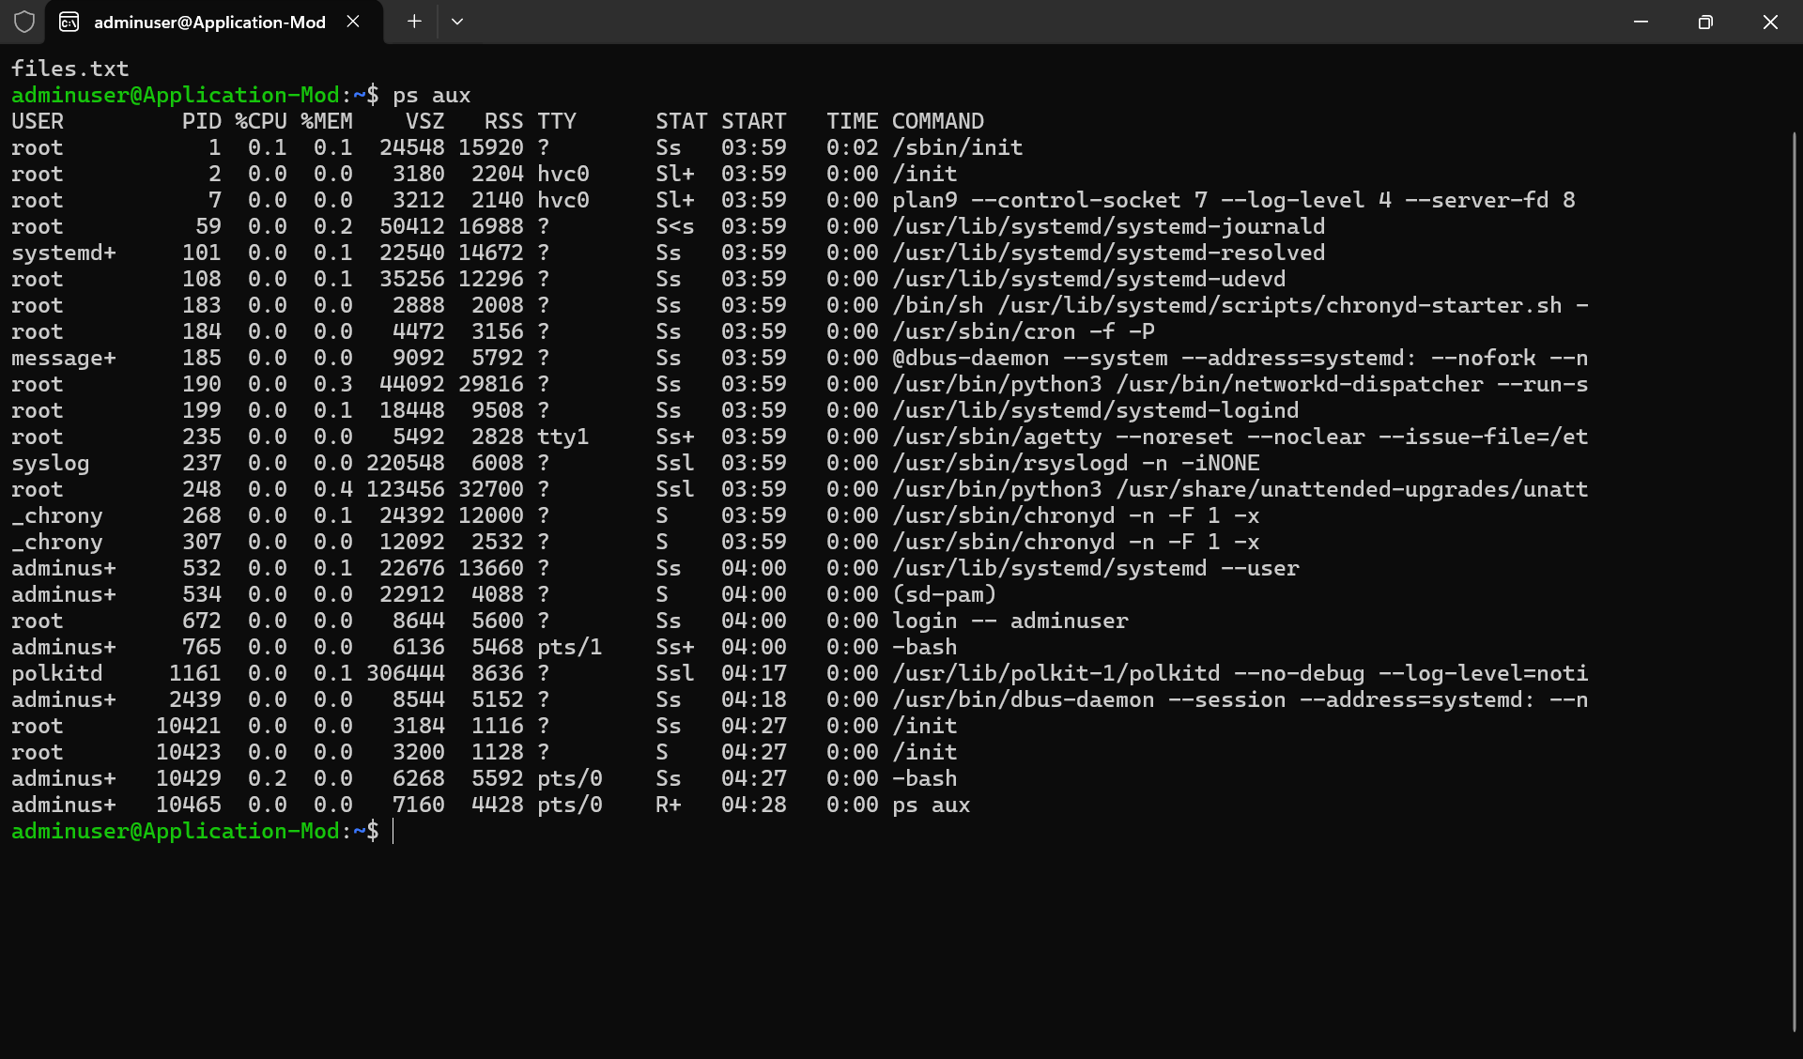
Ps aux | grep bash
- grep searches text for a specified pattern
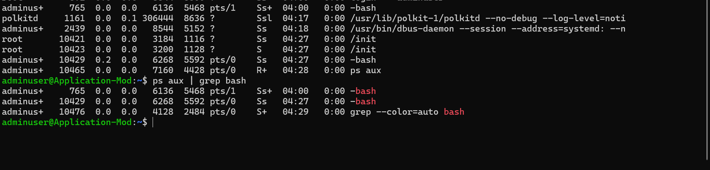

Multi-stage Pipeline
du -sh * | sort -rh | head -5
- du -sh * displayes all files
- du -sh* | sort -rh gives in reverse order
- du -sh* | sort -rh | head – 1 display only first element
- du -sh*|sort sortes in ascending order
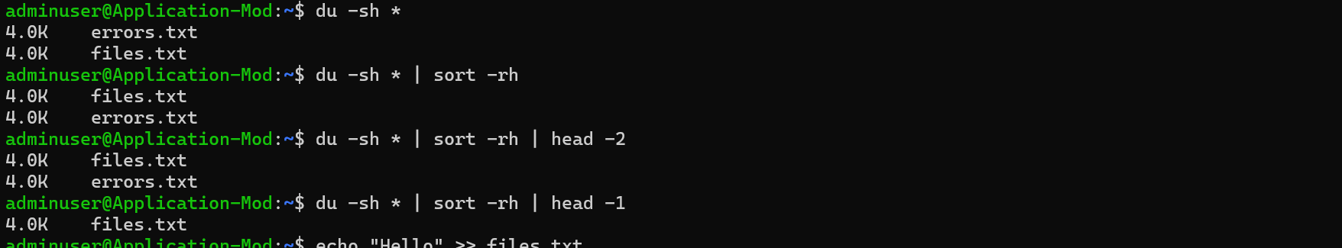
Silent Execution will Suppress output
./script.sh > /dev/null 2>&1
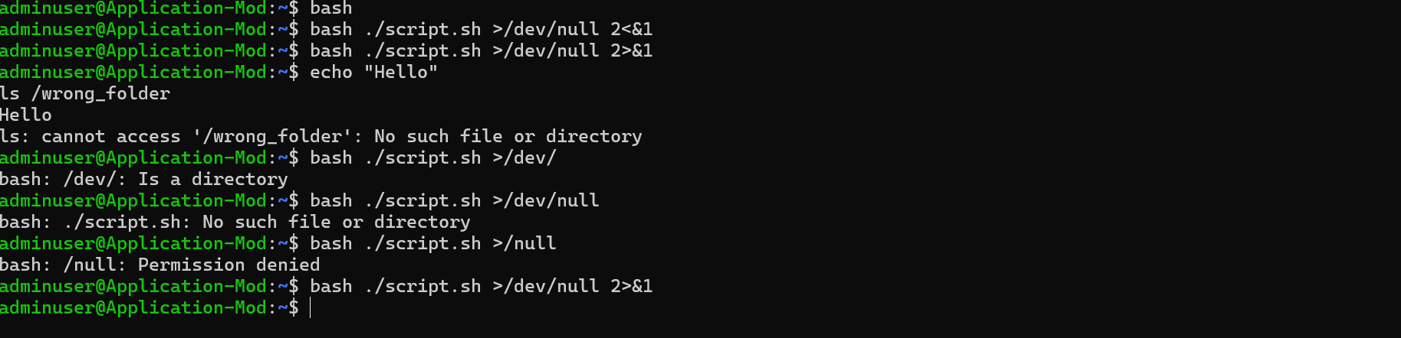
TASK 01:
Sed- sed stands for Stream Editor. It is a Linux command-line utility used to read, search, modify, delete, and print text from files. It processes the input line by line without normally changing the original file.
Go to https://www.lipsum.com/
Pick some dummy data .. and keep it in a file myFile.ttx
- What will this command do
Sed myFile.txt
- Processes the contents of the file and prints them to standard output.
- sed requires a sed expression before the filename.
- sed myFile.txt treats myFile.txt as a sed command, so it produces an error.
- Can you replace a word with another
S → search for 1st occurrence of any old keyword and change it with new in your file..
sed 's/old/new/' filename
- s stands for substitute.
- Searches for old and replaces it with new.
- By default, it replaces only the first occurrence on each line.
- The original file is not modified unless an in-place option such as -i is used.
- G flag → for all occurrences of the word and change it to new word.
sed 's/old/new/g' filename
- g stands for global.
- Replaces all occurrences of old with new on each line.
- Without g, only the first matching occurrence on each line is replaced.
- Try with delete flag
sed '/word/d' filename
- d stands for delete.
- Deletes every line containing the specified word from the output.
- The original file is not changed by default.
- Print specific line numbers line line 3 of your file
sed -n '3p' filename
- -n suppresses automatic printing of lines.
- 3 specifies line number 3.
- p stands for print.
- Prints only line 3.
- Print range of lines
Like from line 2 to 5
sed -n '2,5p' filename
- • Prints lines from line 2 through line 5, inclusive.
- • 2,5 specifies the range.
- • p prints the selected lines.
- • -n prevents other lines from being printed.
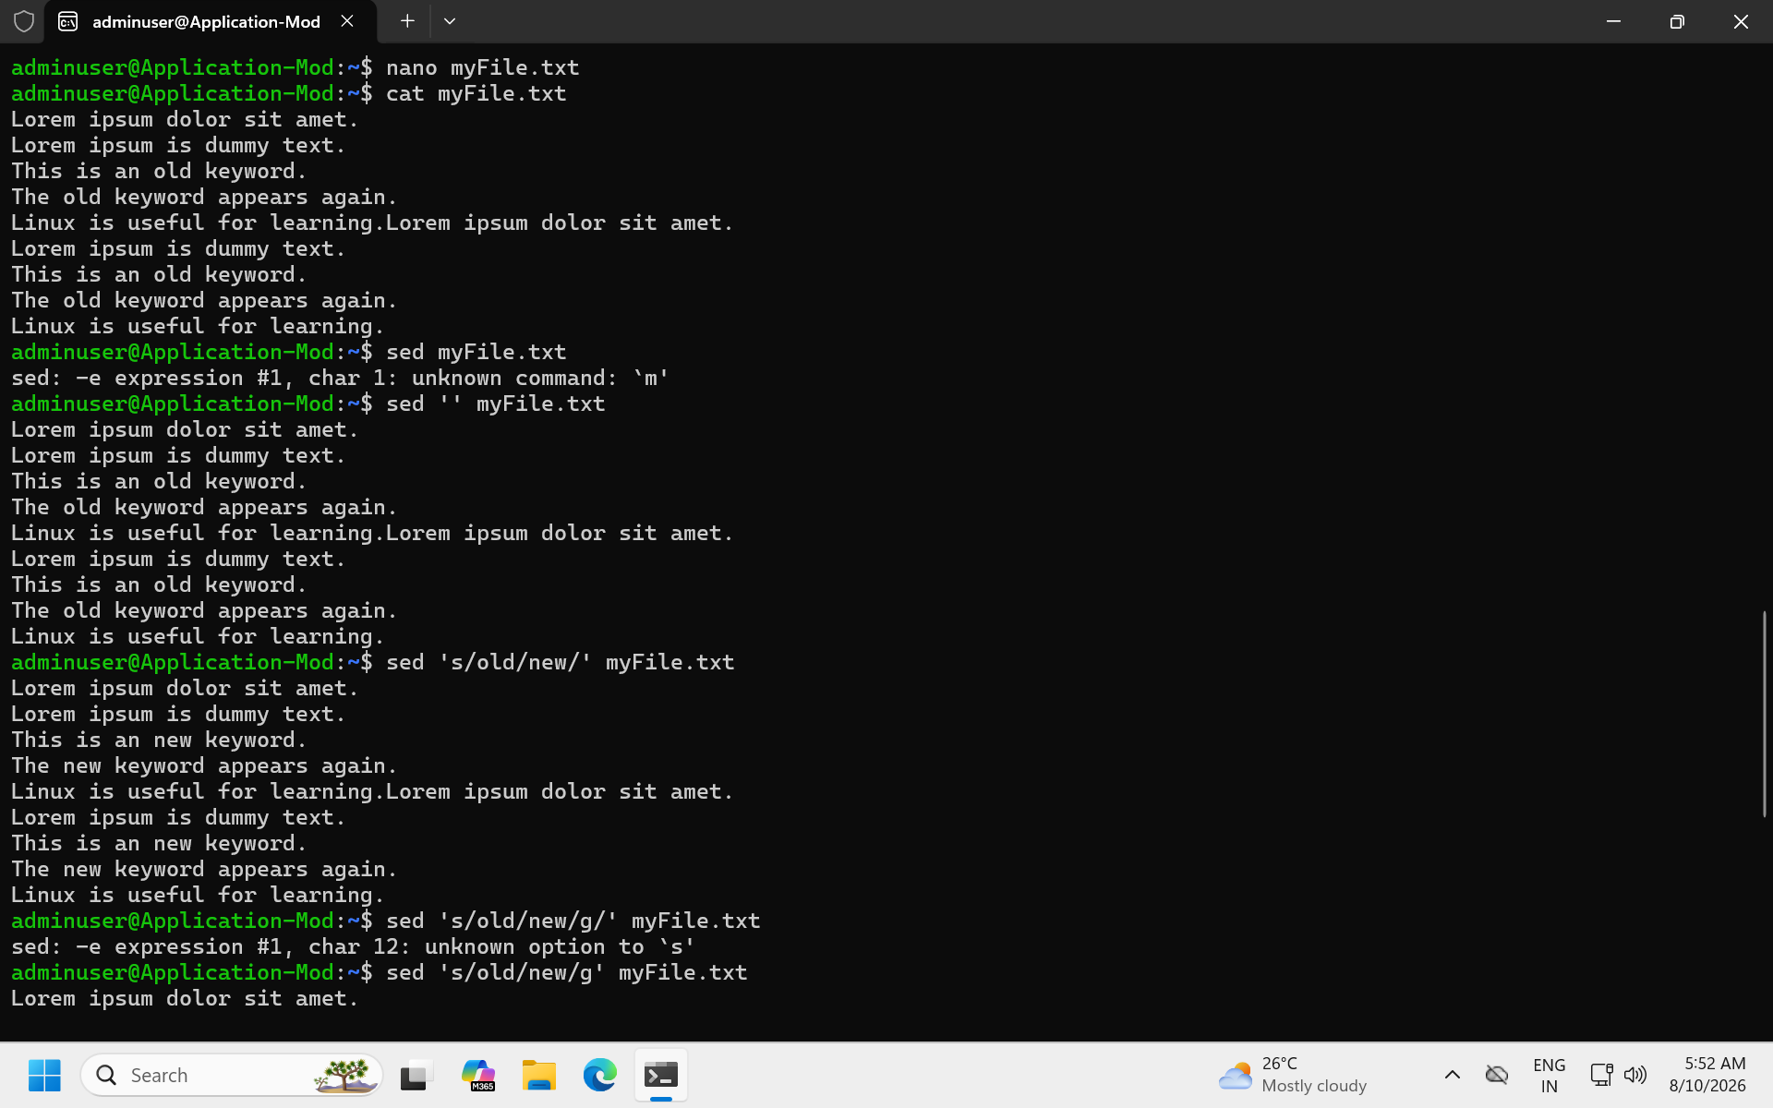
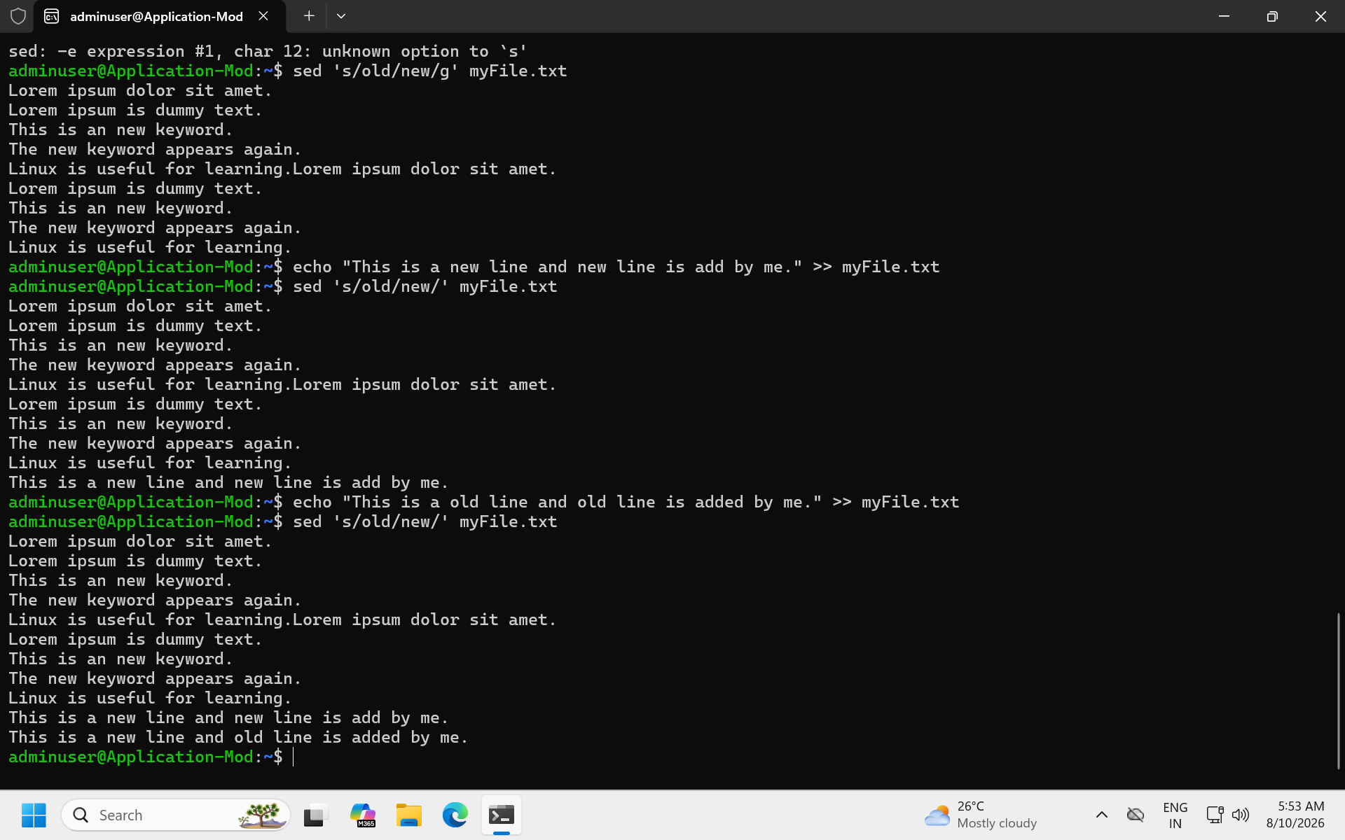
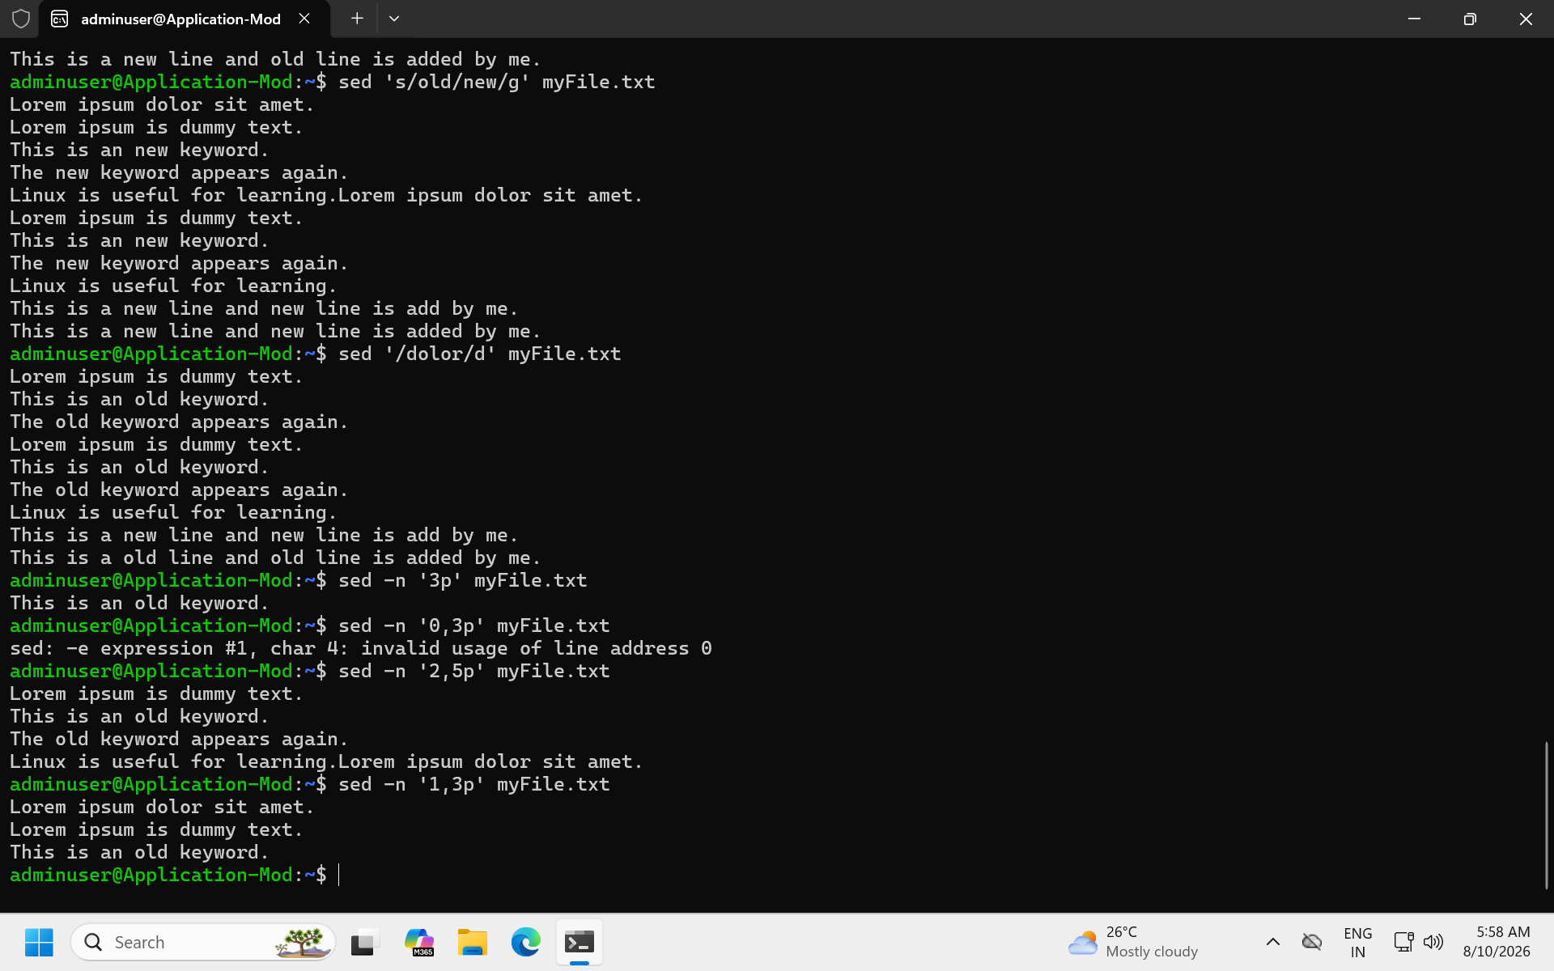

Task 02:
Awk (used for pattern scanning and processing)
- Now try same with awk
awk '{print}' filename
- Prints every line of the file.
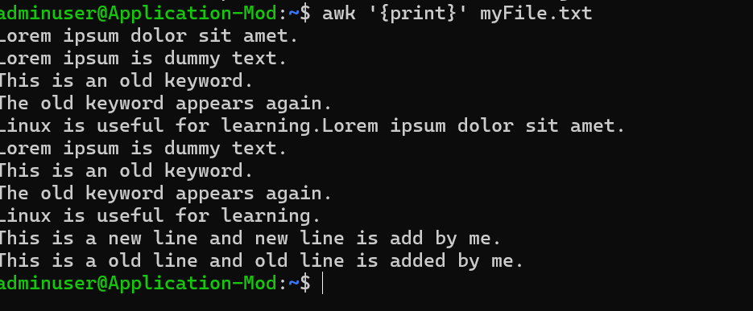

- Print specific column
awk '{print $2}' filename
- Prints the second column from every line.
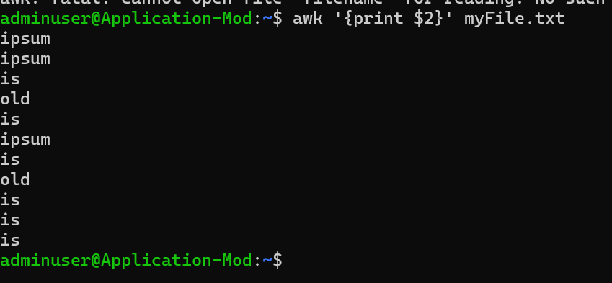
- Print multiple columns
awk '{print $1, $3}' filename
- Prints the first and third columns.
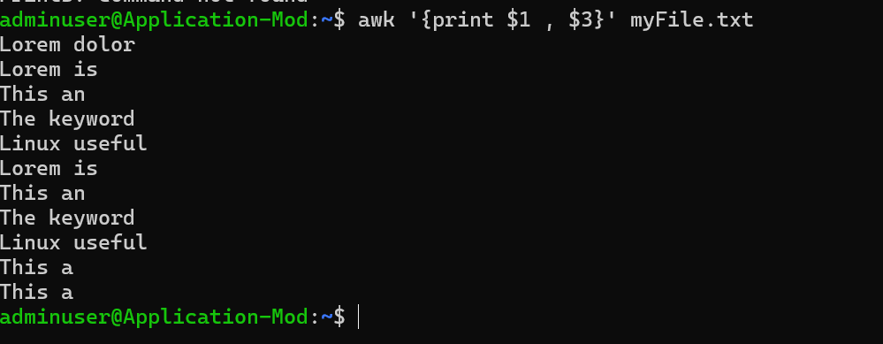

- Filter rows by giving condition
Like print 1st nd 3rd column only if 3rd column value is > 50 fo example..
awk '$3 > 50 {print $1, $3}' filename

- Checks the value in the third column.
- Selects only rows where the third column is greater than 50.
- Prints the first and third columns.
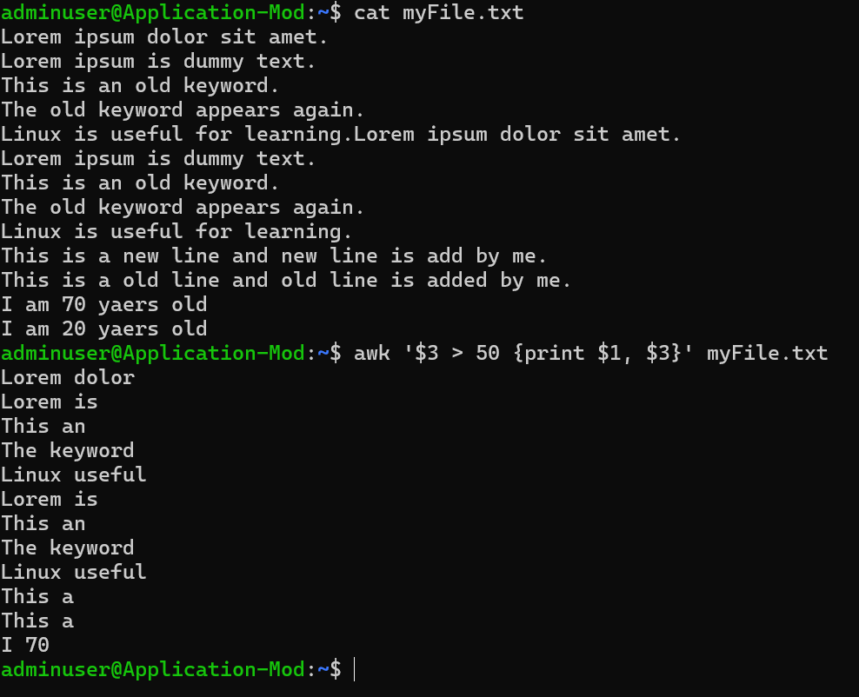

- Use custom delimiter (comma , is a delimiter operator)
awk -F, '{print $1, $2}' filename
- -F specifies the field separator.
- Use comma , as the delimiter between columns.
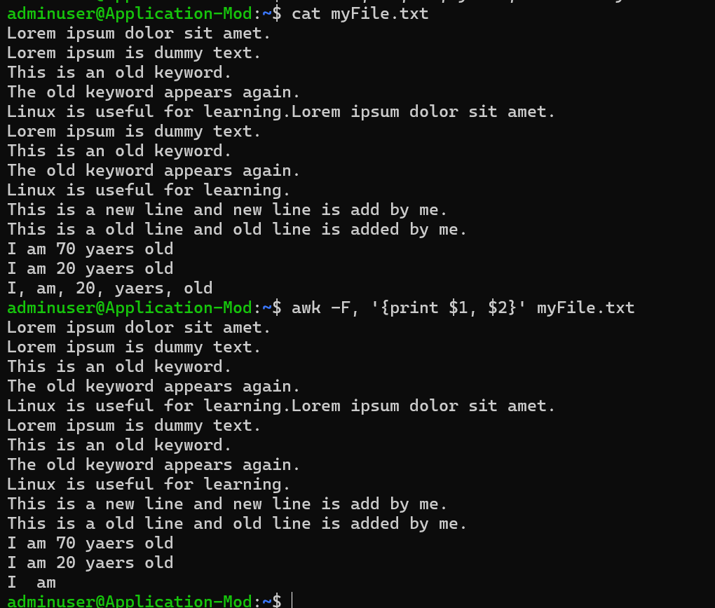
- Now count lines
- Counts the number of lines
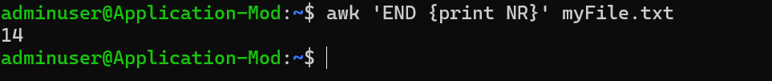

Task 3:
Ping google.com
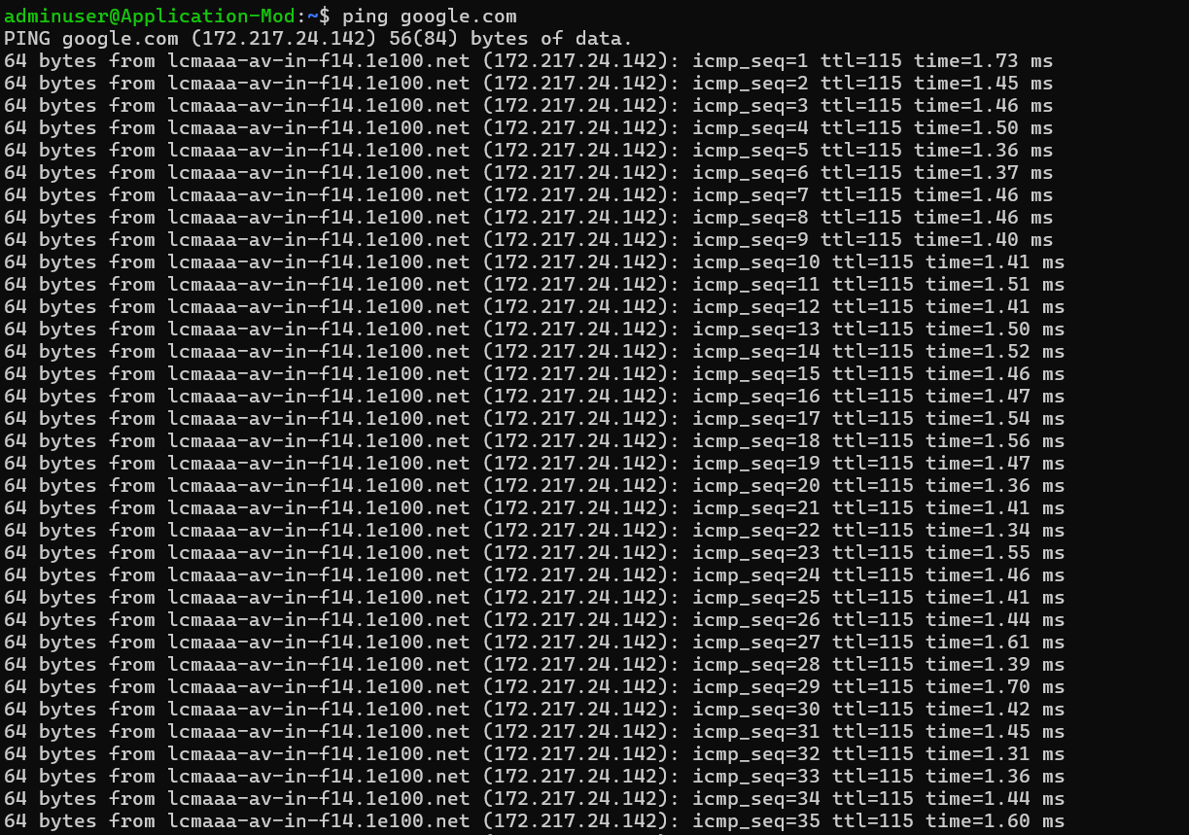
Curl https://google.com
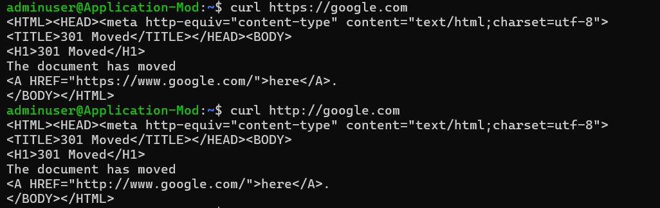

Netstat -an
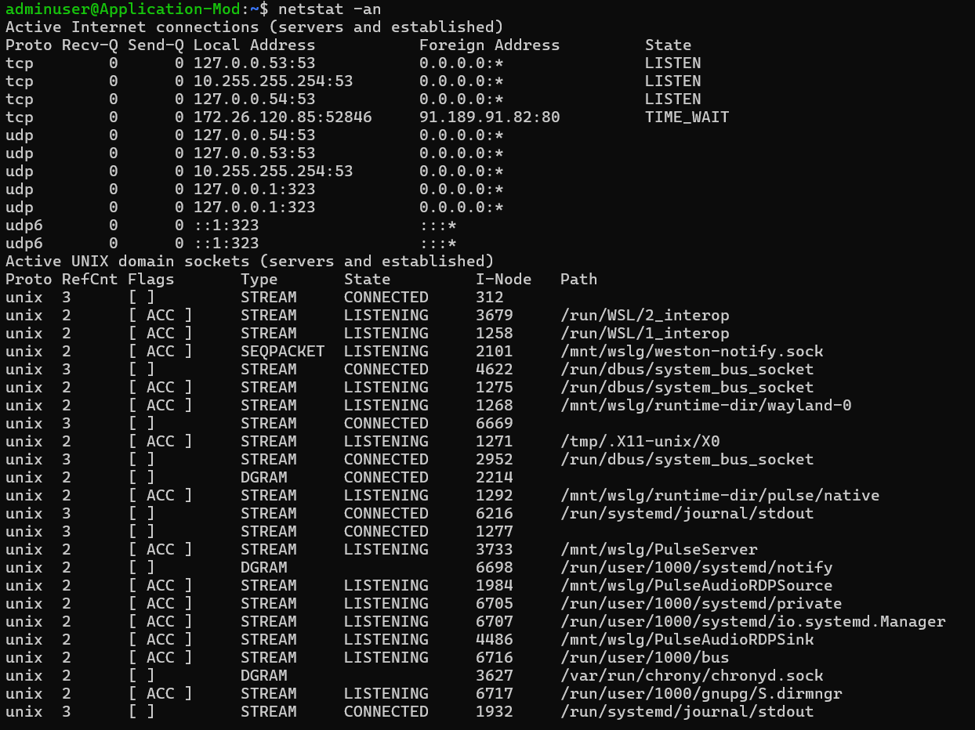

Task 4:
Install open ssl in your system
https://www.xolphin.com/support/OpenSSL/OpenSSL_-_Installation_under_Windows#:~:text=Download%20the%20OpenSSL%20for%20Windows,file%20can%20be%20downloaded%20here.

Or

https://slproweb.com/products/Win32OpenSSL.html

Step 2 Generate a certificate signing request (CSR)

openssl genrsa -out localhost.key 2048
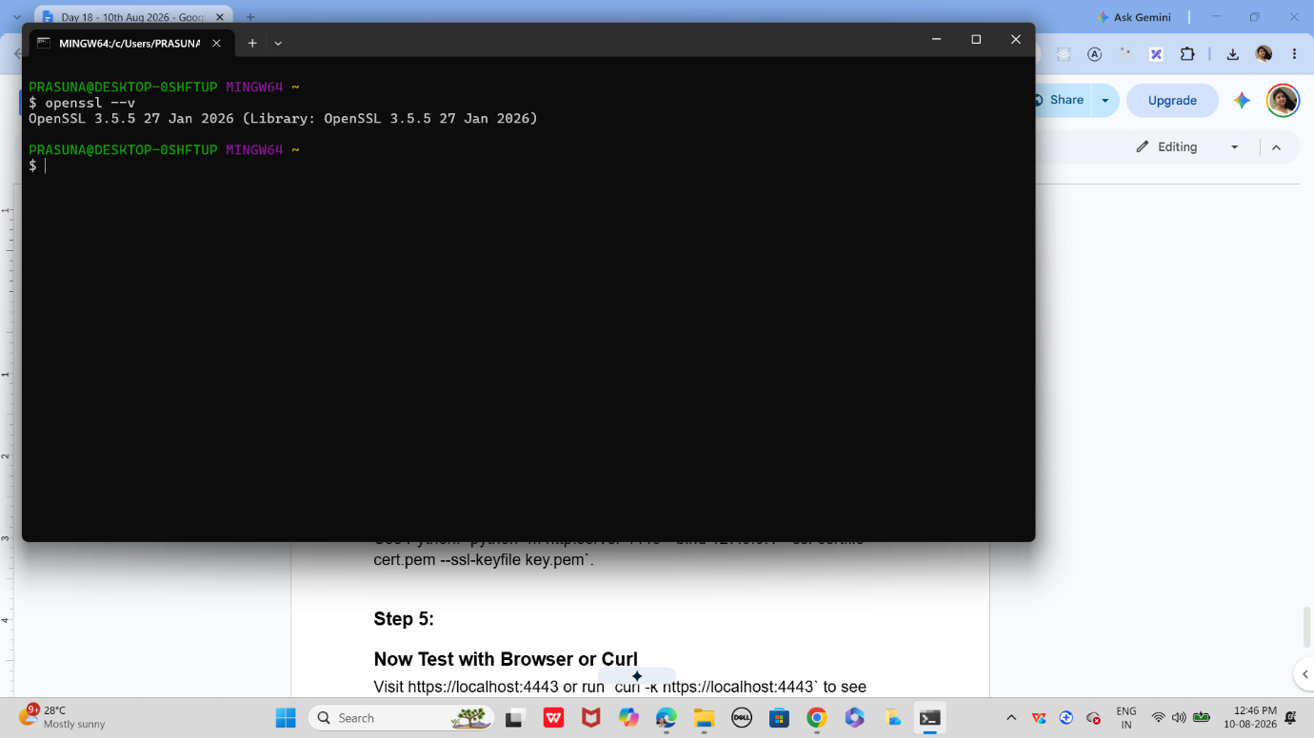

Step 3:

Generate a self-signed certificate
In bash
openssl x509 -req -days 365 -in localhost.csr -signkey localhost.key -out localhost.crt

Step 4:

Now Start a Simple HTTPS Server
Use Python: `python -m http.server 4443 --bind 127.0.0.1 --ssl-certfile cert.pem --ssl-keyfile key.pem`.

Step 5:
Now Test with Browser or Curl
Visit https://localhost:4443 or run `curl -k https://localhost:4443` to see encrypted communication.

Step 6:

Did u Observe TLS Handshake
Use Wireshark or `openssl s_client -connect localhost:4443` to watch how TLS negotiates keys and ciphers.

Step 7:

Verify Certificate Trust
Browsers will warn about self-signed certs; in real deployments, use CA-issued certificates for trust.
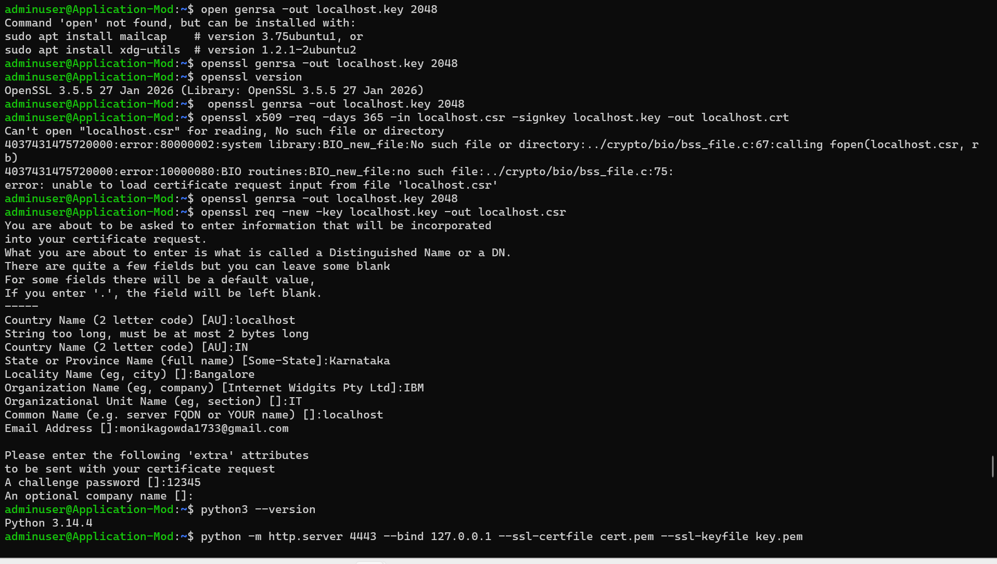
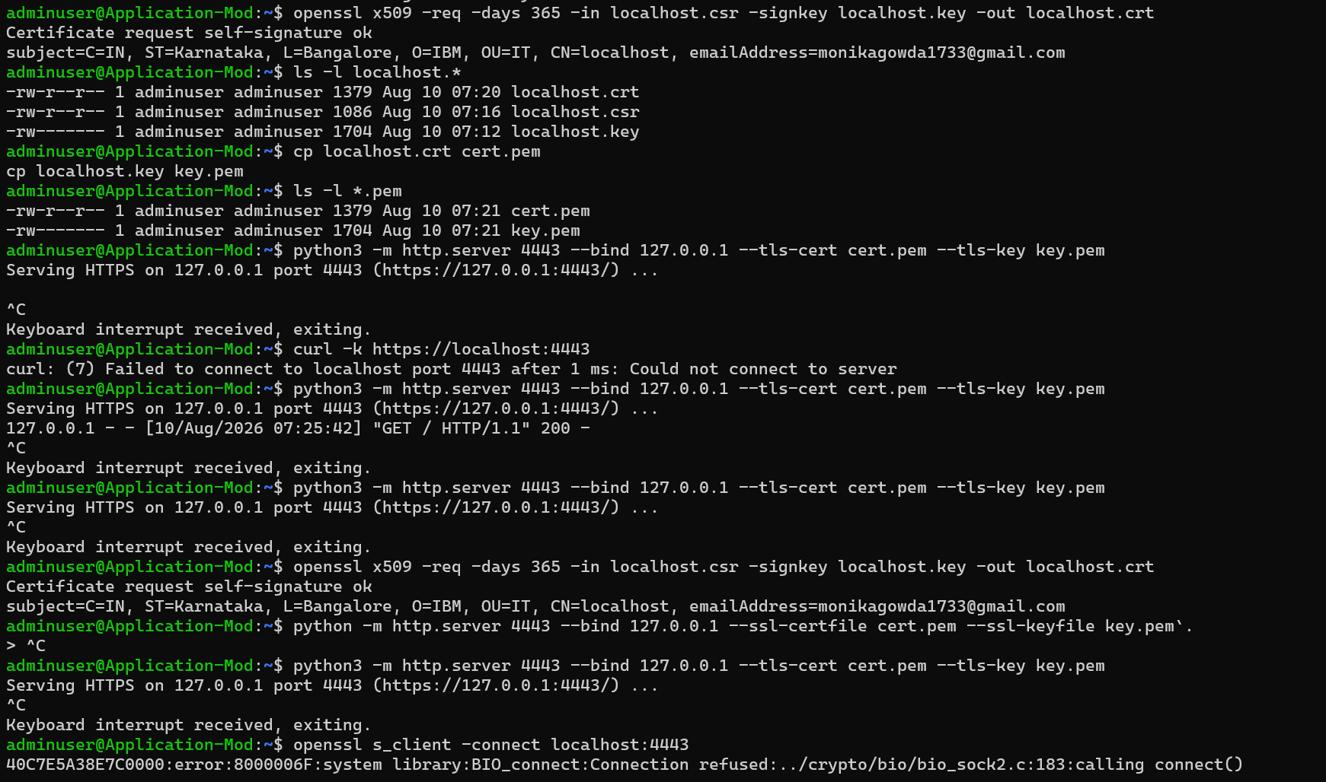
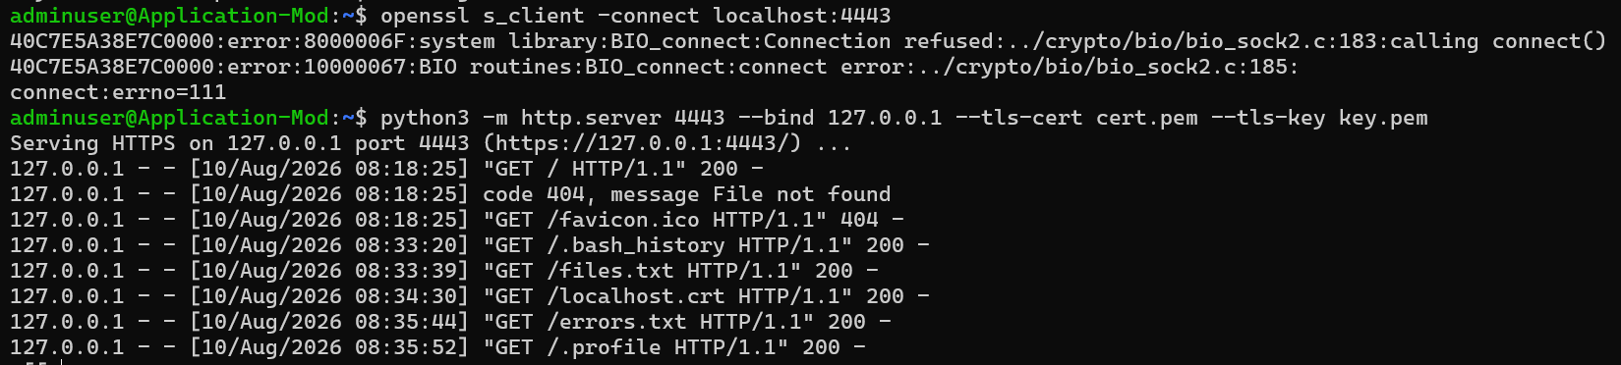

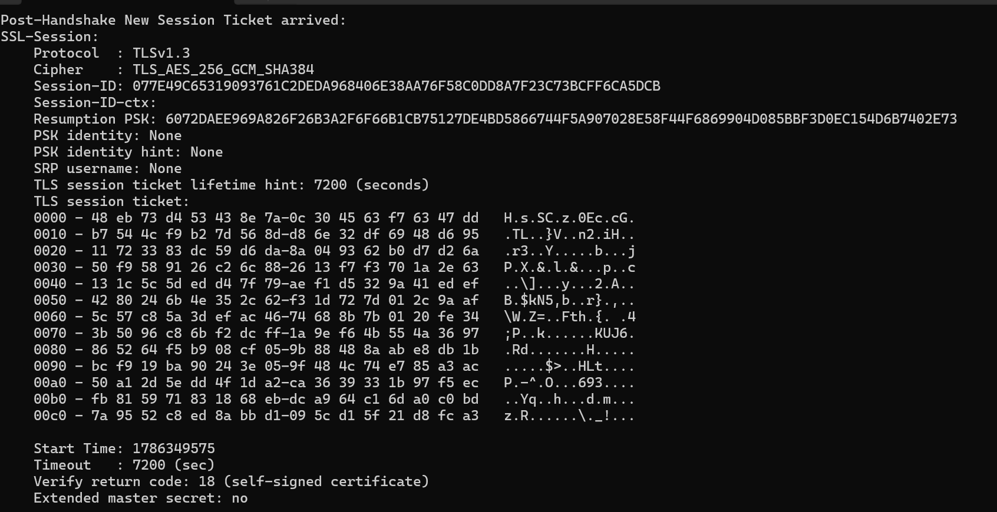
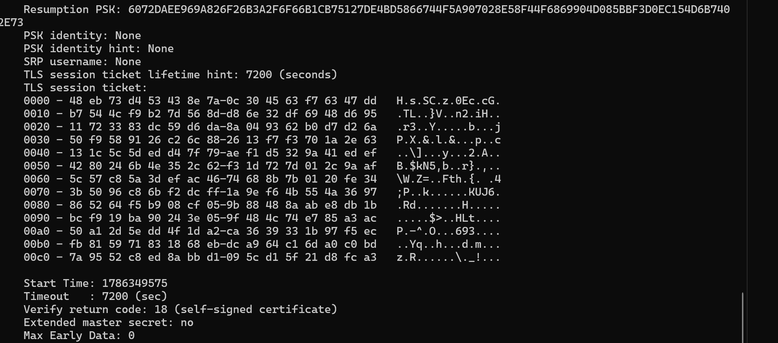

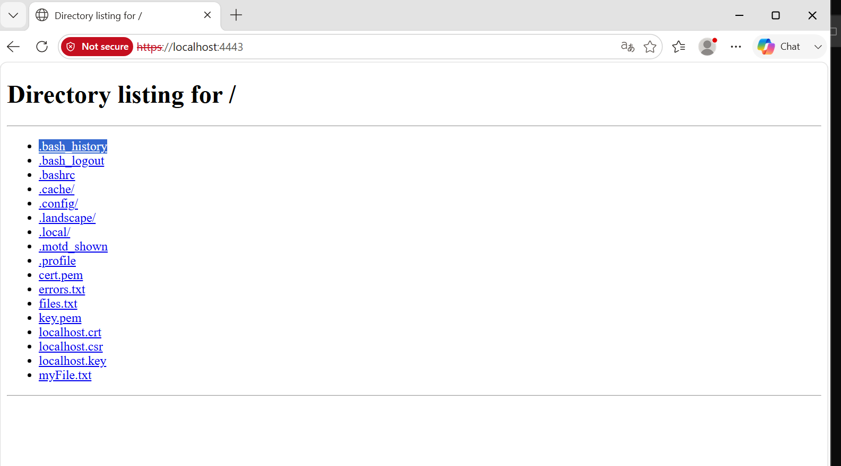
Task 5:
What are trees ? where do you implement them?
- A Tree is a non-linear data structure that is used to represent data in a hierarchical structure. Unlike arrays or linked lists, where data is arranged sequentially, a tree stores data in different levels using nodes and connections (edges).
Trees are commonly used when data needs to be stored and accessed in a hierarchical or organized manner.
Some common applications are:
- File Systems
Operating systems use a tree-like structure to organize folders and files.
- Database Indexing
Trees such as B-Trees and B+ Trees are used in databases to efficiently search, insert, and retrieve data.
- Searching
Binary Search Trees (BSTs) can be used to store sorted data and perform efficient searching.
- HTML/XML DOM
HTML pages are represented internally as a tree structure, where elements have parent-child relationships.
- Decision Making
Decision trees are used in machine learning and for representing decision-making processes.
- File and Folder Navigation
The hierarchical structure of directories and subdirectories can naturally be represented using trees.
- Autocomplete and Dictionaries
Trie trees are used for applications such as autocomplete, spell checking, and word searching.
Task 6:
Can you give types of trees?

- Binary Tree – Each node can have at most two children.
- Binary Search Tree (BST) – A binary tree where smaller values are on the left and larger values are on the right.
- AVL Tree – A self-balancing Binary Search Tree.
- Red-Black Tree – A self-balancing tree using red and black node colors.
- B-Tree – Used mainly for database and file-system indexing.
- B+ Tree – Commonly used in databases for efficient searching and range queries.
- Trie – Used for storing and searching strings, such as in autocomplete.
- Heap – A tree-based structure commonly used to implement priority queues.
Task 7:
What is binary search tree?
- A Binary Search Tree (BST) is a binary tree where each node has at most two children and follows a specific ordering:
Left subtree → values smaller than the root
Right subtree → values greater than the root
- Example:
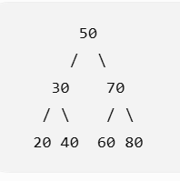

Task 8:
Can you create a simple binary tree using a node and insert values in it?

Like in java

class Node {
int val;
Node left, right;
Node(int val) { this.val = val; }
}

Insert values in left side and right side of the nodes and display the tree values
package com.example;
class Node {
int val;
Node left, right;
Node(int val) {
this.val = val;
}
}
public class Tree {
public static void main(String[] args) {
Node root = new Node(10);
root.left = new Node(5);
root.right = new Node(20);
root.left.left = new Node(3);
root.left.right = new Node(7);
root.right.left = new Node(15);
root.right.right = new Node(25);
// Display tree values
System.out.println("Root: " + root.val);
System.out.println("Left: " + root.left.val);
System.out.println("Right: " + root.right.val);
System.out.println("Left-Left: " + root.left.left.val);
System.out.println("Left-Right: " + root.left.right.val);
System.out.println("Right-Left: " + root.right.left.val);
System.out.println("Right-Right: " + root.right.right.val);
}
}

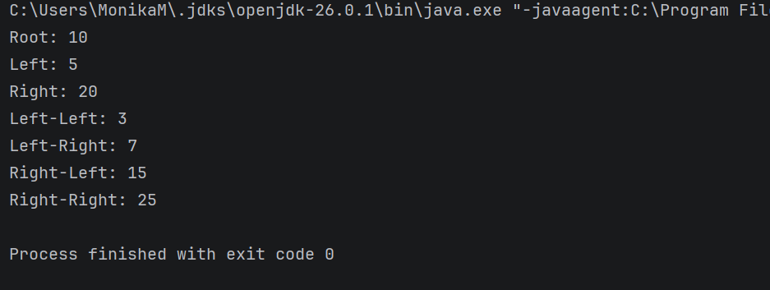

Task 09:
Now extend the above code to search a no in your list.
class Node {
int val;
Node left, right;
Node(int val) {
this.val = val;
}
}
public class BinaryTree {
static boolean search(Node root, int value) {
if (root == null)
return false;
if (root.val == value)
return true;
return search(root.left, value) ||
search(root.right, value);
}
public static void main(String[] args) {
Node root = new Node(10);
root.left = new Node(5);
root.right = new Node(20);
root.left.left = new Node(3);
root.left.right = new Node(7);
root.right.left = new Node(15);
root.right.right = new Node(25);
int number = 25;
if (search(root, number))
System.out.println(number + " found in the tree");
else
System.out.println(number + " not found in the tree");
}
}

Output
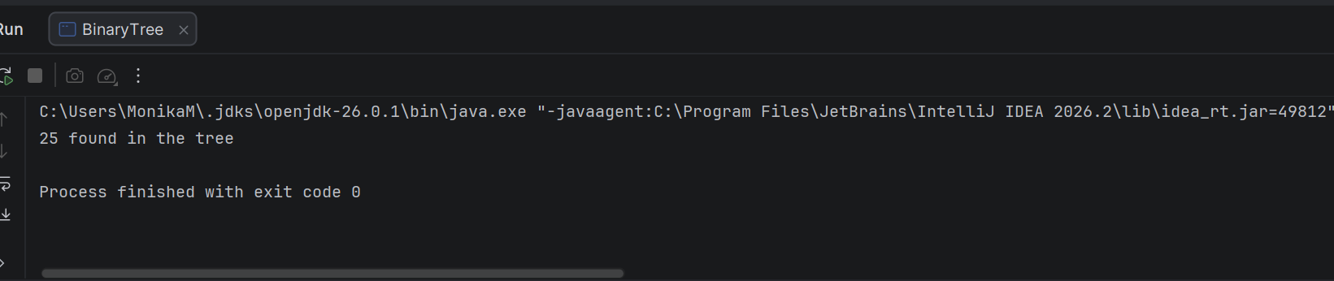

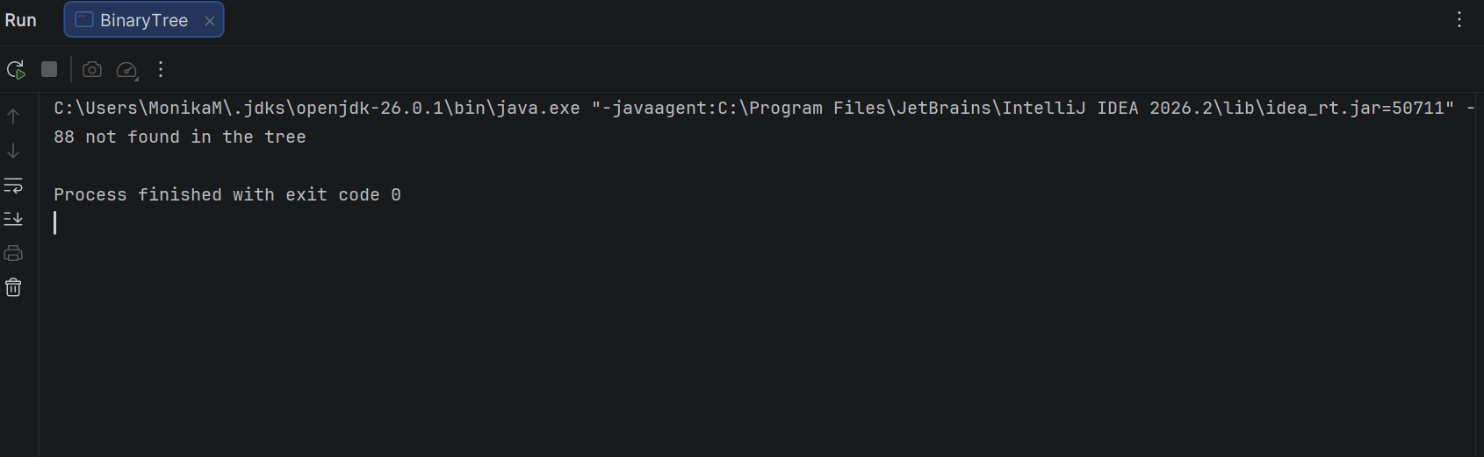
Task 10:
Now can you do inorder traversal in your bst?
class Node {
int val;
Node left, right;
Node(int val) {
this.val = val;
}
}
public class BinaryTree {
// Inorder traversal
static void inorder(Node root) {
if (root == null)
return;
inorder(root.left);
System.out.print(root.val + " ");
inorder(root.right);
}
public static void main(String[] args) {
Node root = new Node(10);
root.left = new Node(5);
root.right = new Node(20);
root.left.left = new Node(3);
root.left.right = new Node(7);
root.right.left = new Node(15);
root.right.right = new Node(25);
System.out.println("Inorder Traversal:");
inorder(root);
}
}

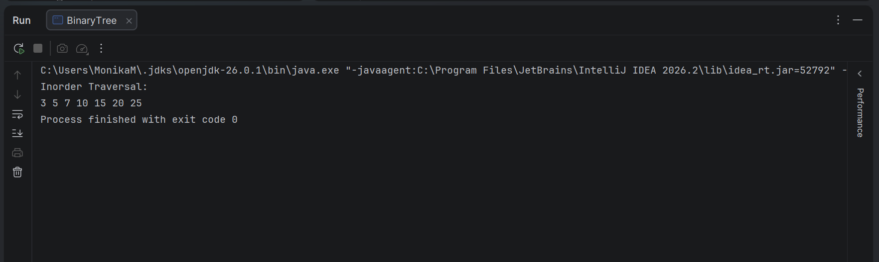

Task 11:
What is the fundamental difference between BFS and DFS?
BFS | DFS
Visits nodes level by level | Goes deep into one branch first
Uses a Queue | Uses a Stack or recursion
Good for finding the shortest path in an unweighted graph | Good for exploring all possible paths/branches
Requires more memory in wide trees | Usually uses less memory for wide trees

Example:
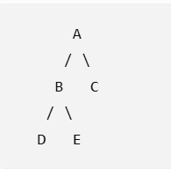
BFS: A → B → C → D → E
DFS: A → B → D → E → C
Task 12:
Which underlying data structures are used to implement BFS and DFS?
BFS (Breadth-First Search):
BFS uses a Queue to visit nodes level by level. It follows the FIFO (First In, First Out) principle.
DFS (Depth-First Search):
DFS uses a Stack to explore one branch deeply before moving to another. It follows the LIFO (Last In, First Out) principle. DFS can also be implemented using recursion, which uses the call stack internally.
Task 13:
How do you find the shortest path in an unweighted graph?
To find the shortest path in an unweighted graph, we use BFS (Breadth-First Search).
BFS starts from the source node and visits all its neighboring nodes level by level. Since every edge has the same cost, the first time we reach a node, we have found the shortest path to that node.
Steps:
- Start BFS from the source node.
- Use a Queue to visit nodes level by level.
- Keep track of the visited nodes.
- Store the parent/previous node of each visited node.
- When the destination is reached, trace back through the parents to get the shortest path.
Task 14:
How do you detect a cycle in a graph?
- In an undirected graph: Use DFS and keep track of the parent node. If a visited node is reached that is not the parent, a cycle exists.
- In a directed graph: Use DFS with a recursion stack. If we reach a node that is already in the current recursion stack, a cycle exists
Task 15:
Explain the internal working of a HashMap.
A HashMap in Java stores data in the form of key-value pairs. It uses a hashing technique to store and retrieve values efficiently.
How it works:
- Hashing the key:
When a key is inserted, Java calculates its hash code using hashCode().
- Finding the bucket:
The hash value is processed to determine the bucket/index where the key-value pair should be stored.
- Storing the entry:
The key and value are stored as an entry in that bucket.
- Handling collisions:
If multiple keys get the same bucket, a collision occurs. HashMap handles collisions using a linked structure, and in modern Java, a heavily-collided bucket can be converted into a Red-Black Tree for better performance.
- Retrieving a value:
When get(key) is called, HashMap calculates the key's hash again, finds the bucket, and compares keys using equals() to find the correct value.
Task 16:
Which property of a hashmap is used to find the intersection of two arrays?
The main property used is fast key lookup.
A HashMap stores elements as key-value pairs and uses hashing to quickly check whether an element exists.
Example:
For finding the intersection of two arrays:
Array 1: 1 2 3 4
Array 2: 2 4 6 8

Intersection: 2 4
We can store the elements of the first array in a HashMap, then check each element of the second array using containsKey().
Task 17:
What is collision in HashMap?
- A collision occurs in a HashMap when two or more different keys produce the same bucket/index after hashing.
- HashMap handles collisions by storing multiple entries in the same bucket, initially using a linked list. If the bucket becomes heavily populated, Java can convert it into a Red-Black Tree.
Task 18:
How Does Java's Capacity And Size Of Hashmap Differ?
Capacity
Capacity refers to the number of buckets available internally in the HashMap to store entries. The default initial capacity is 16.
Size
Size refers to the actual number of key-value pairs currently stored in the HashMap.
Example
HashMap<Integer, String> map = new HashMap<>();

map.put(1, "Java");
map.put(2, "Python");
map.put(3, "SQL");
Here:
- Capacity = 16 (initial capacity)
- Size = 3 (three key-value pairs)
Task 19:
Does hashmap allow you to store null values?
Yes, We can store as many null values in a hashmap as we want but only one null key can be stored not more than that.

Let’s see a program that depicts how we can store null values in a hashmap.

import java.util.*;
import java.io.*;
public class interviewBit {
public static void main(String[] args)
{
HashMap hmap=new HashMap();
hmap.put(1,"Program to store null value");
hmap.put(null,"InterviewBit");
System.out.println(hmap);
}
}

Can you predict the output and also explain.. I or 2 lines
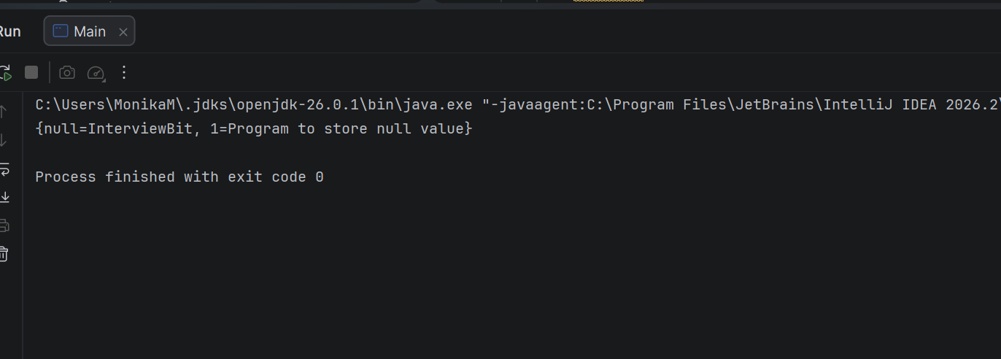
- HashMap allows one null key and multiple null values.
- In this example, null is the key and "InterviewBit" is its value.
- So, the output contains both entries: {null=InterviewBit, 1=Program to store null value}.
Task 20:
Hashmaps in Java are not thread-safe.can you juztify?
- A HashMap is not thread-safe because multiple threads can access and modify it at the same time without synchronization.
- This can cause data inconsistency or unexpected results when operations happen simultaneously.
- For thread-safe operations, we can use ConcurrentHashMap or synchronize the HashMap.
Task 21:
Can you store multiple keys with the same value in a hashmap?
Yes, a HashMap allows multiple different keys to have the same value. However, keys must be unique; inserting the same key again replaces its previous value.
Example:
map.put(1, "Java");
map.put(2, "Java");
Here, keys 1 and 2 have the same value "Java".
Task 22:
can you tell the differences between a Hashmap and a Hashtable in Java.
HashMap | Hashtable
Not thread-safe | Thread-safe
Allows one null key and multiple null values | Does not allow null keys or values
Generally faster | Generally slower due to synchronization
Introduced in Java 1.2 | Legacy class from Java 1.0
Can be used with Iterator | Supports Iterator and legacy Enumeration
Preferred for non-threaded applications | Mostly replaced by ConcurrentHashMap for concurrent applications

Sorting Algorithms
Task 23:
Can you create a java code for bubble sort …
The snippet for your ref is given below
1. Bubble Sort
- Concept: Repeatedly swaps adjacent elements if they are in the wrong order.
- Complexity: O(n2)
- Best for: Small datasets or teaching algorithm basics.
java
for (int i = 0; i < n-1; i++)
for (int j = 0; j < n-i-1; j++)
if (arr[j] > arr[j+1])
swap(arr[j], arr[j+1]);
Visualization: Each pass “bubbles” the largest element to the end.
- Bubble Sort repeatedly compares adjacent elements and swaps them if they are in the wrong order. After each pass, the largest unsorted element moves to the end.
public class BubbleSort {
public static void main(String[] args) {
int[] arr = {5, 3, 8, 4, 2};
int n = arr.length;
for (int i = 0; i < n - 1; i++) {
for (int j = 0; j < n - i - 1; j++) {
if (arr[j] > arr[j + 1]) {
int temp = arr[j];
arr[j] = arr[j + 1];
arr[j + 1] = temp;
}
}
}
System.out.println("Sorted Array:");
for (int num : arr) {
System.out.print(num + " ");
}
}
}
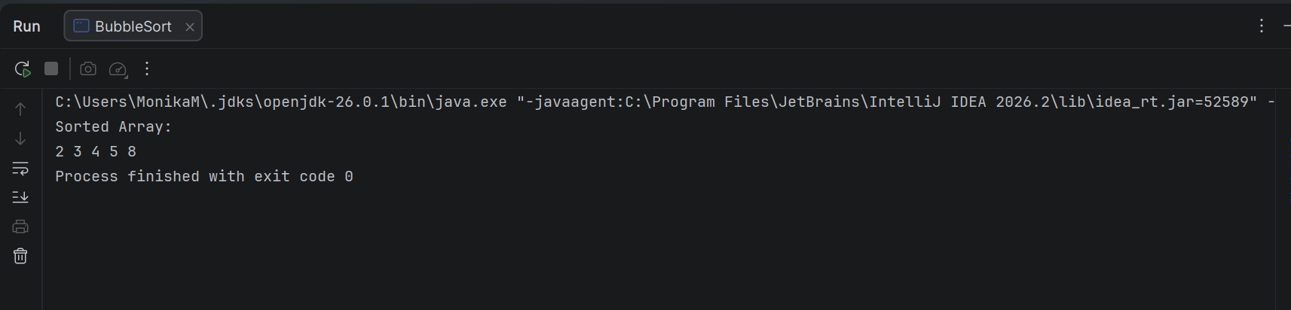
Task 24:
Can you create a java code for selection sort …
The snippet for your ref is given below
2. Selection Sort
- Concept: Selects the smallest element and places it at the beginning.
- Complexity: O(n2)
- Best for: Simple, predictable sorting.
java
for (int i = 0; i < n-1; i++) {
int min = i;
for (int j = i+1; j < n; j++)
if (arr[j] < arr[min]) min = j;
swap(arr[i], arr[min]);
}
- Selection Sort repeatedly finds the smallest element from the unsorted part of the array and places it at the beginning.
public class SelectionSort {
public static void main(String[] args) {
int[] arr = {5, 3, 8, 4, 2};
int n = arr.length;
for (int i = 0; i < n - 1; i++) {
int min = i;
for (int j = i + 1; j < n; j++) {
if (arr[j] < arr[min]) {
min = j;
}
}
// Swap
int temp = arr[i];
arr[i] = arr[min];
arr[min] = temp;
}
System.out.println("Sorted Array:");
for (int num : arr) {
System.out.print(num + " ");
}
}
}
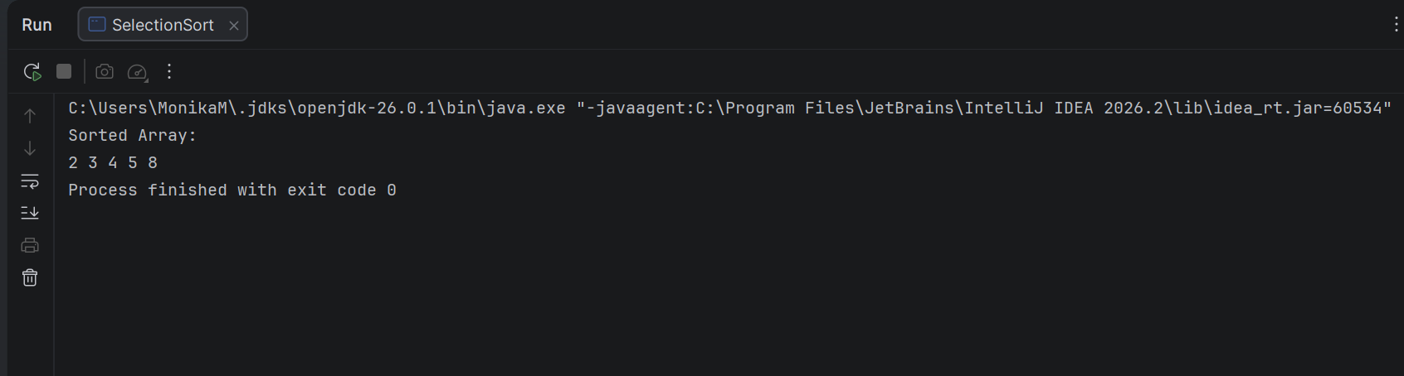
Task 25:
searching Algorithms
Can you create a java code for linear search …
The snippet for your ref is given below
1. Linear Search
- Concept: Sequentially checks each element.
- Complexity: O(n)
- Best for: Unsorted or small datasets.
java
for (int i = 0; i < n; i++)
if (arr[i] == key) return i;
- Linear Search checks each element one by one until the required element is found.
public class LinerSearch {
public static void main(String[] args) {
int[] arr = {10, 25, 30, 45, 50};
int key = 30;
int result = -1;
for (int i = 0; i < arr.length; i++) {
if (arr[i] == key) {
result = i;
break;
}
}
if (result != -1)
System.out.println(key + " found at index " + result);
else
System.out.println(key + " not found");
}
}
