Day 30 - 26th Aug 2026 – Virtual
Task 1: Messaging & Event-Driven Architecture
1. Producers and Consumers
How does the decoupling of producers and consumers improve scalability and fault tolerance?
Producers and consumers can work independently without directly depending on each other. A producer can send messages even if a consumer is temporarily unavailable, because the messaging system stores the messages until they are processed. This makes the system more scalable, flexible, and fault-tolerant than direct point-to-point communication.

2. Consumer Groups and Scaling
Why do consumer groups enable horizontal scaling in Kafka?
Kafka allows multiple consumers in the same consumer group to share the workload by assigning different partitions to different consumers. So, adding more consumers can increase processing capacity.
The trade-off is that one partition can be consumed by only one consumer within a group at a time. Therefore, adding consumers beyond the number of partitions will not provide additional processing capacity.

3. Spring for Apache Kafka
How does Spring Kafka simplify event-driven application development?
Spring Kafka hides much of Kafka's low-level configuration and API handling. Developers can use simple annotations such as @KafkaListener to receive messages instead of manually managing Kafka consumers and polling logic.
Message listeners act as a bridge between the application and Kafka, making event-driven development easier and cleaner.

4. RabbitMQ Concepts – Exchanges, Queues and Bindings
How do exchanges, queues, and bindings work together?
In RabbitMQ, the producer sends messages to an exchange, the exchange decides where the message should go, and bindings connect the exchange to queues based on routing rules. Consumers then read messages from those queues.
This separation makes routing flexible—for example, the same message can be sent to different queues depending on the routing key or exchange type.

5. Spring AMQP / RabbitMQ Integration
What advantages does Spring AMQP provide?
Spring AMQP makes RabbitMQ development easier by providing ready-to-use components such as RabbitTemplate for sending messages and listener containers for receiving them.
Developers don't need to handle RabbitMQ connections and message consumption manually, which results in less boilerplate code and easier configuration and maintenance.

6. Event-Driven Patterns – Notification vs Event-Carried State Transfer
How do Notification and Event-Carried State Transfer differ?
- Notification: Sends only basic information that something happened, such as “Order 101 was created.” The consumer may need to call the producer to get more details. It creates more dependency between systems.
- Event-Carried State Transfer: Sends the event along with the required data, such as order ID, customer, items, and amount. The consumer can process it independently, resulting in less coupling.

Task 02:
- Install RabbitMQ
  - Erlang installation done by 5 out of 20. https://www.erlang.org/downloads
  - Click the above link to download erlang and then install it..
  - After set path like C:\Program Files\Erlang OTP\erts-17.0.5\bin
  - C:\Users\PRASUNA>erl -version
Erlang (SMP,ASYNC_THREADS) (BEAM) emulator version 17.0.5

Done by 20 out of 20

- Download from rabbitmq.com (rabbitmq.com in Bing)
- Start server: rabbitmq-server
C:\Windows\System32>net start rabbitmq
The requested service has already been started.
More help is available by typing NET HELPMSG 2182.
C:\Windows\System32>erl -version
Erlang (SMP,ASYNC_THREADS) (BEAM) emulator version 17.0.5
14 done out of 20
- Management UI: http://localhost:15672 (default user: guest/guest)
- Create Spring Boot Project
  - Use Spring Initializr → add Spring Web, Spring AMQP.
- Add Config, Producer, Consumer (as shown below).
- Plz add
Step 1: Add Dependency
xml
<dependency>
<groupId>org.springframework.boot</groupId>
<artifactId>spring-boot-starter-amqp</artifactId>
</dependency>

Step 2: Configure RabbitMQ (application.properties)
properties
spring.rabbitmq.host=localhost
spring.rabbitmq.port=5672
spring.rabbitmq.username=guest
spring.rabbitmq.password=guest

Step 3: Define Exchange, Queue, Binding
java
@Configuration
public class RabbitConfig {
@Bean
public DirectExchange orderExchange() {
return new DirectExchange("orderExchange");
}

@Bean
public Queue orderQueue() {
return new Queue("orderQueue", true);
}

@Bean
public Binding binding(Queue orderQueue, DirectExchange orderExchange) {
return BindingBuilder.bind(orderQueue).to(orderExchange).with("newOrder");
}
}

Step 4: Producer (Sender)
java
@Service
public class OrderProducer {
@Autowired
private AmqpTemplate amqpTemplate;

public void sendOrder(String order) {
amqpTemplate.convertAndSend("orderExchange", "newOrder", order);
System.out.println("Sent: " + order);
}
}

Step 5: Consumer (Listener)
java
@Component
public class OrderConsumer {
@RabbitListener(queues = "orderQueue")
public void receiveOrder(String order) {
System.out.println("Received: " + order);
}
}
- Run Application
  - Start RabbitMQ server.
  - Run Spring Boot app.
  - Call producer method (e.g., via REST endpoint).
  - Observe consumer logs receiving the message.
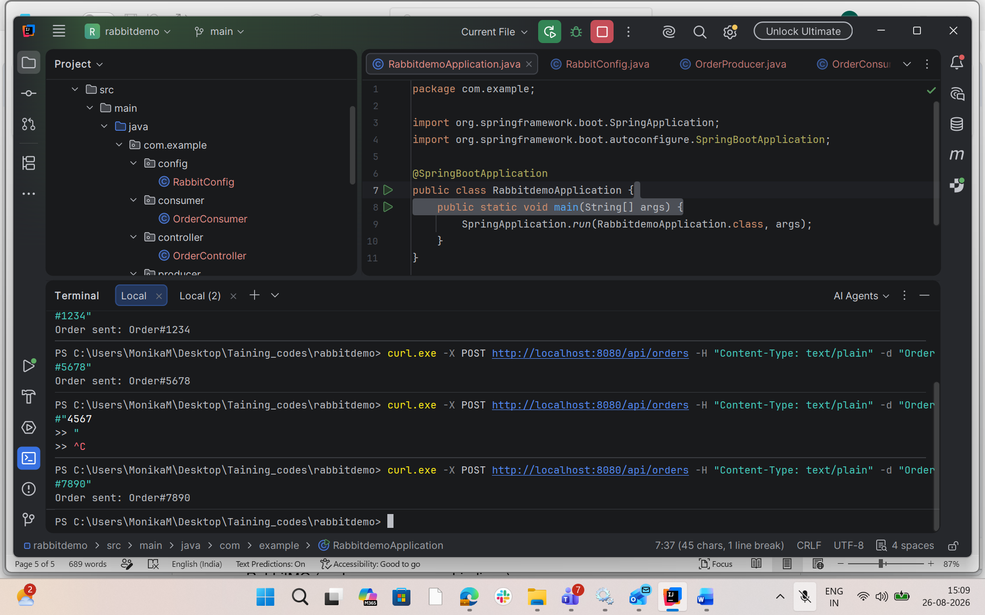

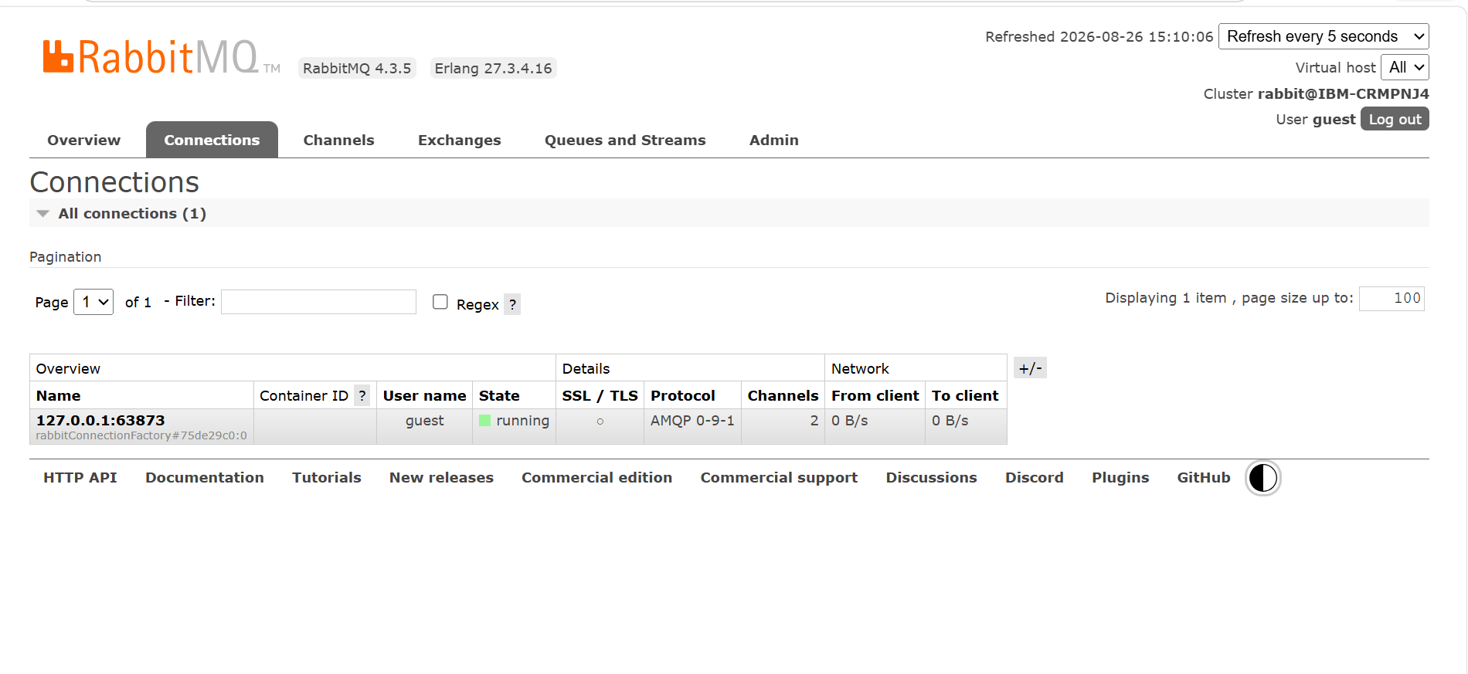

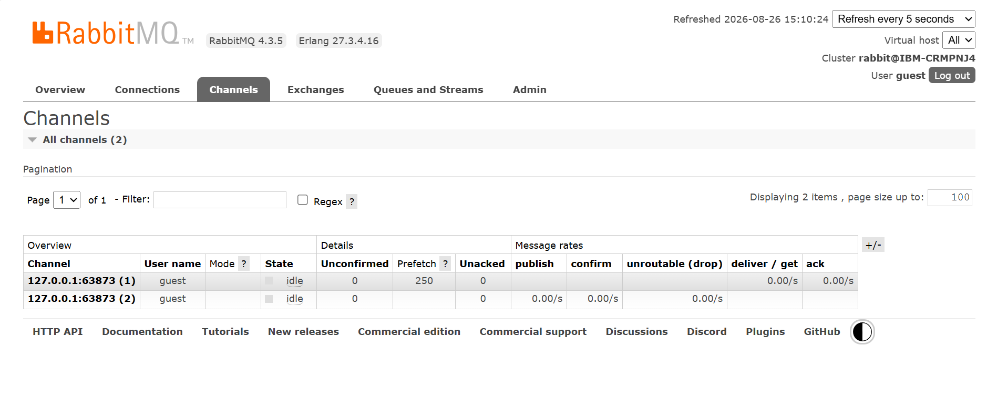

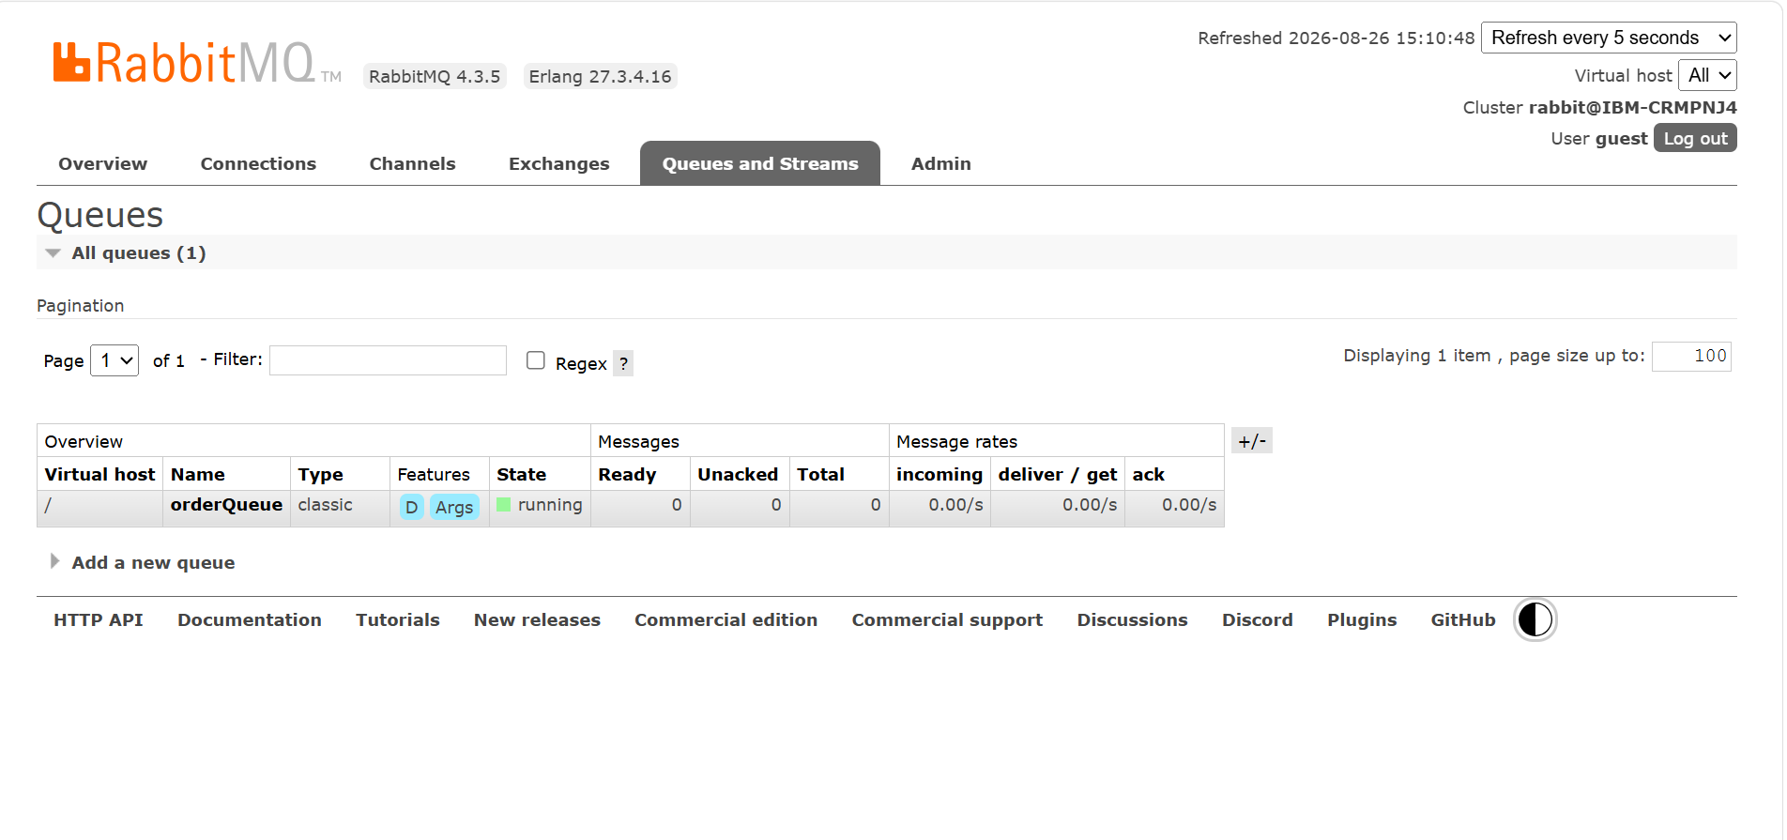
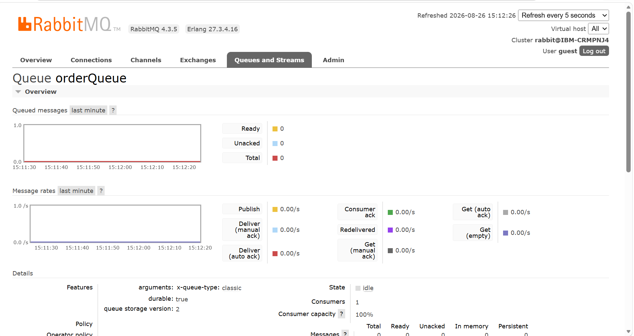
Task 3:
Messaging & Event-Driven Demo

in your earlier Banking Transaction Demo Proj we hav 2 services right :
Transaction Service here we will implement → Publishes events (Kafka or RabbitMQ).
Account Service we will implemnet → Consumes events, updates balances.
we will use
Sychronous vs. Asynchronous calls
Kafka (topics, partitions, consumer groups)
RabbitMQ (exchanges, queues, bindings)
Event-driven patterns (notification, event-carried state transfer)
Idempotency & Saga pattern basics
