Day 16 - 06th Aug 2026
Task 01
In yesterday's project can you implement a custom pipe to mask the account number..
import { Pipe, PipeTransform } from '@angular/core';

@Pipe({
name: 'maskAccount',
standalone: true
})
export class MaskAccountPipe implements PipeTransform {

transform(value: string, type: string = 'account'): string {

if (!value) {
return '';
}

if (type === 'name') {
if (value.length <= 2) {
return value;
}

return value.charAt(0)
+ '*'.repeat(value.length - 2)
+ value.charAt(value.length - 1);
}

// Account Number
if (value.length <= 4) {
return value;
}

return '*'.repeat(value.length - 4) + value.slice(-4);
}
}

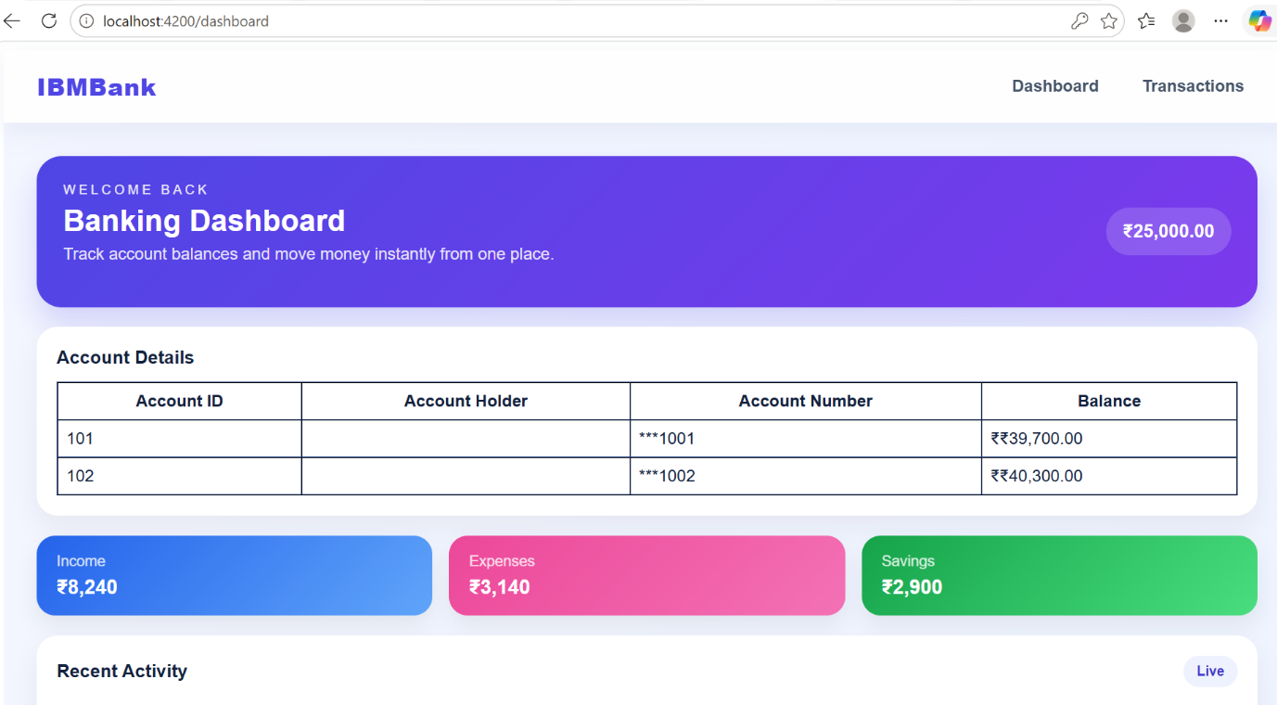

Task 2:
Also use currency pipe for the amount.

For eg In you dashboard.component.ts a sample code for your ref.
Dashboard.ts
import { TransactionService } from '../services/transaction.service';
import { Transaction } from '../models/transaction';
import { Account } from '../models/account';
import { MaskAccountPipe } from '../pipes/mask.account-pipe';
import { CurrencyPipe } from '@angular/common';

@Component({
selector: 'app-dashboard',
standalone: true,
imports: [
CommonModule,
FormsModule,
RouterLink,
MaskAccountPipe,
CurrencyPipe
],

Dashboard.html
<tr *ngFor="let account of accounts">

<td>{{ account.id }}</td>

<td>{{ account.accountHolderName }}</td>

<td>{{ account.accountNumber | maskAccount }}</td>

<td>₹{{ account.balance | currency:'INR' }}</td>

</tr>

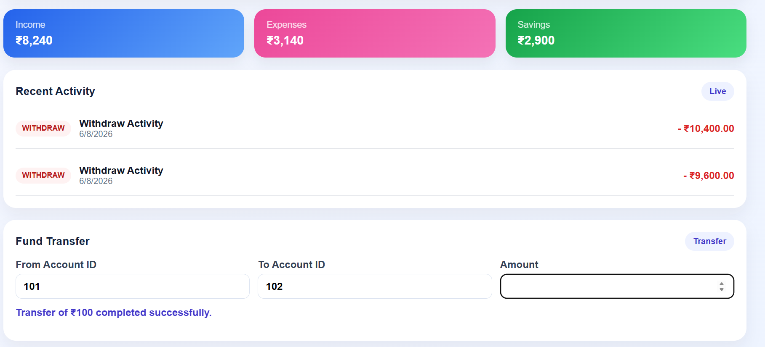
Task 3:

Create a service banking.service.ts or fund-transfer.service.ts

Http requests.. Use the Crud operations for – post , get, delete, patch ….
- BankingService.ts
- import { Injectable } from '@angular/core';
- import { HttpClient } from '@angular/common/http';
- import { Observable } from 'rxjs';

- @Injectable({
- providedIn: 'root'
- })
- export class BankingService {

- private apiUrl = 'http://localhost:3000/accounts';

- constructor(private http: HttpClient) {}

- getAccounts(): Observable<any[]> {
- return this.http.get<any[]>(this.apiUrl);
- }

- addAccount(account: any): Observable<any> {
- return this.http.post(this.apiUrl, account);
- }

- updateAccount(id: number, account: any): Observable<any> {
- return this.http.patch(`${this.apiUrl}/${id}`, account);
- }

- deleteAccount(id: number): Observable<any> {
- return this.http.delete(`${this.apiUrl}/${id}`);
- }

- }

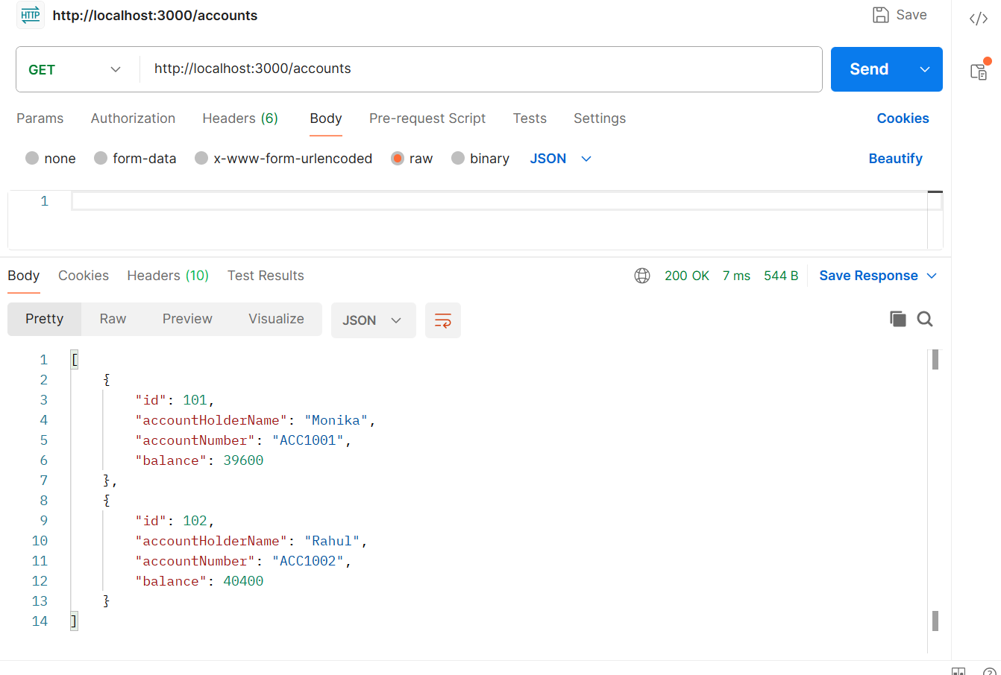

Task 04:
Create authentication for your account’s id and password..
For eg : auth.service.ts

And then add a protection card to your auth.service - like if he is valid user he has to see the transactions..
Name it as auth.gaurd.ts
- Auth.gaurd.ts
import { inject } from '@angular/core';
import { CanActivateFn, Router } from '@angular/router';
import { AuthService } from '../services/auth.service';

export const authGuard: CanActivateFn = () => {

const authService = inject(AuthService);
const router = inject(Router);

if (authService.isLoggedIn()) {
return true;
}

router.navigate(['/login']);
return false;
};

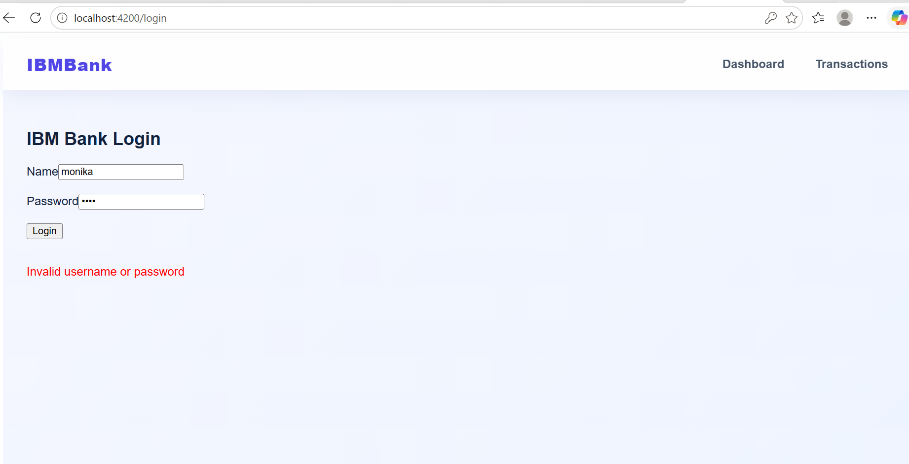
- http://localhost:4200/dashboard
when I tried doing this directly, it will automatically takes to Login Page
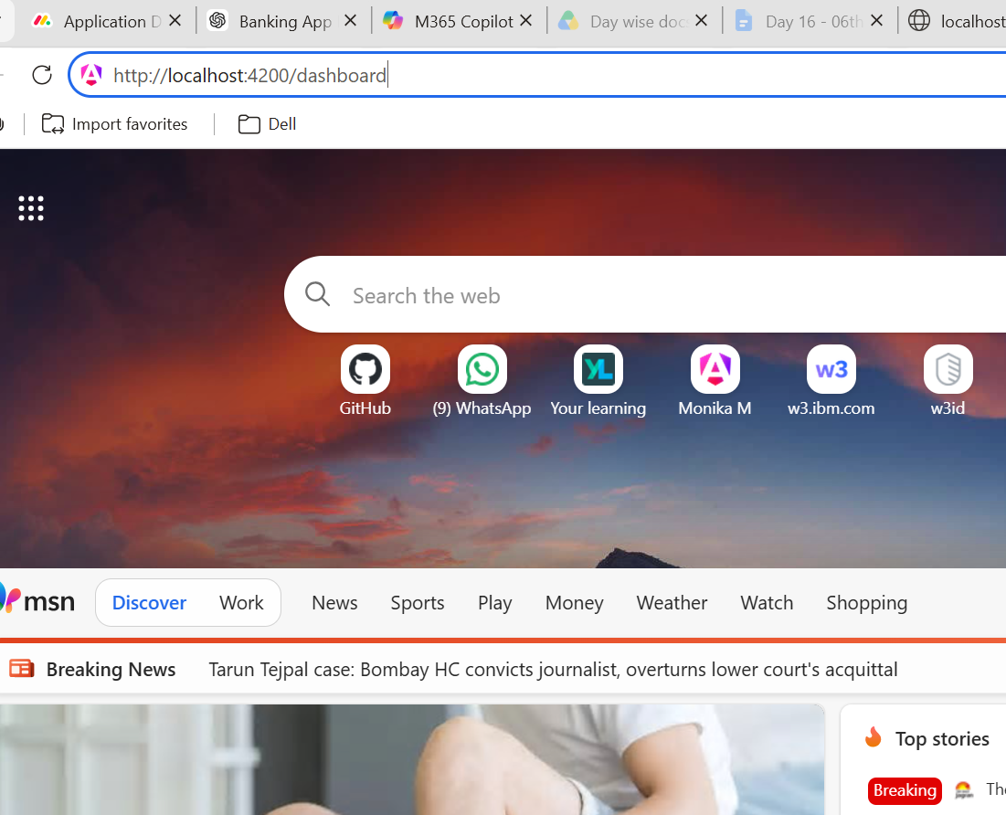
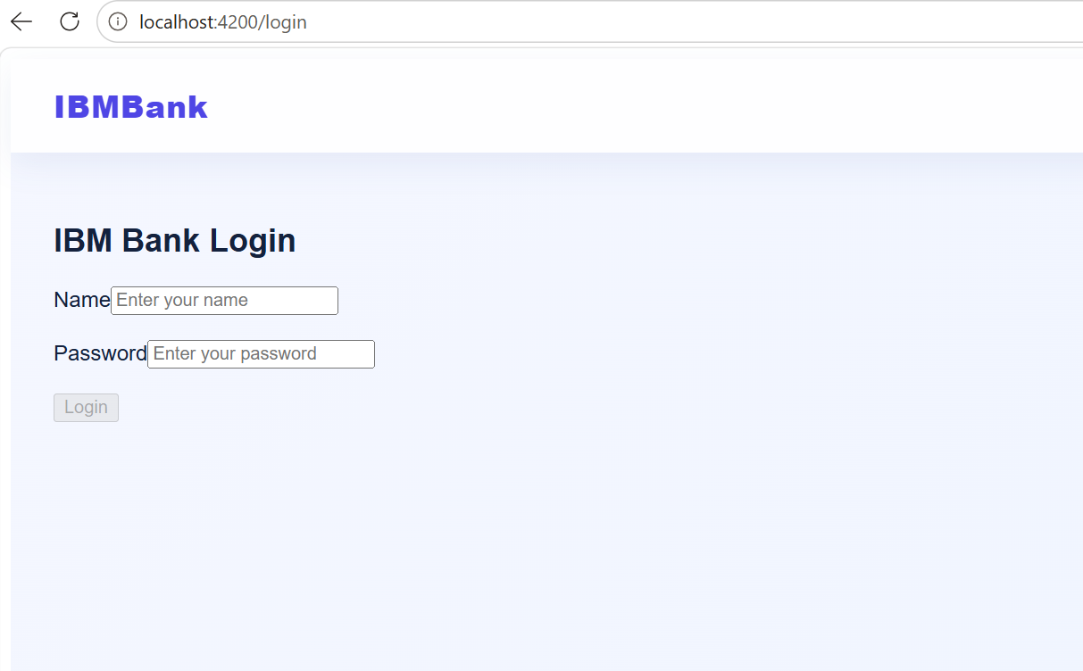

Task 05
- src/app/shared/shared.module.ts
import { NgModule } from '@angular/core';
import { MaskAccountPipe } from '../pipes/mask.account-pipe';

@NgModule({
imports: [
MaskAccountPipe
],
exports: [
MaskAccountPipe
]
})
export class SharedModule { }

Task 06
Create auth.module.ts for your login and register components.ts
import { NgModule } from '@angular/core';
import { ReactiveFormsModule } from '@angular/forms';

@NgModule({
imports: [
ReactiveFormsModule
],
exports: [
ReactiveFormsModule
]
})
export class AuthModule { }

- Register.ts
- import { Component } from '@angular/core';
- import { CommonModule } from '@angular/common';
- import {
- FormBuilder,
- FormGroup,
- ReactiveFormsModule,
- Validators
- } from '@angular/forms';
- import { Router, RouterLink } from '@angular/router';
- import { AuthService } from '../services/auth.service';

- @Component({
- selector: 'app-register',
- standalone: true,
- imports: [
- CommonModule,
- ReactiveFormsModule,
- RouterLink
- ],
- templateUrl: './register.html',
- styleUrls: ['./register.css']
- })
- export class RegisterComponent {

- registerForm: FormGroup;

- constructor(
- private fb: FormBuilder,
- private router: Router,
- private authService: AuthService
- ) {

- this.registerForm = this.fb.group({
- username: ['', Validators.required],
- password: ['', Validators.required],
- confirmPassword: ['', Validators.required]
- });

- }

- register(): void {

- if (this.registerForm.invalid) {
- return;
- }

- if (
- this.registerForm.value.password !==
- this.registerForm.value.confirmPassword
- ) {
- alert('Passwords do not match');
- return;
- }

- this.authService.register(
- this.registerForm.value.username,
- this.registerForm.value.password
- );

- alert('Registration Successful');

- this.router.navigate(['/login']);
- }

- }

- Register.html
- <div class="login-container">

- <h2>Register</h2>

- <form
- [formGroup]="registerForm"
- (ngSubmit)="register()">

- <div class="form-group">

- <label>Name</label>

- <input
- type="text"
- formControlName="username"
- placeholder="Enter your name">

- </div>

- <br>

- <div class="form-group">

- <label>Password</label>

- <input
- type="password"
- formControlName="password"
- placeholder="Enter password">

- </div>

- <br>

- <div class="form-group">

- <label>Confirm Password</label>

- <input
- type="password"
- formControlName="confirmPassword"
- placeholder="Confirm password">

- </div>

- <br>

- <button type="submit">
- Register
- </button>

- <br><br>

- <a routerLink="/login">
- Already have an account? Login
- </a>

- </form>

- </div>

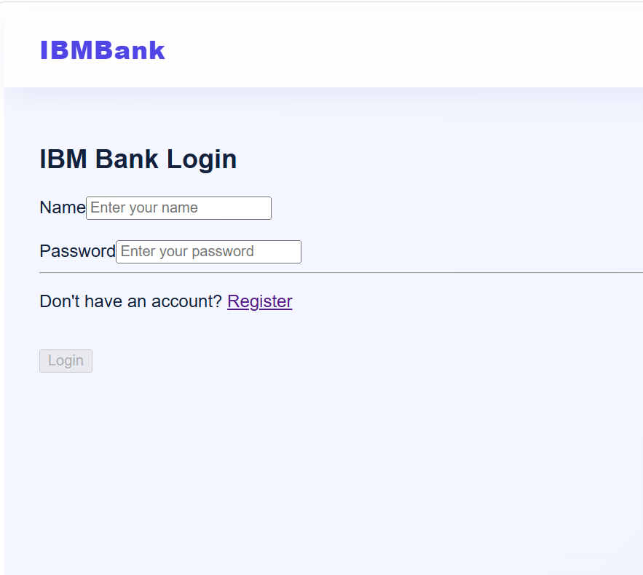
- When clicked on Register then
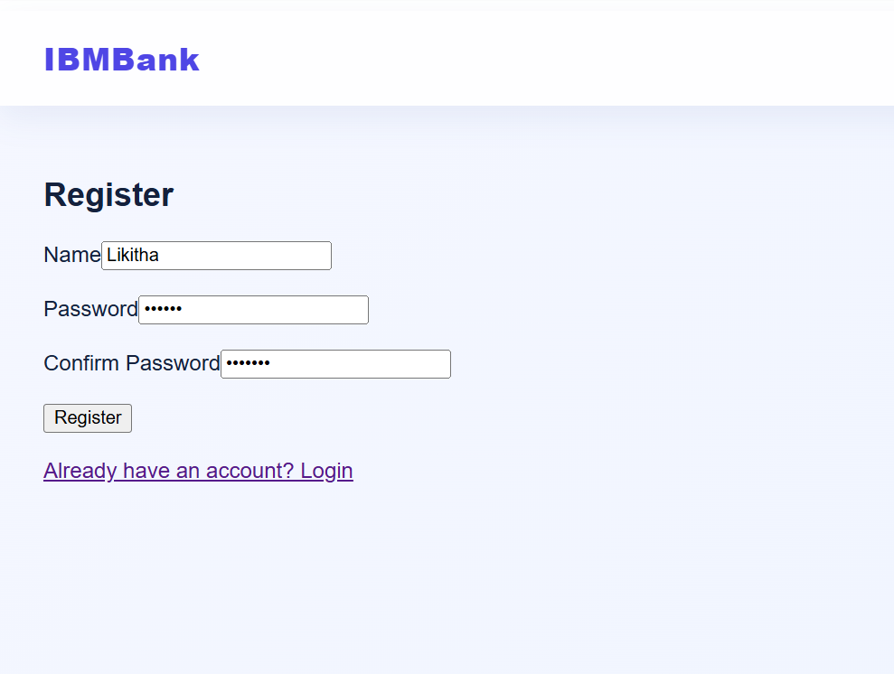

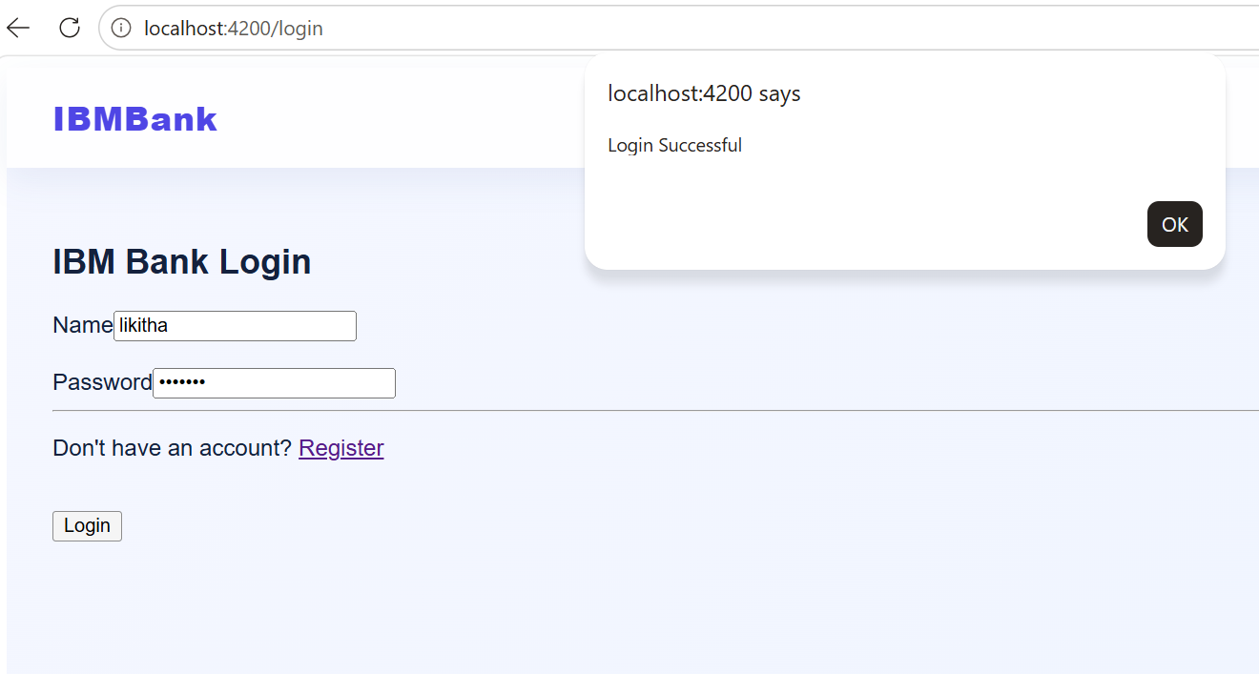

Task 07:

Write unit test cases for banking service and login components.
- Daskboard.spec.ts
import { ComponentFixture, TestBed } from '@angular/core/testing';

import { DashboardComponent } from './dashboard';

describe('DashboardComponent', () => {
let component: DashboardComponent;
let fixture: ComponentFixture<DashboardComponent>;

beforeEach(async () => {
await TestBed.configureTestingModule({
imports: [DashboardComponent],
}).compileComponents();

fixture = TestBed.createComponent(DashboardComponent);
component = fixture.componentInstance;
await fixture.whenStable();
});

it('should create', () => {
expect(component).toBeTruthy();
});
});

- fund-transfer.spec.ts
import { ComponentFixture, TestBed } from '@angular/core/testing';

import { FundTransferComponent } from './fund-transfer';

describe('FundTransferComponent', () => {
let component: FundTransferComponent;
let fixture: ComponentFixture<FundTransferComponent>;

beforeEach(async () => {
await TestBed.configureTestingModule({
imports: [FundTransferComponent],
}).compileComponents();

fixture = TestBed.createComponent(FundTransferComponent);
component = fixture.componentInstance;
await fixture.whenStable();
});

it('should create', () => {
expect(component).toBeTruthy();
});
});

-register.spec.ts
import { ComponentFixture, TestBed } from '@angular/core/testing';

import { RegisterComponent } from './register';

describe('RegisterComponent', () => {
let component: RegisterComponent;
let fixture: ComponentFixture<RegisterComponent>;

beforeEach(async () => {
await TestBed.configureTestingModule({
imports: [RegisterComponent],
}).compileComponents();

fixture = TestBed.createComponent(RegisterComponent);
component = fixture.componentInstance;
await fixture.whenStable();
});

it('should create', () => {
expect(component).toBeTruthy();
});
});

- transation.spec.ts
import { ComponentFixture, TestBed } from '@angular/core/testing';

import { TransactionComponent } from './transaction';

describe('TransactionComponent', () => {
let component: TransactionComponent;
let fixture: ComponentFixture<TransactionComponent>;

beforeEach(async () => {
await TestBed.configureTestingModule({
imports: [TransactionComponent],
}).compileComponents();

fixture = TestBed.createComponent(TransactionComponent);
component = fixture.componentInstance;
await fixture.whenStable();
});

it('should create', () => {
expect(component).toBeTruthy();
});
});

