DAY 13
Task 01
What is an ER diagram? Draw an entity relationship diagram with datatypes .
- An Entity-Relationship (ER) Diagram is a visual representation of a database that shows entities (tables), their attributes (columns), and the relationships between them. It helps in designing and understanding the structure of a database before creating it.

ER diagram
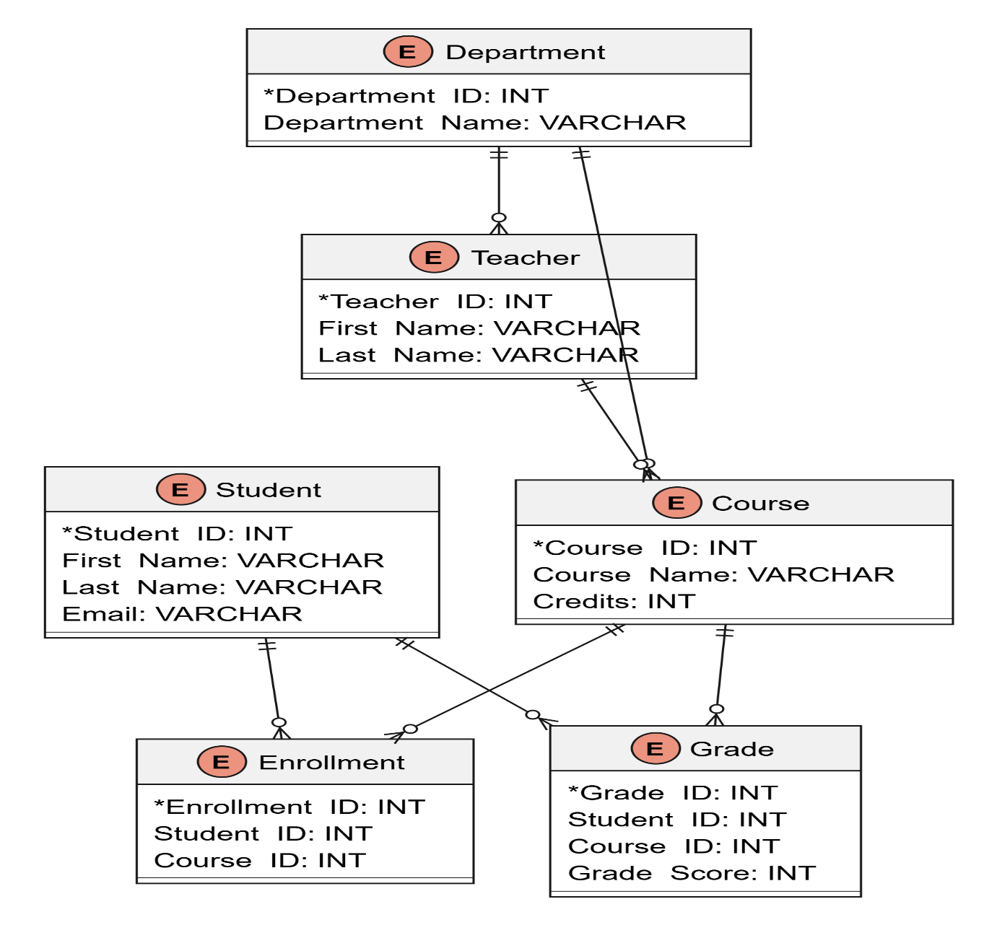

Task 02
What do you understand by indexing in DBMS? How does it work?
- Indexing in a DBMS is a technique used to find data quickly without searching every row in a table. It improves the speed of data retrieval.

How does it work?
- An index is created on one or more columns of a table (for example, Student_ID or Email).
- The database stores these indexed values in a special structure, such as a B-tree.
- When you search for a value in an indexed column, the database first checks the index.
- The index points directly to the matching row, so the database doesn't need to scan the entire table.
Task 03:
Do you think Indexing strategy improve the query performance ? explain .
- Yes, indexing improves query performance because it helps the database find the required data much faster.
- Without an index, the database must check every row in a table to find the required data, which takes more time. With an index, the database can directly locate the matching records, just like using the index of a book to find a topic instead of reading every page.
- For example, if a student table has 10,000 records and you search for a student by Student_ID, an index allows the database to find the record quickly instead of scanning all 10,000 rows.
Task 04
What are the ACID properties in RDBMS? Explain.
- ACID stands for Atomicity, Consistency, Isolation, and Durability
- Atomicity - Atomicity means that a transaction is treated as a single unit of work. Either all the operations in the transaction are completed successfully, or none of them are completed. If an error occurs during the transaction, all the changes made are rolled back.
- Consistency - Consistency ensures that the database remains accurate and follows all rules and constraints before and after a transaction. A transaction should move the database from one valid state to another without violating any data integrity rules.
- Isolation - Isolation ensures that multiple transactions running at the same time do not affect each other. Each transaction works independently, and users cannot see incomplete changes made by other transactions.
- Durability - Durability means that once a transaction is successfully committed, the changes are permanently saved in the database. Even if the system crashes or there is a power failure, the committed data will not be lost.
Task 05:
create database Bank_DB;

create table Accounts(
id serial,
name varchar(10)
);

insert into Accounts values(101, 'Monika');
insert into Accounts values(102, 'Likitha');
insert into Accounts values(103, 'Thanu');

select * from Accounts;

CREATE TABLE Customers(
customer_id serial PRIMARY KEY,
customer_name varchar(50),
email varchar(100),
phone varchar(15),
address varchar(100)
);

insert into Customers Values(111, 'Chinthu','chinthu123@gmail.com', '8796467345','Bangalore');
insert into Customers Values(222, 'Rohan','rohan123@gmail.com', '9656467345','Delhi');

select * from Customers;

Truncate table Accounts;
Select * from Accounts;

Drop Table Accounts;
Select * FROM Accounts;
CREATE TABLE Accounts(
account_id serial PRIMARY KEY,
account_number varchar(20),
account_type varchar(20),
balance decimal(10,2),
customer_id int,
FOREIGN KEY (customer_id) REFERENCES Customers(customer_id)
);

insert into Accounts values(101 , '69065','Savings',500.00, 222);

select * from Accounts;

insert into Accounts values(102 , '6906','Savings',500.00, 333);

select * from Customers;

insert into Customers values(333,'Pari','pari1234@gmail.com','8963456709','Karnataka');

BEGIN;
INSERT INTO Customers
VALUES (444, 'Jeevika', 'jeevika1234@gmail.com', '8568956709', 'Karnataka');

INSERT INTO Accounts
VALUES (103, '6907', 'Savings', 500.00, 444);

COMMIT;
select * from Accounts;
ROLLBACK;

INSERT INTO Accounts
VALUES (104, '6908', 'Salary', 1500.00, 111);
rollback;
BEGIN;
INSERT INTO Customers
VALUES (444, 'Jeevika', 'jeevika1234@gmail.com', '8568956709', 'Karnataka');

INSERT INTO Accounts
VALUES (103, '6907', 'Savings', 500.00, 444);

COMMIT;
rollback;

Task 5:
Alter a table to add a column with unique key

ALTER TABLE Customers
ADD COLUMN aadhar_number varchar(12) UNIQUE;
INSERT INTO Customers
VALUES (666, 'Pallvi', 'pallavi1234@gmail.com', '9880956709', 'Bangalore',);
select * from Customers;
INSERT INTO Customers
VALUES (777, 'chinu', 'chinu1234@gmail.com', '9880990866', 'Delhi','9908467689');
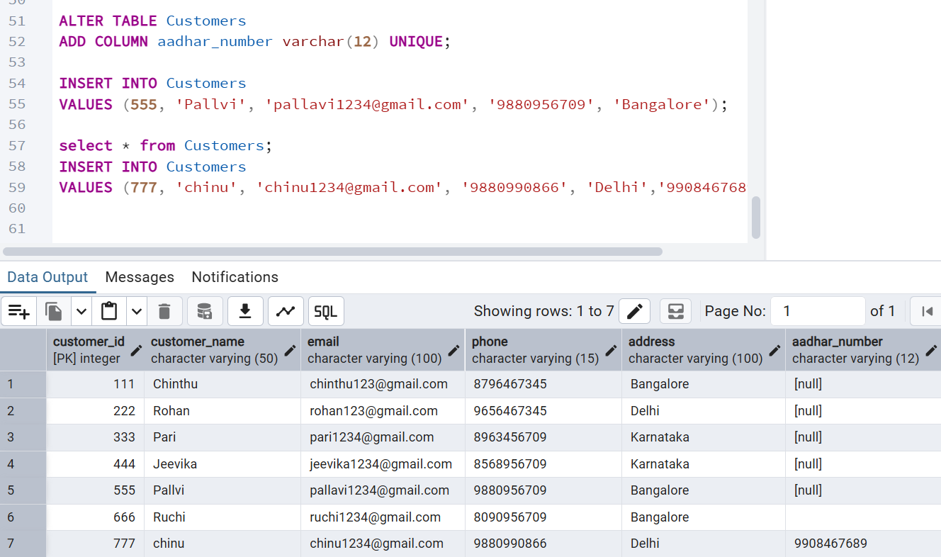

Task 6:
Add a check constraint to your column (eg: balance > 0)
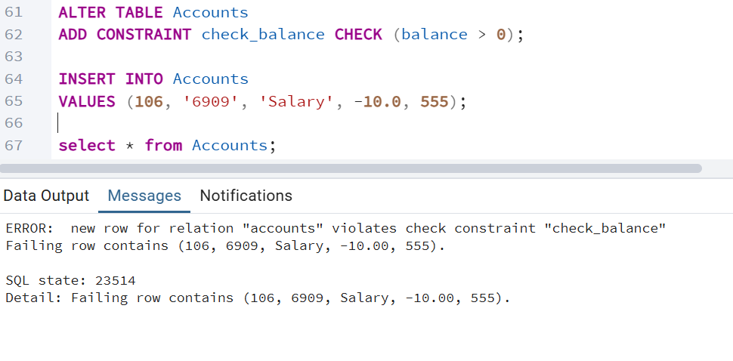
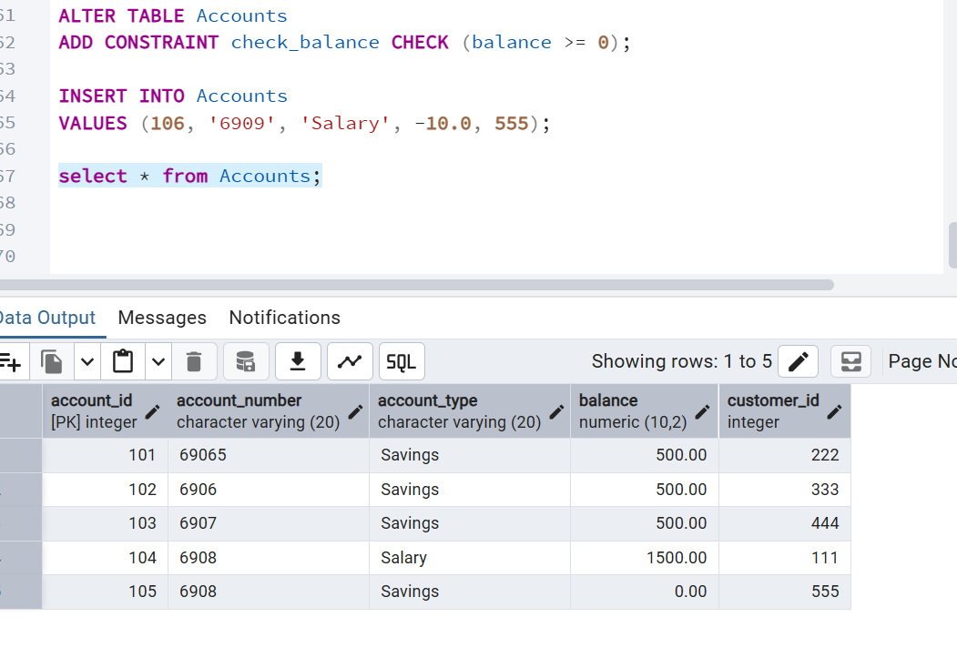

Task 7:
use where clause and check if it works
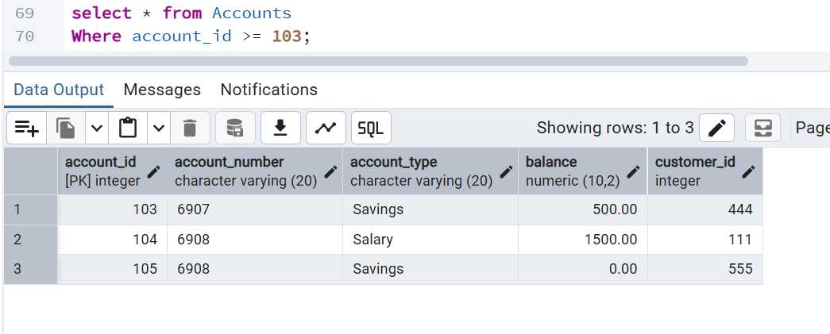
Task 8
Use order by
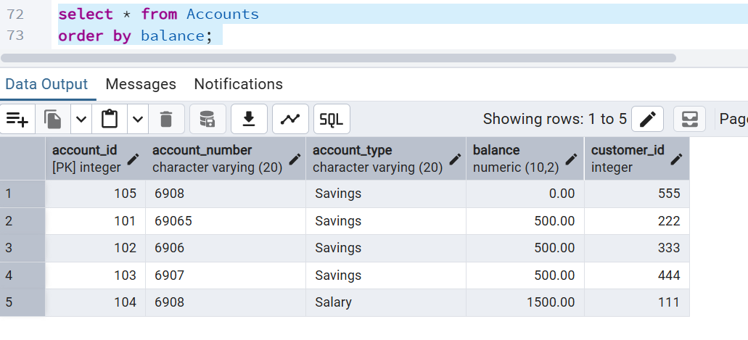
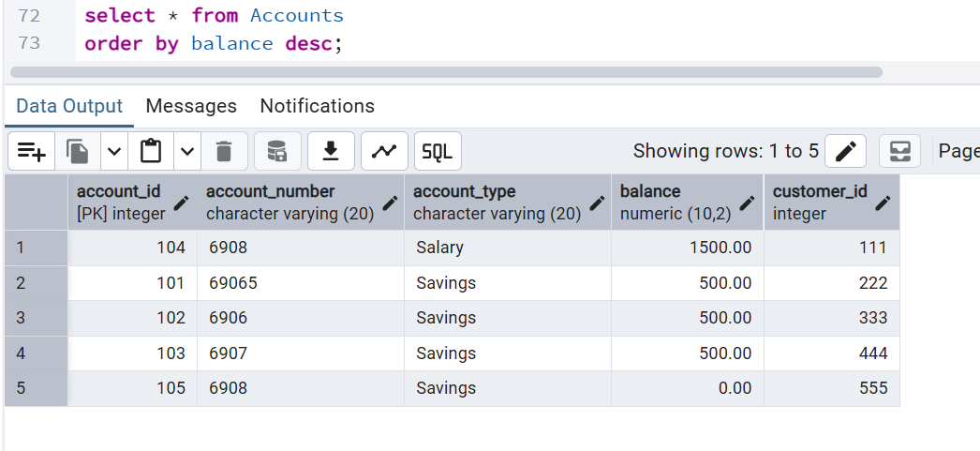
Task 9:
Use limit
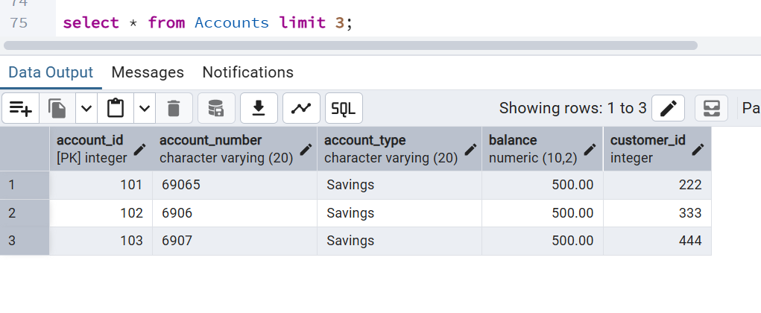
Task 10:
Create queries for left outer join
Right outer join
Inner join
Cross join

Basically all the joins to see its functionality..

- INNER JOIN
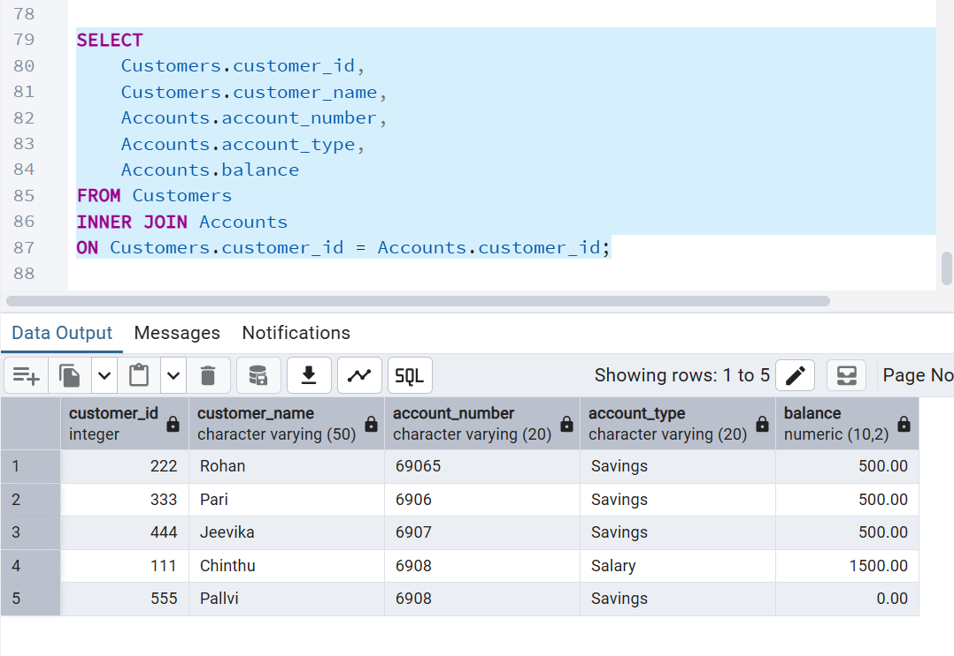
- LEFTOUTER JOIN
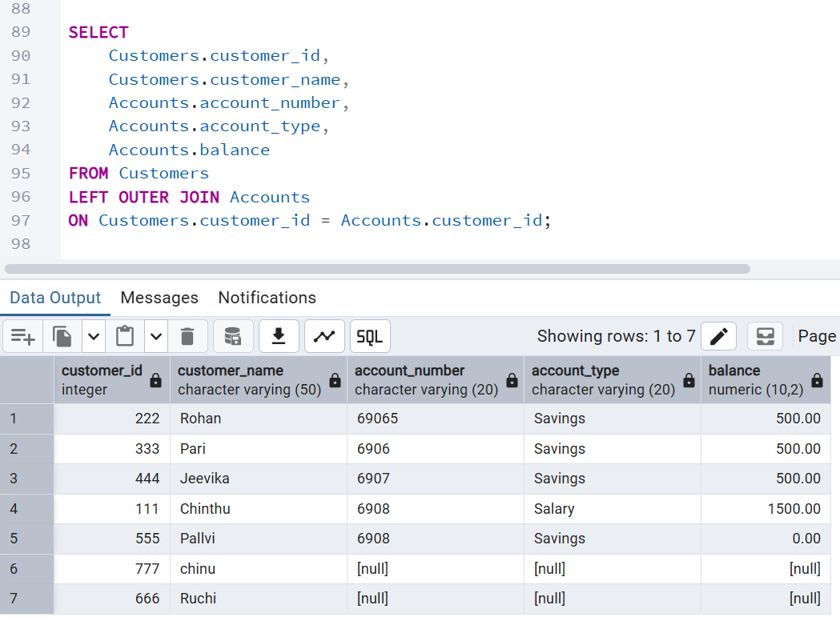
-RIGHTOUTER JOIN
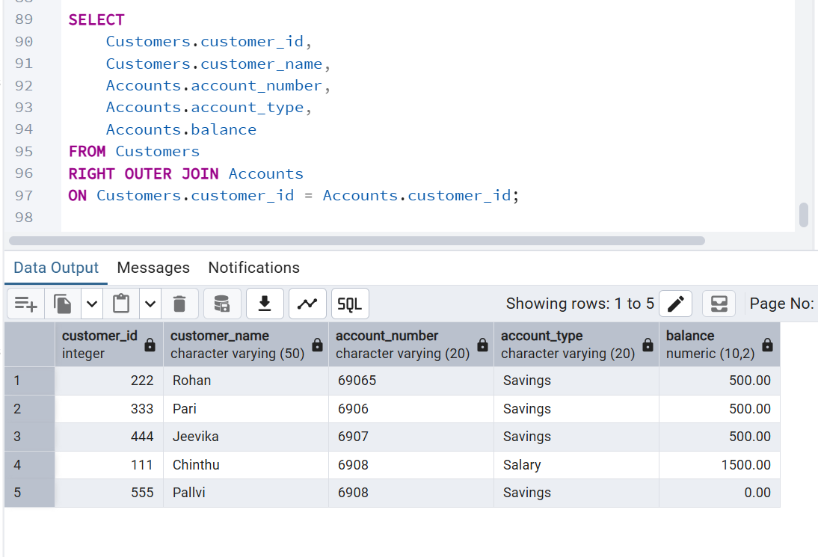

- CROSS JOIN
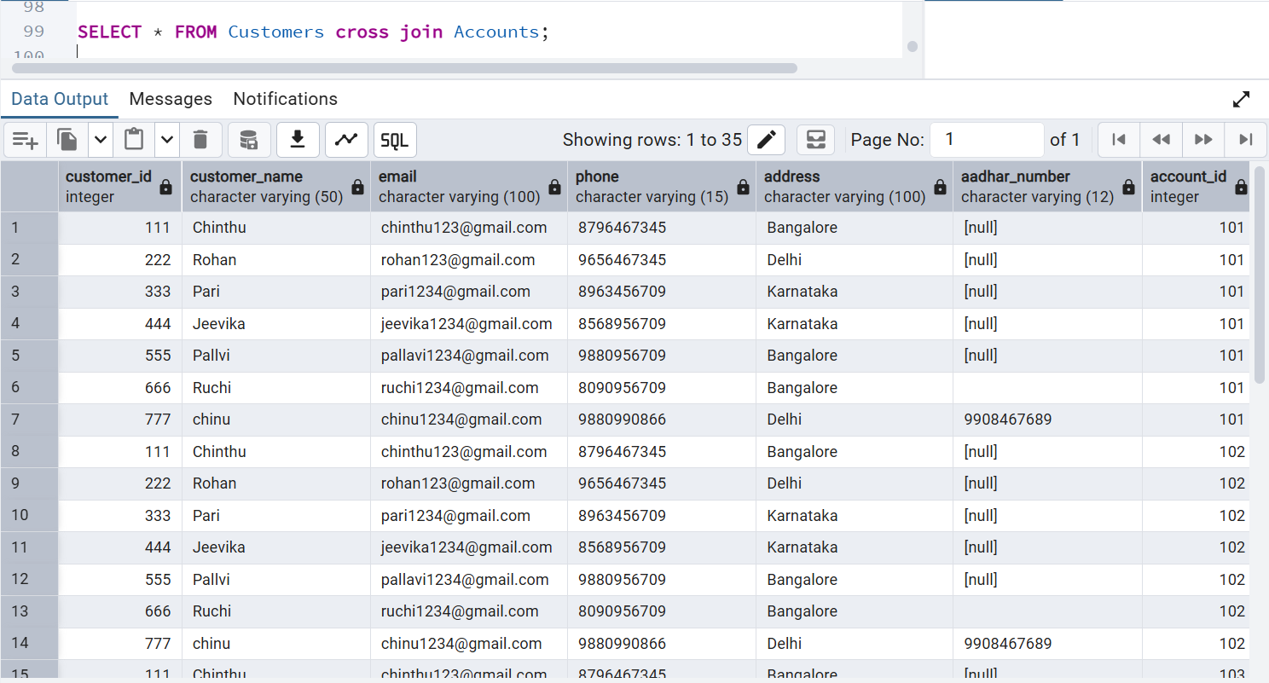
- FULL OUTER JOIN

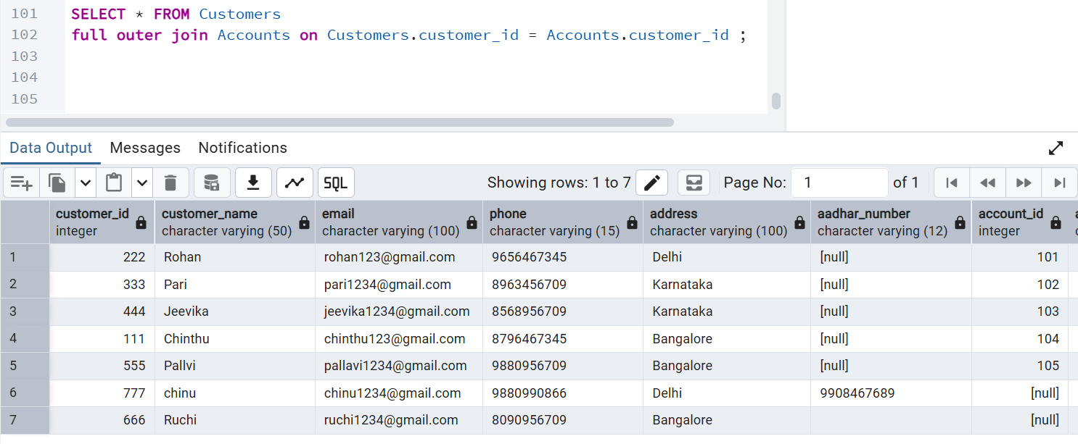

Task 11:
Try playing with indexes on your table.. And see the performance it should increase the query performance.

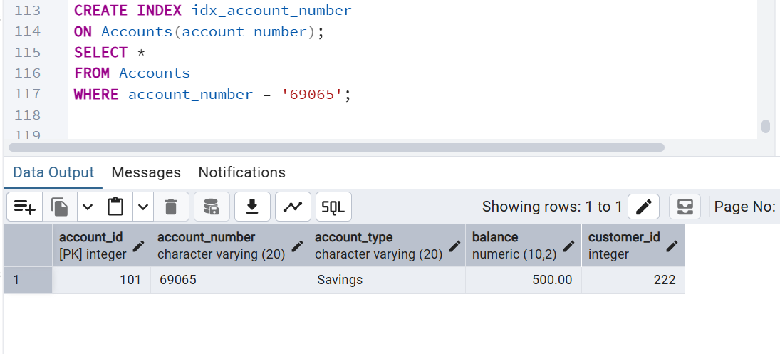
Task 12:
Schemas
Trying creating a schema .. and inside create a table ..
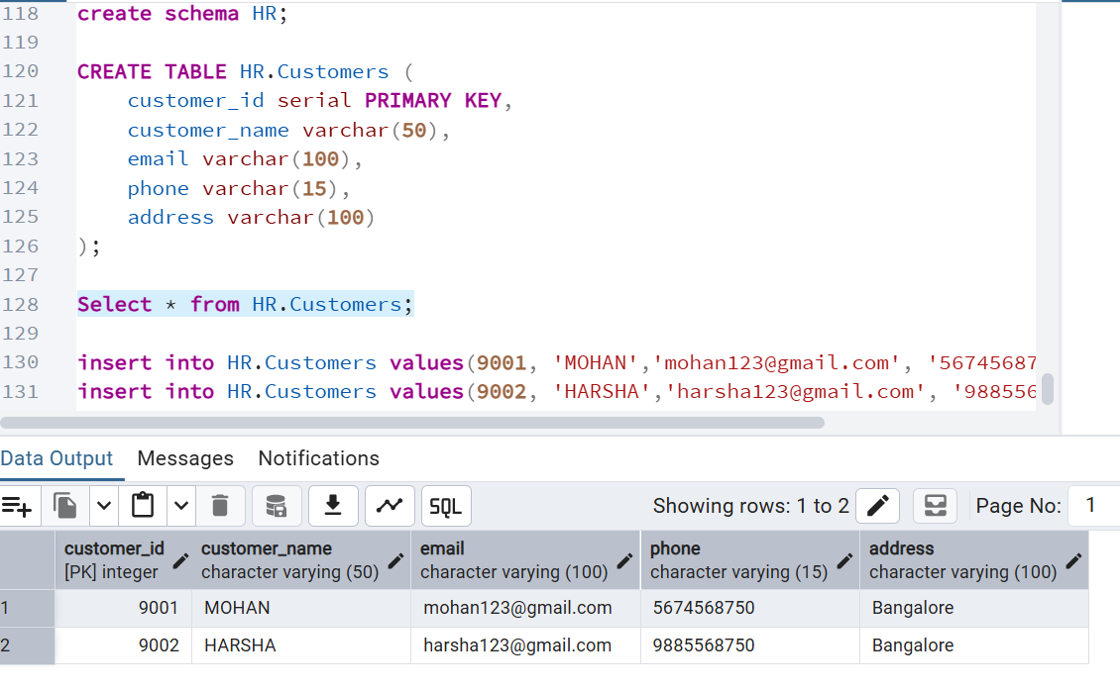
Task 13:
Can you create a java code and connect with the postgresql
- Dependency
- <dependencies>
<dependency>
<groupId>org.postgresql</groupId>
<artifactId>postgresql</artifactId>
<version>42.7.7</version>
</dependency>
</dependencies>

- PostgreSQLConnection.java
package com.example;
import java.sql.Connection;
import java.sql.DriverManager;
import java.sql.PreparedStatement;
import java.sql.SQLException;
public class PostgreSQLConnection {
public static void main(String[] args) {
String url = "jdbc:postgresql://localhost:5432/Bank_DB";
String username = "postgres";
String password = "Password";
try {
Class.forName("org.postgresql.Driver");
Connection con = DriverManager.getConnection(
url,
username,
password
);
System.out.println("Database connected successfully!");
String query = "INSERT INTO Customers(customer_name, email, phone, address) VALUES (?, ?, ?, ?)";
PreparedStatement ps = con.prepareStatement(query);
ps.setString(1, "Rahul");
ps.setString(2, "rahul@gmail.com");
ps.setString(3, "9876543210");
ps.setString(4, "Bangalore");
ps.executeUpdate();
System.out.println("Data inserted successfully!");
con.close();
} catch (ClassNotFoundException e) {
System.out.println("Driver not found");
e.printStackTrace();
} catch (SQLException e) {
System.out.println("Database error");
e.printStackTrace();
}
}
}

OUTPUT
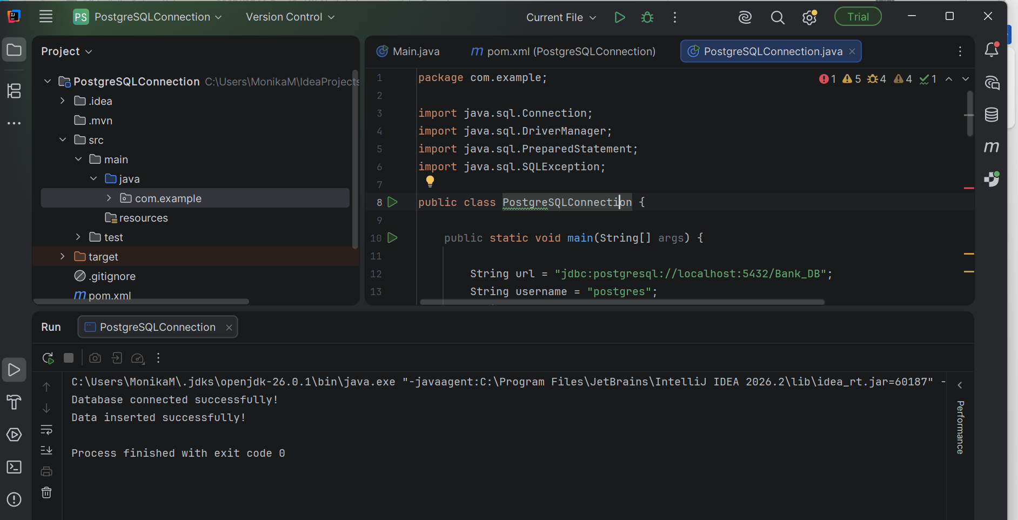
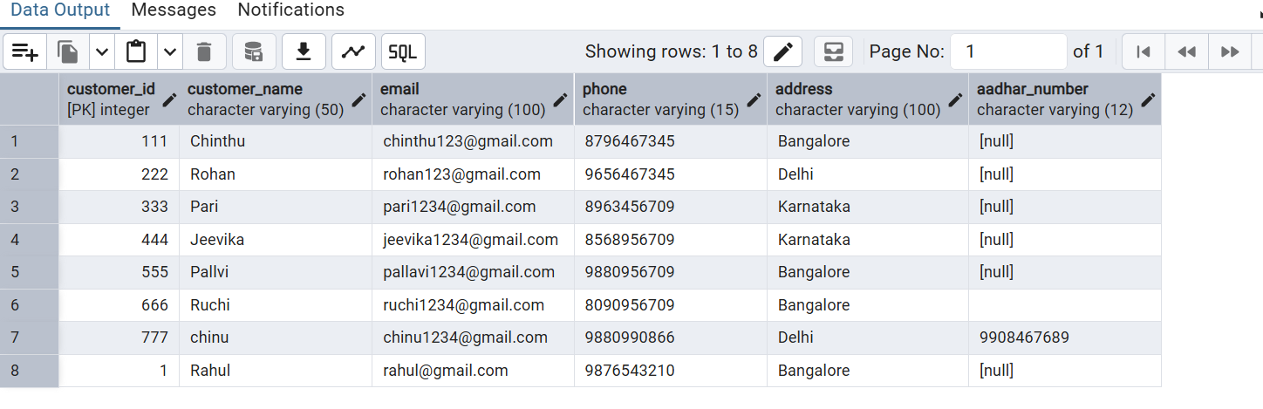
- Rahul was inserted form spring

