DAY 10
Task 01:
What is spring data JPA?
- Spring Data JPA is a Spring framework that simplifies database access using JPA.It automatically provides CRUD operations and generates queries through repository interfaces.
- It works with JPA implementations like Hibernate, reducing boilerplate code and speeding up development.
Task 02:
What are the key features of Spring data JPA?
- Repository support: Provides built-in CRUD operations through interfaces
- Query generation: Automatically creates queries from method names
- Custom queries: Supports JPQL and native SQL using the @Query annotation.
- Pagination and sorting: Built-in support for handling large datasets efficiently.
- Transaction management: Integrates with Spring's transaction management for reliable database operations.
Task 03:
What are core components of Spring data JPA?
The core components of Spring Data JPA are:
- Entity – A Java class mapped to a database table using @Entity.
- Repository – An interface (e.g., JpaRepository) that provides CRUD and database operations.
- EntityManager – The JPA interface that manages the persistence of entities.
- JpaRepository – A repository interface that extends basic CRUD functionality with pagination and sorting.
- Service Layer – Contains business logic and interacts with repositories to perform database operations.
Task 04
Now create a spring application using initializer
Create a customer entity with id and account type
- Create a project – CustomerBank

CustomerServiceApplication.java
package com.example;
import org.springframework.boot.SpringApplication;
import org.springframework.boot.autoconfigure.SpringBootApplication;
@SpringBootApplication
public class CustomerServiceApplication {
public static void main(String[] args) {
SpringApplication.run(CustomerServiceApplication.class, args);
}
}
Customer.java
package com.example;
import jakarta.persistence.Entity;
import jakarta.persistence.GeneratedValue;
import jakarta.persistence.GenerationType;
import jakarta.persistence.Id;
@Entity
public class Customer {
@Id
@GeneratedValue(strategy = GenerationType.IDENTITY)
private Long id;
private String accountType;
public Customer() {
}
public Customer(String accountType) {
this.accountType = accountType;
}
public Long getId() {
return id;
}
public void setId(Long id) {
this.id = id;
}
public String getAccountType() {
return accountType;
}
public void setAccountType(String accountType) {
this.accountType = accountType;
}
}

CustomerController.java
package com.example;
import org.springframework.web.bind.annotation.*;
import java.util.List;
@RestController
@RequestMapping("/customers")
public class CustomerController {
private final CustomerRepository repository;
public CustomerController(CustomerRepository repository) {
this.repository = repository;
}
@GetMapping
public List<Customer> getCustomers() {
return repository.findAll();
}
@PostMapping
public Customer addCustomer(@RequestBody Customer customer) {
return repository.save(customer);
}
}

CustomerRepository.java
package com.example;
import org.springframework.data.jpa.repository.JpaRepository;
public interface CustomerRepository extends JpaRepository<Customer, Long> {
}

Database
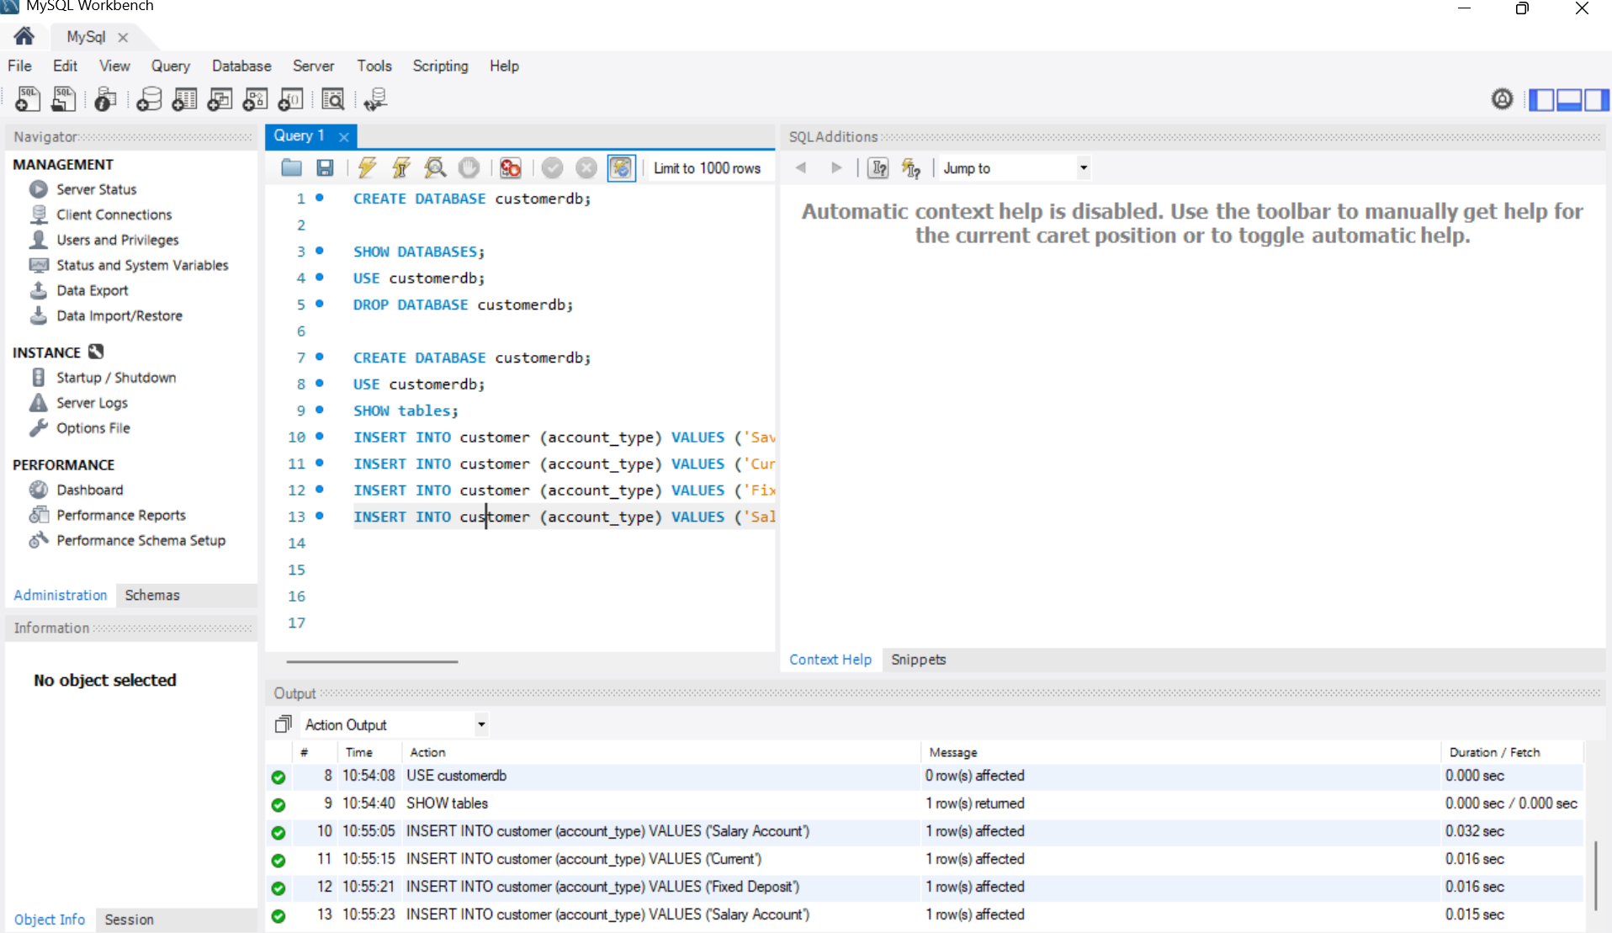
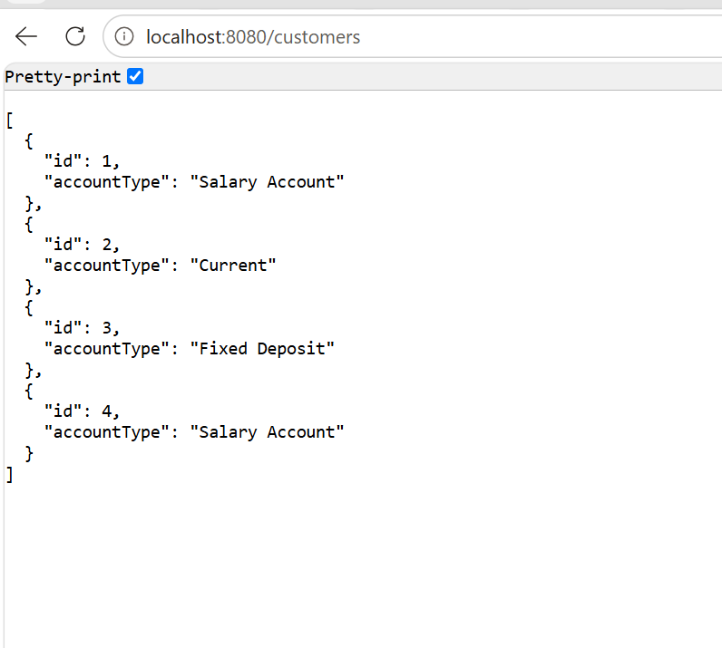
Task 05:
Application.properties
# H2 Database
spring.datasource.url=jdbc:h2:mem:customerdb
spring.datasource.username=sa
spring.datasource.password=
# JPA Settings
spring.jpa.hibernate.ddl-auto=update
spring.jpa.show-sql=true
# H2 Console
spring.h2.console.enabled=true
spring.h2.console.path=/h2-console

<dependency>
<groupId>com.h2database</groupId>
<artifactId>h2</artifactId>
<scope>runtime</scope>
</dependency>
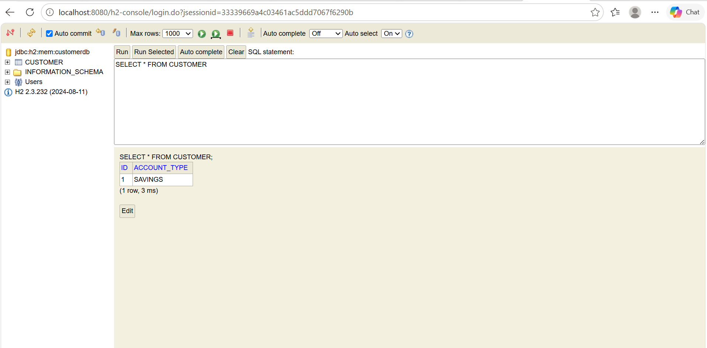
Task 06:
What is Application.proteries file is about?
- Application.properties is a Spring Boot configuration file that stores application settings like database connection, server port, and JPA behaviour
- It helps Spring Boot know how to connect with H2/MySQL and how to manage database tables without changing Java code.
Task 07:
Why use application properties… uses?
- Application.properties is used to store and manage Spring Boot application configurations in one place.
- It is used for database settings, server port changes, JPA/Hibernate configuration, and other application properties.
Task 08:
What is application.yml?
- application.yml is a Spring Boot configuration file used to store application settings like database, server, and JPA configurations.
- It works the same way as application.properties, but it uses YAML format with a cleaner hierarchical structure.
- It helps manage application configurations in a more readable and organized way without changing Java code.
Task 09:
Why use/prefer to use application.yml instead of application.properties?
- application.yml is preferred because it provides a cleaner and more readable way to write complex Spring Boot configurations.
- It supports a hierarchical structure, making it easier to manage multiple environments like development, testing, and production.
- It reduces repeated code and improves organization compared to application.properties, especially in large projects.
Task 10:
What is Eureka Server?
- Eureka Server is a service registry used in Spring Cloud microservices to register and discover services.
- It helps microservices find and communicate with each other without using fixed IP addresses or ports.
- It acts like a phone directory where services register their details and other services can find them easily.
Task 11:
Purpose of Eureka Server
- The purpose of Eureka Server is to provide service discovery in a microservices architecture.
- It allows services to register themselves and helps other services locate and communicate with them dynamically.
- It removes the need for hard-coded service URLs and makes microservices communication easier and scalable.
HOME TASK
Task 01:
What do you know about Spring MVC framework?
Spring MVC (Model-View-Controller) is a web framework provided by the Spring Framework for building scalable and maintainable web applications and REST APIs. It follows the MVC design pattern, where the Model represents the application data, the View displays the data to the user, and the Controller handles user requests and coordinates between the Model and the View. This separation of responsibilities makes the application easier to develop, test, and maintain.
In Spring MVC, when a client sends a request, the DispatcherServlet acts as the front controller and receives all incoming requests. It forwards the request to the appropriate controller, which processes the request, interacts with the service and database if needed, and returns the response. Spring MVC also provides features such as request mapping, form handling, data binding, validation, exception handling, and seamless integration with other Spring modules, making it a popular choice for developing modern Java web applications.
Task 02:
What is Dispatcher Servlet?
DispatcherServlet is the front controller of the Spring MVC framework. It receives every incoming HTTP request, identifies the appropriate controller to handle it, processes the request, and returns the response to the client. It acts as the central coordinator, managing request routing, view resolution, exception handling, and the overall request-response lifecycle in a Spring MVC application.
Task 03:
Can you explain Spring MVC with diagram
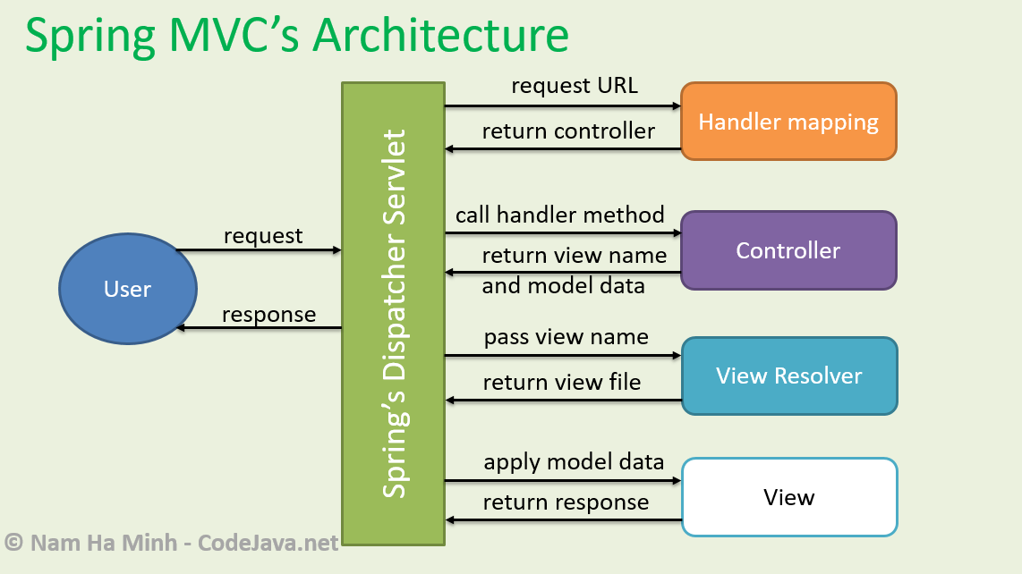
Spring MVC Architecture
Step 1: User Sends a Request
The user sends an HTTP request (such as a GET or POST request) from a browser or Postman. The request first reaches the DispatcherServlet, which is the front controller of Spring MVC.
Step 2: DispatcherServlet Contacts Handler Mapping
The DispatcherServlet asks the Handler Mapping which controller should handle the requested URL. The Handler Mapping identifies the correct controller based on the URL and returns it.
Step 3: Request Goes to the Controller
The DispatcherServlet forwards the request to the identified Controller. The controller processes the request, performs business logic (usually by calling the service layer), retrieves or updates data, and returns the Model Data and the View Name.
Step 4: View Resolver Finds the View
The DispatcherServlet sends the view name to the View Resolver. The View Resolver converts the logical view name into the actual view file, such as a JSP, Thymeleaf, or HTML page.
Step 5: View Displays the Data
The View receives the model data from the DispatcherServlet and generates the final HTML page.
Step 6: Response Sent Back
Finally, the DispatcherServlet sends the generated response back to the user.

