Day 28 - 24th Aug 2026

Task 1:
Task 5 demo of Day 27 – ensure you all are done with..
Task 2:
Note
An API Gateway is the single entry point for all client requests in a microservices architecture.
What do you think is the role of API Gateway in Microservices?
An API Gateway acts as a single entry point between clients and the different microservices in an application. Instead of the client directly communicating with multiple services, it sends requests to the API Gateway, which then routes each request to the appropriate microservice.
The API Gateway also handles common tasks such as authentication, authorization, request routing, logging, rate limiting, and load balancing. This keeps individual microservices simpler and avoids duplicating these responsibilities across every service.
For example, in an e-commerce application, a client may send a request to /orders. The API Gateway identifies that the request belongs to the Order Service, forwards it there, and returns the response to the client.

Task 3:
Also why do we need API gateway in Microservices?
In a microservices architecture, an application is divided into multiple independent services, and each service may have its own API and location. If clients communicate directly with every microservice, the system can become difficult to manage and secure.
An API Gateway provides a single, consistent entry point for clients. It hides the internal structure of the microservices and handles common tasks such as request routing, authentication, authorization, rate limiting, logging, and load balancing.
For example, in an e-commerce application, the client may need to access User Service, Product Service, Order Service, and Payment Service. Instead of making separate connections to each service, the client communicates with the API Gateway, which forwards each request to the correct service.

Task 4:
ensure you have these services in your earlier projects .. (account-service, transaction-service, auth-service)
If you don't have
step 01 :
Set up microservices
Create independent services like Account, Transaction, and Auth using Spring Boot.

Step 02:

This is the project structure.. Keep account services and transaction services ready..
Project Structure
Code
banking-microservices/
│
├── gateway-service/
│ ├── src/main/java/com/example/gateway/
│ │ ├── GatewayApplication.java
│ │ ├── config/RouteConfig.java
│ │ ├── filter/JwtAuthFilter.java
│ │ └── controller/FallbackController.java
│ └── src/main/resources/application.yml
│
├── account-service/
│ ├── src/main/java/com/example/account/
│ │ ├── AccountApplication.java
│ │ └── controller/AccountController.java
│ └── src/main/resources/application.yml
│
├── transaction-service/
│ ├── src/main/java/com/example/transaction/
│ │ ├── TransactionApplication.java
│ │ └── controller/TransactionController.java
│ └── src/main/resources/application.yml
│
└── pom.xml (parent for all modules)
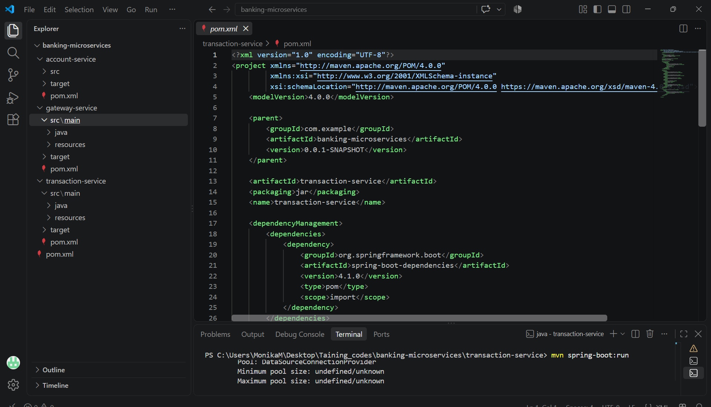
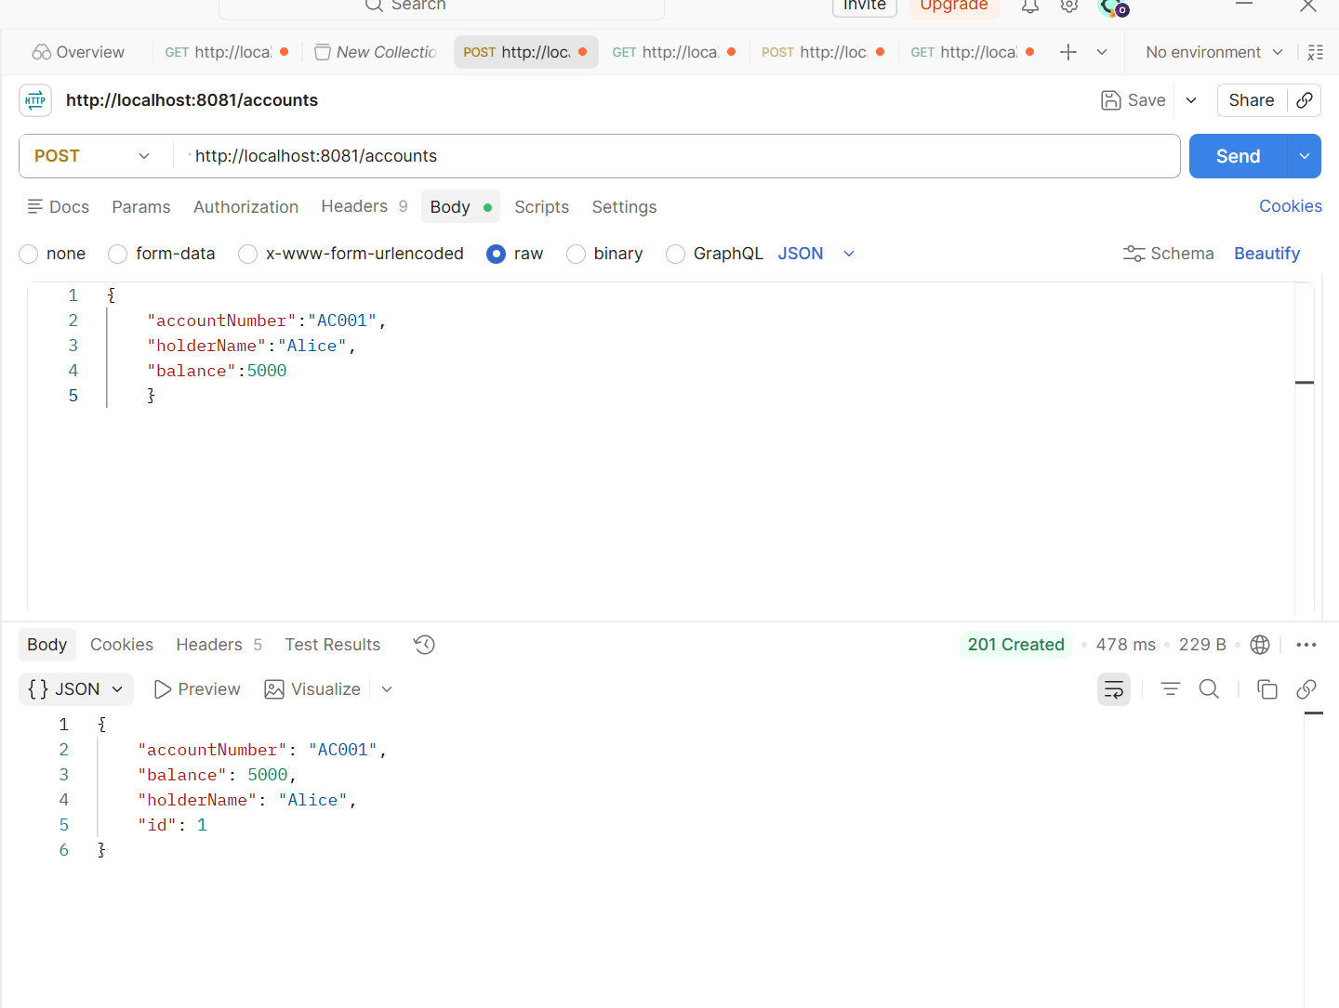

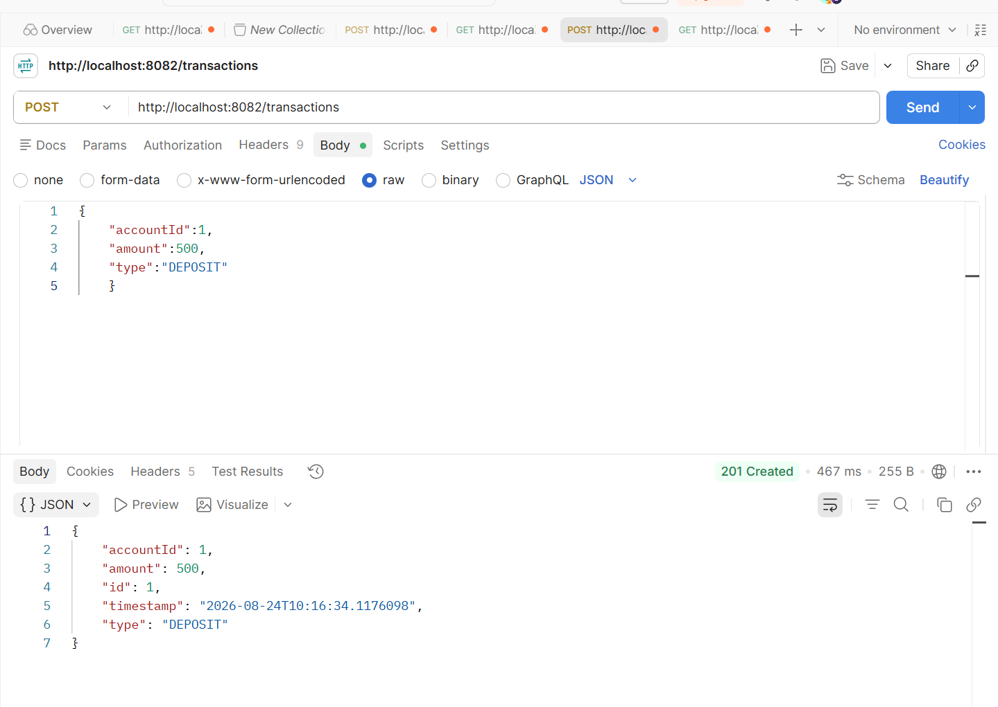
Step 03:
Now create a GatewayApplication.java file
package com.example.gateway;

import org.springframework.boot.SpringApplication;
import org.springframework.boot.autoconfigure.SpringBootApplication;

@SpringBootApplication
public class GatewayApplication {

public static void main(String[] args) {
SpringApplication.run(GatewayApplication.class, args);
}

}

Step 04:
Create RouteConfig.java for routing.. Accounts …. Etc services
package com.example.gateway.config;

import org.springframework.cloud.gateway.route.RouteLocator;
import org.springframework.cloud.gateway.route.builder.RouteLocatorBuilder;
import org.springframework.context.annotation.Bean;
import org.springframework.context.annotation.Configuration;

@Configuration
public class RouteConfig {

@Bean
public RouteLocator customRouteLocator(RouteLocatorBuilder builder) {
return builder.routes()
// Anything hitting the gateway at /accounts/** is forwarded to account-service (port 8081)
.route("account-service", r -> r
.path("/accounts/**")
.uri("http://localhost:8081"))

// Anything hitting the gateway at /transactions/** is forwarded to transaction-service (port 8082)
.route("transaction-service", r -> r
.path("/transactions/**")
.uri("http://localhost:8082"))

.build();
}
}

Step 05:
We need to create filter – jwtauthFilter for auth check
This file is a gatekeeper .. its a security gatekeeper for API gateway..
lets create it
@Component
public class JwtAuthFilter implements GlobalFilter, Ordered {

// Demo-only secret. Must be at least 256 bits for HS256.
private static final String SECRET = "this-is-a-demo-secret-key-for-training-purposes-only-123456";
private static final SecretKey KEY = Keys.hmacShaKeyFor(SECRET.getBytes(StandardCharsets.UTF_8));

@Override
public Mono<Void> filter(ServerWebExchange exchange, GatewayFilterChain chain) {
ServerHttpRequest request = exchange.getRequest();

// Let unauthenticated calls to /fallback/** through, so error responses aren't themselves blocked
String path = request.getURI().getPath();
if (path.startsWith("/fallback")) {
return chain.filter(exchange);
}

String authHeader = request.getHeaders().getFirst("Authorization");

if (authHeader == null || !authHeader.startsWith("Bearer ")) {
return unauthorized(exchange, "Missing or malformed Authorization header");
}

String token = authHeader.substring(7);

try {
Claims claims = Jwts.parser()
.verifyWith(KEY)
.build()
.parseSignedClaims(token)
.getPayload();

// Token is valid — forward the subject as a header downstream services can trust
ServerHttpRequest mutatedRequest = request.mutate()
.header("X-Auth-User", claims.getSubject())
.build();

return chain.filter(exchange.mutate().request(mutatedRequest).build());

} catch (Exception e) {
return unauthorized(exchange, "Invalid or expired token");
}
}

Step 06:
Now a safety net for API gateway .. this provides a beautiful response if any of our microservices gets failed.
@RestController
@RequestMapping("/fallback")
public class FallbackController {

@GetMapping("/accounts")
public ResponseEntity<Map<String, String>> accountServiceFallback() {
return ResponseEntity
.status(HttpStatus.SERVICE_UNAVAILABLE)
.body(Map.of(
"message", "account-service is currently unavailable. Please try again shortly.",
"service", "account-service"
));
}

@GetMapping("/transactions")
public ResponseEntity<Map<String, String>> transactionServiceFallback() {
return ResponseEntity
.status(HttpStatus.SERVICE_UNAVAILABLE)
.body(Map.of(
"message", "transaction-service is currently unavailable. Please try again shortly.",
"service", "transaction-service"
));
}
}

Step 07:
Create application.yml as usual
server:
port: 8081

spring:
application:
name: account-service
datasource:
url: jdbc:h2:mem:accountdb
driver-class-name: org.h2.Driver
username: sa
password:
jpa:
hibernate:
ddl-auto: update
show-sql: true
h2:
console:
enabled: true
path: /h2-console

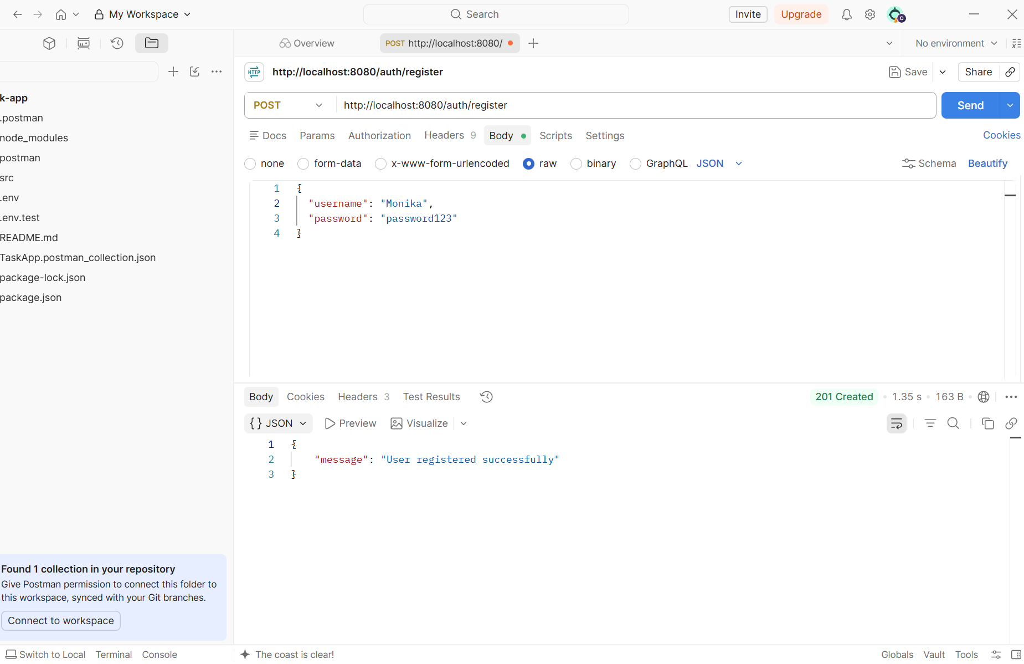
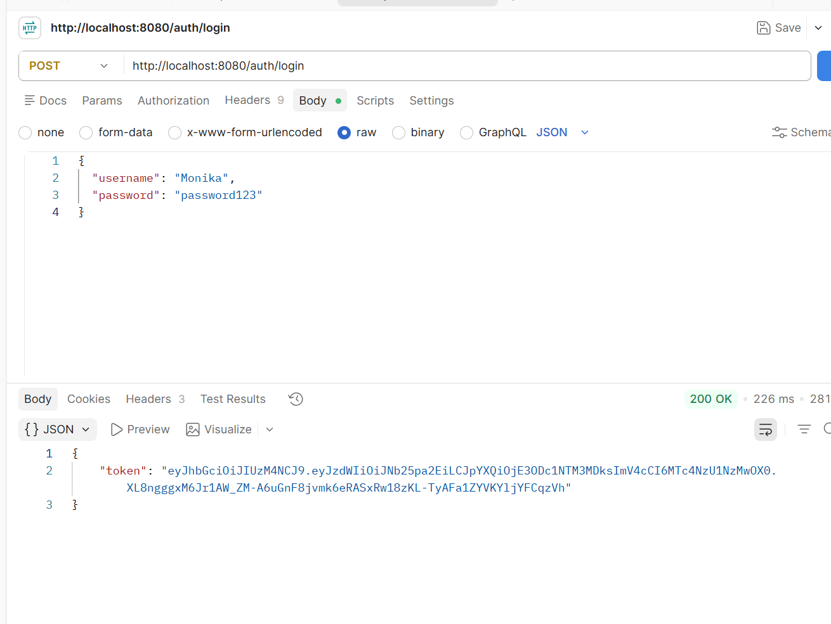
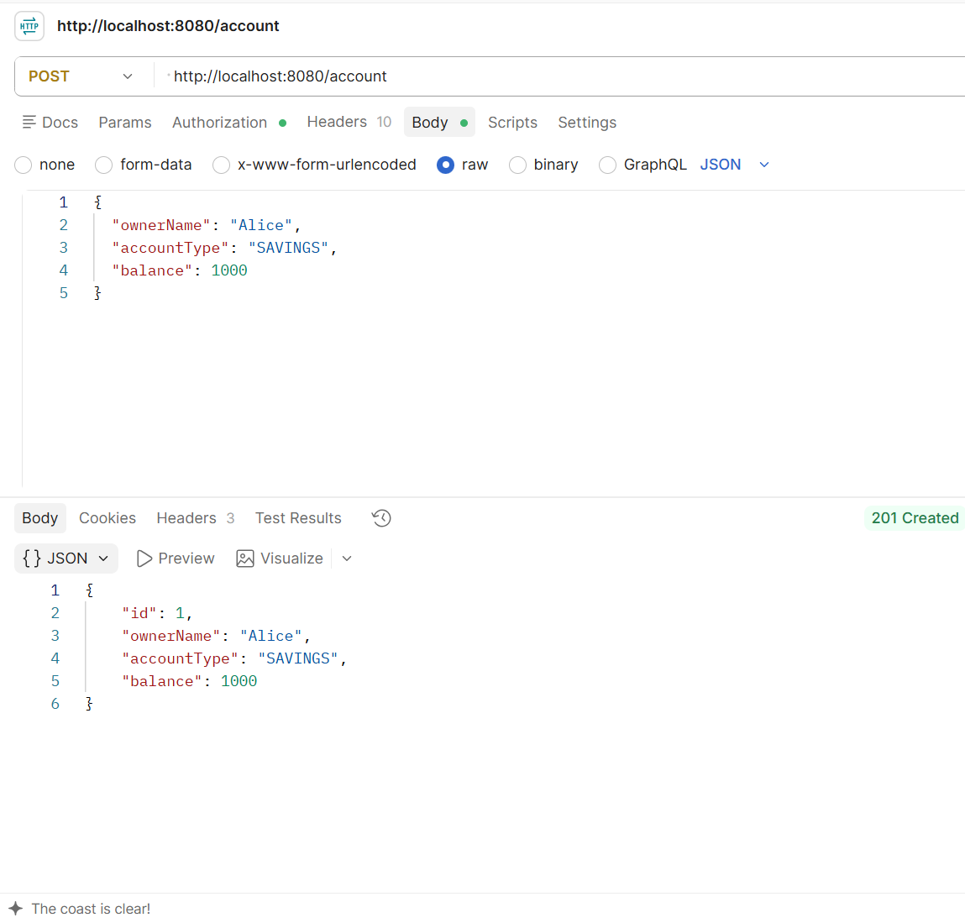
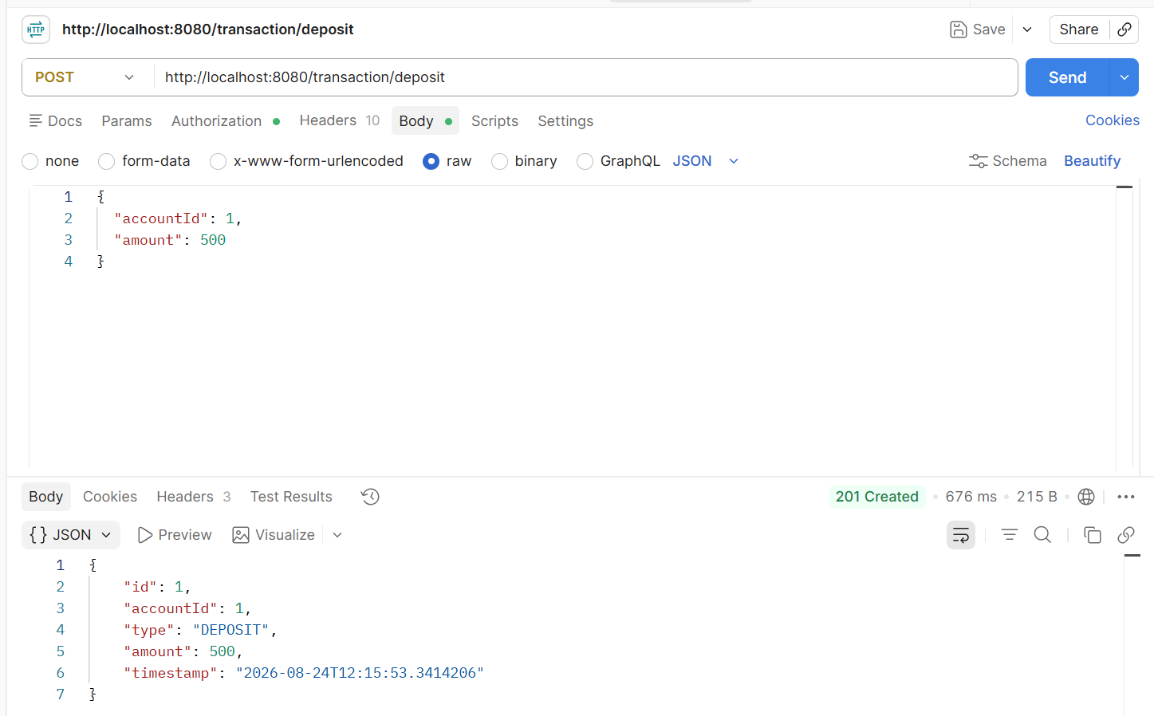

Task 5:

Routing and Request Aggregation at the Gateway
Step 01:
In our same old project we have RouteConfig file
In that we will make some changes like
will include
stripPrefix(1) removes the first path segment so /account/1/balance becomes /1/balance when forwarded.
This keeps microservice endpoints clean and avoids duplication of path segments.
This is my routeconfig… file did few updates @RestController
@RequestMapping("/dashboard")
public class DashboardController {

private static final ParameterizedTypeReference<List<Map<String, Object>>> TRANSACTIONS_TYPE =
new ParameterizedTypeReference<>() {
};

private final WebClient webClient;

public DashboardController(WebClient webClient) {
this.webClient = webClient;
}

@GetMapping("/{id}")
public Mono<ResponseEntity<Map<String, Object>>> getDashboard(@PathVariable Long id) {
Mono<BigDecimal> balance = webClient.get()
.uri("http://localhost:8082/{id}/balance", id)
.retrieve()
.bodyToMono(BigDecimal.class);

Mono<List<Map<String, Object>>> transactions = webClient.get()
.uri("http://localhost:8083/transaction/{id}", id)
.retrieve()
.bodyToMono(TRANSACTIONS_TYPE);

return Mono.zip(balance, transactions)
.map(result -> ResponseEntity.ok(Map.of(
"accountId", id,
"balance", result.getT1(),
"transactions", result.getT2()
)))
.onErrorResume(WebClientResponseException.class, error -> Mono.just(ResponseEntity
.status(error.getStatusCode())
.body(Map.of(
"status", "error",
"message", "Dashboard request failed",
"downstreamStatus", error.getStatusCode().value()
))))
.onErrorResume(error -> Mono.just(ResponseEntity
.status(HttpStatus.SERVICE_UNAVAILABLE)
.body(Map.of(
"status", "error",
"message", "Dashboard data is temporarily unavailable",
"details", "Check that account-service and transaction-service are running"
))));
}
}

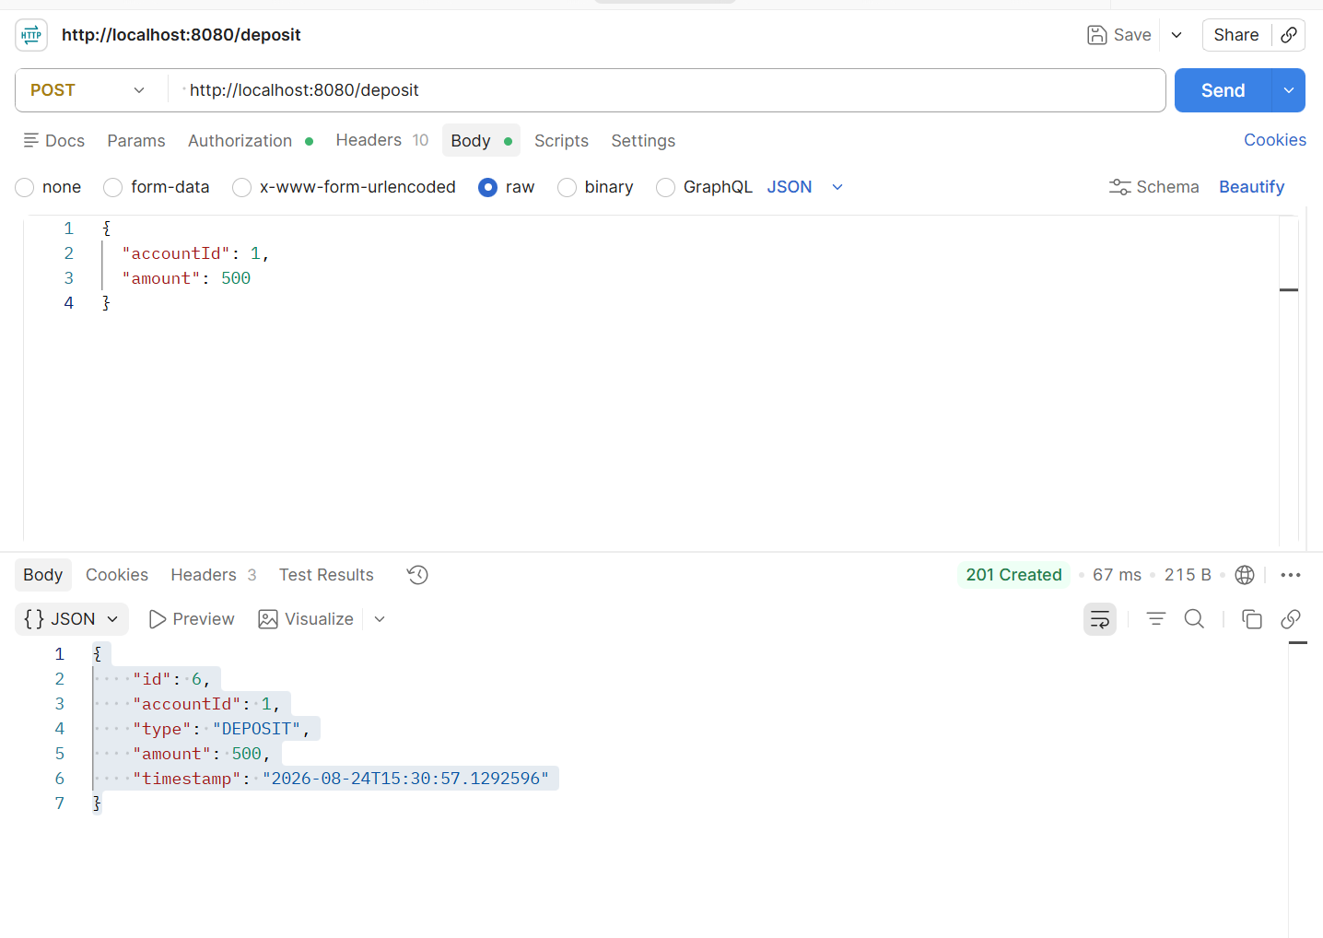

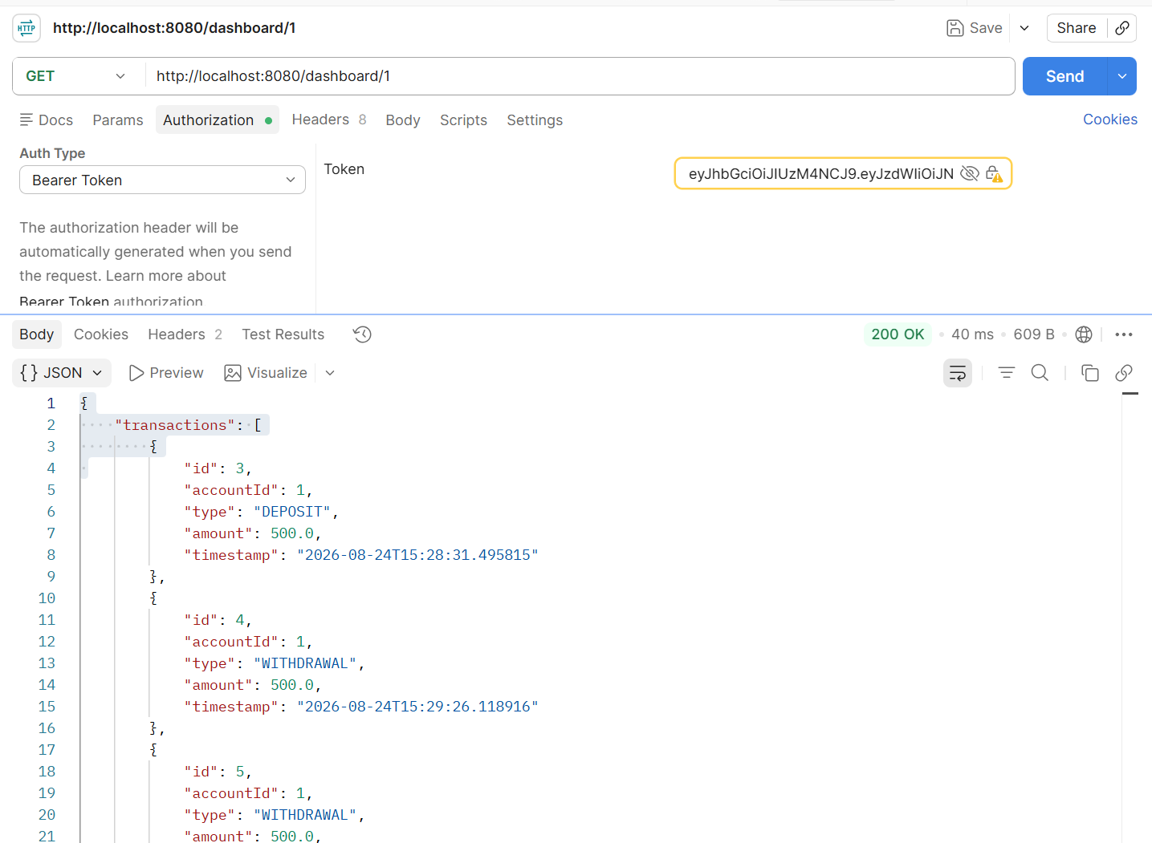
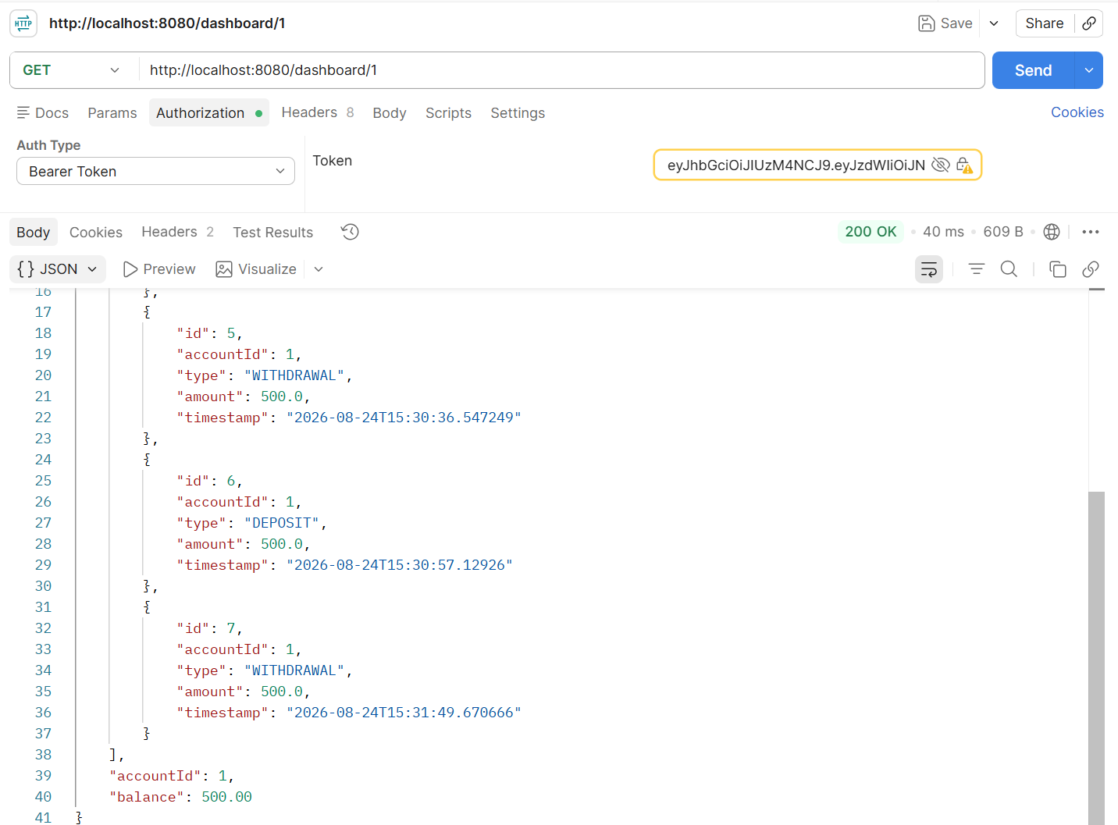

Task 6:
Rate Limiting and Throttling
Inextension to your earlier project…
Step 1:
In Redis we use rate limiting by Spring Cloud Gateway to store counters for requests per client.
So add Redis Dependency..
In our gateway-service/pom.xml.
package com.example.gateway.controller;

import org.springframework.http.HttpStatus;
import org.springframework.http.ResponseEntity;
import org.springframework.web.bind.annotation.GetMapping;
import org.springframework.web.bind.annotation.RestController;

import java.util.Map;

@RestController
public class RateLimitController {

@GetMapping("/rate-limit-error")
public ResponseEntity<Map<String, Object>> rateLimitError() {
return ResponseEntity
.status(HttpStatus.TOO_MANY_REQUESTS)
.body(Map.of(
"status", 429,
"error", "Too Many Requests",
"message", "You have exceeded the allowed request limit. Please try again later."
));
}
}

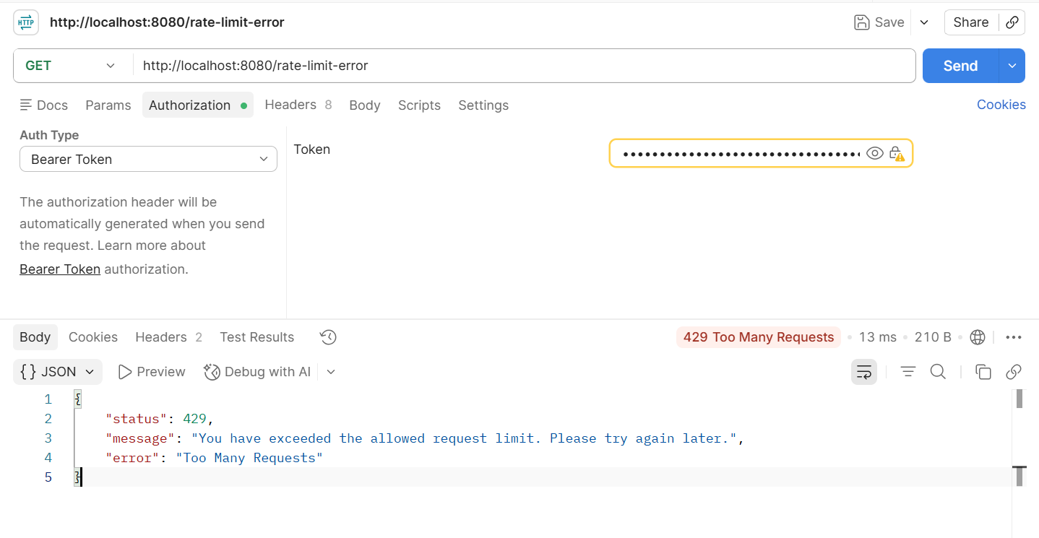
Task 7:
Authentication and Authorization at the Edge
To implement Authentication and Authorization at the Edge (API Gateway) in our project, we willl extend the Gateway so that it enforces security before requests reach microservices.
Same our earlier project ..
gateway-service/
├── src/main/java/com/example/gateway/
controller/FallbackController.java
│ ├── controller/RateLimitController.java
│ └── controller/AuthController.java → Optional: issue tokens for demo
└── src/main/resources/application.yml│ ├── GatewayApplication.java
│ ├── config/RouteConfig.java
│ ├── filter/JwtAuthFilter.java —> Authentication filter
│ ├── util/JwtUtil.java —> Utility for JWT validation

