Day 36 - 03rd Sept 2026
Task 1:
Cluster Architecture
1. What is the difference between the Control Plane and Worker Nodes in a Kubernetes cluster?
Answer:
- A Kubernetes cluster is mainly divided into the Control Plane and Worker Nodes.
- The Control Plane is responsible for managing the overall cluster. It decides where applications should run, monitors their state, and responds when changes are required.
- Worker Nodes are the machines where the actual application workloads run. They contain the components required to run Pods and containers.
- The Control Plane communicates with Worker Nodes and tells them what workloads need to be running.
- In simple terms, the Control Plane is the manager, while Worker Nodes are responsible for doing the actual work.

2. Why is the separation between the Control Plane and Worker Nodes important?
Answer:
- The separation keeps cluster management and application execution independent.
- The Control Plane can manage many Worker Nodes from a central location.
- Worker Nodes can focus mainly on running application workloads.
- If a Worker Node fails, the Control Plane can detect the failure and take corrective action.
- This architecture makes Kubernetes easier to manage, scale, and maintain.
- It also helps improve the reliability and availability of applications.

Pods & Containers
3. What role do Pods play in Kubernetes, and how are they different from containers?
Answer:
- A Pod is the smallest deployable unit in Kubernetes.
- It provides the environment in which one or more containers run.
- A container is responsible for running the actual application, whereas a Pod provides the Kubernetes-level environment around that container.
- Containers within the same Pod share the same network namespace and can also share storage volumes.
- Although a Pod can contain multiple containers, the most common setup is one main application container per Pod.
- In simple terms, a container is where the application runs, while a Pod is the unit Kubernetes manages.

4. Why are Pods considered ephemeral?
Answer:
- Pods are considered ephemeral because they are temporary and can be replaced at any time.
- Kubernetes does not guarantee that a particular Pod will exist forever.
- If a Pod crashes or a node fails, Kubernetes may create a new Pod to replace it.
- The replacement Pod can have a different IP address and a different identity.
- Therefore, applications should not depend on the permanent existence of a specific Pod.
- Kubernetes uses Deployments, Services, and persistent storage to handle these temporary Pod lifecycles.

Networking & Services
5. How does a Kubernetes Service enable communication between Pods?
Answer:
- Pods are temporary, so their IP addresses can change when they are recreated.
- A Kubernetes Service provides a stable network endpoint for accessing a group of Pods.
- A Service uses labels and selectors to identify which Pods should receive traffic.
- When a request is sent to the Service, Kubernetes forwards the request to one of the available matching Pods.
- Services also provide a stable DNS name, making communication easier between applications.
- This means applications don't need to keep track of individual Pod IP addresses.

6. Compare ClusterIP, NodePort, and LoadBalancer Services.
Answer:
ClusterIP
- It is the default type of Kubernetes Service.
- It allows communication with the application inside the Kubernetes cluster.
- It is commonly used for internal services such as backend APIs or databases.
- Example: Frontend → Backend.
NodePort
- It exposes a Service through a specific port on each Worker Node.
- It allows users outside the cluster to access the application.
- It is useful for testing, development, and simple external access.
- Example: User → Node IP:Port → Service → Pod.
LoadBalancer
- It exposes the Service through an external load balancer.
- Cloud platforms can automatically provide the required load-balancing infrastructure.
- It is commonly used when an application needs to be accessible from the internet.
- Example: Internet User → Load Balancer → Service → Pods.

Deployments & Scaling
7. What problem does a Deployment solve in Kubernetes?
Answer:
- A Deployment manages the desired number and version of Pods for an application.
- Without a Deployment, manually managing multiple Pods would be difficult.
- It ensures that the required number of replicas are running.
- If a Pod fails, the Deployment helps create a replacement.
- Deployments also support rolling updates, allowing applications to be updated gradually.
- If an update causes problems, Kubernetes can also support rollbacks to an earlier version.
- Therefore, Deployments make application management more automatic and reliable.

8. How does Kubernetes handle scaling applications up and down?
Answer:
- Kubernetes allows applications to run with multiple Pod replicas.
- When demand increases, the number of replicas can be increased, which is called scaling up.
- When demand decreases, the number of replicas can be reduced, which is called scaling down.
- For example, an application can be changed from 2 replicas to 5 replicas during high traffic.
- Kubernetes can also use the Horizontal Pod Autoscaler (HPA) to automatically adjust the number of Pods.
- HPA can make scaling decisions based on metrics such as CPU or memory utilization.

Storage & Persistence
9. Describe how Persistent Volumes (PV) and Persistent Volume Claims (PVC) work together.
Answer:
- A Persistent Volume (PV) is a piece of storage made available to the Kubernetes cluster.
- A Persistent Volume Claim (PVC) is a request made by an application for a certain amount and type of storage.
- Kubernetes looks for a suitable PV that can satisfy the PVC.
- Once the PVC is bound to a PV, a Pod can use the PVC to access the storage.
- The storage can continue to exist even when the Pod using it is deleted.
- In simple terms:
  - PV = Storage provided to the cluster
  - PVC = Request for storage
  - Pod = Uses the requested storage

10. Why is the PV/PVC abstraction necessary for stateful applications?
Answer:
- Containers and Pods are generally temporary, but some applications need their data to remain permanently.
- Examples include databases, file storage systems, and applications that store user data.
- PV and PVC separate the application from the actual storage infrastructure.
- Developers can request storage without needing to know exactly where the physical storage is located.
- If a Pod is deleted and recreated, it can reconnect to the same persistent storage.
- This helps protect important data and makes Kubernetes suitable for stateful applications.

Configuration Management
11. How do ConfigMaps and Secrets differ in purpose and usage?
Answer:
- ConfigMap is used to store non-sensitive configuration information separately from application code.
- Examples include application URLs, environment names, ports, and feature settings.
- Secret is designed for storing sensitive information.
- Examples include passwords, API keys, access tokens, and certificates.
- Both can be provided to Pods as environment variables or mounted files.
- Keeping configuration outside the application code makes applications easier to configure for different environments.

12. What are the best practices for managing sensitive data in Kubernetes?
Answer:
- Avoid storing passwords and API keys directly inside application source code.
- Do not commit sensitive Kubernetes Secret files to public or shared Git repositories.
- Use Kubernetes Secrets for sensitive configuration.
- Restrict access to Secrets using Role-Based Access Control (RBAC).
- Enable encryption at rest for sensitive data stored in the cluster.
- Use external secret-management solutions such as cloud secret managers or Vault for highly sensitive production environments.
- Follow the principle of least privilege, giving applications access only to the Secrets they actually need.

Scheduling & Resource Management
13. How does the Kubernetes Scheduler decide which node a Pod should run on?
Answer:
- The Kubernetes Scheduler is responsible for assigning Pods to suitable Worker Nodes.
- When a new Pod needs to run, the scheduler examines the available nodes.
- It first checks whether nodes have enough resources such as CPU and memory.
- It then considers scheduling rules and restrictions configured by the administrator or application.
- After evaluating the available options, it selects an appropriate Worker Node.
- The selected node then runs the Pod.

14. What factors influence Kubernetes scheduling decisions?
Answer:
- CPU and memory: The node must have enough available resources.
- Resource requests: Kubernetes considers the resources requested by the Pod.
- Node labels and selectors: A Pod may be restricted to particular types of nodes.
- Node affinity: Allows Pods to prefer or require specific nodes.
- Taints and tolerations: Control which Pods are allowed to run on certain nodes.
- Pod affinity/anti-affinity: Controls whether Pods should run together or separately.
- Node health: Kubernetes avoids unhealthy or unavailable nodes.
- These rules help Kubernetes place workloads in a way that improves performance, availability, and resource utilization.

Self-Healing & Automation
15. What mechanisms does Kubernetes use to ensure workloads remain available when Pods or Nodes fail?
Answer:
- Kubernetes continuously monitors the state of applications and infrastructure.
- If a container fails, Kubernetes can restart it.
- If a Pod fails, a Deployment or ReplicaSet can create a replacement Pod.
- If a Worker Node becomes unavailable, workloads can be scheduled on another suitable node when possible.
- Liveness probes help detect applications that are unhealthy and need restarting.
- Readiness probes determine whether a Pod is ready to receive traffic.
- Running multiple replicas also ensures that one Pod failure does not necessarily stop the entire application.

16. How does self-healing and automation contribute to high availability?
Answer:
- Kubernetes continuously compares the desired state with the actual state of the cluster.
- If something goes wrong, Kubernetes automatically tries to restore the desired state.
- Failed containers can be restarted and failed Pods can be replaced.
- Multiple replicas allow an application to continue serving users even when some Pods fail.
- Workloads can also be distributed across multiple Worker Nodes to reduce the impact of node failures.
- This reduces the need for manual intervention and helps applications remain available, reliable, and resilient.
Task 2:
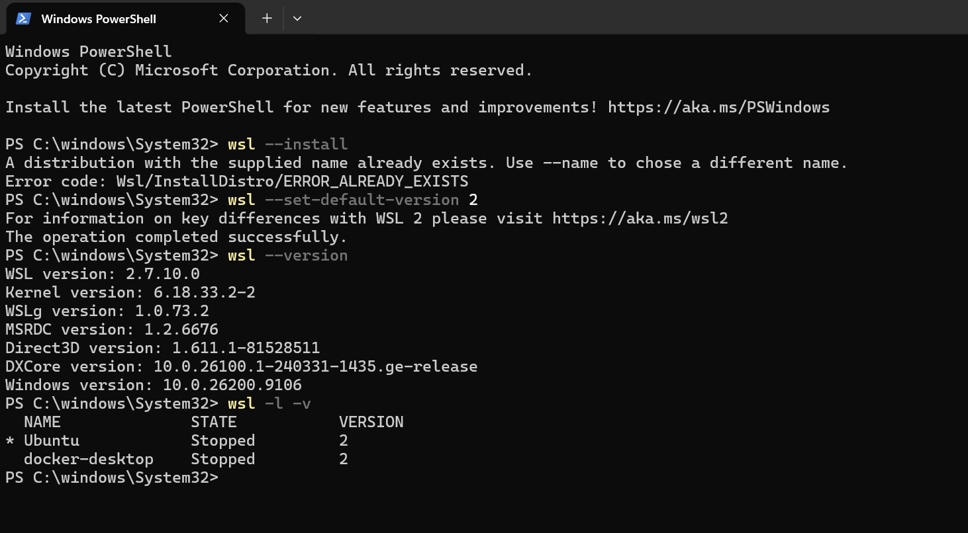
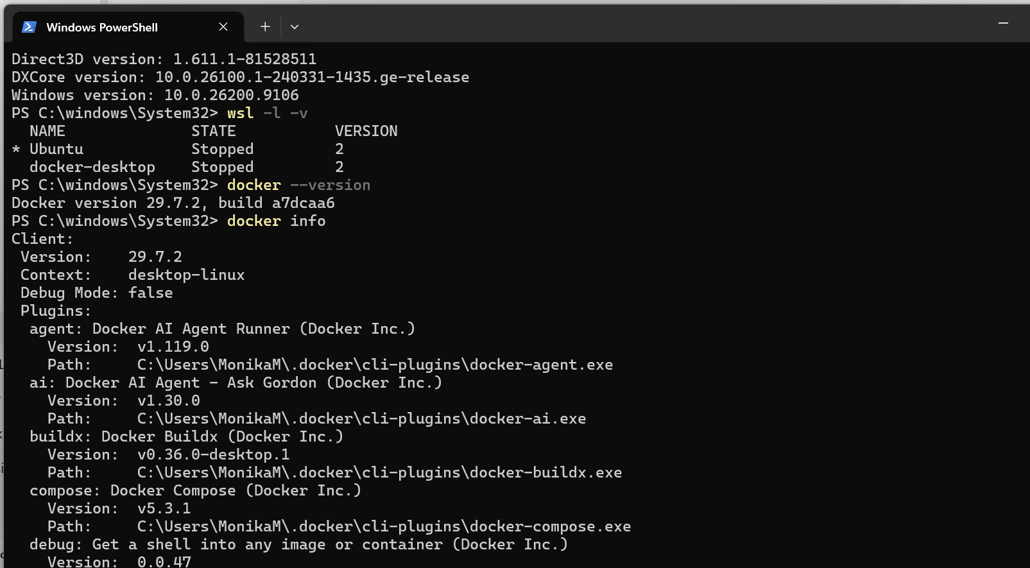

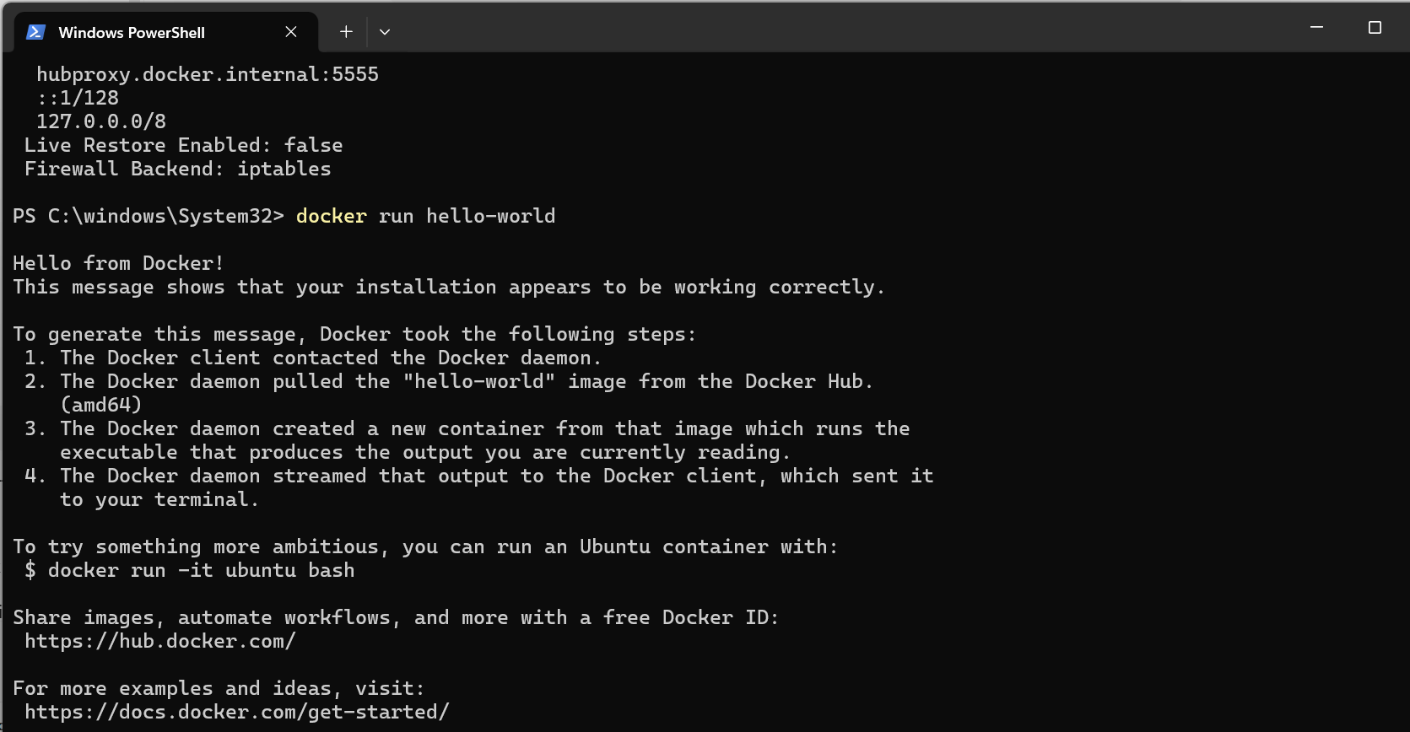
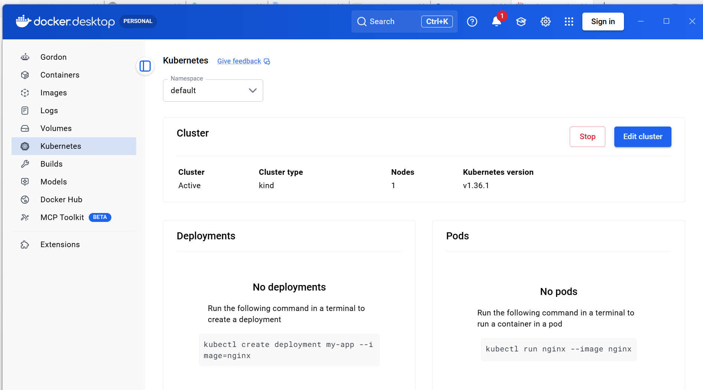

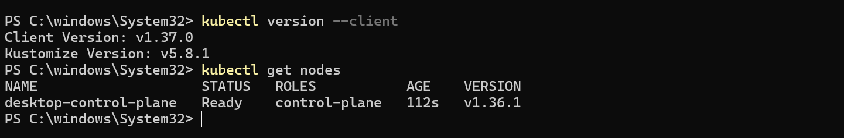
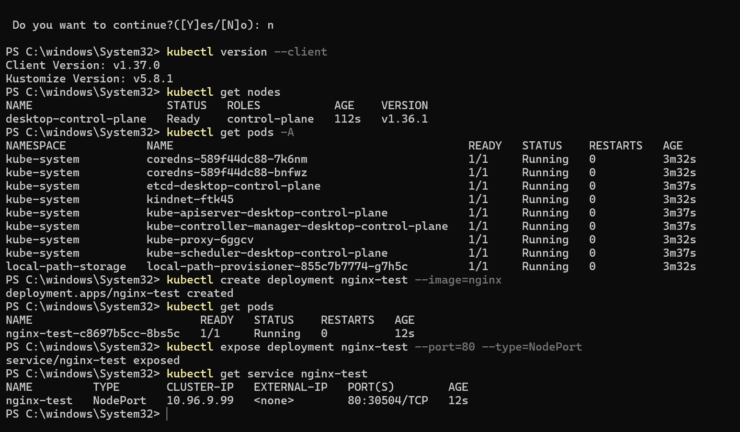
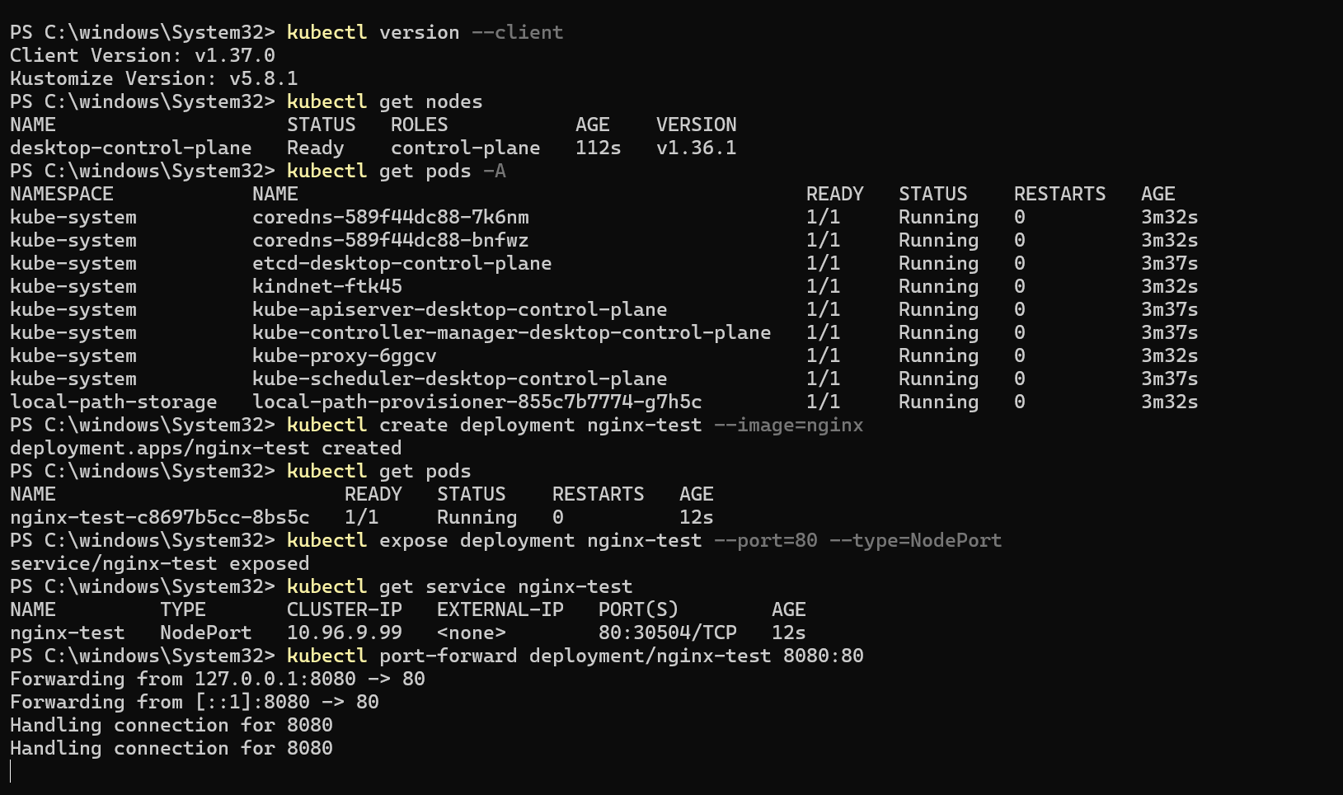
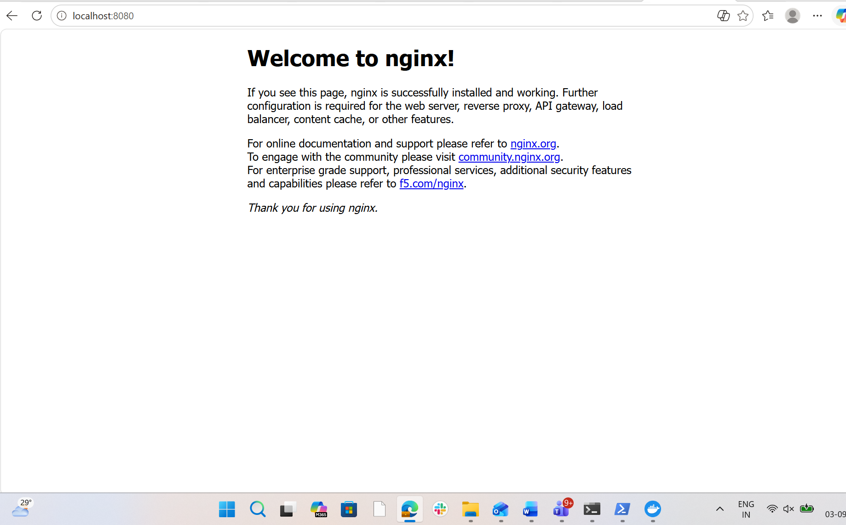

Task 3:
