34 - 01st Sept 2026
Task 1:
- Run docker --version → shows installed version
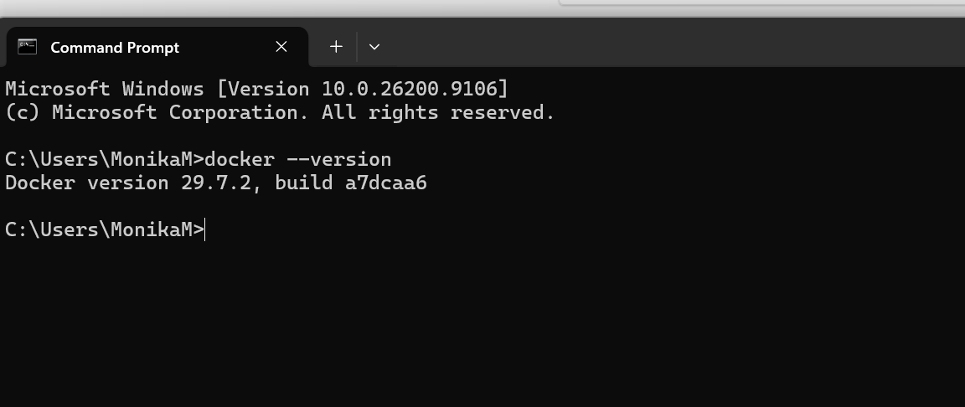
- Run: docker pull hello-world
Fetches the latest hello-world image
Confirms internet connectivity
Prepares for container run

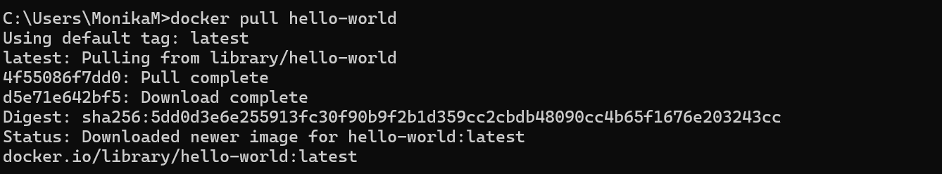

- Run docker run hello-world → should print Hello from Docker!

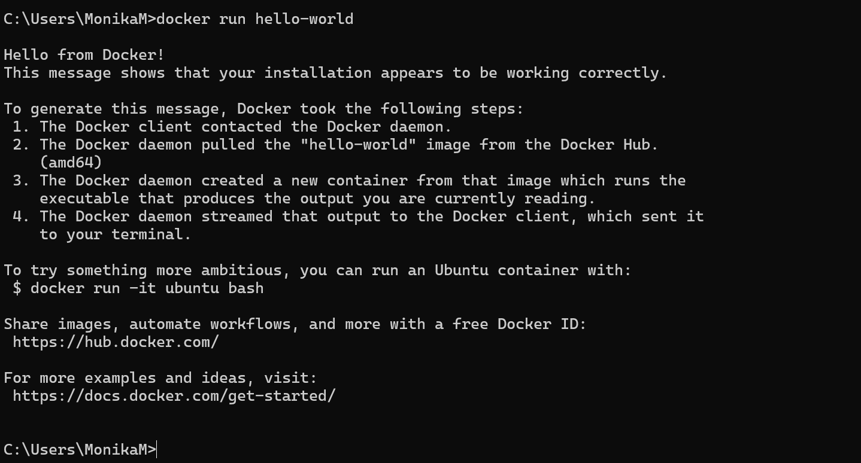

- Docker run ubuntu
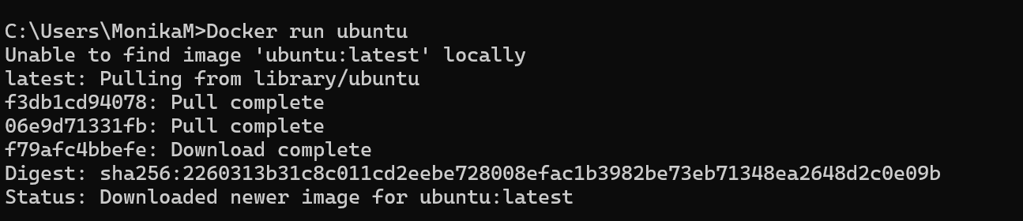
- Try interactive mode: docker run -it ubuntu bash
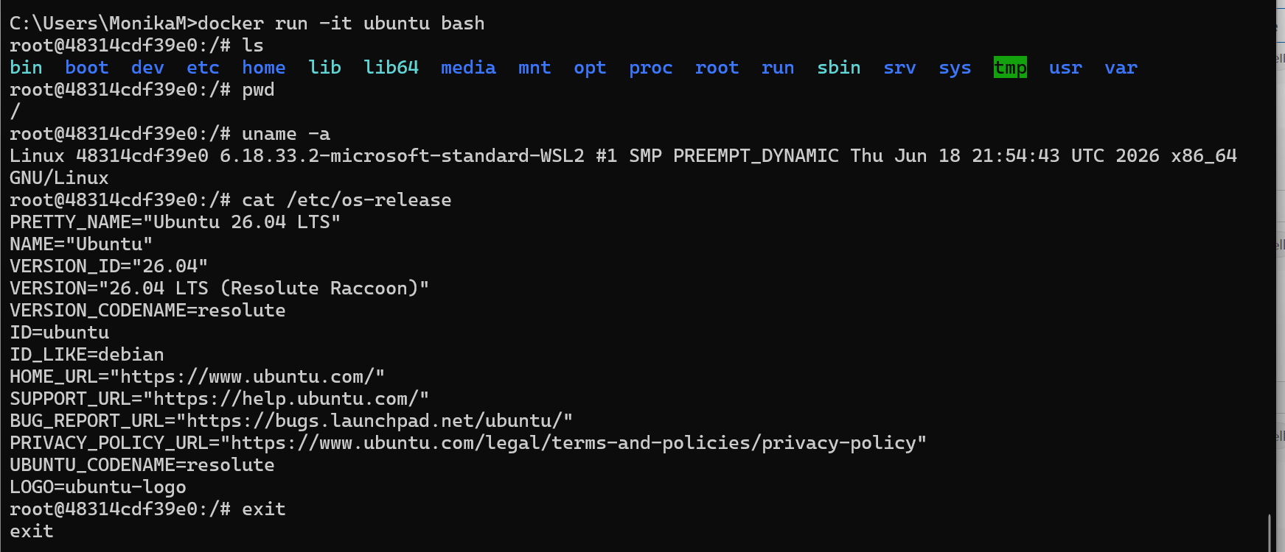
- docker run -d nginx —> runs service in background.
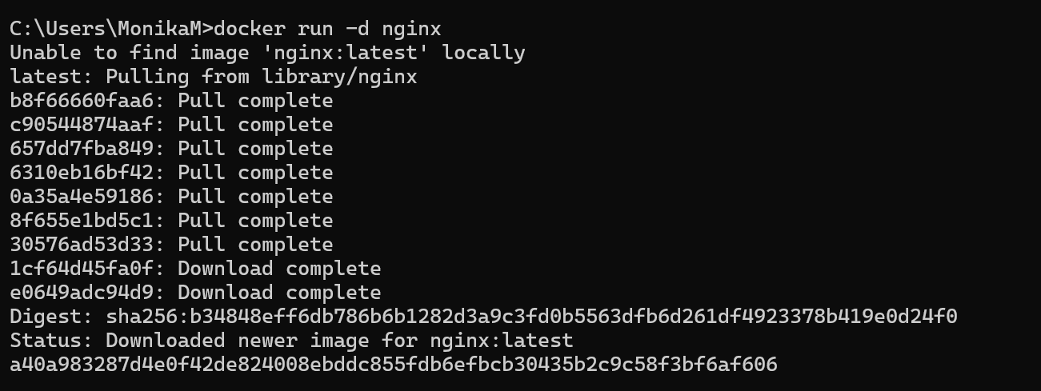
- Docker ps
- Map Ports for Access
Expose container services to your host machine.
docker run -d -p 8080:80 nginx
Maps host port 8080 → container port 80
Access via browser at http://localhost:8080
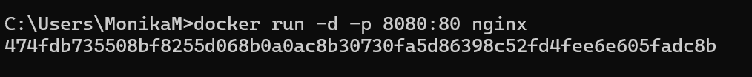
- Name Your Container
Assign a custom name for easier management.
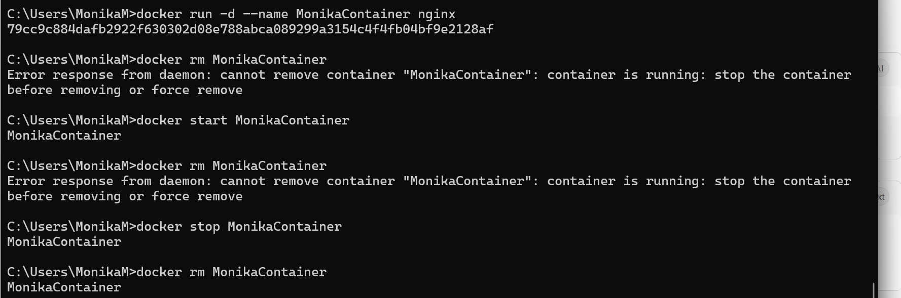
- docker run -d -p 8081:80 -v
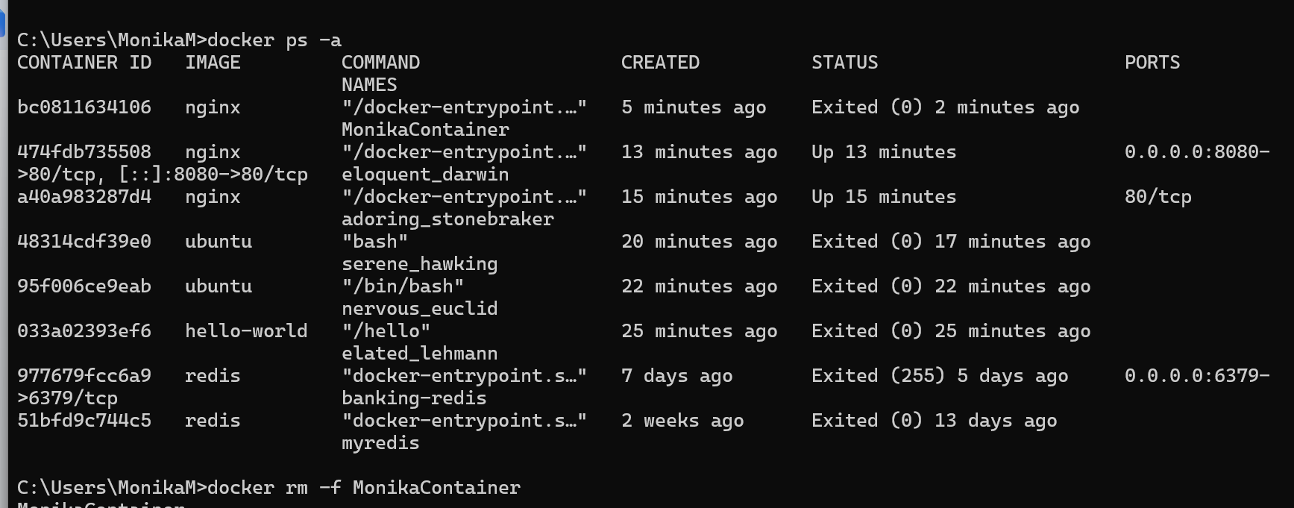
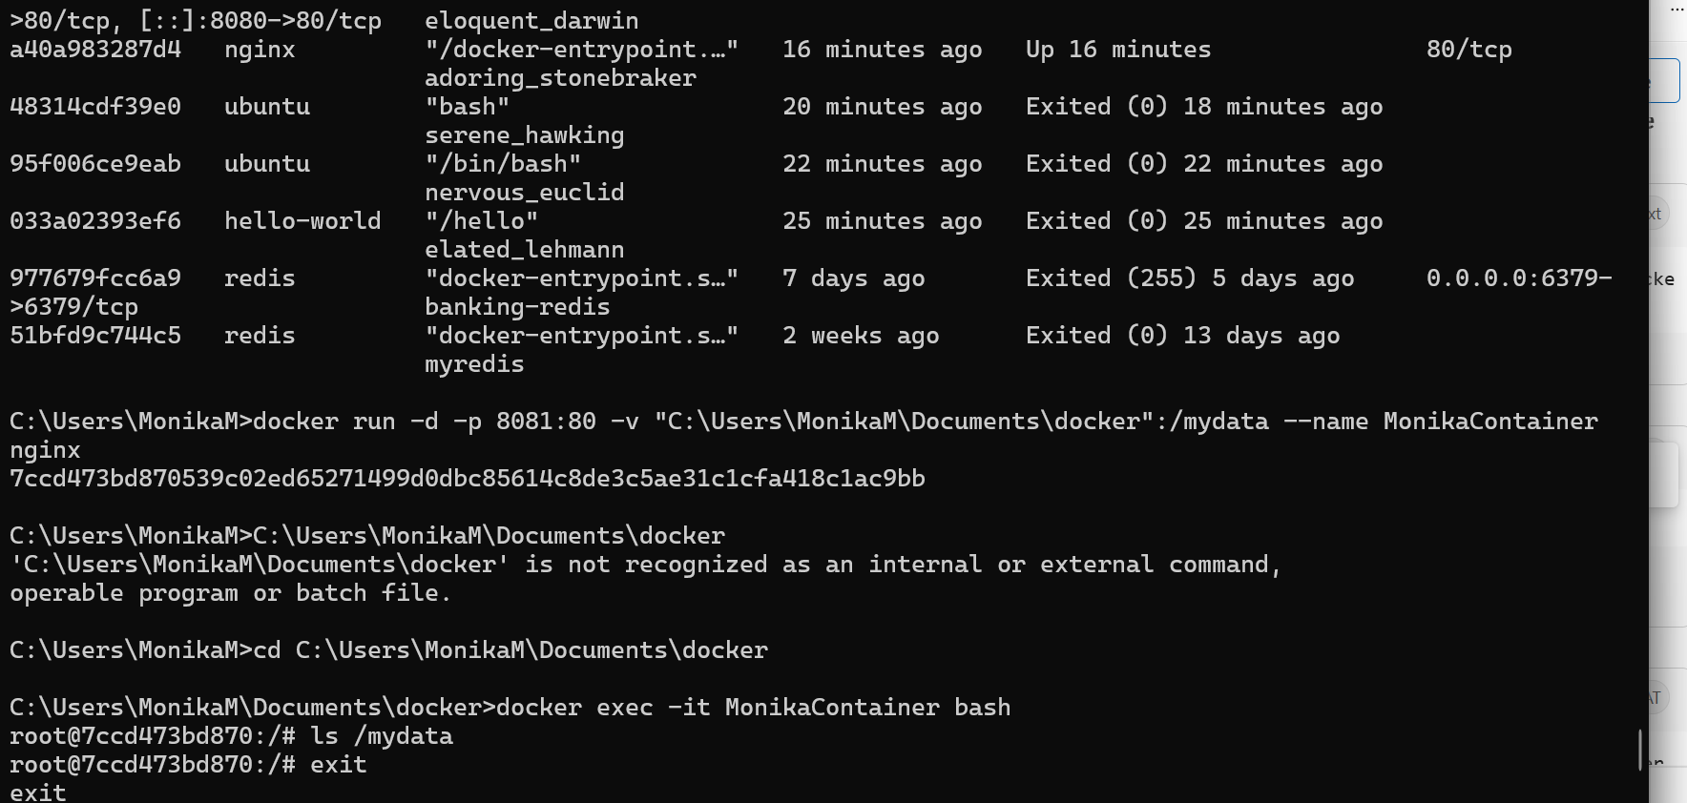
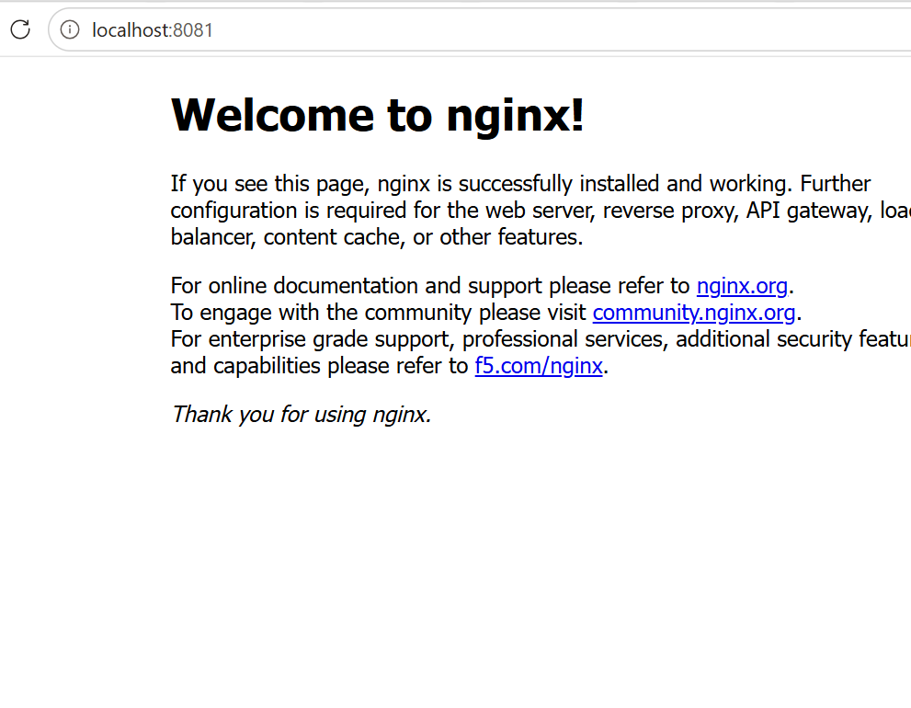

Task 2:
to serve your own HTML file from that mounted folder instead of the default Nginx page
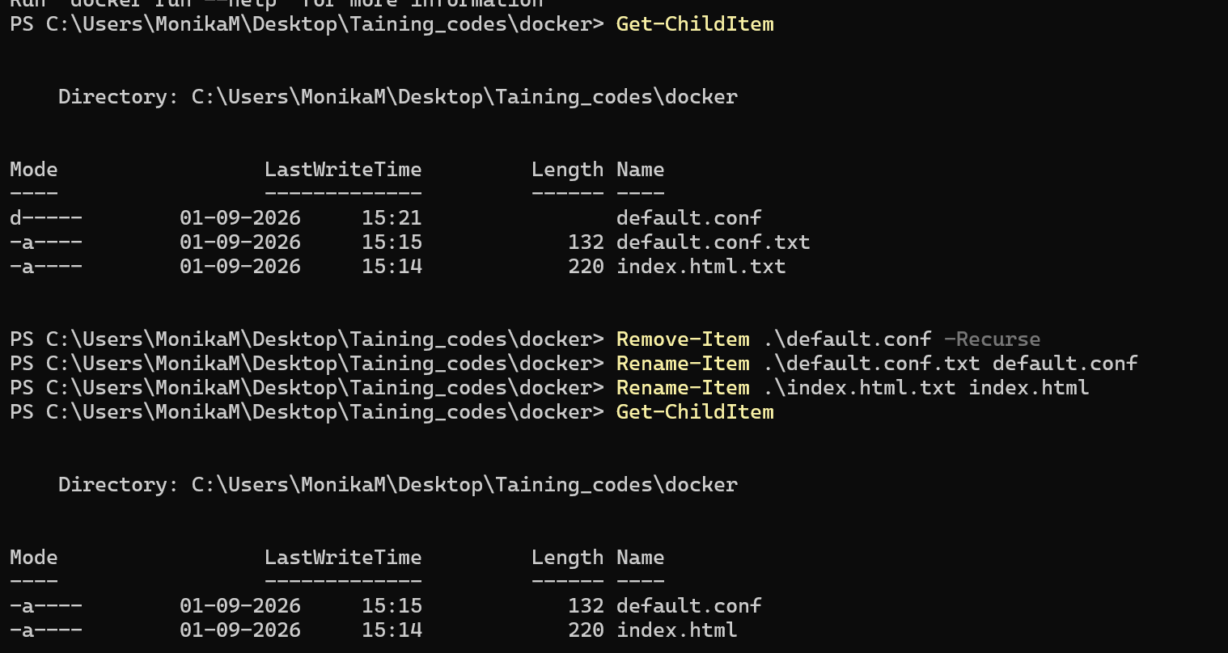
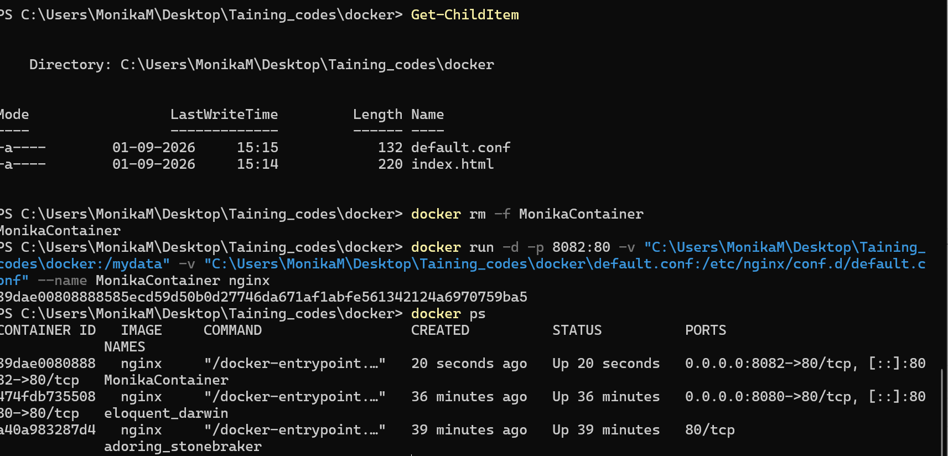
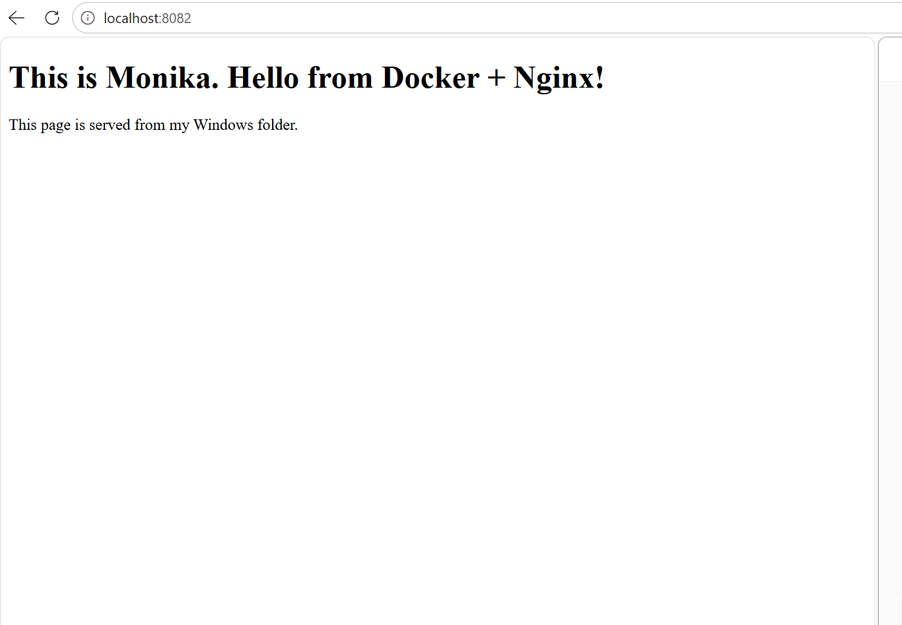

Task 3:

You now have a full-stack Docker project with app, DB, and proxy.
It demonstrates images, compose, registry, engine, storage, and networking in one workflow.

================================================================================================================================

docker-project/
├── app/
│ ├── Dockerfile
│ ├── server.js
│ └── package.json
├── nginx/
│ └── nginx.conf
└── docker-compose.yml
