Day 15 - 05th Aug 2026
Task 01:
What is angular? Explain briefly.
- Angular is a popular open-source front-end framework developed by Google. It is used to build dynamic, interactive, and single-page web applications (SPAs). Angular is based on TypeScript, which makes the code more organized, readable, and easier to maintain.
- It follows a component-based architecture, where an application is divided into small, reusable components. Angular also provides built-in features like data binding, dependency injection, routing, and form handling, making web development faster and more efficient.
Task 02:
What is data binding? Explain.
How many types of data bindings do you have .. can you explain them.
Data binding is the process of connecting the data (from the component) with the user interface (HTML template). It allows data to flow between the component and the view, so the UI stays updated whenever the data changes.
Types of Data Binding in Angular
Angular provides four types of data binding:
1. Interpolation ({{ }})
- Used to display data from the component in the HTML.
- It supports one-way data binding (Component → View).
- Example : <h2>{{ username }}</h2>
2. Property Binding ([ ])
- Used to bind a component property to an HTML element property.
- It is also one-way data binding (Component → View).
- Example : <img [src]="imageUrl">
3. Event Binding (( ))
- Used to handle user events like clicks, key presses, or mouse movements.
- It is one-way data binding (View → Component).
- Example : <button (click)="showMessage()">Click Me</button>
4. Two-Way Data Binding ([( )])
- Combines property binding and event binding.
- Data flows in both directions (Component ↔ View).
- It is commonly used with ngModel.
- Example : <input [(ngModel)]="username">
<p>{{ username }}</p>
Task 03:
Why do you need Angular? Can you give some advantages of using angular with description
- Angular is used to build modern, dynamic, and responsive web applications. Instead of writing a lot of JavaScript code manually, Angular provides a structured framework with built-in features that make development faster, easier, and more efficient.
- It helps developers create Single Page Applications (SPAs), where pages update without reloading the entire website, resulting in a faster and smoother user experience.
ADVANTAGES:
- Component-Based Architecture – Makes code reusable, organized, and easy to maintain.
- Two-Way Data Binding – Automatically keeps the UI and component data synchronized.
- Dependency Injection – Improves code reusability and makes testing easier.
- Routing – Enables smooth navigation between pages without reloading the application.
- TypeScript Support – Reduces errors and improves code readability and maintainability.
Task 04:
What is Rest API?
REST API acts as a bridge between the client (frontend) and the server (backend). The client sends a request, the server processes it, and then returns the required data, usually in JSON format.

Common HTTP Methods in REST API
- GET – Retrieves data from the server.
- POST – Sends new data to the server.
- PUT – Updates existing data.
- DELETE – Removes data from the server.
Task 05:
Why do we use Rest API?
- Connects Frontend and Backend – Allows applications like Angular, React, or mobile apps to communicate with the server.
- Transfers Data Efficiently – Sends and receives data in JSON format, which is lightweight and easy to process.
- Supports CRUD Operations – Makes it easy to Create, Read, Update, and Delete data using HTTP methods.
- Platform Independent – Works with any programming language or platform that supports HTTP.
- Scalable – Can handle large numbers of users and requests efficiently.
- Reusable – The same API can be used by web, mobile, and desktop application.
Task 06:
What are single Page Applications?
- A Single Page Application (SPA) is a web application that loads only one HTML page initially. When the user navigates to different sections, only the required content is updated dynamically without reloading the entire page.
- SPA provides a faster and smoother user experience because the browser does not refresh the whole page every time the user performs an action.
Task 07:
Explain modules, components and services in Angular.
MODULES
- A Module is a container that groups related components, directives, pipes, and services into a single unit. It helps organize the application and defines which parts belong together.
- Example: AppModule is the root module that starts the Angular application.
COMPONENTS
- A Component is the basic building block of an Angular application. It controls a specific part of the user interface (UI) and consists of:
- An HTML template (View)
- A TypeScript class (Logic)
- A CSS file (Styling)
- Example: Login Component, Header Component, Footer Component, Dashboard Component.

SERVICES
- A Service is a class used to store business logic, share data, or perform tasks such as API calls, authentication, or data processing. Services are shared across multiple components using Dependency Injection (DI).
- Example: A UserService that retrieves user details from a REST API.
Task 08:
In data binding can you explain Property Binding ,Event Binding, String Interpolation, Two way data binding
- Same as TASK 02
Task 09:
What are decorators? Explain types of decorators.
- Decorators are special functions in Angular that add metadata to a class, property, method, or parameter. They tell Angular how a class or member should behave.
Types of Decorators in Angular
1. Class Decorators
Class decorators define the purpose of a class, such as whether it is a component, module, service, or directive.
Examples:
- @Component
- @NgModule
- @Injectable
- @Directive
- @Pipe
2. Property Decorators
Property decorators are used to decorate properties of a class.
Examples:
- @Input()
- @Output()
- @HostBinding()
3. Method Decorators
Method decorators are applied to methods to handle events or define behavior.
Examples:
- @HostListener()
4. Parameter Decorators
Parameter decorators are used on constructor parameters to tell Angular how to inject dependencies.
Examples:
- @Inject()
- @Optional()
- @Self()
- @SkipSelf()
Task 10:
What are annotations in angular?
- Annotations are special metadata attached to a class that provide information about the class to Angular
- Annotations describe the role and behavior of a class so that Angular can understand how to create and manage it.
Common Angular Annotations
- @Component – Defines a class as an Angular component.
- @NgModule – Defines an Angular module and its dependencies.
- @Injectable – Marks a class as a service that can be injected using Dependency Injection.
- @Directive – Defines a custom directive.
- @Pipe – Defines a custom pipe for transforming data.
Task 11:
In the below code snippet what are we doing .. can you explain..
// parent component
import { Component } from '@angular/core';
@Component({
selector: 'app-parent',
template: `
<app-child [childMessage]="parentMessage"></app-child>
`,
styleUrls: ['./parent.component.css']
})
export class ParentComponent{
parentMessage = "message from parent"
constructor() { }
}
// child component
import { Component, Input } from '@angular/core';
@Component({
selector: 'app-child',
template: `Say {{ childMessage }}`,
styleUrls: ['./child.component.css']
})
export class ChildComponent {
@Input() childMessage: string;
constructor() { }
}
Parent to Child Communication Using @Input()
In Angular, data can be passed from a parent component to a child component using the @Input() decorator.
The parent component has a variable:
parentMessage = "message from parent";
It passes the value to the child component using property binding:
<app-child [childMessage]="parentMessage"></app-child>
The child component receives the data using:
@Input() childMessage: string;
The child displays the received message using interpolation:
Say {{ childMessage }}
Task 12:
Can you create a typescript class with a constructor and a function.
class Student {
name: string;
age: number;

// Constructor
constructor(name: string, age: number) {
this.name = name;
this.age = age;
}

// Function/Method
displayDetails() {
console.log("Name: " + this.name);
console.log("Age: " + this.age);
}
}

let student = new Student("John", 20);
student.displayDetails();
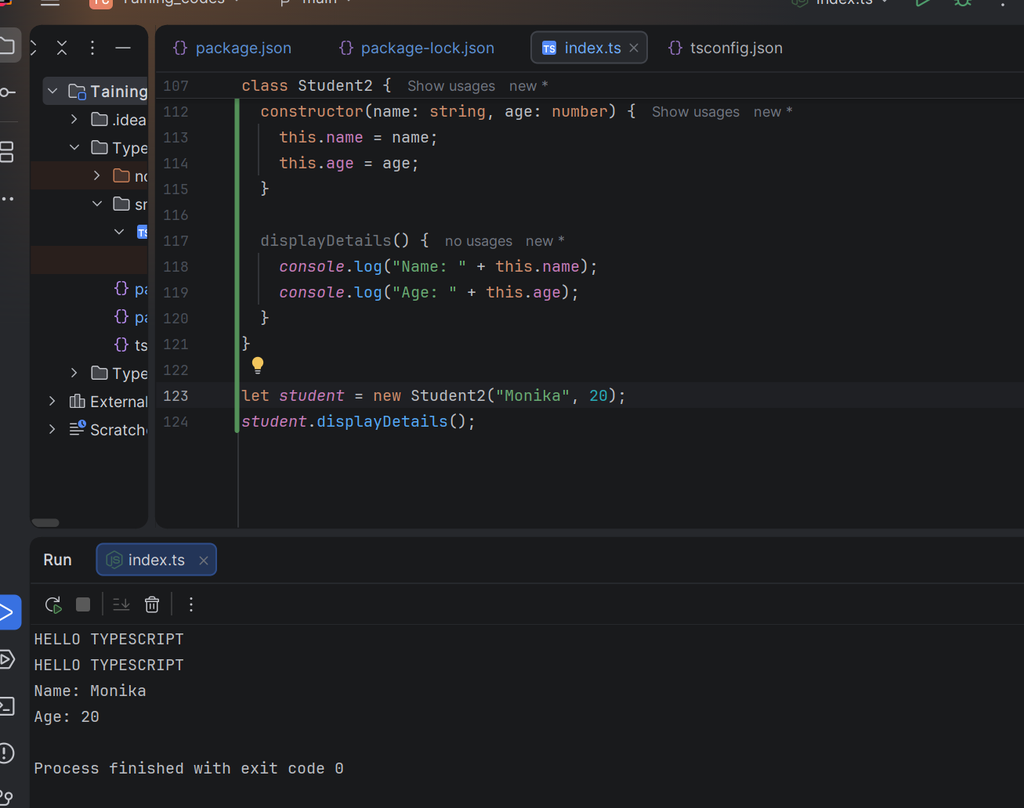
Task 13:
There is something called eager loading. What do you mean by eager and lazy loading?
- Eager Loading
Eager loading means loading a module or component when the application starts. All required files are loaded at the beginning.
Example:
When the application opens, the required modules are loaded immediately.
- Lazy Loading
Lazy loading means loading a module or component only when it is needed. The files are loaded when the user navigates to that feature.
Example:
The Admin module loads only when the user opens the Admin page.
Task 14:
What is an observable response?
- An Observable response is a response received from an asynchronous operation, such as an HTTP request, where data is delivered over time instead of immediately.
Advantages of Observables:
- Handles asynchronous operations like API calls.
- Can receive multiple values over time.
- Supports error handling and data transformation.
- Improves performance by executing only when subscribed.
Task 15:
What is the flow of your Angular project.. Explain with an ex.
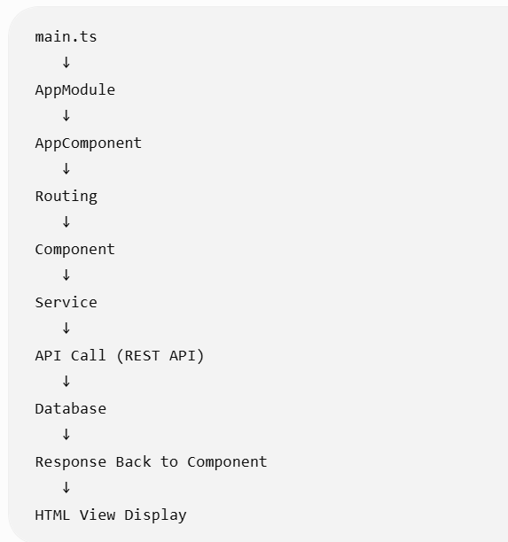

Suppose we have an Employee Management Application.
1. Application Starts (main.ts)
- The Angular application starts from the main.ts file.
- It loads the root module (AppModule).
2. AppModule
- AppModule is the main module of the application.
- It registers components, services, and other dependencies.
Example:
@NgModule({
declarations: [AppComponent, EmployeeComponent],
imports: [BrowserModule],
providers: [EmployeeService]
})
export class AppModule { }
3. AppComponent
- It is the root component of the application.
- It loads the main layout of the application.
Example:
<app-employee></app-employee>
4. Component
- Component controls the UI and handles user interaction.
- It requests data from the service.
Example:
export class EmployeeComponent {
employees = [];

constructor(private employeeService: EmployeeService) {}

getEmployees() {
this.employeeService.getEmployees()
.subscribe(data => {
this.employees = data;
});
}
}
5. Service
- Service contains business logic and communicates with the backend using HTTP calls.
Example:
getEmployees() {
return this.http.get('api/employees');
}
6. REST API
- The API receives the request and fetches data from the database.
- It sends the employee data back as a response.
7. Display Data in HTML
- The component receives the response and displays it in the UI using data binding.
Example:
<div *ngFor="let emp of employees">
{{ emp.name }}
</div>

Task 16 on words
Task of the day:

create a form component… say loginform.

Validation ensures users don’t transfer less than ₹100.
You can add async validators (e.g., check if account exists via API).
🔹 Advanced Features
FormArray → For multiple beneficiaries.
Custom Validators → e.g., prevent transfer to the same account.
Async Validators → e.g., check account balance before transfer.
Dynamic Forms → Add/remove fields at runtime.

